ANTIBIOTIC RESISTANCE: CAUSES, GLOBAL BURDEN, AND SOLUTIONS

Dr. Janki Patel, Dr. Pinkal Patel, Vaishali Patel, Kautul Patel, Kenny Hirpara, Yashkumar Panchani
Faculty of Pharmacy, Parul Institute of Pharmacy and Research, Parul University, Limda, Waghodia, Vadodara, Gujarat, India.

ABSTRACT

Antibiotic resistance is a few of the pre-eminent customary health heed thus far. Microorganisms can broaden resistance to antibiotics used within the remedy with an expansion of mechanisms. The Sqandering of antibiotics inside the veterinary, agricultural & clinical sectors, which include the irrelevant prescribing of antibiotics and their overuse within the cattle zone, and inadequate hygiene practices in health center, all make a contribution to the rise of AMR. There are many mechanisms that bacteria show off to shield themselves from antibiotics and knowledge the mechanisms by means of which bacteria face up to antibiotics will become vital to solving the disaster. Laboratory primarily based antibiotic resistance detection strategies can decide resistance or susceptibility of an isolate against any therapeutic applicants appropriate use of antibiotics, vaccination, schooling, research, development of novel antibiotics, policy, rules and surveillance of antimicrobial resistance and antibiotic use have a first-rate position in minimization of antibiotic resistance.
In this text, the general mechanisms of resistance to antibiotics along with its universal burden, detecting procedure, minimization strategies have been summarized.
Key words: Antibiotics, antibiotic resistance, mechanism ,DNA: Deoxyribonucleic Acid; RNA: Ribonucleic Acid; AMR: Antimicrobial resistance, strategies, minimization, controlling of AR and its global burden.

INTRODUCTION

Antibiotics are used in treatment & prevention of bacterial infections. Antibiotics plays key role in improvising treatment for infections due to micro-organisms into late 20th century. Antibiotics have transformed animal husbandry and agriculture. They uses antibiotics as growth promoters to prevent, and treat infectious diseases, and to improvise efficiency in health in animals & plants [1]. Antibiotics can be cytotoxic or can be cytostatic to microbes, which enables the human & animal’s natural defense systems such as immunological system and eliminate microbes. They are low molecular weight containing compounds, which are mostly naturally synthesized products, made up of microorganism or are naturally derived products which are effective against other microorganisms at lower concentration levels, although few antibiotics such as sulfa-group containing drug and oxazolidinones are naturally occurring [2]. It is not derived artificially. They act by inhibition mechanism acting on bacterial cell formation, synthesis process of proteins, DNA, RNA, act via membrane disruptors, or other actions. Antibiotic resistances remains world's one of the most important health issues till now [3]. Because of the overuse of antibiotics in agricultural field & medicinal field, AMR mechanisms often comes out and threatens the modern medicine by reducing availability of clinically relevant antibiotics. (AMR) has resulted in mortality due to failure in therapy and increased medical costs [4]. Until now, doctors have largely chosen antibiotics to treat bacterial infections base on previous clinical experience. However, with increased bacterial resistance to conventional antimicrobial agents, [5] it becomes more difficult for researchers to select a particular antimicrobial agents. The rise of worldwide AMR is huge threat to animals & humans, jeopardizing decades of improved health outcomes. It dangers the latest human & veterinary medicinal agents and negotiate with dietary health [6].Traditional methods of antibiotic susceptibility(phenotypic) testing remains important for daily routine diagnostics, because they straightly check the bacteria growth in solid and liquid medium in presence of the antibiotic agents. Solid medium consists antibiotics susceptibility tests, such as disc-diffusion assays, Epsilonometric- tests, requires at least 22 hours for an organism for growing on agar plate to visually assess growth inhibition [7] .The Molecular level analysis can be used for determination of presence of the AMR genes [8]. Responsible use of antibiotic drugs, research, vaccination, education and development of new antibiotic

drugs , regulations and policies , studying of AMR and usage of antibiotics play an key role in reducing AMR [9]. So, the goal of this review is to examine AMR mechanism, strategies & methods to combat AMR.

ANTI-MICROBIAL RESISTANCE (AMR)

Anti-microbial Resistance (AMR) is a complicated issue and a world-wide concern. Mistreatment of antibiotics in medicine, agri-material & veterinary, including inaccurate or false antibiotic prescribing, extreme use in animal husbandry, and bad hygiene practices in clinics, all contribute in increasing Antimicrobial Resistance. World trade and travel also enhances AMR spreading. Parallely, the advancement of new antibiotics is slowing, largely because of deficient approaches, allowing organisms to overtake new drug development process. It meant that disease was cured, surgery became safer, and modern medicine could be developed. Microorganisms are called antibiotic-resistant when they can no longer be suppressed by formerly sensitive antibiotic agents. This type of resistance is called Acquired resistance, and it’s coded by resistant genes in DNA of the micro-organism. This type of gene can arise from instinctive mutation into the microbial-DNA and some had evolution over the period of time, resulting into natural selection from natural antibiotics available nature. These Genetic code are also transferred from resistance of micro-organisms to susceptible microorganisms of drug. The primary drug species resistance were recognized in late years of 1940. Only 4 years have passed since higher dose of penicillin therapy was introduced, From then, spreading of species of drug-resistant micro-organism, has continually increased. Bacterial species which are highly resistant such as methicillin-resistant S.aureus and vancomycin-resistant enterococci accounting for higher proportion of nosocomial induced infections.[11]
AMR is the ability of bacterial species to antagonize the action of antibacterial, anti- reproductive agents and fungicides. The modification of AMR in bacterial species, often occurs which results in unwanted and unsuitable usage of antibiotic agents. The greater use of antibiotic agents has gave rise to resistant organisms over years, making therapy of these infection with these resistant organisms problematic. At present, at one side, attempts are made to develop new drugs, on other hand, the faster growth of resistance to this drugs makes them difficult to treat. The increase in resistance to

antibiotic drugs is major public health concern worldwide. There are 4 major types of evolving antibiotic resistance, [24-26]
  - Acquired resistance
  - Intrinsic or Natural resistance
  - Cross over resistance
  - Use of multiple resistant antibiotics.

No genetic heritage. It occurs as a result of naturally occurring resistance or microorganisms that do not contain the structure of the targeted antibiotic molecule that fails to reach their targets because of their properties. For eg, vancomycin in Gram negative bacteria do not cross outer bacterial membrane, so Gram negative bacteria are resistant to drug vancomycin. As, cell wall-less bacteria, L-type bacteria, and cell-wall-less bacteria such as Ureaplasma and Mycoplasma are inherently resistant towards the beta-lactam antibiotic agents that inhibits cell-wall synthesis in bacterial cell.
Acquired Resistance: Acquired resistance occurs because the genetic traits of bacteria change so that they are no longer affected by the aforementioned antibiotics. This type of resistance is mainly based on chromosomal or extrachromosomal structures (plasmids, transposons, etc.).
Chromosomal resistance results from mutations in the developing bacterial chromosome (spontaneous). Such mutations can be caused by physical factors (such as UV light) and chemical factors. This may be the outcome of structure change in the bacterial cell. As a result, bacterial drug permeability may be decreased or the drug's target within the cell may be altered. Streptomycin, aminoglycosides, erythromycin, and lincomycin can develop resistance to spontaneous chromosomal mutations 10 -7- 10-12. Such resistance is therefore less clinical and often problematic and plasmids carry bacterial genetic material in three ways: Conjugation, transduction, transformation, and transposition. Transduction with a bacterial viral resistance gene transformation by a DNA-binding protein called Competence factor, conjugation occurs by the sex pili between two living bacteria by resistance gene transfer. Antibiotic resistance genes on chromosomes or plasmids are bound together and

located at start of specific integrating unit called integrins. Integerons are found in humid and warmer regions in which re-editing is very commonly seen. [1,4&5]
Cross-resistance: few microorganism which are resistant to some drugs that are working by similar mechanisms, are resistant to another drug also. This conditions are frequently seen with structurally similar antibiotic drugs, like resistance between erythromycin, kanamycin, neomycin, and resistance produced between cephalosporin & penicillin. But, it can also increase in other groups of drugs. Examples are cross- resistance between erythromycin and lincomycin drugs, it can be extrachromosomal/chromosomal in origin.
Multi Drug Resistance (MDR) and Pan-resistance: MDR organisms are bacteria that have developed resistance to antibiotics usually practice for treatment. This means that certain drugs are no longer able to kill or fight germs. Inappropriate usage of antibiotics for treatment has lead to the selection of pathogen that are resistant to multiple drugs. Bacterial multidrug resistance occurs by any mechanisms. Initially these bacteria can gather multiple gene, each one encoding resistance to the drug. Such type of resistance frequently seen in Resistance plasmids. The other type of resistance, MDR, can also be caused from expansion of expression of gene encoding multi-drug efflux pumps, inactivation of enzymes, structural change in targets. Considered as multidrug resistant.
If bacterial strains are resistant to one/two groups of antibiotics, which are considered drug- resistant species, and if a strain is resistant to every group of antibiotics, They are classified as pandrug resistant. For example, (MDR) Acinetobacter spp.have resistant to at least (3) classes of antibiotic agents: all cephalosporins and penicillins , fluoroquinolones ,aminoglycosides. can be defined as an isolate. "extreme drug resistant (XDR) Acinetobacter. Isolate resistant to 3 classes of described antimicrobial agents (MDRs) and also carbapenems. Be Pdrug-resistanT or PDR.
Efflux-pumps are transport proteins that are tangled in transport of toxical substance from the inside cell to extraneous environment. Bacterial efflux pump are extensive cause of drug-resistance phenomenon. They push wider range of antibiotic agents out of the organism.

That’s why the infection with these pathogen can be ambitious for treatment . Few efflux pumps are distinct for one drug only, while other can deliver multi-substrates. [30-32]

Antibiotic Inactivation

Bacteria use multiple mechanisms to inactivate antimicrobial agents, including hydrolysis process of antibiotics, group-transfer & redox processes. The production of Beta-lactamase enzymes ,which hydrolyzes Beta-lactam ring of penicillin, is example of inactivation activity of antibiotics. Enzymes are often released by bacteria which inactivates the antimicrobial agents before it reaches the target inside the bacterium. Enzyme-mediated structural alterations of drugs by transfer of functional-group, For example- thiol groups. The newer antibiotics are unable to bound with target , which occurs due to conformational changes and its response is inevitable. The 3rd mechanism for antibiotics inactivation are redox reactions.[18,19]

Target Modifications

Alteration of antimicrobial target sites prevents antibiotics from binding properly to the sites. Microorganism cannot block antimicrobial effects by completely abolishing them due to critical bacterial cell functions at the target site. In such mechanism, the bacterium had found ways to change the antimicrobial target.[20]

Mutation

A Mutation is a spontaneously occurring change in sequence of DNA in genes that can lead to changes in traits it encodes .One pair changes and leads for corresponding change in 1 or more of the amino acids, as it encodes, changes the enzymes or its cellular structure, resulting into a target antimicrobial affinities or Strong activity changes. Mutations due to exogenous base changes common in prokaryotic genome.[22]

MECHANISM OF RESISTANCE TO ANTIBIOTIC AGENTS

The variations that occurs in target regions of drug-associated receptors and compounds "antibiotic compounds" differ. It can differ in enzyme or ribosome. Resistance achieved with altered ribosomal targets is most commonly seen with macrolide antibiotics. Mutations in the penicillin-binding protein (β-lactamase enzyme) and strains of Staphylococcus aureus, pneumoniae, Meningococcus, and Enterococcus faecium have tendency to grow resistance to penicillin. Structural changes in targets, Macrolides, beta-lactams, tetracycline, Rifampicin quinolones, glycopeptides, resistance are important mechanisms in development .

Inactivation of antibiotic via enzymes:

Mostly, Gram negative and Gram positivebacteria synthesizes enzyme that deteriorate antibiotic agents. This inactivation mechanism by enzymes is very important resistance mechanisms. In this group, a growing number of beta- lactamases, aminoglycosides, modifying enzymes (acetylases, adenylase and other enzymes) degrade beta-lactam antibiotics. Inactivating enzymes include chloramphenicol and erythromycin.
Reduced Intimal and Outer Membrane Permeability: This resistance is rapidly eliminated by changes in inner and outer membrane permeability, decreased drug uptake into the cell, or active resistance of the pump system.
Active pump system: Resistance development occurs active system, most common is the tetracyclines. Tetracyclines are excreted by an active pump system which are energy dependent and cannot gather intracellularly. Such resistance controls plasmids and chromosomes. Active pump systems are efficient in resistance to 14 membered ring macrolides, Quinolones, beta-lactams, chloramphenicol, and beta-lactams. Use of alternative pathways: Unlike some retargeting in bacteria, new pathways in drug- sensitive compounds eliminate the need to manipulate targets.
Thus, resistance between sulfonamides and trimethoprim was established. Bacteria can acquire the property of providing folate from the environment rather than synthesizing it.

Mechanism of Resistance by Antibiotic Groups

Resistance towards β Lactam Antibiotics: and 5th generation antibiotic, monobactams, and carbapenems. Mostly, the very common mechanism for resistance involves the synthesis of beta-lactamase enzymes.
β-lactamases: Molecular studies have described β-lactamase enzymes of level 4 classes which are (i)A, (ii)B, (iii)C & (iv)D. A & C & D β-lactamase enzymatically require cold ester-mediated B-class zinc ions, which are metalloenzymes. Class A β- lactamases: Gram positive and Gram negative bacteria are generally plasmids or transposons. Usually inductive. His TEM, SHV, ESBL (50 bacteria) of Gram negative bacteria are included in this group. ESBLs are found primarily in Escherichia coli and Klebsiella pneumonia [24,27,28]. Class B beta-lactamases (group 3): Enzymes that hydrolyze detectable species of Stenotrophomonas maltophilia, Bacteroides fragilis, Aeromonas and Legionella, carbapenems, penicillins and cephalosporins). Class C β lactamases: Mainly some of cephalosporins and It is usually found in Gram-negative bacteria and is localize to chromosomes (group I, AmpC, etc.).[27,29,41]

Resistance to Aminoglycoside Antibiotics: Enzymes that change the structures of aminoglycoside
In aerobic Gram negative bacteria, enzyme inactivation is the most important mechanisms in growth toward resistances to aminoglycoside. It plays major role in resistances towards aminoglycoside-differing enzymes. Such enzymes are usually derived from plasmids and transposons. This groups includes acetyltransferases and phosphotransferases. A modified enzyme is responsible for higher levels of gentamicin resistances in enterococci.
Preventing passage of drugs into the cytoplasm: anaerobic bacteria, a major mechanism of resistance to aminoglycosides. Altered ribosomal targets: especially important for streptomycin resistance. The 30S subunit caused by a mutation in the ribosomal protein S12 does not bind to target the streptomycin drug. Such type of streptomycin resistance is important in enterococci. [29,46]

Resistance to Tetracycline

Avoidance of Drug-Uptake in Cell and Active pump system: Sudden chromosomal mutations in bacteria resulting in drug uptake to decrease membrane permeability to prevent the growth of resistance. Active resistance to tetracycline can also occur in active pump system.
Ribosome Protection: A Second Important Mechanism Leading to Tetracycline Resistance. Synthesis of the tetM, tetO, tetQ, and tetS genes inhibits the activity of the drug's cytoplasmic ribosome-associated protein. These genes are found in bacteria like Campylobacter,Ureaplasma , Mycoplasma, &Bacteroides. Originally they are plasmid and chromosomal .[27,29,38]

Macrolides, lincosamides, streptogramins (MLS) group MLS group of antibiotics.
Alterations of ribosomal targets is very commonly seen resistance mechanism in the Gram positivebacteria. The distinctive methylation of drug-associated adenine molecule of the 50-S ribosome subunit by the 23-S ribosomal subunit of rRNA result in a conformational changes that decreases drug binding to rRNA. The enzymes which are responsible for process of methylation is coded in the gene regions erythromycin ribosome methylation. Such resistance can be structural or inducible in nature.
Enzymatic inactivation: Macrolides plays role in resistance by inactivating enzyme involved in resistance.

Chloramphenicol Resistance

Chloramphenicol-Acetyl-transferase is the enzyme which is synthesized by enzymatic activity of a control plasmid. A wider range of Gram positiveand Gram negative enzyme plasmids can be delivered using transposons .[28,29]

Fluoroquinolone resistance

These are the chromosomal origin and mechanism of DNA mutation of the enzyme gyrase (topoisomerase II) (gyrA, gyrB). DNA gyrase enzymes are composed of four subunits. One subunit is primary target of the quinolones. This subunits encodes

Gyr. Bacterial resistance mutation involved in generation of all quinolones. Mutations in the gyrB gene, particularly P. aeruginosa and E.coli quinolones, confers Resistances. [29,48]
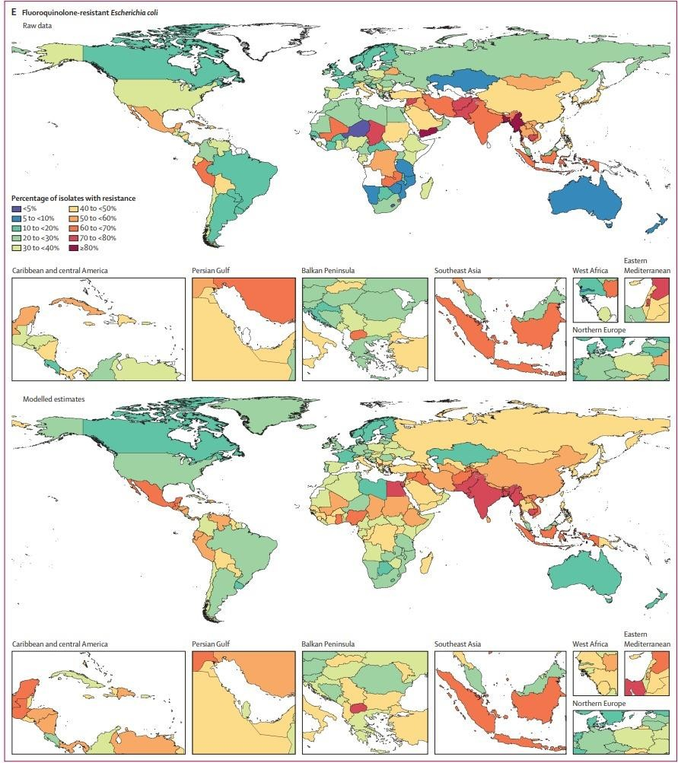
Figure 1: Raw data and modelled estimates for the percentage of pathogen isolates that are resistant by country and territory (Fluoroquinolone Resistant E.coli)

Rifampicin Resistance

Rifampicin will disturb binding to subunits of DNA-dependent RNA-polymerase enzymes in Gram-positive bacteria and mycobacteria. A chromosomal mutation that occurs in B-gene certificate, which encode the enzyme RNA polymerase, which causes rifampicin resistance. [29,32, 51-54].

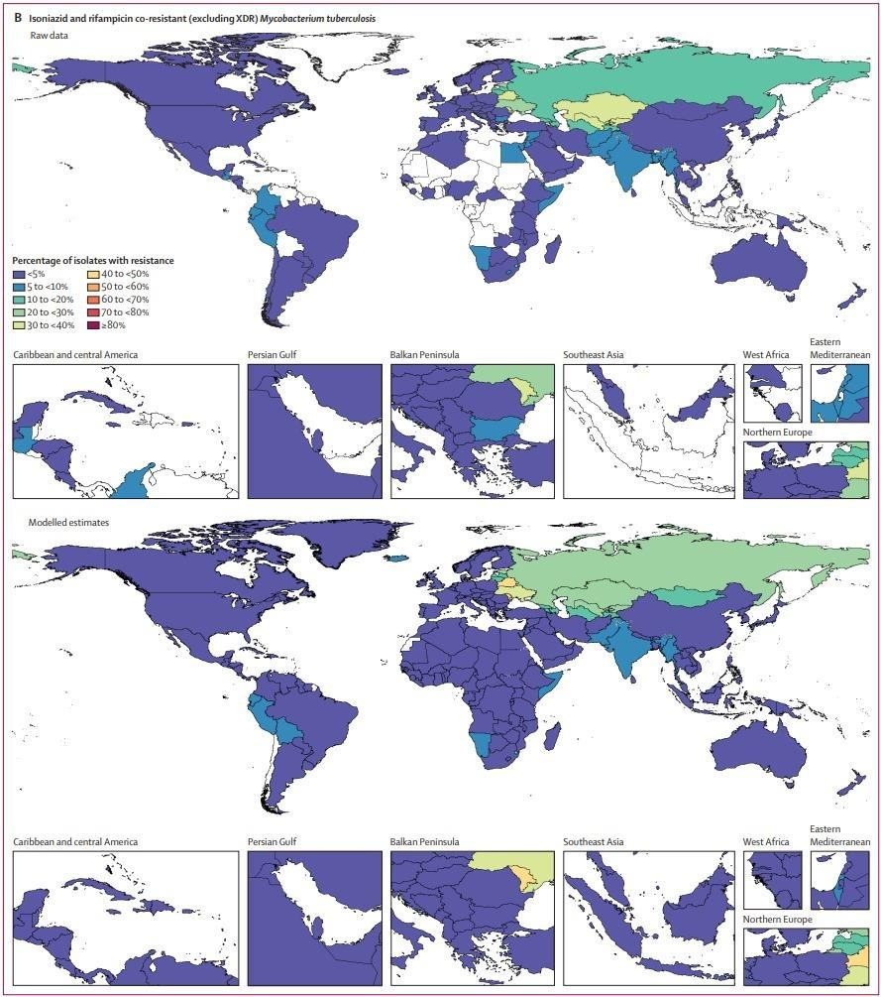
Figure 2: Raw data and modelled estimates for the percentage of pathogen isolates that are resistant by country and territory (Isoniazid and rifampicin co-resistant Mycobacterium tuberculosis)

CAUSES OF ANTIMICROBIAL RESISTANCE [55, 56]

In microorganism antibiotic resistance occurs naturally but our actions can amplify the development and spread of resistance.
  - When health care workers overuse antibiotics
  - When patient don't take their antibiotic as prescribed
  - When people don't wash their hands properly and poor hygiene
  - Due to migration of people and spreading resistant bacteria.

Anti-microbial Resistance Occurs Naturally:

AMR is natural process in bacterial cells, but the usage of antibiotics exacerbates it. turn on specific internal resistance processes mutate to defend against antibiotics acquire resistance genes from other bacteria.

Antibiotic Use Increases AMR:

The main cause of antbiotic resistance is the use of antibiotics. Antibiotic agents kills few of the bacteria, but the strains which are resistant can multiply after survival. Overusage of antibiotic makes resistant bacterial strains more common.
The more antibiotics we use, the more likely bacteria becomes resistant. This means antibiotic will not work when need it in the future-time.

Mutation:

Microorganisms divides and reproduces every hour & minutes. This allows to evolve them quickly and adapt rapidly to newer environment. Mutations occur during replicating process, and few of these mutations aids a single microorganism to survive exposure to antimicrobial agents. We can also get gene from each other, including Bacteria multiply billions of times. Bacteria with drug-resistant-DNA can transfer copies of similar gene to other bacteria. Non-resistant-bacteria acquires newer DNA and resistance occurs towards the drugs.

Social Pressure:

Usage of antibiotic drugs, even in limit, causes selective pressure for antibiotic drugs resistant strains. Also, there are various type of societal pressures accelerating the rise of antimicrobial resistance.

Inappropriate use:

Inappropriate usage of antimicrobial agents increase the selection of resistant organisms. Health care providers may inappropriately prescribe antibiotics to appease persistent patients with viral infections or undiagnosed conditions.

METHODS OF DETECTING OF RESISTANCE

The Antimicrobial Susceptibility Testing Method is an in vitro method for detecting AMR in individual bacterial isolate cultures. These laboratory-based assays can be used for determination of resistances or susceptibility of isolates to therapeutic entrants. These approaches can also be used to monitor the evolution & spread of resistant organisms in populations. [57]

Disc-Diffusion Method:

Utilisation of easily available drug soaked filter papers discs to surface of seeded-agar plates until confluent with the organisms of interest are referred to disc diffusion. Disc-diffusion is called as the Kirby Bauer antibiotics test. Drugs dispersed gradually in the agar and the concentrations of drug decreases in logarithmic manner with increasing distance from disc, resulting in a circular growth-inhibitory zone around the disc, whose diameter is below the MIC is inversely proportional. For, the inhibition zone, inversely correlated with MIC of bacteria used in test. Generally, larger the zone of inhibition, lower is the concentrations of anti-microbials are required to inhibit the growth of the organism. The disc diffusion assay is performed by placing approx. 1-2 x 108 CFU/mL of bacteria inoculum on surface of 150 mm diameter Mueller and Hinton agar plates. The rise in blockage zone around every antibiotics disc is measured to nearest mm. The zone diameter indicates sensitivity of isolate of bacteria and diffusion rate of the drug through zone of agar diameters for each drug are analyzed using requirements published by Clinical Laboratory Standard Organization (CLSO), is simple to perform reproducible, and it do not need any cost effective equipment.[61]

Dilution method:

Agar-dilution method & broth-dilution methods are widely used for determination of minimum concentration of antimicrobials that kills microorganisms (bactericidal) or inhibits growth of microorganisms (bacteriostatic) is the way it is done. The dilution method is performed when a quantification method is necessary for microorganism with different growth rate. [58]

Broth dilution method:

Broth dilution method expose the isolate to varying concentrations of the antimicrobial agent in a broth environment. The microdilution test use a total culture volume of approximately 0.05 to 0.1 mL and is easily be performed in a microtiter plate format. Macro level dilution studies use approximately 1.0 mL of volumes of culture in standardly used test-tubes. For broth methods, the lower concentrations at which isolates are totaly inhibited, are registered as minimum inhibitory concentration (MIC). Therefore, the Minimum Inhibitory Concentrations is the lowest concentration of an antibiotic agent that inhibits the isolate of bacteria. The broth-dilution methods for antibiotic agents susceptibility testing is called as MIC method. Test-tubes containing each antibiotics tested at increasing concentration from 0.0312-512µg/ml are inoculated using solid cultures containing standard concentrations of bacteria. Each tube of has twice the antibiotic concentration of previous test-tube. In Broth- dilution assay, culture tubes containing non-selective broth media are spiked with varying concentrations of antimicrobial agents. The tubes are incubated for 16 to 24 hours under optimal conditions for the test organism. Antimicrobial activity can be determined by spectrophotometry or plating counts. [63]

Agar dilution method:

Agar dilution is normally prepared in Petri dish, with the benefit of testing more than one organisms on every dish, in agar dilution technique, the antimicrobials are inoculated in agar medium, with every dish containing distinctive awareness of agent. Inoculum can be quickly carried out to agar surface the usage of inoculum replicator. Mueller-Hinton agar is ready from dehydrate base, and the advantages of the agar- dilution check includes exponential results and increase of maximum non-troubling microorganisms. Although the agar dilution take a look at is not normally performed in recurring medical laboratories, it could be ideal for neighborhood reference & research laboratories that want to check big numbers of isolate. [64]

Epsilonometer Test (E-Test):

‘The epsilonmetric test (E-test) are exponential slope methods for determining AMR. The E test was developed for the direct quantification of the antimicrobial agents’ susceptibility of microorganism. It is a quantitative method that uses dilution

of the antibiotic, and diffusion of the antibiotics into medium. This device consists of a defined continuous & exponential concentration gradient of antibiotics immobilized within a rectangular plastic test strip [65]. The principle of the E-Test method is based on antimicrobial concentration gradient on agar plate. This strips are soaked with a concentration gradient of dry antibiotic at the bottom side and have a concentration scale on the top. When this E test strip is placed on the inoculated agar plate, the active substance was immediately released. The E test is used to determine the MIC of organisms such as S.pneumoniae and β hemolytes. E test is uncomplicated, precise and convenient, and also used to record the MIC of anti-fungal and anti-mycobacterial agents. [57]

Automated Instrument Methods:

Various automated system are commercially available which helps and reduces the technical timing required for performing & record sensitivity tests. For eg, the results for the Disk-Sensitivity Test & Breakpoint Sensitivity Test can also be read by using camera which is connected to computer system. Another system use liquid culture to detect the effects of antibiotic agents on bacteria growth rates by measuring turbidity (nephrometry) or CO2 production. Such automated systems may significantly reduce required incubating time.[66,67]

Molecular Method for Detecting AMR:

Molecular characterization of the genetic mechanisms of specific phenotypic results obtained by conventional antimicrobial susceptibility testing is essential for many clinical studies related to bacterial infections. Part of public. In few cases, molecular analysis is done to explore the presence of specific genes when phenotypic results is taking very longer time, indecisive, or not available. Molecular method are widely use in research & reference labs. Few approaches used, such as Polymeric Chain Reaction and Hybridization technique.

GLOBAL BURDEN OF ANTIMICROBIAL RESISTANCE [73]

There is global concurrence that AMR is a serious to human life. However, into many parts of world, critical monitoring and exposure data are missing, making it crucial to

get a complete picture of the state. Also, stress is a wide term that can mean copious different things. It is generally thought to be the mortality rate, caused by the disease.

Economic Burden:

Antimicrobial resistance is absolutely very expensive for each individual, health care and society. A study in this country found that the average total commutative cost of treating bacteria caused by resistant bacteria. The impact on the global economy is also huge.

Health Burden of Antibiotics Resistance:

It mainly regards as deaths figures caused by infections with resistant Species. Although it may look simple but there are many different ways to measure and evaluate this, making exposure estimates and data comparisons across studies. The number of people dying during suffering from an antibiotic resistant infection is regardless of the availability of other disease or condition. The total excess deaths caused by a particular resistant infection.

Mortality attributed to antibiotic resistance:

Excess deaths in patients with antibiotic resistant disease compared to patients without antibiotic resistant disease critical factors are the diagnostic capabilities of the healthcare system and the methods used for identification. Determines the number of deaths to record. For example, if a terminally ill cancer patient becomes infected with resistant bacteria, develops septic infection or suddenly dies, it is uncertain whether the purpose of infection and antibiotic perceptibility can be identified if the patient lives in a field with finite laboratory diagnostics. Data on of antibiotic resistance are particularly sparse in poor and developing countries, although such countries are usually known to be more affected. Efforts to ensure health coverage are also important for data generation.

Antimicrobial Resistance –

Emerging - Now Antimicrobial resistance can be viewed as both a slow moving epidemic and a silent tsunami. Despite the fact that many people die every day from drug-resistant infections, the burden is growing.

Global data for 2019 shows that:

One of five deaths from -resistant bacteria is a child under the age of five. The burden of the AMR falls disproportionately on poor & developing countries. Read about first comprehensive report mapping the global burden on health of AMR

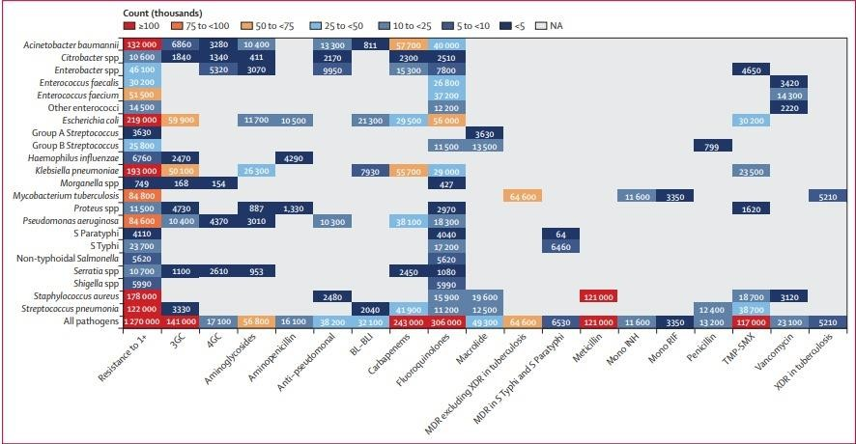
Figure 3: Global deaths (counts) attributable to bacterial antimicrobial resistance by pathogen–drug combination, 2019 For this figure, only deaths attributable to resistance, not deaths associated with resistance, are shown due to the very high levels of correlation for resistance patterns between some drugs. 3GC=thirdgeneration cephalosporins. 4GC=fourth-generation cephalosporins. Anti- pseudomonal=anti-pseudomonal penicillin or beta-lactamase inhibitors. BL-BLI=β-lactam or β- lactamase inhibitors. MDR=multidrug resistance. Mono INH=isoniazid mono-resistance. Mono RIF=rifampicin mono-resistance. NA=not applicable. Resistance to 1+=resistance to one or more drug.
S Paratyphi=Salmonella enterica serotype Paratyphi. S Typhi=S enterica serotype Typhi. TMP- SMX=trimethoprim-sulfamethoxazole. XDR=extensive drug resistance.

Global Burden of Disease:

Global Burden of Disease study estimates the burden of various situations and disorders in 195 countries. In 2018, it was announced that the Global Burden of Disease will also consider mortality and morbidity data on drug resistant infections. This work was conducted in association with the Global Research on Antimicrobial Resistance (GRAM) project, with the starting goal of producing estimates of his ABR exposure since 1990 for 17 pathogen antibiotic combinations. First outcome are expected in 2021. However, these estimates are not straight forward.
Unique characteristics of antimicrobial resistance e.g., not a disease per se, bacteria can flourish resistance to multiple antimicrobials.
Lack of microbiological data. Choice of methodologies.
For example, you can compare it to traffic. I wish the drivers would be more careful when driving on roads with a lot of traffic accidents. But if the driver knew that there was an average of 1 fatal accident per week on that particular road, the reaction might be different. Perhaps you will cancel your trip or choose another, statistically safer route. And authorities and policymakers are more likely to compute finding solutions to alleviate the issues and make our roads safer.
The same is true for antibiotic resistance. Knowing the scale of the problem, both nationally and globally, helps convey the exigency of the crisis. It can help inform strategies, target mediation, and raise awareness. These are all crucial parts of the antimicrobial resistance response. In other sense, the lesser data on burden of AMR is very necessary to address as it could delay national and global efforts. We need to look more closely at how to fill the gaps in the data. This includes further strengthening the capacity and capacity of health systems to identify and document drug resistant disorder outcomes, but also complementing data collection with point prevalence surveys, etc. will be As we continue to fill data gaps, we must determine that we have sufficient education and insight to take descision here and now.

SOLUTIONS TO MINIMIZE ANTI-MICROBIAL RESISTANCE

A considerable list on AMR bacteria was recently published by the sector fitness agency (World Health Organization) in a reality article dated 27-02-2017. Microorganisms are labeled as essential, high, and intermediate, and the type is based on degree of resistance, mortality and its healing potential, such a situation is especially essential for infection resulting from Gram (-ve) (P.aeruginosa, S.aureus, E.faecium K.pneumoniae, A. baumanii, and Enterobacter) bacteria which are antibiotic- proof against carbapenems, which are considered a final treatment to antibiotics. M.tuberculi , the agent causing T.B added to this listing, is known as one of the top international fitness priority. They can initialize critical and deadly

infection together with bloodstream infection and pneumonia, that bacteria are resistant to many antibiotics including 3rd Gen carbapenem and cephalosporin. It's best antibiotic for treating MDR bacteria. With no new antibiotics within the pipeline, this resistance is associated with excessive mortality. This pathogen priority list may be used as a guiding principle for R&D incentive and investment aiming for discovering new powerful antimicrobials [74-77]. Multidrug-resistant bacteria currently purpose about 25,000 deaths in Europe per annum [78] and price the financial system(economy) about € one. Five billion per annum and in United States scenario is also same. Multi-Drug Resistant bacteria kill 23,000 human beings each year out of two million inflamed human beings. For this reason, Antimicrobial Resistance, is considered through World Health Organization, as one of the 3 biggest public fitness threats of the 21st century [79, 80].
As the protection of anti-biotic medication declines, it is important to maintain its efficacy and scale up the present antibiotic arsenal. Moreover, improving antibiotic compliances [81] is critical, upgrades can consequently be made by using
- Supplying more modern dosage forms to replace outdated pills,

- Extending the life of present antibiotics.

The first goal is tough to aim without extensive government funding, and recentl y have seen a decline in funding by means of pharmaceutical businesses in coming across new antibiotics [82]. The motives for this investment reduces both economic & clinical limitations. From the monetary factor of view, newer antibiotics are much less worthwhile than dosages for treating persistent illnesses, and antibiotic therapy is regularly quick-lived and healing. Additionally, antibiotics are usually ineffective against resistant microorganism, decreasing profitability [83]. There are also clinical challenges. From the 'golden age' 2 new class of antibiotics drugs are delivered into the market. Antibiotics in development are derivatives of medicine which might be already approved and to which many bacteria have already got resistance mechanisms [84,85]. Synergy and drug combos are a hit approach inside the combat towards MDR microorganism, and the usage of antibiotic adjuvants has already proven to assist drugs already in such area. The best in class known successful example is combination of amoxicillin & clavulanic acid. Clavulanic acid is a beta-lactamase inhibitor with vulnerable antibacterial action, and Amoxicillin is a strong beta-lactam antibiotic, inactivated by beta-lactamase. Above mentioned combination of antibiotics drugs with antibiotic adjuvants brought about Augmentin, the top-promoting drug or blockading resistance agent of 2001.Antibiotic adjuvants also can suppress the inherited resistance that has brought about the elevated spectrum of motion of antibiotics, certainly, there are examples within the literature reporting using Gram positive selective antibiotics to deal with infections because of Gram -ve antibiotics. This is also an amazing strategy for antibiotics in which toxicity is an difficulty, along with: B. colistin. In this situation, antibiotic adjuvants that promotes the susceptibility of micro-organism to antibiotics allow lower doses to be powerful, decreasing therapeutic outcomes [86]. Up to this point, mainly his three styles of antibiotic adjuvants were advanced to block the above antibiotic resistance mechanisms. (a) Efflux pumps inhibitors, (b) β-lactamase inhibitors, and (c) outer-membrane- permeabilizers. Table below provides a listing of antibiotic adjuvant mentioned on this evaluation, additionally, newer potent inhibitors focused on virulence, the potential of micro-organism to motive contamination, are being developed to decorate the antimicrobial efficacy of medication [87]. This approach entails identifying proteins, genes, and other biopolymers liable for bacterial virulence. Blockage of those makes the bacteria much less suited and greater prone to attack with the aid of the antibiotics and immune system. By Facts, it has suggested that such objectives, despite the fact that now not important for survival, are not likely to generate mutations. it may be blended with current antibiotics to extend drug discovery objectives [88].

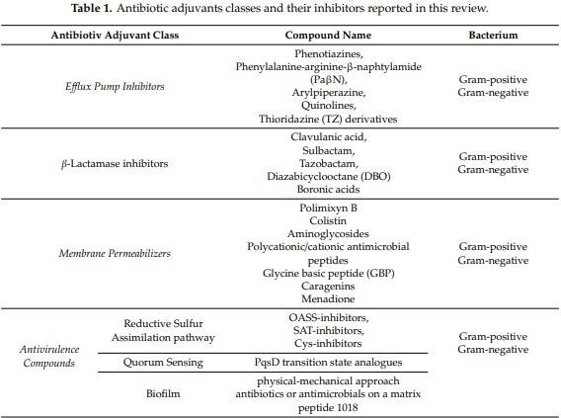

1. Targeting Efflux pump mechanism

The efflux pump is most essential example of bacterial mechanism that causes cross- resistance to numerous antibiotic drugs [89]. Such resistance mechanism entails antibiotic drugs, mainly tetracyclines, macrolides, and fluroquinolones , which provides antibacterial outcomes within the bacteria[90]. Excretory or Eliminary systems can actively take away traditional antibiotics, ensuing in expanded minimum inhibitory concentrations or, in a few instances, lack of antimicrobial interest, such system can eliminate not only antibiotic agents, but additionally non-antibiotic substrate which include heavy metals and detergents from body [91 -93]. These trans- membrane proteins are present in nearly each & every organisms, which including humans [94,95]. It is usually accepted that they typically cause moderate levels of resistance, and the effects of effective losing of antibiotics may be summarized as follows:-
- The best instance is P.aeruginosa, wherein knocking out the mex-B gene produces mutant that are highly sensitive towards various kinds of antibiotics.[96]

- Cross-resistance includes the evolutionary event of antibiotic that reduces the susceptibility of organisms to multiple medicines. This is commonly because of high exposure to particular antibiotics.
- Vast resistance is visible in bacterial species in which active efflux works in synergy with different resistance mechanism, along with Escherichia.coli lines that explicit both Beta-lactamases and efflux-pump and are also not sensitive to beta- lactam. [97]. The mixture of these two resistance mechanisms (efflux pump & beta- lactamase) has been proven to boom resistance to quinolones [98].
- The mutation favors micro-organism overexpressing efflux pump mechanism. In this manner, antibiotic goals are highly exposed to sub-inhibitory concentrations and may mutate in a manner that inhibits antimicrobial action [99], in the long run leading to excessive tiers of resistance. Efflux(Active) of antibiotics drugs was first mentioned Thirty(30) years in the past. That time, the presence of a plasmid-encoded-proteins that extrudes tetracyclines and resistances to this antibiotic drugs in E.coli [100] was studied by Mc-Murry and associates. Considering from then, numerous efflux pump are characterized in each Gram positiveand Gram negative bacteria. Presently, efflux pump mechanism can be taken and is capable antimicrobial objectives because of their role in antibiotics resistance, and the modification of inhibitor may additionally enhance therapeutic arsenals against resistant strain of microbes. In result of mixture antibiotic therapy, efflux pump are wonderful from different resistance mechanism (together with beta-lactamases) that act on particular antibiotic households. In fact, efflux pumps can extrude out extensive variety of various antibiotic classes. For this reason, its inhibition increases bacterial susceptibility, and mixture with multiple antimicrobials may fit .There are several methods to inhibit efflux pumps: (i) adding functional group to drug substrates to intefere with recognition ,(ii) interfering with efflux genes expression, (iii) can block the action of small molecules designed efflux pumps as substrate analogues, or (iv) can intervene with the pump's energy transfer mechanism, (v) interfering with channel protein system or (vi) block channels can be [101,102] .Consequently, it may be confirmed that inhibition of efflux results in various positive outcomes. (i) booms the action of eliminated antimicrobials, (ii) maintain drug concentration at therapeutic doses, and (iii) lessen remedy length by means of lowering MDR [103,104] . The most common approach for combination therapy with specific antibiotics is the development of efflux pump inhibitors. Efflux-

pump-inhibitor (EPI) are smaller molecule that binds to efflux pumps & block their extrusing action. Efflux pump inhibitors commonly don't have any inherent antibacterial action. So for that reason, those compounds may be further examined for synergy stic action with various concentrations of antibiotic drugs towards singlular concentration of inhibitors in bacteria cell wall containing efflux-pump. Inhibitors showing a synergistic discount in MIC of as a minimum eight-fold are in addition evaluated the usage of the fraction inhibition attention (FIC) approach [105]. One disadvantage of focusing on efflux pumps is associated with the one of the physiological features they're involved in, and their blockage can lead to combined toxicity, in particular for EPIs derived from drug repurposing strategies, may be linked. In reality, the principle problem with combinational therapy is associated with wanting to use EPI at higher dose, related to capability on and off-target side outcomes. In this review, studies has centered in finding compound or compounds that are selectively & inhibit pumps that feature most effective in prokaryotic cells [106]. Given this need, several research were executed for identifying substrates & inhibitors of these pumps.. The mostly used example is Reserpine which has been proven for inhibition of multi-drug transporters together with Nor-A [107], whch increase intra-cellular concentrations of fluoroquinolones antibiotics, and decrease MICs.

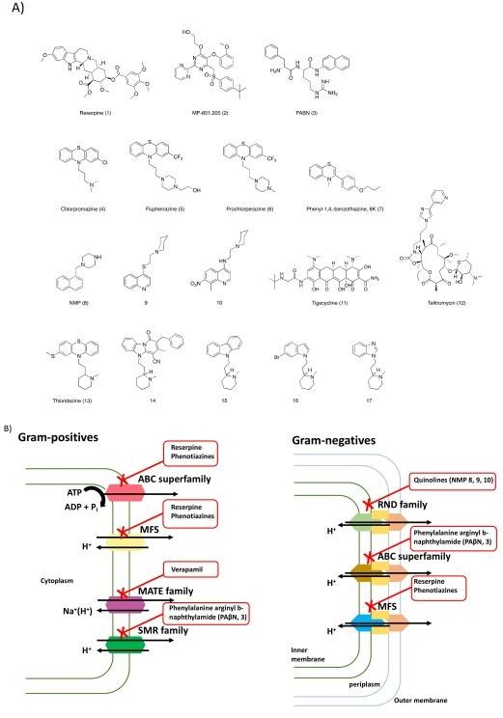
Figure 4. (A) Chemical structures of the efflux pump inhibitors (EPIs) discussed in this review and (B) efflux pumps expressed in Gram-positives and Gram-negatives bacteria and their respectively inhibitors.

Same consequences were mentioned with phenothiazines, calcium channel blockers, selective serotonin reuptake inhibitors or omeprazole, derivatives are presently being

evolved that lacks the pharmacological action of related compounds. The sole inhibitor stated thus far is MP 601 given in form of aerosols to the patients with cystic fibrosis [106,107] .The principle Efflux Pump Inhibitor compounds are dipeptide- amides called as phenyl-alanine-arginine-β-naphthyl-amide which inhibits some and not every RND-efflux-pump. It had determined to increase or repair the working of numerous antibiotics inclusive of 4-fluoroquinolones, macrolides & chloramphenicol towards wider range of microorganisms [108]. Such molecules shows mechanism of movement with the binding target transporters at the equal sites that the efflux pumps uses to bind to the antibiotic drug that it's pushing out [109], also, such molecules and their derivatives are very toxic for use therapeutically [110],other molecules that inhibit efflux pumps are phenothiazine derivatives and lots attempt has been committed to optimizing them for therapeutic use. Phenothiazines had been known to enhance activity of numerous class of antibiotic drugs, along with , levo-floxacin, azithromycin, and erythro-mycin. MOA of this class of EPI is associated with disruption of proton gradient present on bacterial inner membrane [111]. Chlorpromazine additionally inhibits Salmonella Enterica, however synergistically with the aid of modifying the expressions of the acr-B genes rather than at once inhibiting the efflux pump [112]. Quinolines had been proven to inhibit antibiotic efflux in isolates of multidrug-resistant micro organism. In truth, many quinoline derivatives had been proven to decorate antibiotic activity through inactivating the efflux transporter [113]. Studies on this class of compounds have been carried out towards Gram negative bacteria [114]. Other institution of EPI are the N-heterocyclic compound, especially aryl-piperazine derivatives which show hobby against each efflux pump in the bacteria E. coli [115]. A representative chemical, 1 -(1- naphthylmethyl) piperazine exhibits greater EPI inhibiton. Its mechanism is to reduce drugs resistance in bacteria E.coli. and clinical isolate of E.coli are susceptible to fluoroquinolone[116]. According the MOA of this elegance of EPIs, NMP is proposed to inhibit the efflux pump via interfering with functional group that play crucial roles inside the extrusion of multiple substrates. a main disadvantage of the usage of arylpiperazines is their rather low efficiency, just like serotonergic agonists [117]. instead, antibiotic launch can be impeded with the aid of altering its shape to lessen efflux pump affinity. In the tetracycline and macrolide derivative lessons, new compounds inside the glycyl-glycine & ketolide instructions range from the discerned compounds in which compound have lower affinity for precise efflux pump[118].

Tigecycline, isn't always appreciably extruded with the aid of each Gram positiveand Gram negative bacteria [119]. Telithromycin indicates increased potency towards bacteria mediated with the aid of elevated macrolide efflux [120]. It has additionally been mentioned that EPI inhibits M.tuberculi efflux pump each in-vitro & in-vivo [121]. On such regard, latest studies through Pieroni etal, It analyzed and verified how compounds that interfere with bacteria metabolisms should have an impact on drug activity and could be mixed with contemporary treatment plans.

Targeting β-lactamase Enzyme

Production of an enzyme that may inactivate antibiotics, it is one of resistance mechanism that bacteria use to resist the results in antibiotics [122]. Beta Lactam antibiotics were primary successfully developed and in the end modified natural antibacterial compounds and, due to their antibacterial action and selectivity, nevertheless represents completely essential class of antibiotics. The speedy spreading of resistant strains worldwide observed the commercialization of β-lactam resistance. In Gram positive bacteria cells, hydrolysis of primary commercially available penicillins by means of β-lactamases turned into the first stated mechanism of Beta- lactam resistance. MOA of those antibiotics involves inactivation of trans-peptidases enzyme required for final step of bacteria cell-wall synthesis. Bacteria strains produces Beta-lactamase that disrupt the β-lactam ring, which results in the ineffectiveness of antibiotic drugs consisting such functional group. The Beta-lactam ring is main component which is important for antibiotic activity because of its electrophilicity, by which it irreversibly acylates penicillin binding protein (PBP). PBP is concerned in formation of peptidoglycan, which is involved in structural integrity of bacterial cellular walls. For maintaining the cell wall, Beta-lactamases synthesized by bacterial cells can hydrolyze β-lactam-primarily based antibiotic agents by using developing in-active open circuit, and extent of hydrolysis is decided by using of beta ab–lactamase, Produced through microorganisms. Gram negative bacteria release beta-lactamases in periplasmic space to avoid antibiotics from accomplishing their targets in cytoplasmic membrane [123], while Gram positive bacteria release those enzymes in extra-cellular area. Today, hundreds of Beta- lactamases had located within the identical MOA. They vary from each in amino acid sequence, resulting in various affinities for various substrate. In popular, beta- lactamases are further classified consistent with Two(2) strategies. First, is the

Ambler classification, based on structural property, and the Second, is the Bush and Jacoby type, based totally on functional properties [123,124]. Large doses of Beta- lactam antibiotic drugs are used therapeutically to promote synthesis of particular class of beta-lactamases referred to as extended range-spectrum beta-lactamase (ESBL) that covers maximum beta-lactams and hydrolyze the antibiotic. can be, those are characterised especially in the family Enterobacteria. [125,126]. Carbapenemase represents most flexible class of beta-lactamases, with a broad range-spectrum as compared to other beta-lactam hydrolase, lots of those enzymes recognize almost all hydrolysis compatible beta-lactams and maximum are resistant against inhibition via all commercially available beta-lactamase inhibitors [127]. In this review, because of the growing variety of newly found beta-lactamases, there is need for new and effective beta-lactamase inhibitors as antibiotic adjuvants in antibiotic remedy [ 122]. Two techniques had been pursued to conquer beta-lactamase-mediated resistance to beta-lactams: (i) beta-lactamase-stable ones, such as cephalosporin and carbapenem, which are stable to hydrolysis through beta-lactamases;(i) development of antibiotics and (ii) the development of selective β-lactamase inhibitors (BLI) to be used in combination with beta-lactam antibiotics. Choice of inhibitors may be combined with specific beta-lactam antibiotic drugs is a complicated step thinking about several necessities. a) Capacity of the inhibitor for shielding the antibiotics from enzyme hydrolysis, b) Dose of the inhibitor for the safety; c)Stability and Feasibility of combination. On such state of affairs, the invention of clavulanic-acid ,a secondary metabolite from Streptomyces-clavuligerus, changed into an essential step in the discipline of antibiotic discovery. This β-lactams can inactivate most β-lactamases and showcase greater antibacterial activity. This caused the improvement of the first beta-lactamase inhibitor combination, Augmentin (amoxicillin/clavulanic-acid) [128].Such aggregate of antibiotic molecule and antibiotic drugs adjuvant became a massive business fulfillment, followed through other aggregates.

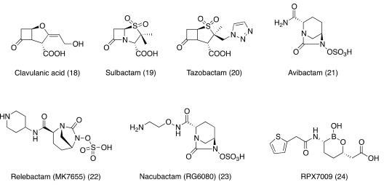
Figure 5. Chemical structures of β-lactamases inhibitors discussed in this review.

After discovery of clavulanic-acid, a med-chemistry research had launched aiming for synthesizing several penicillanate-sulfones with beta-lactamase inhibition activity. Of these, sulbactam and tazobactam have been successfully marketed. [131]

Attacking the Outer Membrane

Therapeutic antibiotics exert their antibacterial outcomes via attacking appropriate targets in the cells. To do that, antibiotic requires for crossing the bacteria membrane to reach their objectives. to resist antibiotic penetration, Gram negative bacteria are covered by presence of other layer of defense, outer membrane [132]also, the Gram negative outer membrane, composed in particular of poly-anionic-lipopolysaccharides and porins, limits the entry of foreign particles including antibiotics stucture. As a result, a few antibiotics are much less powerful in treatment of Gram negative infection due to the complex cellwall structure . Also, the complicated structure & composition of the cell membrane wall strongly have an impact on bacterial susceptibility to antibiotics. Consequently, it isn't surprising that maximum of the emerging resistant traces commonly accumulate protein mutation on the outer- membrane level to conquer the effects of a few antibiotics. To penetrate the bacterial wall, the antibiotic uses two unique techniques depending on chemical nature of small molecules. Hydro-phobic compounds (consisting of rifampicin and macrolides) passes lipid bilayers through passive transport mechanism. b. Hydro-philic molecules (fluoroquinolones, beta-lactams,etc.) diffuses through active transport mechanism and take advantage of their ability to have interaction with specific porins[132,133].The outer cell membrane of bacteria is potential target which may address bacterial

species resistance, and better expertise of its structure will enable us to design new training of antibiotics with specific MOAs. [135]. Use of antibiotic drug adjuvants to elevate membrane permeability (e.g. permeabilizing agents) have tested to be an terrific strategy for enhancing antibiotic penetration by destabilizing the membrane wall via interacting with , or via doing away with cations in outer layer. Resulting, the outer membrane is extra permeable to xenobiotics. Eg. of outer cell membrane permeabilizer are polymyxin consisting of polymyxin-B, colistin, aminoglycosides, cationic peptides, or polyamines [136,137].
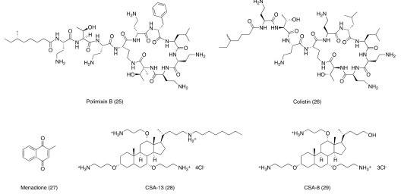
Figure 6. Chemical structures of membrane permeabilizers discussed in this review.

Targeting ofAnti-virulence factors

While identification of new antibiotics drugs active towards drug-resistant strains, it’s motive is to consider alternative cellular pathway as sources of target for development of latest anti-microbial adjuvant classes is conventional, which presents an interesting opportunity to technique the Antibiotics regularly because of latent and chronic infections which can be very tough to deal with. At some stage in host , pathogens are exposed to extraordinarily hostile environments and require considerable reconsidering of bacterial metabolic function to survive unfavourable condition, so , concentrated on main metabolic capabilities related to pathogen survival beneath such conditions may also cause higher antibiotic therapy and increase susceptibility to standard antibiotics. On this note, a first-rate element within the deterioration of affected person health, all through bacterial infections is the virulence of the bacteria. In the closing decade, new procedures aimed at preventing bacterial virulence or virulence have emerged, not like traditional antibiotics, which kill bacteria or prevent

them from developing, antiviral drug act on precise target are called virulence factors. Virulence factors is simply expressed in bacteria at some point of infection, even though they're not essential for simple bacteria cell cycle, and essential for process of pathogenesis, and pharmacological-inactivation renders bacteria will not able to purpose pathological infection inside the host. In this manner, the immune system of host is capable of working more quickly and easily against less virulent [152] pathogens, furthermore, considering the fact that anti-pathogenic inhibitors do not goal for pathogen life cycle, selection stress for resistant mutants is considered less applicable in this context [153]. Examples of nonessential target-rich pathways encompass the pathway of sulfur assimilation, quorum sensing, and biofilms destruction [154].

CONCLUSION

The environment has functioned in development & spread of resistance. Antibiotic resistance is at high peak in all parts of the world. In spite of measures to be taken by some authorities of World health organization (WHO), Uses of antibiotics in humans, animals, and agriculture is increasing. The high monetary load in the clinical department has become a rising problem due to prolonged hospital stays, separated wards, inflexible infection control measures & care failures. The public health officers should run proper vigilance system coordinated at international levels. Running investigation and necessary reporting system for antibiotic resistance. Both domestic and global policies are required to be traditional and adhered to block the misuse of antibiotics and improvise the techniques to detect resistant strains of microorganisms and develop newer classes of antibiotics, which are highly therapeutic against resistant species.

REFERENCES:

[1]. Qiao M, Ying GG, Singer AC, Zhu YG Review of antibiotic resistance in China and its environment. Environ Int 110. 2018. Page no: 160-172.
[2]. Martens E, Demain AL The antibiotic resistance crisis, with a focus on the United States. J Antibiot 70(5). 2017 . Page no: 520-526.
[3]. Zaman S Bin, Hussain MA, Nye R, Mehta V, Mamun KT, et al. A review on antibiotic resistance: alarm bells are ringing. Cureus 9(6). 2017. Page no:1403.
[4]. Avesar J, Rosenfeld D, Truman Rosentsvit M, Ben Arye T, Geffen Y, et al. Rapid phenotypic antimicrobial susceptibility testing using nanoliter arrays. Proc Natl Acad Sci 114(29). 2017. E5787-E5795.
[5]. White DG, Acar J, Anthony F, Franklin A, Gupta R, et al. Antimicrobial resistance: standardisation and harmonisation of laboratory methodologies for the detection and quantification of antimicrobial resistance. Rev Sci Tech Int des Epizoot 20(3). 2001 .Page no: 849-855.
[6]. Gay N, Belmonte O, Collard JM, Halifa M, Issack MI, et al, Review of antibiotic resistance in the Indian Ocean Commission: A human and animal health issue. Front public Heal 5. 2017 .Page no: 162.
[7]. Veses Garcia M, Antypas H, Löffler S, Brauner A, Andersson Svahn H, et al. Rapid Phenotypic Antibiotic Susceptibility Testing of Uropathogens Using Optical Signal Analysis on the Nanowell Slide. Front Microbiol 9. 2018
[8]. Anjum MF, Zankari E, Hasman H. Molecular Methods for Detection of Antimicrobial Resistance. Microbiology 5(6). 2017.
[9.] Laxminarayan R, Duse A, Wattal C, Zaidi AKM, Wertheim HFL, et al. Antibiotic resistance-the need for global solutions. Lancet Infect Dis 13(12). 2013 Page no: 1057-1098.
[10].Merrett, GLB Tackling antibiotic resistance for greater global health security. Chatham House. 2013.

[11]. Holmes AH, Moore LSP, Sundsfjord A, Steinbakk M, Regmi S, et al. Understanding the mechanisms and drivers of antimicrobial resistance. Lancet 387(10014). 2016 Page no: 176-187.
[12]. Bassetti M, Merelli M, Temperoni C, Astilean A. New antibiotics for bad bugs: where are we?, Ann Clin Microbiol Antimicrob. 2013 Page no: 12-22.
[13]. Oppenheim BA, Antibiotic resistance in Neisseria meningitides, Clin Infect Dis 1997. 24: S98-101.
[14]. Nikaido H. Prevention of drug access to bacterial targets: permeability barriers and active efflux. Science 1994; 264 Page no:382-388.
[15]. Medeiros AA. Evolution and dissemination of §-lactamases accelerated by generations of §-lactam antibiotics. ClinInfect Dis 1997; Pg no 24:S19-45.
[16]. Philippon A, Arlet E, Lagrange PH. Origin and impact ofplasmid-mediated extended-spectrum beta-lactamases Eur J ClinMicrobiol Infect Dis 1994; Pg no13
:17-19.

[17]. Gülay Z. Beta-laktamlara direnç mekanizmaları. Ulusoy S.Bilimsel Tıp Yayınevi, Ankara, , 2005. Page no: 9-34
[18]. Moellering RC Jr. Vancomycin-resistant enterococci. ClinInfect Dis 1998; Pg no 26:1196-1199.
[19]. French GL. Enterococci and vancomycin resistance. ClinInfect Dis 1998; Pg no 27:S75-83.
[20]. Hollenbeck BL, Rice LB. Intrinsic and acquired resistancemechanisms in enterococcus.Virulence 2012; 3:421-433.21. Spratt BG. Resistance to antibiotics mediated by targetalterations. Science 1994 ; Page no:264:388-393.
[22]. Sahm DF, Gilmore MS. Transferability and genetic relatedness of high-level gentamicin resistance among enterococci.Antimicrob Agents Chemother 1994; 38:1194-1196.23. Davies J. Inactivation of antibiotics and the dissemination of resistance genes. Science 1994; 264:375-382.20. Davies J, Davies D 2010 Origins and evolution of antibiotic resistance. Microbiol. Mol Biol Rev 74(3). 2010 Page no: 417- 433.

[21]. Poole K Mechanisms of bacterial biocide and antibiotic resistance. J Appl Microbiol 92. 2002 .Page no: 55S-64S.
[22]. Martinez JL, Baquero F Mutation frequencies and antibiotic resistance. Antimicrob. Agents Chemother 44(7). 2000. Page no: 1771-1777.
[23]. Soto SM Role of efflux pumps in the antibiotic resistance of bacteria embedded in a biofilm. Virulence 4(3). 2013 Page no: 223-229.
[24]. Yüce A. Antimikrobiyal ilaçlara direnç kazanma mekanizmaları. Klimik Dergisi. 2001; Pg no 14:41-46.
[25]. Tenover FC, Hugles JM. The challenges of emerging infectious diseases development and spread of multiply resistant bacterial pathogens. JAMA 1996; 275: Page no:300-304.
[26]. Gold HS, Moellering RC Jr. Antimicrobial drug resistance. NEngl J Med 1996; 335: Page no:1445-1453.
[27]. Jawetz E, Melnick JL, Adelberg EA. Medical Microbiology.East Norwalk, CT: Appleton & Lange,1995, Page no: 137-167.
[28]. Mayer KH, Opal SM, Medeiros AA. Mechanisms of antibiotic resistance. In Principles and Practice of Infectious Diseases. Edby GL Mandell, JE Bennett, R Dolin. Mandell, Douglas, and BennettÕs Fourth ed. New York: Churchill Livingstone, 1995, Page no: 212-225.
[29]. Nikaido H. Multidrug resistance in bacteria. Annu RevBiochem 2009; 78 Page no:119-146.
[30]. Vikas Manchanda, Sinha Sanchaita, NP Singh. MultidrugResistant Acinetobacter. J Glob Infect Dis 2010; 2 Page no:291-304.
[31]. Eliopoulos GM, Maragakis LL, Perl TM. Acinetobacter baumannii: Epidemiology, Antimicrobial Resistance, and Treatment Options. Clin Infect Dis 2008; 46 Page no:1254-1263.

[32]. Eliopoulos GM. Mechanisms of bacterial resistance toantimicrobial drugs. In Infectious Diseases. Ed by SL Gorbach, JGBartlett, N Blacklow. Philadelphia: WB Saunders Co, 1992.Page no:280-286.
[33].Ayliffe GA. The progressive intercontinental spread ofmethicillin-resistant Staphylococcus aureus. Clin Infect Dis 1997; 24 Page no:S74-79.
[34]. Tomasz A. Antibiotic resistance in Streptococcus pneumoniae Clin Infect Dis 1997; Page no:24:S85-88.
[35]. Bassetti M, Merelli M, Temperoni C, Astilean A. New antibiotics for bad bugs: wherearewe?. AnnClinMicrobiolAntimicrob2013; Page no:12-22.
[36]. Oppenheim BA. Antibiotic resistance in Neisseria meningitidis. Clin Infect Dis 1997; Page no: 24:S98-101.
[37]. Nikaido H. Prevention of drug access to bacterial targets:permeability barriers and active efflux. Science 1994; Page no: 264,382-388.
[38]. Medeiros AA. Evolution and dissemination of §-lactamases accelerated by generations of §-lactam antibiotics. ClinInfect Dis 1997; Page no:19-45.
[39]. Philippon A, Arlet E, Lagrange PH. Origin and impact ofplasmid-mediated extended-spectrum beta-lactamases Eur J ClinMicrobiol Infect Dis 1994; Page no:13,17-19.
[40]. Gülay Z. Beta-laktamlara direnç mekanizmaları. Ulusoy S.Bilimsel Tıp Yayınevi, Ankara, 2005, Page no:9-34.
[41]. Moellering RC Jr. Vancomycin-resistant enterococci. ClinInfect Dis 1998; Pg no 26:1196-1199.
[42]. French GL. Enterococci and vancomycin resistance. ClinInfect Dis 1998; Page no: 27:S75-83.
[43]. Hollenbeck BL, Rice LB. Intrinsic and acquired resistancemechanisms in enterococcus.Virulence 2012; Pg no 3:421-433.
[44]. Spratt BG. Resistance to antibiotics mediated by targetalterations. Science 1994; Page no: 264:388-393.

[45]. Sahm DF, Gilmore MS. Transferability and genetic relatedness of high-level gentamicin resistance among enterococci.Antimicrob Agents Chemother 1994; Pg no38,1194-1196.
[46]. Davies J. Inactivation of antibiotics and the disseminationof resistance genes. Science 1994. Page no: 264,375-382.
[47]. Manaia, C. M. Assessing the risk of antibiotic resistance transmission from the environment to humans: non-direct proportionality between abundance and risk. Trends Microbiol. 25, 173–181 (2017).
[48]. Schijven, J. F., Blaak, H., Schets, F. M. & De Roda Husman, A. M. Fate of extended-spectrum β-lactamase-producing Escherichia coli from faecalsources in surface water and probability of human exposure through swimming. Environ. Sci. Technol.49, 2015 .Page no: 11825–11833.
[49]. Collignon, P., Beggs, J. J., Walsh, T. R., Gandra, S. & Laxminarayan, R. Anthropological and socioeconomic factors contributing to global antimicrobial resistance: a univariate and multivariable analysis. Lancet Planet. Health 2, 2018 e398–e405.
[50].Dancer, S. J. Controlling hospital-acquired infection: focus on the role of the environment and new technologies for decontamination. Clin. Microbiol. Rev.27, 2018. Page no:665–690 .
[51]. Weber, D. J., Anderson, D. & Rutala, W. A. The role of the surface environment in healthcare-associated infections. Curr. Opin. Infect. Dis. 26. 2013., Page no: 338– 344.
[52]. Søraas, A., Sundsfjord, A., Sandven, I., Brunborg, C. & Jenum, P. A. Risk factors for community-acquired urinary tract infections caused by ESBL-producing Enterobacteriaceae –a case–control study in a low prevalence country. PLoS ONE 8,2018 , e69581 .
[53]. Zhou, S.-Y.-D. et al. Prevalence of antibiotic resistome in ready-to-eat salad. Front.PublicHealthhttps://doi.org/10.3389/fpubh.2020.00092.

[54]. Uyttendaele, M. et al. Microbial hazards in irrigation water: standards, norms, and testing to manage use of water in fresh produce primary production. 2010.
[55].National Research Council, Committee on Drug Use in Food Animals. The use of drugs in food animals: benefits and risks. Washington (DC): National Academy Press; 1999.
[56]Mellon M, Benbrook C, Benbrook KL. Hogging it: Estimates of antimicrobial abuse in livestock. Cambridge (MA): Union of Concerned Scientists; 2001.
[57].Jorgensen JH, Turnidge JD Susceptibility test methods: dilution and disk diffusion methods. Eleventh Edition American Society of Microbiology,2015. Page no:1253-1273.
[58]. Guetaba MY Prevalence and Antibiotic Resistance of Salmonella Sp., Shigella Sp. and Escherichia Coli in Fresh Retail Chicken in the Accra Metropolis. University of Ghana Digital collections 2015.
[59]. Balouiri M, Sadiki M, Ibnsouda SK : Methods for in vitro evaluating, 2014. antimicrobial activity: A review. J Pharm Anal 6(2): 71-79,2016.
[60]. Patel RM The guiding principles on antimicrobial susceptibility testing. Bull Pharm Res 2(3): 146-153. (2012).
[61]. Jones RN, Ballow CH, Biedenbach DJ, Pettis Memorial VA Multi laboratory assessment of the linezolid spectrum of activity using the Kirby-Bauer disk diffusion method: Report of the Zyvox® Antimicrobial Potency Study (ZAPS) in the United States. Diagn Microbiol Infect Dis 40(1-2), 2012, Page no:: 59-66..
[62]. Tendencia EA, Lila Ruangpan Laboratory Manual of Standardized Methods for Antimicrobial Sensitivity Tests for Bacteria Isolated from Aquatic Animals and Environment. Aquaculture Department Southeast Asian Fisheries Development Center,2013, Page no: 13-29.
[63]. Pierce Hendry SA, Dennis J Bacterial culture and antibiotic susceptibility testing. Compend Contin Educ Vet 32(7),2010, Page no:: 1-5.
[64]. Chow VTK, Inglis TJJ, Song KP Diagnostic clinical microbiology. World Scientific. 2005,Page no:539-592.
[65]. Wiegand I, Hilpert K, Hancock REW Agar and broth dilution methods to determine the minimal inhibitory concentration (MIC) of antimicrobial substances. Nat Protoc 3(2).2018, Page no:163-175.
[66].Lalitha MK (Manual on antimicrobial susceptibility testing. Perform. Stand. Antimicrob. Test Twelfth Informational Suppl,2004, Page no: 454-456.
[67] Luber P, Bartelt E, Genschow E, Wagner J, Hahn H Comparison of broth microdilution, E Test, and agar dilution methods for antibiotic susceptibility testing of Campylobacter jejuni and Campylobacter coli. J Clin Microbiol 41(3),2003, Page no:1062-1068. (2003).
[68].Ncube NS, Afolayan AJ, Okoh AI Assessment techniques of antimicrobial properties of natural compounds of plant origin: current methods and future trends. African J Biotechnol 7(12), 2008.
[69]Jorgensen JH, Ferraro MJ Antimicrobial susceptibility testing: a review of general principles and contemporary practices. Clin Infect Dis 49(11), 2009, Page no: 1749- 1755.
[70]. Clark AW, Gladnick P, Armstrong RE, Bachur N, Berndt KW, et al. Automated microbiological testing apparatus and methods therefore. 2000.
[71].Lee CR, Cho IH, Jeong BC, Lee SH Strategies to minimize antibiotic resistance. Int J Environ Res Public Health 10(9), 2013, Page no: 4274-4305.
[72]. Tillotson G Antimicrobia ,2015.

[73].https://www.reactgroup.org/antibiotic-resistance/course-antibiotic-resistance-the- silent-tsunami/part-1/the-burden-of-antibiotic-resistance/. 2018.
- Lee CR, Cho IH, Jeong BC, Lee SH Strategies to minimize antibiotic resistance. Int J Environ Res Public Health 10(9),2013, Page no: 4274-4305.

- Laxminarayan R, Duse A, Wattal C, Zaidi AKM, Wertheim HFL, et alAntibiotic resistance-the need for global solutions. Lancet Infect Dis 13(12),2013 Page no: 1057- 1098. . .
- Tillotson G Antimicrobial resistance: what’s needed. Lancet Infect Dis 15(7),2015,Page no:758-760. 2015.
- González-Bello, C. Antibiotic adjuvants—A strategy to unlock bacterial resistance to antibiotics. Bioorg. Med. Chem. Lett. 2017, 27, Page no:4221–4228. [CrossRef] [PubMed]
- Cassini, A.; Högberg, L.D.; Plachouras, D.; Quattrocchi, A.; Hoxha, A.; Simonsen, G.S.; Colomb-Cotinat, M.; Kretzschmar, M.E.; Devleesschauwer, B.; Cecchini, M.; et al. Attributable deaths and disability-adjusted life-years caused by infections with antibiotic-resistant bacteria in the EU and the European Economic Area in 2015: A population-level modelling analysis. Lancet Infect. Dis. 2019, 19, Page no:56–66. [CrossRef]
- Blair, J.M.A.; Webber, M.A.; Baylay, A.J.; Ogbolu, D.O.; Piddock, L.J.V. Molecular mechanisms of antibiotic resistance. Nat. Rev. Microbiol. 2015, 13, Page no:42–51. [CrossRef] [PubMed]
- Bush, K.; Courvalin, P.; Dantas, G.; Davies, J.; Eisenstein, B.; Huovinen, P.; Jacoby, G.A.; Kishony, R.; Kreiswirth, B.N.; Kutter, E.; et al. Tackling antibiotic resistance. Nat. Rev. Microbiol. 2011, 9, Page no:894–896. [CrossRef]
- Goff, D.A.; Kullar, R.; Goldstein, E.J.C.; Gilchrist, M.; Nathwani, D.; Cheng, A.C.; Cairns, K.A.; Escandón-Vargas, K.; Villegas, M.V.; Brink, A.; et al. A global call from five countries to collaborate in antibiotic stewardship: United we succeed, divided we might fail. Lancet Infect. Dis. 2017, 17, Page no: e56–e63. [CrossRef]
- Tommasi, R.; Brown, D.G.; Walkup, G.K.; Manchester, J.I.; Miller, A.A. ESKAPEing the labyrinth of antibacterial discovery. Nat. Rev. Drug Discov. 2015, 14, Page no:529–542. [CrossRef]
- Ventola, C.L. The Antibiotic Resistance Crisis. Pharm. Ther. 2015, 40, Page no:277–283.

- Laxminarayan, R.; Duse, A.; Wattal, C.; Zaidi, A.K.M.; Wertheim, H.F.L.; Sumpradit, N.; Vlieghe, E.; Hara, G.L.; Gould, I.M.; Goossens, H.; et al. Antibiotic resistance—The need for global solutions. Lancet Infect. Dis. 2013, 13, Page no:1057–1098. [CrossRef]
- Wright, G.D. Antibiotic Adjuvants: Rescuing Antibiotics from Resistance. Trends Microbiol. 2016, 24, Page no: 862–871. [CrossRef]
- Hartzell, J.D.; Neff, R.; Ake, J.; Howard, R.; Olson, S.; Paolino, K.; Vishnepolsky, M.; Weintrob, A.; Wortmann, G. Nephrotoxicity Associated with Intravenous Colistin (Colistimethate Sodium) Treatment at a Tertiary Care Medical Center. Clin. Infect. Dis. 2009, 48, Page no:1724–1728. [CrossRef]
- Clatworthy, A.E.; Pierson, E.; Hung, D.T. Targeting virulence: A new paradigm for antimicrobial therapy. Nat. Chem. Biol. 2007, 3, Page no: 541–548. [CrossRef] [PubMed]
- Garland, M.; Loscher, S.; Bogyo, M. Chemical Strategies to Target Bacterial Virulence. Chem. Rev. 2017, 117, Page no: 4422–4461. [CrossRef] [PubMed]
- Nikaido, H.; Zgurskaya, H.I. Antibiotic efflux mechanisms. Curr. Opin. Infect. Dis. 1999, 12, Page no:529–536. [CrossRef] [PubMed]
- Webber, M.A. The importance of efflux pumps in bacterial antibiotic resistance.
J. Antimicrob. Chemother. 2003, 51, Page no: 9–11. [CrossRef] [PubMed]

- Ramos, J.L.; Duque, E.; Gallegos, M.-T.; Godoy, P.; Ramos-González, M.I.; Rojas, A.; Terán, W.; Segura, A. Mechanisms of Solvent Tolerance in Gram-Negative Bacteria. Annu. Rev. Microbiol. 2002, 56, Page no:743–768. [CrossRef] [PubMed]
- Zgurskaya, H.I.; Nikaido, H. Multi-drug resistance mechanisms: Drug efflux across two membranes. Mol. Microbiol. 2000, 37, Page no: 219–225. [CrossRef] [PubMed]
- 27. Nies, D.H. Efflux-mediated heavy metal resistance in prokaryotes. FEMS Microbiol. Rev. 2003, 27, Page no: 313–339. [CrossRef]
- Pagès, J.-M.; Masi, M.; Barbe, J. Inhibitors of efflux pumps in Gram-negative bacteria. Trends Mol. Med. 2005, 11, Page no:382–389. [CrossRef]

- Saier, M.H., Jr.; Paulsen, I.T. Phylogeny of multi-drug transporters. Semin. Cell Dev. Biol. 2001, 12, Page no: 205–213. [CrossRef]
- Morita, Y.; Tomida, J.; Kawamura, Y. Responses of Pseudomonas aeruginosa to antimicrobials. Front. Microbiol. 2014, 4. [CrossRef [97] Zhanel, G.G.; Hoban, D.J.; Schurek, K.; Karlowsky, J.A. Role of efflux mechanisms on fluoroquinolone resistance in Streptococcus pneumoniae and Pseudomonas aeruginosa. Int. J. Antimicrob. Agents 2004, 24, Page no:529–535. [CrossRef] [PubMed]
- ] Davin-Regli, A.; Bolla, J.-M.; James, C.E.; Lavigne, J.-P.; Chevalier, J.; Garnotel, E.; Molitor, A.; Pagès, J.-M. Membrane permeability and regulation of drug “influx and efflux” in enterobacterial pathogens. Curr. Drug Targets 2008, 9, Page no:750–759. [CrossRef] [PubMed]

- Lomovskaya, O.; Lee, A.; Hoshino, K.; Ishida, H.; Mistry, A.; Warren, M.S.; Boyer, E.; Chamberland, S.; Lee, V.J. Use of a genetic approach to evaluate the consequences of inhibition of efflux pumps in Pseudomonas aeruginosa. Antimicrob. Agents Chemother. 1999, 43, Page no:1340–1346. [CrossRef] [PubMed]
- McMurry, L.; Petrucci, R.E.; Levy, S.B. Active efflux of tetracycline encoded by four genetically different tetracycline resistance determinants in Escherichia coli. Proc. Natl. Acad. Sci. USA 1980, 77, Page no:3974–3977. [CrossRef] [PubMed]
- Kumar, S.; Mukherjee, M.M.; Varela, M.F. Modulation of Bacterial Multi-drug Resistance Efflux Pumps of the Major Facilitator Superfamily. Int. J. Bacteriol. 2013, 2013, Page no:1–15. [CrossRef]
- Bolla, J.-M.; Alibert-Franco, S.; Handzlik, J.; Chevalier, J.; Mahamoud, A.; Boyer, G.; Kie´c-Kononowicz, K.; Pagès, J.-M. Strategies for bypassing the membrane barrier in multi-drug-resistant Gram-negative bacteria. FEBS Lett. 2011, 585, Page no:1682–1690. [CrossRef]
- Adams, K.N.; Takaki, K.; Connolly, L.E.; Wiedenhoft, H.; Winglee, K.; Humbert, O.; Edelstein, P.H.; Cosma, C.L.; Ramakrishnan, L. Drug Tolerance in Replicating Mycobacteria Mediated by a Macrophage-Induced Efflux Mechanism. Cell 2011, 145, Page no:39–53. [CrossRef]

- Adams, K.N.; Szumowski, J.D.; Ramakrishnan, L. Verapamil, and Its Metabolite Norverapamil, Inhibit Macrophage-induced, Bacterial Efflux Pump- mediated Tolerance to Multiple Anti-tubercular Drugs. J. Infect. Dis. 2014, 210, Page no:456–466. [CrossRef]
- Kamicker, B.J.; Sweeney, M.T.; Kaczmarek, F.; Dib-Haj, F.; Shang, W.; Crimin, K.; Duignan, J.; Gootz, T.D. Bacterial Efflux Pump Inhibitors. In New Antibiotic Targets; Champney, W.S., Ed.; Humana Press: Totowa, NJ, USA, 2008; Volume 142, Page no: 187–204.

- Zechini, B.; Versace, I. Inhibitors of multi-drug-resistant efflux systems in bacteria. Recent Patents Anti-Infect. Drug Disc. 2009, 4, Page no:37–50. [CrossRef]
- P Tegos, G.; Haynes, M.; Jacob Strouse, J.; Md T Khan, M.; G Bologa, C.; I Oprea, T.; A Sklar, L. Microbial Efflux Pump Inhibition: Tactics and Strategies. Curr. Pharm. Des. 2011, 17, Page no: 1291–1302. [CrossRef] [PubMed]
- Lynch, A.S. Efflux systems in bacterial pathogens: An opportunity for therapeutic intervention? An industry view. Biochem. Pharmacol. 2006, 71, Page no:949–956. [CrossRef] [PubMed]
- Tohidpour, A.; Najar Peerayeh, S.; Mehrabadi, J.F.; Rezaei Yazdi, H. Determination of the Efflux Pump-Mediated Resistance Prevalence in Pseudomonas aeruginosa, Using an Efflux Pump Inhibitor. Curr. Microbiol. 2009, 59, Page no:352–
355. [CrossRef] [PubMed]

- Kanagaratnam, R.; Sheikh, R.; Alharbi, F.; Kwon, D.H. An efflux pump (MexAB-OprM) of Pseudomonas aeruginosa is associated with antibacterial activity of Epigallocatechin-3-gallate (EGCG). Phytomedicine 2017, 36, Page no:194–200. [CrossRef]
- Chan, Y.Y.; Ong, Y.M.; Chua, K.L. Synergistic interaction between phenothiazines and antimicrobial agents against Burkholderia pseudomallei. Antimicrob. Agents Chemother. 2007, 51, Page no:623–630. [CrossRef]
- 47. Bailey, A.M.; Paulsen, I.T.; Piddock, L.J.V. RamA Confers Multi-drug Resistance in Salmonella enterica via Increased Expression of acrB, Which Is

Inhibited by Chlorpromazine. Antimicrob. Agents Chemother. 2008, 52, Page no:3604–3611. [CrossRef]
- Mahamoud, A.; Chevalier, J.; Davin-Regli, A.; Barbe, J.; Pagès, J.-M. Quinoline derivatives as promising inhibitors of antibiotic efflux pump in multi-drug- resistant Enterobacter aerogenes isolates. Curr. Drug Targets 2006, 7, Page no:843– 847. [CrossRef]
- Pradel, E.; Pages, J.-M. The AcrAB-TolC Efflux Pump Contributes to Multi- drug Resistance in the Nosocomial Pathogen Enterobacter aerogenes. Antimicrob. Agents Chemother. 2002, 46, Page no:2640–2643. [CrossRef]
- Bohnert, J.A.; Kern, W.V. Selected Arylpiperazines Are Capable of Reversing Multi-drug Resistance in Escherichia coli Overexpressing RND Efflux Pumps. Antimicrob. Agents Chemother. 2005, 49, Page no:849–852. [CrossRef]
- Schumacher, A.; Steinke, P.; Bohnert, J.A.; Akova, M.; Jonas, D.; Kern, W.V. Effect of 1-(1-naphthylmethyl)-piperazine, a novel putative efflux pump inhibitor, on antimicrobial drug susceptibility in clinical isolates of Enterobacteriaceae other than Escherichia coli. J. Antimicrob. Chemother. 2006, 57, Page no:344–348. [CrossRef]
- Zechini, B.; Versace, I. Inhibitors of multi-drug-resistant efflux systems in bacteria. Recent Patents Anti-Infect. Drug Disc. 2009, 4, Page no: 37–50. [CrossRef
- Lynch, A.S. Efflux systems in bacterial pathogens: An opportunity for therapeutic intervention? An industry view. Biochem. Pharmacol. 2006, 71, Page no:949–956. [CrossRef] [PubMed]
- Chopra, I. New developments in tetracycline antibiotics: Glycylcyclines and tetracycline efflux pump inhibitors. Drug Resist. Updat. Rev. Comment. Antimicrob. Anticancer Chemother. 2002, 5, Page no:119–125. [CrossRef]
- Farrell, D.J.; Morrissey, I.; Bakker, S.; Morris, L.; Buckridge, S.; Felmingham,
D. Molecular Epidemiology of Multiresistant Streptococcus pneumoniae with Both erm(B)- and mef(A)-Mediated Macrolide Resistance. J. Clin. Microbiol. 2004, 42, Page no:764–768. [CrossRef] [PubMed]

- Li, G.; Zhang, J.; Li, C.; Guo, Q.; Jiang, Y.; Wei, J.; Qiu, Y.; Zhao, X.; Zhao, L.; Lu, J.; et al. Antimycobacterial activity of five efflux pump inhibitors against Mycobacterium tuberculosis clinical isolates. J. Antibiot. 2016, 69, Page no:173–175. [CrossRef] [PubMed]
- Bush, K. Beta-lactamase inhibitors from laboratory to clinic. Clin. Microbiol. Rev. 1988, 1, Page no:109–123. [CrossRef]
- Walsh, C. Molecular mechanisms that confer antibacterial drug resistance. Nature 2000, 406, Page no:775–781. [CrossRef]
- Kapoor, G.; Saigal, S.; Elongavan, A. Action and resistance mechanisms of antibiotics: A guide for clinicians. J. Anaesthesiol. Clin. Pharmacol. 2017, 33, Page no:300. [CrossRef]
- Bradford, P.A. Extended-Spectrum -Lactamases in the 21st Century: Characterization, Epidemiology, and Detection of This Important Resistance Threat. Clin. Microbiol. Rev. 2001, 14, Page no:933–951. [CrossRef]
- Shah, A.A.; Hasan, F.; Ahmed, S.; Hameed, A. Extended-Spectrum β- Lactamases (ESBLs): Characterization, Epidemiology and Detection. Crit. Rev. Microbiol. 2004, 30, Page no:25–32. [CrossRef]
- Queenan, A.M.; Bush, K. Carbapenemases: The Versatile -Lactamases. Clin. Microbiol. Rev. 2007, 20, Page no:440–458. [CrossRef]
- Neu, H.C. β-Lactamases, β-lactamase inhibitors, and skin and skin-structure infections. J. Am. Acad. Dermatol. 1990, 22, Page no:896–904. [CrossRef]
- Campoli-Richards, D.M.; Brogden, R.N. Sulbactam/Ampicillin: A Review of its Antibacterial Activity, Pharmacokinetic Properties, and Therapeutic Use. Drugs 1987, 33, Page no:577–609. [CrossRef] [PubMed]
- Bryson, H.M.; Brogden, R.N. Piperacillin/Tazobactam: A Review of its Antibacterial Activity, Pharmacokinetic Properties and Therapeutic Potential. Drugs 1994, 47, Page no:506–535. [CrossRef] [PubMed]

- Wise, R.; Andrews, J.M.; Bedford, K.A. In vitro study of clavulanic acid in combination with penicillin, amoxycillin, and carbenicillin. Antimicrob. Agents Chemother. 1978, 13, Page no:389–393. [CrossRef] [PubMed]
- Delcour, A.H. Outer membrane permeability and antibiotic resistance. Biochim. Biophys. Acta 2009, 1794, Page no:808–816. [CrossRef] [PubMed]
- Nikaido, H. Molecular Basis of Bacterial Outer Membrane Permeability Revisited. Microbiol. Mol. Biol. Rev. 2003, 67, Page no:593–656. [CrossRef]
- Zahn, M.; Bhamidimarri, S.P.; Baslé, A.; Winterhalter, M.; van den Berg, B. Structural Insights into Outer Membrane Permeability of Acinetobacter baumannii. Structure 2016, 24, Page no:221–231. [CrossRef]
- Li, C.; Budge, L.P.; Driscoll, C.D.; Willardson, B.M.; Allman, G.W.; Savage,
P.B. Incremental Conversion of Outer-Membrane Permeabilizers into Potent Antibiotics for Gram-Negative Bacteria. J. Am. Chem. Soc. 1999, 121, Page no:931– 940. [CrossRef]
[134] Kwon, D.H.; Lu, C.-D. Polyamines Increase Antibiotic Susceptibility in Pseudomonas aeruginosa. Antimicrob. Agents Chemother. 2006, 50, Page no:1623– 1627. [CrossRef]
- Li, X.-Z.; Nikaido, H. Efflux-Mediated Drug Resistance in Bacteria: An Update. Drugs 2009, 69, Page no:1555–1623. [CrossRef]
- Hurdle, J.G.; O’Neill, A.J.; Chopra, I.; Lee, R.E. Targeting bacterial membrane function: An underexploited mechanism for treating persistent infections. Nat. Rev. Microbiol. 2011, 9, Page no:62–75. [CrossRef]
- Vooturi, S.K.; Firestine, S.M. Synthetic Membrane-Targeted Antibiotics. Curr. Med. Chem. 2010, 17, Page no:2292–2300. [CrossRef]
- Falagas, M.E.; Rafailidis, P.I.; Matthaiou, D.K. Resistance to polymyxins: Mechanisms, frequency and treatment options. Drug Resist. Updat. 2010, 13, Page no:132–138. [CrossRef] [PubMed]
- Vaara, M. Polymyxins and their novel derivatives. Curr. Opin. Microbiol. 2010, 13, 574–581. [CrossRef] [PubMed]

- Li, Y.-Q.; Sun, X.-X.; Feng, J.-L.; Mo, H.-Z. Antibacterial activities and membrane permeability actions of glycinin basic peptide against Escherichia coli. Innov. Food Sci. Emerg. Technol. 2015, 31, Page no:170–176. [CrossRef]
- Andrade, J.C.; Morais Braga, M.F.B.; Guedes, G.M.M.; Tintino, S.R.; Freitas, M.A.; Quintans, L.J.; Menezes, I.R.A.; Coutinho, H.D.M. Menadione (vitamin K) enhances the antibiotic activity of drugs by cell membrane permeabilization mechanism. Saudi. J. Biol. Sci. 2017, 24, Page no:59–64. [CrossRef]
- Guaní-Guerra, E.; Santos-Mendoza, T.; Lugo-Reyes, S.O.; Terán, L.M. Antimicrobial peptides: General overview and clinical implications in human health and disease. Clin. Immunol. 2010, 135, Page no: 1–11. [CrossRef]
- Ding, B.; Taotofa, U.; Orsak, T.; Chadwell, M.; Savage, P.B. Synthesis and Characterization of Peptide–Cationic Steroid Antibiotic Conjugates. Org. Lett. 2004, 6, Page no:3433–3436. [CrossRef]
- Lai, X.-Z.; Feng, Y.; Pollard, J.; Chin, J.N.; Rybak, M.J.; Bucki, R.; Epand, R.F.; Epand, R.M.; Savage, P.B. Ceragenins: Cholic Acid-Based Mimics of Antimicrobial Peptides. Acc. Chem. Res. 2008, 41, Page no:1233–1240. [CrossRef]
- Jenssen, H.; Hamill, P.; Hancock, R.E.W. Peptide Antimicrobial Agents. Clin. Microbiol. Rev. 2006, 19, Page no:491–511. [CrossRef]
- Li, C.; Peters, A.S.; Meredith, E.L.; Allman, G.W.; Savage, P.B. Design and Synthesis of Potent Sensitizers of Gram-Negative Bacteria Based on a Cholic Acid Scaffolding. J. Am. Chem. Soc. 1998, 120, Page no:2961–2962. [CrossRef]
- Epand, R.M.; Epand, R.F.; Savage, P.B. Ceragenins (Cationic Steroid Compounds), a novel class of antimicrobial agents. Drug News Perspect. 2008, Page no:21, 307. [CrossRef]
- Surel, U.; Niemirowicz, K.; Marzec, M.; Savage, P.B.; Bucki, R. Ceragenins— A new weapon to fight multi-drug-resistant bacterial infections. Med. Stud. 2014, 3, Page no:207–213. [CrossRef]

- Rasko, D.A.; Sperandio, V. Anti-virulence strategies to combat bacteria- mediated disease. Nat. Rev. Drug Discov. 2010, 9, Page no:117–128. [CrossRef] [PubMed]
- Allen, R.C.; Popat, R.; Diggle, S.P.; Brown, S.P. Targeting virulence: Can we make evolution-proof drugs? Nat. Rev. Microbiol. 2014, 12, Page no:300–308. [CrossRef] [PubMed]
- Fernebro, J. Fighting bacterial infections—Future treatment options. Drug Resist. Updat. 2011, 14, Page no:125–139. [CrossRef].

