Digital Project Repository: A Community For Students To Collaborate On Research Projects
K R Saradha
Department of Information Technology,
Sri Sairam Engineering College,Chennai,India. saradha.it@sairam.edu.in

B Kamala
Department of Information Technology,
Sri Sairam Engineering College,Chennai,India. kamala.it@sairam.edu.in

Shubhadeepa Sahu
Department of Information Technology,
Sri Sairam Engineering College, Chennai,India.
Shubhadeepa26@gmail.com

R Harini
Department Of Information Technology,
Sri Sairam Engineering College,Chennai,India.
harinijan2001@gmail.com

ABSTRACT
Digital Project Repository (DPR) is a web-application system that provides a virtual platform for storing the students' academic university projects. The main purpose of this application is to give the students of our college, an online access to store their projects and allow their junior students to find some references and ideas for their future or upcoming final year projects. It gives a digital repository experience with the capacity to customize, create, maintain and easily share accessible digital objects. It can also be used to manage professional works done by the faculties of the college so far. The system is also integrated with a task progress system which will help the staffs to monitor the progress of students’ project with the help of chart projections.. On the other hand it can also help faculties to find similar projects in a much simpler way using cosine similarity algorithm. It is developed using PHP/OOP (Object-Oriented Programming) and has several other features and functionalities.
Keywords - Web application,Cosine similarity for plagiarism, project management system, project planning, task monitoring, collaboration.

I. INTRODUCTION

Projects play a crucial role in today's economy and society as software has become an integral part of our daily lives. Projects have the potential to revolutionize the way we live and work, from enhancing medical treatments to improving educational opportunities. Here a project management system helps individuals or teams plan, organize, execute, and monitor projects from start to finish. It provides a platform for students to collaborate, communicate, and share information and resources required to achieve project objectives. The system enables users to store their projects for quick access, communicate with other project people, track progress, and identify potential bottlenecks or risks that may affect project outcomes.
Prior to this research, most of the processes and activities involved in students’ projects, were completely carried out manually and relied heavily on traditional methods for communication, assessment, submission and management of finished projects.Our web application, DPR will provide continuous, timeless and boundless communication between project coordinators and students, students and their supervisors, as well as students researching in the same field. It can be customized to meet the specific needs and requirements of each project and can significantly enhance the efficiency and effectiveness of project management processes. With the increasing complexity of modern projects and the need for real-time collaboration among team members, project management systems have become an essential tool for students seeking to deliver projects on time.
Students’ projects are often characterized by poor quality, duplication of existing works, prolonged research writing and late submission. The project will eliminate the duplication and recycling of existing projects by making sure that such projects are rejected at the very point of submission for approval, as well as guarantee high quality and timely completion and submission of students’ projects.

II. AIM AND OBJECTIVES

The aim of our project management system is to help organizations effectively manage and coordinate their student’s projects, from planning to completion. Our web application provides an organized framework for managing projects, enabling teams to work together more efficiently and effectively. The primary objective of our system is to streamline the workflow, ensuring that projects are completed within the specified timeframe without compromising the quality standards. By providing tools for organizing, and task management, our system helps teams identify potential issues and risks, enabling them to take corrective measures proactively. Additionally, the system helps to improve collaboration among team members, staffs, and project coordinators by providing a platform for effective communication and documentation. Overall, the aim and objective of a DPR is to deliver successful projects that meet or exceed the expectations.

III. EXISTING SYSTEM

Google drive is the mostly used platform to manage the projects of the college but it does have some disadvantages. This platform doesn’t provide any collaborative tools for the management of project. While Google Drive allows users to create folders and subfolders to organize their files, this can quickly become unwieldy and difficult to manage if there are a large number of files or if multiple people are working on the same project.
Bakar et. al. reported their experience in developing and using final year project management system at Universiti Kebangsaan Malaysia [1]. Their system consists of three major modules which include: user profile, project monitoring and appointment setting modules. DPR contains similar functionalities and also incorporates additional modules like project progress module, file repository and online communication.
HKU CS Project Management System is a project management system developed in the University of Hong Kong, Department of Computer Science. The system can show project information, news, schedules and project allocation. In its main page, the system offers functions such as blogs, calendar and form downloading [2]. Also, there is a list of projects and related information.

IV. SYSTEM OVERVIEW

The system was developed using PHP programming language with python for plagiarism check along with MySQL as the Database Management System. Based on functionalities, DPR is divided into five modules. The modules include: project submission module, communication module, project management module, plagiarism check module for eliminating duplicate submissions of projects.
These modules are useful for servicing the needs of the different participants involved in the execution of the students’ projects: Project Admin, Supervisors, and Students. There are three different ways to access the system: faculty access, student access, and administrative access. In the admin login, he or she has access to a wide range of rights, including publishing projects that have been submitted, assessing plagiarism before publishing, controlling CRUD lists, managing department lists, and validating students and faculty members in the system. The student login follows, after which the student has access to submit projects, view all published projects, and contact seniors to make changes to their project. Also, students are permitted to submit assignments related to their projects to the relevant guide and receive pertinent feedback. The faculty module is the last one, where they have access to submit their own projects, track the progress of students' projects, and leave comments.

A. System Requirements
1. Hardware:
- Processor: Pentium 4
- RAM:4GB or more
- Hard disk: 16GB or more

2. Software:
- Windows Operating System.
- Visual studio code/Sublime
- Python idle
- PHP MyAdmin
- Xampp server
- My SQL

V. IMPLEMENTATION

A. Project submission module
The current system for keeping track of student projects is manual and requires extra work to organize and manage. This procedure is automated by our system, which also makes it simple to keep as many projects as necessary. For project submission, the system requires an abstract, team members, guide, domain, department, project documentation, and keywords. Projects submitted may also be edited if necessary. The project coordinator reviews the submitted projects before making them accessible to the DPR system. Students can easily retrieve their projects whenever they need to using this method. Other students can view the projects that are made public for reference, and students also have access to additional features including project filtering by department and domain. The projects are currently being stored in Mysql database. Given that most of the data is organised, the MySql database was selected. In the future, cloud services might be chosen if it becomes necessary to store more projects.
B. Communication module
Most students working on their projects are unaware of projects being done by another group of students that are comparable to their own. Students can join in to our system and look for projects that are being carried out that are similar to their own. They can then quickly contact with those folks using our chat module to learn what improvements they can make to their projects. The major goal of this capability is to provide our college's students with online access to keep their projects and to make it possible for their junior classmates to obtain resources and ideas for their forthcoming or future final-year projects. The sender and receiver are mapped using the unique IDs that are generated for each user to do this. Then, communications are controlled using incoming and outgoing message IDs, saved in a database, and retrieved in accordance with the appropriate user ID.
C. Plagiarism module
In order to eliminate submission of duplicate projects the system will stop existing projects from being recycled and duplicated by making sure that such projects are rejected before they are even submitted for approval by checking on the plagiarism scores. This is done by using cosine similarity algorithm. If a project document is being submitted firstly using the NLTK library under NLP package in python the initial steps like stemming, tokenization and stop word removal are done. All the text are converted into vectors and it is compared with other document vectors and append the matching vectors in a list. Finally the mean value of the matching vectors summarized in the list is returned as the plagiarism score.
D. Project progress module
It is challenging for project mentors to monitor the students' project progress. Their remarks and suggestions have not been recorded. A project progress module is created to remove this problem. A staff member should be chosen to serve as the project's guide when it is first submitted so that they may be mapped to their guide. The students can submit their work with supporting materials in accordance with the project phases, such as abstract submission, literature survey, implementation, testing, and project documentation, after appropriate mapping. After tasks are submitted, they are retrieved on the guide's page where they may be checked for progress and given pertinent feedback. The status of completion of projects can be visualized in charts.

VI. RESULTS
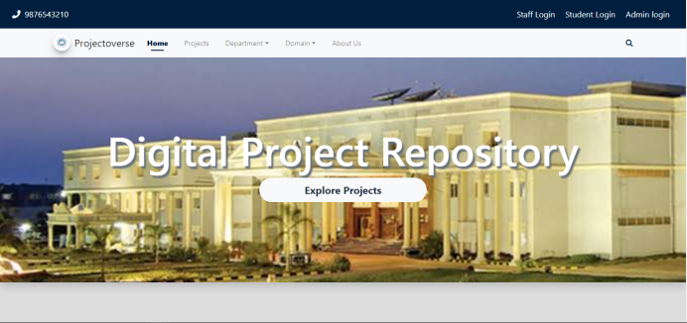

Fig 1. Home page

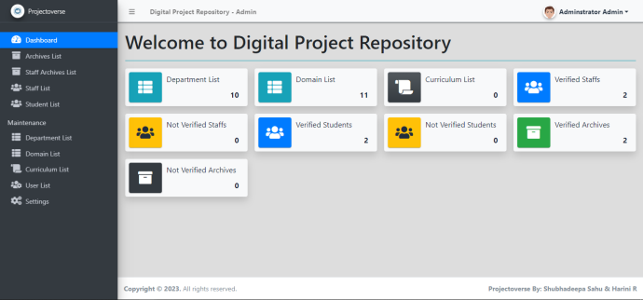
Fig 2. Admin Dashboard

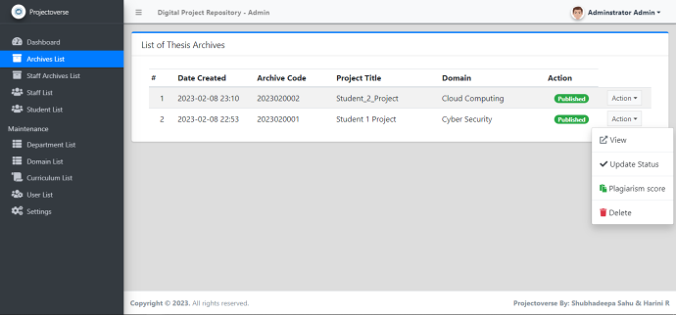
Fig 3. Project list (Admin)

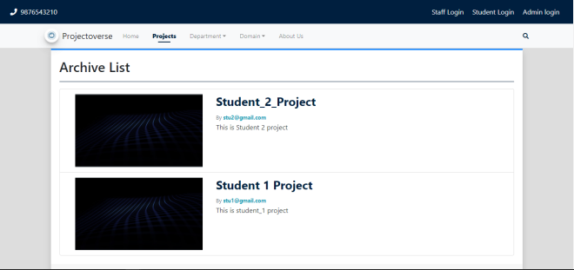
Fig 4. Explore Project (student)

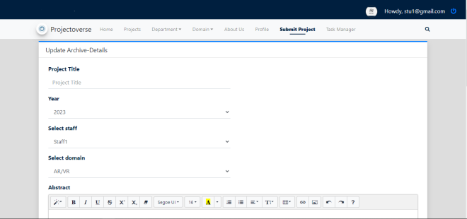
Fig 5. Submit Project (Student & Staff)

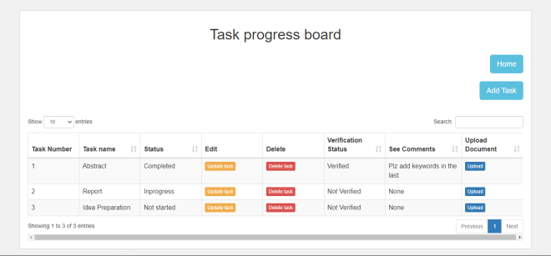
Fig 6. Task progress (student)

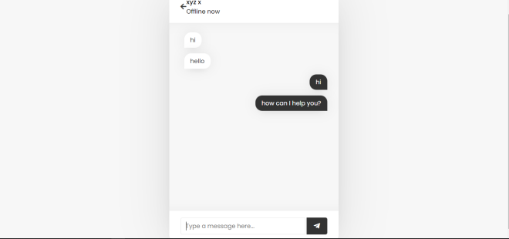
Fig 7. Chat module

VII. CONCLUSION

Digital Project Repository system (DPR) considerably reduces the workload of project coordinator. The system enables the automatic completion of the duties of arrangement, collecting, storage, and evaluation. On the other hand, the method makes it convenient for both teachers and students as they work to complete their projects effectively. In order to move forward with their `projects, students can connect with other project participants and receive clarifications. The project tracking module makes it simple for supervisors to monitor students' progress. Finally, the technology allows faculty members to easily access the project's deliverables and submit feedback. It also features a straightforward to use interface which makes it simple for the users in adapting to this program.

VIII. FUTURE ENHANCEMENTS

The current system is developed for single department of college i.e. “Department of Information Technology, Sri Sairam Engineering College”. The system will be further improved by being built or expanded so that it may be applied at different levels of an organization or institution. Further security can be added to it. More security and privacy issues can be preserved by using several layers of identification and verification.
privacy issues can be preserved by using several layers of identification and verification.
being built or expanded so that it may be applied at different levels of an organisation or institution. Further security can be added to it. More security and privacy issues can be preserved by using several layers of identification and verification.

IX. REFERENCES

- Bakar M. A., Jailani N., Shukur Z., Yatim N. F. M. (2011). Final Year Supervision Management System as a Tool for Monitoring Computer Science Projects. Procedia Social and Behavioral Sciences 18, 273–281
- HKU CS (2014). Hong Kong University Project Management System, URL: https://community.cs.hku.hk/web/csis0801/
- Design and implementation of a virtual project repository system, International Journal of Computer Science and Information Security, 16 November 2021.
- Clement R. & Bounds P. (2013). Making Connections between Final Year Students and Potential Project Supervisors, Proceedings of the HEA STEM Learning and Teaching Conference.
- Safieddine, F.(2015) Student’s guide:final year project thesis.(K.Lomidze, Ed) New York: CreativeSpace Publishing Project Management System 017 IJEDR | Volume 5, Issue 2
- Fundamentals of project management for development organization, 2 nd edition, PDEVM, Project Management for Development Organization, pp. 13-20.
- “Web Based Project Collaboration, Monitoring and Management System” (ICTer)-109-155/ 2014 IEEE
- Unal, Z., and Unal, A. (2011). Evaluating and comparing the usability of web-based course management systems. Journal of Information Technology Education, 10, 19-38 View publication.
- Kamarudin D. (2019). Applying skills and knowledge in final year projects. New Straits Tmes
- Pradeepa S. Seneviratna, S.T. Nandasara “Web Based Project Collaboration, Monitoring and Management System” (ICTer)-109-155/2014 IEEE.

