Brief review of Stability study , a recent trend of of ayurvedic pharma industry w.s.r to acceclerated stability study of KVGAP’S Haemocare syrup
K Shruthan ¹, KG Purushotham² , Nayak N Gopala Krishna³,. M Harshitha ⁴ K B Pavana⁵
1. Assistant Professor 2. Professor and Head 3. Assistant professor 4. Professor 5. Associate Professor
Department of Rasashastra and Bhaishajya Kalpana, KVG Ayurveda medical college and hospital , Ambatedaka , Sullia 574327
Abstract
Stability studies are new quality control paradigms which ensures better safety, quality and efficacy of proprietary medicines throughout their shelf life under controlled storage conditions of temperature and humidity. Accelerated stability testing of an ayurvedic proprietary medicine: KVGAP’S Haemocare syrup was conducted as per guidelines of Ayurvedic pharmacopeia of India. 3 pilot batches of KVGAP’S Haemocare Syrup were manufactured packaged in the container and closure system proposed for marketing, stored at elevated stress conditions (Temperature 40 ± 2 °C, while the relative humidity was 75 ± 5 %.) The reference samples at a temperature less than 10 ⁰c. Samples were evaluated at the intervals of 0, 3, and 6 months for organoleptic parameters, Physico-chemical Parameters , TLC ,Microbial analysis, Test for specific pathogens. Results showed samples did not showed differences from the initial values of physico chemical parameters beyond the specified limits (25 percent). Neither new spots were seen in TLC plates, nor did the existing spots disappear. The product’s appearance, taste, odor, color remained unchanged throughout the study period. No growth of microbes were detected and specific micro-organisms were absent in the samples throughout the study period. Hence the product remains stable in accelerated storage conditions. Shelf life of the Haemocare syrup was estimated to be 4.18 years if stored in accelerated stress conditions. This study can provide valuable information to design stability studies of ayurvedic formulations.
Introduction
Ayurveda (literal meaning: Science of life) with at least 2000 years of history is an Indian system of medicine. It is gaining popularity across the globe by virtue of its unique scientific principles, prevention and healing potentials. Being a holistic system of medicine, it can offer newer possibilities and dimensions for the future of medicine. One of the prime components of Ayurvedic system of medicine is medicines, which are of different origin: herbal, mineral and animal. Ayurvedic manufacturing industry is upraising, since past decades with an exponential growth in the number of manufacturing companies and subsequent increase in number of formulations in market (both classical: prepared according to the formulae described in the books of Ayurveda and proprietary: patented products). Proprietary medicines are the popularly marketed formulations; total numbers of such formulations are in thousands.
Like any industry, Ayurvedic drug manufacturing industry is also under the strict radar of regulatory authorities to ensure the quality of prepared medicines. Stability studies are new quality control paradigm which ensures better safety, quality and efficacy of proprietary medicines throughout their shelf life under controlled storage conditions of temperature and humidity. The purpose of stability testing is to provide evidence on how the quality of a drug substance or drug product varies with time under the influence of a variety of environmental factors such as temperature, humidity, and light, and to establish a re-test period for the drug substance or a shelf life for the drug product and recommended storage conditions¹. ICH ² guidelines for stability testing provided framework for the stability studies in international realm. The stability study guidelines for Ayurvedic products were framed in Ayurvedic pharmacopeia of India ³ which is official book prescribing standards for Ayurvedic products. Amongst types of stability studies two main types are Real time stability study and accelerated stability study. Real time stability studies are conducted in recommended storage conditions and accelerated stability studies a product is stored at elevated stress conditions (Temperature 40 ± 2 °C, while the relative humidity was 75 ± 5 %.)
Legal responsibilities and urge to provide quality products has driven the present study , which was designed to evaluate the accelerated stability testing of an ayurvedic proprietary medicine : KVGAP’S Haemocare syrup, manufactured by GMP certified KVG Ayurveda Pharma and Research centre, Sullia, Dakshina Kannada district, Karnataka. KVGAP’S Haemocare syrup is a natural haematinic containing ingredients like Kharjura (Dates), Draksha (Grapes), Gairika (Red ochre) and other 15 herbs. It is usually prescribed at a dose of 10 ml Bid. It is indicated mostly as haematinic and tonic. Stability study guidelines were derived from Ayurvedic Pharmacopoeia of India and also from CCRAS (central council for research in ayurvedic sciences) published book: laboratory guide for the analysis of Ayurveda and Siddha formulations.⁴

Materials and methods
Test Drug: KVGAP’S Haemocare Syrup was manufactured in KVG Ayurveda Pharma and Research centre, Ambateadka, Sullia adhering to the strict GMP guidelines.

Contents of KVGAP’S Haemocare Syrup
Contents of KVGAP’S Haemocare Syrup are presented in Table 1

Table No 1: Showing ingredients of KVGAP’S Haemocare Syrup
Each 5 ml of syrup contains:
Drug | Botanical Name | Amount
Draksha | Vitis vinifera | 187mg
Kharjura | Phoenix sylvestris | 112 mg
Ashwagandha | Withania somnifera | 75mg
Bhoomiyamalaki | Phyllanthus niruri | 75mg
Gairika | Red ochre | 75 mg
Guduchi | Tinospora cordifolia | 75 mg
Manjistha | Rubia cordifolia | 75 mg
Mandhukaparni | Centella asiatica | 75 mg
Punarnava | Boerrhavia diffusa | 75 mg
Sariva | Hemidesmus indicus | 75 mg
Haritaki | Terminalia chebula | 60 mg
Vibhitaki | Terminalia bellirica | 60 mg
Amalaki | Emblica officinalis | 60 mg
Yasthimadhu | Glycyrrhiza glabra | 56 mg
Haridra | Curcuma longa | 37.5 mg
Shunti | Zingiber officinale | 37.5 mg
Vacha | Acorus calamus | 30 mg
Pippali | Piper longum | 7.5 mg
Sita | Sugar | 2600 mg

Fig 1: Showing Ingredients of KVGAP’S Haemocare Syrup

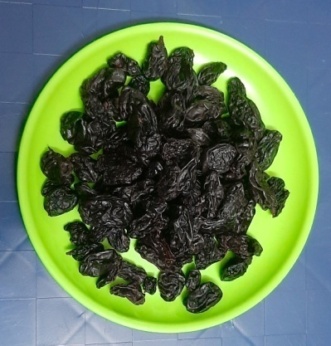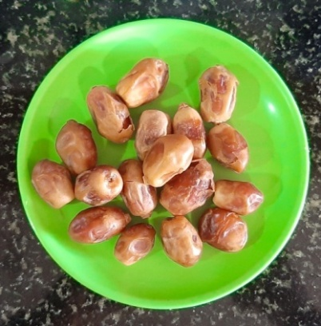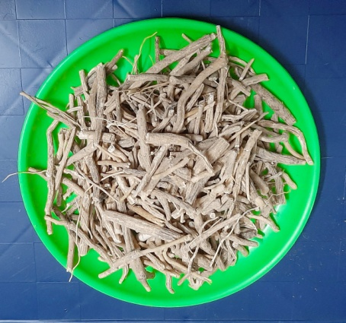
Draksha Kharjura Ashwagandha
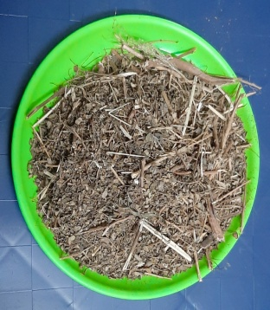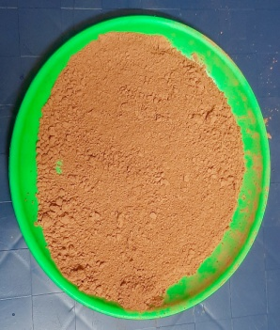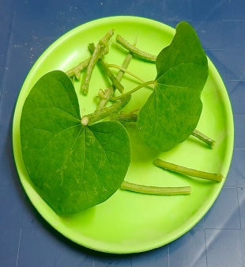
Bhoomiyamalaki Gairika Guduchi
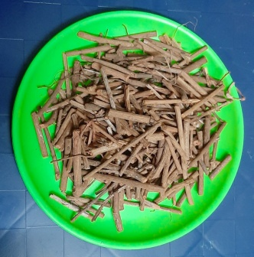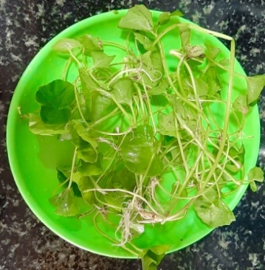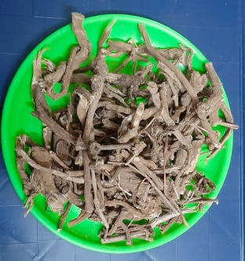
Manjistha Mandhukaparni Punarnava
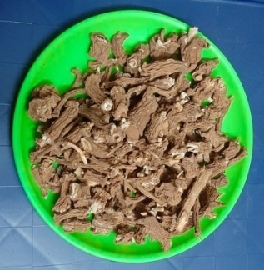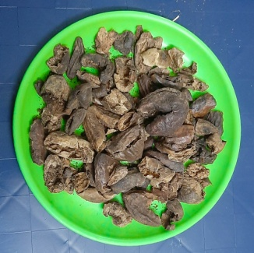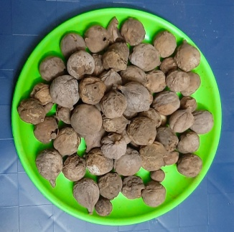
Sariva Haritaki Vibhitaki
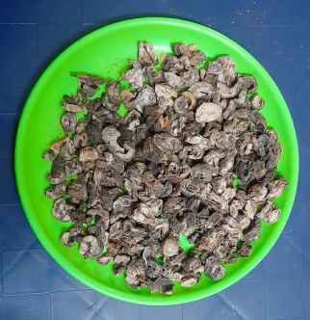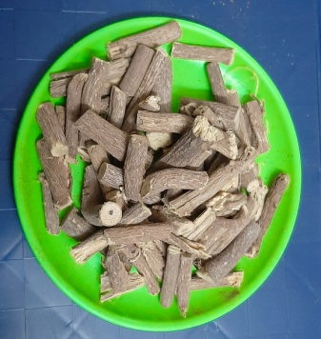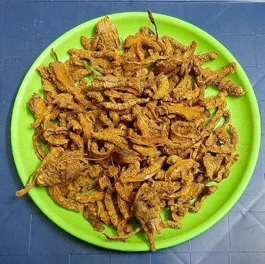
Amalaki Yasthimadhu Haridra
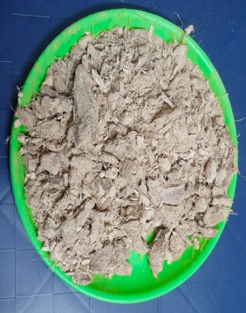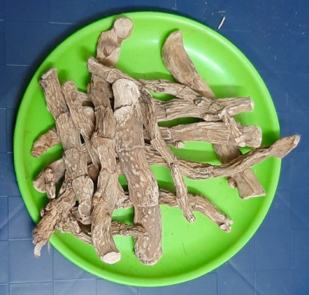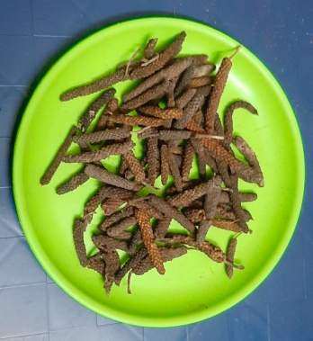
Shunti Vacha Pippali
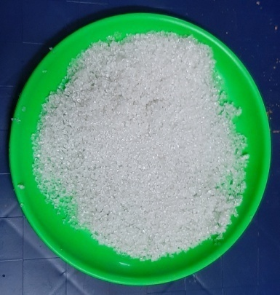
Sita

Selection of batches
3 pilot batches of KVGAP’S Haemocare Syrup were manufactured by following methods and procedures used for commercial scale production batches. Pilot batches were manufactured at 1/10th of the commercial batch size. The overall quality of the pilot batches were representative of the commercial batches.
Container and closure system
The stability studies were conducted on the dosage form packaged in the container and closure system proposed for marketing (including as appropriate, any secondary packaging and container.
Storage Conditions: The accelerated stability study was conducted as per the ICH guidelines. The samples are stored in stability chambers and temperature maintained during the study period was 40 ± 2 °C, while the relative humidity was 75 ± 5%.
The reference samples for the above study were stored at a temperature less than 10 ⁰c.
Frequency of withdrawal of the Sample: The samples were withdrawn from the stability chamber at the intervals of 0, 3, and 6 months and evaluated for relevant parameters.

Parameters for Evaluation
The samples were evaluated for the following parameters at the interval of 0, 3, 6 months.
Organoleptic characters
- Colour
- Odour
- Taste
- Appearance
Physico-chemical Parameters
- pH⁵
- Viscosity⁶
- Total solid⁷
- Sp.gravity⁸
- Total sugars⁹
- Reducing sugar¹⁰
- Non reducing sugar¹¹
- Refractive index¹²
- Brix value

TLC
Microbial analysis ¹³
- Total viable aerobic count
- Total fungal count
- Total Enterobacteriaceae count

Test for specific pathogen ¹⁴

- Staphylococcus Aureus
- Escherichia coli
- Pseudomonas aeruginosa
- Salmonella Species

Results
Table No.02: Showing Physicochemical parameters of KVGAP’S Haemocare Syrup - Reference Samples
Parameters | 0 Month |  |  | % | S.D (+₋) | S.E (+₋) | t value | p value | Remarks
PH | 5.28 | 3 months | 4.68 | 11.30 | 0.488 | 0.345 | 2.12 | <0.05 | S
 |  | 6 months | 5.30 | -0.38 | 0.666 | 0.471 | 0.05 | >0.05 | NS
Viscosity | 7.91 | 3 months | 9.15 | 13.55 | 0.434 | 0.307 | 4.95 | <0.05 | S
 |  | 6 months | 10.17 | 22.25 | 1.469 | 1.039 | 2.67 | <0.05 | S
Total solid | 49.10 | 3 months | 46.93 | 4.43 | 3.117 | 2.204 | 0.58 | >0.05 | NS
 |  | 6 months | 47.13 | 4.01 | 3.117 | 2.204 | 1.09 | >0.05 | NS
Sp.gravity | 1.19 | 3 months | 1.17 | 1.55 | 0.007 | 0.005 | 1.48 | >0.05 | NS
 |  | 6 months | 1.18 | 0.70 | 0.007 | 0.005 | 2.12 | >0.05 | NS
Total sugars | 49.67 | 3 months | 51.76 | 4.05 | 1.085 | 0.767 | 3.35 | <0.05 | S
 |  | 6 months | 51.71 | 3.95 | 0.906 | 0.641 | 3.91 | <0.05 | S
Reducing sugar | 2.80 | 3 months | 4.31 | 34.98 | 2.489 | 1.760 | 1.05 | >0.05 | NS
 |  | 6 months | 4.28 | 34.58 | 2.366 | 1.673 | 1.08 | >0.05 | NS
Non reducing sugar | 46.87 | 3 months | 47.18 | 0.66 | 1.541 | 1.089 | 0.20 | >0.05 | NS
 |  | 6 months | 47.43 | 1.19 | 1.035 | 0.732 | 0.44 | >0.05 | NS
Refractive index | 1.40 | 3 months | 1.40 | 0.43 | 0.005 | 0.004 | 3.93 | <0.05 | S
 |  | 6 months | 1.40 | 0.36 | 0.005 | 0.004 | 1.73 | >0.05 | NS
Brix value | 48.50 | 3 months | 47.00 | 3.09 | 3.066 | 2.168 | 0.83 | >0.05 | NS
 |  | 6 months | 47.37 | 2.34 | 3.066 | 2.168 | 0.64 | >0.05 | NS

Chart No.01: Showing physicochemical parameters of KVGAP’S Haemocare Syrup - Reference Samples

Table No. 03: Showing Physicochemical parameters of KVGAP’S Haemocare Syrup – Accelerated temperature Samples
Parameters | 0 Month |  |  | % | S.D (+₋) | S.E (+₋) | t value | p value | Remarks
PH | 5.28 | 3 months | 4.79 | 9.28 | 0.395 | 0.279 | 1.39 | >0.05 | NS
 |  | 6 months | 5.17 | 2.08 | 0.719 | 0.508 | 0.32 | >0.05 | NS
Viscosity | 7.91 | 3 months | 8.49 | 7.29 | 0.588 | 0.416 | 1.29 | >0.05 | NS
 |  | 6 months | 9.16 | 15.84 | 0.335 | 0.237 | 3.53 | <0.05 | S
Total solid | 49.10 | 3 months | 48.57 | 1.09 | 6.784 | 4.797 | 0.19 | >0.05 | NS
 |  | 6 months | 49.77 | 1.36 | 6.332 | 4.478 | 0.18 | >0.05 | NS
Sp.gravity | 1.19 | 3 months | 1.37 | 15.94 | 0.332 | 0.235 | 0.94 | >0.05 | NS
 |  | 6 months | 1.18 | 0.14 | 0.015 | 0.011 | 0.15 | >0.05 | NS
Total sugars | 49.67 | 3 months | 52.47 | 5.64 | 0.675 | 0.478 | 3.52 | <0.05 | S
 |  | 6 months | 51.54 | 3.78 | 0.822 | 0.581 | 2.18 | <0.05 | S
Reducing sugar | 2.80 | 3 months | 4.28 | 52.86 | 2.511 | 1.776 | 1.06 | >0.05 | NS
 |  | 6 months | 4.39 | 56.90 | 2.171 | 1.535 | 1.13 | >0.05 | NS
Non reducing sugar | 46.87 | 3 months | 48.19 | 2.82 | 2.251 | 1.592 | 0.76 | >0.05 | NS
 |  | 6 months | 46.48 | 0.82 | 1.066 | 0.754 | 0.20 | >0.05 | NS
Refractive index | 1.40 | 3 months | 1.40 | 0.48 | 0.003 | 0.002 | 4.00 | <0.05 | S
 |  | 6 months | 1.39 | 0.64 | 0.002 | 0.001 | 2.86 | <0.05 | S
Brix value | 48.50 | 3 months | 46.67 | 3.78 | 2.309 | 1.633 | 5.42 | <0.05 | S
 |  | 6 months | 47.33 | 2.41 | 3.055 | 2.160 | 4.92 | <0.05 | S

Chart No. 02: showing physicochemical parameters of KVGAP’S Haemocare Syrup - Accelerated Samples

Table No. 04 : Showing comparative result of Physicochemical parameters of KVGAP’S Haemocare Syrup
 | Reference Group A | Accelerated Group B | SE | T Value
PH | 5.09 | 5.08 | 0.035 | 0.047
Viscosity | 9.08 | 8.52 | 0.359 | 2.498
Total solid | 47.72 | 49.15 | 0.791 | 0.996
Sp.gravity | 1.18 | 1.25 | 0.082 | 0.999
Total sugars | 51.05 | 51.23 | 0.240 | 0.193
Reducing sugar | 3.80 | 3.82 | 0.072 | 0.042
Non reducing sugar | 47.16 | 47.18 | 0.642 | 0.013
Refractive index | 1.40 | 1.40 | 0.001 | 0.759
Brix value | 47.62 | 47.50 | 0.242 | 0.122

TLC
Solvent of extraction: Ethyl acetate
Mobile Phase : Toluene: Ethyl acetate: Formic acid (7: 3: 0.1)
Detection : Under UV at 366nm
Applied volume : 20µl

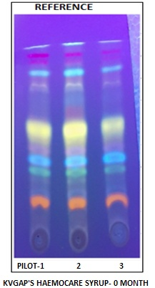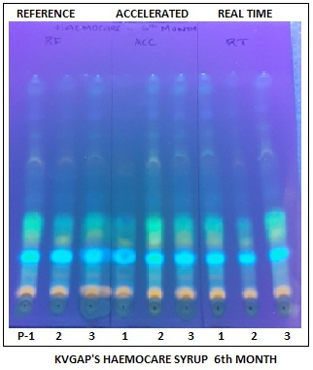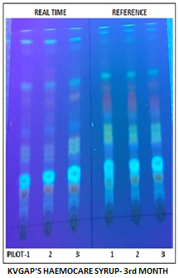

Microbiology report of KVGAP’S Haemocare Syrup

Table No 05: Showing the Microbial Analysis report of KVGAP’S Nutricare Powder (Reference samples)

Sl. No | Parameters | 0 Month | 3 months | 6 months | Specifications | Test Method
1 | Total viable aerobic count | NIL | NIL | NIL | <105  cfug-1 | API Part 1 vol 8, first  edition 2011
2 | Total fungal count | NIL | NIL | NIL | 103 g-1 | API Part 1 vol 8, first  edition 2011
3 | Total Enterobacteriaceae count | NIL | NIL | NIL | 103 g-1 | API Part 1 vol 8, first  edition 2011

Table No 06: Showing the specific pathogens report of KVGAP’S Nutricare Powder (Reference Samples)
Sl. No | Parameters | 0 Month | 3 months | 6 months | Specifications | Test Method
1 | Staphylococcus Aureus | NIL | NIL | NIL | absent | API Part 1 vol 8, first  edition 2011
2 | Escherichia Coli | NIL | NIL | NIL | 10 g-1 | API Part 1 vol 8  first edition 2011
3 | Pseudomonas aeruginosa | NIL | NIL | NIL | Absent | API Part 1 vol 8 , first edition 2011
4 | Salmonella Species | NIL | NIL | NIL | Absent | API Part 1 vol 8 , first edition 2011

Microbiology Report of Accelerated study samples

Table No 07: Showing Microbial analysis report of KVGAP’S Haemocare Syrup (Accelerated Temperature Samples)

Sl. No | Parameters | 0 Month | 3 months | 6 months | Specifications | Test Method
1 | Total viable aerobic count | NIL | NIL | NIL | <105  cfug-1 | API Part 1 vol 8, first  edition 2011
2 | Total fungal count | NIL | NIL | NIL | 103 g-1 | API Part 1 vol 8, first  edition 2011
3 | Total Enterobacteriaceae count | NIL | NIL | NIL | 103 g-1 | API Part 1 vol 8, first  edition 2011

Table No 08: Showing Specific pathogens report of KVGAP’S Haemocare Syrup (Accelerated Temperature Samples)
Sl. No | Parameters | 0 Month | 3 months | 6 months | Specifications | Test Method
1 | Staphylococcus Aureus | NIL | NIL | NIL | absent | API Part 1 vol 8, first  edition 2011
2 | Escherichia Coli | NIL | NIL | NIL | 10 g-1 | API Part 1 vol 8 , first edition 2011
3 | Pseudomonas aeruginosa | NIL | NIL | NIL | Absent | API Part 1 vol 8 , first edition 2011
4 | Salmonella Species | NIL | NIL | NIL | Absent | API Part 1 vol 8 , first edition 2011

Table No 09: showing approximate Period for 10% Degradation in Reference Sample
 | Initial | 10% Degradation | Approximate months for 10% Degradation
PH | 5.28 | 4.80 | 144.00
Viscosity | 7.91 | 7.19 | 1.91
Total solid | 49.10 | 44.64 | 6.00
Sp.gravity | 1.19 | 1.08 | 6.00
Total sugars | 49.67 | 45.15 | 13.26
Reducing sugar | 2.80 | 2.55 | 1.03
Non reducing sugar | 46.87 | 42.61 | 45.38
Refractive index | 1.40 | 1.27 | 6.00
Brix value | 48.50 | 44.09 | 6.00
Mean Months |  |  | 25.51

Table No 10: Shelf Life (Reference samples)
Months | Multiplication Factor | Shelf Life (Months) | Years
25.51 | 3.33 | 84.94 | 7.07

Table No 11 Approximate Period for 10% Degradation in Accelerated temperature Samples
 | Initial | 10% Degradation | Approximate months for 10% Degradation
pH | 5.28 | 4.80 | 26.18
Viscosity | 7.91 | 7.19 | 3.44
Total solid | 49.10 | 44.64 | 6.00
Sp.gravity | 1.19 | 1.08 | 6.00
Total sugars | 49.67 | 45.15 | 14.44
Reducing sugar | 2.80 | 2.55 | 0.96
Non reducing sugar | 46.87 | 42.61 | 66.69
Refractive index | 1.40 | 1.27 | 6.00
Brix value | 48.50 | 44.09 | 6.00
Mean Months |  |  | 15.08

Table No 12: Showing Shelf Life (Accelerated temperature Samples)

Months | Multiplication Factor | Shelf Life (Months) | Years
15.08 | 3.33 | 50.21 | 4.18

Discussion
Stability studies are mandatory requirements for marketing proprietary formulations. Hence stability study of KVGAP’S Haemocare syrup was conducted in accordance with API guidelines. Results showed no significant change in odor, taste, and appearance of KVGAP’S Haemocare syrup after storing for 6 months under accelerated conditions. Physicochemical profiles (pH, Viscosity ,Total solid ,Sp.gravity , Total sugars ,Reducing sugar, Non reducing sugar, Refractive index, Brix value,) of the samples during the study period of 6 months didn’t show much differences. The variations in the physicochemical parameters did not vary beyond 25 percent of the initial value. TLC showed no appearance of new spots and existing spots disnot disappeared in subsequent months in comparison with the initial TLC plates. Microbiological analysis of the samples showed no signs of microbial growth and specific pathogens were absent in all the samples. Based on the degradation rate of the physico chemical parameters, shelf life of KVGAP’S Haemocare syrup was calculated. The reference samples shelf life was estimated to be 7.07 years. Estimated shelf life of Accelerated study samples was 4.18 years. The prescribed shelf life of Syrups as per Drug and cosmetic act is 2 years ⁵. Increased shelf life of the accelerated temperature samples can be attributed to the standard operative procedure followed in the preparation and proper packing of the formulation.
Though this study can profoundly pronounce the stability and shelf life an Ayurvedic propreitory formulation KVGAP’S Haemocare syrup, the way ahead of ayurvedic pharma industry is still challenging. The complexity of the ayurvedic formulation with multiple number of the ingredients makes it difficult to identify and quantify the marker compounds. For the Mammoth ayurvedic pharma industry with thousands of propretiory medicines, compiling and establishing stability studies of their products seems to be an herculean task .

Conclusion
Stability study marks an important milestone in the recent advancement of pharma industry. Ayurvedic pharma industry, major stakeholder with approximately 8000 GMP certified manufacturing units which markets thousands of propretiory medicines every year . Stability studies , mandated by the regulatory authorities aims at testing and ensuring that product remains stable throughout its shelf life in regulated storage conditions. That implies product should not be degraded with respect to its physicochemical properties beyond the specified limits. Though guidelines are available for stability studies, a viable model is the need of the hour. An accelerated stability study of KVGAP’S Haemocare syrup tries to present a model for the stability study of ayurvedic proprietary products. 3 pilot batches of KVGAP’S Haemocare syrup were manufactured , stored in accelerated storage conditions (temperature 40 ± 2 °C, relative humidity 75 ± 5%.) tested periodically at the interval of 0, 3 and 6 months . The samples were analyzed for its physico chemical parameters, TLC profile and microbiological analysis. Results showed samples did not showed differences from the intial values of physic chemical parameters beyoed the specified limits ( 25 percent ) . Neither new spots were seen in TLC plates, nor did the existing spots disappear. The product’s appearance, taste, odor, color remained unchanged throughout the study period. No growth of microbes were detected and specific micro-organisms were absent in the samples throughout the study period. Hence the product remains stable in accelerated storage conditions. Shelf life of the Haemocare syrup was estimated to be 4.18 years if stored in accelerated stress conditions. For the ayurvedic medicine manufacturers who are in the pursuit of viable stability study models, this study can provide valuable information to design stability studies of their formulation. Stability studies can instill new breath of air to the futuristic trends in pharmaceutical sciences by establishing and ensuring quality, safety and efficacy of medicines thus ensuring patient compliance and safety.

REFERENCES
1. https://www.ema.europa.eu/en/documents/scientific-guideline/ich-q-1-r2-stability-testing-new-drug-substances-products-step-5_en.pdf
2. https://www.ich.org/page/quality-guidelines
3.Ayurvedic Pharmacopeia of India, Part 1, Vol 8. 1st edition. Delhi; Govt of India; 2011. 227-229p
4.Lavekar G.S, Padhi MM, Verma S C, Singh Arjun (editors). Laboratory guide for the analysis of ayurveda and siddha formulations. New Delhi: Central council for research in Ayurveda and Siddha; 2010. 129-133 p
5. Lavekar G.S, Padhi MM, Verma S C, Singh Arjun (editors). Laboratory guide for the analysis of ayurveda and siddha formulations. New Delhi: Central council for research in Ayurveda and Siddha; 2010. 42-44 p
6. Ayurvedic Pharmacopeia of India, Part 2, Vol 2. 1st edition. Delhi; Govt of India; 2008. 220-221p
7. Ayurvedic Pharmacopeia of India, Part 2, Vol 2. 1st edition. Delhi; Govt of India; 2008. 221p
8. Ayurvedic Pharmacopeia of India, Part 2, Vol 2. 1st edition. Delhi; Govt of India; 2008. 193p
9. Experiment 4- Determination of Reducing sugars, Total Reducing sugars, Sucrose and Starch In Practical Manual – Food Chemistry and physiology. New delhi; IGNOU; 2017 . 19-23p
10. Experiment 4- Determination of Reducing sugars, Total Reducing sugars, Sucrose and Starch In Practical Manual – Food Chemistry and physiology. New delhi ;IGNOU; 2017 . 19-23p
11. Experiment 4- Determination of Reducing sugars, Total Reducing sugars, Sucrose and Starch In Practical Manual – Food Chemistry and physiology. New delhi ;IGNOU; 2017 . 19-23p
12. Ayurvedic Pharmacopeia of India, Part 2, Vol 2. 1st edition. Delhi; Govt of India; 2008. 193p
13. Ayurvedic Pharmacopeia of India, Part 1, Vol 8. 1st edition. Delhi; Govt of India; 2011. 208-210p
14. Ayurvedic Pharmacopeia of India, Part 1, Vol 8. 1st edition. Delhi; Govt of India; 2011. 211-213p

