INDIGENOUS BREEDS OF POULTRY
Shivani Das
College of Veterinary Science & Animal Husbandry
Odisha University of Agriculture & Technology
Bhubaneshwar, Odisha, India
Email- shivanidas093120@gmail.com

I. Introduction

In most developing and poor nations, native or indigenous breeds of chicken play a significant part in rural economies.They play a significant role in providing the rural poor and marginalized population with supplemental income as well as wholesome chicken eggs and meat for their personal consumption. Small landowners raise hens for their socio-religious purposes in the tropics. This refers to the dedication of a person or group to a certain spiritual entity, deity, or time of year, and traditional/religious celebrations are judged by the standard of the offerings that satisfy the recipients' distinctive morphological requirements for chicken.
Local chickens are terrific mothers and decent sitters despite being sluggish grows and poor layers who produce little eggs. Additionally, they are superb foragers, robust, and endowed with innate immunity to common diseases.The ability of native chicken to withstand difficult weather circumstances and subpar husbandry procedures without much output loss is one of their most valuable favorable characteristics.
In India, notable breeds including Aseel, Ankaleshwar, Busra, Daothigir, Denki, Ghagus, Haringhatta black, Kadaknath, etc. have been documented.
II. Aseel

Aseel is a game chicken breed from India. It is scattered throughout most of India, especially in the states of Odisha, Andhra Pradesh, Tamil Nadu, and the Chhattisgarh region. They were originally kept for cock fighting but nowadays they are kept for ornamental purposes. It is not advisable to keep many roosters together because they will fight until death. They are friendly, very tame and trusting towards humans.

Aseel chickens are known for their distinctive appearance with a muscular build, short and powerful legs and a small head with a large comb. They come in a variety of colors including black, white and red and can have either smooth or feathered legs. Both roosters and hens are very beautiful.

Aseel chickens are a slow growing breed but they are known for their flavorful meat. They have a high muscle to bone ratio. They lay smaller eggs with a rich and flavorful yolk.

Aseel chickens are used as a base for crossbreeding with other breeds. They have also been used in traditional cultural events, religious ceremonies, etc.

Aseel chicken has a rich history. Their origin dates back to the Indus valley civilization. They were highly priced for their fighting abilities and were considered as a symbol of power and wealth.

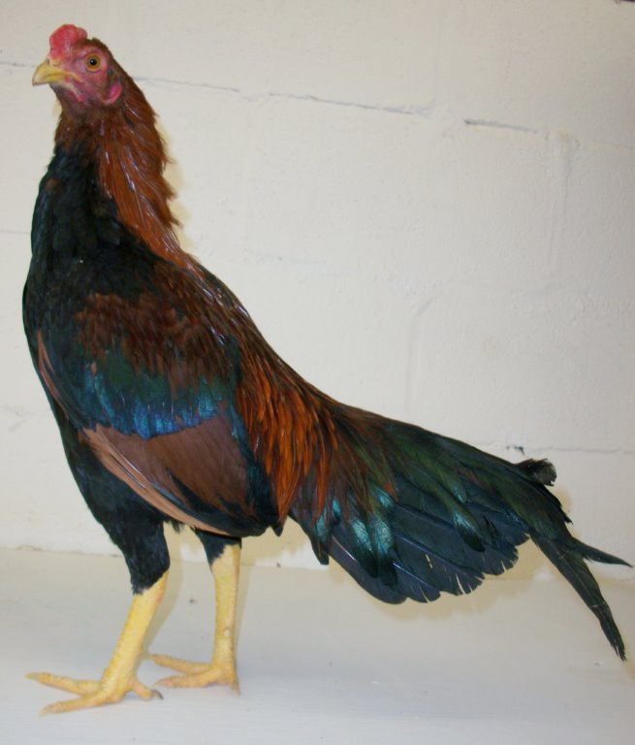
Figure 1: Aseel

III. Ankaleshwar

Ankleshwar birds are found in Bharuch and Narmada district of Gujarat, mainly in Ankleshwar, Jambusar, Bharuch, Valia areas. In their breeding tract, they are also called desi/ gowrani/ gamthi. Ankleshwar chicken is quite hard and adapted to its environment. The chicken is associated with the culture of the tribe (Vanvasi) which rear them. The backyard system is used to maintain ankleshwar birds, which are a good source of animal protein for the tribal people. They are raised to provide eggs and meat.

Plumage colour ranges widely from a combination of white and light grey to brown and golden. The plumage pattern is generally stripped with golden yellow feathers having black tips. Yellow plumage is more common in cocks and black golden is more common in hens. The red comb has a rose pattern. Small and yellow is the color of the beak.

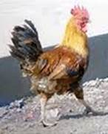
Figure 2: Ankleshwar

IV. Busra

Busra birds are layer type small to medium size and found in some parts of Maharashtra and Gujarat. This is the only breed of backyard poultry in Maharashtra and the tribal peoples economy is basically dependent on it. These birds are raised for both sale and domestic consumption. They are housed in a free-range setting. Average flock size ranges from 2 to 25.
Busra birds are tiny and have a range of colors on their bodies. The majority of the bird's plumage is white, with black feathers on the neck, back, and tail, as well as reddish-brown feathers on the shoulders and wings. Comb is red and single.

The weight of a cock is roughly 0.85 to 1.25 kg, and that of a hen is between 0.8 and 1.2 kg. Age at first egg ranges from 5 to 7 months and a hen lays about 12 to 13 eggs in about two weeks of time.

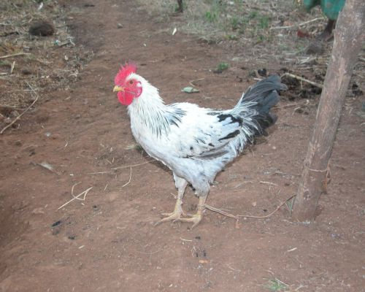
Figure 3: Busra

V. Daothigir

Daothigir breed of chicken is found in Bodoland region of Assam. Breeding tract comprises mainly of Kokrajhar district and some parts of Dhubri, Bongaigaon, Barpeta and on the North Bank of the Brahmaputra. These birds are raised primarily to supply domestic demand for meat and eggs. These are also used by the farmers as a cash reserve.

Flock size in the Daothigir breed ranges from 10 to 60 with an average of about 23. Birds are kept in the open system. They collect their feed from forest areas and eat whatever is available in the form of grains, seed, vegetation, insects, etc. In the evening, they return back to the owner’s house.

Even though they are little, birds are hefty and have long legs. Most of the feathers in the plumage are black, with some white ones thrown in. Brown with white or white with black are both common color combinations. Striped or spotted plumage patterns are present. Feathers on the neck and back are either golden yellow or brown. Short and nearly level with the back is the tail.
Average weight of cock is 1.79 kg and that of hen is 1.63 kg. Age at first egg varies between 5.8 and 6 months. A 60–70 egg output per year is typical. Light brown is the color of egg shells.

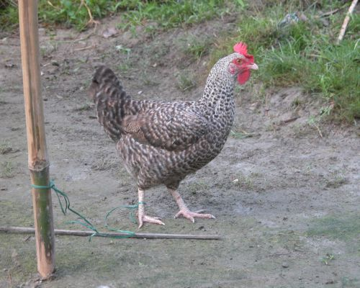
Figure 4: Daothigir

VI. Ghagus

Ghagus is an important chicken breed found in Karnataka.Birds mostly distributed in Kolar and adjourning parts of Bangalore district of Karnataka, Chittoor and Anantapur district of Andhra Pradesh. It is an indigenous breed of chicken to India. It is a medium-sized bird with good broodiness or mothering abilities. Male birds have shiny, bluish black tail, feathers and breast and reddish brown coloured plumage.The brown coloured feathers are found in the neck. Feathers of female birds range in color from dark to light brown, making up the majority of their plumage. The most common type of comb seen in birds is the pea comb, but some birds also have single combs.

Compared to Aseel, Danki, and Kalasthi birds, Ghagus birds are smaller, but they produce more eggs. The average egg production in a year is 45 to 60 eggs in a laying cycle. There are about 3 laying cycles. The adult cocks and hens weigh on an average about 2.16 kg & 1.43 kg respectively. Their age at first egg ranges from 5 to 8 months. In rural tribal areas, they are raised using semi-intensive, backyard, and free range systems.

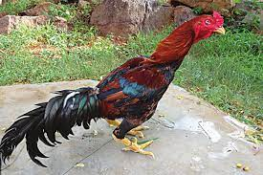
Figure 5: Ghagus

VII. Haringhata Black

Haringhata black is the native breed of West Bengal state. It has red comb and wattles and is completely black, with white shanks. It can be used for starting backyard poultry farming. They are used for both egg & meat purpose. They mainly act as game birds. The body weight of male bird generally ranges from 1 to 2 kg. The female bird starts to lay eggs after 4 months. They lay about 100 to 120 eggs annually.The meat and egg satisfy most of the nutrient requirements and are rich in minerals and vitamins. Power of tolerance, survivability from predators and adaptability is superb.

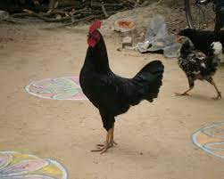
Figure 6: Haringhata Black

VIII. Kadaknath

Kadaknath, also called as Kali Masi (fowl with black flesh) is an Indian Native breed of chicken. The birds originated from Dhar and Jhabua areas of western Madhya Pradesh; these birds are mostly bred by rural people & Bhil tribals. Kadaknath birds are in demand due to its meat quality, texture and taste. It is said to have some medicinal properties.

Males and females are black in colour with golden head and neck. The bird is entirely black, including its skin, shank, and internal organs. The eggs of kadaknath are very expensive because they are an excellent source of protein, iron and are low in fat.

Male bird weighs from 1.8 to 2 kg and the female bird weighs from 1.2 kg to 1.4 kg. Age at first egg is long (185 days), and this breed has a considerably lower egg production capability (approximately 50 to 55 eggs in 40 weeks). 120 to 140 eggs are produced each year, on average.

Nowadays, People are preferring kadaknath chicken to lose weight because it has low fat. These birds have significant homeopathic medicinal potential and can help with treating neurological illnesses. Additionally, it aids in the treatment of numerous pulmonary issues by raising blood cell and hemoglobin concentrations. The health of ladies will benefit from eating kadaknath chicken. Headaches, asthma, and nephritis are all treated with Kadaknath chicken eggs. When compared to similar types of other chicken breeds, these birds' flesh contains more protein, less fat, and lower cholesterol levels, which is their main advantage.

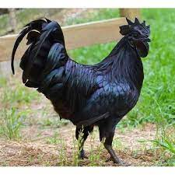

Figure 7: Kadaknath

IX. Kalasthi

Kalasthi is an indigenous breed distributed in Chittoor and adjoining parts of Nellore and Cuddapah district of Andhra Pradesh. They are known as desi. The majority of kalasthi birds are raised for meat, and cocks are employed in fights. Utility of these birds for egg production is not much due to the very small number of eggs being laid, about 30 to 40 eggs per year.

The backyard system is used to raise the birds. Average flock size ranges from 3 to 53. They spend their nights on trees. Fighting cocks are kept individually under a basket.

The plumage colour is bluish black & brown. Cocks have shining bluish black feathers. It has a long, golden feather-covered neck. Wattles are small & red in colour. Comb is red & is of pea or mixed type.

Hens and cocks weigh an average of 1.85 kg and 2.48 kg, respectively. At the age of 5 to 9 months, hens begin to lay eggs. Annual egg production is 34 eggs.

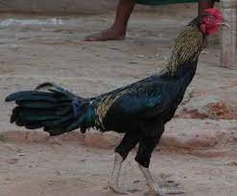
Figure 8: Kalasthi

X. Punjab Brown

A breed that serves multiple purposes, produces high-quality meat, and is raised in a backyard system with only night-time access to housing made primarily of mud and occasionally of wood. These can be found in the rural areas of Ambala, Haryana, and Gurdaspur, Punjab.

Brown plumage is the color. On the neck, wings, and tail of males, black dots or stripes are typically present. Large, solitary, and red in color is the comb. Males have huge wattles, whereas females have smaller wattles.

Hens and cocks weigh an average of 1.6 kg and 2.15 kg, respectively. The first egg is laid between 5 and 7 months of age, and 60 to 80 eggs are produced annually. In Punjab, they are utilized to produce eggs in addition to meat.

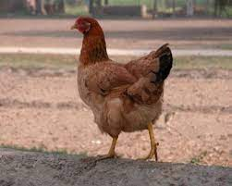
Figure 9: Punjab Brown

XI. Conclusion

India is full of non-descriptive breeds of poultry. The documentation of the breeds are going on, but much is still left. There is a need to do much research on non-descriptive breeds. Preservation should be done and we have to find out the adaptability and other good qualities of indigenous breeds and genetically upgrade them with crossbreeding, which can enhance their utility and benefit the rural, tribal, marginal and landless families of India.

REFERENCES

[1]https://nbagr.icar.gov.in/wp-content/uploads/2020/02/Ghagus-Chicken.pdf

[2]https://www.pashudhanpraharee.com/importance-of-native-breeds-of-poultry-for-rural-economy-in-india/

[3]https://r.search.yahoo.com/_ylt=Awr1TaVL0cdk9j0c51S7HAx.;_ylu=Y29sbwNzZzMEcG9zAzEEdnRpZAMEc2VjA3Nj/RV=2/RE=1690845643/RO=10/RU=http%3a%2f%2fsapplpp.org%2farchive%2fgoodpractices%2ffolder-for-related-files%2fSAGP03-GPNote.pdf%23%3a~%3atext%3dThe%2520NDDB-FAOSouth%2520Asia%2520Pro-Poor%2520Livestock%2520Policy%2520Programme%2528SA%2520PPLPP%2529%2cas%2520international%2520policies%2520and%2520programs%2520affecting%2520their%2520livelihoods%2527./RK=2/RS=YJZ79GORQhEV5sIZkG9r6Ya1cFk-

[4]https://r.search.yahoo.com/_ylt=Awr1Qad60cdkEzwckD.7HAx.;_ylu=Y29sbwNzZzMEcG9zAzEEdnRpZAMEc2VjA3Ny/RV=2/RE=1690845691/RO=10/RU=https%3a%2f%2fnbagr.icar.gov.in%2fen%2fregistered-chicken%2f/RK=2/RS=txJAfihLg_iVQvXJwOpCrjFV3JE-

[5]https://r.search.yahoo.com/_ylt=Awrx_xTU0cdkB4UbQsu7HAx.;_ylu=Y29sbwNzZzMEcG9zAzEEdnRpZAMEc2VjA3Nj/RV=2/RE=1690845781/RO=10/RU=https%3a%2f%2fwww.ncbi.nlm.nih.gov%2fpmc%2farticles%2fPMC4838803%2f%23%3a~%3atext%3dIndigenous%252Fnative%2520breeds%2520of%2520chickens%2520are%2520playing%2520an%2520important%2cchicken%2520egg%2520and%2520meat%2520for%2520their%2520own%2520consumption./RK=2/RS=laCqpWaqFnyxi0LRnLCVuKoM96Q-

[6]https://r.search.yahoo.com/_ylt=AwrKB1gj0sdkFC4cxny7HAx.;_ylu=Y29sbwNzZzMEcG9zAzEEdnRpZAMEc2VjA3Nj/RV=2/RE=1690845859/RO=10/RU=https%3a%2f%2faliah.ac.in%2fupload%2fmedia%2f07-04-20_1586256727.pdf%23%3a~%3atext%3dThe%2520most%2520popular%2520varieties%2520are%2520peela%2520%2528golden%2520red%2529%252C%2cwhite%2520silver%2529%252C%2520Teekar%2520%2528brown%2529%2520and%2520Reza%2520%2528light%2520red%2529./RK=2/RS=oXl.2_LMlHr5XfYlrx51JMvdCHQ-

[7]https://r.search.yahoo.com/_ylt=Awr1Qade0sdkuSMcpF.7HAx.;_ylu=Y29sbwNzZzMEcG9zAzQEdnRpZAMEc2VjA3Ny/RV=2/RE=1690845918/RO=10/RU=https%3a%2f%2fdownloads.hindawi.com%2fjournals%2fscientifica%2f2016%2f2604685.pdf/RK=2/RS=1LqhDPTBxvA.6N3GDWkkMN4chNk-

[8]https://r.search.yahoo.com/_ylt=AwrKB1iP0sdkgjwcM4C7HAx.;_ylu=Y29sbwNzZzMEcG9zAzIEdnRpZAMEc2VjA3Ny/RV=2/RE=1690845968/RO=10/RU=https%3a%2f%2fwww.agrifarming.in%2fkadaknath-chicken-breed-information/RK=2/RS=CzsolXhHWnDiGNNgf3wnSMTnLew-

[9]https://r.search.yahoo.com/_ylt=Awrx_R660sdk73Ycnlm7HAx.;_ylu=Y29sbwNzZzMEcG9zAzIEdnRpZAMEc2VjA3Ny/RV=2/RE=1690846010/RO=10/RU=https%3a%2f%2fnbagr.icar.gov.in%2fen%2fregistered-chicken%2f/RK=2/RS=XF81vFOad1gmpuwiiJm0eZNfWFc-

