Zebrafish: An emerging model for assessment of drug effects in animals
Abhijit Mohan Kanavaje¹*, Vipul Ajit Sansare²
¹Oriental College of Pharmacy, Sanapada, Navi-Mumbai, 400705, India
²Department of Pharmaceutics, Dnyandeep College of Pharmacy, Boraj, Khed, Maharashtra, 415709, India.
Address for correspondence
amkanavaje48@gmail.com

ABSTRACT
Zebrafish (Danio rerio) are a species of tropical freshwater fish that belong to the minnow family. In their natural habitat, these fish inhabit rivers and ponds in various Asian countries, but they are now commonly available in pet stores. These fish derive their name, "zebrafish," from the distinctive horizontal blue stripes adorning both sides of their bodies. Despite the apparent differences between humans and zebrafish, there is a remarkable degree of similarity between us. In fact, approximately 70% of human genes can be found in zebrafish. Many of the genes and essential pathways responsible for developing these characteristics are highly conserved between humans and zebrafish. As a result, zebrafish can potentially serve as a model for studying various diseases that induce alterations in human bodily structures.
INTRODUCTION
Why use zebrafish when you could use mice?
While mice share more evolutionary similarities with humans due to their mammalian nature, zebrafish offer several advantages over their furry counterparts. One significant benefit of zebrafish is that adult individuals are petite and prefer to be housed in large groups, known as "shoals." Consequently, they require less space and incur lower maintenance costs compared to mice.
Another advantage is the rapid breeding capability of adult zebrafish, with the potential to produce anywhere from fifty to three hundred eggs in a single clutch approximately every ten days. This stands in contrast to mice, which typically give birth to litters of one to ten pups and may only produce around three litters throughout their lifespan. Given that scientific experiments often entail multiple repetitions to ensure the accuracy of results, having an animal species capable of consistently generating a substantial number of offspring proves highly advantageous.^{[2]}
Zebrafish embryos offer the advantage of external arrangement and fertilization, facilitating various manipulation techniques. In cases where needed, in vitro fertilization can be performed. At the one-cell-stage, fertilized zebrafish eggs can be easily subjected to DNA or RNA injection for genetic modification, resulting in the creation of transgenic or knock-out zebrafish lines. Performing similar procedures with mice is significantly more challenging. Mouse embryos develop internally within the mother, necessitating her sacrifice for access and manipulation.[3] To maintain the viability of fertilized embryos or those subjected to injections, they would need to be transplanted into another female mouse.
Furthermore, zebrafish embryos possess transparency, enabling scientists to observe the complete development of fertilized eggs into fully formed juvenile fish under a microscope. This transparency also allows for the visualization of fluorescently labeled tissues in transgenic zebrafish embryos. Mouse embryos lack transparency and develop internally within the mother, making it impossible to observe live embryo development as is feasible with zebrafish.^{[4]}
However, there are limitations to the types of diseases that can be studied in zebrafish. Zebrafish cannot serve as suitable models for human diseases caused by genes that are absent in zebrafish. Additionally, zebrafish are not effective models for human diseases that predominantly affect tissues or organs that zebrafish lack, such as the prostate, exocrine glands, or lungs. Frequently, a patient's DNA is sequenced to identify potential mutations in genes that might be responsible for their illness symptoms. To investigate whether the loss of function in a specific gene could lead to symptoms resembling those observed in the patient, the same gene is mutated or "knocked out" in zebrafish. Subsequently, the fish are examined for similar symptoms. Although it is a more challenging endeavor, the exact mutation present in the patient can also be introduced into zebrafish, a process known as a "knock-in."If one or more of the patient's symptoms are replicated in the zebrafish knock-out or knock-in model, further studies can be conducted using these zebrafish to help elucidate why the mutation in that particular gene results in the disease. For instance, when dealing with a patient afflicted by a muscle-related illness, it becomes possible to scrutinize the muscle fiber structure for any abnormalities under a microscope. In cases where the patient's illness symptoms originated during prenatal development, examinations can involve the study of knock-out or knock-in zebrafish embryos to identify alterations in gene expression (in comparison to embryos lacking the mutation) that could contribute to abnormal development. In situations concerning a patient with a neurological disorder, it is feasible to fluorescently label the neurons of knock-out embryos to assess whether they undergo improper formation.^{[7]}
Besides employing zebrafish disease models for the characterization of human diseases, researchers can also employ them for the discovery and evaluation of new medications to treat these modeled diseases. Zebrafish's ability to produce a large number of embryos during each breeding cycle renders them particularly valuable for high-throughput drug screening purposes. ^{[8]}
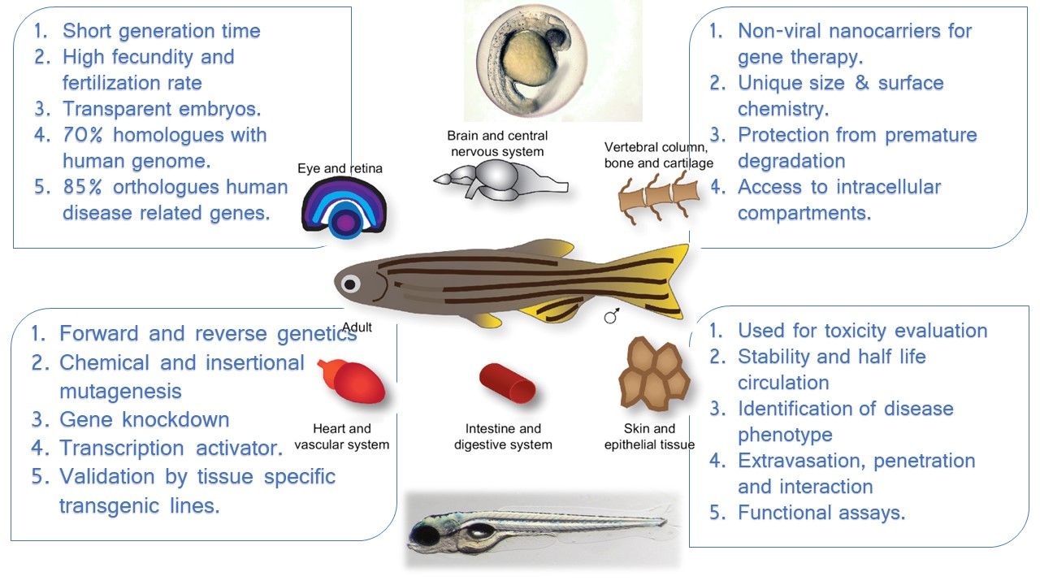

3R VALUE TO DRUG DISCOVERY TOXICOLOGY GIVEN BY ZEBRAFISH^{[9,10]}
Fig 1. Zebrafish as a Genetic and developmental model

The three Rs—replacement, reduction, and refinement of animal studies in analysis—as well as the ideologies behind their use, legal requirements, and emerging technologies—the latter of which may be advantageous to both science and animal welfare—have changed throughout time. New methods have emerged, with the zebrafish becoming as a favorite substitute animal model. The European Commission's 2010 directive states that some animal experiments that take place in their earliest stages of life are exempt from regulation as animal studies. In the case of zebrafish, independent feeding, which starts about five days after fertilization (DPF), is regarded as the main stage that is subject to regulation as an animal study. Thus, research with zebrafish eggs or larvae under five DPF will be taken into consideration as a substitute for animal trials.
3R apply to zebrafish^{[10,11]}
• REPLACEMENT: In order to determine whether larval zebrafish are a suitable model for the system (target, gene, pathway, mechanism, tissue, organ, etc.), zebrafish assays utilizing larval zebrafish may be utilized in place of some animal toxicity studies. with research on validation.
• REDUCTION: Zebrafish larvae could be utilized as a first-tier model of toxicity to identify drug candidates that are dangerous, allowing safer compounds to be evaluated in mammalian models. This would ultimately result in fewer animals being used for testing.
• REFINEMENT:the embryonic and larval zebrafish model offers refinement to animal study design because the embryos fertilized and inseminated externally and are transparent through the early days of life. This permits for non-invasive observation of toxicities and maybe recovery.

Challenges of zebrafish as an animal model^{[12]}
Zebrafish are a popular choice for laboratory experiments for a number of reasons, some of which are related to their ease of handling. In contrast to mammalian models, this model has numerous shortcomings that make it difficult to investigate various aspects of toxicology in zebrafish and raise unresolved problems about the translatability of toxic potencies and damaged organs. In water dosing, for instance, is the most widely used method for dosing zebrafish, both larval and embryonic. This is achieved by solubilizing drugs in water.
Two problems arise from this: first, only chemicals with reasonable water solubility will be tested in high-throughput screening; second, because fish are immersed and/or swimming in the treatment solution, in-water dosing may produce unique exposures compared to typical mammalian routes. Chemicals with poor solubility and/or absorption must therefore be forced into fish to achieve adequate exposure. It is necessary to investigate how this second problem appears, as it affects the data' translatability and probably differs based on the biological system and substances under study.^{[13]}
Zebrafish's small size is one of their key advantages as a model organism, but it also presents certain difficulties. Nonclinical toxicological studies are used to provide absorption, distribution, metabolism, and excretion (ADME) pharmacology, direct clinical dose to higher limits based on those exposures, and forecast a therapeutic window between beneficial and noxious exposures. As with the questions surrounding unique exposures prompted by in-water dosing, more research is needed in this area and the toxic in-water dosing levels derived from larval zebrafish studies cannot yet be conclusively linked to mammalian plasma levels. These questions also likely depend on the system under investigation.In [14] Although they are still in the early phases of development, strategies for assessing plasma levels of adme from larval zebrafish are currently being investigated.Finally, compared to data from mammalian models, zebrafish would, on average, produce less information that can be applied to clinical toxicity due to evolutionary distance as it is reflected in variances in anatomy and physiology. Making the most of this model can be achieved by strategic research that use zebrafish to examine systems and compounds that have the highest likelihood of being translatable.^{[16]}
In addition to gene similarity, the balance of cellular mechanisms, and comparable tissue biology, investigations on toxicology and zebrafish toxicology must take the model's capacity for regeneration into account. Not only can zebrafish repair their fins but also their brains, retinas, spinal cords, and hearts. As the retina has shown, this regenerating capacity may influence translational toxicity endpoints.

Environmental parameters and farming practices
Zebrafish have a natural advantage in that they can withstand a wide range of environmental conditions. Because of this quality, it is possible to produce and raise these animals for analysis using a variety of techniques. Because of this, there aren't many guidelines for caring for fish and their environment, and traditional methods have long revolved around the clear-cut objective of creating fish that are healthy, able to reproduce, and survive at a rate high enough to finish studies.^{[13]}
Although this adaptability has contributed significantly to the zebrafish model's overall expansion, it paradoxically restricts the pharmaceutical industry's use of the model. This may be because drug companies have already accepted and widely used other animal models (mice, rats, rabbits, and dogs) for preclinical toxicology studies. These models are, in contrast, well-established and have commercially available standardized breeds or strains along with robust historical control data.In [14]This allows the researchers to control a number of variables (such as nutrition, genetic background, and pathogen status) in a way that is not possible with fish when utilizing these models. Preclinical research involving fish may also be less reliable and more challenging to conduct without this degree of uniformity, particularly if they need for team collaborations at several locations.The zebrafish model faces two challenges with regard to experimental variability: first, the absence of readily available guidelines for researchers to adhere to exacerbates the problem of inadequate or erroneous reporting of environmental and husbandry factors.^{[12]}
Although there are already technologies like protocols.io, arrive guidelines, and benchmark toxicity concentrations that can be used to improve reporting, there may still be many unanswered questions regarding the general absence of standards for diet, health monitoring, and genetic maintenance.By advancing scientific knowledge of these variables to the point where it is confidently possible to make broad suggestions for standards, standards may be produced. Simultaneously, industrial platforms are needed to support these efforts, such as when it comes to producing fish that are specifically pathogen-free (SPF) and have specialized diets. The lack of this infrastructure at the moment is restricting.^{[16]}

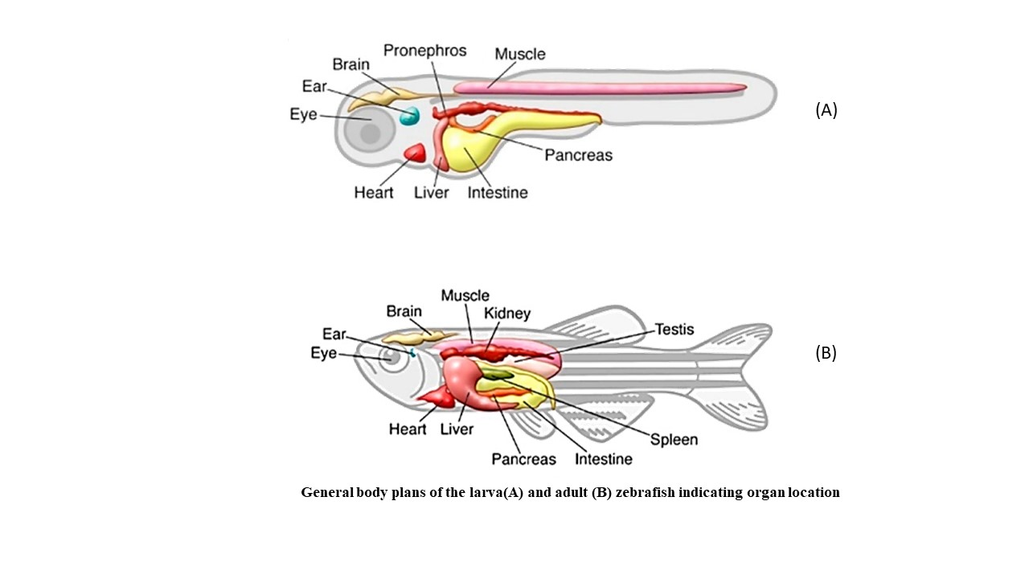
Fig.2: General body plans of the larva(A) and adult (B) zebrafish indicating organ location

Applications in a clinical study:

- Systems pharmacology:
One such method that combines the advantages of pharmacometrics and systems biology is systems pharmacology. Preclinical and clinical data are integrated with modeling and simulations. Toxicological predictions can be improved by integrating mechanistic and computational models with omics data. In vitro experiments can provide information that helps with the basic understanding of a toxin; but, due to the complexity of organ toxicities, in vivo whole organism trials—such as those that employ zebrafish naiads—provide additional information that advances our comprehension of the system. By combining all methods, interspecies restatement can be improved by comprehending the natural systems of a model organism and how these systems vary between species.^{[15]}

- Embryo toxicity:
The use of zebrafish embryos for testing the experimental toxicity of potential medications and substances is growing. Formerly recognized as a reliable and essential method for evaluating fish acute toxicity, the zebrafish embryo model is currently being investigated as a potential implicit remedy for one of the nonsupervisory in vivo mammalian embryo fatal experimental toxicity studies (OECD, No. 236). (17)In light of the ICH S5 guideline's upcoming third amendment regarding the identification of reproductive harm in human medicines. In vitro, ex vivo, and nonmammalian in vivo tests are not thought to be the standard method for experimental toxicity testing, although they may be taken into consideration for nonsupervisory reasons in some situations, according to the guideline's 2015 final conceptual paper. There is a section on the qualification of essential test systems for nonsupervisory acceptance in the 2017 draft of the revised guidelines.^{[18]}
The zebrafish embryo is a particularly interesting model because, unlike other related tests like the whole embryo culture and embryonic stem cell test, effects are evaluated in a full vertebrate organism during the whole organogenesis period. Furthermore, zebrafish embryo experiments need less time and money than investigations on the development of embryos in rats and rabbits.^{[19]}
There has been a recent acceptance of the need to better predict the quantities of embryotoxic medium in the zebrafish embryo assay and correlate them with concentrations of embryotoxic rat plasma. Similar to this, the assay's predictivity can be raised and improved. In terms of metabolism, it is widely acknowledged that zebrafish embryos have a low intrinsic biotransformation capacity, particularly for cytochrome P450 intermediated responses, and that exogenous metabolic activation using rat liver microsomes raises the assay's sensitivity for specific drugs.^{[20]}
- Neurotoxicity and behavioural analyses
The mechanism and pathophysiology of neurological illnesses and conditions are being widely studied using zebrafish, which has significant promise for drug discovery and toxicity testing in this field. The zebrafish's central nervous system is well-described throughout its life cycle and is similarly organized to other invertebrates'. The brain's primary structures and many of its top subdepartments are seen in zebrafish, and behavioral research has shown a close correlation between the zebrafish's and the human brain's functional areas. Zebrafish cannot be used to represent cognitive processes that rely on the neocortex because it is one brain region that they lack.23]In zebrafish, neurotransmitter systems that resemble dopamine, GABA, glutamate, noradrenaline, serotonin, histamine, and acetylcholine can be targets for pharmacological and toxicological interventions.^{[24]}
Adult zebrafish are able to exhibit a wide range of sophisticated behaviors, such as pursuing prey, memory and reading, and social interactions. The network of neurotoxic items makes considerable use of the photomotor response assay, which complies with the automatic shadowing of larval movement in response to necessary illumination circumstances. This assay's basic idea depends on the particular patterns that arise in response to the change in illumination. Convulsant drugs, including the GABA receptor antagonists pentylene tetrazol and picrotoxin, cause a cure-dependent increase in locomotor activity, while antiepileptic drugs, like valproic acid and diphenylhydantoin, cause a decrease in locomotor activity.^{[25]}
Recent developments in neurology using zebrafish have enormous promise for unborn mileage in the research of complaints. The conservation of genes linked to neurologic complaints in zebrafish facilitates the identification of potential targets in molecular medicine. The ability to observe these conserved proteins using fluorescent markers is made possible by the zebrafish's ex-vivo development, and the simplicity with which they can be genetically modified has resulted in the establishment of multiple zebrafish neurologic transgenic models. These models enable research on neuropsychiatric disorders including anxiety and depression, neurodevelopmental disorders like autism, and neurodegenerative syndromes like Alzheimer's and Parkinson's symptoms.^{26,27]}

- Optical toxicity
Given the great degree of conservation of vertebrate eyes, zebrafish provide a useful model system for investigating optical toxicity. Zebrafish and human eyes have several anatomical features, such as the cornea, lens, choroid, retina, and vascularization and innervation. They also share similar gene expression patterns, cellular compositions, and tissue architecture. Zebrafish embryos develop vision quickly, as evidenced by the fact that 4 DPF larvae rely on visual cues for evasive maneuvers and predation. Three DPF separate the primary retinal cell types into distinct layers, and axons from the ganglion layer innervate the optical tectum.[29] Zebrafish have homologous retinal layers and cell types for all mammalian counterparts; they include the photoreceptor, pigmented epithelium, inner and outer plexiform, nerve fiber, and ganglion. Due to their cone-rich retinas, which are similar to those of humans, zebrafish are able to see color during the day. In contrast, rats and mice have relatively smaller cones and poor color vision. Zebrafish do not have a fovea, or region of concentrated cones, despite having a cone-compact retina.
In addition, zebrafish retinas differ from those of mammals in that they have more cones than rods, have cones that are UV-sensitive, and have double cones, which stand for a red-sensitive (principle) compartment and a green-sensitive (appurtenant) compartment, respectively. One significant distinction in using zebrafish as a toxicological model is the ability of the retina (both larval and adult) to regenerate. Müller glial cells that divide in response to tissue damage give rise to retinal progenitor cells that can differentiate into any of the primary retinal neurons.Though there are minor distinctions, the vascularization of the zebrafish retina is generally similar to that of mammals.^{30]}
The two most popular methods for estimating vision in adult and larval zebrafish are the optokinetic and optomotor response assays. In the optomotor assay, the fish are free to swim and are permitted to react to temporal or spatial changes in light. In the optokinetic assay, a paralyzed fish is surrounded by dark and light interspersing perpendicular stripes, and eye saccades are counted as an indicator of a healthy eye response to moving stimulants. In order to evaluate overall mobility, this last test typically makes use of a substitute, comparator, or encouragement (sound or touch). In order to gauge reaction, both assays often compute on videotape recordings. Zebrafish have recently taken the place of mammalian models in tests used to assess retinal toxicity in pharmaceutical drug discovery combinations.^{[31]}
- Nephrotoxicity
Because it requires more blood exposure than other organs to perform its duty of removing hazardous compounds from circulation, the kidney is particularly susceptible to the toxic effects of xenobiotics. Thus, Primary endpoints in preclinical toxicology include monitoring kidney failure biomarkers and renal histology. Recently, zebrafish larvae have been utilized to represent kidney illness or nephrotoxicity due to their tractability for research into vertebrate biology.^{[32]}
Comprehensive modelling of kidney toxicity in zebrafish is impractical due to the mammalian kidney's greater complexity than the zebrafish kidney. With this model, nephrotoxicity can be reasonably investigated, though. Compared to the mammalian metanephros, the zebrafish larval pronephros has a simpler structure and only has two nephrons with merged glomeruli. The zebrafish is appealing because of the similarities in the pronephros' cellular structure and function to those of mammals' metanephros. ^{[33,34]}Podocytes and fenestrated capillary endothelial cells can be found in the glomerulus of the zebrafish. The nephron tubules are lined by polarised epithelial cells with primary cilia and are divided into distinct areas for differential secretion from and reabsorption into the blood.Zebrafish larvae can be used as a proof-of-concept by several researchers to check for drug-induced nephrotoxicity.^{[35]}

- Hematological toxicity
Numerous blood cell types seen in zebrafish are similar to those found in human peripheral blood cells. This contains dendritic cells, T and B cells, neutrophils, monocytes, macrophages, and red blood cells. The thrombocyte is a cell's counterpart to a platelet. For each of these lineages, reporters have been developed as tissue-specific promoters that drive fluorescent proteins. It can therefore determine toxicity and see various colors for each type of blood cell. Numerous studies have examined the embryonic biology and trafficking of blood stem cells.^{[37]}
There are several mutant zebrafish that mimic hematologic conditions. 26 mutant complementation groups were found in the initial screen, and five of those genes turned out to be novel genes that were later linked to human illnesses. It is possible to conduct genetic or chemical suppressor tests using zebrafish animals. This might result in brand-new therapies.Zebrafish have been used in a few hematologic toxicity investigations. There are numerous approaches to evaluating the hematopoietic system.^{[38]}

- Cardiovascular toxicity
At the anatomical, cellular, and membrane-biology levels, human and zebrafish cardiovascular physiology is conserved. It has been demonstrated that zebrafish are an excellent model for cardiotoxicity. Zebrafish genetic models have been used to mimic a wide range of human cardiovascular diseases, and zebrafish physiology has shown similar responses to numerous human cardiovascular medications.Systematic research have shown that zebrafish respond to drugs that prolong QT in humans in a manner that is >95% preserved.Milan et al. developed an automated, high-throughput assay for bradycardia in zebrafish embryos, and they discovered that it correlated with human QT prolongation. After evaluating 100 compounds using an assay, they discovered that 22 out of 23 drugs known to prolong QT in humans also cause bradycardia in zebrafish.^{[40]}
The study also demonstrated the existence of drug-drug interactions that prolong QT, including the well-known synergistic interactions between cimetidine and terfenadine and erythromycin and cisapride. These interactions, which are unique to a complete organism, result from one molecule's physiological effects influencing the other compound's metabolism. These findings demonstrate the significance of doing toxicity research in zebrafish, which may reach the scale and throughput of in vitro experiments while taking place in a physiological environment that preserves complicated pharmacokinetic and pharmacodynamic processes. Early research demonstrated that over 90% of medicines that cause repolarization toxicity in people also have corresponding electrophysiological effects in zebrafish.^{[41]}

CONCLUSION
In general, the evidence for zebrafish-to-mammal toxicology translation and the tractability of zebrafish for assessing a broad spectrum of toxicities make zebrafish an effective tool for pharmaceutical toxicity research. In the literature, zebrafish applications for pharmacological toxicology are constantly being developed and improved. These include relevant studies on metabolism, bioavailability, transcriptomics, and proteomics, as well as studies examining toxic mechanisms, adverse outcome pathways (AOPs), drug abuse liability, and endocrine disruption.To help avoid toxicities that are encountered during the development of novel drugs, mechanistic evidence can be employed as a key. Structure-activity relationship (SAR) research can be guided by knowledge of the harmful mechanism, which speeds up the search for less toxic medication options.Zebrafish can be employed in high-throughput early screening experiments to evaluate the toxicity of drug candidates. Such testing involves a little quantity of test articles due to their small size and transparency, relatively little lab space, and data that can be acquired noninvasively over time in vivo. These data can be used to find co-therapies that may lessen the toxicity of potential medicines, prioritize safer compounds for testing in mammals, and reveal the toxicity mechanisms. Zebrafish toxicity experiments are used to investigate xenobiotics where there is evidence of conserved vertebrate biology and they can quickly and inexpensively produce data that can be translated on a variety of tissues, organs, and systems.

REFERENCES:
- Spitsbergen, J. M. & Kent, M. L. The state of the art of the zebrafish model for toxicology and toxicologic pathology research--advantages and current limitations. Toxicol. Pathol. 31, 62–87 (2003)
- Bailone RL, Aguiar LK, Roça RO, Borra RC, Corrêa T, Janke H, et al. Zebrafish as an animal model for food safety research: trends in the animal research. Food Biotechnol. 2019a;33(4):283–302. https://doi.org/10.1080/08905436. 2019.1673173
- Rosemberg, D. B. et al. Behavioral effects of taurine pretreatment in zebrafish acutely exposed to ethanol. Neuropharmacology 63, 613–623 (2012).
- Blomme EA, and Will Y (2016) Toxicology Strategies for Drug Discovery: Present and Future. Chem. Res. Toxicol 29 (4), 473–504. [PubMed: 26588328]
- Kanungo J, Cuevas E, Ali SF, and Paule MG (2014) Zebrafish model in drug safety assessment. Curr. Pharm. Des 20 (34), 5416–29. [PubMed: 24502596]
- McGrath P, and Li CQ (2008) Zebrafish: a predictive model for assessing drug-induced toxicity. Drug Discovery Today 13 (9–10), 394–401. [PubMed: 18468556]
- Strahle U, Scholz S, Geisler R, Greiner P, Hollert H, Rastegar S, Schumacher A, Selderslaghs I, Weiss C, Witters H, and Braunbeck T (2012) Zebrafish embryos as an alternative to animal experiments–a commentary on the definition of the onset of protected life stages in animal welfare regulations. Reprod. Toxicol 33 (2), 128–32. [PubMed: 21726626]
- Grech A, Tebby C, Brochot C, Bois FY, Bado-Nilles A, Dorne JL, Quignot N, and Beaudouin R (2019) Generic physiologically-based toxicokinetic modelling for fish: Integration of environmental factors and species variability. Sci. Total Environ 651, 516–531. [PubMed: 30243171]
- MacArthur Clark J (2018) The 3Rs in research: a contemporary approach to replacement, reduction and refinement. Br. J. Nutr 120 (s1), S1–S7. [PubMed: 29081302]
- Russell WM (1995) The development of the three Rs concept. Altern Lab Anim 23 (3), 298–304. [PubMed: 11656565]
- Strahle U, Scholz S, Geisler R, Greiner P, Hollert H, Rastegar S, Schumacher A, Selderslaghs I, Weiss C, Witters H, and Braunbeck T (2012) Zebrafish embryos as an alternative to animal experiments–a commentary on the definition of the onset of protected life stages in animal welfare regulations. Reprod. Toxicol 33 (2), 128–32. [PubMed: 21726626]
- Villacrez M, Hellman K, Ono T, Sugihara Y, Rezeli M, Ek F, Marko-Varga G, and Olsson R (2018) Evaluation of Drug Exposure and Metabolism in Locust and Zebrafish Brains Using Mass Spectrometry Imaging. ACS Chem. Neurosci 9 (8), 1994–2000. [PubMed: 29350027]
- MacRae CA, and Peterson RT (2015) Zebrafish as tools for drug discovery. Nat. Rev. Drug Discovery 14 (10), 721–31. [PubMed: 26361349]
- Santoriello C, and Zon LI (2012) Hooked! Modeling human disease in zebrafish. J. Clin. Invest 122 (7), 2337–43. [PubMed: 22751109]
- Van Wijk RC, Krekels EHJ, Hankemeier T, Spaink HP, and van der Graaf PH (2016) Systems pharmacology of hepatic metabolism in zebrafish larvae. Drug Discovery Today: Dis. Models 22, 27–34.
- Garcia GR, Noyes PD, and Tanguay RL (2016) Advancements in zebrafish applications for 21st century toxicology. Pharmacol. Ther 161, 11–21. [PubMed: 27016469]
- OECD. Test No. 236: Fish Embryo Acute Toxicity (FET) Test OECD Guidelines for the Testing of Chemicals, Section 2 OECD Publishing: Paris, France, 2013.
- International Council for Harmonisation of Technical Requirements for Pharmaceuticals for Human Use Detection of Toxicity to Reproduction for Human Pharmaceuticals S5(R3) https:// www.fda.gov/media/108894/download (accessed July 31, 2019).
- International Council for Harmonisation of Technical Requirements for Pharmaceuticals for Human Use Final Concept Paper S5(R3): Detection of Toxicity to Reproduction for Human Pharmaceuticalshttps://admin.ich.org/sites/default/files/inline-files/S5- R3EWG_Step2_Guideline_2017_0705.pdf (accessed July 31, 2019).
- Gustafson AL, Stedman DB, Ball J, Hillegass JM, Flood A, Zhang CX, Panzica-Kelly J, Cao J, Coburn A, Enright BP, Tornesi MB, Hetheridge M, and Augustine-Rauch KA (2012) Interlaboratory assessment of a harmonized zebrafish developmental toxicology assay - progress report on phase I. Reprod. Toxicol 33 (2), 155–64. [PubMed: 22210281]
- Brannen KC, Panzica-Kelly JM, Danberry TL, and Augustine-Rauch KA (2010) Development of a zebrafish embryo teratogenicity assay and quantitative prediction model. Birth Defects Res., Part B 89 (1), 66–77.
- Van den Bulck K, Hill A, Mesens N, Diekman H, De Schaepdrijver L, and Lammens L (2011) Zebrafish developmental toxicity assay: A fishy solution to reproductive toxicity screening, or just a red herring? Reprod. Toxicol 32 (2), 213–9. [PubMed: 21704152]
- Yamashita A, Inada H, Chihara K, Yamada T, Deguchi J, and Funabashi H (2014) Improvement of the evaluation method for teratogenicity using zebrafish embryos. J. Toxicol. Sci 39 (3), 453– 64. [PubMed: 24849680]
- Babin PJ, Goizet C, and Raldua D (2014) Zebrafish models of human motor neuron diseases: advantages and limitations. Prog. Neurobiol 118, 36–58. [PubMed: 24705136]
- Bandmann O, and Burton EA (2010) Genetic zebrafish models of neurodegenerative diseases. Neurobiol. Dis 40 (1), 58–65. [PubMed: 20493258]
- Lee J, and Freeman JL (2014) Zebrafish as a model for investigating developmental lead (Pb) neurotoxicity as a risk factor in adult neurodegenerative disease: a mini-review. NeuroToxicology 43, 57–64. [PubMed: 24698670]
- Horzmann KA, and Freeman JL (2016) Zebrafish Get Connected: Investigating Neurotransmission Targets and Alterations in Chemical Toxicity. Toxics 4 (3), 19. [PubMed: 28730152]
- Panula P, Chen YC, Priyadarshini M, Kudo H, Semenova S, Sundvik M, and Sallinen V (2010) The comparative neuro-anatomy and neurochemistry of zebrafish CNS systems of relevance to human neuropsychiatric diseases. Neurobiol. Dis 40 (1), 46–57. [PubMed: 20472064]
- Chhetri J, Jacobson G, and Gueven N (2014) Zebrafish– on the move towards ophthalmological research. Eye (London, U. K.) 28 (4), 367–80.
- Greiling TM, and Clark JI (2008) The transparent lens and cornea in the mouse and zebra fish eye. Semin. Cell Dev. Biol 19 (2), 94–9. [PubMed: 18065248] (126). Easter SS Jr., and Nicola GN (1996) The development of vision in the zebrafish (Danio rerio). Dev. Biol 180 (2), 646–663. [PubMed: 8954734]
- Avanesov A, and Malicki J (2010) Analysis of the retina in the zebrafish model. Methods Cell Biol 100, 153–204. [PubMed: 21111217]
- (189). Fuchs TC, and Hewitt P (2011) Biomarkers for drug-induced renal damage and nephrotoxicityan overview for applied toxicology. AAPS J 13 (4), 615–31. [PubMed: 21969220]
- Elmonem MA, Berlingerio SP, van den Heuvel LP, de Witte PA, Lowe M, and Levtchenko EN (2018) Genetic Renal Diseases: The Emerging Role of Zebrafish Models. Cells 7 (9), 130.
- Gehrig J, Pandey G, and Westhoff JH (2018) Zebrafish as a Model for Drug Screening in Genetic Kidney Diseases. Front Pediatr 6, 183. [PubMed: 30003073]
- Gorgulho R, Jacinto R, Lopes SS, Pereira SA, Tranfield EM, Martins GG, Gualda EJ, Derks RJE, Correia AC, Steenvoorden E, Pintado P, Mayboroda OA, Monteiro EC, and Morello J (2018) Usefulness of zebrafish larvae to evaluate drug-induced functional and morphological renal tubular alterations. Arch. Toxicol 92 (1), 411–423. [PubMed: 28932931]
- (229). Choudhuri A, Fast EM, and Zon LI (2017) Using Zebrafish to Study Pathways that Regulate Hematopoietic Stem Cell Self-Renewal and Migration. Stem Cell Rep 8 (6), 1465–1471.
- Ransom DG, Haffter P, Odenthal J, Brownlie A, Vogelsang E, Kelsh RN, Brand M, van Eeden FJ, Furutani-Seiki M, Granato M, Hammerschmidt M, Heisenberg CP, Jiang YJ, Kane DA, Mullins MC, and Nusslein-Volhard C (1996) Characterization of zebrafish mutants with defects in embryonic hematopoiesis. Development 123, 311–319. [PubMed: 9007251]
- Boatman S, Barrett F, Satishchandran S, Jing L, Shestopalov I, and Zon LI (2013) Assaying hematopoiesis using zebrafish. Blood Cells, Mol., Dis 51 (4), 271–6. [PubMed: 23916372]
- Lenard A, Alghisi E, Daff H, Donzelli M, McGinnis C, and Lengerke C (2016) Using zebrafish to model erythroid lineage toxicity and regeneration. Haematologica 101 (5), e164–7. [PubMed: 26944471]
- MacRae CA, and Fishman MC (2002) Zebrafish: the complete cardiovascular compendium. Cold Spring Harbor Symp. Quant. Biol 67, 301–7. [PubMed: 12858553]
- Santoro MM, Beltrame M, Panakova D, Siekmann AF, Tiso N, Venero Galanternik M, Jung HM, and Weinstein BM (2019) Advantages and Challenges of Cardiovascular and Lymphatic Studies in Zebrafish Research. Front. Cell Dev. Biol 7, 89. [PubMed: 31192207]

