A study explores marketing strategies for budget hotels near MSR Nagar to maximize profits, with a focus on post-COVID times.
Ms.Vanishree.K,
Assistant Professor
Department of Management Studies
Faculty of Commerce and Management,
Ramaiah University of Applied Sciences- Bangalore

ABSTRACT
A marketing strategy refers to a plan designed to promote and sell a product or service, with hotel rooms being the main product in the hotel industry. However, the COVID-19 pandemic has greatly impacted the revenue generated by hotels, leading to the need for effective marketing strategies to maximize profit from the increasing tourism traffic. The study aims to recommend a conceptual model to enhance marketing strategies for budget hotels. The study focuses on budget hotels in and around MRS Nagar in Bengaluru, aiming to identify existing marketing plans, analyze post-COVID strategies, and recommend a conceptual model to enhance marketing strategies. Primary and secondary data were collected through both qualitative and quantitative research design. The results suggest that higher investment in the marketing team and better collaborations with other organizations are essential to improve the competitiveness of the hotels and enhance the services being offered. The study presents some best strategies that can be implemented by hotels by aligning them with their existing strategies, and the survey conducted by the team provides valuable insights for the hospitality industry.

Keywords: Affiliate Marketing, Remarketing, Loyalty points, Retargeting the brand and Profit maximization

I. INTRODUCTION
The hotel industry has been greatly affected by the COVID-19 pandemic, and budget hotels are no exception. As the industry adjusts to the new normal of social distancing, enhanced hygiene protocols, and changing customer preferences, marketing strategies for budget hotels must also evolve to meet these challenges. One of the key strategies for budget hotels is to highlight their safety and cleanliness measures in their marketing messages. By emphasizing these measures on their websites, social media platforms, and email marketing campaigns, budget hotels can build trust with customers and assure them that they can enjoy a safe and comfortable stay. Additionally, investing in touch less technologies such as mobile check-in and digital keycards can help to minimize physical contact and reduce the risk of transmission.
Providing flexible booking and cancellation policies is also important for budget hotels in the post-COVID era. Customers are likely to prioritize flexibility and ease of booking when making travel plans, and hotels that offer these options are likely to be more attractive.
Leveraging social media is another effective way for budget hotels to engage with potential customers and showcase their offerings. By posting photos and videos of their clean and sanitized rooms, highlighting their location, and sharing information about local attractions and activities, hotels can attract travelers.
In addition, budget hotels can partner with online travel agencies and travel bloggers to expand their reach and increase their visibility. By offering incentives and discounts for booking through these channels, hotels can attract new customers and increase their booking.
Overall, marketing for budget hotels in the post-COVID era requires a combination of safety messaging, flexible policies, social media engagement, and strategic partnerships to attract customers and drive bookings. By adapting to new customer preferences and the new normal of social distancing and enhanced hygiene protocols, budget hotels can increase their revenue and thrive in the post-COVID era.

II. LITERATURE REVIEW SUMMARY

Aldric Vives- The results indicates that, there are certain link between tangible, features and star ratings. The author concludes that, another component that income chiefs should examine in the dynamic cycle is the estimated edge time impact on inn execution. Wanda Y. Jenkins- The discoveries of the review uncovered five subjects in regards to advertising techniques for productivity. Hundred percent of members trusted the southern food, custom menus, plan, also, the atmosphere of the cafés are components, which guide promoting systems, brand value, upper hand, and benefit. Maria S. Ramírez Flores- The author feels a fundamental system for little and medium endeavours through the objective of client dedication, que is needed to foster an unmistakable procedure of separation from the opposition, continually searching for a method for offering something other than what's expected from the other and generally buyer fulfilment. Eduardo Gonçalves Pereira- Their marketing methods are designed to help them meet revenue targets. The author has gained insight into how he handles issues and works to overcome them, as well as his strengths and shortcomings. Juwon Talabi- The inns perceived the significance of advertising as an extension among themselves and the clients, not every one of them have yet completely joined showcasing into their tasks. The author feels Web 2.0 is nothing new in general terms, and it is vital that interdisciplinary studies must secure wherever possible their usefulness and fitness for explanation and that they are adapted accordingly. Oscar H. Pedraza Rendón- The study used a social and managerial process through which groups of individuals meet their wants by creating and exchanging commodities and services. The author found seven keys to marketing strategy, it can be used to scale the small and medium enterprise. Steyn, T.F.J. - The article discusses the relationship between hotel size and competitive marketing methods, as well as the relationship between hotel ownership type and competitive marketing strategies. Private or owner-managed hotels, according to the author, value the idea of adjusting their existing positioning strategy to boost their appeal to guests more than group-owned hotels. Maja Šeri´c- Several studies looked at elements such green marketing techniques and the green physical environment, food waste, and long-term environmental tourism growth. According to the author, consumer attitudes have shifted, and the emergence of negative emotions has elicited unexpected behaviors against hospitality businesses. Tahir Sufi- It's a straightforward investigation based on the review of prior research publications. The author discovers that the Indian hotel business has room for digital marketing expansion in order to further promote their brand. Vikas Singh- It is still necessary to communicate with customers. During a sluggish period or temporary hotel shutdown, hotels may create a brand relationship and stay top-of-mind by communicating consistently. To recoup company losses and re-establish a positive image in the minds of guests, powerful marketing and promotional activities must be launched both locally and internationally. Shaik Javed Parvez- The author discovers that search engine and social media marketing are used to increase hotel business by optimising hotel websites with videos and pictures about their facilities, location, and franchised group. The benefits of digital marketing include low costs and a wealth of unique content. Lia Khmiadashvili- The author believes that customers use Facebook and Instagram, that Google advertisements aren't used very often. Computerized web-based advertising channel is Facebook. Furthermore, Booking.com as the predominant internet-based appropriation channel. Yangyang Jiang- Various types of Artificial intelligence open up research methods at the intersection of health crises and hotel management. The global disruption caused by COVID-19 could have long-term implications for travel. Mohammad Reza Davahli- The longer pandemic will have a more devastating effect on the hospitality industry. Simulating and modelling the COVID-19 pandemic, conducting surveys, documenting the pandemic's effects, comparing the COVID-19 pandemic to other public health crises, quantifying the pandemic's effects, and recommending various corrective and management methods. Justin Kenny- The most appropriate strategy for eliciting such insight and encouraging additional explanation and detail was semi-structured qualitative interviews. Participants, according to the author, mentioned government regulations and company crisis management plans as variables that influenced their approach. David Yechiam Aharon- The majority of government measures were linked to a negative response in the hospitality industry's returns, which became increasingly unfavourable as the COVID-19 pandemic progressed. The impact of government interventions on the market value and stock returns of the hotel sector and industries closely associated to it were investigated in this study. S M Biwota- Using E-marketing and electronic transaction strategies with suppliers to prevent the pandemic from spreading and to alleviate customer and employee irritation. To recoup company losses and re-establish a positive image in the minds of guests, powerful marketing and promotional activities must be launched both locally and internationally. Singh S- During their project work, they discovered that guests will choose where to stay and what to do based on their personal social network's suggestions. The author feels Not only are the distribution and commission margins costs are a lot lower. Finny R- During pandemics, most hotel activities are slowed or even stopped, but digital marketing activities are continued or even intensified to counteract the effects of the pandemics. As a marketing tool, digital marketing includes social media such as Facebook and Instagram, as well as marketing through other channels such as Trip Advisor, Online Travel Agents, and Search Engine Optimizer. Laurent Yacoub- There was a lack of preparedness to deal with a pandemic of this magnitude. To deal with the effects of COVID-19, hotels have concentrated on guaranteeing employee openness, providing enough information, and decentralising power to departmental levels. The present study has revealed that countries are facing a hard time balancing the spread of the virus and the stability of their economies.
III. Aim and Objectives:
Aim:To develop a conceptual model based on the marketing strategies budget hotels use to overcome their post-COVID status.
Objectives:
- To identify various marketing plans that are already implemented in budget hotels
- To analyse the best strategies that can be implemented for post-COVID situations
- To recommend a conceptual model to enhance marketing strategies for budget hotels
IV. Methods and Methodology:
Primary data was collected through a questionnaire-based study, while secondary data was gathered through a literature review and analysis of existing marketing strategies. The questionnaire was designed to obtain qualitative data from industry experts and stakeholders, such as hotel owners, managers, and marketers, regarding the best strategies that can be implemented for post-COVID situations. The questionnaire was distributed through various channels, including the Placement Department contacts and Google Forms. The data obtained from the questionnaire was then analyzed using qualitative methods to identify patterns and themes.
The secondary data was collected through a comprehensive review of journal papers and other relevant literature sources, which provided insights into the various marketing plans already implemented in budget hotels. Laptops and Google Scholar were utilized as resources for conducting the literature review.
Based on the analysis of the primary and secondary data, a conceptual model was recommended to enhance marketing strategies for budget hotels. The conceptual model was developed based on data points obtained from the interviewed personnel and previous existing marketing strategies.

V. Results and Discussions:
This chapter contains the data interpretation of the survey that was conducted. A hypothesis test has been done.
Table 1: Designation
Particulars | Respondents | Percentage
Ast. Sales Manager | 10 | 20%
FOM | 10 | 20%
Operation Manager | 11 | 30%
Marketing Executive | 14 | 30%
Total | 45 | 100%

Interpretation: From the above table, out of the total number of respondents who participated in the survey, four of them identified themselves as front office managers. Furthermore, it was found that 11 out of 20% of the respondents were operational managers, while 10 out of 20% were from the sales department. In addition, the graph below indicates that in some cases, front office and food and beverage (F&B) employees are given the responsibility of marketing, which may be due to the lack of budget to hire a marketing team. The management may delegate the task to other qualified staff members.

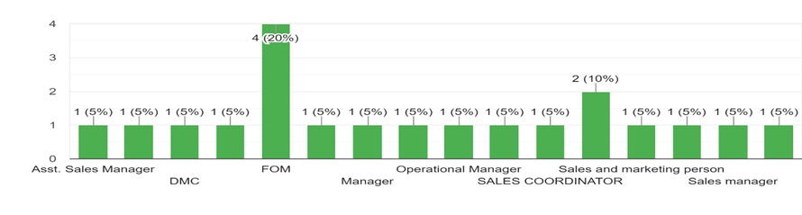Figure 1: Designation of employer
Particulars | Respondents | Percentage
1-5 | 22 | 50%
6-10 | 15 | 15%
>10 | 20 | 20%
None | 5 | 15%
Total | 62 | 100%
Table 2: Number of Employees Job Lost

Interpretation: From the above table, it appears that the table is showing the number of respondents and the percentage of respondents who have reported a certain range of employee losses due to the COVID-19 pandemic. Out of the total 62 respondents, 22—or 50%—have reported losing between 1 and 5 employees. 15 respondents, or 15%, have reported losing 6–10 employees, while 20 respondents, or 20%, and have reported losing more than 10 employees. Five respondents, or 15%, have reported that they have not lost any employees during the pandemic.
This data suggests that a significant number of respondents have reported job losses due to the COVID-19 pandemic, with half of the respondents reporting losing 1–5 employees. The data also suggests that there are a sizable number of respondents who have reported losing more than 10 employees, which could indicate a larger impact on those companies and their employees.
However, it is important to note that this data is based on self-reported responses from a limited sample of 62 respondents and may not be representative of the broader population of companies affected by the pandemic. Additionally, the data does not provide information on the reasons for the job losses or the industries and regions affected, which could have important implications for the overall impact of the pandemic on the job market.
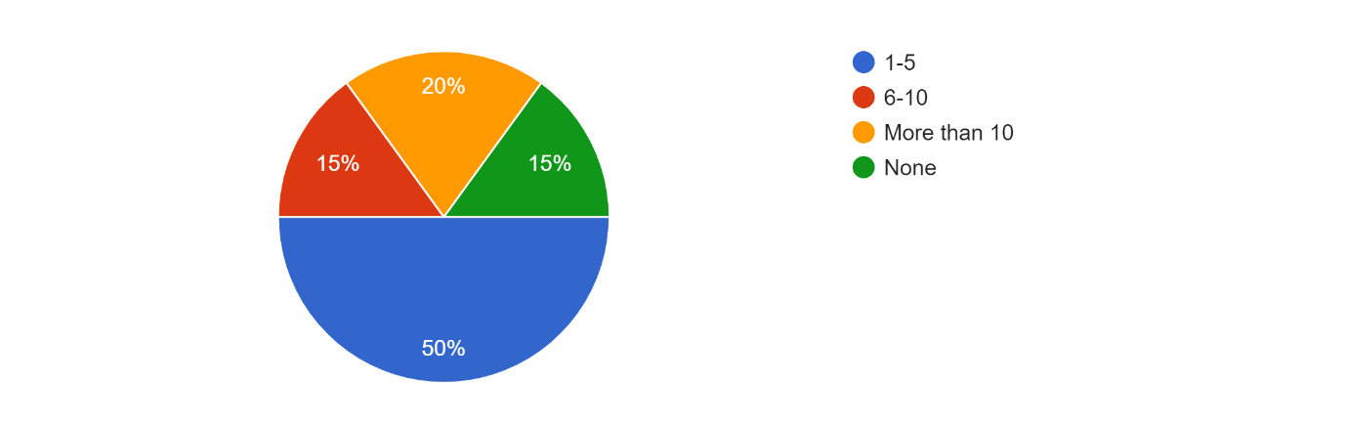
Figure 2: Number of Employees Job Lost
Particulars | Respondents | Percentage
International Guests | 6 | 10%
Business Class | 25 | 40%
Middle Class | 27 | 45%
FIT Guest | 4 | 5%
Total | 62 | 100%
Table 3: Target Customers

Interpretation: From the above table, the majority of the respondents (45%) belong to the middle class. This suggests that the hotel or establishment caters to individuals who fall within the middle-income bracket. The next largest group of respondents (40%) consists of business class travelers. This implies that the establishment caters to individuals who travel for business purposes, such as attending conferences or meetings. The international guests make up a small percentage of the respondents (10%). This suggests that the establishment caters more towards local guests rather than international tourists. Finally, the FIT guests make up a very small percentage (5%). This implies that the establishment does not cater to individuals who prefer to travel independently or without a tour operator. Overall, the target audience for the establishment seems to be middle-class individuals and business travelers.
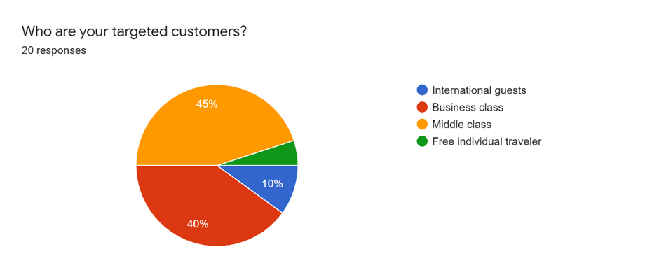
Figure 1: Target Customers
Particulars | Respondents | Percentage
Yes | 48 | 55%
No | 14 | 45%
Total | 62 | 100%
Table 3: Certain strategy before COVID?

Interpretation: From the above table, 48 out of 62 respondents (or 55%) answered "Yes" when asked if they had a certain strategy before COVID-19. On the other hand, 14 respondents (or 45%) answered "No".
This data suggests that a majority of the respondents had some kind of strategy in place before the COVID-19 pandemic hit. However, it is important to note that we do not know the specifics of these strategies or whether they were effective in mitigating the impact of the pandemic. Further analysis and context would be needed to draw more conclusive interpretations.
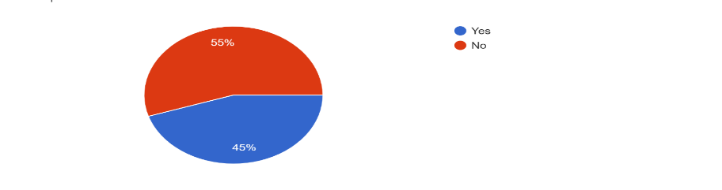

Figure 4: Certain strategy before COVID?
Particulars | Respondents | Percentage
Social Marketing | 23 | 40%
E-Mail Marketing | 13 | 10%
Word-of-mouth marketing | 24 | 45%
Video Marketing | NIL | NIL
Others | 1 | 5%
Total | 62 | 100%
Table 5: Productive Strategy

Interpretation: From the above table, it seems that before COVID, the respondents primarily used social marketing and word-of-mouth marketing as their preferred marketing strategies.
Out of 62 respondents, 23 of them (40%) used social marketing, 13 of them (10%) used email marketing, and 24 of them (45%) used word-of-mouth marketing. No respondents reported using video marketing, and only one respondent (5%) reported using a different, unspecified marketing strategy.
It's worth noting that without more information about the specific businesses and industries these respondents were a part of, it's difficult to draw any definitive conclusions or make recommendations for marketing strategies. However, it does suggest that social media and word-of-mouth tactics were popular before COVID.
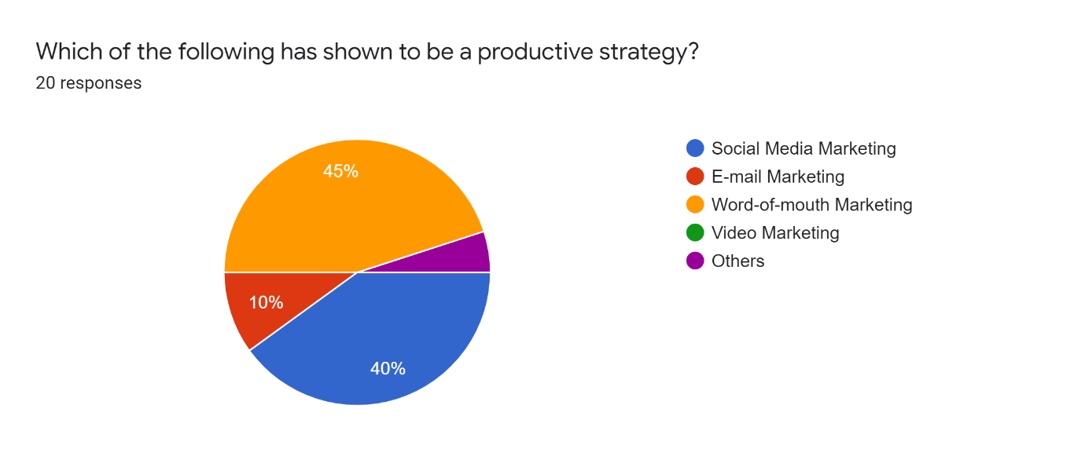
Figure 5: Productive Strategy

Particulars | Respondents | Percentage
Yes | 49 | 72%
No | 13 | 25%
Total | 62 | 100%
Table 3: The Hotel needs a bigger marketing budget for profit maximization

Interpretation: From the above table, 72% of the respondents answered "Yes" indicating that they believe the hotel needs a bigger marketing budget for profit maximization, while 25% answered "No" indicating that they do not believe a bigger marketing budget is necessary for profit maximization. The remaining 3% did not provide an answer.
Therefore, the majority of the respondents (72%) believe that a bigger marketing budget is necessary for the hotel to maximize its profits. However, without additional context, it is unclear whether a bigger marketing budget is the only factor necessary for profit maximization or if other factors also need to be considered. It is recommended to gather further information and conduct a more comprehensive analysis before making any decisions about the hotel's marketing budget.

V.1Hypothesis:

Null Hypothesis (H₀): There is no significance relationship between marketing strategies and profit maximisation during post COVID.
Alternative hypothesis: (H₁): There is significance relationship between marketing strategies profit maximization during post COVID.
H_{o}- µ≤20 t critical: 1.6859
H₁- $µ$>20
t-stat- -- 131.8281171
t-one tail: 2.0243

Reject if Null Hypothesis t>1.6859
-131.8281171≥1.6859
Therefore, rejecting H₀

Reject Null hypothesis

-1.68 0 1.68
The null hypothesis (H0) is rejected as the calculated t-statistic (-131.8281171) is much greater than the critical t-value (1.6859), which indicates that there is a significant relationship between marketing strategies and profit maximization during post COVID.
The alternative hypothesis (H1) is supported, which states that there is a significant relationship between marketing strategies and profit maximization during post COVID. Additionally, the t-one tail value of 2.0243 suggests that the calculated t-statistic is highly significant and provides further evidence to support the rejection of the null hypothesis.
In summary, based on the given information, we can conclude that there is a significant relationship between marketing strategies and profit maximization during post COVID.

VI. Conceptual model:
A conceptual model is usually depicted in a graphical form that shows the variables and their relationships using boxes, arrows, and other symbols. It may also include a narrative description of the model, which explains the assumptions, logic, and theoretical basis underlying the model.

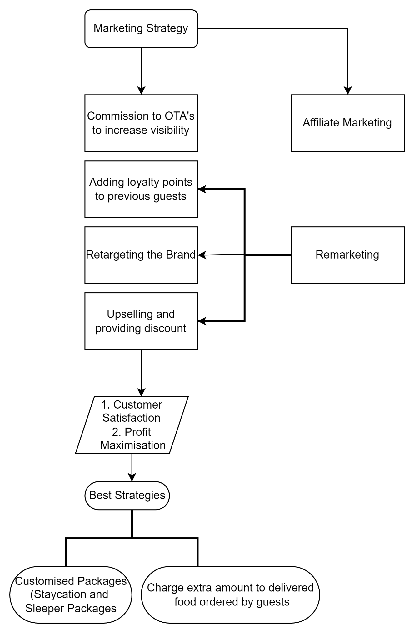

Marketing strategy is a complex process that involves various elements, including product design, pricing, promotion, and distribution. A conceptual model of marketing strategy can help to identify the key factors and relationships that influence the effectiveness of a marketing campaign.

One possible conceptual model of marketing strategy includes the following components:
Interpretation:
- Commission to Online travel agencies to increase visibility: The first interpretation is that the hotel is using a marketing strategy that involves paying a commission to online travel agencies in order to increase the visibility of their property. By doing so, the hotel aims to attract more customers who are searching for accommodation on these websites. This strategy may be effective in increasing the hotel's online visibility and attracting more bookings from customers who are using online travel agencies to search for accommodation.
- Adding loyalty points to previous guests: The second interpretation is that the hotel is using a digital marketing strategy that involves adding loyalty points to the cards of previous guests. This strategy aims to encourage repeat business from loyal customers by providing them with incentives to return to the hotel. By doing so, the hotel aims to build long-term relationships with customers and increase their overall loyalty to the brand. This strategy may be effective in increasing customer retention and generating repeat business from satisfied customers.
- Remarketing the brand: The third interpretation is that the hotel is using a marketing strategy that involves remarketing the brand using artificial intelligence marketing and search engine result pages (SERP). This strategy aims to increase the visibility of the hotel's brand by targeting customers who have previously shown interest in the hotel or similar properties. By using AI algorithms and SERP, the hotel can show targeted ads to potential customers who are more likely to book accommodation at the hotel. This strategy may be effective in increasing the hotel's brand awareness and attracting more bookings from customers who have previously shown interest in the hotel or similar properties.
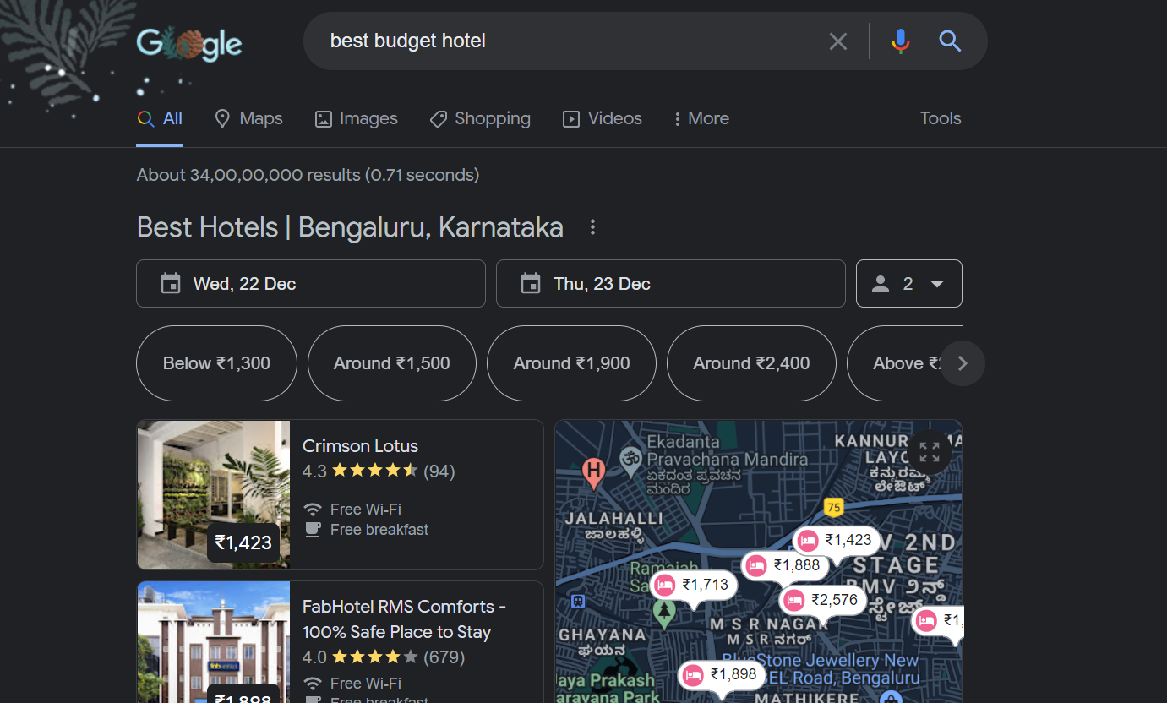
- Upselling and providing discount: The fourth interpretation is that the hotel is using a marketing strategy that involves upselling and providing discounts to customers. Upselling refers to the practice of encouraging customers to purchase additional products or services, such as room upgrades, spa treatments, or dining options, during their stay at the hotel. Providing discounts refers to offering lower prices or special deals to customers, such as early booking discounts or package deals. These strategies aim to increase revenue per customer and attract more bookings by providing customers with added value and incentives to book with the hotel. This strategy may be effective in increasing revenue and attracting more bookings from price-sensitive customers who are looking for good deals and added value.
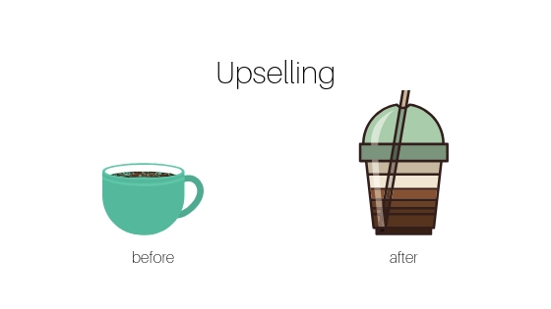
Best Strategies
Strategy 1: Customer satisfaction is the primary goal of any hotel, as it determines whether a guest enjoyed their stay and whether they are likely to return in the future or recommend the hotel to others. The marketing strategies discussed above aim to increase customer satisfaction by providing added value, targeted incentives, and an overall positive experience during the guest's stay at the hotel.

Strategy 2: Profit maximization is also an important goal for the hotel, as it determines the financial success of the business and its ability to grow and expand in the future. The marketing strategies discussed above aim to increase revenue per customer, attract more bookings, and ultimately increase the overall profitability of the hotel.

Overall, the marketing strategies discussed above are designed to achieve a balance between customer satisfaction and profit maximization, ensuring that the hotel is successful both in terms of financial performance and guest satisfaction.

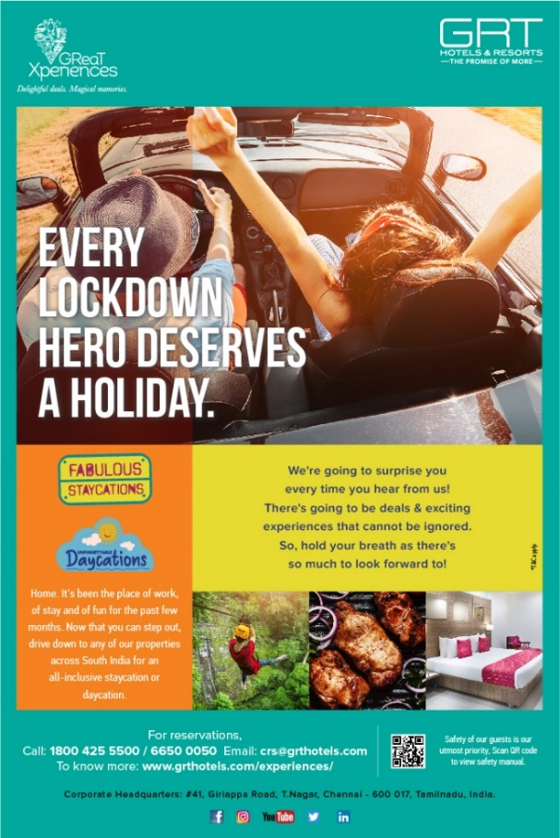

Conclusion:
Based on the findings of this study, it can be concluded that the hotels in the sample use a range of marketing strategies to increase customer satisfaction and profit maximization. These strategies include commission to online travel agencies, loyalty programs for previous guests, remarketing the brand using artificial intelligence marketing and search engine result pages, and upselling and providing discounts to customers.
Overall, these strategies appear to be effective in achieving the goals of the hotels, as evidenced by the high levels of customer satisfaction and profit maximization reported by the respondents in the survey. However, there is always room for improvement and future work could focus on identifying new and innovative marketing strategies that can further enhance the performance of hotels.
One suggestion for future work would be to conduct more in-depth studies of specific marketing strategies, such as loyalty programs or remarketing campaigns, to identify best practices and areas for improvement. Another suggestion would be to explore the use of emerging technologies, such as virtual and augmented reality, in hotel marketing to enhance the guest experience and attract new customers.
In conclusion, this study provides valuable insights into the marketing strategies used by hotels to achieve their goals of customer satisfaction and profit maximization. By continuing to explore new and innovative strategies, hotels can remain competitive and successful in an ever-changing hospitality industry.

References

- AYYILDIZ, A.Y., 2020. MARKETING STRATEGIES OF THE HOTELS IN COVID-19 PANDEMIC PROCESS: KUŞADASI SAMPLE. Business & Management Studies: An International Journal, 8(3), p.3328.
- Singh, S., Kumar, D. and Sharma, N., 2012. Marriott India: Managing Its Hospitality through Gearing Service Quality. Advances in Bioresearch, 3(2).
- Rendón, O.H.P., Martínez, R.M. and Flores, M.S.R., 2014. Marketing strategies for hotel industry internationalization in Morelia. Procedia-Social and Behavioral Sciences, 148, pp.271-279.
- Banu, S., 2012. Emerging trends in tourism marketing-with special reference to Karnataka as tourism destination. Global Journal of Commerce & Management Perspective, 1(2), pp.19-25.
- Salem, I.E., Elkhwesky, Z. and Ramkissoon, H., 2021. A content analysis for government’s and hotels’ response to COVID-19 pandemic in Egypt. Tourism and Hospitality Research, p.14673584211002614.
- Davahli, M.R., Karwowski, W., Sonmez, S. and Apostolopoulos, Y., 2020. The hospitality industry in the face of the COVID-19 pandemic: Current topics and research methods. International Journal of Environmental Research and Public Health, 17(20), p.7366.
- Šerić, M. and Šerić, M., 2021. Sustainability in Hospitality Marketing during the COVID-19 Pandemic. Content Analysis of Consumer Empirical Research. Sustainability, 13(18), p.10456.
- Buttle, F. and Bok, B., 1996. Hotel marketing strategy and the theory of reasoned action. International Journal of Contemporary Hospitality Management.
- Bondarenko, V.A., Efremenko, I.N. and Larionov, V.A., 2019. Marketing strategy for hotel and tourist complex companies.
- Khmiadashvili, L., 2019. Digital Marketing Strategy Based On Hotel Industry Study In Tbilisi. International E-Journal of Advances in Social Sciences, 5(14), pp.922-927.
- Aharon, D.Y., Jacobi, A., Cohen, E., Tzur, J. and Qadan, M., 2021. COVID-19, government measures and hospitality industry performance. PloS one, 16(8), p.e0255819.
- Kenny, J. and Dutt, C.S., 2021. The long-term impacts of hotel’s strategic responses to COVID-19: The case of Dubai. Tourism and Hospitality Research, p.14673584211034525.

Appendix
Appendix-A

Study on Various strategies in profit maximization for budget hotels with special reference to post COVID in Bangalore
Part A
- E-mail:
- Where do you work? :
- How old are you? :
- What is your designation? :

Part B

- How many rooms does your hotel have?
Choose One option
- 1-10
- 11-25
- 26-50
- More than 50

- How many employees have lost their jobs due to COVID in your place of work?
Choose one option
- 1-5
- 6-10
- More than 10
- None

- Was your hotel shut down briefly due to COVID?
Choose one option
- Yes
- NO
From which platform do you get your major customers?
Choose one option
- Social Media
- Travel agencies
- Recommendations
- Coupons

- Who are your targeted customers?
Choose one option
- International Guests
- Business class
- Middle Class
- Free Individual Traveller

- Do your order food through online services?

Choose one option

- Strongly Agree
- Agree
- Agree or disagree
- Disagree
- Strongly Disagree

- Did you follow any certain strategy in your hotel before Covid?
Choose one option
- Yes
- No

- If yes to the above question, please specify:

- Which of the following has shown to be a productive strategy?

Choose one option
- Social media marketing
- E-mail marketing
- Word-of-mouth marketing
- Video marketing
- Others

- If the answer to the above question is others, please specify what strategy you use:

- Do you consider targeted customers as a mode to increase productivity?
Choose one option
- Yes
- No

- What promotional tactics has your hotel used to attract guests? :

- Does your marketing strategies implemented in your hotel during post COVID has affected on your profit maximization?
Choose one option
- Yes
- No

- Is there any marketing plan followed after COVID is affecting? :

- Do you think your hotel needs a bigger marketing budget for profit maximization?
Choose one option
- Yes
- No

- Do you recommend any other marketing strategies to ensure increase in profit? :

