Dr. Bhuma Sundar Raman
Asst Prof, St. Mira’s College for Girls, Pune
Mail id: coolbhuma.raman@gmail.com
Contact no.: +91 8378995269

BUILDING RESILIENT SUPPLY CHAINS THROUGH BIG DATA ANALYTICS

ABSTRACT
Purpose: This paper is an attempt to analyze the use of Big Data Analytics (BDA) in building resilient supply chains (RSCs) and a conceptual relationship between BDA and RSCs is sought to be established. For this purpose, the three decision making areas in supply chain management viz., procurement, production (operations), and logistics have been identified in which the five facets of resilient supply chains viz., contingency planning, localization/diversification strategies, visibility, agility, and sustainability can be applied using BDA.
Methodology: This is a conceptual paper for which qualitative research has been done. The literature pertaining to resilient supply chains and application of big data analytics in supply chain management have been studied in order to arrive at a conceptual relationship between BDA and RSC.
Contribution: The conceptual relationship proposed between BDA and RSCs can be tested by organizations for improving visibility and minimizing risk disruption in the supply chain design in the long term.
Key words: localization, resilience, risk management, sustainability, visibility.

- INTRODUCTION
  - SUPPLY CHAIN MANAGEMENT (SCM)
The concept of supply chain encompasses all the entities in the manufacturing and distribution process viz., the suppliers, manufacturer, distributors, transport and storage facilitators, several other intermediaries and including the customers too. According to Mihai and Irina, supply chain management (SCM) can be viewed from two perspectives: the view of the practitioners and the concept propounded by theorists. Theorists consider SCM as an amalgamation of an array of disciplines including purchasing, logistics, operations management, transportation, distribution and even information technology. According to the theorists, the concept of SCM is associated with synchronizing those activities that are concerned with the final delivery of the product to the customer. These activities include the purchase of raw materials and spare parts, production, operations management, stores management, order management, distribution and delivery to customers through various channels, and above all the management information systems needed to conduct all the above activities seamlessly. On the other hand, the practitioners of SCM concentrate their attention on achieving the objectives of SCM like value addition to customers, improvising operations, cost optimization, reducing time lags in the distribution channels etc., through the adoption of relevant practices across departments. Mihai and Irina have quoted Waller in defining supply chain as the integration of material flows, information flows and financial flows. The material flow, i.e., activities involved in buying, manufacturing, and selling is of course the most crucial aspect in SCM. However, the flow of information through the digital medium and the financial flows between the various agents in the supply chain is equally critical for the successful execution of supply chain operations. Along with these three flows, the importance of knowledge flow between various production processes in SCM also needs to be emphasised in a world where disruptive innovation has become the norm. Finally, it should be borne in mind that SCM is not a one-way traffic. The reverse movement of goods from customer to manufacturer for repair, maintenance, recycling or any other such purpose provides a window for the organization to maximize customer satisfaction and achieve its sustainability goals.
  - BIG DATA ANALYTICS (BDA)
Big Data refers to data that comprises of the “5Vs”, namely, Volume, Velocity, Variety, Veracity, and Value. It can be said that big data refers to the generation of a humungous quantity of data at a tremendous rate from multiple sources and sharing it with various decision-making points. However, simply making data available is not going to be of value to the user. Big Data Analytics is the process wherein the big data is analyzed and patterns are identified based on which predictive models are developed for decision making. BDA in SCM can be applied across various functions like procurement, production, warehousing, transportation, and sales management. BDA in SCM can be applied at various levels, viz., descriptive, predictive, and prescriptive. Descriptive analytics is used to categorize and describe historical data. It applies association techniques to test relationships among the various elements of the supply chain thus enabling decision making. Predictive analytics uses classification algorithms such as data mining, web mining, and text mining to establish predictive patterns in the big data. These algorithms are used for predicting events and identifying the sustainability of processes in the various functions of supply chain. Prescriptive analytics is used for decision making through the application of the algorithms. The tools used in prescriptive analytics for recommending a particular course of action include multicriteria decision making, optimization, and simulation.
  - RESILIENT SUPPLY CHAINS (RSCs)
The first step in building a resilient supply chain is to identify the critically vulnerable links. Such vulnerabilities arise largely in procurement, production, and logistics. These links could be disrupted either due to wars, political conflicts, natural disasters, and as is the case at present, due to the pandemic. Disruption in these links have a spiralling effect due to the multi-layered nature of the supply chain network right up to the final customer. The only way to monitor disruption risks in real-time is to develop visibility across the supply chain through the various tiers. Such a monitoring system can be enabled by digital solutions like 5G technology, big data analytics, and cloud computing. According to a survey of 200 senior-level supply chain executives across sectors like consumer products, retails, automotive, life sciences etc., conducted by Ernst and Young LLP, 64% of the executives believe that the pandemic will result in fast-tracking digitization. According to 52% of the surveyed executives, the adoption of autonomous supply chain technologies like robots in warehouses, driverless forklifts and trucks, and delivery drones is already underway and will see full-fledged automation by 2025. In fact, 60% of organizations are set to increase their investments in digitization and all industries surveyed have committed to investing in supply-chain advanced analytics due to the pandemic.
- LITERATURE REVIEW
Bahrami et al (2022) have studied how Big Data Analytics (BDA) capabilities have an impact on supply chain performance. For their study, they collected responses from 187 participants from their survey which included supply chain managers, operations managers, and IT managers. The results of their analysis showed that BDA capabilities had a significant impact on supply chain resilience, supply chain innovation and supply chain performance with supply chain resilience and supply chain innovations acting as important mediators.
Baker Mckenzie (2020) report on Supply Chain Resilience, Stanley Jia has spoken about the automotive and electronic industries in China. According to Stanley, the falling output in these industries will negatively impact the associated supply chain industries. To begin with, the restrictions on human movement has reduced manpower availability and is hampering production within the country. Further, the availability of raw materials and components from abroad is severely impacted due to international restrictions. Thus, both downstream and upstream enterprises with which these businesses are associated are facing disruptions in their supply chains.

Elia et al, (2021) have provided insights similar to those given by the professors at IIMD regarding the expansion of trade since the 1990s and its consequent decline post the 2008 global financial crisis. They have provided evidence of the political, social, economic, and technological factors that were the causes for such a slowdown. They have further argued that several academicians as well as practitioners believe that the pandemic has fast tracked the changes which were already underway, and firms will be inclined to realign their Global Value Chains (GVCs) to make them more regional (RVCs) or domestic (DVCs) at least partially.
Ernst and Young (2020) have analysed 15 sectors in India and conducted a detailed study on how to manage the impact of covid-19 on the supply chains in these industries. According to the report, beginning with the US-China trade war and further fuelled by the pandemic, countries across the world are looking for relocating their production centres in India and other low-cost countries in Asia and Africa. The authors believe that India can take advantage of these supply chain shifts by providing quality material at low cost and establishing the necessary infrastructure in the form of good logistics and transportation networks. Such a shift from China would result in the expansion of manufacturing hubs across the world with associated GVCs that would result in providing large scale employment and propel economic growth in these countries.
European Union (External Relations Directorate General for External Policies of the Union) (2021), in its policy report has found that GVCs are bound to be impacted by exogenous shocks like the current pandemic as also by the increasing number of natural disasters occurring due to climate change. GVCs producing essential goods (for example, medical or security related items) will certainly require government intervention to minimize the impact of these supply shocks. However, the trend of reshoring to the European Union was not very strong in the pre-pandemic years despite catalysts like automation and additive manufacturing. In fact, the report suggests that adopting digital technologies might facilitate reshoring only to a limited extent and the latter maybe triggered by factors like proximity to market and declining importance of wage cost differentials in decisions pertaining to location of production. The proliferation of ICT technologies might in fact facilitate offshoring and outsourcing supply and sales networks while factors such as high sunk costs and increasing market size of growing economies will dissuade firms from reshoring decisions. On the other hand, under the green transition initiative, countries will probably promote domestic or regional value chains which will be shorter than the existing GVCs and thus try to reduce their carbon footprint. Further, border adjustments undertaken by individual countries for environmental reasons and boosting sovereignty maybe perceived as protectionist policies by other countries which may retaliate with likewise measures. Thus, the report predicts that as international trade becomes more costly and inconvenient, reshoring processes will gain momentum.
Fan et al (2015) have classified the big data pertaining to supply chain (SC) risks into two categories, SC internal big data and SC external big data. Based on this classification, the authors have proposed a framework for incorporating big data technologies into the supply chain risk management system. According to the authors, research about big data application in supply chain management is very rare even though big data technologies play a big role in predicting and detecting potential supply chain risks and help in building visible and flexible supply chains.
Golan et al (2020) have reviewed the literature on resilient supply chains which focused on resilience modelling and quantification, and which also connected the supply chain to other networks like transportation and command and control. They found that only 47 relevant papers were published between 2007 and 2016, and 94 papers were found for the period 2017-2019. They observed that supply chain resilience models were developed and tested for specific disruption scenarios while disruption arising from uncertainties were not addressed adequately. They also found that studies which proposed advanced models focused exclusively on supply chain networks and did not address the associated issues pertaining to transportation and command and control networks. Further, they suggest that the trade-offs of efficiency and lean networks with flexibility and resilience has not been adequately investigated. Among other things they have suggested that systemic threats should be considered in order to make supply chains more resilient.
International Chamber of Commerce (ICC) report has studied exhaustively the subject of Localization Barriers to Trade including the various types of barriers and the barriers imposed by countries across sectors. They have shown how localization barriers to trade (LBT) are harmful and countries would be better off adopting productivity and innovation based economic development policies to boost growth rather than regressive mercantilist policies. According to the authors, while the median global tariff rate has declined from 26% to less than 7% today, the number of technical barriers to trade (mostly in the form of LBTs) reported in 2012 reached a record high of 1,560. The LBTs are being used by countries to attract foreign direct investments or to get domestic manufacturers to stay invested in the country through the offer of highly rewarding incentives. Such a strategy though profitable in the short run will not be rewarding for global economic growth in the medium term and long term. Hence, countries should try and attract foreign investments in the country by working on their comparative advantages such as rule of law, skilled labour pool, robust infrastructure (physical and digital), competitive tax rates as well as attractive industrial recruitment incentives and thus achieve the innovation-based growth which they seek to achieve in the 21st century.

International Institute for Management Development (IIMD) (2020) in its study has found that the juggernaut of globalization fuelled by cheap labour and the exponential growth in transport and communication caused global trade to expand for several decades. A related outcome was the creation of lean supply chains and cost cutting based on the ‘just in time’ principle. However, even before the pandemic, the regressive forces of nationalism coupled with anti-immigrant sentiments was leading governments to promote domestic production via incentives and discouraging exports through increased trade barriers. This change in outlook was primarily due to the 2008 global financial crisis and the resultant economic decline in the US as also several European countries. The pandemic has further boosted this narrative and global trade as well as global supply chains are inclined to becoming more localized than globalized. Firms are ready to sacrifice efficiency for resilience so that they can survive the upheaval caused by the pandemic.
Ittmann (2015) has highlighted the growing importance of big data and analytics in supply chain management. He has shown through examples how big data analytics is being applied successfully by various organizations. According to him, supply chain managers should proactively embrace these two trends in order to derive maximum benefit from these trends.
KPMG report (2021) on Rethinking supply chains in Asia Pacific dwells on the consequences of the shift in supply chains to Asia and ASEAN regions due to the pandemic. The report highlights the fact the pandemic and geopolitical tensions caused by the US-China trade war has forced manufacturers to think of diversification in terms of alternative suppliers of raw materials as well as distribution networks. In fact, organizations have been increasingly attracted to move their business from China to other countries in Asia and the ASEAN regions in order to avoid dependence on any single country/manufacturer. The report however warns that problems pertaining to cyber-attacks, unethical sourcing, bribery and corruption in these markets should be taken into account before arriving at any diversification decisions. In fact, manufacturers should thoroughly investigate the credentials of the alternative suppliers and policies of the host country where they are planning to relocate their operations.
Li and Liu (2019) have presented a data-driven supply chain management framework since data is increasingly driving decision making in supply chain management. According to them, the traditional strategies of supply chain management lead to limitations in the comprehensive usage of data. They have proposed a framework which they have explained with the help of a conceptual analogy with the power split device of hybrid vehicles. They have discussed data pertaining to different facets of supply chain management. Finally, they have proposed some new value additions to the data-driven supply chain management.
Mageto (2021) has applied Toulmin’s argumentation model to review existing literature on sustainable supply chain management (SSCM). However, he found that studies on the benefits of using BDA in the manufacturing supply chains is very limited. He has identified six elements of BDA and four facets of SSCM and has proposed a conceptual relationship between BDA and SSCM.
Meriton and Graham (2016) have aimed at highlighting the importance of big data analytics in supply chain management through an exhaustive literature survey. They found that adoption of BDA can lead to huge gains for businesses; however, the latter are not adequately prepared to assimilate the new technology in terms of costs as well as mindsets. Their study also revealed that adopting BDA was a strategic decision for organizations and as such every business had to tailor their big data strategy to fit in with their core competencies in order to reap sustainable competitive advantage.
Nguyen et al (2018) have conducted a comprehensive literature review on the role of big data analytics (BDA) on supply chain management. They have created a new classification framework that provides insight into the application of BDA in supply chain management. For this purpose, they based their study on four research areas viz., the areas of supply chain management where BDA is being applied, the level of analytics in BDA being used in these areas, the types of BDA models used in supply chain managements, and the techniques used to develop these models.
OECD report (2021) has highlighted the differences in industries and economies with respect to their exposure to imports/exports. Those industries or companies with greater GVC integration are prone to be impacted by demand and supply shocks. However, the report does not believe that reshoring of GVCs is a solution for the supply chain disruption caused by the pandemic. This is because the costs of localisation may outweigh the benefits of stability accruing to a limited number of downstream countries participating in such a GVC. According to the OECD report GVCs are recommended not only for their efficiency but also for absorbing shocks. However, the report also advocates the role of the government in formulating appropriate policies in promoting localization/globalization of supply chains as the situation demands.
Seyedan and Mafakheri (2020) have studied the predictive BDA applications in supply chain demand forecasting because BDA has a big role in supply chain management which includes customer behaviour analysis, trend analysis, and demand prediction. The authors have classified the applications into six categories and have also pointed out that the literature on application of BDA for demand forecasting in closed-loop supply chains is particularly very limited.
William Drake (2016) has highlighted the contemporary challenges of data localization policies and barriers to Transborder Data Flows (TDF) and suggested international trade policy instruments for providing solutions. According to Drake, “data flow is the lifeblood of the global information economy, and the Internet and other electronic networks are its circulatory system”. He has quoted a McKinsey report which estimates that “total cross-border Internet traffic increased 18-fold from 2005 to 2012 and data flows accounted for US$2.8 trillion of global GDP in 2014”. Since cross-border data flows generate more economic value than the traditional flows of goods and services, he believes that the new businesses that will drive the fourth industrial revolution will be dependent on the unhindered flow of data across the Internet. With seamless TDF, enterprises will be able to generate $14.4 trillion of net profit between 2013 and 2022. However, several barriers to TDF and data localization requirements have been introduced by countries either due to security concerns or for protecting privacy of individuals. However, industrialists view these measures more as protectionist policies which could restrict global economic growth and personal empowerment and hence should be regulated by world trade regulations.

Yan and Wang (2021) studied the firms located in the development zones in Weifang, China in order to study the effect of the pandemic on supply chains and sales networks,. Their study revealed that while the logistics networks in the development zones were already localized to a great extent, the pandemic had further reinforced this characteristic due to the weakening of global links. They also inferred that the connectivity of logistics networks had increased because of the reduction in their average path length (supply and sales networks). Further, due to the restrictions placed on the movement of goods and people across borders (national and administrative), the logistics networks in the development zones were forced to adopt localization strategies.
Yavari and Ajalli (2021) have proposed a green-resilient supply chain network that can face disruptions. They suggest adopting the coalition risk mitigation strategy to minimize risks arising from disruptions in the supply chain. They found that the proposed risk mitigation strategy is more in line with economic and environmental considerations as compared to other strategies.

- RESEARCH METHODOLOGY
This is a conceptual paper and as such qualitative research has been done for this study. The concept of supply chain management was studied and three key decision-making areas in SCM were identified viz., procurement, production (operations) and logistics. The literature pertaining to building resilient supply chains, particularly those published in the last two years were reviewed and the five important features of resilient supply chains were ascertained, namely, contingency planning, localization/diversification strategies, visibility, agility, and sustainability. Finally, a conceptual relationship between BDA and RSCs has been proposed through the application of BDA in the three key decision-making areas of SCM in order to build resilient supply chains.
OBJECTIVES
- To study the impact of the pandemic on global supply chains and analyse the challenges arising from the disruption of global supply chains
- To identify the key decision-making areas in supply chain management and the important facets of resilient supply chains.
- To establish a conceptual relationship between big data analytics and resilient supply chains through the application of BDA in key decision-making areas of supply chain management.
- FINDINGS
  - CHINA: THE GLOBAL MANUFACTURING HUB
The emergence of COVID-19 pandemic in China which is considered the manufacturing hub of the world brought home the stark reality that depending on any one country for supply of finished or semi-finished goods can be disastrous for an industry and/or country.
The share of China in total world exports of finished goods is 16% and that for intermediate goods is 20%. (PwC report). Obviously, any country that depends on China directly or indirectly for supplies is going to be impacted. For example, as recently as 2018-19, India depended on China for over 65% of its imports for Active Pharmaceutical Products (PwC) report). With the onset of the pandemic, India faced prolonged delays in the procurement, operations, and sales networks of its pharmaceutical products. In fact, there was a worldwide shortage of personal protective equipment (PPE) and other critical products required by the medical fraternity due to export restrictions on these items. At the same time, a lockdown in nearly 90 countries severely restricted the movement of people and goods which had adverse effects on global supply chains (PwC report). Wuhan in particular occupies a strategic position in global supply chains. Apart from being a manufacturing base for decades, it is also host to several industries of high technology and modern manufacturing. According to a report by Deloitte, “more than 200 out of Fortune Global 500 companies have a direct presence; 163 out of the Fortune 1000 companies have Tier 1 suppliers and 938 companies have one or more Tier 2 suppliers in Wuhan”. Being host to the largest inland port, Wuhan is also the transportation hub in China. Wuhan has developed extensive networks in roadways, airways and waterways. Moreover, influential industrial cities like Beijing and Shanghai, Guangzhou among others are located within a radius of 1200 km of Wuhan. Hence, even industries with no direct linkage in Wuhan in terms of production or distribution are facing serious logistics issues (Deloitte report).
  - CHALLENGES ARISING FROM SUPPLY CHAIN DISRUPTIONS
Organizations across the world are unable to identify supply disruption risks since they can trace only their Tier 1 suppliers. In the absence of advanced digital solutions most of the organizations are not in a position to predict supply chain disruptions. Supply shortages across the wide supply networks have a domino effect and supply chains across the globe are impacted negatively in a matter of days. Firms across various sectors faced several challenges due to supply chain disruptions during the pandemic. According to a Capgemini report, these challenges could be summarized thus:
- Problems in planning for both demand and supply due to unavailability of data on fluctuating demand (68% of firms) as well as Delays (69% of firms).
- Delays in shipments and longer lead times (74%) and shortage of critical parts/materials (74%).
- Problems in reconfiguring production lines quickly (68%) and/or scaling up or scaling down production quickly (69%).
- Problems in balancing stock between warehouses (69%) and in inventory pileup across borders (68%)
- Problems in switching to online sales (71%) or lost sales due to stockouts (67%)
- Problems in end-to-end monitoring of supply chain (72%)
- Problems in scaling workforce up/down (69%)
- Problems in controlling costs (68%)
- Problems in maintaining healthy and safe working conditions (60%)
In the case of the manufacturing sector, not only are they facing difficulties in the distribution of their products, but their profit margin is also shrinking due to the rising cost of distribution. Further, the inability to clear stocks at a fast pace is causing a pile up of inventories which is hiking storage costs. The producers of perishable goods are the worst affected with huge losses and wastages due to these snags in storage and distribution. Global trade (imports and exports) has been severely impacted due to the restrictions in the movement of goods and people. As a result, the pileup of goods in ports and warehouses have seen delays running into weeks for clearing stocks. Retail trade has been affected along the same lines as manufacturers with respect to storage and distribution. Hence, distress selling has become a possibility in such a scenario. The online retailers have experienced greater difficulties in selling their products as compared to their brick-and-mortar counterparts. Food services have seen an exponential growth in home deliveries due to the capacity restrictions on hotels and restaurants. In a bid to retain their patrons and/or attract new customers, more and more restaurants have been offering home deliveries. While other organizations could adopt work from home strategies, restaurants had to prune their product offerings and widen distribution network in order to sustain business. There has been increasing pressure on governments across the world to resume international flights in the face of mounting losses by international airlines. While cargo planes are very expensive, most of the passenger carriers transport cargo in the belly of the aeroplanes. Further, shipping companies have been forced to cut manpower due to high costs and low turnover. As such, international distribution networks are hiking freight rates to compensate for the low volumes. Manufacturers and traders are therefore entering into partnerships with transporters in order to facilitate smooth flow of goods. Faced with the above challenges businesses have been forced to rethink their business models. While some firms have moved from traditional selling methods to direct selling, others are trying to generate revenue through service-oriented business models (Capgemini report).
4.3 CHANGING SUPPLY CHAIN POLICIES AT THE NATIONAL LEVEL
The trend towards localization/regionalization has gained momentum with the onset of the pandemic. Not only organizations but also countries are realigning (reshoring) their supply chain policies to minimize risks arising from future disruptions in the supply of essential inputs. While the European Union governments are being urged by France to actively pursue reshoring strategies, the US government is offering subsidies to companies that are willing to shift their manufacturing base from China. Japan has already announced incentives to the tune of US$2.2 billion for companies having operations in Asia to shift their base within the country. India of course is actively trying to take advantage of this golden opportunity and is trying to woo manufacturers away from China by making investment opportunities in India as attractive as possible. Another consequence of the pandemic induced supply chain disruption has been the institution of restrictions on exports for essential items (including medical equipment) to cope with the domestic demand. Such a protectionist policy has found favour even with the World Trade Organization (WTO) to a certain extent. The fallout of such measures is that the importing countries most of which are developing and emerging markets and are not having the capacity to produce these restricted items find their economic growth severely impacted. The industrial growth of developing countries in Sub-Saharan Africa is particularly dented due to the disruptions in the GVCs for goods, finance, technology as well as human resources (PwC report)
  - ADJUSTING TO THE NEW NORMAL
The pandemic has caused widespread disruptions in the supply chains across industries. For a majority of firms, it has taken more than three months to recover from these disruptions. A rethinking of supply chain strategies has therefore become inevitable.
1. Increasing Investments
Many firms are reconfiguring sourcing and manufacturing strategies (by replacing just in time principle) in order to build more resilient supply chains while several organizations are boosting investments to this end. These investments are in the form of supplier base diversification, manufacturing base diversification or diversification in transport options. At the same time supply chain sustainability has also become an issue of significance since consumers are becoming highly sensitized to this aspect of commercial activities. As a result, many organizations are also investing in sustainable supply chain practices encompassing a whole gamut of operations in procurement, production, and logistics. Along with resilience and sustainability, a majority of the firms are also looking to build more agile supply chains which can support new business models.
2. Cost considerations
While a study conducted in 2018 found that 77% of organizations give priority to saving costs, the proportion continues to remain high at 66% even today (Capgemini report) Even though firms want to build resilient and sustainable supply chains, they also want to maintain a tight control over costs. Only few of the firms are ready to incur higher costs in the process of undertaking these measures. These firms are ready to face hike in costs in order to improve resilience and to improve sustainability in their supply chains. Since supply chains are primarily viewed as cost centres and raw materials form the chief component of these costs, it is seen that many of the organizations are prone to optimizing raw material costs and transportation costs to a great extent. This kind of reliance on a single or few suppliers/transporters leaves them exposed to risks arising from disruptions in the supply chain. Further, in the absence of visibility, firms are unable to fully map the risks associated with locations of suppliers. Thus, only few organizations have optimized for costs arising from location-based risks like strikes, political disturbances, natural disasters etc.
- Improving Visibility
The absence of transparent supply chains has made risk management very challenging during the pandemic. As such, organizations are committed to improving visibility across their supply chains. To this end firms are keen to share data with their supply chain partners including subcontractors, transporters, warehouses etc. Supply chain networks are however highly complex and only few of the organizations have succeeded in identifying their Tier 1 supply networks. While 50% of the firms in the discrete manufacturing sector and one-third of firms in the retail sector have not mapped their supply networks at all, 44% of the organizations have not been able to establish visibility in their supply networks. Only 2 percent of companies have visibility into their supply base beyond the second tier (McKinsey report) The significance of improved visibility across innumerable suppliers has resulted in organizations moving from linear and lean supply chains to more interconnected chains. This drastic change has been rendered possible through the adopting of Technologies like IoT devices that provide real time data of the goods including their locations and condition.
- Digitization in SCM
The onset of the pandemic and the restrictions that followed on the movement of people necessitated remote working. As organizations adapted to this new working mode, 58% of organizations were able to manage supply chain planning successfully while the remaining 42% had experienced delays in decision making with reference to supply chains. Such a discrepancy was due to the adoption or otherwise of digital tools in supply chain management. The successful companies were 2.5 times more likely to have adopted advanced analytics capabilities. As a result, 71% of the companies which had experienced difficulties in supply chain management during the pandemic are now willing to invest in digital solutions. Such a willingness is found across sectors barring the health care sector (this sector has adopted regionalization as a resilience strategy in a big way). Every industry saw adoption of additional digital tools by more than 50% of the firms with great strides being made by those firms having the lowest analytics capacities. Almost all the firms in the commodities and automotive sectors had invested in advanced analytics during the past year even though some of them had been reluctant to do so in early 2020. On the other hand, the construction sector is the only sector that has not shown an inclination towards adopting digital supply chain technologies. The pandemic has acted as a catalyst and fast-tracked adoption of end-to-end supply chain processes. While a majority of organizations have already invested in advanced analytics in the past year, many had ended up investing more than they had initially planned due to the extensive benefits of these tools. The only exception was the advanced electronics and high-tech industry which saw a slowing down of digitization probably because the adoption of analytics in this industry was already very high.
The adoption of digital tools in supply chain management can occur over four focus areas:
- Supply chain visibility: More than three-quarters of firms (77%) are believed to prioritize investments in digital performance-management systems in order to monitor the real time performance of their supply chains.
- Specific planning tools. Again 75% of firms are likely to adopt improved planning tools either for specific purposes like logistics management or broader end-to-end planning.
- Network modelling: Less than half of the firms (45%) are willing to invest in systems that will improve supply-chain design in the long term.
- Supply-chain disruption monitoring: It comes as a surprise that in spite of the disruptions induced by the pandemic, only 39% of firms are adopting digital tools that will help them to monitor risks and disruptions.
Thus, it is found that firms are focusing on visibility and planning, but they are neglecting supply-chain disruption monitoring (McKinsey report).
Product based strategies
The steps taken by organizations to increase visibility and enhance responsiveness is bound to increase the costs in the supply chain and thus reduce the competitiveness of the firm’s products. As such, the trade-off between risk mitigation in supply chain and the efficiency of the firm needs to be addressed. Further, the impact of the risk mitigation measures differs for functional and innovative products. Functional products are low in value and easy to access. Customers are highly sensitive to the prices of these products. Hence, inventory redundancy establishment is an effective strategy to build resilience in the supply chain for functional products. The manufacturers of these products must focus on surviving the pandemic instead of making new investments in developing additional supply chains. The GSCs for functional products would fare better by relying on global suppliers instead of local sources. This will enable them to retain their competitive advantage and avoid shortages, thus becoming more efficient. In the case of innovative products, their high value and short expiration dates makes capacity redundancy a relevant GSC resilience strategy. High inventory levels will lead to hiking operational costs and increase the risk of losses from expiration. Hence, GSCs for innovative products will be better off relying on local sourcing. This will help them in avoiding shortages and ensure better responsiveness.

- DISCUSSION
BUILDING RESILIENCE THROUGH BIG DATA ANALYTICS
From the above discussion, three key decision areas in supply chain management have been identified:
- Procurement
- Production/Operations
- Logistics (Storage and Transportation)
Before the pandemic, the literature on supply chain management was focused on sustainability and to some extent on the debate between localization and globalization. The conversation pertaining to Resilient Supply Chains (RSCs) has assumed significance only recently due to the disruption of global supply chains with the onset of the pandemic. On the basis of the review of literature it was found that developing Resilient Supply Chains encompass building the following capabilities in supply chain management systems:
- Contingency Planning
- Localization/Diversification strategies
- Increasing Visibility
- Enhancing Agility
- Ensuring Sustainability
The process of building Resilient Supply Chains can be executed more effectively through the application of Big Data Analytics in the three key decision-making areas of SCM. This process has been explained in the following paragraphs.
Contingency Planning
Contingency planning in supply chain management refers to the preparedness of organizations to deal with unexpected/unforeseen disruptions. Contingency planning in the three key decision-making areas of SCM can be incorporated using BDA as illustrated in Fig. 1 (Appendix A).
- Procurement: In the case of procurement, BDA can be used to identify alternative suppliers through the extensive database on suppliers. In the event of disruption in supply due to unforeseen circumstances, BDA will enable supply chain managers to quickly restore materials supply through alternative sources at similar cost with minimum delay.
- Production: BDA has a big role to play in demand management so as to ensure that the right products are produced in the right quantity and are available for supply at the right time. The concept of demand management includes:
- Demand forecasting (estimating demand based on historical data)
- Demand sensing (estimating demand based on real time data)
- Demand shaping (influencing demand to match planned supply by tweaking product/pricing strategies)
- Logistics: As in the case of procurement, BDA can be used to identify alternative transport mechanisms in the case of disruptions either in procurement of materials or in the movement of goods to warehouses/distributors. This will enable supply chain managers to prevent/minimize delays in movement of raw materials and finished goods.
Localization/Diversification Strategies
As brought out in earlier paragraphs, due to the pandemic, organizations and countries all over the world are rethinking supply chain strategies in order to minimize risks arising from disruptions in the supply chain. One of the strategies which would increase supply chain resilience is adopting localization or diversification strategy depending on the kind of industry/product. Fig. 2 (Appendix A) illustrates how BDA can be used to implement this strategy over the three key decision-making areas of SCM.
- Procurement: Organizations must take decisions on either localizing or diversifying their supplier base depending on their requirement. BDA can enable supply chain managers to select the appropriate strategy in procurement through a comparative analysis of suppliers’ data pertaining to costs, time involved in procurement, quantities that can be made available etc.
- Production: Outsourcing the production of some components or even of the complete product has been the norm for the last 2-3 decades since China became the manufacturing hub of the world. Organizations are now rethinking their manufacturing strategy in order to avoid disruptions in production. BDA can assist supply chain managers in choosing between localizing or diversifying their manufacturing base by analysing not only the costs but also the time lags between the processes, the efficiency, and the length of the network.
- Logistics: Depending on the localization/diversification strategies adopted in procurement and production, the transporter base of the organization will also change. BDA can help supply chain managers to analyze and arrive at the optimum combination of transport networks to be used in order to minimize risks in disruption.
Visibility and BDA
Increasing visibility is the most critical function of BDA in SCM. As illustrated in Fig. 3 (Appendix A), as explained below, this can be seen across the three key decision-making areas of SCM.
- Procurement: Building visibility beyond Tier 1 suppliers through BDA is crucial for supply chain managers to monitor and identify in real time any disruption in the supply chain. They can then proactively switch to alternative suppliers and minimize delays in production.
- Production: Monitoring operation processes / production line in real time through BDA will enable supply chain managers to identify potential risks (pertaining to maintenance) in the chain and take corrective action thus minimizing disruptions in production.
- Logistics: By building visibility in logistics through BDA, supply chain managers will be able to better manage inventory in transit as well as in storage. The movement of finished goods from factory to distributors can become smooth without causing a pileup of inventory at either end.
Agility and BDA
An agile supply chain can be built using BDA which will enable businesses to conduct their activities with the minimum amount of disruption in procurement, production and logistics as shown in Fig. 4 (Appendix A) This has become very relevant not only due to the pandemic but also the uncertain geopolitical situation arising from the Ukraine crisis.
- Procurement: Visibility refers to the ability of supply chains managers to identify suppliers beyond Tier I and ensuring uninterrupted supply of raw materials/components through alternative suppliers in the case of disruptions. However, when the suppliers of a particular raw material or component are limited and there are no alternative suppliers, the supply chain managers should be able to identify alternative materials/components which can be used in the production process and deftly switch over to the new suppliers. This agility can be built into the supply chains using BDA.
- Production: The pandemic has forced businesses to rethink their business models, their product mix as well as their scale of production. However, in the absence of agile supply chains businesses found it difficult to introduce these changes quickly. With the help of BDA, businesses can map their entire production process and quickly identify the area where intervention will be required to introduce changes.
  - Changes in Business Models: Using BDA, the right kind of product mix required in a particular situation can be identified for the target market segment which a business wants to capture. At the same time, the pricing strategies, the marketing channels, value added services to the customers etc., needs to be reworked according to changing market requirements.
  - Scaling up/down production: Depending on the extent of disruption, a business might require to quickly scale up or scale down production of certain products. Using BDA, supply chain managers can identify the products wherein changes in scale of production is required and accordingly adjust upstream and downstream flow of materials and goods respectively.
  - Scaling up/down labour force: This aspect runs parallel to the above. As and when production scale is reset, the labour force requirements will also change. When identified quickly, the changes in labour force can be executed more efficiently without loss of time.
- Logistics: For a supply chain to be truly agile, intelligent transportation systems and in-transit inventory management are crucial. Optimising the warehousing (storage assignment) and transportation routes (order picking) real time while maintaining the quality of the goods in-transit can be achieved using BDA.
Sustainability and BDA
Growing consciousness regarding climate change and global warming has made sustainability a key ingredient of business. Firms can build resilient supply chains by incorporating sustainability using BDA across the three key decision-making areas of SCM as shown in Fig. 5 (Appendix A).
- Procurement: In the case of identifying the appropriate suppliers, BDA can be used by supply chain managers to mine big data for responsible sourcing. As customers become aware of the materials that go into the production process including the locations from where these materials are sourced, businesses have to be mindful of their suppliers and ensure that the suppliers are resorting to sustainable practices at their end.
- Production: The product itself has to fulfil the parameters of sustainability which customers expect businesses to adhere to. Thus, supply chain managers have to ensure that sustainability is built into operations along the following three facets:
  - Packaging: Materials used in packaging should be sourced from green suppliers.
  - Product Design: The raw materials and components that go into the product should be sustainable as far as possible
  - Recycling: Along with recycling, repairs and maintenance also go a long way in assuring customers that businesses are adopting sustainable practices. Supply chain managers have to ensure an efficient supply chain from customers back to the business for this purpose.
- Logistics: Supply chain managers can use BDA in making their logistics network sustainable. The costing of different combinations of storage and transport networks can be worked out using BDA and the supply chain managers can choose the least cost combination so as to keep the carbon footprint of the firm to the minimum level.
The preceding paragraphs have been summarized and presented in Appendix B. Big Data Analytics can be used to build Resilient Supply Chains by incorporating Contingency Planning, Localization/Diversification Strategies, Visibility, Agility, and Sustainability in the three key decision-making areas of Supply Chain Management, viz., Procurement, Production, and Logistics.
The adoption of digital technologies does not automatically entail the creation of a digitized supply chain. The supply chain technologies across planning, procurement, manufacturing, and logistics need to be interconnected for creating a truly autonomous supply chain. Further, a highly skilled workforce is required to operate high-tech tools. While the proportion of companies having adequate skilled manpower was already abysmally low at 10% in 2020, this proportion has reduced sharply to a dismal 1% in one year (McKinsey Report). The widening skill gap requires to be addressed urgently by industries and they are doing this by:
- Reskilling (55% of the firms are training their staff in the use of advanced digital tools)
- Redeploying (30% of firms are reassigning job roles to existing staff)
- Hiring new talent (52% of firms are exploring the labour market for recruitments)
- Taking on specialist contract staff for specific projects (21% of firms are using this method)

- LIMITATIONS OF THE STUDY
Empirical evidence on the benefits of adopting BDA in building RSCs is not yet widely available since this trend has picked up only recently due to the pandemic. Hence, the conceptual relationship being proposed between BDA and RSC is yet untested.

- FUTURE SCOPE OF STUDY
Apart from the uncertainties surrounding the pandemic and the stagnation in China’s economy, the Ukraine crisis has forced nations and organizations to rethink their supply chain strategies with respect to crude oil, edible oil, wheat, aluminium, nickel and other important minerals required in the manufacture of semiconductor chips and aerospace industry. While the outcome of the war is itself unpredictable, the global trade map will see significant changes. Further studies can thus collect empirical data on the impact of BDA in building RSCs.

- CONCLUSION
Traditionally, supply chains have been considered as cost centres and organizations have aimed at maintaining lean supply chains and adopted just-in-time sourcing strategies. However, with the disruptions in the supply chains across the globe due to the pandemic, organizations have realized the importance of making their supply chains more resilient. Resilience in supply chains encompasses several activities including examining diversification/localization decisions, improving visibility, strengthening agility, enhancing contingency planning capabilities, and aiming at greater sustainability. While the need for building resilience in supply chains is universally acknowledged, a majority of the firms are inadequately prepared for any such future disruption. For instance, though companies had planned to increase reshoring, they actually ended up increasing inventory. Hence, even though organizations may prepare road maps to achieve supply chain resilience, achieving these goals is going to be a challenge for the supply chain executives. Every organization should ensure that the right mix of resilience measures is built into their products. Given the current unstable geopolitical situation in the world, building resilient supply chains is no longer an option.

References:
Alicke, A. Barriball, E. Trautwein, V. (2021). How COVID-19 is reshaping supply chains. McKinsey & Company
Bahrami, M. Shokouhyar, S. Seifian, A. (2022). Big data analytics capability and supply chain performance: the mediating roles of supply chain resilience and innovation. Modern Supply Chain Research and Applications. Vol. 4 No. 1, 2022 pp. 62-84 Emerald Publishing Limited 2631-3871 DOI 10.1108/MSCRA-11-2021-0021.
Baker Mckenzie report. (2020). Beyond COVID-19: Supply Chain Resilience Holds Key to Recovery. (2020). Oxford Economics. Retrieved from: https://www.bakermckenzie.com/-/media/files/insight/publications/2020/04/covid19-global-economy.pdf

Drake, J. W. (2016). BACKGROUND PAPER for the workshop on Data Localization and Barriers to Transborder Data Flows. The World Economic Forum, Geneva.

Elia, S. Fratocchi, L. Barbieri, P. Boffeli, A. and Kalchschmidt, M. (2021). Post-pandemic reconfiguration from global to domestic and regional value chains: the role of industrial policies. (2021). Transnational Corporations. Volume 28, 2021, Number 2, pp 67-95.

Ernst and Young LLP. (2020). Managing the impact of COVID-19 on India’s supply chains – Now, Next, and Beyond. Retrieved from: https://assets.ey.com/content/dam/ey-sites/ey-com/en_in/topics/government-and-public-sector/2020/09/managing-the-impact-of-covid-19-on-india-supply-chains.pdf

Fan, Y., Heilig, L., & Voß, S. (2015). Supply Chain Risk Management in the Era of Big Data. HCI. DOI:10.1007/978-3-319-20886-2_27.

Felea, Mihai; Albăstroiu, Irina (2013): Defining the Concept of Supply Chain Management and its Relevance to Romanian Academics and Practitioners, Amfiteatru Economic Journal, ISSN 2247-9104, The Bucharest University of Economic Studies, Bucharest, Vol. 15, Issue. 33, pp. 74-88. Weblink: http://hdl.handle.net/10419/168777.

Frederico, G. (2021). Rajagiri Management Journal. Vol. 15 No. 2, pp. 94-104. Emerald Publishing Limited. e-ISSN: 2633-0091. p-ISSN: 0972-9968. DOI 10.1108/RAMJ-08-2020-0047.

Golan, M.S. Jernegan, L.H. & Linkov, I. (2020). Trends and applications of resilience analytics in supply chain modeling: systematic literature review in the context of the COVID-19 pandemic. Environ Syst Decis 40, 222–243. https://doi.org/10.1007/s10669-020-09777-w

Gya, R. Becker, M. Petit, J. Lago, C. Junghanns, J. Perea, L. Schneider-Maul, R. Kumar, V. Buvat, J. Nambiar, R. Dahlmeier, S. C. Penka, A. KVJ, S. Puttur, R. K. (2020) FAST FORWARD: Rethinking supply chain resilience for a post-COVID-19 world. Capgemini Research Institute.

Harapko, S. (2020). How COVID-19 impacted supply chains and what comes next. Ernst & Young LLP (EY US).

International Chamber of Commerce (ICC) Commission on Trade and Investment Policy. (N. A.). Localization Barriers to Trade. Retrieved from: https://iccwbo.org/publication/icc-policy-statement-localization-barriers-to-trade/

International Institute for Management Development. (2020). The Localization Of Global Supply Chains Amid The Pandemic. Retrieved from: https://www.imd.org/research-knowledge/articles/the-localization-of-global-supply-chains-amid-the-pandemic/

Ittmann, H.W., 2015, ‘The impact of big data and business analytics on supply chain management’. Journal of Transport and Supply Chain Management. 9(1), Art. #165, 9 pages. http://dx.doi. org/10.4102/jtscm.v9i1.165

Kilpatrick, J. Lee, B. (2020). Managing supply chain risk and disruption. A report by Deloitte Development LLC.

KPMG Report. (2021) Rethinking supply chains in Asia Pacific - A study on supply chain realignment and competitiveness across high growth markets.
Li, Q. Liu, A. (2019). Big Data Driven Supply Chain Management. Procedia CIRP 81. Pp1089-1094. ScienceDirect.

Mageto, J. (2021). Big Data Analytics in Sustainable Supply Chain Management: A Focus on Manufacturing Supply Chains. Sustainability, 13(13), 7101. https://doi.org/10.3390/su13137101

Meriton, R and Graham, G. (2016). Big data and supply chain management: A marriage of convenience? Proceedings. 20th Cambridge International Manufacturing Symposium. 29-30 Sep 2016, Cambridge, UK. University of Cambridge, Institute for Manufacturing. ISBN 9781902546766. orcid.org/0000-0002-9908-4974.

Nguyen, T. Zhou, L. Spiegler, V. Ieromonachou, P. Lin, Y. (2018). Big data analytics in supply chain management: A state-of-the-art literature review. Computers & Operations Research. Volume 98. Pages 254-264 ISSN 0305-0548 https://doi.org/10.1016/j.cor.2017.07.004. (https://www.sciencedirect.com/science/article/pii/S0305054817301685)

OECD Report. (2021). Global value chains: Efficiency and risks in the context of COVID-19. Retrieved from: https://www.oecd.org/coronavirus/policy-responses/global-value-chains-efficiency-and-risks-in-the-context-of-covid-19-67c75fdc/
Policy Department for External Relations Directorate General for External Policies of the Union. (2021). Post Covid-19 value chains: options for reshoring production back to Europe in a globalised economy. PE 653.626 EP/EXPO/INTA/FWC/2019-01/LOT5/R/06. Print ISBN 978-92-846-7832-7. doi: 10.2861/428| QA-05-21-009-EN-C. PDF ISBN 978-92-846-7831-0. doi: 10.2861/118324 | QA-05-21-009-EN-N. Catalogue number: QA-05-21-009-EN-C.

PricewaterhouseCoopers Report. (2020). Impact of COVID-19 on the supply chain industry. Retrieved from: https://www.pwc.com/ng/en/assets/pdf/impact-of-covid19-the-supply-chain-industry.pdf

Seyedan, M., Mafakheri, F. Predictive big data analytics for supply chain demand forecasting: methods, applications, and research opportunities. J Big Data 7, 53 (2020). https://doi.org/10.1186/s40537-020-00329-2

Xu, Z. Elomri, A. Kerbache, L. Omri, A. (Corresponding author: Adel Elomri.). (2020). Impacts of COVID-19 on Global Supply Chains: Facts and Perspectives. IEEE Engineering Management Review, VOL. 48, NO. 3, Third Quarter, pp 153-167. IEEE DOI 10.1109/EMR.2020.3018420.

Yan, Y.; Wang, X. (2021). Global Contraction and Local Strengthening of Firms’ Supply and Sales Logistics Networks in the Context of COVID-19: Evidence from the Development Zones in Weifang, China. ISPRS Int. J. Geo-Inf. 2021, 10, 477. https://doi.org/10.3390/ ijgi10070477
Yavari, M. & Ajalli, P. (2021) Suppliers’ coalition strategy for green-Resilient supply chain network design, Journal of Industrial and Production Engineering. 38:3, 197-212, DOI: 10.1080/21681015.2021.1883134

APPENDIX A

Fig.1: Contingency Planning and BDA
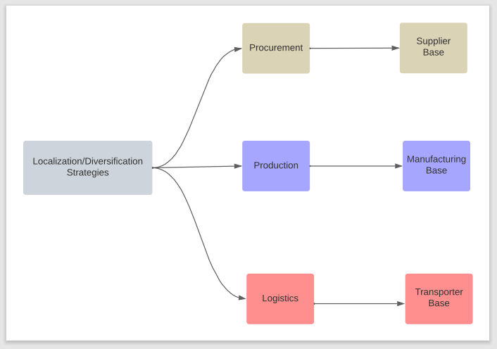
Fig. 2: Localization/Diversification strategies and BDA

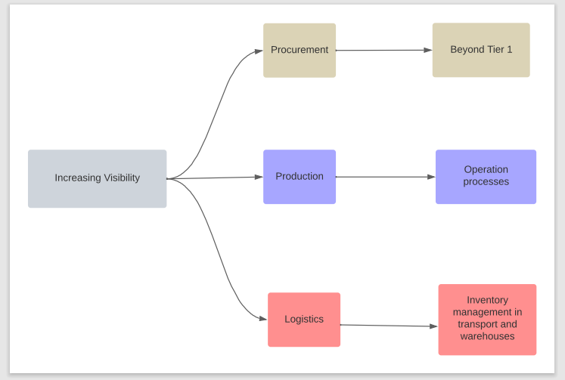
Fig. 3: Increasing Visibility and BDA
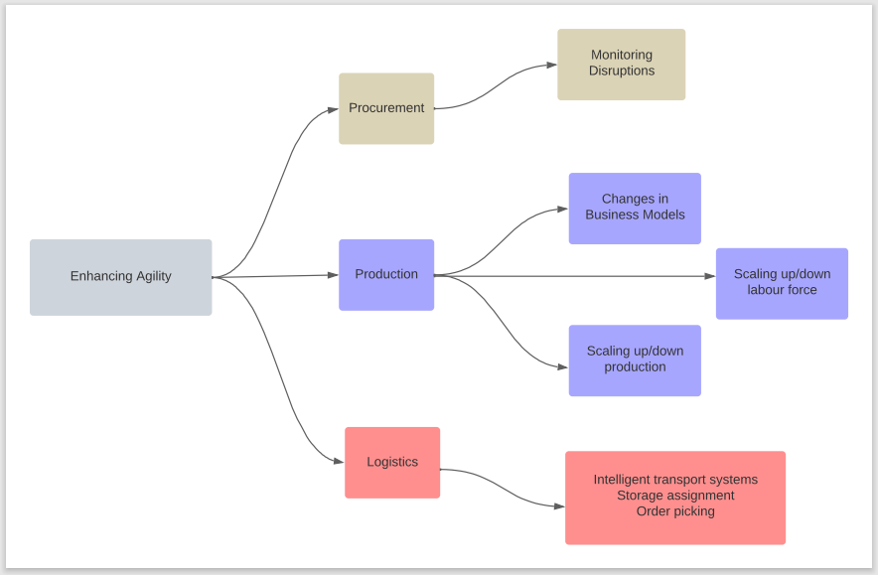
Fig. 4: Agility and BDA
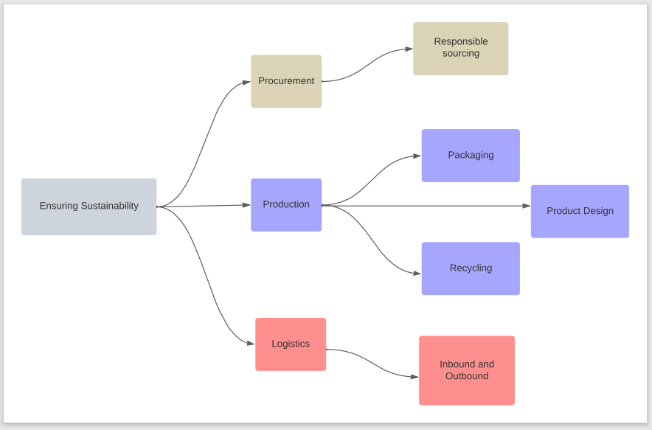
Fig. 5: Sustainability and BDA

APPENDIX B

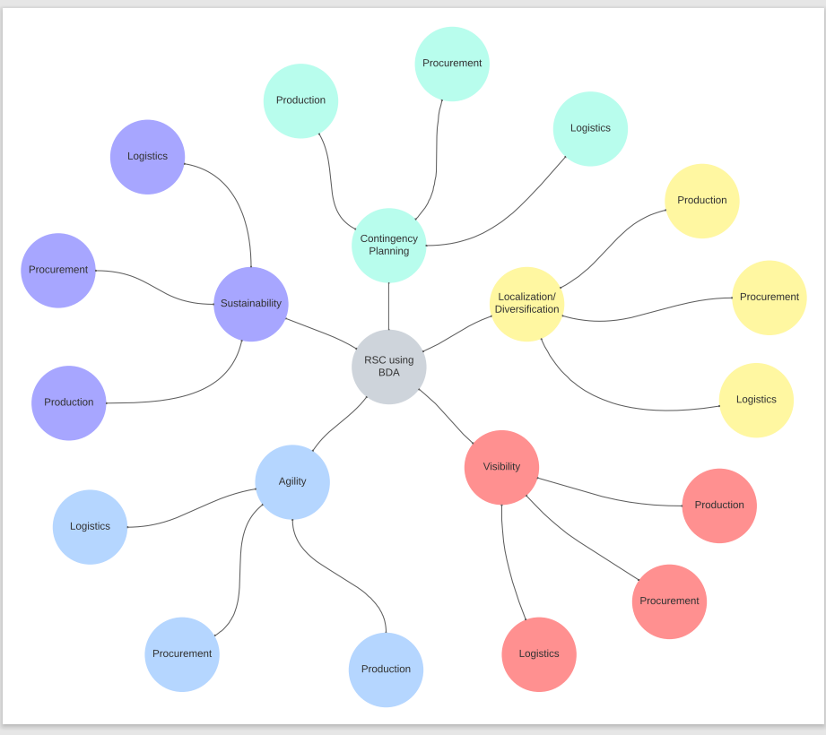
Building Resilient Supply Chains using Big Data Analytics

