Study of Climate Change Impact on the Global Food Supply

DaljeetKaur Husnara Khan
Department of Computer Science Department of Computer Science
Gyan Ganga College of Technology Gyan Ganga College of Technology
Jabalpur, M.P, India - 482002 Jabalpur, M.P, India - 482002
Email: daljeetkaurkalsi83@gmail.com Email: husnarakhn@gmail.com

ABSTRACT

As a result of its climate change, India is under pressure to cut back on GHG (Greenhouse Gas) emissions into the atmosphere. Although developing nations are anticipated to contribute an increasing share of future emissions, the industrialised world has the bulk of the burden for reducing greenhouse gas emissions. The impact would be especially severe in the tropical regions, which are primarily developed nations like India.I. The effects of greenhouse gas emissions on climate change are currently worsening than we could have predicted ten years ago. India, a developing nation, was unable to implement any strategies due to its focus on social and economic growth. In the western Liaoning Province, which is in the northern hemisphere, this research focuses on examining the energy resources and precipitation trends in the context of global warming over the past 60 years.

INTRODUCTION
Given that India is a subcontinent, the effects of climate change must be considered globally. Climate change poses problems for, among other things, food production, water supply, coastal communities, forest ecosystems, health, and energy security. Despite the fact that climate change is a global problem, we are facing pressure because of how seriously it affects us. India, a developing country, is now believed to be able to offer a worldwide answer to this issue. Lessening the impact of climate change on our planet is now required. India has the ability to provide substantial mitigation at an affordable price. This work captures and sh an additional risk to India. Even while conversations on decreasing GHGs among various industrialised nations have not led to the intended results, action is being taken to address the problem of climate change. India currently carries a sizable share of the responsibility for cutting GHG and CO2 emissions. The need to use green technologies across its industrialised nation is growing in India. Many environmentalists have volunteered their time to assist with the "Green Revolution" that is taking place in the industrialised world. They failed to secure the backing of their superiors or the Indian political system, therefore their attempts were ineffective. Climate change is influenced by natural variables, including variations in the world's temperature or human actions. production of food for humans. Climate change describes substantial, ongoing ares the implications and views on climate change from the Indian context. Climate change may be a threat climatic changes on a worldwide scale.
Climate change could disrupt progress towards a hunger-free world. A strong and consistent global pattern can be seen in the effects of climate change on crop productivity, which can affect food availability. The stability of healthy food systems can be threatened by short-term fluctuations in supply due to climate change. However, the potential impacts are less clear at the regional scale, but it is likely that climate change and change will worsen food security in areas that are currently vulnerable to hunger and malnutrition. It can also be assumed that the loss of drinking water availability and health risks can weaken the indirect spillover effects of food availability and use on household and individual incomes and food consumption. Evidence supports the need for significant investment in adaptation and mitigation efforts to create a “climate-smart food system” that is more resilient to the food security impacts of climate change.
Fighting hunger is one of the greatest challenges of our time Hunger has many dimensions and causes, from macronutrient and micronutrient deficiencies to short-term nutritional disorders and chronic deficiencies. The causes range from limitations in the adequate quantity and quality of food and lack of purchasing power to the complex interactions of nutrition with sanitation and infectious diseases that lead to poor health. Several of these causes have been addressed in recent decades, and significant progress has been made in reducing the proportion of the world's undernourished population from an estimated 980 million in 1990-1992 to approximately 850 million in 2010-2012 (2) . ). But other important nutritional indicators, such as underweight and short stature in children and health studies, about 2 billion people still suffer from micronutrient deficiencies.

In this study, we examine the anticipated impacts of climate change on the world's food supply under various scenarios for socioeconomic development in the future. expressed in terms of the population and income level that the Special Report on Emissions Scenarios (SRES) of the Intergovernmental Panel on Climate Change (IPCC) has defined. Different rates of population growth and economic development will have an impact on the degree of climate change in the future, as well as how agriculture adapts to changing climate conditions on a regional and global level. Understanding the nature of these complex systems is the study's main objective.

The agricultural sector will face numerous obstacles in the ensuing decades as a result of the expanding world population, land degradation, and loss of cropland due to urbanization. Although food production has been able to keep up with population growth on a global scale, there are significant regional deficits, and close to a billion people worldwide suffer from nutritional deficiencies caused by poverty. In this century, climate change is one factor that may have an impact on food availability and production in many regions of the world, especially those that are most vulnerable to famine and drought.

Here, we provide a summary of the evidence supporting the potential impact of climate change on global food security, with a focus on the world's less developed regions. We purposefully take a broad view of the intricate relationships that exist between global food security and climate change, expressing what we do know with some degree of confidence while also acknowledging areas where there is little to no evidence. We conclude by putting forth a number of guidelines for those deciding on practical or policy matters regarding the effects of climate change.

The sun, earth, oceans, wind, rain, snow, forests, deserts, savannas, and human activity all contribute to the overall climate of the world. For example, New York's climate can be characterised by its annual temperature variations, rainfall, and other factors. However, as depicted in figure 1, the global climate is more than just the "average" of the climates in various locations.

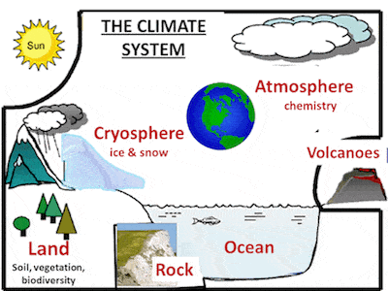
Figure-1:The Climate System

RELATED WORK

Over many centuries, ecosystems and human societies have adjusted to the rather constant Holocene climate conditions[1]. Agricultural techniques created for these conditions are the foundation of the majority of the food production[2]. There are indications that many significant crops all across the world are already being impacted by the recent, increasing global environmental change. [3] Frequently, the change shows up in a number of indicators. This also holds true for climate change, which is predicted to affect both aridity and patterns of rainfall and temperature. These crucial variables have a direct impact on society and the activities that support human life, such as maintaining food production and water availability.

Various studies have assessed the changes in agricultural conditions under climate change[4] by analyzing the changes in climatic conditions[5] and their potential impact on yields It would, however, be important to also understand which areas might experience a truly novel climate under which no major agriculture exists today, along the lines of safe operating space (SOS) and climate niche concepts for human societies.[6] SOS by definition2 refers to the Earth system conditions that would sustain human life as we know it. Although the planetary boundary framework includes an SOS for climate change.

Although the possible effects of climate change on current livestock systems around the world are a significant issue, the subject is only briefly touched upon in international publications like those written by the Intergovernmental Panel on Climate Change. In this paper, we examine the threat of climate-related effects along the food supply chain for land-based livestock. There is strong evidence that there will be impacts along the entire supply chain, from farm production to processing operations, , transport, retailing, storage and human consumption[7], even though a quantification of the net effects of climate change on the livestock sector is beyond the scope of our current understanding.

Food production affects climate change, and we also clarify the impact of climate change on food production. In order to provide such an overview, we consider the relationship between different parts of the food supply chain continuum (agricultural production, food processing, animal husbandry, food transportation and storage, food waste management,food retail,) and climate change. (Reciprocal) relationships were explored through bibliometrics. analysis [8].

The Food and Agriculture Organization (FAO) defines food security as: For an active and healthy life. ” This definition includes four key aspects of the food supply., Stability, Access, Availability, Utilization. The first dimension relates to the availability of sufficient food. H. On the overall capacity of agricultural systems to meet food demand. Its subdimensions include the agroclimatic basis of plant and pasture agriculture [9].

CASE STUDY OF Climate Change Impact on the Global Food Supply

According to the United Nations Food and Agriculture Organization, "Climate change is putting food safety at risk and action is needed to prepare the food system for the challenges ahead" (FAO). According to a recent report of FAO, "Climate change: Unpacking the burden on food safety," climate change is endangering the safety of food that is obtained from both land and the sea. The paper also describes how exposure to various food-borne dangers may rise globally.
This study concludes that climate change is directly impacting food through chemicals such as heavy metals, pesticides, mycotoxins and algae biotoxins. Microbiological hazards such as foodborne parasites and pathogens . Further, It is also expected with climate change, to reduce the nutrition value of staple foods by decreasing levels of micro and macro nutrients.
Malnutrition reduces immunity and makes people more susceptible to food-borne diseases; combined with the increased risk of exposure to food-borne risks brought on by climate change, this creates a dire situation that demands immediate worldwide attention. making a circumstance. He is an FAO food safety and quality specialist, and he stated that this is significant since hazardous food not only jeopardizes people's health and food security, but also threatens livelihoods, national economies, and international trade.
The climate has a significant influence on both agriculture and fishing. Carbon dioxide (CO2) and rising temperatures may boost harvests in some areas. The availability of water, soil moisture, nutritional levels, and other factors must also be satisfied in order to realize these advantages. Farmers and ranchers may face difficulties as a result of changes in the frequency and intensity of floods and droughts, which might jeopardize global food security. In the meanwhile, warming waters are changing the habitats of several fish and shellfish. and the ecology might fail. In general, climate change may make it more difficult to cultivate crops, rear animals, and fish in the same manner and locations. Together with other changing elements impacting agricultural productivity, the influence of climate change must be taken into account. A. Modifications to agricultural methods

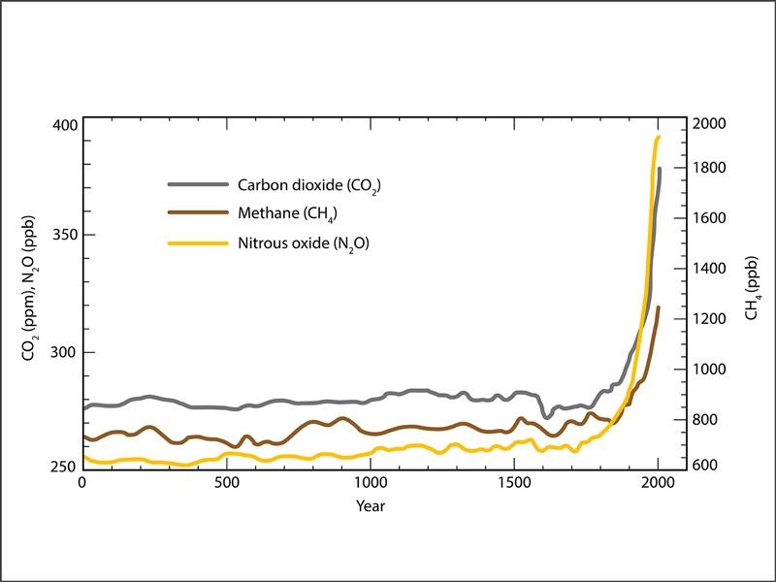

Figure 2: Climate change impact on crops

Climate change impact on Crops

The food supply in this country and throughout the world depends on crops cultivated in the United States. Almost 25% of all the grains (including wheat, maize, and rice) sold on the world market are produced by US farms. Crop yields may be significantly impacted by changes in temperature, atmospheric carbon dioxide (CO2), and the frequency and severity of extreme weather.
The impact of increased temperature on a given culture will vary depending on the temperature required for the culture's development and reproduction. Warming in certain areas could help the crops that are typically cultivated there or enable farmers to switch to crops that are now grown in warmer areas. Also, when temperatures rise above the crop's ideal range, yields are reduced.

Crop production can be impacted by elevated CO2 levels. Increased CO2 content has been demonstrated to improve plant growth in several lab trials. These potential production improvements, however, are hampered by other elements including temperature variations, ozone, and water and nutrient scarcity. If, for instance, temperatures are higher than what is ideal for the crop and there is inadequate water and nutrition available, yield gains may be diminished or even reversed. decreased quality is brought on by lower nitrogen levels. Low-quality grain and feed can make pastures and rangelands less suitable for supporting livestock grazing.Precipitation and extremely high temperatures inhibit plant development. Severe weather conditions, particularly droughts and floods, can harm crops and lower harvests. For instance, in the U.S. maize belt in 2010 and 2012, high evening temperatures had an effect on corn output.

In locations where the soil is dried up by hotter summer temperatures, coping with drought can be difficult. The water supply may be limited in certain areas, leaving less water available for irrigation when more is required, while in others it may be feasible to expand irrigation.
Warm, humid temperatures and high CO2 levels are favorable to the growth of many weeds, pests, and fungus. Now, American farmers spend more than $11 billion a year to eradicate weeds that rob crops of light, w nutrients and water. With climate change, it is anticipated that weeds and pests would spread and grow in size. Farmers who have never dealt with these species before may experience new crop issues as a result.

The development of plants is accelerated by increased CO2, but most crops lose some of their nutritious value. Most plant species, including wheat, soyabeans, and rice, experience a decrease in protein and vital minerals as a result of elevated atmospheric carbon dioxide levels. potentially endangers the health of people. Due to rising insect pressure and declining pesticide efficiency, growing pesticide usage also poses a hazard to human health.As shown in Figure 2 , impacts of climate change on crops.

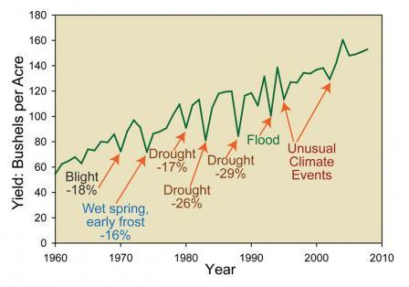
Figure 3: Impact of Climate change on crops

Impact of climate change on Livestock

More than 36 million tonnes of meat and poultry are consumed yearly in the United States. More than half of agricultural revenue in the United States, frequently in excess of $100 billion yearly, comes from livestock and poultry. Animals are impacted by climate change both directly and indirectly. Heat waves, which are anticipated to get worse due to climate change, might endanger animals. In 2011, a farmer lost more than $1 billion as a result of heat-related disasters. Animals are impacted by heat stress both directly and indirectly. Heat stress has the potential to decrease milk output, lower fertility, and increase illness susceptibility over time.
Droughts can pose a hazard to forage and grazing resources. The quantity of high-quality feed available to graze livestock is decreased by drought. Due to rising summer temperatures and less rainfall, certain regions may endure longer and more severe droughts. Drought-related changes in crop output can also cause issues for animals that depend on grains. The incidence of illnesses and parasites that affect cattle may rise as a result of climate change. Certain parasites and diseases may find it easier to survive in early spring and mild winters. Pathogens that depend on moisture can flourish in regions with heavy rainfall.
The usage of parasiticides and other animal health treatments to maintain the health of cattle may be increased as a result of changes in pests, parasites, and microorganisms brought on by the changing environment. This may have an effect on the security, distribution, and consumption of livestock and aquaculture products by raising the possibility that pesticides will enter the food chain or contributing to the emergence of pesticide resistance.Carbon dioxide (CO2) augmentation boosts pasture output but degrades pasture quality. The production of crops used to feed cattle can rise due to the increasing CO2 in the environment. However part of the fodder present in pastures deteriorates due to elevated CO2. Cows must thus consume more food in order to receive the same nutritional advantages.

Climate change is currently affecting food security in four ways
1. People with the lowest emissions suffer the most
Unprecedented droughts and floods are already being brought on by more severe weather conditions in emerging nations. A severe El Nio event this month alone poses a danger to Papua New Guinea's four million residents' access to water. One of the world's poorest nations is this one. In the United States, 83% of food is produced, therefore inclement weather may be terrible for food security.

2. Poor women bear the brunt of this suffering
Extreme weather conditions increase women's vulnerability to poverty since they are seen as owners of crops rather than land in many of the world's poorest nations. For instance, a flood may entirely destroy a crop but not the land on which it is grown, leaving the landowner even more penniless but maintaining his or her fortune. shall be
Moreover, women lack access to current climate knowledge. For instance, a woman managed the household finances when El Nio struck Peru in 2002, but only fishermen were informed since it would have an impact on seafood supply.

3. It affects the number of fish in the sea
A latest report by the United Nations Climate Commission found that extreme weather and sea conditions have reduced fish catches by 40-60% in some tropical regions.

4. Prices are rising, that tends to political instability

Food prices are already becoming more unpredictable globally due to decreased water availability brought on by climate change, as well as unpredictably occurring floods and droughts. With the increased expense of international shipping, many developing nations rely on importing food, which is particularly expensive.
Many have argued that recent political uprisings like the Arab Spring were caused by rising food costs. Political change isn't always negative, but there are hazards involved. Food price increases and the "collapse of democratic institutions" were found to be closely related in a research by the IMF that tracked food prices in the 1970s.
. The trend became worse, with the Food Policy Institute predicting that the price of certain foods such as maize and sorghum, staples of most sub-Saharan Africans, will rise by more than 100% by 2050. I'm assuming it's possible.

Impact of Climate, which affects food production now

Farmers and the wider populations who rely on them for food face several challenges as a result of climate change. Think about the impact of the following five main climatic changes on the supply of food both now and in the future, from irregular rainfall to seasonal shifts.
There might be more harsh weather occurrences that harm livestock and crops. Farms have traditionally suffered from powerful storms. This is either due to storm-related wind damage or landslides and erosion that may continue to develop even after the storm has passed. Yet they are now more prevalent than ever. For instance, in the Midwest of the United States in the spring of 2018, extremely strong rains and snowstorms created significant floods, burying some regions with almost 3m deep sand.
Farmers lost livestock worth an estimated $440 million in Nebraska alone. Several farmers have been forced to delay spring planting as a result of severe flood conditions. Farmers experience stress due to the delayed development of crops like maize and soybeans, which can also result in volatile food prices and even food insecurity.
The upkeep of crops and cattle is tough and expensive in the southern United States due to water limitations. In the western United States, a prolonged drought is anticipated because a lack of snow cover makes it more difficult to maintain reservoir levels over the summer. Lack of water may quickly ruin crops, dry up the soil, and endanger livelihoods. As an illustration, it is predicted that California lost $3.8 billion in direct economic activity between 2014 and 2016.

The seasons have changed from what they once were. In temperate areas, the growth season begins earlier and grows hotter. Theoretically, a prolonged growing season would have certain advantages over time, but it would also present greater challenges right now. B. Pest populations might grow, increasing the number of incidences each year. Early spring can also destroy fruit trees that sprout early and then experience spring frost. It can also lead plants to flourish before the soil has received adequate water and nutrients. Other agricultural techniques, such the storing of grain, may also be impacted by warmer winters.
A farm can be destroyed by a wildfire even if the flames never reach it. Because to the intensifying wildfire season, western ranchers have recently suffered significant losses, ranging from outright fatalities to burned pastures and diminished hay stands. However, there are several "second-order consequences," such as the smokey smell that taints wine and the difficulties of maintaining a farm while surrounding fires are raging and evacuation orders are about to be issued. They all result in increased costs. Farms may be obliged to send workers home during the busiest harvest season since working in a hot, smoke-filled atmosphere is hazardous to respiratory health.
Increased CO2 levels and warmer temperatures have an influence on food availability, safety, and quality. 25–30% of the food produced globally is wasted, although not all for the same causes, according to the 2019 IPCC Land Use Report. For instance, even if it occasionally appears abandoned, customers in industrialized nations often just toss away food that they perceive to be "surplus" or "extra". Lack of refrigeration facilities in poor nations contributes significantly to waste since goods degrade between producers and consumers. According to an IPCC analysis, food waste costs around $1 trillion yearly and is responsible for 10% of the food system's greenhouse gas emissions. Over 1 billion people globally are now undernourished, while roughly 2 billion are overweight or obese, underlining the inefficiencies and injustices of current systems.

Factors-The sensitivity and vulnerability of food production systems to climate change varies by area.

Level of exposure, adaptation, and resilience, as well as geographic location, are two characteristics that affect how vulnerable and susceptible food production systems are to climate change in various places. Large losses and damages as a result of climatic shocks frequently result in disaster.

Lower degrees of adaptation make areas more vulnerable to the effects of the climate. Increasing resilience can open up more space for flexible food systems and chances to mitigate the effects of climate change. For instance, the use of seeds that are resistant to drought and flooding, better water management techniques, and advancements in postharvest technology (better drying and storage infrastructure) can significantly reduce rice losses in Southeast Asia, offsetting the decline in yields brought on by climate change. The limitations of adaptability are established by biological variables like crop heat tolerance. The 2030, 2050, and 2080/2100 climate scenarios are used to describe future climatic patterns. Based on worldwide patterns in greenhouse gas emissions and climate sensitivity, the time periods enable one to evaluate climatic consequences throughout time.
For the world's present livestock systems, climate change is a big threat. Animal health, production, and feed and water supplies are all impacted by global warming and the concomitant changes in average climatic factors. The effects of climate change on the supply chain for animal feed are depicted in Figure 3. The linkages between actual climatic systems, exposures, and vulnerabilities that endanger cattle supply networks are depicted schematically in this diagram.

The connection between vulnerability, exposure, and the actual climate system. In order to create the risk of climate-related consequences, climate-related hazards, such as hazardous occurrences and trends, interact with people's sensitivity and exposure as well as the vulnerability and exposure of natural systems. Although shifting risk patterns also play a part, socioeconomic trends and societal factors have a significant impact on determining vulnerability and exposure. Changes in the climatic system as well as in the socioeconomic processes (right), which are depicted on the left and right, respectively, are the fundamental forces behind the numerous crucial components (vulnerability, exposure, and hazards) that make up risk.

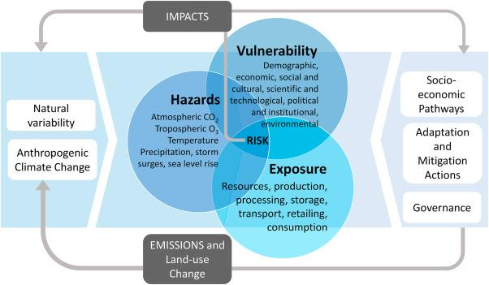

Figure 4- schematic of the interaction among the physical climate system

Crop yield change estimates
Uncertainty comes from a variety of factors when estimating yield changes. At the site level, the use of crop models to estimate yield functions is a significant source of uncertainty. There are numerous simplifications built into the crop model. For instance, it is thought that pests, illnesses, and weeds are managed. absence of troublesome soil issues (such as salinity or acidity). Deposition of acid's negative effects and how this impacts yield levels have not been studied. A significant research problem continues to be the challenging and unclear assessment of the direct impacts of CO2 on agricultural crops. Although the plant model can replicate the impacts of drought, it cannot simulate the effects of flooding (Rosenzweig et al., 1999). Features may not accurately reflect the diversity of agricultural systems within similar regions when seen at a regional level.

The ability of agricultural production systems to adapt to climate change will be increased by understanding the interaction between climate and crops. To this goal, numerous studies that analyse how culture reacts to environmental conditions have been conducted, stressing also decades and climatic shifts. Climate variability, 1, 2, 3, climatic extremes, 5, 6, 7, vapour pressure hands, 8, and atmospheric CO2 concentration. Negatively, crop productivity has been impacted by extreme weather occurrences like drought, which have been trending upward 11, 12, and 13. 6, 1 . Key information for early warning and mitigation is intended to be provided through the Drought Monitoring and Prediction System. strategies. increases agricultural output and tolerance to drought15,16,17. Adaptive actions, such as shifting planting dates, switching to an existing crop type, and creating new varieties, are also taken.

Impacts on Food Production and Availability

The impact of climate change on agriculture and food production will be extensive. It influences the demand for agricultural products indirectly through effects on growth and income distribution as well as directly through changes in agroecological conditions, which directly affect food production. Many studies have quantified effects under various assumptions (3). In quantifying impacts on food security, a selection of these results are shown. Below, a summary of the most significant agroecological environment changes caused by climate change is helpful.

Impact Continued greenhouse gas emissions will cause changes in temperature and precipitation, which will affect the suitability of the land and crop output. Namely, the Special Reports on Emission Scenarios (SRES) A2, B2, A1, and B1 families of emission scenarios linked to socioeconomic development have been discovered by the Intergovernmental Panel on Climate Change (IPCC) (4). I'm thinking about. Business as usual scenario A1 relates to the greatest emissions in the context of this review, while SRES scenario B1 corresponds to the lowest emissions. There are other possibilities between these two. SRES A2 assumes the highest projected population increase of the four (UN high projection), which is significant for agriculture and world nutrition because it is linked to the biggest food demand. Based on the possibilities for SRES emissions and the
. Area A longer growing season, better soil quality, and perhaps a larger crop yield. In some moist temperate grasslands, moderate progressive warming could boost grazing output and lessen the requirement for housing and complex feeds. The increased frequency of extreme events cancels out these improvements. B. An increase in heat waves, droughts, and floods in temperate zones or in the Mediterranean region. This may lead to a rise in coastal storms (6). Additionally, they must be compared to the likelihood that semi-arid and dry pastures may lower livestock productivity and raise animal mortality (3). Climate models project higher evapotranspiration and lower soil moisture in dry places (5, 8). As a result, some agricultural areas and other tropical grasslands may become less productive.

Severe weather events including, droughts, hailstorms, hurricanes and floods are anticipated to increase in frequency and severity, and global and regional weather patterns are anticipated to become more unpredictable than they are now (3, 8). Large variations in crop yields and local food supplies, as well as an increase in the risk of landslides and erosion damage, can have an impact on the stability and security of the food supply.
Impacts of Climate Change on Food Utilization.

By affecting food safety conditions and disease pressures from vectors, waterborne, and foodborne pathogens, climate change will also have an impact on people's ability to consume food successfully. In Chapter 8 of its Fourth Assessment Report, IPPC Working Group II gives a thorough overview of the effects of climate change on health (3). We investigate the potential expansion or contraction of many diseases, particularly vector-borne illnesses like malaria, in response to climatic change. This article focuses on a small number of illnesses that have a direct impact on food safety. H. Waterborne and Foodborne Infections.

The vicious cycle of infectious diseases generating and intensifying hunger, making affected populations more susceptible to infectious diseases, is a key problem in the context of climate change and food security. As a result, there may be a large decline in labour productivity, which would increase mortality and poverty. There is mounting evidence that the effects of climate change on food and nutrition security are also having an impact on disease pressures. This includes droughts, rising temperatures, and heavy rains. Here I am.
Impacts of Climate Change on Access to Food.
The ability of people, communities, and nations to receive food in an adequate amount and quality is referred to as access to food. Falling real food prices and rising real incomes over the past three decades have significantly increased access to food in many developing nations. More individuals are consuming nutrient-dense foods with higher levels of protein, micronutrients, and vitamins in addition to basic foodstuffs as a result of rising purchasing power. East Asia, as well as the Middle East and North Africa to a lesser amount It has benefited especially from a mix of declining real food prices and rapid income growth. According to the FAO Malnutrition Index, between 1970 and 2001, the rates of hunger in these regions declined from 24% to 10.1% and from 44% to 10.2%, respectively. It was endogenous income growth in East Asia.
Global food insecurity has increased, and a big part of the reason lies with climate change. Global warming is creating heat waves, torrential rain, and droughts, which is altering the weather. A further 30 million individuals in low-income nations would experience food insecurity in 2021 as a result of increased food commodity prices. However, a substantial percentage of the problem is caused by the way food is normally produced in the modern world. Only the energy sector is believed to be responsible for more greenhouse gas emissions than the global food system, which is also the primary source of methane and biodiversity loss.
Only a few of the numerous interrelated models that make up macro models include economic, agricultural, and climate models. The results of this approach to the

Impacts on Food Prices.
In essence, all SRES development pathways indicate a world with rapid economic development and a long-term reduction in the importance of agriculture, maintaining decades-old patterns in many emerging countries. Here I am. According to the SRES scenario, as global incomes rise, the majority of people will be able to find solutions to problems related to food security and stability while also addressing potential production gaps locally through imports. is rendering The share of income spent on food should decrease in a society where real earnings are rising faster than food prices, yet even in this world, when food prices are high, a significant portion of the marginalised poor's expenses still go towards food. Likely to have little effect. Yet not all parts of the world are equal.

Secondly, food prices are expected to rise on average somewhat if temperatures rise significantly (by 2050). By 2050, real prices may even slightly drop, according to some analyses. Second, when temperatures continue to climb after 2050, prices are anticipated to increase much more dramatically. Price increases of up to 80% are predicted by some research and certain commodities (such as sugar and rice). without taking into account climate change. Third, the predicted price increases brought on by the effects of global warming are often much smaller than those brought on by socioeconomic trends. For instance, the SRES A2 scenario predicts an increase in real grain prices of nearly 170%. According to Hadley Center Coupled Model, Version 3, Climate Change Case, the (extra) price rise caused by climate change is just 14.4%. Overall, it seems like

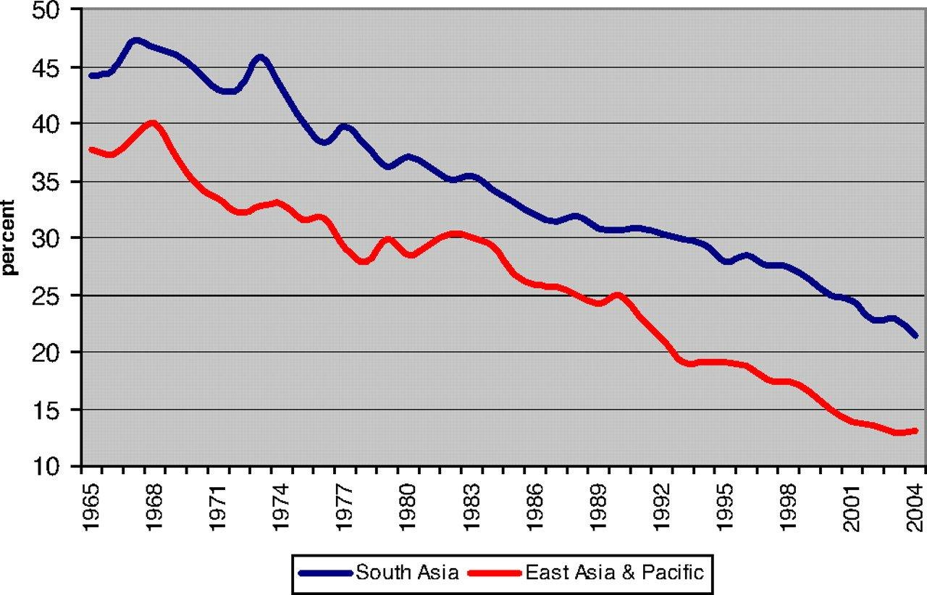

Figure-5 Schematic graphical representation of climate change impact with year by year

The consequences of climate change on food security have lately been quantified in a number of studies. These studies employ the IIASA-Basic Linked System (BLS) economic model to analyse economic implications and are based on either the AEZ tools created by the IIASA analysis or the Decision Support System for Agrotechnology Transfer suite of crop models for calculating agronomic yield change projections. Others have utilised these techniques to conduct comparable assessments and give sensitivity analyses across a variety of SRES and general circulation model (GCM) projections, with some tweaks to how crop yield changes are simulated. The impacts of climate change have also been studied in numerous additional simulations, both with and without adaptation (induced technological progress, domestic policy change, international trade liberalization, etc.), provide impact analyses for various rates of climate change, both with and without mitigation (e.g., CO2 stabilisation, variations for temperature, rainfall change, and distribution). The quantitative results for food security are the main focus of this part, which aims to highlight some of the discrepancies and glean the key takeaways from the numerous research. All simulation results presented below, unless otherwise noted, take into account the combined effects of climate change and rising CO2 emissions to crops.
Uncertainties and Limitations
It is not recommended to take the findings, at least not solely as probabilistic projections, that socioeconomic growth pathways are predicted to have significant implications for future food security and beyond the effects of climate change. This is due to the fact that SRES scenarios offer numerous potential outcomes "without any sense of likelihood." The SRES scenarios, like all scenarios, are unable to fully account for how the economy, emissions, and climate will develop in the future.

Second, the substantial effects of climate change on food security and vulnerability have not been quantified in current worldwide evaluations of climate change and food security, which has reduced food availability (stability). could only concentrate on the effect on access and sex. This means that the prevalence of foodborne infections and additional effects from extreme occurrences like droughts and floods (for similar concerns) are not taken into account in these analyses. The possible effects of rate alterations have not been quantified (both positive and negative). Or the interaction between changes in the incidence of vector-borne illnesses like malaria and affects on nutrition and health, as well as the potential effects of sea-level rise on agricultural production or marine life on food availability. We also disregard impacts.

Despite the very real uncertainties in current knowledge and future trends, policymakers and practitioners facing the prospect of climate change impacts on food security are still making decisions. not down. For decision makers, we propose six principles regarding the impact of climate change on food security, placing a reasonable level of confidence in the evidence.
1) Climate change impacts on food security are worst in countries already suffering from high levels of hunger and will worsen over time.
2) Actions to address global malnutrition and climate change The malnutrition impact of not taking
3) Food inequalities will increase, from local to global levels, because the degree of climate change and the extent of its effects on people will differ from one part of the world to another, from one community to the next, and between rural and urban areas.
4) People and communities who are vulnerable to the effects of extreme weather now will become more vulnerable in the future and less resilient to climate shocks.
5) There is a commitment to climate change in the next 20-30 years as a result of past greenhouse gas emissions, and the need for immediate adaptation action to address global food insecurity over the next 20-30 years.
6) Extreme weather is likely to occur more frequently in the future, increasing risk and uncertainty in the global food system. .
All of these precepts support the need for considerable investment in adaptation and mitigation actions to prevent the impacts of climate change from slowing progress in eradicating global hunger and undernutrition. A wide range of potential adaptation and resilience options exist and more are being developed. These need to address food security in its broadest sense and to be integrated into the development of agriculture worldwide. Building agricultural resilience, or “climate-smart agriculture,” through improvements in technology and management systems is a key part of this, but will not be sufficient on its own to achieve global food security. The whole food system needs to adjust to climate change, with strong attention also to trade, stocks, and to nutrition and social policy options. We need to work toward what could be termed a climatesmartfood system that addresses climate change impacts on all dimensions of food security.
Conclusions
Climate change will affect all four dimensions of food security: food availability (production and trade), food access, food security and food use. The importance of various aspects and the overall impact of climate change on food security varies by region and over time, mainly due to the overall depends on your socioeconomic status.
Essentially all quantitative assessments show that climate change affects food security. Climate change will increase the dependence of developing countries on imports and reinforce the existing focus of food insecurity in sub-Saharan Africa and, to a lesser extent, South Asia. In developing countries, the adverse impacts of climate change will disproportionately hit the poor. A number of quantitative assessments also indicate that the socioeconomic environment in which climate change is expected to occur is more important than the expected impacts from biophysical changes of climate change.

References

[1] Scheffer, M., Carpenter, S., Foley, J.A., Folke, C., and Walker, B. (2001). Catastrophic shifts in ecosystems. Nature 413, 591–596.
[2] . Rockstro¨ m, J., Steffen, W., Noone, K., Persson, A., Chapin, F.S., Lambin, E.F., Lenton, T.M., Scheffer, M., Folke, C., Schellnhuber, H.J., et al. (2009). A safe operating space for humanity. Nature 461, 472–475.
[3] Smith, B.D., and Zeder, M.A. (2013). The onset of the Anthropocene. Anthropocene 4, 8–13.
[4] Ramankutty, N., Foley, J.A., Norman, J., and mcsweeney, K. (2002). The global distribution of cultivable lands: current patterns and sensitivity to possible climate change. Glob. Ecol. Biogeogr. 11, 377–392.
[5] Zabel, F., Putzenlechner, B., and Mauser, W. (2014). Global agricultural land resources – a high resolution suitability evaluation and its perspectives until 2100 under climate change conditions. PLoS One 9, e107522.
[6] Xu, C., Kohler, T.A., Lenton, T.M., Svenning, J.-C., and Scheffer, M. (2020). Future of the human climate niche. Proc. Natl. Acad. Sci. U S A 117, 11350–11355.
[7] Impacts of climate change on the livestock food supply chain; a review of the evidence,ScienceDirect- Volume 28, March 2021, 100488.
[8] An overview of the interactions between food production and climate change, Science Direct, Volume 838, Part 3, 10 September 2022, 156438.

