NUTRITIONAL TRANSITION AND POOR FOOD PREFERENCES

AMONG YOUNGER GENERATION: A FORERUNNER

TO CHRONIC DISEASES

N GEETHA,

Department of Zoology (PG)

PSG College of Arts & Science

Coimbatore – 641014

[geethsen@gmail.com](mailto:geethsen@gmail.com)

ABSTRACT

Food being the primary source of energy and health, incorporating good eating practices in people is mandatory for which it is essential to assess the existing eating habits, dietary beliefs and food preferences. Hence the present investigation was aimed to analyze the lifestyle, eating preferences among younger generation and their basic knowledge about the food they consume. Online Questionnaire administered via google form to 100 participants reveals that dietary habits and diseases are intertwined. Late night snacking and recurrent outside dining can potentially make them susceptible to infectious disease due to lack of dietary micro and macro nutrients. Besides, visiting fancy restaurants are often correlated with high social status which squeezes more people into food trends. Interestingly, when we compare the gender and eating habits, females are more health conscious than males.

Keywords—Dietary habit; physical activty; eating disorder;depression

1. **INTRODUCTION**

Besides globalization and dietary changes, increased fast food chains and easy accessibility has elevated the availability of processed meal products (Hawkes, 2006). Socio economic status and lifestyle changes accompanied with increased consumption of simple sugars and saturated fats from animal fats are the major contributors for the development of diabetes, obesity and it becomes extremely essential to incorporate healthy eating habits in the population. The prevalence of obesity has increased many folds in most Asian countries (Kim and Lee, 2009). Unfortunately, India has reported the highest number of people with diabetes (Ramachandran and Snegalatha,2010). Not only the lifestyle changes but also our emotions have an impact on our eating habits. Emotions like anger, fear, sadness, anxiety, and joy are found to have an influence on the eating speed, food choices, food preference, amount of food ingested in addition to metabolism and digestion (Blair et al., 1991). Emotions can increase the food consumption in restrained eaters while it can decrease the consumption rate in non-restrained eaters but different emotions can have diversified effect on food intake. For example: weariness may be related to increased appetite while sadness may be related to decreased appetite. Depressive episodes and poor lifestyle habits can lead to metabolic syndromes.

The key to promote and maintain optimal health is to consume different combination of nutrient rich food with low energy density profile (Yiheng Chen, et.al.,2018). An individual with impaired nutritional status is highly susceptible to various infections and on the other hand recurrent infections can increase the risk of malnutrition by causing eating disorder such as anorexia (Katona and Judit, 2008). There is a close link between diseases and dietary habits. These days viral infections are the major cause of mortality but the impacts of the infections can be reduced by building a strong immunity with the help of proper nutrition which includes vitamins, omega 3 fatty acids and other trace elements. Thus, a well-balanced diet with adequate level of micronutrients and other essential elements can account for proper development and expression of immune response (Argentiero et al., 2020).

NFCS (National food consumption surveys) are essential in recognising nutrient inadequacies at population level and evaluating the risk of hazardous substances in developing dietary habits ( Ahluwalia et al., 2016). There are many studies and surveys explaining the healthy eating patterns, only a few randomized trials and underpowered studies are made about eating habits, mental health, and lifestyle in India. Despite the fact that India stands as one of the first growing country to apprehend the want to cope with intellectual fitness with its National Mental Health Program (NMHP) being released in 1982, the real implementation and improvement took other 14 years to be initiated (Patel *et al*.,2011). There is a need for understanding the possible relationship between lifestyle changes, dietary choices and their effects on young people's physical and mental wellbeing. Hence the present study was focused on the comparative analysis of eating habits, dietary knowledge and mental health status among younger generation.

1. **MATERIAL AND METHODS**

**Study design and subjects:**

The online survey was conducted during the month of February and March in the year 2021.The sample size is 100 comprising of 38% males and 62% females. The participants were mostly students. Contribution to the survey is voluntary and used for education purpose only. The Google form was actively circulated and was made available for about 8 weeks for receiving the responses. Participants were assured that the data collected would be confidential.

**Collection of data:**

The online questionnaire consists of 31 questions related to participant’s demographics, dietary habits, physical activity, mental status and body shape. The questionnaire was not sectioned itself but it can be divided into different parts to ease the analysis. Each part serves a unique purpose supporting the survey. Data regarding socioeconomic status or familial history of depression was not collected.

**Part – I: Demographics**

Under the demographics, the participants were enquired regarding their age, gender, occupation and other personal information.

**Part – II: Consumption frequency of preferred foods**

Questions are targeted to find the subject’s preferred food and their frequency of consumption. It enquires preferred meat/fruits/vegetables. Information related to frequency of meat/fruits/vegetables consumption is also obtained. The data obtained was used to examine the contribution of food habits to the occurrence of depression.

**Part – III: Dietary habits and Physical activity**

Questions analyzing the subject’s dietary habit includes the number of meals per day, eating pace, number of times they snack in-between the meals, late night snacking, daily consumption rate of liquids like water, juice, tea/coffee, alcohol and energy drinks. Questions related to their smoking habits and physical activity level helped for qualitative analysis of their lifestyle and activeness.

**Part – IV: Dietary beliefs and knowledge**

The dependency on vitamin supplements and the prevalence of long-lost Indian food items in the participant’s diet chart was assessed. Their insights on dairy products were also collected.

**STATISTICAL ANALYSIS:**

All the analyses were made using Statistical Package for Social Sciences (SPSS version 25). Chi-square test was performed to analyse qualitative variables (Manji Darooghegi et al., 2022). Pie, Bar and Column charts were used as a diagrammatic representation of the data.

1. **RESULTS**

The participants were asked to complete the circulated questionnaire. The participants ranged in age from 19.0 to 30.0 years of age with the mean age of 22.26. Majority of the participants are students.

|  |  |  |  |
| --- | --- | --- | --- |
| Variable | Division | Study sample | Percentage |
| Gender | Male | 38 | 38% |
| Female | 62 | 62% |
| Age | Under 22 | 70 | 70% |
| Above 22 | 30 | 30% |

Table 1: Gender and age of the studied population.

**Meal and snacking pattern:**

Of 100 respondents, 69% of the participants reported to have three meals a day ; 22% of the respondents opted for two meals a day; 8% responded that they have only one meal a day and 1% of the participants reported to have either two or three meals a day. Figure 1 represents the meal skipping activity in the study sample: Those in the study sample reported skipping meals: 36% of the study population reports skipping breakfast occasionally. Surprisingly, 53% of the survey sample has a signed meal plan; 45% of the sample personally organise their meals; and 2% of the sample ask a nutritionist or online tool for assistance in creating their meal pattern. Snacking between the meals can be a part of the routine or the outcome of boredom. 55% of the respondents report that they snack only once between their meal ; 30% of the study population reported to snack two times between their meals while 15% of the sample have a habit of snacking more than two times between their meals. Fig.2 represents the late night snacking which is practiced by 23% of the study population.



Fig.1: Meal skipping activity observed in study sample.

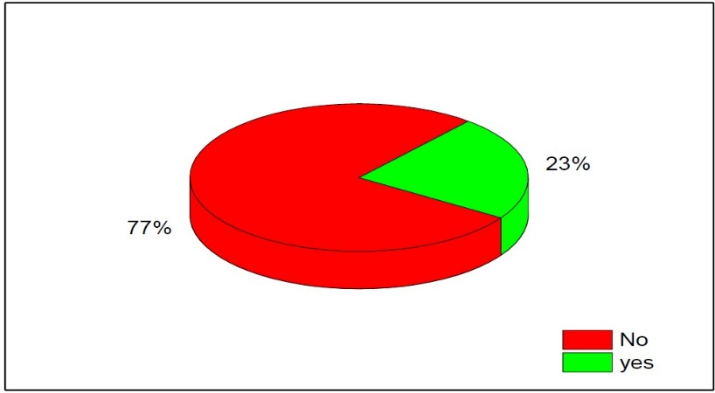

Fig.2: Late night snacking habit

**Eating pattern and pace:**

Participants were enquired about how often they eat and their eating speed. Participants were allowed to choose more than one occasion they would eat and from figure 3 it is evident that emotions do have an influence of eating pattern. Figure 4 depicts the eating speed in the study population. It reveals that 15% of the participants address themselves as fast-eaters while 15% of the participants are slow-eaters and the remaining 70% reported that they are neither fast nor slow.



Fig.3 : Eating occasions among the respondents

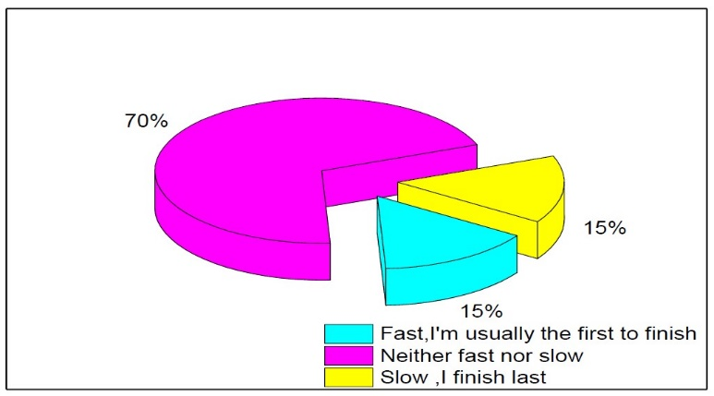

Fig.4: Eating pace in the study population

**Eating disorder, smoking status and alcohol\soda\energy drinks:**

Only 7% of the study population claims that they have eating disorder. Figure 5 expresses the smoking status of the study sample. Favorably, it states that 91% of the participants do not smoke and the data obtained declares that 89% of the participants do not drink alcohol and 82% of the participants do not consume soda\energy drinks assuring that most of the individuals are not related to addictive substances.

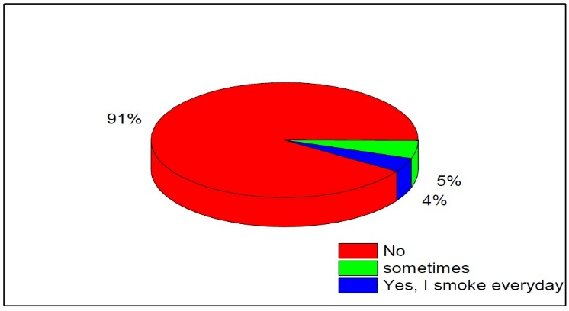

Fig.5: Smoking status recorded in the study

**Consumption frequency of meat and preferred meat:**

Table 2 and figure 6 posits the data on preferred meat. It reveals that 64 participants have included white meat in their diet; 29 of them have included red meat and 50 individuals have included sea food in their diet. Notably, 6 % of the participants reported that they eat meat every day; 36 % eat meat one to three times a week and 6% of them eat meat four to six times a week.

Table-2 The preferred meat of the respondents, excluding the participants who do not eat meat.

|  |  |
| --- | --- |
| **Most preferred meat (only if your diet includes meat )** | **Number of**  **individuals** |
| Red meat (beef , pork ) | 1 |
| Red meat (beef, pork ), white meat (chicken ) | 1 |
| Red meat (beef, pork ), white meat (chicken ), seafood (fish ,crab ,lobster) | 2 |
| Red meat (beef, pork ), white meat (chicken ), seafood (fish ,crab ,lobster),  Mutton | 1 |
| Red meat (beef , pork , goat ) | 5 |
| Red meat (beef ,pork ,goat ), seafood (fish ,crab ,lobster) | 3 |
| Red meat (beef , pork , goat ), white meat (chicken ) | 6 |
| Red meat (beef , pork ,goat ), white meat (chicken ), seafood (fish ,crab  ,lobster) | 10 |
| seafood (fish ,crab ,lobster) | 18 |
| white meat (chicken ) | 28 |
| white meat (chicken ), seafood (fish ,crab ,lobster) | 16 |

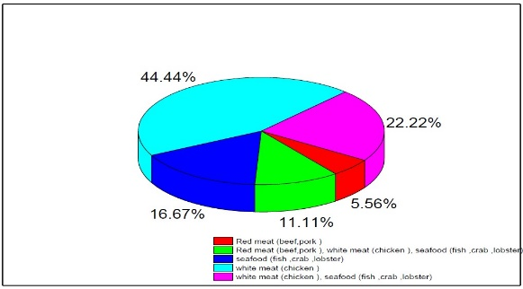

Fig.6 Portrayal of preferred meat by the participants

**Depression and Physical activity:**

Figure 7 depicts the occurrence rate of depression as reported by the respondents. It shows that 42 % of the respondents declare that they experience depression once in a while; 45% of the respondents affirm that they occasionally experience depression while 13 % of the participants claim that they never experience depression. Figure 8 expresses the level of activeness in the study population. It displays that 20 % of the participants define themselves to be highly active; 76% are moderately active and 4% are inactive.

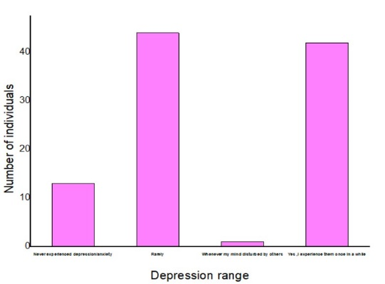



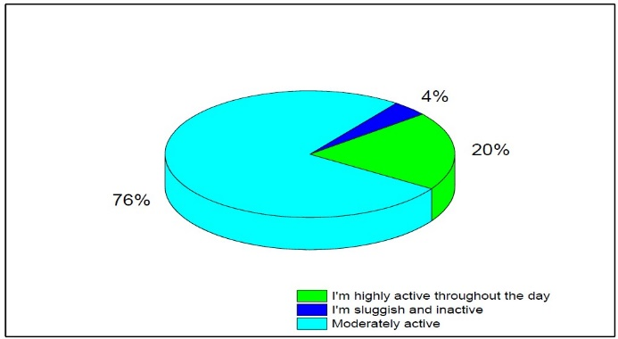

Fig.8: Physical activity

**Frequency of outside dining (female versus male):**

Health enthusiast tend to avoid restaurant foods and so a comparison of consumption frequency of restaurant foods between the male and female will bring out differences in their dietary choices. Figure 9 flaunts the frequency of visits to restaurants. It is transparent that most male participants usually eat at restaurants much frequently.

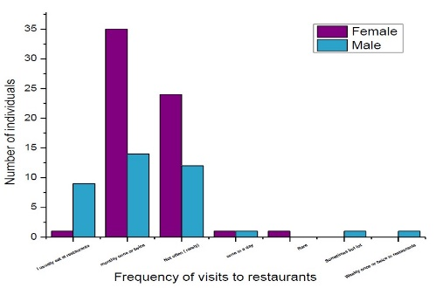

Fig.9: Comparison of outside dining that persists in male and female.

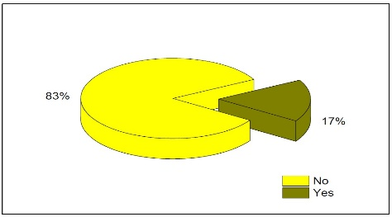

Fig.10: Penetrance of vitamin supplementation in the study population

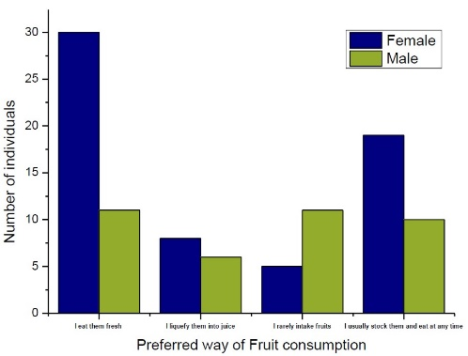

Fig.11: Comparison of fruit consumption activity that exists in study population

1. **DISCUSSION**

Over the past 50 years, a considerable increase in the number of studies examining the relationship between food and health has been observed (Mozaffarian et al., 2018), but the understanding and transparency about the relationship between food and health is questionable (Zulfiqar, et al., 2018).Food is vital to way of life and identity, which ends up in strongly held preferences, beliefs and biases (Zulfiqar, et al., 2018). Food habits has the power to make life better or bitter. Micronutrient deficiencies in India are due to poverty, under-nutrition and poor dietary quality. Environmental as well as internal human influences might have an impact on eating habits. (Worsley, 2002).

**Meal and snacking pattern:**

The timing and frequency of meal has an influence on overall health (Paoli et al., 2019). Recent research has found that a high meal frequency (6 meals per day) is much more associated with disease and risk factors than a low meal frequency. (Paoli et al., 2019). A balanced diet should consist of a high-energy breakfast, fewer meals throughout the day (2–3), and regular fasting periods (Bianco et al., 2019). Consumption of more than 3 meals a day (snacking) is associated with increase in body mass index. However breakfast skipping is not promoted. Figure 1 highlights the Breakfast skipping activity in some individuals of our study population which may be due to the hectic and chaotic lifestyle, unawareness of the importance of first meal and also due to financial hardship.

Breakfast is termed as the important meal of the day but many people tend to skip their breakfast. Megan witbracht et al., (2015) conducted a survey linking the breakfast skipping activity with the stress and cardio metabolic health among 30 women who skips breakfast and 35 women who are breakfast eaters. Salivary free cortisol levels were assessed upon waking, at bedtime, and after a typical lunch, and the results show that regular skipping of breakfast is linked to higher levels of circulating cortisol, which causes stress. In some people, prolonged breakfast skipping may also increase their risk of cardio metabolic disease. Individuals who skip breakfast tend to eat large meals in afternoon and at night leading to abnormal glucose fluctuations that is reported in breakfast skippers. The frequency and timing of food intake is internally regulated by circadian rhythm and asynchronous food consumption such as frequent snacking habit can lead to adverse effects like obesity (Bellisle,2014).

**Eating pace:**

Some people generally gobble up before their busy schedule as reported by our study sample ( figure 4). Fast eating pace is correlated with elevated risk of metabolic syndrome (Miyaji et al., 2020), cardiovascular disease and obesity. Irrespective of total energy intake and reducing the eating speed can decrease the chances of metabolic syndrome (Miyaji et al., 2020). Despite the developing popularity for competitive speed eating, it is a self-destructive behavior which can lead to morbid obesity, nausea, vomiting and even the need for gastrectomy. Fast eating can prevent the initial breakdown process by salivary enzymes which disrupts the whole process of digestion.

**Eating disorder:**

Eating disorders as reported by our study population can be defined as severe psychiatric illness in which individuals develop intense thoughts about their body weight and shape (Treasure et al., 2020). Eating disorders are defined as abnormal eating behavior which includes symptoms such as restricted food intake or excessive food intake along with magnified thoughts about food quality or quantity. Eating disorder when left untreated can lead to psychosocial morbidity. Functional abnormalities in specific regions of brain are reported in individuals with eating disorder. Studies reveal that eating disorder alter the hormonal balance which is responsible for the characteristic symptoms such as restricted eating, binge eating and depressive moods. In women with eating disorder, disruptions in ovarian hormones are a major contributor for the condition (Culbert et al., 2016).

**Smoking and alcoholism:**

Smoking and alcohol consumption affects health in many ways. The combination of smoking and alcohol consumption seen in people is said to have effects on oxidant/antioxidant pathways and on metabolic pathways. Smoking is a significant contributor to oxidative stress, which is thought to play a role in the development of chronic diseases like cancer, chronic obstructive pulmonary disease, and heart disease. (Tapiero et al., 2004). Some individuals of our study population have reported smoking habit (Figure 5) which may be due to stressful lifestyle or nicotine addiction.

Smoking is associated with oxidative modification of low-density lipoproteins which can lead to initiation and development of coronary atherosclerosis. Smoking is capable of oxidative degradation of carotenoids which has a major member in clearing the reactive oxygen species and the oxidized products of carotenoids can promote carcinogenesis by inducing DNA damage. Indulge in alcohol consumption are reported to reduce humoral and cellular immunity (Tapiero et al., 2004), decrease the expression of major histocompatibility complex class I (MHC-1) and also the synthesis of antibody. Alcohol consumption also results in excessive urination due to the disruption in the levels of vasopressin causing dehydration and excessive thirst.

**Meat consumption versus fruit and vegetable consumption:**

Meat consumption is predominantly seen in the study population. Mental disorders are becoming more prevalent in the population. So, the correlation between dietary choices and their outcomes are elaborately studied. Red meat is irreplaceable but most controversial food in nutrition history. It does contain essential level of proteins and minerals such as zinc and iron but it also possess cholesterol, saturated fats and arachidonic acids that can aggregate depression by promoting inflammation (Azadbakht et al., 2021). The red meat consumption has a noteworthy relationship in increasing the risk of type 2 diabetes and cardiovascular diseases (Feskens et al., 2013) and the Mediterranean diet which supports lower intake of red meat has an inverse effect. Red meat and processed meat increase the gut bacteria such as Bacteroides entero that has a significant role in provoking depression by mediating a communication between gut and brain (Ciocoiu et al., 2018).

L- carnitine is rich in red meat and is reduced to TMA(trimethylamine)by bacteroides which is oxidized to TMAO(trimethyl –N-oxide) in liver(Ciocoiu et al.,2018). High plasma levels of TMAO is associated with risk of cardiovascular diseases and making alteration in dietary pattern by avoiding red meat can reduce the level of TMAO and cardiovascular disease.

Red meat consumption is associated with the risk of various cancers such as colorectal, esophagus, ovarian and prostate cancer while white meat is negatively with some types of cancer and high consumption of seafood such as fish can significantly lower the risk of ovarian and prostate cancer, because seafood consists of functional components such as n-3-polyunsaturated fatty acids that is absent in red meat and so consumption of seafood helps in maintaining and promoting health(Hosomi et al.,2012). To conclude, moderate amount of red meat has no significant effects but high consumption of red meat can lead to anxiety, psychological distress and depressive moods. Different types of meat such as red meat, white meat and seafood have differential effects on the physical and mental health of an individual but processed meat consumption is a direct indicator of poor dietary quality (Cosgrove et al., 2005). But people still choose to eat processed meat or red meat because they are not aware of the adverse effects.

In contrast fruits and vegetables have a positive effect on mental and physical health as they are rich source of antioxidants, bioactive compounds, phytochemical which frames a balanced diet enhancing overall health (Larson et al., 2011).The statistical analysis of our study shows the significant relationship between gender and fruit consumption activity(Figure 11) because females comparatively tend to eat the recommended amount of fruits and vegetables than males because they are health conscious and more often indulge themselves in healthy diet with the aim of maintaining their figure while males. Consumption of plant foods such as fruits and vegetables are recommended to reduce the risk of obesity (Larson et al., 2011), blood pressure, chronic kidney disease and cardiovascular disease (Tsai et al., 2019). Vegetarian-style pattern has lower energy and sodium profile in addition to abundant dietary fiber, magnesium, potassium and vitamin C (Larson et al., 2011).

Fruit intake enhances the dietary quality and overall health. National health and nutrition examination survey 2013-2016 comprising of 10,112 adults was used to estimate the nutrients enhancement when 100% fruit juices are replaced by whole fruits and the results state that consumption of 100% fruit juices is associated with lower risk of obese and metabolic syndrome. It is also confirmed that replacement of fruit juices with whole fruits had no significant effect except for dietary fibers. In the present study, Chi-square test revealed that there is a significant relation between gender and fruit consumption.

**Outside dining:**

Outside dining is increasingly reported in our study population (Figure 9) especially in males which may be due to the changes in lifestyle and lack of interest in cooking. A study was conducted to qualitatively assess the relationship between the amount of time spent on food preparation with the frequency of restaurant use among 1,319 adults which concluded that time spent on cooking is indeed a vital factor in assimilating healthy eating practices among adults (Pablo et al., 2014).The findings also indicate that less time (<1hr) spent on cooking is associated with more frequent use of fast food restaurants. (Pablo et al., 2014). Food coloring agents and taste enhancers used in fast foods attracts more people into fast food community. In addition to fast food consumption the use of energy drinks and carbonated drinks at the end of a heavy meal has also increased. Though it is evident that energy drink consumption is associated with variety of health risk factors, a study was conducted to explore the relationship between energy drink users and non-users with their dietary behavior. Study sample consists of 585 individuals and data was scrutinized with linear regression and it was concluded that energy drinkers more likely have higher BMI and they prefer frozen meals. Energy drink consumption is also associated with low intake of fruits, vegetables and milk deteriorating the health status and the ill effects of carbonated drink is due to the presence of methylglyoxal(MG) that can induce carbonyl stress in humans (Natalie et al., 2015).

**Dietary knowledge:**

Though dairy products were once well known for it’s nutritious property, the usage of milk and other dairy products are decreasing than the advised levels and their potential benefits are put to test. But studies have revealed that milk has various health benefits in different stages of life such as preventing the risk of non-communicable chronic diseases. People who are in attempt to lose weight avoid dairy products intentionally without realizing that including dairy products in the diet is associated with reduced risk of metabolic syndrome, colorectal and bladder cancer (Zhang et al., 2021). Since dairy products are best known for its calcium content and positive effects on bone health, calcium supplements are widely used as a replacement for dairy products. However, calcium supplements are known to intrude in several metabolic pathways and they do not possess the other nutrients such as proteins, potassium and magnesium that are provided by dairy products (Rozenberg et al., 2016). Insulin-like growth factor-I (IGF-I), which favors bone formation, have also been reported in high levels in people who include dairy compared with calcium supplements (Manios et al., 2007). Few individuals of our study sample have vitamin supplementation (Figure 10) but supplements can be taken only after the occurrence of dietary deficiency and not as a substitution for food items.

To infer, eating restaurant food and ultra-processed food have to be avoided. People with busy lifestyle can prefer fruits and vegetables over the ready- to- eat food on the counter. Healthy foods in adequate quantity at appropriate time can ensure a remarkably better physical and mental health. Besides it is highly essential to enlighten the younger generation about our traditional foods and inculcate healthy eating habits to diminish the rate of chronic diseases.

**REFERENCES**

[1] **Hawkes, C**., (2006). Uneven dietary development: Linking the policies and processes of globalization with the nutrition transition, obesity and diet-related chronic diseases. ***Globalization and Health***, 2 (1):1.

[2] **Kim G. H**, Lee H. M.,(2009). Frequent consumption of certain fast foods may be associated with an enhanced preference for salt taste. ***Jornal of Human Nutrition and Dietetics***, 22(5):475-80. doi: 10.1111/j.1365-277X.2009.00984.x. PMID: 19743985.

[3] **Ramachandran A.**, Snehalatha C.,(2010). Rising burden of obesity in Asia. ***Journal of Obes***, 868573. doi: 10.1155/2010/868573. PMID: 20871654; PMCID: PMC2939400

[4] **Blair E. H.**, Wing R. R., Wald A.,(1991). The effect of laboratory stressors on glycemic control and gastrointestinal transit time. ***Psychosomatic Medicine***, 53(2):133-43. doi: 10.1097/00006842-199103000-00003. PMID: 2031067

[5] **Yiheng C**., Marek M., Luis.B Agellon., (2018). Importance of Nutrients and Nutrient Metabolism on Human Health. [***Yale Journal of Biology and Medicine***.](https://www.ncbi.nlm.nih.gov/pmc/articles/PMC6020734/)91(2): 95–103. PMCID: PMC6020734. PMID: [29955217](https://pubmed.ncbi.nlm.nih.gov/29955217).

[6] **Katona P**., Judit,K Apte.,(2008). The interaction between nutrition and infection. ***Clinical Infectious disease***. 46(10):1582-8.

 doi: 10.1086/587658

[7] **Argentiero A.**, Esposito S., Pecora F., Neglia C., Persico F.,(2020). The Role of Micronutrients in Support of the Immune Response against Viral Infections. ***Nutrients***, 2020 Oct 20;12(10):3198. doi: 10.3390/nu12103198. PMID: 33092041; PMCID: PMC7589163.

[8] **Ahluwalia N.**, Dwyer J., Johnson C., Moshfegh A.,Terry A., (2016). Update on NHANES Dietary Data: Focus on Collection, Release, Analytical Considerations, and Uses to Inform Public Policy. ***Advances in Nutrition***, 7(1):121-34. doi: 10.3945/an.115.009258. PMID: 26773020; PMCID: PMC4717880.

[9] **Patel V**, [Somnath Ci](https://pubmed.ncbi.nlm.nih.gov/?term=Chatterji+S&cauthor_id=21227486), [Dan C](https://pubmed.ncbi.nlm.nih.gov/?term=Chisholm+D&cauthor_id=21227486), [Shah E](https://pubmed.ncbi.nlm.nih.gov/?term=Ebrahim+S&cauthor_id=21227486), [Gururaj G](https://pubmed.ncbi.nlm.nih.gov/?term=Gopalakrishna+G&cauthor_id=21227486), et.al., (2011). Chronic diseases and injuries in India. ***Lancet.*** 377(9763):413-28.

 doi: 10.1016/S0140-6736(10)61188-9.

[10] **Manji Darooghegi,M**., Sina,N,Keyhan,L,et.al (2022). Egg and Dietary Cholesterol Intake and Risk of All-Cause, Cardiovascular, and Cancer Mortality: A Systematic Review and Dose-Response Meta-Analysis of Prospective Cohort Studies. Frontiers in Nutrition, May 27;9:878979. doi: 10.3389/fnut.2022.878979.

[11] **Muzaffarian D**., Sonia.Y.A.,Tim,A.,JuanA.R.,(2018). Role of government policy in nutrition-barriers to and opportunities for healthier eating**. BMJ** Jun 13;361:k2426. doi: 10.1136/bmj.k2426

[12] **Zulfiqar A**. B., Rifat,A., Navjiot,L.,Kamran,A., (2018) Alma Ata and primary healthcare: back to the future, ***BMJ*** 363 doi: <https://doi.org/10.1136/bmj.k4433>

[13] **Worsley A**.,(2002). Nutrition knowledge and food consumption: can nutrition knowledge change food behaviour? ***Asia Pacific Journal of Clinical Nutrition***, 11 Suppl 3:S579- 85. doi: 10.1046/j.1440-6047.11.supp3.7.x. PMID: 12492651

[141] **Paoli A**., Grant,T., Antonino,B., Tatiana,M.,(2019). The Influence of Meal Frequency and Timing on Health in Humans: The Role of Fasting. ***Nutrients.*** 11(4): 719. doi: [10.3390/nu11040719](https://doi.org/10.3390%2Fnu11040719).

[15] **Bianco A**., Moro T., Paoli A., Tinsley G., (2019). The Influence of Meal Frequency and Timing on Health in Humans: The Role of Fasting. ***Nutrients***, 11(4):719. doi: 10.3390/nu11040719. PMID: 30925707; PMCID: PMC6520689.

[16] [**Megan W**](https://pubmed.ncbi.nlm.nih.gov/?term=Witbracht+M&cauthor_id=25545767)., [Nancy L K](https://pubmed.ncbi.nlm.nih.gov/?term=Keim+NL&cauthor_id=25545767),, [Shavawn F](https://pubmed.ncbi.nlm.nih.gov/?term=Forester+S&cauthor_id=25545767)., [Adrianne W](https://pubmed.ncbi.nlm.nih.gov/?term=Widaman+A&cauthor_id=25545767), Kevin,L.(2015). Female breakfast skippers display a disrupted cortisol rhythm and elevated blood pressure. ***Physiology &Behavior***, 140:215-21.doi: 10.1016/j.physbeh.2014.12.044.

[17] **Bellisle F** .,(2014) . Meals and snacking, diet quality and energy balance. ***Physiology& Behavior***, 134:38-43. doi: 10.1016/j.physbeh.2014.03.010.

[18] **Miyaji Y**., Limin,Y., Kiwako,Y.,Masami,N., Hirohisa,S., Yukihiro,O., (2020). Earlier aggressive treatment to shorten the duration of eczema in infants resulted in fewer food allergies at 2 years of age***. The Journal of Allergy and Clinical Immunology.In Practice***.8(5):1721-1724.e6. doi: 10.1016/j.jaip.2019.11.036.

[19] **Treasure J.,** Tiago,A. D., Ulrike,S., (2020). Eating disorders. ***Lancet***. 395(10227):899-911. doi: 10.1016/S0140-6736(20)300593.

[20] **Culbert KM**, Klump KL, Racine SE., (2016). Hormonal Factors and Disturbances in Eating Disorders. ***Curr Psychiatry Rep***, 2016 Jul;18(7):65. doi: 10.1007/s11920-016-0701-6.

[21] **Tapiero H**, (2004). Influence of alcohol consumption and smoking habits on human health*.* ***Biomedicine & Pharmacotherapy****,* 58(2), 75–76. doi:10.1016/j.biopha.2004.01.001.

[22] **Azadbakht L.**, Darooghegi Mofrad M., Mozaffari H., Sheikhi A., Zamani B., (2021). The association of red meat consumption and mental health in women: A cross-sectional study. ***Complementary Therapy in Medicine***, 56:102588. doi: 10.1016/j.ctim.2020.102588. Epub 2020 Oct 8. PMID: 33197663.

[23] **Feskens EJ**, Sluik D, van Woudenbergh GJ., (2013). Meat consumption, diabetes, and itscomplications. ***Curr Diab Rep***, 13(2):298-306. doi: 10.1007/s11892-013-0365-0. PMID: 23354681.

[24] **Ciocoiu M**, Sava A, Costea CF, Floria M, Leustean AM, Tarniceriu CC, Tanase DM., (2018).Implications of the Intestinal Microbiota in Diagnosing the Progression of Diabetes and the Presence of Cardiovascular Complications. ***J Diabetes Res***, 5205126. doi: 10.1155/2018/5205126. PMID: 30539026; PMCID: PMC6260408.

[25] **Hosomi R**, Munehiro,Y., Kenji,F., (2012). Seafood Consumption and Components for Health. ***Global journal of Health*** Science.  4(3): 72–86. doi: [10.5539/gjhs.v4n3p72](https://doi.org/10.5539%2Fgjhs.v4n3p72).

[26] **Cosgrove M**, Flynn A, Kiely M., (2005). Consumption of red meat, white meat and processed meat in Irish adults in relation to dietary quality. ***Br J Nutr***, 93(6):933-42. doi: 10.1079/bjn20051427. PMID: 16022764.

[27] **Larson N.**, Laska M.N., Neumark-Sztainer D., Story M., (2011) .Young adults and eating away from home: associations with dietary intake patterns and weight status differ by choice of restaurant. [***Journal of the American Dietetic Association***](https://www.sciencedirect.com/journal/journal-of-the-american-dietetic-association). 111(11): 1696-1703.

[28] **Tsai Y**., Lin T.,Chang C., Wu T., Lai W., Lu C., Lai H., (2019). Probiotics, prebiotics and amelioration of diseases. ***Journal of Biomedical Science***. 26(3). https://doi.org/10.1186/s12929-018-0493-6.

[29] **Pablo M**., Anju A., Adam D., (2014). Time Spent on Home Food Preparation and Indicators of Healthy Eating. ***American Journal of Preventive Medicine.*** 47(6): 796-802.

[30] **Natalie S.P**., Keryn E P., (2015). Energy drink consumption is associated with unhealthy dietary behaviours among college youth. Perspectives in Public Health.135(6): 316-321. <https://doi.org/10.1177/1757913914565388>.

[31]  **Zhang, X**., Chen, X., Xu, Y. *et al*. (2021). Milk consumption and multiple health outcomes: umbrella review of systematic reviews and meta-analyses in humans. *Nutr Metab (Lond)* **18**, 7 (2021). https://doi.org/10.1186/s12986-020-00527-y.

[32] **Rozenberg S**, Body JJ, Bruyère O, Bergmann P, Brandi ML, Cooper C, Devogelaer JP, Gielen E, Goemaere S, Kaufman JM, Rizzoli R, Reginster JY.(2016). Effects of Dairy Products Consumption on Health: Benefits and Beliefs--A Commentary from the Belgian Bone Club and the European Society for Clinical and Economic Aspects of Osteoporosis, Osteoarthritis and Musculoskeletal Diseases***. Calcified Tissue International***. 98(1):1-17. doi: 10.1007/s00223-015-0062-x. Epub 2015 Oct 7. PMID: 26445771; PMCID: PMC4703621.

[33] **Manios Y**., Costarelli, V., Kolotourou, M. *et al.* (2007). Prevalence of obesity in preschool Greek children, in relation to parental characteristics and region of residence. *BMC Public Health* **7**, 178. https://doi.org/10.1186/1471-2458-7-178.