ROLE OF HARITHA KERALA MISSION FOR SUSTAINABLE DEVELOPMENT OF TRIBAL RESOURCES & PEOPLE IN KERALA: A CASE STUDY OF IHRML-UNDP PROJECT
HAREESHA.K*1
Dr. RUBY.S**2
1*RESEARCH SCHOLAR,
FATIMA MATA NATIONAL COLLEGE, KOLLAM
8891301037 hareeshamanesh1988@gmail.com

2**ASSISTANT PROFESSOR OF COMMERCE,
BJM GOVT.COLLEGE, CHAVARA
9446525874 rubysivanandini1984@gmail.com

Introduction
With its parallel estuaries and wetlands, crisscrossing rivers and canals, sleepy sloping, forested and biodiverse Western Ghats along its eastern side, the state of Kerala distinctive in both its topographical and climatic characteristics. Over the years the state has witnessed a decline in the area under cultivation, use of plastic and other non-reusable waste. The sustainable development of the state is challenged from all these fronts. In order to live in harmony with nature, modern civilised communities can learn a lot from the basic lifestyles of the tribes (Simon 2011). There is a paucity of knowledge regarding healthy man-environment interaction, even as contemporary civilizations recognise the need to safeguard the environment alongside technological advancement (Agarwal 1985). The state has begun tracking threats to the environment's quality. The tribes that inhabit the biologically diverse forest are extremely underdeveloped. However, the wealthy technological masters reside in regions with very little biological diversity. However, biological diversity needs to be preserved for the sake of future generations of humans. As a responsible state, the Government of Kerala has initiated a series of programs and policies in the direction of sustainable development. As a flag ship project, Haritha Kerala Mission has been launched in Kerala in the year 2016 to play a vital role in building quality environment for quality life.
Objectives of the study
1.To examine the sustainable development project initiated for the conservation of biodiversity and natural resources of tribal areas in Kerala.
2.To assess the role of Haritha Kerala Mission for sustainable development of tribal resources.

Relevance of the study
Government of Kerala has been focusing on the sustainable development issues through its traditional machinery of Local Self-Governing Departments (LSGDS), Department of Irrigation and Department of Rural development. They were given operational flexibility in chalking out plans for sustainable development and its execution. The projects were monitored and supervised by the respective departmental heads. With the launch of Haritha Kerala Mission in 2016, the entire projects on sustainable environment development in the state was brought under the armpit of this Mission. It is worth notey that as an endorsement of Haritha Kerala Mission functioning, NITI Ayog has listed the state in the first position in the ranking of states with respect to sustainable development in India, consecutively in 2018, 2019, 2020 and 2021. In Niti Aayog SDG India index 2021 Kerala retained the top rank with a score of 75. This is for the fourth time Kerala bagged this position consecutively. The state acquired this position after the implementation of HKM.Haritha Kerala Mission play an important role in the development of tribal people and conservation of resources.
Methodology
The current study is only based on secondary data and is descriptive in nature. The secondary information gathered from several books, magazines, government reports, and websites.
Theoretical Framework and Discussions
HARITHA KERALA MISSION
The Kerala government started the Haritha Kerala Mission in December 2016 with a focus on hygienic waste management for efficient garbage disposal, soil and water conservation, and organic farming in order to create a sustainable growth mechanism. It is a mission focused on the general public that will be carried out under the direction of local self-governing bodies that include nonprofit organisations, NGOs, social activists, environmentalists, students, young people, and other astute individuals and groups. To accomplish the Mission's goals, the following three-tiered activities must be coordinated in both letter and spirit.
- The local self-governing committees will oversee the planning and execution of the initiatives, with a single, exclusive scheme (Single Plan) being envisioned for the neighbourhood. Other programmes must be carried out by the appropriate departments and organisations.
- The resources under different Departments and the plans of the Central and State Governments must be integrated with the plans envisioned by the Haritha Kerala Mission.
- The Mission Haritha Kerala Scheme shall be incorporated with any plans and initiatives developed and envisioned for implementation by the general public.

Local organisations are responsible for coordinating the efforts of various government agencies in the development of such public-benefit initiatives. When necessary, Mission Haritha Keralam would provide the technical know-how and assistance for the public programmes. Under the direction of the Local self-governing bodies, a sizable public gathering is envisaged in order to accomplish the Mission's goals.

Role of Haritha Kerala Mission for Sustainable Development of Tribal Resources & People in Kerala: A Case Study of IHRML-UNDP Project
With funding from the Global Environment Facility (GEF), the United Nations Development Programme (UNDP) supports the implementation of the project "Sustainable Livelihood and Biodiversity Conservation through Multiuse Management of Anchunad and Adjoining Landscape". The project's goal is to safeguard the biodiversity of the High Range Mountain Landscape in peninsular India's southern Western Ghats. The project's implementation is supported by the Global Environment Facility (GEF), which provides money to the Ministry of Environment, Forests and Climate Change (MoEFCC) and United Nations Development Programme (UNDP). The specific purpose vehicle for carrying out the initiative in the state is the Haritha Keralam Mission. The task of carrying out operations in the forested areas has been given to the Kerala State Forests and Wildlife Department.
A significant portion of the vegetation found in the clearly defined mountainous topography is indigenous. Over 200 indigenous plant species are found in the area, of which 100 are listed by the International Union for the Conservation of Nature and Natural Resources (IUCN) as being either rare, endangered, or threatened. It is well known that the endemic Strobilanthes kunthianus (Neelakkurinji) shrub blooms just once every 12 years, enchantingly covering the entire mountainous terrain of Eravikulam National Park and the surrounding areas with mauve petals. In the area, particularly along the drier section of Marayoor-Chinnar, are rare medicinal plants with potential for economic growth. A variety of wildlife can be found in the mountainous terrain. Several are of conservation concern, including the Nilgiri Tahr, Indian Elephant, and Tiger..
The High Ranges encompass a 600,000 hectares area. However, this project's direct focal area is about 259,878 acres. The project landscape is home to 265 species of butterflies, 72 species of fish, 79 species of mammals, 122 species of reptiles, 50 species of amphibians, and 111 species of odonata.
By ensuring local communities and governments own the project, mainstreaming biodiversity concerns in local planning and implementation, and converging resources, the project aims to show how biodiversity concerns can become an integral part of planning and implementing local development activities.

Project Overview (2018-2022)
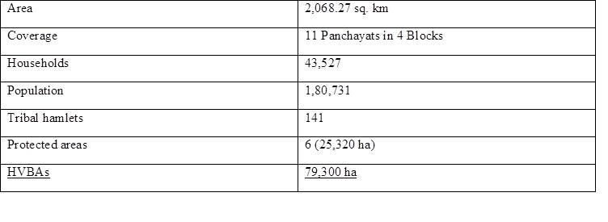
Implementation Mechanism: Through funding from the Global Environment Facility (GEF), the Ministry of Environment, Forests and Climate Change (MoEFCC) and United Nations Development Programme (UNDP) support the project's implementation. The specific purpose vehicle for carrying out the initiative in the state is the Haritha Keralam Mission. The task of carrying out operations in the forested areas has been given to the Kerala State Forests and Wildlife Department.
Other partners include organisations that support local self-government, relevant line departments, civil society groups, and research institutions.

Proposed Landscape: The project landscape is divided into four clusters comprising of 11 Grama Panchayats

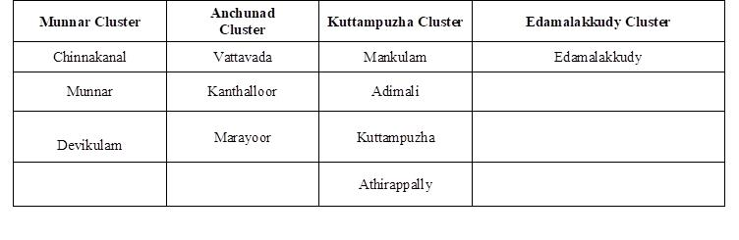
CLUSTERS-BASED INTERVENTION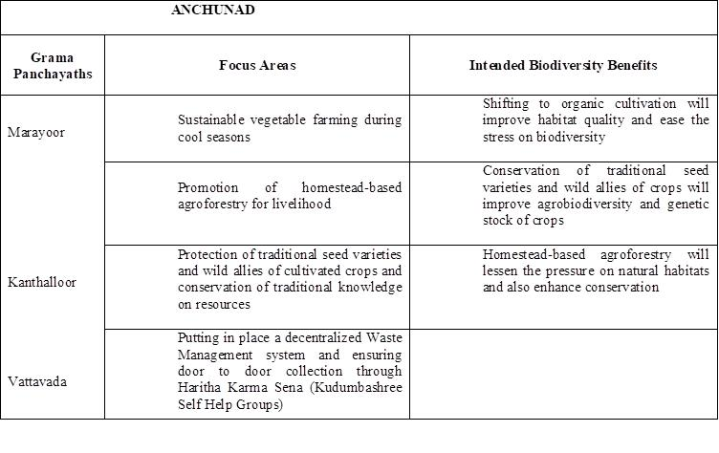
Source-(http://haritham.kerala.gov.in/ihrml-undp-project-2/)

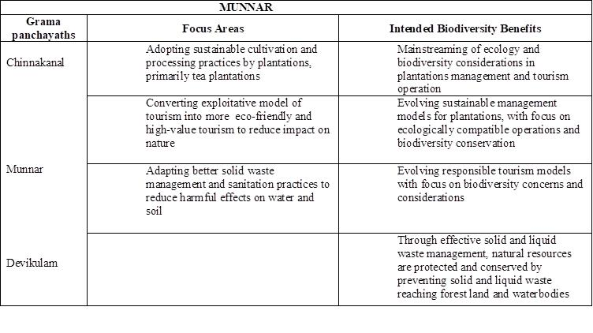

Source-(http://haritham.kerala.gov.in/ihrml-undp-project-2)

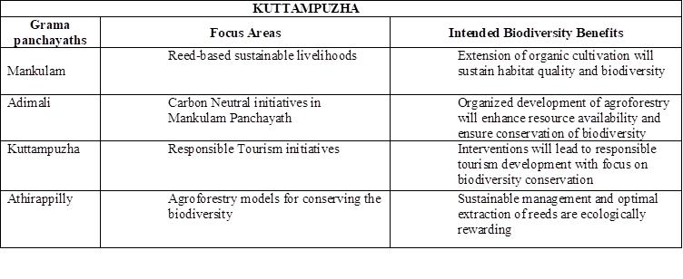
Source-(http://haritham.kerala.gov.in/ihrml-undp-project-2/)

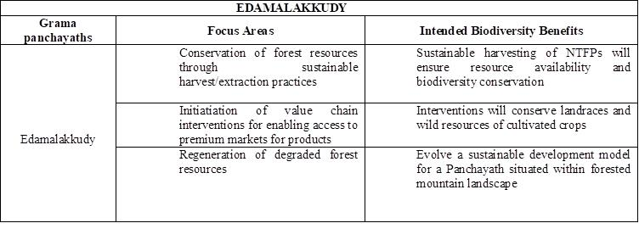
Source-(http://haritham.kerala.gov.in/ihrml-undp-project-2/)

PROJECT OUTCOMES
Improved community-based capacity for sustainable use and management of natural resources.
Application of multiple use landscape management to protect the ecological integrity of high-range landscape. Development of a widely recognised governance framework for multiple-use high range landscape management.
Outcome 1 : Enhanced community-based sustainable resource management and usage capabilities
Output
a . Capabilities of community organisations and Local Self Governments established to prepare for sustainable resource usage
1.Workshops, meetings, and discussions on project-related matters with relevant stakeholders (government officials, Panchayat officials, elected officials, and people of the community)
2. Create IEC products for work connected to the project.
3. Educating key players for mainstreaming BD considerations, including elected officials, government employees, and members of the Panchayat.
4. Visiting specific stakeholders to introduce them to different landscape-based conservation models
5.Technical studies to establish baselines and evaluate the effects of present resource usage patterns on the environment
b. Sustainable resource use techniques that have been proven to enhance quality of life
Waste management away from forests
- Starting the "Green Munnar" Project, which aims to clean up dumping grounds, treat biodegradable and non-biodegradable trash, promote waste minimization, treat sewage, and revitalise the Nallathanni River.
- Waste management efforts in Athirappally
c.Enhanced products/services value chains developed for providing ecologically sustainable livelihood options
1. Sustainable livelihood strategies for tribal groups' NTFP (including the promotion of Vamasree stores and goods, bamboo and reed agriculture, and related industries).
2. Improvement of reservoir fish production and development of livelihood opportunities for the tribal community in the Munnar landscape through the use of native species in aquaculture, intervention in the lemongrass value chain, sustainable farming, value addition, and market linkage of the tribal community at Athirappilly
3. Sustainable livelihood strategies for agricultural communities and institutions that support them Value chain interventions for passion fruit
Market mapping research and fruit and vegetable value chain analysis implementation

d. Community-based models developed for sustainable access and use of forest resources by local communities
1. Creating a comprehensive strategy based on the examination of Edamalakudy's socioeconomic study
2. Execution in accordance with the comprehensive plan for Edamalakudy
3. Assistance with the project's landscape's application of Community Forest Rights.
4. Technical Experts/Consultants Appointed by State Forest Department, Haritha Kerala Mission, and MoEFCC (Salaries)
Outcome 2: Multiple use landscape management is applied to secure the ecological integrity of the High Range landscape
Out put
a .Capacities of conservation and production sector personnel developed for applying landscape approaches in to sectoral planning and operations
1.Geospatial mapping of the area utilising ground data (various sector & biological features) and high resolution satellite images identifying high value biodiversity sites and evaluating the plants and animals in several sholas inside tea estates
2. Create and validate sector-specific state-of-the-art documentation for mainstreaming into sectoral stakeholders' policies and practises (the tea, coffee, cardamom, oil, forest plantations, and tourism sectors).
b. Evidence of the mainstreaming of biodiversity issues in significant producing sectors
1. The demonstration of created potential strategies in the plantation sector (forest, tea, coffee, and cardamom plantations); 2. The demonstration of developed potential strategies in the tourism sector in the environment.
3. Getting rid of invasive and exotic species and restoring the environment in deteriorated areas outside of forest areas
4. Implementing soil stabilisation strategies outside of forests, particularly in Devikulam Block's recognised landslide-prone regions like those along the National High Way between Munnar and Chinnakanal, where deep-rooted plants like vetiver and shola are planted.
Outcome 3: Commonly accepted governance framework for multiple-use high range landscape management evolved
Output
- Landscape level management plans and sustainable resource management systems in place
-improved management of protected areas
1. Efforts to lessen dangers to biodiversity protection, such as forest fires and traffic fatalities
Thermal sensor installation at Malayattoor and Chalakkudy as part of reducing human-animal conflict is one example of technology for tracking wildlife movement.
b. Institutional platforms of multiple stakeholders evolved and
strengthened at appropriate levels for planning and reviewing sustainable resource use
1. Providing advanced woodworking instruction to 25 tribal kids as part of training for communities who depend on the forest for their livelihoods, VSS, EDCs, and frontline forest officials on: * Ecotourism destination management: Visitor management and disaster risk reduction in eco-tourism destinations
* Climate Change Local Action Plans in 8 FDAs (106 VSS & EDCs)
* Using training and involving tribal groups, advanced community research techniques and habitat monitoring protocol are improved.
2. Bird conservation on a local level in Thattekad and the surrounding areas
offering tribal youngsters a certified ornithology and birdwatching coursepublishing a bird book in the native tongue constructing Salim Ali sathram as a historic structure
3. Strengthening the Chilla market through market automation and the establishment of facilities for the transportation of agricultural products and NTFPs from tribal communities
4. Strengthening the RRT (Marayoor, Munnar, and Malayattoor) in the environment by constructing tool rooms and improving facilities
5. establishing a decision support system that manages existing geographic maps, studies, surveys, research publications, and other data through a centralised digital database.
6. Improvement of eco-tourism destinations and interpretation centres in Athirappally and Thattekad, including creation of an eco-tourism website tailored to the needs of people with disabilities.
7. Creating a green construction code with energy-efficient facilities and testing it in the landscape (one for each of the following: Divisional Office, Forest Station IB, and Check Post).
8. Construction of a live museum in Marayoor
9. Hosting a multi-stakeholder forum at the landscape scale for sustainable landscape management
Increasing the efficiency of HVBA management
c.Management effectiveness of designated biodiversity rich ecosystems are strengthened to address existing and emerging challenges to ecosystem conservation and services
1. creation of a cybercrime control cell at the forest headquarters
2. Review of State Forest Policy, Management Plan Guidelines, and the validation of PA METT and MEE scores within the context of the project to identify gaps
3. Establishing a habitat and animal health monitoring cell at Thattekkad and creating an eco-compatible habitat monitoring cell within Eravikulam National Park
4. Creation of a thorough project report - State-level Digital Forensic Lab at Forest Head Quarters and Centralised Hospital for Elephants at Vadakkanchery Habitat Improvement - Strategies and Implementation
5. removal of plantings (eucalyptus and willow), removal of foreign weeds from PAs and other areas, eradication of invasive species from high-altitude montane grasslands (both inside and outside of PAs), Designing a long-term sustainability plan for the Nilgiri Tahr and restoring identified vulnerable and degraded forest areas, including shola/grasslands segments within PAs and other degraded areas, such as improving the Nilgiri Tahr habitat in Meesappulimala (Removing exotics and restoring grasslands).
6. At the Thattekkad Bird Sanctuary, bamboo ecosystems are being mapped in terms of species, age, and conservation efforts (such as those to stop exotic invasive species and forest fires).
7. Based on the advice from the 2019–2020 study titled "Ecosystem Requirements of Hornbill," conservation of particular habitat, such as Hornbill and Vayal habitats.
8. strengthening the migrating bird habitat through the restoration of aquatic ecosystems at the Thattekkad Bird Sanctuary and the establishment of long-term monitoring systems
9. Restoration of flood-damaged riparian vegetation (Establishment of a monkey rescue centre at Malayattoor; stabilisation of riverbanks by rehabilitation centre).Improved conservation practises protect endemic species and rare, endangered, and threatened (RET) habitats.
1. Construction of nurseries with a facility for micropropagation for RET species in Devikulam
2. Construction of a centralised grassland/shola/nursery at Pampadumshola and Devikulam. Marayoor's sandalwood nursery. Nursery for riparian species in Chalakkudy and Vazhachal
3. Extension of Technical Experts/Consultants to Haritha Keralam Mission, State Forest Department, and MoEFCC (Salaries)

CONCLUSION
The project's main objective is to create demonstration models for the promotion of sustainable livelihoods and the conservation of biodiversity. Through partnerships with local self-government institutions, the forest department, line departments, civil society organisations, etc., the models created through this initiative aim to have a long-term impact on the community. The overarching purpose is to advance the sustainable development objectives and strengthen stakeholders' capacities for formulating and carrying out such projects. The same sceneries can be used to reproduce effective models. To have a longer-term, wider impact, successful practises can also be included into government initiatives and projects. A crucial first step towards a sustainable future is recovering the High Range Mountain Landscape while maintaining livelihoods.
References
1.Simon M.S Norman S., Suresh K. 2011.Ethno medical plants ,used by the uraly tribes of Idukki district, Kerala which are hitherto un reported in codified Ayurveda System of Medicine, International Journal of Research in Ayurveda and Pharmacy2(2)pp 469-47
2.Agarwal,A.,&Narain S(Eds)1985-Thestate of India’s Environment,1985-85:The Second Citizen’s Report. New Delhi: Centre for Science and Environment.
3. http://haritham.kerala.gov.in/ihrml-undp-project-2/
4. http://haritham.kerala.gov.in/home page/
5. http://haritham.kerala.gov.in/haritha-keralam/
6.https://info.undp.org/docs/pdc/Documents/IND/2020_QPR_3_IHRML.docx.pdf

