Entrepreneurial Aspects of Agricultural Innovative Tools and Implements
*Teronpi Amrita
* Department of Agricultural Engineering, Assam Agricultural University, Jorhat-13; amrita.teronpi@aau.ac.in
In North East India, agriculture is one of the key economic activities that are carried out by majority of the population. Employing the widest population base, agriculture is the main source of earnings for many living below poverty line. It is almost found in most of the primitive and remotest area of Assam or other North-Eastern parts, farmers lacks basic modern tools. Many aspirant marginal farmers have themselves come up to sort out their own problems related with agriculture and tried to develop small innovative agricultural tools and implements. These develop tools as well as implements not only help that fabricator to serve its purpose but will also help them to generate income for themselves by selling the replica of it to their neighbouring farmers. So, this chapter deals with various agricultural tools and implements which the farmers as well as small fabricator can develop it as well as can sell it and be an entrepreneurs.
Creativity, innovation, and invention are key concepts for any entrepreneurial voyage. Fostering creativity and innovation will insert essential tools to entrepreneurial toolkit. The science, study, and practice of creativity and design thinking are persistently evolving.
Agribusiness is an expression used to portray the sector that encompasses all economic activities that are related to farming, i.e., breeding, crop production/farming, farm machinery, distribution, marketing etc. It relates to industries that are engaged in farming or that produce farm inputs. Examples of agribusiness include farm machinery manufacturing, seed supply, and agrichemicals.
Entrepreneur refers to an individual that has an idea and intends to execute on that idea, usually to interrupt the current market with a new product or service. Entrepreneurship in agriculture can also be defined as the formation of novel economic organisation for the intention of growth under risk and uncertainty in agriculture (Dollinger, 2003).
Farmers as Entrepreneurs: Farmer-entrepreneurs visualize their farms as a trade. They see their farms as a means of earning profits. They are obsessive about their farm business and are willing to take calculated risks to make their farms profitable and their businesses grow.
Entrepreneurship Dynamics: Successful farmer-entrepreneurs are technically competent, innovative and plan ahead so they can push their farm businesses through the stages of enterprise development – from establishment and survival to rapid growth and maturity. However, there are many challenges that these farmers face: social barriers, economic barriers, regulations, access to finance and information, and their own managerial capacity to deal with risks and changes and to seize opportunities.
Farmer cum Fabricator cum Innovator: Farmer cum Fabricator cum Innovator has remarkable ability to adapt. They look for better ways to organize their farms. They try new crops and cultivars, better animals, and alternative technologies to increase productivity, diversify production, and reduce risk – and to increase profits. They have become more market oriented and have learned to take calculated risks to open or create new markets for their products. They fabricate small yet innovative tools and implements which solve agricultural problems at grassroots level. Experts from academics and research need to identify those technologies and must add value in those so that these technologies become more refined than being in crude stage.
The Farmer cum Fabricator cum Innovator produces a clear picture in his mind of what is possible and the future he wants. He assumes what is possible is determined by the market. The Farmer-Entrepreneur is always looking for new opportunities. He knows that new opportunities are found in the market. The farmer-entrepreneur wants to make profits. An entrepreneurial farmer has the initiative, drive, capacity and ability to take advantage of opportunities.
While farmer-entrepreneurs are free and independent, they do not work alone. They operate in a complex and dynamic environment. They are part of a larger collection of people including other farmers, suppliers, traders, transporters and processors, each of whom has a role to play in the value chain.
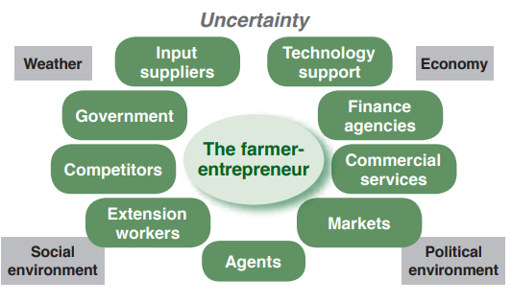
Fig.1: The world of the farmer-entrepreneur
Most of the farmer entrepreneur are less educated and are need to be trained for expanding their business. For their better present and future profitability as well as productivity it is very much essential that they follow their chart for their entrepreneurial journey. Fig.2 showcases a model of agricultural innovation ecosystem.
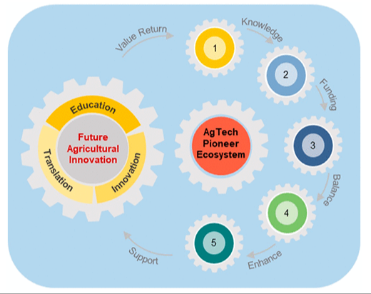
Fig.2: Agricultural innovation ecosystem for the development of young, entrepreneurial-minded farmers who can be co-creators and active participants in agricultural innovation.

Also, even after adapting these model farmers often under certain barrier in entrepreneurships. They are:
- Poor or absent infrastructure
- Unsupportive laws and regulations
- Lack of financial support
- Social barriers
- Lack of training facilities
- Lack of support services and trained extension staff
- Marketing constraints
These can be depicted by the following figures:
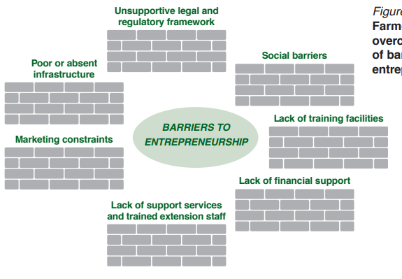
Fig. 3: Farmers must overcome a range of barriers to entrepreneurship
It is the responsibility of government to address these barriers and to provide an environment that supports farm businesses. However, with or without this assistance, farmers can take the lead by recognising the qualities they possess get training and think and act as entrepreneurs.
Our Government have identified various entrepreneurs, awarded them for their extraordinary inventions and funded for their start up by various Govt. Autonomous bodies under various departments such as National Innovation Foundation- India, Entrepreneurship Development Institute of India, North Eat Agriculture Technology Entrepreneurs Hub ( NEATEHUB-AN AIC –AAU) etc.
Now although the farmers are motivated throughout their entrepreneurial journey by mentors adopted by the govt. bodies, but it is also important that they are encourage to follow the Six Thinking Hats method. There are different versions of this ideation game, but all of them are quite useful for encouraging thought by limiting the mindset of those involved in the game. The six hats are:
- White Hat: acts as information gatherer by conducting research and bringing quantitative analysis to the discussion; sticks to the facts.
- Red Hat: brings raw emotion to the mix and offers sensibilities without having to justify them
- Black Hat: employs logic and caution; warns participants about institutional limitations; also known as the “devil’s advocate”
- Yellow Hat: brings the “logical positive” of optimism to the group; encourages solving small and large problems
- Green Hat: thinks creatively; introduces change and provokes other members when needed; new ideas are the purview of the Green Hat
- Blue Hat: maintains the broader structure of the discussion and may set the terms by which progress will be judged; makes sure the other hats play by the rules, or stay in their respective lanes, so to speak.
Fig.4: The Six Thinking Hats exercise is designed to have each participant focus on a particular approach to the problem or discussion. (attribution: Copyright Rice University, OpenStax, under CC BY 4.0 license)
If this exercise is practice well, the challenges of implementing it are well worth the effort. Given below are photographs of successful entrepreneurs of North East India whom our India Government have facillated as well as awarded. These entrepreneurs have fabricated few innovations on farm machinery backed and are doing pioneers projects on them after value adding it.
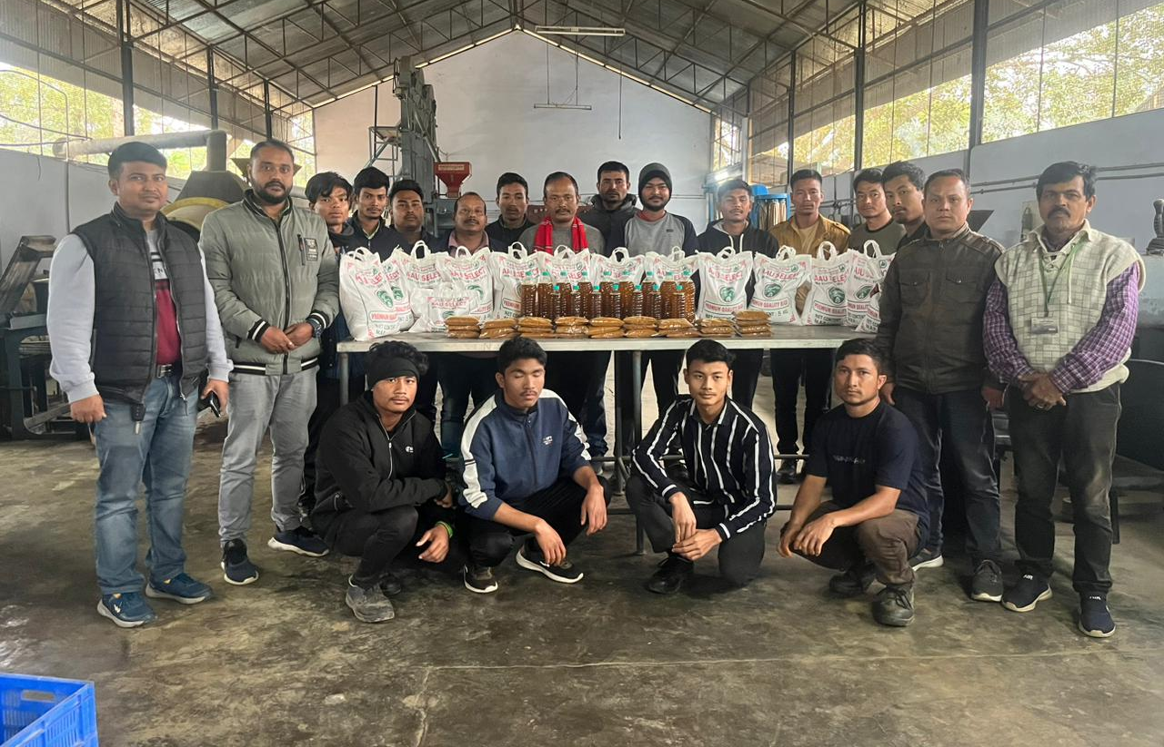

Fig.5: Training to the farmers cum fabricator by the Department of Agri. Engg. AAU, Jorhat to extract/expel and packaging of mustard oil; to dehydrate and grind of turmeric powder and ; to mill rice.

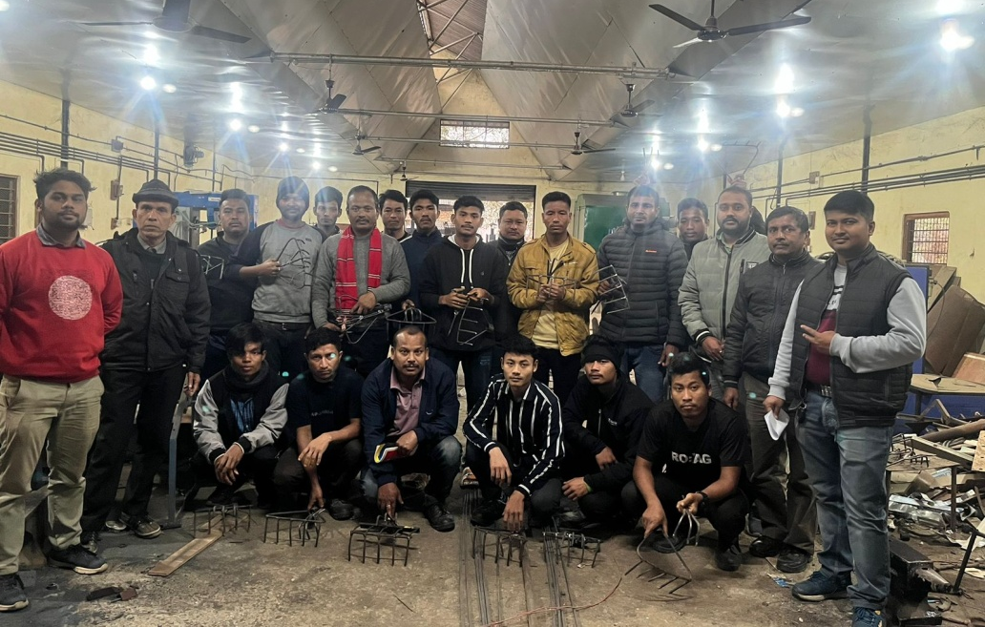

Fig.6: Training of the grassroots farmers by the Department of Agri. Engg, AAU, Jorhat, to fabricate farm tools and implements.

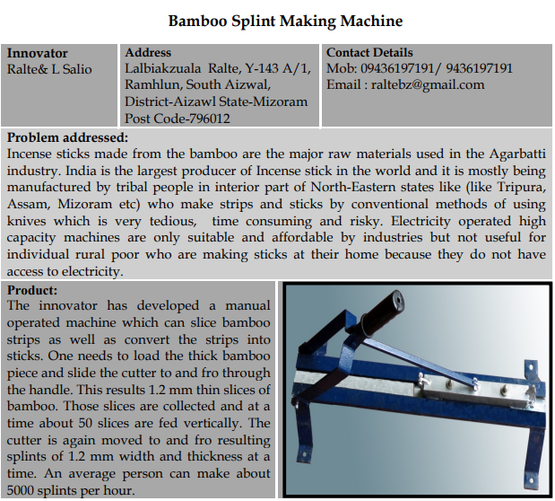
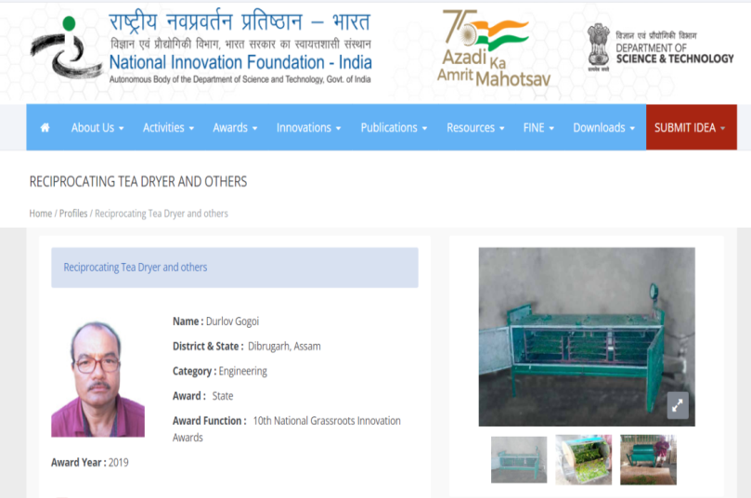

\

Fig.1: Source: Reciprocating Tea Dryer and others | National Innovation Foundation-India (nif.org.in)
Fig.2: Source: Bamboo-Splint-Making-Machine-ralte.pdf (nif.org.in)
There are many more success stories of innovators as well as entrepreneurs from North East India which are not documented in this book chapter yet they are doing marvelous job. This chapter is to educate the young minds of today and tomorrow that how innovations can uplift and turn the entrepreneurial dimensions of a person and what methodology is to be adapted for its long run success.

