Introduction, Scope and Application of Nanotechnology
Tejaswini Pagarª
ªDepartment of Chemistry, Mahatma Gandhi Vidyamandirs Loknete Vyankatrao Hiray Arts, Science and Commerce College Panchavati, Nashik 422003, India (Affiliated to Savitribai Phule Pune University, Pune.)
Introduction:
The idea of nanotechnology was released by American researchers & a recipient of the Nobel Richard Feynman in 1959 & first demonstrated. Within the yearly conference of the American Physical Society, Feynman delivered a lecture named "A Great Deal of Space at the Bottom" at California's Institute of Modern Technology (Caltech). He asked, "For what reason can't we publish the entire 24 volumes of the Britannica Encyclopaedia on the top of a pin?"& envisioned an era in which machines will be used to develop much smaller machines, starting with molecules [1]. Feynman is regarded as the founder of contemporary nanotechnology because of this new theory, which shows that his predictions have been validated. After fifteen years of research, Norio Taniguchi, a Japanese researcher, introduced the word "Nanotechnology" for the first time, since 1974. "Nanotechnology" mainly includes the processing of material by a single atom or a single molecule for separation and consolidation as well as deformation [2]. The Feynman established this new field of research, two methods have been developed to characterize many possible substitutes for building of nanostructures. The two categories of producing strategies—"Top-down and Bottom-up"—can be classified depending on the level of quality, the speed, as well as the price of the manufacturing process. Using the Top-down method, the bulk material is essentially broken down to create nanoparticles. This can be done by utilizing State-of-the-art methods created and enhanced by businesses during the last few years, such as accuracy in engineering and lithographic processes. The majority of the microelectronics business is based on precision engineering to help with all aspects of production and a combination of advancements can result in excellent performance. These include size control sensors, effective nanostructures based on a cubic boron nitride or the diamond, the numerical handle, and servo drive technology. In lithography, the outer layer is patterned by exposure to light and ions as well as electrons before material is deposited on it to produce desired material. "Bottom-up technique" is the method of constructing nanostructures from the ground up, atom by atom or molecule by molecule, using both chemical and physical processes within the nanoscale (1 nm to 100 nm) range. A method for producing raw materials is known as chemical synthesis. These materials can either serve as the building blocks for higher-quality ordered substances or can be used effectively in products in bulk-disordered form. When atoms or molecules interact chemically and physically to form created nanostructures, self-assembly is a bottom-up method used to achieve this. Positional assembly is the sole method that allows for the independent placement of individual atoms, molecules, or clusters [3]. (Figure 1) There are many methods used to prepare nanoparticles including bottom-up and top-down concepts These techniques are used for basic information as shown in Figure 1.
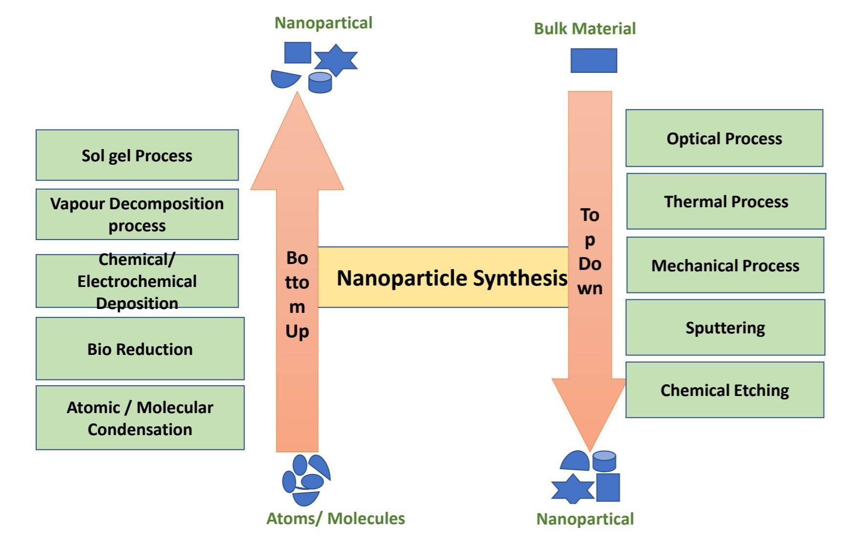
Figure 1: Bottom-up and Top down method.
The K. Eric Drexler authored the first publication about nanotechnology in 1986 named "Engines of Creation: The Coming Era of Nanotechnology," which helped the "molecular building" concept achieve greater and greater guidance [4]. Drexler explained how to construct intricate machines out of individual atoms that are capable of independently manipulating molecules and atoms to create self-assembling nanostructures. In a later on publication named "Unbounding the Future: The Nanotechnology Revolution," Drexler, Peterson, and Pergamit use the word "nanobots" or "assemblers" for the nano processes applied to health care applications. This work was published in the year 1991. The well-known phrase "Nanomedicine" was first used at that time [5].
Definitions:
The Greek word "nano" indicates the "dwarf or "extremely little" and describes a millionth of a measurement ( 10⁻⁹ m). It is important to distinguish between nanotechnology and Nano science.
The study of molecules and structures on the nanometer scale is known as nanoscience. Nanotechnology is the use of materials with a size between 1 and 100 nm in every object like devices and other objects [6].
The use of technology at the nanoscale" is the fundamental explanation for nanotechnology. There are many concepts of nanotechnology. It is necessary to expand this first description, for example, by defining what is meant by the term “nanoscale” as a result, without first defining “nanoscale”, or scale that ranges from 1 to 100 nm, we cannot properly define nanotechnology. The terms "atomically accurate technique" or "engineering with the atomic accuracy" can be used to characterize nanotechnology [7].
Systems and materials that use nanoscale components and structures to represent innovative, greatly enhanced physical and biological capabilities, and processes are related to nanotechnology.
The dictionary defines nanotechnology as "The creation, analysis, production, determine, and size-controlled application are important in the nanoscale" [8].
A subclassification of technology in the domains of fluid science, chemical science, physical science, life sciences, and various nanoscale sciences, nanotechnology is a field of study that focuses on the investigation of phenomena [9].
The scope and distribution of a catalyst's particles greatly affect how effectively it works. The advantages of NPs as catalysts are due to their chemical characteristics, which include their high outermost layer-to-volume ratio, surface morphology and electrical characteristics, all of which are related to particle size [9,10]. Significant advancement is being made in the fields that enable the creation and comprehensive understanding of the properties (particle in terms of size, arrangement, organization) and significance of NPs as promoters for the improved performance of chemical actions [11]. This definition states that there are two prerequisites for nanotechnology. First, there are issues with measurement: s Utilizing structures by changing their dimensions and forms at the nanoscale is the main goal of nanotechnology. The second issue is a novelty: because of their nanoscales, small things in nanotechnology must be handled in a way that makes use of specific properties [12].

History: The Romans' use of nanoparticles and structures in the fourth century AD is one of the most fascinating instances of nanotechnology in antiquity. The Lycurgus Cup, a piece of the British Museum collection, is one of the greatest amazing creations in the field of historical glass. It is the earliest instance of dichroic glass that is generally recognized. Two distinct varieties of glass are referred to be dichroic glass because they exhibit color change under particular lighting conditions. This indicates that the cup has two distinct colors: the glass appears green in natural light and turns purple when light shines through it. (Figure 2) [13].

Figure 2: The cup of Lycurgus, (A) the glass appears green, and in light
(B) , it appear red-purple[13].

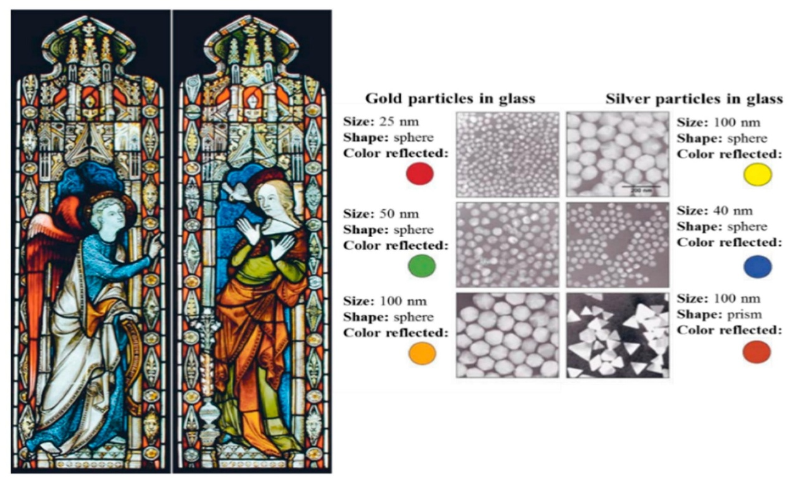
with the help of a transmission electron microscope (TEM), researchers examined the cup in 1990 [14]. Due to the presence of 50-100 nm diameter nanoparticles, dichroism (two colours) has been detected The nanoparticles are identified as silver gold (Ag-Au) alloys by an X-ray analysis, which has an approximately 7:3 ratio of Ag to Au and an additional 10% of copper (Cu) dispersed throughout the glass matrix [15,16]. Due to the light's (520 nm) absorption, the Au nanoparticles take on a reddish hue. The green color is a result of the light scattered by a colloidal dispersion of Ag nanoparticles with a size of 40 nm, while the red-purple color is from the absorption by the larger particles. One of the earliest known synthetic nanomaterials is the Lycurgus cup [6]. A similar outcome is seen in the late-medieval church windows, which radiate brilliant red and yellow due to the fusion of the gold and silver nanoparticles into glass. The stained glass windows in (Figure: 3) are an illustration of how these nanoparticles of various sizes affect them [17].

Figure 3: Nanoparticle impact on stained-glass windows coloration [17]

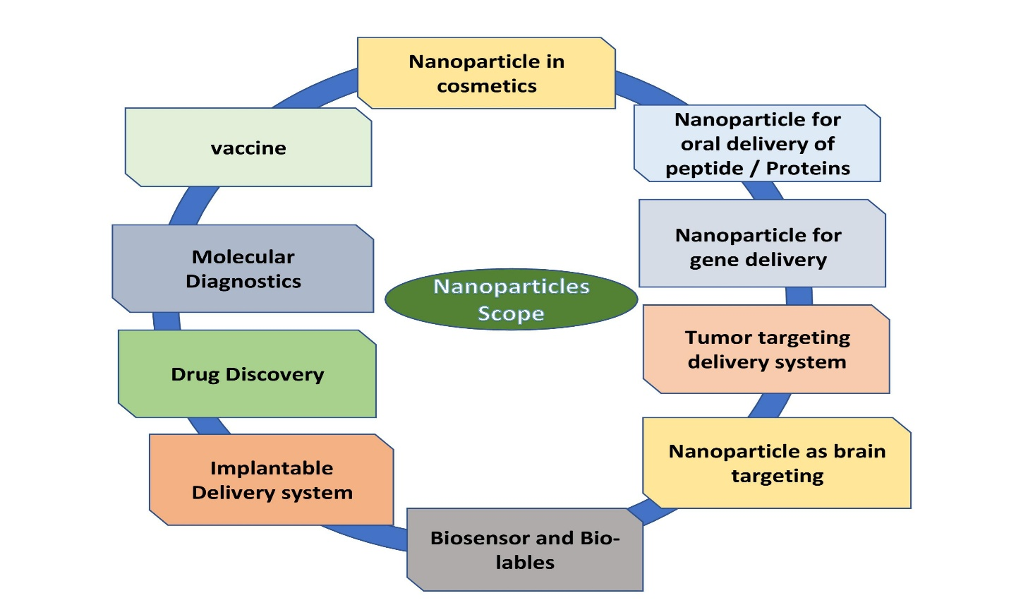
Scope of Nanotechnology:
Figure 4: Scope of Nanotechnology
- Nanomaterials have been developed for numerous uses in a variety of industries, including medicine, medication delivery, electronics, fuel cells, food and space, among others. The use of nanoparticles in catalysis to speed up chemical reactions is growing.
- Nanoparticles are used increasingly in catalysis to boost chemical reactions.
- This helps some money and cut down on pollution by lowering the number of catalytic materials required to achieve desired outcomes. Petroleum refinement and catalytic converters for automobiles are two significant applications.
- nanotechnology application can be found in engineering, biological and medical fields as well as chemical, materials and physical research. Material that demonstrates its transformational power includes carbon, silica, gold, polydimethylsiloxane, cadmium selenide and iron oxide.
- Nanotechnology for brain drug delivery.
- Nanotechnology, which has the potential to completely revolutionize industries like manufacturing, agriculture, electronics, pharmaceuticals and military is one of the topics that is developing the fastest.
- Nanomaterials are used widely in food and agriculture systems as intelligent carriers of agrochemicals, Nano formulations, Nano biosensors, for precise farming and food packing, Nano bioremediations, Nano fibers, for genetic engineering etc.
- Nanotechnology may in the future enable objects to absorb energies from their environment.
Innovative nanomaterials and concepts are currently being researched that have high rates of conversion and can produce anything from motion, sunshine, changes in temperature, carbohydrates, and other sources.
Types of Nanotechnology:
- Nano-particles:
Nanomaterials are substances that have undergone nanoscale engineering or manipulation to produce novel properties or behaviors not present in their bulk equivalents. Nanoparticles include things like carbon nanotubes & quantum dots. For example, carbon nanotubes' exceptional strength and conductivity make them useful in a range of applications, such as electronics, battery storage, and the science of materials. A range of materials, including metal, oxides, and polymers, can be used to create nanoparticles, which have at least one dimension on the nanomaterial sizes. Thanks to their unique properties, nanoparticles are valuable in several fields, including the medical, cosmetics, and environmental ones. Quantum dots are tiny semiconductor particles that can be employed in displays, solar cells and medical imaging.
- Nano-medicine:
Nanomedicine is the use of nanotechnology in the medicinal industry. It includes the use of small components and nanoscale medical equipment to detect and treat diseases. Diagnostics nanoparticles and targeted drug delivery systems are two examples. Targeted drug delivery systems use nanoparticles to deliver the drug directly to particular cells or tissues, minimizing negative effects and boosting treatment effectiveness. Resolution images of the inside of the human body can be captured using diagnostics nanoparticles to identify disorders early on. Targeted drugs are delivered directly to targeted cells or tissues using nanoparticles.
- Nano-electronics:
To produce electrical devices that are quicker and more effective, nanoelectronics uses small transistors and another electronic component at the nanoscales. Nanoscale transistors and memory components are a few examples. Smaller, more energy-efficient electronic devices that process and store more data than conventional electronic devices are made possible by this tiny transistor and other components.
- Nano-composite:
Nanocomposites, such as nanoparticles & nanotubes, or lamellar nanostructures, are composite materials that contain components with nanoscale shapes. They are referred to as multiphase materials because they include several phases, a minimum of one of which should have a width of around 10 and 100 nm.
- Nano-lithography:
This expanding area of nanotechnology techniques focuses on the creation of nanometre-scale structures on a variety of materials. The modern phrase related to the design of structures made at a scale between 10⁻⁹ to 10⁻⁶ m (nanometre scales)
- Nano-biotechnology:
Nanobiotechnology is the study of the tiniest biological components (1-100nm) to develop systems and devices in the same size range that can be used for novel applications. It is a brand new branch of study that provides unique physicochemical and biological characteristics of nanostructures and their uses in a variety of fields, including agriculture and medicine. Metal nanoparticles are the main chemicals impacting fungi that cause disease in both plants and people.
- Microscopy, Spectroscopy, Nano-robotics, Wet nanotechnology, Nano-fluidics, Nano-electromechanical relay, Nano-photonics, Optoelectronics etc.

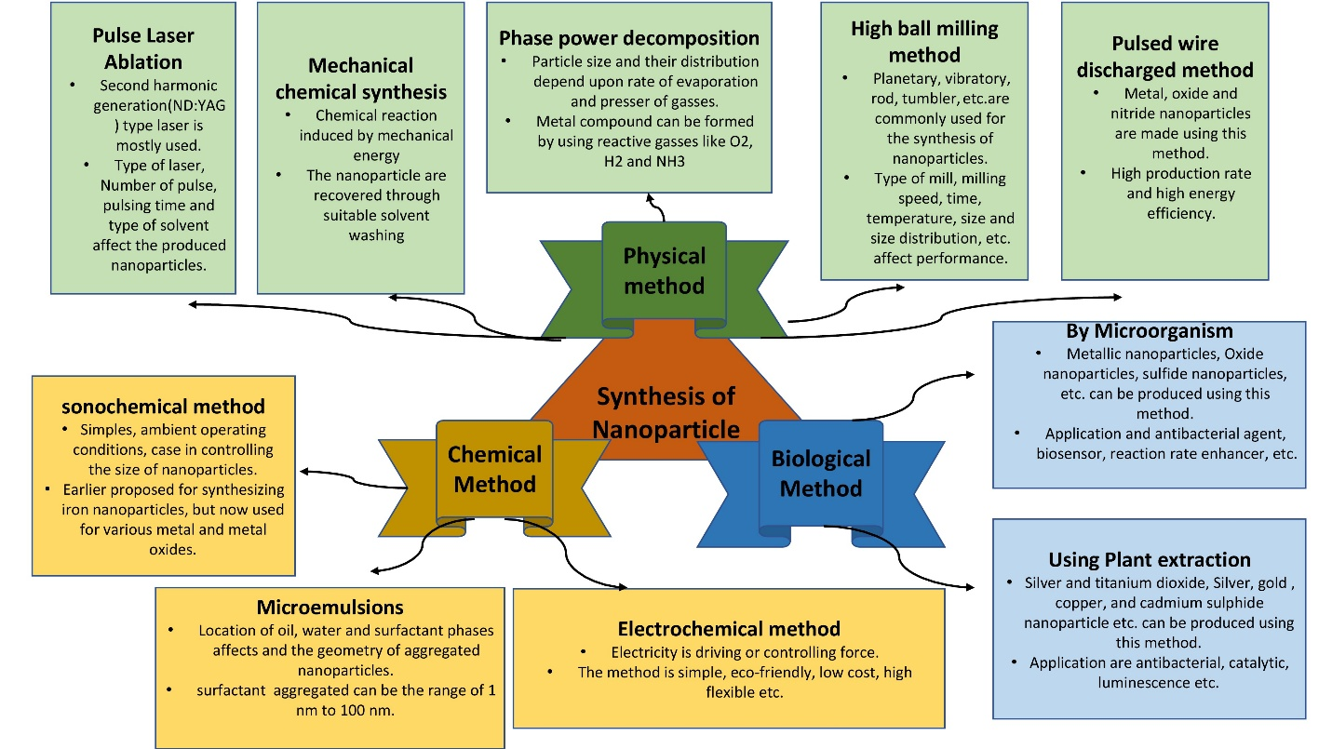
Nanoparticle Synthesis:

Figure 5: A different technique for creating nanoparticles.
Particles, colloids, thin films, tubes, rods, clusters, wires, powders and more can all be used to make various types of nanomaterial. As shown in (Figure 5), these processes can be divided into three primary categories for producing Nanomaterials. Quantum dots (QDs), nanowires, Nanorods, and nanoplates are examples of the several types of nanostructures that can be used in an approach.
Application:
- Medical Science: Cancer Treatment, Drug Delivery, Imaging Tools and Equipment, Tissue Engineering, Gene Therapy, Treating Wound Injuries.
- Textiles: Making anti-bacterial, stain-resistant, wrinkle and fuzz-resistant textiles.
- Devices: Glucose, Sensors, Lithium-Ion Batteries, Thin Film, Solar Panels, High-Efficiency Sensors.
- Material Science: Flexible Materials, Lightweight Armours, Stealth Materials, Wear-Resistant Coatings, Anti-Corrosive Paints, Masks.
- Environment Conservation: Water and Air Purification Membranes, Detection of Harmful Chemicals Oil Spills.
- Nano-composites: Nanoparticles and nanotubes have an important role to play in composites. Carbon fibers and bundles of multi-walled CNTs are used in polymers to enhance and control connectivity.
- Nano lubricants: The inorganic materials of nano-spheres are used as lubricants. They are more durable as compared to conventional solid lubricants.
- Nanocoating and Nanostructured Surfaces: Coatings with thickness at nano or atomic scales are in active production.
Reference:
- Feynman R.P. There’s plenty of room at the bottom. Eng. Sci. 1960;23:22–36. [Google Scholar].
- Taniguchi N., Arakawa C., Kobayashi T. On the basic concept of nano-technology; Proceedings of the International Conference on Production Engineering; Tokyo, Japan. 26–29 August 1974.
- Iqbal P., Preece J.A., Mendes P.M. Supramolecular Chemistry. John Wiley & Sons, Ltd.; Chichester, UK: 2012. Nanotechnology: The “Top-Down” and “Bottom-Up” Approaches.
- Drexler E.K. Engines of Creation: The Coming Era of Nanotechnology. Anchor Press; Garden City, NY, USA: 1986. [Google Scholar].
- Drexler E.K., Peterson C., Pergamit G. Unbounding the Future: The Nanotechnology Revolution. William Morrow and Company, Inc.; New York, NY, USA: 1991. [CrossRef]
- Mansoori, G.; Fauzi Soelaiman, T. Nanotechnology—An Introduction for the Standards Community. J. ASTM Int. 2005, 2, 1–22.
- National nanotechnology initiative: leading to the next industrial revolution. Washington, DC: National Science and Technology Council; 2000.
- Abad E. Nano dictionary. Basel: Collegium Basilca; 2005
- Mansoori GA, Soelaiman TAF. Nanotechnology introduction for the standards community. J ASTM Int 2005;2(6):17–38.
- Mansoori GA, Mohazzabi P, McCormack P, Jabbari S. Nanotechnology in cancer prevention, detection and treatment: bright future lies ahead. World Rev Sci Technol Sustain Dev 2007;4(2–3):226–57.
- Mansoori GA, Vakili-Nezhaad GR, Ashrafi AR. Some mathematical concepts are applicable in Nanothermodynamics. Int J Pure Appl Math Sci 2005;2:58–61.
- Allhoff, F. On the Autonomy and Justification of Nanoethics. Nanoethics 2007, 1, 185–210. [CrossRef]
- The British Museum. Available online: www. britishmuseum.org /research/ collection _ online/collection_ Object_details.aspx?objobjec=61219&partId=1
- Barber, D.J.; Freestone, I.C. An investigation of the origin of the color of the Lycurgus Cup by analytical Transmission electron microscopy. Archaeometry 1990, 32, 33–45. [CrossRef].
- Freestone, I.; Meeks, N.; Sax, M.; Higgitt, C. The Lycurgus Cup—A Roman nanotechnology. Gold Bull. 2007, 40, 270–277. [CrossRef]
- Wagner, F.E.; Haslbeck, S.; Stievano, L.; Calogero, S.; Pankhurst, Q.A.; Martinek, K.-P. Before striking gold in gold-ruby glass. Nature 2000, 407, 691–692. [CrossRef].
- The New York Times. Available online: www.nytimes.com/imagepages/ 2005/ 02/ 21/ science/20050222_ NANO1_GRAPHIC.html

