Thermal Barrier Coatings: Techniques and Materials
¹,Bharath G, Assistant Professor, School of Engineering & Technology, CMR University, Bengaluru.
²,Dr. Devaraj E, Assistant Professor, School of Engineering & Technology, CMR University, Bengaluru.
Abstract
Enhancing combustion energy utilization is the main focus in order to reduce energy waste and fuel consumption, which would ultimately aid in lowering pollution levels. The review of the study is about the thermal barrier coatings (TBCs) as a critical method for minimizing combustion energy losses in ICEs. TBCs, which have multiple layers, are used to protect engine parts from the heat. It is explained in detail how the primary layers' bond coats and top coatings boost engine performance. Two different forms of TBCs, fast heat response coatings and low heat rejection coatings, each have unique benefits for boosting engine performance. The study concentrates on the historical development of TBCs, first in aero plane engines and then in diesel engines, in response to concerns about fuel efficiency. It emphasizes the critical function of the crucial parts of the engine like the piston in an engine's efficiency as well as the potential for TBCs to reduce heat losses and boost overall efficiency. Materials for TBCs are explored, with a focus on Yttria Stabilised Zirconia (YSZ) and other possibilities with low thermal conductivity and stability at high working temperatures. Thermal spraying, chemical-vapor deposition, ion implantation, among other methods, are all effective techniques to apply thermal barrier coatings. The advantages and applications of each technique are thoroughly covered in this chapter.
Keywords: Internal Combustion Engine, Yttria Stabilised Zirconia, Thermal Conductivity, Coating Materials, Thermal Spray Coating.
- Introduction
The commitment of many countries of the world towards global climate has led to set lofty targets for reaching net-zero greenhouse gas emissions by 2050 [1]. As a result, advancements in the efficiency of internal combustion engines (ICE) are gaining traction, particularly in terms of more efficiently using combustion energy [2, 3]. If the combustion energy is not wasted within the engine, for example, more energy can be turned to notwithstanding heat losses to the cylinder, cooling fluid, and exhaust. The power transferred to the wheels increases which leads in lower fuel usage. Therefore, improved combustion energy utilisation may aid in meeting net-zero emission targets. Because lower fuel use correlates directly with lower pollution levels.
Thermal barrier coatings (TBCs) have been intensively explored for ICE applications in recent years to achieve decreased combustion-energy losses. TBCs are multi-layered coatings that are placed to the surface of a material with the primary goal of providing thermal insulation to the substrate [4]. The bond coat is the first layer of the TBC and serves as a transition layer between the metallic substrate and the following layer of ceramic [5]. The bond coat has a strong oxidation resistance and increases coating adherence. The top coat is the second coating. This coating, which is made of a low thermal conductivity ceramic substance, serves as the high temperature resistance layer. TBCs have shown promising results when constructed as either a low heat rejection coating [7-11] or a fast heat response coating [3,12-14]. Because of their low thermal conductivity, low heat rejection coatings cause combustion energy to be retained inside the engine's combustion chamber. This, paired with less cooling due to limited heat transfer, has resulted in higher engine efficiency.
Coating metallic surfaces in compression and spark ignition engines enhances performance by minimising engine-part wear, corrosion, oxidation, and excessive heat [15]. However, its main advantages in Internal Combustion Engines (ICEs) are increased brake-thermal efficiency, reduced brake specific fuel consumption (BSFC), and gas emission control [16]. Ceramic coating technology was first employed in the space and aviation industries before being applied to ICEs, particularly diesel engines, in the 1970s [17]. The reported increase in performance and decrease in BSFC of ceramic-coated systems sparked renewed interest [18]. Previously, a diesel piston crown with a thermal barrier coating was introduced utilising the thermal spraying approach with improved results [19]. Currently, experts all over the world are striving tirelessly to develop an automotive engine that does not release harmful substances in its exhaust fumes while maintaining performance. One of these innovations is the use of thermal barrier coating (TBC) within the combustion chamber to improve thermal resistance and stability when working at high leap temperatures. In order to sustain additional thermal stress, the barrier coating material should have a higher thermal coefficient of expansion than the metal substrate [20].
Thermal barrier coating (TBC) was originally used to improve the performance of aviation engines. Thermal barrier coating for diesel engines was first proposed in the 1980s. The petroleum crisis and the following increase in the cost of fuels have made the improvement of fuels and the improvement of fuel economy of I.C Engines a top priority for researchers [21]. Thermal barrier coatings (TBCs), which protect metallic components from high-temperature environments, are commonly used in high-temperature and corrosion-resistant structural sections such as gas turbine engines, diesel engines, and power generation systems. The piston is the most important component in every engine. Assume it's the IC engine's heart. The piston's job is to compress the fuel during the compression stroke and send power to the connecting rod via the crankshaft. During the expansion stroke of a petrol engine, 1/3 of total energy is squandered due to coolant and 1/3 due to exhaust. Only one-third of it is used to generate electricity, therefore if it improves engine efficiency, it will reduce heat losses. In theory, reducing heat loss from the engine wall will boost efficiency. The engine's overall efficiency is close to 40-42%. It's a key issue for the engineer, and solving it helps with thermal barrier coatings.
Coating materials include Yttria Stabilised Zirconia (YSZ), Partially Stabilised Zirconia (PSZ), Garnets, Spinel, Mullite, Alumina, and others. This material's characteristics are useful for having very low conductivity while remaining stable at nominal operating temperatures commonly observed in applications. Figure 1 depicts [21]. The purpose of a coated piston is to reduce friction, improve thermal efficiency, reduce specific fuel consumption, and increase engine output.
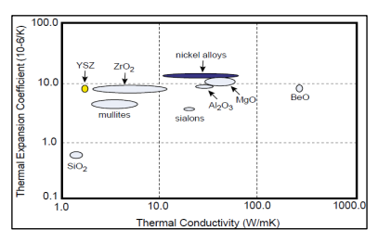
Fig 1: Materials for thermal barrier coating
- Classifications of Coating Method
Thermal Spraying, Physical-Vapour Deposition, Chemical-Vapour Deposition, and Ion Implantation procedures are the categories under which the coating techniques described and reviewed in this paper fall [22]. Physical-Vapour Deposition (PVD), Chemical-Vapour Deposition (CVD), and Ion-Implantation procedures are used to obtain the minimum thicknesses [23].
  - Thermo-Spraying Technique
In thermal-spraying procedures, powders are heated to their melting point and then deposited in a molten or semi-molten condition on a ready-made substrate [23]. Electrical arc or thermal plasma are the heat sources used in this technique. Materials in the form of powder or wire made of metals, alloys, ceramics, or polymers are employed [24]. The following are some thermal spraying techniques [25]

    - Atmospheric Plasma Spraying
In the Atmospheric Plasma Spraying (APS) method, feedstock materials are heated and melted using a plasma torch before being sprayed onto a substrate to produce a functional or protective coating. This technique is frequently used to coat various surfaces with coatings that have particular qualities in the manufacturing, aerospace, automotive, energy, and other sectors. The APS approach is mostly used due of its high deposition rate, low cost, and high-porosity microstructure, which lowers the heat conductivity and coating ability of big components [24]. A plasma-jet with a temperature range of 8000 K–14000 K is used in atmospheric plasma-spraying to inject particles with a typical diameter of 5 m–50 m [26]. A high-temperature plasma is created to start the procedure. A plasma is a type of state of matter made up of ionized gas that is heated to extremely high temperatures, usually between 10,000°C and 30,000°C. A high-temperature gas, such as argon or nitrogen, is passed through an electric arc or radiofrequency discharge to produce this plasma. The substance to be deposited is added to the plasma stream, frequently in the shape of powder, wire, or rod. The feedstock material is swiftly melted and partially vaporized by the plasma's intense heat. The force of the plasma gas flow is then used to propel the molten or semi-vaporized material in the direction of the substrate. The substance rapidly cools and hardens when it makes contact with the substrate, generating a coating layer. Metals, ceramics, composites, and other materials can all be used to create the substrate.
Benefits of APS:
- Versatility: APS is adaptable for a variety of industrial applications since it can be used to apply a wide variety of materials, including metals, ceramics, polymers, and composites.
- High Temperature: Materials that need high melting points, such ceramics and refractory metals, can be deposited in the plasma due to its extraordinarily high temperatures.
- Thick Coatings: APS can be used to make coatings that are reasonably thick, which makes it helpful for situations where a significant volume of material is required.
- Enhancements: Depending on the materials used, coatings made by APS may have special qualities including improved wear resistance, corrosion protection, thermal insulation, or electrical conductivity.
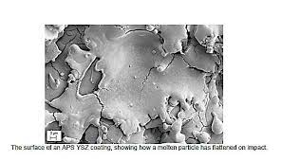
Fig 2: An APS YSZ coating's surface demonstrating how a molten particle flattened upon impact [27]
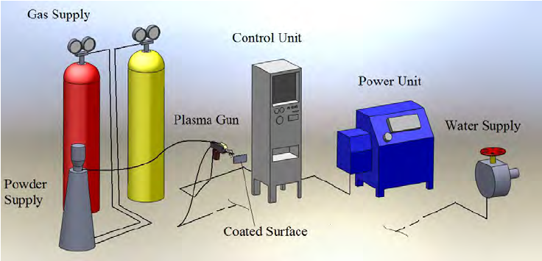
Fig 3: Plasma Spray Coating Equipment [28].
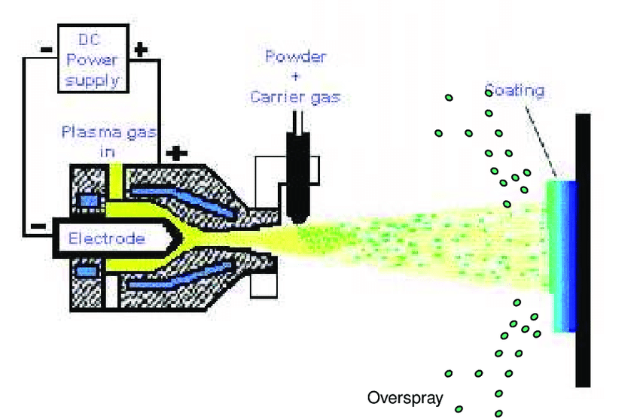
Fig 4: Plasma Spray Gun [29].

    - High-Velocity Oxy-Fuel (HVOF) coatings:
This procedure falls under the category of flame spraying [30]. A known HVOF systems function at hypersonic gas speeds greater than Mach 5 [31]. A high-velocity flame is produced during the combustion of a fuel and oxygen mixture to form High-Velocity Oxy-Fuel (HVOF) coatings, which are advanced thermal spray coatings. In order to produce a top-notch coating, this flame is utilized to drive feedstock materials onto a substrate, usually in the form of fine powder.
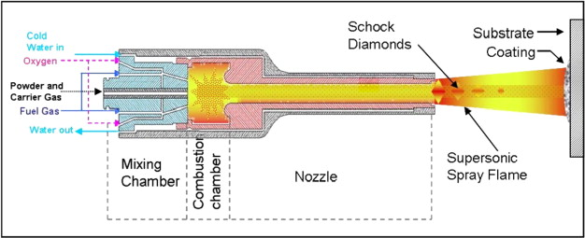
Fig 5: HVOF Gun [32].
A fuel gas (often hydrogen or kerosene) and pure oxygen are mixed together in a combustion chamber to begin the HVOF process. This mixture ignites to produce a high-temperature, high-velocity blaze. The material to be coated is normally introduced into the high-velocity flame downstream from the combustion chamber in the form of fine powder. The flame's high heat and rapidity accelerate and soften the powder particles. The substrate that needs to be coated is approached quickly by the accelerated powder particles. These particles quickly join together after impact to form a thick, tightly-bonded covering.
High density, low porosity, strong adherence to the substrate, and improved wear and corrosion resistance are just a few of the outstanding characteristics of HVOF coatings. Additionally, depending on the use, these coatings may have certain qualities like hardness, thermal insulation, or electrical conductivity.
In industries where high-performance coatings are necessary, HVOF coatings are frequently used. Coating industrial pumps and valves, machinery used in the oil and gas industry, automobile parts, and medical devices are just a few examples of common applications.
HVOF coatings provide a number of benefits, including the capacity to produce coatings with a high bond strength and a low porosity that can endure harsh circumstances. Additionally, a variety of materials, such as metals, ceramics, and carbides, can be deposited using them.
    - Detonation Gun Coatings:
Conventional flame-spray methods are limited in their capacity to create well-bonded, thick coatings with a porosity of less than 2% [33]. The combustion is contained within a tube or barrel into which powders are injected in detonation guns, though, which results in larger thermal and kinetic energy jets [34]. The powder particles receive more heat and momentum transfer from this arrangement [35]. A supersonic shockwave is produced by the detonation of a fuel and oxygen combination during the thermal spray coating process known as a "detonation gun" (or "D-Gun") coating. Using this shockwave, feedstock materials are propelled onto a substrate to create an extremely dense and wear-resistant covering.
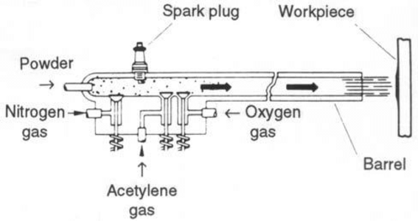
Fig 6: D-Gun [35]
A mixture of a fuel gas (often acetylene) and oxygen is first added to a combustion chamber to start the D-Gun process. This mixture experiences a controlled detonation upon ignition, producing a powerful shockwave. Usually, the substance to be coated is in the form of powder. The high-pressure shockwave downstream from the detonation chamber is given this powder injection. The detonation's shockwave causes the powder particles to accelerate to extremely high speeds. After being launched onto the substrate, these particles collide and combine to form a thick covering.
The extraordinary qualities of D-Gun coatings, such as their high density, low porosity, great wear resistance, and superior adherence to the substrate, are well known. These coatings are perfect for uses that demand high wear and corrosion resistance. D-Gun coatings are widely used in many different industries, especially where heavy machinery parts, drilling and oilfield equipment, aerospace parts, and parts sensitive to abrasive wear and harsh environments are concerned. D-Gun coatings can be used to create coatings with a fine microstructure, a low oxide content, and great bonding strength, among other benefits. They can also be used with a variety of substances, such as metals, ceramics, and carbides.
    - Electric Arc Coatings:
Two consumable wire electrodes fed into the coating gun and connected to a high direct current (DC) power source form an arc that melts the wire tips during the coating process [33]. A jet of air is then used to atomize the molten metal and drive it in the direction of the substrate. Because the entire input energy is used to melt the metal, this coating is energy-efficient. Thermal spray coatings that are created using an electric arc as the heat source are referred to as "electric arc coatings." In order to melt and propel the coating material onto a substrate, this method entails creating an electrical arc between two disposable electrodes, which are normally formed of the coating material.
Electrical current is used to form the electric arc between two electrodes. The electrodes melt and vaporize as a result of the tremendous heat produced by the electrical resistance at the point of contact. One of the disposable electrodes is normally the substance to be applied as a coating. Molten droplets created by the melting electrode are ejected onto the substrate. The arc's force propels the molten droplets it produces towards the substrate, where they are deposited onto the surface. They solidify and adhere to the substrate upon impact, generating a covering.
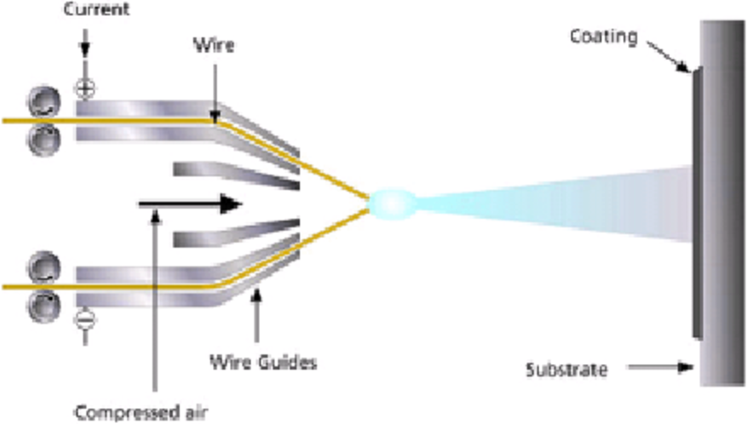
Fig 7: Electric Arc Coating [36]
Depending on the material used and the particular application, electric arc coatings can have a variety of different qualities. These coatings are renowned for their adaptability and are capable of offering qualities including thermal insulation, wear resistance, and corrosion protection.
Industries using electric arc coatings include industry, aerospace, energy, and more. Coating industrial equipment, tools, and turbine parts are frequently used to increase their performance and durability. Electric arc coatings provide a number of benefits, including the ability to apply coatings with strong bonds and little porosity. Additionally, a variety of materials, including metals, alloys, and hard-facing materials, can be deposited using them.
    - Cold-Spray Coatings
Cold-spray coating is a material deposition process in which relatively small particles are accelerated to high speeds typically 300 to 1200 m/s, or 980 to 3940 ft/s, and subsequently develop a deposit on a suitable substrate by an impaction process.
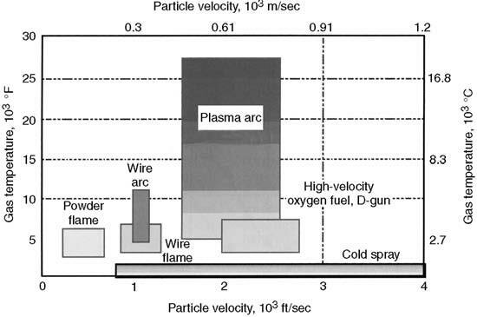
Fig 8: Comparison of common thermal-spray techniques' temperature/velocity regimes with cold-spray technology [28]
Fig. 8 compares the particle velocities and gas temperature ranges of cold-spray and other thermal-spray processes [28]. The feed-stock particles simply reflect from the surface when the particle-velocity (V_{p}) is too low for the specific coating or substrate combination, making it impossible for them to create a continuous coating or deposit. As with shot blasting of surfaces, solid-particle erosion within the surface may happen at greater levels of (Vp). Particles start to plastically deform, create an overlay coating, and stick to the substrate when (Vp) surpasses a critical value V_{crit} (which varies with particle and substrate material) [16].

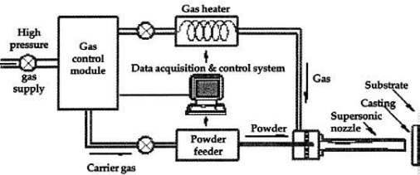
Fig 9: Cold Spray System [37]
  - Chemical-Vapour Deposition
High-quality thin films, coatings, and bulk materials are created using the materials processing technique known as Chemical Vapour Deposition (CVD). On the surface of a substrate, it involves the chemical reaction of gaseous precursor compounds to produce a solid substance. In fields including electronics, semiconductor manufacturing, optics, and materials research, CVD is frequently used.
High-purity and high-performance solid materials are produced using this technique [15]. Its primary use is in the production of thin films for the semiconductor sector [23]. The substrate is exposed to one or more volatile precursors during chemical vapour deposition, which results in the desired deposit as a result of surface reactivity or breakdown. Gas flow across the reaction chamber is used to eliminate volatile process by-products [34]. Due to its ability to coat complicated surfaces with strong conformal coverage, this approach is a highly desirable process for producing TBCs [15]. The main disadvantage is that the normal deposition rates are frequently less than 10 m/h. To increase the deposition rates, research was done on plasma and laser as auxiliary energy sources.

  - Sol-Gel & Slurry Method
The production of TBCs can be done easily and inexpensively with slurry spraying [38]. Materials can be created using the wet-chemical sol-gel process as gels, powders, or thin films. To create the desired material, a precursor solution (sol) is transformed into a gel-like state, then dried and heated. Powder suspended in liquid makes up slurry, which is often applied to a surface using a spray gun in many coats. The multilayer coating is dried, compressed in a chamber after sintering in a furnace or using an acetylene torch, and finally sintering is completed [39]. This technique has the advantage of being able to coat complex geometries, including surfaces inside of pipes that are hidden from view [39]. According to Kawasaki and Watanabe [17], slurry-coating can also be applied by dipping the substrate in a ceramic-powder mixture and letting it dry. Until the appropriate thickness is achieved, this process is repeated, and then the coating is densified by hot isostatic pressing [39]. When applying a sol-gel coating, the substrate is sprayed with the solution or dipped into it, and then the solution is gravitationally drained and evaporated [34]. The dry sol is then compressed during a firing process to provide a strong oxide covering. Fig. 10 shows a sol-gel covering with ceramic particles included [17].
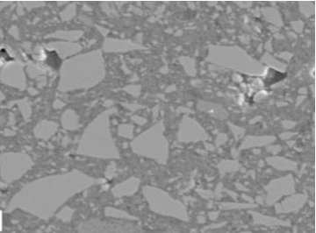
Fig: 10 Sol Gel Covering With Ceramic Particles [17]
  - Physical-Vapour Deposition Method
Physical vapour deposition (PVD) is a method for depositing thin films or coatings on substrates that is employed in materials science and numerous industries. It is a physical process in which solid materials are transformed into a vapour phase and the vapour is subsequently condensed onto a substrate to create a thin film. PVD is frequently utilised for tasks like boosting the surface qualities of materials, enhancing wear resistance, offering protection against corrosion, and adding ornamental finishes.
Here, material is vaporised in the form of atoms or molecules from a solid or liquid source and transported as a vapour through a vacuum- or low pressure-gaseous environment to the substrate, where it condenses [35]. However, they can also be used to create multi-layer coatings, graded composition deposits, extremely thick deposits, and free-standing structures. PVD methods typically deposit films with thicknesses ranging from a few nanometres to thousands of nanometres. There are several different PVD techniques, including Electron Beam - Physical Vapour-Deposition (EB-PVD), Vacuum (Evaporation) Deposition, Sputter Deposition, Arc-Vapour Deposition, and Ion-Plating [15].
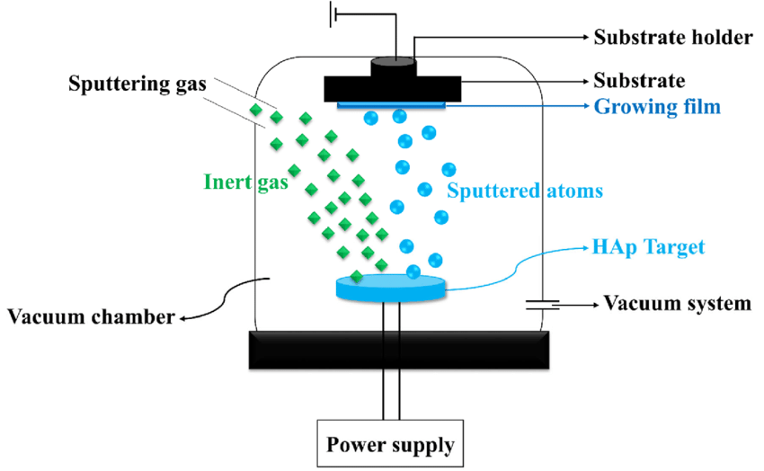
Fig 11: Physical-Vapour Deposition Method [40]

  - Ion-Implantation Method
A beam of ions is guided and accelerated towards the substrate during the ion-implantation process, which is carried out in a vacuum (133 x 10-6 to 1.33 x 10-3 Pa). Normally, the ions are accelerated to a 100 keV energy level. The ions can reach a maximum depth of 0.25 m and an average depth of 0.1 m [33].
Ion implantation coating is a method of surface modification that improves the characteristics of materials by injecting ions into the substrate's top layer. It is frequently used to enhance wear resistance, corrosion resistance, hardness, and other surface-related qualities of materials in a variety of industries, including electronics, aerospace, and materials research. An accelerator or ion implanter is often used as the first ion source in the procedure. This source produces ions of a chosen element or substance that will be injected beneath the surface of the substrate. Normally, the ions are positively charged. A vacuum chamber is used to contain the substrate (the object to be coated). The removal of gas molecules that can obstruct the ion implantation procedure and ensure that the ions reach the substrate's surface without scattering makes it necessary to create a vacuum. The produced ions are propelled by an electric field to high energies inside the vacuum chamber.
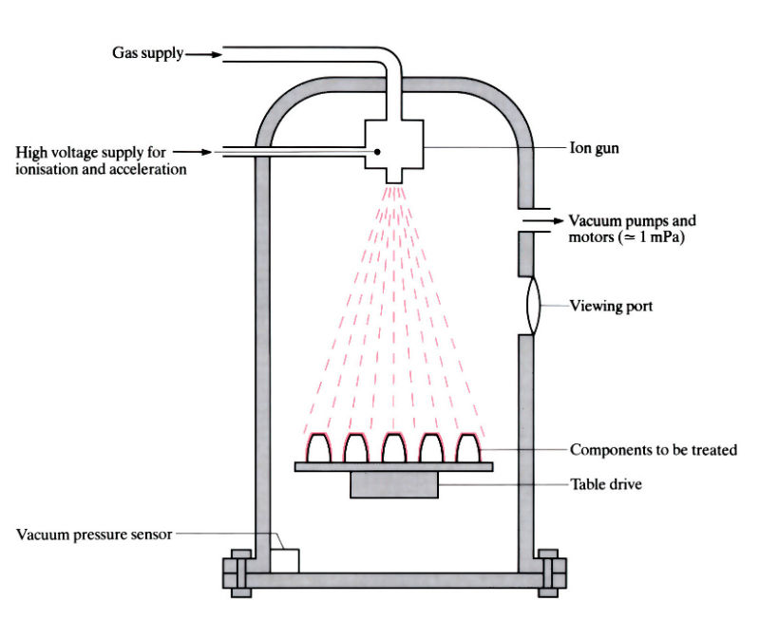
Fig 12: Ion-Implantation Method
The ions must receive enough energy from this acceleration in order for them to be able to permeate the substrate's surface. The substrate is the target of the accelerated ions, which penetrate the material's surface. The energy of the ions and the makeup of the substance determine how far they can go. The ions either cause lattice defects or embed themselves in the substrate's lattice structure. To obtain the desired coating thickness and qualities, the process parameters, including ion species, energy, and dose (the number of ions implanted per unit area), are carefully controlled. The choice of ion species and energy is important since it affects the substrate's chemical and physical changes. The substrate may go through annealing, a carefully regulated heating process, after ion implantation. Annealing promotes diffusion of implanted ions into the substrate, activates dopants, and aids in the healing of radiation damage. For the desired material qualities to be achieved, this stage is extremely crucial.
- Materials for Thermal Barrier Coatings
  - Yttria-stabilized zirconia YSZ
Zirconia was one of the few refractory oxides that could also be produced as thick films using the then-known plasma-spraying method, making it a prime candidate for YSZ (4 mol% Y2O3) as a TBC material. A series of stricter tests, particularly those conducted under thermal cycling circumstances, led to the discovery of yttria as the ideal stabiliser and composition. When Zr4+ ions were replaced with Y3+ ions in the fluorite structure, a high point defect concentration was created, which resulted in a narrow spacing between point defects. This was once thought to be the cause of the poor and temperature-independent thermal conductivity of YSZ. [41]
  - Fluorite Oxides
Fluorite-structured materials are a great place to seek for further TBC materials. HfO₂, CeO₂, and ThO₂ are the obvious contenders; UO₂ and transuranic fluorite-structured oxides are obviously excluded. Additionally, even though doped ceria displays comparable thermal conductivity, volatilization prevents it from being a feasible option. HfO₂ and ThO₂ measurements are comparable to those of monoclinic ZrO₂. The thermal conductivity, however, can be decreased by co-doping zirconia and hafnia, according to recent study. The most exciting findings are co-doping YSZ with a combination of trivalent ions that are larger than Y3+ and smaller than Y3+ while maintaining the metastable zirconia structure. For compositions in which some of the Zr4+ is substituted with Hf4+, decreases in thermal conductivity have also been noted. Although studies were done on porous coatings rather than dense materials, therefore it is unknown whether porosity contributed to the low thermal conductivity, the findings suggest that these materials need further study. [41]
  - Pyrochlore Oxides
Because the pyrochlores, A₂³⁺B₂⁴⁺O₇, have poorer thermal conductivity than YSZ₃, attention has been focused on them since the fluorites do not provide any other promising candidate materials. The intimate link between the fluorite and pyrochlore structures makes this family of minerals of fundamental significance as well. The pyrochlores are especially appealing due to the fact that several of them are thermally stable and refractory up to temperatures considerably above 1500°C. [41]
Fig 13: Eighth of the pyrochlore, A₂B₂O₇ unit cell, with oxygen in red, B⁴⁺ ions in yellow, and A³⁺ ions in blue. [41]
  - Other Oxides
Numerous other oxide compounds have been suggested as potential low-conductivity materials in addition to fluorites and pyrochlores. These include the magnetoplumbite lanthanum hexaaluminate (LaMgAl₁₁O₁₉), the garnets (Y₃Al_{x}Fe_{5-x}O₁₂), and the monazite (LaPO₄). None offer the possibility of compositions with lower conductivity than the pyrochlores zirconated, despite the fact that they all have very low thermal conductivities. The perovskites, ABO₃, are a class of crystal structures that, in contrast to these other types of oxide, can support a wide range of various ions in solid solution, including ions with enormous atomic masses. Many compositions can withstand temperatures that are exceedingly high. No other member has yet been discovered to have conductivity as low as the zirconate pyrochlores, despite several members having fairly low thermal conductivity at high temperatures. [41]
  - Glasses and Nano Crystalline Materials
For a very long time, it was believed that the so-called amorphous limit, or lower limit, to the thermal conductivity of materials at high temperatures, was represented by the high-temperature conductivity of silica glass. The statistics indicate that, whereas amorphous materials can exhibit much poorer thermal conductivity than their crystalline counterparts at ambient temperature, the difference becomes insignificant at temperatures well over the Debye threshold. However, others have pushed for the use of nanocrystalline materials because they may be able to reduce heat conductivity by adding grain boundary scattering as an extrinsic phonon-scattering event. There is now no conclusive data at high temperatures to support the claim that this is an effective method for many materials. There are no grains size affect, according to a first examination of nanocrystalline-stabilized zirconia ceramics. [41]
4.0 Conclusion
Atmospheric plasma spraying is a crucial manufacturing method for covering surfaces with special materials, making it essential in high-tech sectors. High-Velocity Oxy-Fuel (HVOF) coatings are advanced technologies for industrial components, while Detonation Gun (D-Gun) coatings are wear-resistant and long-lasting. Electric arc coatings provide functional or protective coatings on various substrates, offering improved qualities in various industries. Cold spray coating (CVD) creates high-purity, high-performance solid materials, primarily used in the semiconductor industry. Sol-Gel and Slurry Method can coat intricate geometries, while ion implantation coating enhances material properties by injecting ions into the substrate.
After examining the various coating techniques, it was discovered that applying ceramic material as a coating layer using the Plasma-Spray and Flame-Spray coating techniques, respectively, raised the temperature in the combustion chamber of ICEs, decreased erosion-corrosion, friction-wear, and improved heat insulation on metallic surfaces. According to the literature, covering turbine and stator blades as well as combustion chambers with thin layer coatings has been successful in the gas turbine business. In this review, plasma-spray and flame-spray coating techniques are advised.
Zirconia, a refractory oxide, was a potential candidate for YSZ (4 mol% Y₂O₃) as a TBC material. Thermal cycling tests revealed yttria as the ideal stabiliser and composition. However, replacing Zr⁴⁺ with Y³⁺ created a high point defect concentration. Fluorite-structured materials like HfO₂, CeO₂, and ThO₂ are promising for TBC materials. However, doped ceria is not feasible due to volatilization. Co-doping zirconia and hafnia can decrease thermal conductivity, with YSZ co-doping causing significant decreases. Further study is needed to understand the role of porosity in low thermal conductivity in porous coatings. The pyrochlores are especially appealing due to the fact that several of them are thermally stable and refractory up to temperatures considerably above 1500°C. Besides fluorites and pyrochlores, a large number of additional oxide compounds have been proposed as promising low-conductivity materials. The amorphous limit to thermal conductivity, represented by silica glass's high-temperature conductivity, is insignificant at temperatures over the Debye threshold, despite exhibiting poorer thermal conductivity at ambient temperatures.
References:
1. Bouckaert, S.; Pales, A.F.; McGlade, C.; Remme, U.; Wanner, B.; Varro, L.; D’Ambrosio, D.; Spencer, T. Net Zero by 2050: A Roadmap for the Global Energy Sector. 2021. Available online: https://www.iea.org/events/net-zero-by-2050-a-roadmap-for- the-global-energy-system (accessed on 12 June 2022).
2. Somhorst, J.; Uczak De Goes, W.; Oevermann, M.; Bovo, M. (Eds.) Experimental Evaluation of Novel Thermal Barrier Coatings in a Single Cylinder Light Duty Diesel Engine; SAE International: Warrendale, PA, USA, 2019.
3. Uczak de Goes, W.; Somhorst, J.; Markocsan, N.; Gupta, M.; Illkova, K. Suspension plasma-sprayed thermal barrier coatings for light-duty diesel engines. J. Therm. Spray Technol. 2019, 28, 1674–1687. [CrossRef]
4. Tucker, R.C.J. (Ed.) Thermal spray processes. In Thermal Spray Technology; Tucker, R.C.J. (Ed.) ASM International: Almere, The Netherlands, 2013; Volume 5A, ISBN 978-1-62708-171-9. 5. Evans, A.G.; Mumm, D.R.; Hutchinson, J.W.; Meier, G.H.; Pettit, F.S. Mechanisms controlling the durability of thermal barrier coatings. Prog. Mater. Sci. 2001, 46, 505–553. [CrossRef]
7. Tree, D.R.; Oren, D.C.; Yonushonis, T.M.; Wiczynski, P.D. (Eds.) Experimental Measurements on the Effect of Insulated Pistons on Engine Performance and Heat Transfer; SAE International: Warrendale, PA, USA, 1996.
8. Kamo, R.; Mavinahally, N.S.; Kamo, L.; Bryzik, W.; Schwartz, E.E. (Eds.) Injection Characteristics That Improve Performance of Ceramic Coated Diesel Engines; SAE International: Warrendale, PA, USA, 1999.
9. Hejwowski, T.; Wero ́nski, A. The effect of thermal barrier coatings on diesel engine performance. Vacuum 2002, 65, 427–432. [CrossRef]
10. Taymaz, I. The effect of thermal barrier coatings on diesel engine performance. Surf. Coat. Technol. 2007, 201, 5249–5252. [CrossRef]
11. Modi, A.J. (Ed.) Experimental Study of Energy Balance in Thermal Barrier Coated Diesel Engine; SAE International: Warrendale, PA, USA, 2012.
12. Kosaka, H.; Wakisaka, Y.; Nomura, Y.; Hotta, Y.; Koike, M.; Nakakita, K.; Kawaguchi, A. Concept of “temperature swing heat insulation” in combustion chamber walls, and appropriate thermo-physical properties for heat insulation coat. SAE Int. J. Engines 2013, 6, 142–149. [CrossRef]
13. Kawaguchi, A.; Iguma, H.; Yamashita, H.; Takada, N.; Nishikawa, N.; Yamashita, C.; Wakisaka, Y.; Fukui, K. (Eds.) Thermo-Swing Wall Insulation Technology;-A Novel Heat Loss Reduction Approach on Engine Combustion Chamber; SAE International: Warrendale, PA, USA, 2016.
14. Andruskiewicz, P.; Najt, P.; Durrett, R.; Biesboer, S.; Schaedler, T.; Payri, R. Analysis of the effects of wall temperature swing on reciprocating internal combustion engine processes. Int. J. Engine Res. 2018, 19, 461–473. [CrossRef]
15. Ravikumar, T.; Kiran, K.; Ravichandra, V. K. and Chetan, A.C.(2014). Alternative Thermal Barrier Coatings for CI Engines – A Research Review. International Journal of Research in Advent Technology, 2, 5, pp. 2321-9637.
16. Behzad, F.; Navid, N. and Amir, D. (2019). On Coating Techniques for Surface Protection: A Review. Journal of Manufacturing and Materials Processing, 3, 28, pp. 1-23.
17. Kawasaki, A. and Watanabe, R. (2002). Thermal Fracture Behavior of Metal/Ceramic Functionally Graded Materials. Engineering Fracture Mechanics, 69, 14–16, pp. 1713-1728.
18. Miyairi, Y.; Matsumsa, T.; Ozawa, T.; Odcawa, H. and Nakashima, N. (1989). Selective Heat Insulation of Combustion Chamber Wall, for a Diesel Engine with Monolithic Ceramics. SAE Technical Paper, 890141.
19. Isaac, F.O. (2021). Unpublished PhD Dissertation, Ambrose Alli University, Ekpoma.
20. G. R. Kannan, R. Karvembu, and R. J. A. E. Anand, “Effect of metal based additive on performance emission and combustion characteristics of diesel engine fuelled with biodiesel,” Applied Energy, vol. 88, no. 11, pp. 3694–3703, 2011.
21. K. Thiruselvam, Thermal Barrier Coatings In Internal Combustion Engine, Journal of Chemical and Pharmaceutical Sciences
22. Thiruselvam, K. (2015). Thermal Barrier Coatings in Internal Combustion Engine. National Conference on Recent Trends and Developments in Sustainable Green Technologies, 7, pp. 413-418.
23. Nishant V.; Divyansh, M.; Pawan, K.A.; Subhash, G.; Chandan, B.B. and Abhishek, K. (2018). Thermal Analysis of Ceramic Coated Piston Head in Diesel Engine. International Research Journal of Engineering and Technology (IRJET), 5, 5, pp. 3770-3779.
24. Sobhanverdi, R and Akbari, A. (2015). Porosity and Microstructural Features of Plasma Sprayed Yttria Stabilized Zirconia Thermal Barrier Coatings. Ceramics International, 41, 10, pp. 14517-14528.
25. Azadi, M.; Farrahi, G.H. and Moridi, A. (2013). Optimization of Air Plasma Sprayed Thermal Barrier Coating Parameters in Diesel Engine Applications. Journal of Materials Engineering and Performance, 4, pp. 24-30.
26. Fauchais, P.L.; Heberlein, J.V.R. and Boulos, M. (2014). Thermal Spray Fundamentals from Powder to Part, 2nd ed. Boston: Springer International Publishing, pp. 320.
27. Isaac F.O. (2022): A Review of Coating Methods and Their Applications in Compression and Spark-Ignition Engines for Enhanced Performance, FUOYE Journal of Engineering and Technology (FUOYEJET), 7(2), 217-221.
28. Kuldeep, S. and Jakhar, O.P. (2014). The Behaviour of Temperature on Insulated (MgZrO3) Diesel Engine Piston with ANSYS. International Journal of Emerging Technology and Advanced Engineering, 4, 8, pp. 692-695.
29. Keith LeggKeith LeggBruce D. Sartwell, Investigation of Plasma Spray Coatings as an Alternative to Hard Chrome Plating on Internal Surfaces September 2006
30. Khor, K.A.; Murakosh, Y.; Takahashi, M. and Sano, T. (1995). Plasma Spraying of Titanium Aluminide Coatings: Process Parameters and Microstructure. Journal of Materials Processing Technology, 48, pp. 413–419.
31. Taymaz, I.; Çakır, K. and Mimaroğlu, A. (2005). Experimental Study of Effective Efficiency in a Ceramic Coated Diesel Engine. Surface and Coatings Technology, pp. 1182-1185.
32. Safavi, M.S.; Walsh, F.C.; Surmeneva, M.A.; Surmenev, R.A. and Khalil-Allafi, J. (2021). Electrodeposited Hydroxyapatite-Based Biocoatings: Recent Progress and Future Challenges. Coatings,11, 110, pp. 1-62.
33. Davis, J.R. (2004). Handbook of Thermal Spray Technology, USA: ASM International, pp. 347.
34. Beg, R.A.; Bose, P.K.; Ghosh, B.B.; Banerjee, T.K. and Ghosh, A.K. (1997). Experimental Investigation on Some Performance Parameters of a Diesel Engine using Ceramic Coating on the Top of the Piston, 1997 International Congress & Exposition, Detroit, Michigan, USA, pp. 158-163.
35. Donald, M.M. (2010). Handbook of Physical Vapour Deposition (PVD) Processing, 2nd ed. UK: Published by Elsevier Inc., pp. 771.
36. Hathaipat Koiprasert et al, Sealing of thermally-sprayed stainless steel coatings against corrosion using nickel electroplating technique, Songklanakarin Journal of Science and Technology, July 2007.
37. Karger, M.; Vaßen, R. and Stöver, D. (2011). Atmospheric Plasma Sprayed Thermal Barrier Coatings with High Segmentation Crack Densities: Spraying Process, Microstructure and Thermal Cycling Behavior. Surface and Coatings Technology, 206, 1, pp. 16-23.
38. Hocking, M.G.; Vasatasree, V. and Sidky, P.S. (1989). Metallic and Ceramic Coatings, High Temperature and Applications, London, UK, pp. 213.
39. Nguyen, P.; Harding, S. and Ho, S.Y. (2007). Experimental Studies on Slurry Based Thermal Barrier Coatings. Proceedings of the 5th Australasian Congress on Applied Mechanics, pp. 545.
40. Safavi, M.S.; Walsh, F.C.; Surmeneva, M.A.; Surmenev, R.A.; Khalil Allafi, J. Electrodeposited Hydroxyapatite Based Biocoatings: Recent Progress and Future Challenges. Coatings 2021, 11, 110.
41. David R. Clarke†and Simon R. Phillpot, Thermal barrier coating materials, Materials today, June 2005.

