ANTIBACTERIAL EFFECT OF TANNASE PRODUCING BACTERIA - ISOLATED FROM GOAT FAECAL SAMPLE

B. Aruna, Assistant Professor,
Department of Microbiology, St. Francis College for Women,
Begumpet, Hyderabad-500016, Telangana State, India
kaviliaruna@sfc.ac.in

Aarthi Kunwar Rathore, Post Graduate Student
Department of Microbiology, St. Francis College for Women,
Begumpet, Hyderabad-500016, Telangana State, India

aarthi.rathore855@gmail.com

ABSTRACT
The faecal samples of goat were used for isolation of tannase producing bacteria. The tannase producing isolates (T1 and T2) were identified as Corynebacterium xerosis and Corynebacterium kutser. The tannase activity of the isolates, were found to be 15.2 U/mL and 16.5 U/mL at 37ᴼC; 16.2 U/mL and 16.1 U/mL at pH 8 by using tannin as a carbon source. The tannase activity was maximum at 37 ̊ C and pH 8. Tannase activity of the isolates was further confirmed by detection of gallic acid using chromatographic method and showed antimicrobial activity. Tannins are found in industrial effluents that are toxic to the plant. Tannase producing bacteria that degrade tannins, reduce the toxic effect of tannins towards plants in contaminated environments and help in plant growth.

Keywords: Tannase; Tannase activity; Corynebacterium; Gallic acid; Antimicrobial activity

I. INTRODUCTION
Tannase or tannin acyl hydrolase is an inducible microbial enzyme that catalyzes the hydrolysis of ester and depside bonds between varied substrate like gallo-tannin, epigallocatechin-3-gallate, gallic acid esters and hydrolysable tannins to release gallic acid and glucose. Tannase is produced by variety of microorganisms such as fungi, bacteria, and yeast. Tannins are known for their antimicrobial property and are resistant against microbes to protect plant bodies. They are toxic and release bacteriostatic compounds making non-reversible action with proteins (1). Although having antimicrobial activity, tannins serve as a nutrient compound or substrate for some microbes that utilise it with the help of the hydrolytic enzyme named Tannase. Tannic acid is a heteropolymer composed of glucose and gallic acid in 1:9 ratios and has various commercial applications. Tannase enzyme greatly affected in its production capacity when considering environmental conditions. Tannin is the phenolic compound with molecular weight 0.5-3.0 kDa. Its molecular weight depends on the bond possessed with protein and polysaccharide. Industrial bioconversion of tannic acid is achieved with Tannase (2). Gallic acid has significance in food and pharmaceutical industry (3). It can be used as a precursor in production of antioxidant such as, propyl gallate. It is an important intermediary compound in the synthesis of the anti-bacterial drug, trimethoprim, used in pharmaceutical industry. In recent years, it is fond out that bacteria producing tannase have been associated with colon cancer allocating the possibility of bacterial tannase as biomarker for colon cancer (4, 5). Tannase enzymes can be used as a hydrolysing agent in cleaning up the highly polluting tannin from the effluent of leather industry. Industrial application of tannase in food, beverage, pharmaceutical and bioremediation, has made it one of the most important enzymes in research. Tannase enzyme also used in the prevention of phenol-induced turbidity in wine (6).
Tannase can be extracted from different sources like; microbes, plants, and animals. In plants, tannase is extracted from leaves, branch, and bark and in animals tannase is extracted from bovine stine and ruminal mucous. But, the most important source to obtain this enzyme is by microbial way, because the produced enzymes are more stable than similar ones obtain from other sources (4.). The sources of tannins are very varied. There is a multitude of trees and shrubs which contain tannins. For both hydrolysable and condensed structures, the species rich in extracted from bovine intestine and ruminal mucous. But, the most important source to obtain this enzyme is by microbial way, because the produced enzymes are more stable than similar ones obtain from other sources (4). The sources of tannins are very varied. There is a multitude of trees and shrubs which contain tannins. For both hydrolysable and condensed structures, the species rich in tannins are many. Notable for either their present or past economic and/or industrial importance are black wattle or black mimosa bark (Acacia mearnsii), quebracho wood (Schinopsis balansae or lorentzii ), oak bark (Quercus spp.), chestnut wood (Castanea sativa), mangrove wood, Acacia catechù , Uncaria gambir , sumach, myrabolans (Terminalia and Phyllantus tree species), divi-divi (Caesalpina coraria), algarobilla chilena, tara, and the bark of several species of pines and firs, among them Pinus radiata and Pinus nigra , not counting even more plants with extractable tannins. The major sources of tannase producers are mainly from the two groups: Fungi and bacteria.
Bacteria: over the last 25 years a number of bacterial strains have been isolated that contained tannase activity. Several species were identified among which organisms from the genus Bacillus, Lactobacillus, Staphylococcus, Serratia, Pseudomonas and some of the genera falling in the Enterobacteriaceae family are predominant (7 8).

Fungi: the first tannase protein was extracted and identified from the fungi strain now known as Aspergillus niger. Apart from this several fungal tannase have also been indentified from the genus Aspergillus, Penicillium, Trichoderma, Fusarium, Paecilomyces and Rhizopus (7).

II. MECHANISM OF TANNASE ACTION

Tannase has been reported to have dual activities catalyzing the hydrolysis of ester bonds (galloyl ester of an alcohol moiety) and depside bonds (galloyl ester of gallic acid) present in gallotannins, complex tannins, and gallic acid esters but they do not affect the carbon-carbon bonds, tannase is unable to hydrolyze condensed tannins (9, 10, 7, 11). The Figure below illustrates the bonds that are hydrolyzed by tannase.
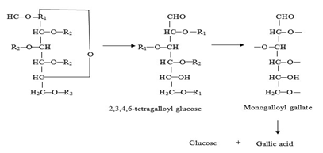

Figure 1: Hydrolysis pathway of tannic acid by tannase
(Source: https://www.biotech-asia.org/vol5no1/tannase-enzyme-the-most-promising-biocatalyst-for-food-processing-industries/)

Tannase from different sources, have different molecular masses such as in the case of fungi and yeasts are glycoproteins and often form hetero- or homo-oligomers with two to eight subunits. Bacterial tannases on the other hand, exist mainly as monomers (11). The dual activities of tannase cause this enzyme to have a wider range of substrate specificity. This specificity depends on the source and the methods utilized for its production and isolation (10, 11). Apart from it being a bi-functional enzyme, tannase also exists as isoenzymes. Tannase hydrolyzes other substrates such as methyl gallate, propyl gallate, digallic acid, epicatechin gallate, and epigallocatechin gallate-releasing gallic acid (12). Tannase also acts on ellagitannins such as rosacyanin or phyllanemblinin. In those cases, tannase selectively hydrolyses the galloyl moieties, yielding gallic acid and degalloylated ellagitannins (13).
Tannase are a family of serine esterases, with a catalytic triad having its serine residue present in the conserved pentapeptide motif (-Gly-X-Ser-X-Gly-) which is necessary for its catalytic activity (10, 11). The enzyme’s mechanism of action was best described by Ren, et al., (2013) for the Lactobacillus plantarum tannase. After the substrate binds to the enzyme, the hydroxyl group of Ser163 starts a nucleophilic attack on the carbonyl unit of the galloyl unit. This attack is assisted by His451 that acts as a general base. This causes the formation of a tetrahedral intermediate, stabilized by hydrogen-bonding interactions with Gly77 and Gly164 that form the oxyanion hole. His451-H acts as a general acid, the tetrahedral intermediate then collapses to produce the alcohol product and the acyl-enzyme intermediate. A water molecule is then activated by His451 to attack the acyl-enzyme to form the second tetrahedral intermediate, which then collapses to release gallic acid and regenerate the enzyme.

III. APPLICATION OF TANNINS IN VARIOUS INDUSTRY

Tannins, naturally occurring polyphenolic compounds, find applications in various industries due to their diverse properties:

- Food and Beverage Industry
Tannins are utilized in winemaking, where they contribute to the color, flavor, and mouthfeel of wines. They are also used in brewing, providing astringency and stabilizing proteins. Additionally, tannins are used as natural food additives for their antioxidant properties and as natural preservatives in food products.

- Leather Industry
Tannins have been used for centuries in the tanning process to convert animal hides into leather. They bind to collagen fibers, making the leather more durable, flexible, and resistant to decay.

- Pharmaceutical Industry
Tannins exhibit antimicrobial, anti-inflammatory, and antioxidant properties, making them valuable in the development of pharmaceutical products. They are used in traditional medicine for wound healing, treating diarrhea, and managing various ailments.

- Textile Industry
Tannins can be employed as natural dyes or mordants to enhance colorfastness in textiles. They provide rich and vibrant colors and can be used with both natural and synthetic fibers.

- Water Treatment
Tannins are effective in water treatment processes, particularly for the removal of organic contaminants and heavy metals. They act as natural coagulants and flocculants, aiding in the purification of water in industries such as municipal water treatment and wastewater management.

- Wood and Paper Industry
Tannins are used in wood adhesives, providing improved bonding properties. In the paper industry, tannins are utilized as natural dispersants and fillers, enhancing the paper's quality and strength.

- Cosmetics and Personal Care Industry
Tannins are utilized in skincare products for their astringent properties. They can help tighten pores, control excess oil, and provide a toning effect on the skin.

- Antibacterial properties of tannins
Tannin and its derivatives show great antibacterial properties which are used against a large number of bacterial species such as Aeromanas, Bacillus, Clostridium, Enterobacter, Helicobacter, Klebsiella, Proteus, Pseudomonas, Shigella, Escherichia, Staphylococcus, or Streptococcus and fungal species like Aspergillus, Coniophora, or Penicillium. Antibacterial activity of tannins particularly, polymeric proanthocyanidins proved highly effective against Escherichia coli and Staphylococcus aureus. It is attribute to binding of tannins with urinary tract epithelium and intestinal epithelium that prevent binding of disease-causing organisms. In view of above findings, tannic acid is used as an inhibitor and immunomodulatory against multidrug resistant bacteria (MDR). The antibacterial properties of tannins are not only studied in animals but in plants too.
Recently, crude methanol extract of Sapium baccatum was used against the Ralstonia solanacearum, a causal agent of bacterial wilt of tomato. The extract mainly contains gallic acid, methyl gallate, corilagin, tercatain, chebulagic acid, chebulinic acid, and quercetin 3-O-α-L-arabinopyranoside which all show strong antibacterial activity except one tannin-based product, that is, quercetin 3-O-α-L-arabinopyranoside. In in vivo studies, the concentration of 2000 and 1000 μg/mL of crude extract reduced the development of tomato bacterial wilt by 83 and 63%, respectively. Tannin and its derivatives show great antibacterial properties which are used against a large number of bacterial species such as Aeromanas, Bacillus, Clostridium, Enterobacter, Helicobacter, Klebsiella, Proteus, Pseudomonas, Shigella, Escherichia, Staphylococcus, or Streptococcus and fungal species like Aspergillus, Coniophora, or Penicillium. Antibacterial activity of tannins particularly, polymeric proanthocyanidins proved highly effective against Escherichia coli and Staphylococcus aureus. It is attribute to binding of tannins with urinary tract epithelium and intestinal epithelium that prevent binding of disease-causing organisms. In view of above findings, tannic acid is used as an inhibitor and immunomodulatory against multidrug resistant bacteria (MDR).
The antibacterial properties of tannins are not only studied in animals but in plants too. Recently, crude methanol extract of Sapium baccatum was used against the Ralstonia solanacearum, a causal agent of bacterial wilt of tomato. The extract mainly contains gallic acid, methyl gallate, corilagin, tercatain, chebulagic acid, chebulinic acid, and quercetin 3-O-α-L-arabinopyranoside which all show strong antibacterial activity except one tannin-based product, that is, quercetin 3-O-α-L-arabinopyranoside. In in vivo studies, the concentration of 2000 and 1000 μg/mL of crude extract reduced the development of tomato bacterial wilt by 83 and 63%, respectively.

IV. MATERIAL AND METHODS

Faecal samples were collected from goat farm. Faecal sample was serially diluted and plated on Tannic acid agar medium (TAA) and incubated at 37º C for 96 hours. Addition of tannic acid to nutrient agar forms a tannin–protein complex; cleavage of this complex by bacteria producing tannase forms a zone around the colonies. After incubation TAA plates were flooded with Gram’s iodine instead of FeCl₃ (14). Gram’s iodine formed a dark brown complex with tannic acid but not with hydrolysed tannic acid and giving a sharp distinct zone around the tannase producing microbial colonies even in cases of low levels of tannase production. Colonies exhibiting clear zone of tannic acid hydrolysis were selected as tannase producers. Secondary screening was carried out on the basis of study of zone of tannic acid hydrolysis activity of the different isolates. The colony showing highest zone was selected for further studies.
Carbohydrates with free aldehyde or ketone groups have the ability to reduce solutions of various metallic ions. Reducing sugars under alkaline conditions tautomerize and form enediols. Enediols are powerful reducing agents. They reduce cupric ions to cuprous form and are themselves converted to sugar acids. The cuprous ions combine with OH- ions to form yellow cuprous hydroxide which upon heating is converted to red cuprous oxide.

A. Identification of tannase producing bacteria
The isolate was sub cultured on nutrient agar medium. Colony characteristics such as size, shape, texture, consistency and transparency were noted down. Gram staining was carried out for the isolate. Biochemical tests like Indole test, Methyl red test, Voges- Proskauer, Triple sugar iron (TSI) agar test and Carbohydrate utilization test were performed for the isolate.

B. Tannase production
The isolate which produced maximum zone in Tannic Acid agar plates was inoculated in to 50 ml of tannic acid broth in a 250 ml Erlenmeyer flask and incubated at 37ºC for 24 hours. The culture was filtered and the filtrate was used as the crude enzyme for tannase assay.

C. Estimation of Tannase by Folin lowry method
The concentration of Tannase was estimated by Folin lowry method (1951), using Bovine serum albumin (BSA) as Standard (15) with a concentration of 0.1 mg/ ml.

D. Thin Layer Chromatography - Analysis of Gallic Acid
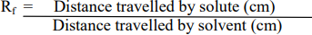
Tannase catalyzes the hydrolysis of tannic acid to release glucose and gallic acid. The active culture of isolates was inoculated in Nutrient broth containing Tannic acid and incubated for 24 – 48 hrs. Then the culture was centrifuged and the supernatant was used for detection of gallic acid by TLC. The degradation product gallic acid liberated by the action of tannase from bacterial isolate was detected by thin layer chromatography. The solvent system, ethyl acetate: chloroform: acetic acid in a ratio of 50:50:1 was used for the study. The results were visualized by using iodine crystal vapour. Retention factor (Rf) value was calculated according to the following equation from the chromatogram.

E. Detection of Glucose by DNS Method

The concentration of glucose was estimated by DNS (3, 5-Dinitrosalicylic acid), using glucose as Standard with a concentration of 1 mg/ ml.

F. Effect of Temperature and pH on Tannase activity and determination of glucose production by DNS method
Tannase activity was determined by estimating the reduced glucose liberated using 3,5- dinitrosalicylic method. To 1 ml of supernatant (crude enzyme), 1 ml (0.1M) acetate buffer (pH 7.0), 1ml (0.5%) tannic acid as substrate was added and incubated for 15 min at 5°C, 27°C, 37°C, 48°C respectively. DNS of 0.5 ml was added to all the test tubes, the contents were incubated for 10 min in a boiling water bath and cooled to room temperature, 0.5 ml of distilled water was added to all test tubes, contents were mixed and absorbance was recorded at 540 nm.
Tannase activity was determined by estimating the reduced glucose liberated using 3,5- dinitrosalicylic method. To 1 ml of supernatant (crude enzyme), 1ml (0.5%) tannic acid as substrate and 1 ml (0.1M) acetate buffer adjusted pH to 4.0, 5.0, 6.0 and 8.0 added respectively and incubated for 15 min, 1ml (0.5%) tannic acid as substrate was added and incubated for 15 min at 37°C respectively. To all the test tubes, DNS of 0.5 ml was added, the contents were mixed, incubated for 10 min in a boiling water bath and cooled to room temperature, 0.5 ml of distilled water was added to all test tubes, contents were mixed and absorbance was recorded at 540 nm.
The activity was calculated using following formula:
Enzyme Activity = (Amount of Product formed) / (Time) / (Volume of enzyme solution)

G. Antibacterial activity of tannase
Agar well diffusion method was used to evaluate the antimicrobial activity. The agar plate surface was inoculated by spreading a volume of the microbial inoculum over the entire agar surface. Then, a hole with a diameter of 6 to 8 mm was punched aseptically with a sterile cork borer and a volume (20 µl) of the supernatant (antimicrobial agent) was added into the well. The agar plates were incubated at 37°C for 24 hr. The antimicrobial agent diffuses in the agar medium and inhibits the growth of the bacteria.

V. RESULTS AND DISCUSSION

A. Isolation and Screening of Tannase Producing Bacteria
Six morphologically different bacterial colonies were obtained from the faecal samples which showed tannic acid hydrolysis on TAA (Tannic acid agar medium) plates. Out of six isolates T1 and T2 exhibited maximum zone (25 mm) of tannic acid hydrolysis, were selected for further studies. Bacillus subtilis showed clear zone of clearance around the isolates after 72 hr (8). The tannase producing bacteria were isolated from tannin rich sources (16), their study was in correspondence with the present data.
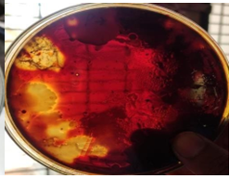

Figure 2: Tannic acid hydrolysis by T1 & T2 bacterial isolate detected by addition of iodine

B. Cultural, Morphological and Biochemical Characteristics of Isolate
Cultural, morphological and biochemical characteristics of Bacterial isolate T1 & T2 were studied and the results are represented in Figure 3, Figure 4 and Table 1. The colony of T1 was large in size, irregular, wavy, opaque and cream in colour with moist consistency. The T1 and T2 isolates were gram positive and non-motile. T1 isolate showed M-R test positive, fermentation test for glucose, maltose and lactose was positive (Table 3); positive for triple sugar iron test; positive for citrate test. The T2 isolate colony was medium in size, round, smooth, opaque and cream in colour with moist consistency. T2 showed M-R test positive, fermentation test for glucose, lactose was positive and maltose negative. The T2 isolate was negative for citrate test. Both the isolates (T1 and T2) were positive for indole test and negative for Voges Prauskauer test (Table 2, Figure 5). The cultural characteristics, biochemical reactions and Carbohydrate utilization tests of the isolates were compared with Bergey’s Manual of Systematic Bacteriology and was found to be Corynebacterium xerosis (T1 isolate) and Corynebacterium kutseri (T2 isolate). The tannase enzyme producing bacteria isolated from tea waste dump soil site and maximum tannase activity produced by Corynebacterium striatum III B 8914, and was positive for MR test, fermentation of sugars like glucose, maltose and lactose were analysed and triple sugar iron test was found to be positive (17) and the results were in accordance with the present data.
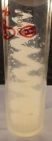
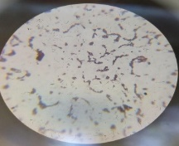

Figure 3: T1 Isolate - Growth on nutrient agar slant and
Microscopic view – Gram positive short rods
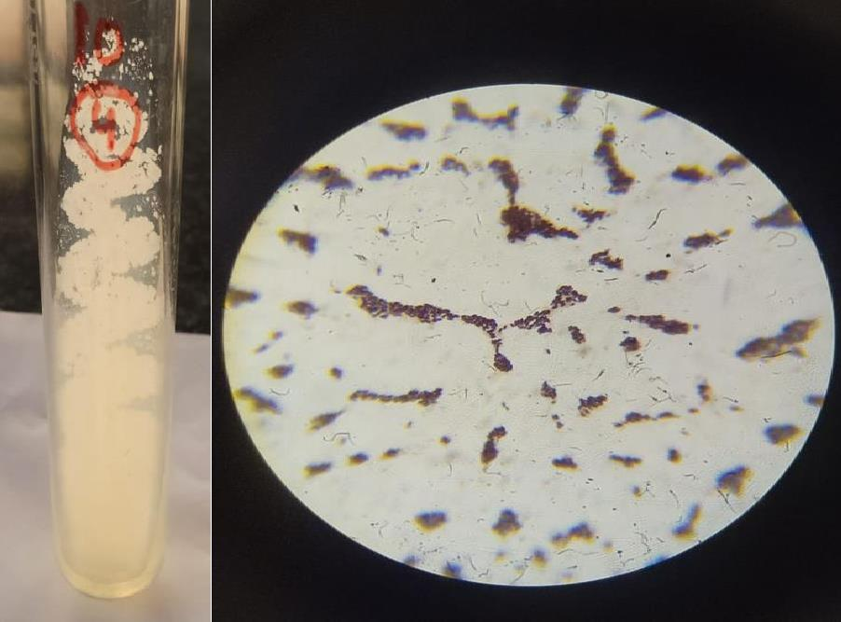

Figure 4: T2 Isolate - Growth on nutrient agar slant and

Microscopic view – Gram positive short rods

Table 1: Colony morphology and Gram nature studies of isolates

Isolate | Colony  characters | Morphological characters
 |  | Gram nature, Shape of the cell | Endospore | Acid fast | Motility | Identification
T1 | Large, Irregular, Opaque, Moist Cream colour | Positive, short rods | - | - | - | Corynebacterium xerosis
T2 | Medium in size, Round, Smooth, Opaque, Cream colour, Moist consistency | Positive, short rods | - | - | - | Corynebacterium kutseri

Table 2: Biochemical tests
Biochemical Test | T1 Isolate | T2 Isolate
Indole | - | +
Methyl red | + | +
Voges Proskauer | - | -
Citrate | + | -
Catalase | + | +
Oxidase | - | -
Starch | - | +
H₂S | - | -
Urease | - | +

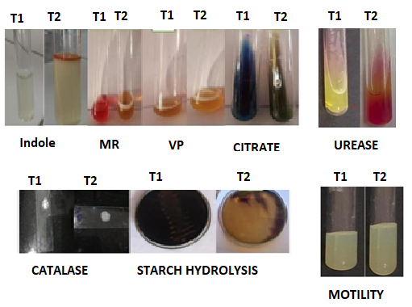

Figure 5: Biochemical tests

Table 3: Carbohydrate fermentation tests

Isolate | Glucose |  | Lactose |  | Mannitol
 | Acid | Gas | Acid | Gas | Acid | Gas
T1 | Positive | Positive | Negative | Negative | Positive | Positive
T2 | Positive | Negative | Positive | Positive | Positive | Positive

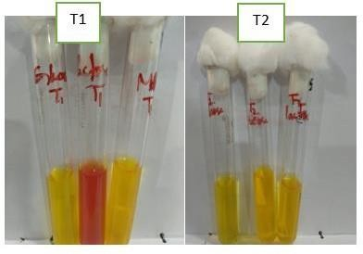

Figure 4.5: Carbohydrate fermentation tests

C. Estimation of tannase by Folin Lowry method
The maximum tannase production was observed in T2 isolate, 0.61mg/ml compared to T1 isolate, 0.49 mg/ml (Figure 6). The study result was in accordance with purification method of tannin acyl hydrolase and maximum tannase production (0.61mg/ml) was by Bacillus subtilus. (18).

Figure 6: Estimation of tannase by Folin Lowry method

D. Thin Layer Chromatography – For the detection of Gallic Acid
Thin layer chromatography (TLC) was used to detect, the presence of gallic acid as a product of tannin hydrolysis. Pure gallic acid was used as standard, and was compared with the test (T1 and T2 isolates) to detect the presence of gallic acid. The Rf value of pure Gallic acid was 2.5, T1 isolate was 2.2 and T2 isolate was 2.4 (Figure 7). The Rf value of isolates was nearer to the pure Gallic acid. The study showed that the isolates were producing Tannase, hydrolyzed tannic acid to Gallic acid. The Rf value of standard gallic acid was 1.0 and the Rf value of test sample was 0.90, which is nearer to the Rf value of standard gallic acid, the tannic acid was hydrolysed by the tannase enzyme produced by Bacillus megaterium (19), this investigation was in correspondence with the present data.

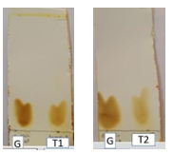

Figure 7: Thin layer chromatography of gallic acid by isolate T1 and T2
G: Gallic acid

E. Detection of glucose by DNS method
The concentration of glucose produced by hydrolysis of tannic acid was estimated by DNS method and it was observed as 0.32 mg/ml by T1 isolate and 0.31mg/ml by T2 isolate (Figure 8). The tannase assay was studied by spectrophometrically and concentration of glucose produced by hydrolysis of tannase was estimated as 0.35mg/ml (20), which was correspondence to the present data.

Figure 8: Detection of glucose by DNS method

F. Effect of Temperature and pH on Tannase activity and determination of glucose production by DNS method
The T2 isolate showed maximum tannase activity, 16.5 U/mL at 37ᴼC (Figure 9). The maximum tannase activity by Pseudomonas aeruginosaIII B 8914 was observed at an incubation temperature of 37 °C (21). The maximum tannase activity was observed at 30°C by Citrobacter freundii (22). The maximum tannase activity was observed at pH 8 (Figure 10) with both the isolates T1 (16.2 U/mL) and T2 (16.1 U/mL). An optimum pH of 7 for Pseudomonas aeruginosa III B 8914 (21), while an optimum pH of 6 for Bacillus cereus KBR9 reported maximum tannase activity (21, 23). For Bacillus lichiniformis KBR6, the tannnase activity was maximum at optimum pH 7.5 (23).

Figure 9: Effect of Temperature on Tannase

Figure 9: Effect of Temperature on Tannase activity

Figure 10: Effect of pH on Tannase activity

G. Antibacterial activity of Tannase
The Staphylococcus aureus showed maximum sensitivity, E. coli showed least sensitivity, Pseudomonas sp and Proteus sp were resistant to tannase of T2 isolate. Theindicator organisms were resistant to tannase of T1 isolate The Staphylococcus aureus and Bacillus sp showed maximum sensitivity to tannase produced by Citrobacter sp isolated from water and soil samples (24).

Zone of inhibition (mm)
Indicator organism | T1 | T2
E.coli | - | 0.2
Pseudomonas sp | - | -
Staphylococcus aureus | - | 0.6
Bacillus sp | - | 0.5
Klebsiella sp | - | 0.4
Proteus sp | - | -

Figure 10: Antibacterial activity of Tannase

VI. CONCLUSION

Faecal sample was used to isolate the bacteria having natural ability to degrade hydrolysable tannins by producing tannase. Six bacterial strains were isolated from goat faecal sample. Among them isolate T1 and isolate T2 was selected which could hydrolysis tannin. The isolate was identified by morphological and biochemical characteristics and was found to be Corynebacterium xerosis and Corynebacterium kutseri. Temperature played a major role in tannase production. The T2 isolate showed maximum tannase activity (16.5 U/mL) at 37ºC for 15 mins of incubation period. The T2 and T1, both showed maximum tannase activity (16.2 U/mL and 16.1 U/mL) at pH 8 for 15 min of incubation period.

REFERENCES
[1] Bhat, T. K., Singh, B. and Sharma, O. P. (1998). Microbial degradation of tannins-A current perspective. Biodegradation. 25: 343-357.
[2] Mondal, K. C., Banerjee, D., Jana, M. and Pati, B. R. (2001). Colorimetric assay method for determination of tannin acyl hydrolase (E.C. 3.1.1.20)
activity. Anal Biochem 295: 168-171.
[3] Pourrat H, Regerat F, Morvan P, Pourrat A. (1987). Microbiological production of gallic acid from Rhus coriaria L. Biotechnol. Lett. 9: 731-734.
[4] Lekha, P.K., Lonsane, B. K. (1997). Production and application of tannin acyl hydrolase: state of the art. Adv. Appl. Microbiol. 44: 215-260.
[5] Das Mohapatra, P.K., Mondal, K. C. Pati, B. R., Halder, S. K., Maity, C. and Jana, A. 2012). Rapid screening of tannase producing microbes by
using natural tannin. Braz. J. Microbiol. 43(3):1080-1083
[6] Koichi, Y. and Tokuji, T. (1972). Wine making using Tannase in fermentation process, Japanese patent 2224100.
[7] Belur, P. D., Gopal, M., Nirmala, K. R and Basavaraj, N. (2010). Production of novel cell-associated tannase from newly isolated Serratia ficaria
DTC. Journal of Microbiology and Biotechnology. 20(4): 732-736.
[8] Jana, A., Maity, C., Halder, S.K., Mondal, K.C., Pati, B.R.and Mohapatra, P.K.D. (2013). “Enhanced tannase production by Bacillus subtilis PAB2
with concomitant antioxidant production”. Biocatalysis Agricultural Biotechnology, 2: 363-371.
[9] Haslam, E. and Stangroom, J. E. (1966). The esterase and depsidase activities of tannase. Journal of Biochem. 99: 28-31.
[10] Rodriguez-Dur´an, L. V., Valdivia-Urdiales, B., Contreras-Esquivel, J. C., Rodriguez- Herrera, R. and Aguilar, C.N. (2011). Novel
Strategies for Upstream and Downstream Processing of Tannin Acyl Hydrolase. Enzyme Research. 823619.
[11] Ren, B., Wu, M., Wang, Q., Peng, X., Wen, H., McKinstry, W.J. and Chen, Q. (2013). Crystal structure of Tannase from Lactobacillus
plantarum. Journal of Molecular Biology. 425: 2737-2751.
[12] Curiel, J. A., Rodriguez, H., Acebrion, I., Mancheno, J. M., de Blanca Rivas, L. and Munoz, R. (2009). Production and physicochemical
properties of recombinant Lactobacillus plantarum tannase. Journal of Agricultural and Food Chemistry. 57 (14): 6224-6230
[13] Lu, M. J. and Chen, C. (2007). Enzymatic tannase treatment of green tea increases in vitro inhibitory activity against N-nitrosation of
dimethylamine. Process Biochemistry. 42: 91285–1290.
[14] Rakesh Kumar., Ashwani Kumar., Ravinder Nagpal., Jitender Sharma and Anju Kumari. (2010). A novel and sensitive plate assay for screening
of tannase-producing bacteria. Annals of Microbiology. 60: 177-179.
[15] Lowry, O. H., Rosebrough, N. J., Farr, A. L., Randall, R. J. (1951). Protein measurement with the Folin phenol reagent. J Biol Chem.193(1): 265-
75.
[16] Hamada A. Abou-Bakr., Malak A. El-Sahn and Amr A. El-BannaInt. (2013). International Journal of Agricultural and Food Research. 2 (3): 1-
12.
[17] Dave, A., Modi., H.A., Chavada, N. (2011). Study and isolation of tannase enzyme production bacteria from tea waste dump soil site. Int. J. Pharm.
Appl. Sci. 2(1): 20-22.
[18] Iibuchi, S., Monida, Y. and Yamada, K. (1967). Studies on tannin acylhydrolase of micro-organisms Part III. Purification of enzyme and some
properties of it. Agr. Biol. Chem. 32: 803-809.
[19] Archana D. Tripathi, Kajal Sharma and Lakshmi B. (2016). Study on Tannase Producing Bacillus megaterium Isolated fromTannery Effluent. Int.
J. Adv. Res. Biol. Sci. 3(7): 28-35.
[20] Sharma, S., Bhat, T.K. and Dawra, R.K. (2000). A Spectrophotometric Method for Assay of Tannase using Rhodonine. Analytical Biochemistry.
278: 8589.
[21] Selwal, M.K., Yadav, A., Selwal, K.K., Aggarwal, N.K., Gupta, R. and Gautam, S.K. 2010. Optimization of culture conditions for tannase
production by Pseudomonas aeruginosa III B 8914 under submerged fermentation. Wolrld J. Micrbiol. Biotechnol. 26: 599-605.
[22] Kumar, R. A., Gunasekaran, O. and Lakshmanan, M. (1999). Biodegradation of tannic acid by Citrobacter freundii isolated from tannery
effluent. Journal of Basic Microbiology. 39:161-168
[23] Mondal, K.C., Banerjee, D., Banerjee, R and Pati, B.R. (2001). Production and characterization of tannase from Bacillus cereus KBR9. The
Journal of general and applied microbiology.47: 263-267.
[24] Wilson, P.A., Rojan, P.J., Kumar, P. and Sabu, T. (2009). Tannin Acyl Hydrolase Production by Citrobacter species isolatedfrom Tannin rich
Environment, using Tamarindus indica seed, powder. Journal of Applied Sciences and Environmental Management.13: 95-97.

