Psidium Guineense: A Review on its Pharmacological Potential

Akshat Jain, Dulendra Damahe*, Abhiram Patil, Somya Singh, Priti Singh, Sachin B. Narkhede
Smt. B.N.B. Swaminarayan Pharmacy College, Salvav-Vapi 396191 Gujarat, India
Email: d.damahe@gmail.com

Psidium guineense is a medicinal plant that has been used traditionally for its curative nature concerning different types of diseases. This review article is concerned with the plant's chemical composition and pharmacological potential for its optimal valuation. Seven phytochemical constituents were isolated from different parts of the shrub by using specified solvents. NMR identified the first chemical constituent as steroid sitosterol. The second compound was identified as triterpene ursolic acid using 1D and 2D NMR. The third compound was recorded as an antioxidant and cytotoxic activity-pursuing agent. The fourth compound was confirmed to be tyrosol ester derivative, 2-(4-hydroxyphenyl) ethyl hexanoate by 1H NMR spectrum. The last compound was found to be 17³-ethoxyphaeophorbide A, a derivative of chlorophyll. An antioxidant activity noted by DPPH, ABTS; and MDA methods in combination with spathulenol. The highest antioxidant effect was recorded for antioxidant activity on the serum antioxidant capacity test performed on Wistar rats. The most active compounds were limonene (0.3-47.4%),-pinene (0.1-35.6%), -caryophyllene(0.1-24.0%), epi-bisabolol(6.5-18.1%), caryophyllene oxide(0.3-14.1%) and ar-curcumin. P. guineense was reported for its antioxidant, anti-microbial, and anti-inflammatory properties and nutritional value.

Keywords:
Psidium guineense, Brazilian Guava, Antimicrobial, Anti-Inflammatory, Antioxidant, Myrtaceae

Introduction:
Known as a hotspot for biodiversity conservation, the Brazilian Savanna is home to at least 837 bird species, 161 mammal species, 150 amphibian species, and 120 reptile species, as well as several indigenous floras. One of the indigenous species in this extraordinarily diverse assemblage of nature is the Psidium species. About 266 different species of Psidium may be found throughout the world's tropical and subtropical climates. Because essential oils are present and because of the diversity of their chemical and biological makeup, Psidium species offer excellent ecological, economic, and medicinal characteristics. The Psidium guineense species is the subject of this review article, which focuses on both its chemical makeup and its potential medicinal applications. A native shrub of the Brazilian savanna belonging to the Myrtaceae family, it is sometimes referred to as "araca", Brazilian guava, or guava. The twisted stem, smooth bark, and leathery leaves help identify the plant. This evergreen shrub has successfully adapted to the soil and climate of northeastern Brazil, where it spreads out naturally. They are renowned for their berry-like fruits with pale flesh that emerges with many seeds and is coated in many types of colored peels, including yellow, red, and purple. In addition to Psidium guineense, it has been noted that the Brazil central west area is geographical native to species of the Psidium laruotteanum Cambess, Psidium firmum O.Berg, Psidium myrsinites DC, Psidium sartorianum, and Psidium salutare types. The aim of the review article is to provide a brief insight of the chemical and pharmacological power of the plant for its optimal valuation.

Common names:
Brazilian Guava, Sour Guava, Guinea Guava

Taxonomical Classifications:
The taxonomical classification of the shrub is:

Table 1: Scientific classification of Psidium guineense

Kingdom | Plantae
Division | Magnoliophyta
Class | Magnoliopsida
Order | Myrtales
Family | Myrtaceae
Genus | Psidium
Species | Psidium guineense

Plant (Shrub) Description:
P. guineense is a slow-growing shrub with a typical height of 1-3 meters and a maximum height of 7 meters. The greyish bark, immature shoots, and cylindrical or slightly flattened branchlets of this shrub can all be used to identify it. Morphologically, leaves are oblong, elliptic, or ovate-shaped, measuring 3.5 to 14 cm long and 2.5 to 8 cm wide. The lower portion of the leaf is marked with glands and coated in light or rust-colored hairs, while the top portion has sparsely haired or occasionally finely toothed hairs on it.
The blooms of the leaves, which may grow single or in group of three, develop in the axils. They have a white color and 150–200 noticeable filaments that protrude from the bloom. The mature, 1-2.5 cm broad fruit has a round or oblong form. The flesh around the white center pulp is surrounded by thickened, pale-yellowish skin that is typically yellow. They taste somewhat like strawberries and are acidic, resinous, and resinous. It has a large number of tiny, firm seeds once it has fully ripened.

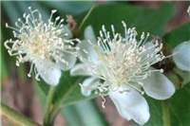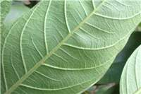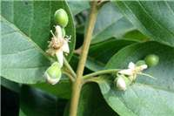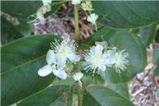
(FIG 1: Representing different parts of P. guineense (Source: Sheldon Navie Photographs)

Various Species:

Table 2: Various species of Psidium guineense

Psidium amplexicaule | Psidium incanescens
Psidium araaoRaddi | Psidium montanum
Psidium aracaRaddi | Psidium pedicellatum
Psidiuma ustraleCambess | Psidium robustum
Psidium friedrichsthalium | Psidium cinereum
Psidium galapageium | Psidium harrisianum
Psidium guajava | Psidium sartorianum
Psidium firmum | Psidium sintenisii
Bioactives:
Using certain solvents, seven phytochemical components with known pharmacological effects may be extracted from various shrub sections. The first substance, which was isolated as colorless crystals, was identified as the steroid sitosterol by NMR. This phytosteroid is widely recognized for acting as an anti-inflammatory in the body and as a vitamin D precursor. Second, a white powdered chemical component was extracted, and using 1D and 2D NMR, it was determined to be the triterpene ursolic acid. This substance, which is most frequently identified as belonging to the Myrtaceae family, shows wide variety of pharmacological effects, including anti-inflammatory, cytotoxic, anti-HIV, and antiplatelet effects. The third substance was shown to be a cytotoxic activity-pursuing agent as well as an antioxidant. It was discovered as a green solid and eventually identified as 17³-ethoxyphaeophorbide A, a chlorophyll derivative. The identity of the fourth molecule, 2-(4-hydroxyphenyl) ethyl hexanoate, a tyrosol ester derivative, was established by the 1H NMR spectra after it was separated as a yellow solid using ethyl acetate. Its pharmacological effect has not yet been discovered. Next, the fifth, sixth, and seventh compounds—were found as the flavonoids kaempferol, rutin, and quercetin—were separated as yellow solids using methanol as a solvent. They are widely known for their multi-targeting, anti-inflammatory, antiviral, and antioxidant actions.
The rich literature work shows different biological and pharmacological potentials of secondary metabolites as antioxidant, anti-inflammatory and antimicrobial activities. Hence, give proper justification for the traditional use of P. guineense.

VOLATILE PROFILE:
Additionally, several volatile oils were extracted from the shrub's leafy portion using the hydro-distillation method, and they were then identified using GC and GC-MS. The monoterpene and sesquiterpene componenets in the separated oils were abundant. The C10 skeletons are divided into acyclic kinds such as myrcene, limonene, p-menthane, bornane, and thujane. Acyclic cadinene, germacrene, β-caryophyllene, caryophyllene oxide,α-copaene, ar-curcumin, β-bisabolene, muurola-4,10(14)-dien-1-β-ol, epi-β-bisabolol, and β -bisabolol are examples of compounds that include the C15 skeletal groups. As seen in ( FIG-2). Citing many publications led to the conclusion that limonene, α-pinene, and β-caryophyllene had anti-inflammatory properties. Studies conducted in vivo and in vitro revealed that limonene has anti-inflammatory properties; as a result, it has been recommended as a dietary supplement to help reduce inflammation.
A intrude of peritoneal decreased exudates leukocytes and the numbers of polymorphonuclear leukocytes were also reduced, in the induced peritonitis. The anti-phlogistic effect of α-Pinene was noted in human chondrocytes, exhibiting potential anti-osteoarthritic activity. The β-caryophyllene was also evaluated for its anti-inflammatory effect.
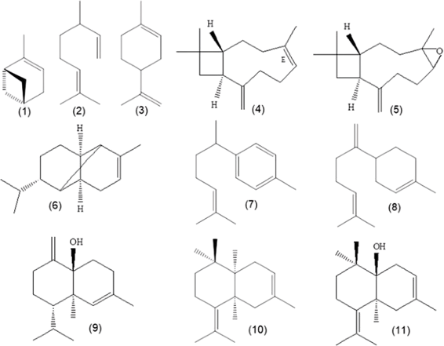

(FIG-2 Main components spotted in the oils of P. guineense: (1) α-pinene, (2) myrcene, (3) limonene, (4) β-caryophyllene, (5) caryophyllene oxide, (6) α-copaene, (7) ar-curcumene, (8) β-bisabolene, (9) muurola-4,10(14)-dien-1-β-ol, (10) epi-β-bisabolol, (11) β-bisabolol)

BIBLIOGRAPHIC SEARCH CRITERIA
Bibliographic research was performed using the Google search engine, PubMed, Science Direct, Research Gate, MedLine, Wikipedia, etc. Used keywords were Psidium guinennse, “Volatile oils” and “essential oils”.

CHEMICAL PROFILE AND THEIR GEOGRAPHICAL DISTRIBUTION:
P.guineense was classified into 16 chemical classes. Profiles I-XIII of them were from leaves and Profile XV-XVI (Profile XV extracted by SDE and Profile XVI extracted by HS-SPME) were from fruits. (As shown in FIG 3&4)
P.guineense is a botanical asset that shows wide commercial applications based on its fruits and functional elements as well as by the use of its leaves as an Anti-Phlogistic and Anti-bacterial agent. A research study was conducted by a selection of twelve Araca specimens with occurrences in various locations of Para state(PA), Brazil, which showed different compositions of leaf oils. The yield of oils from these twelve Araca samples ranged from 0.1-0.9%, where the acclamatory yields were from plants sampled from the Northeast of Para, Brazil(0.4-0.9%) and the underneath yields were from the specimens collected in the west of Para and Brazil.

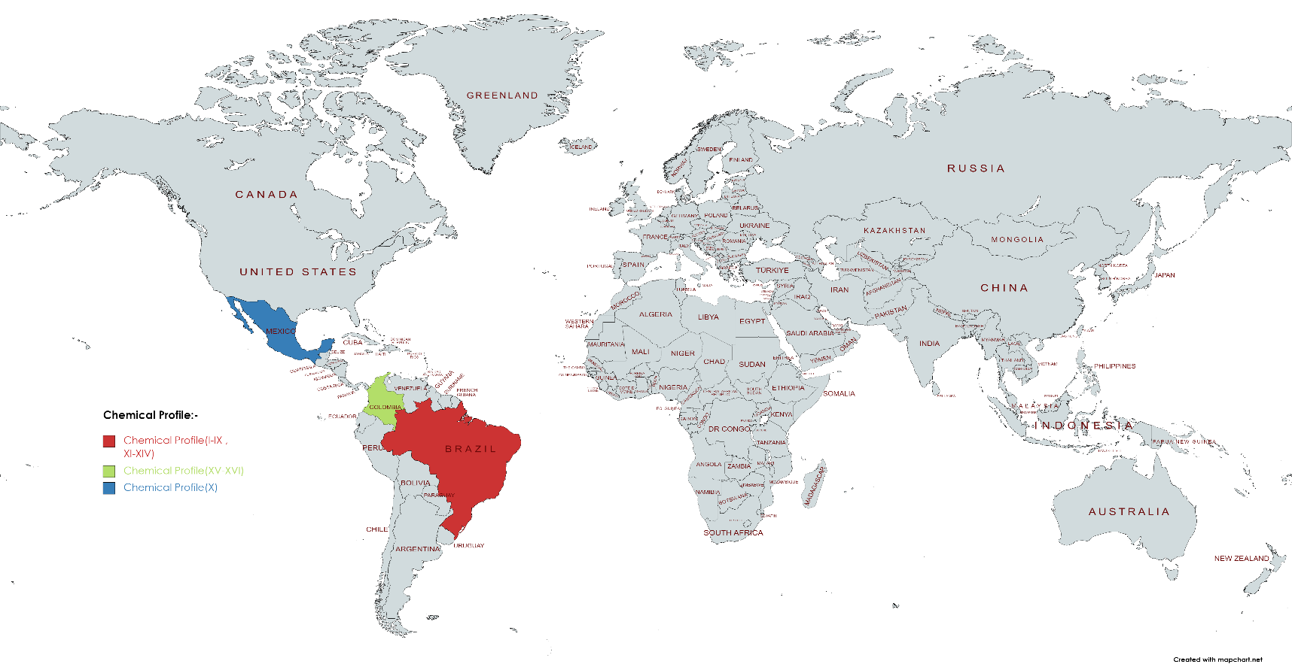
(FIG-3 DIFFERENT CHEMICAL PROFILES ALONG WITH GEOGRAPHICAL LOCATION THROUGHOUT WORLD)

The spotting of the constituent of the oils by GC and GC-MS was 92.5% average, with a total of 157 compounds, where Limonene (0.3-47.4%), α- pinene(0.1-35.6%), β-caryophyllene(0.1-24.0%), epi-β-bisabolol(6.5-18.1%) caryophyllene oxide(0.3-14.1%),β-bisabolene(0.1-8.9%),α-copaene(0.3-8.1%), myrcene(0.1-7.3%), muurola-4,10(14)-dien-1-β- ol(1.6-5.8%), β-bisabolol(2.9-5.6%) and ar-curcumin (0.1-5.0%) were the prime components.

In general, the components which were spotted in the oils belong to the terpenoid class, with the predominance: Monoterpene hydrocarbon (0.9-72.6%), oxygenated sesquiterpenes(5.2-63.5%), sesquiterpenes hydrocarbon (5.6-46.7%) and oxygenated Monoterpenes(1.9-8.8%)

(FIG-4 CHEMICAL PROFILES ALONG WITH GEOGRAPHICAL LOCATION WITHIN BRAZIL)

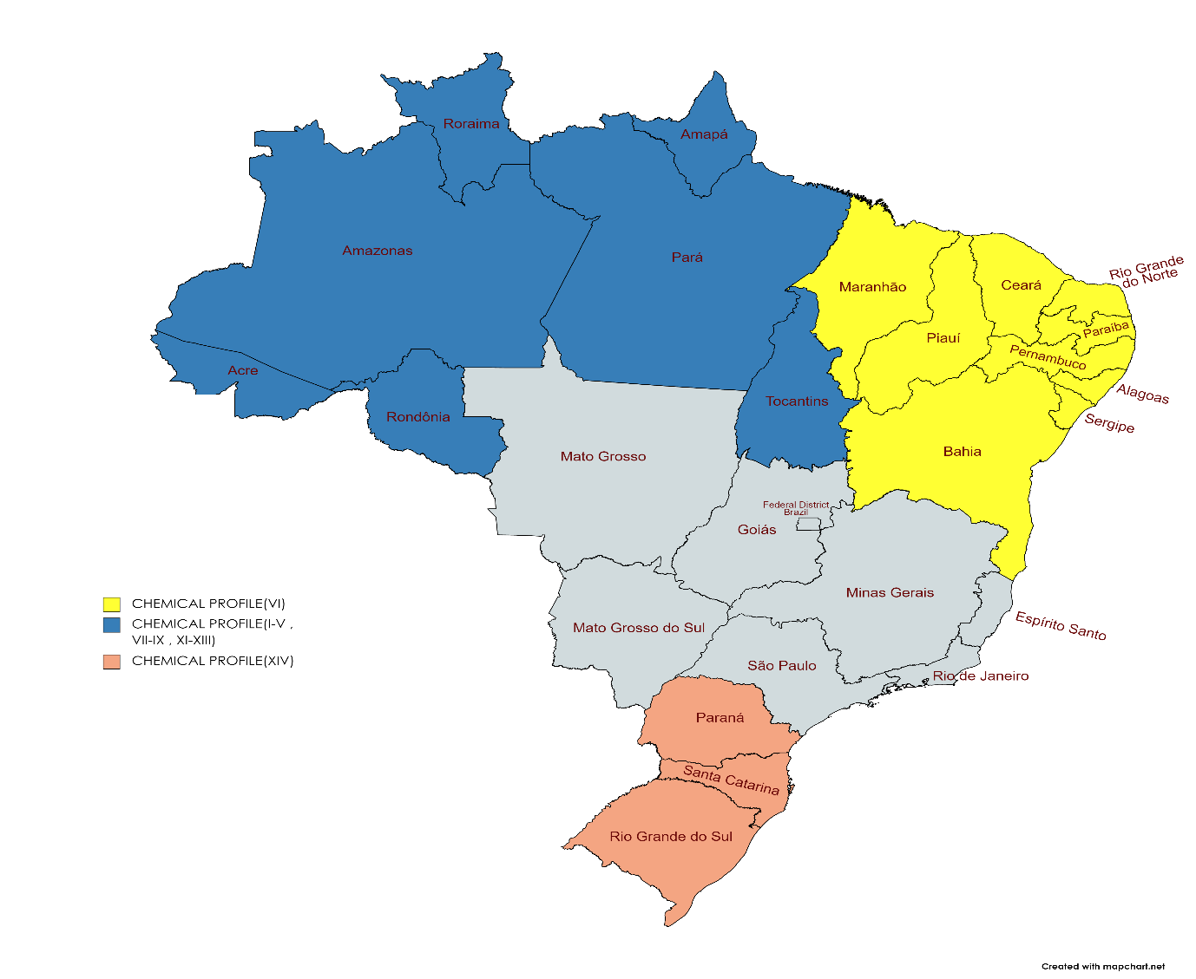
DIFFERENT CHEMICAL PROFILES WITH MAJOR VOLATILE OIL CONSTITUENTS AND GEOGRAPHICAL LOCATION.
CHEMICAL PROFILE | MAJOR CONSTITUENTS | GEOGRAPHICAL  LOCATION
I^{[34]} | LIMONENE(47.5%) | NORTHERN BRAZIL
II^{[35]} | LIMONENE(30.3%)  PINENE(17.7-34.0%) | NORTHERN  BRAZIL
III^{[35]} | LIMONENE(26.6%)  PINENE(13.6%)  COPAENE(7.3%) | NORTHERN BRAZIL
IV^{[35]} | LIMONENE(9.7%)  EPI β BISABOLOL(6.6%) | NORTHERN BRAZIL
V^{[35]} | LIMONENE(23.5%)  EPI β BISABOLOL(9.7%)  BISABOLENE(6.6%) | NORTHERN BRAZIL
VI^{[36]} | 1,8-CINEOLE(40.6%)  EUDESMOL(19.5%)  PINENE(13.8%)  ELEMOL(7.7%)  PINENE(8.8%)  ELEMOL(7.7%)  EUDESMOL(5.2%) | NORTHEAST  BRAZIL
VII^{[35]} | PINENE(35.6%)  COPAENE(8.1%)  E-CARYOPHYLLENE(6.1%)  MUUROLA-4,10-DIENE-1-OL(5.8%) | NORTHERN BRAZIL
VIII^{[35]} | PINENE(26.4%)  LIMONENE(14.0%)  E-CARYOPHYLLENE(5.2%) | NORTHERN  BRAZIL
IX^{[35]} | BISABOLENE(8.9%)  CURCUMENE(5.0%) | NORTHERN  BRAZIL
X^{[37]} | BISABOLENE(13.2%)  PINENE(12.7%)  Z-NEROLIDOL(5.5%)  SESQUIPHELLANDRENE(5.2%)  LIMONENE(5.1%) | MEXICO
XI^{[35]} | E-CARYOPHYLLENE(24.0%)  LIMONENE(5.4%) | NORTHERN  BRAZIL
XII^{[38]} | BISABOLOL(17.4%)  LIMONENE(6.8%)  EPI-BISABOLOL(6.8%) | NORTHERN BRAZIL
XIII^{[35]} | EPI- BISABOLOL(18.1%)  -BISABOLOL(5.6%) | NORTHERN  BRAZIL
XIV^{[39]} | SPATHULENOL(80.6%) | SOUTH BRAZIL
XV^{[40]} | E- CARYOPHYLLENE(8.6%)  BUTANOL(7.4%)  ETHYL BUTYRATE(7.8%)  SELIN-11-EN-4-OL(5.9%) | COLOMBIA
XVI^{[40]} | ETHYL BUTYRATE(30.3%)  ETHYL HEXANOATE(23.7%) | COLOMBIA

Pharmacological effect:

Antioxidant Activity:
When Wistar rats' serum antioxidant capacity was tested, P. guineense was found to generate antioxidant activity. The greatest levels of antioxidant activity were found when spathulenol was combined with the 2,2-diphenyl-1-picrylhydrazyl (DPPH), 2,2′-azino-bis-(3-ethylbenzothiazoline-6-sulfonic) acid (ABTS), and malondialdehyde (MDA) techniques. Lipid peroxidation, catalase, glutathione peroxidase, and superoxide dismutase have all been linked to significant alterations in the plasma antioxidant enzyme systems. Psidium guajava (PG) reportedly demonstrates its antioxidant effect by inhibiting NF-kβ activation and restoring enzymatic antioxidants.
Antimicrobial Activity:
The minimal inhibitory concentration of P. guineense in combination with other drugs was found to give a synergistic effect in the experiment held to determine the antimicrobial concentration of the same. The test for inhibition of microbial growth was carried out with S. aureus and P. aeruginosa which ended with the conclusion of antimicrobial activity against them of P.guineense.

Anti-phlogistic Activity:
Anti-phlogistic activity was recorded of P. guineense in the combination of spathulenol using two framework, including pleurisy and edema, in mice. 70 Brazilian medicinal plants were been collected and tested for their anti-inflammatory activity, of which P. guineense was one of them.

Anti-Diabetic Activity:
Blood glucose levels have reportedly been reduced with Psidium guineense. It has been demonstrated that guava fruit extract dramatically reverses weight loss and lowers blood glucose levels in diabetics.

Anti-Diarrheal Activity:
The primary constituent of Psidium guineense leaf extract, quercetin, inhibits the three symptoms of acute diarrheal sickness: decreased capillary permeation capacity in the gut cavity, and suppression of increased fluid secretion.

Antiviral Activity:
It has been discovered that the glycosyl flavonoids in Psidium guineense have antiviral properties. They can work in a variety of different ways, including blocking the virus' attachment to and entry into host cells, impeding certain viral translation or reproduction processes, and digesting polypeptides to prevent the virus from spreading to surrounding cells.

Anti-Coronaviral Activity:
The anti-coronavirus effectiveness of glycosyl flavonoids is partly due to the blockade of the enzymatic activity of significant target site involved in the phases of virus replication, such as SARS-CoV-2 3CLpro, spike glycoprotein, SARS-CoV-2 PLpro, and RdRp. However, during viral infection, alteration in the body's antioxidant defense mechanism lead to oxidative stress, which assist in viral pathological process by encouraging inflammation, a decline in immune function, and an increase in viral multiplication that may be caused by activation of the nuclear factor kappa B (NFᴋ-B) transcription pathway, which may result in a cytokine storm. Flavonoids have potent antioxidant effects that reduce the body's synthesis of reactive oxygen species (ROS), which may delay the apoptotic signals caused by coronaviruses.

Discussion:
Due to its therapeutic properties, this shrub might be considered the most significant shrubs in the world. Brazilian guava, often called as guava, is a plant that has historically been utilized for its ability to treat many ailments. This review's objective is to outline the shrub in question's phytochemical makeup and pharmacological effects. Guava has a significant percentage of lycopene, a carotenoid plant nutrient known for its anti-tumor and prostatic adenocarcinoma preventive properties. The fruit has helpful benefits for diabetes as well, since it is strong in dietary fibers, which can lower blood sugar levels. This fruit's anti-inflammatory properties can be utilized to treat patients with chronic pain. The fertility in humans can be enhanced with the help of a mineral known as folate present in it. The antimicrobial and antibacterial properties present in it can flush out all the toxins and bacteria present in the GIT. The presence of magnesium turns out to give a relaxant effect on our smooth muscles. The pinker the pulp it represents, the higher the concentration of lycopene in it.

Conclusion:
We can conclude with the results which show that Psidium guineense was examined for its anti-oxidant, anti-microbial, anti-inflammatory properties, and nutritional values. The upcoming researchers can go for its anti-diarrheal, anti-hypertensive, Analgesic, anti-cancer, anti-hypertensive, antifungal, and antipyretic properties examination in it. The fruit obtained from this plant is eatable (safe to eat) and can be eaten riped or even after cooking it also. Pulp can be used for the preparation of different types of beverages also. Leaves are also edible for their medicinal properties. This superfood is mainly used for its nutritional value present in it. So we should cultivate it in larger amounts so that more nutritional benefits of it can be used by many individuals at a cheaper cost.

Reference:
- Macaúbas-Silva C, Félix MD, Aquino AK, Pereira-Júnior PG, Brito EV, Oliveira-Filho AA, Igoli JO, Watson DG, Teles YC. Araçain, a tyrosol derivative and other phytochemicals from Psidium guineense Sw. Natural product research. 2019 Oct 3:1-5.
- Yahia EM, editor. Postharvest biology and technology of tropical and subtropical fruits: Mangosteen to white sapote. Elsevier; 2011 Jun 30.
- Lorca MA. Chilean Guava—Myrtus ugni. InExotic Fruits 2018 Jan 1 (pp. 129-139). Academic Press.
- Lim, T. K. Edible Medicinal and Non-Medicinal Plants: Volume 3, Fruits. Springer. 2012. pg. 728-29
- Figueiredo PL, Silva RC, da Silva JK, Suemitsu C, Mourão RH, Maia JG. Chemical variability in the essential oil of leaves of Araçá (Psidium guineense Sw.), with occurrence in the Amazon. Chemistry Central Journal. 2018 Dec; 12(1):1-1.
- Ortega JT, Estrada O, Serrano ML, Contreras W, Orsini G, Pujol FH, Rangel HR. Glycosylated Flavonoids from Psidium guineense as Major Inhibitors of HIV-1 Replication in vitro. Natural Product Communications. 2017 Jul;12(7):1934578X1701200712.
- Marques AM, Tuler AC, Carvalho CR, Carrijo TT, da Silva Ferreira MF, Clarindo WR. Refinement of the karyological aspects of Psidium guineense (Swartz, 1788): a comparison with Psidium guajava (Linnaeus, 1753). Comparative cytogenetics. 2016; 10(1):117.
- Rajput AP, Rajput TA. Isolation of Stigmasterol and β-Sitosterol from chloroform extract of leaves of Corchorus fascicularis Lam. International Journal of biological chemistry. 2012;6(4):130-5.
- Gupta A, Maheta P, Chauhan R, Pandey S, Yadav JS, Shah S. Simultaneous quantification of bioactive triterpene acids (ursolic acid and oleanolic acid) in different extracts of eucalyptus globulus (L) by HPTLC method. Pharmacognosy Journal. 2018; 10(1).
- Teles YC, Gomes RA, Oliveira MD, Lucena KL, Nascimento JS, Agra MD, Igoli JO, Gray AI, Souza MD. Phytochemical investigation of Wissadula periplocifolia (L.) C. Presl and evaluation of its antibacterial activity. Química nova. 2014; 37(9):1491-5.
- Li H, Li L, Zheng Q, Kuroda C, Wang Q. 2012. Phaeophytin analogue from Ligularia knorringiana. Molecules. 17(5):5219–5224.
- Bernini R, Mincione E, Barontini M, Crisante F. 2008. Convenient synthesis of hydroxytyrosol and its lipophilic derivatives from tyrosol or homovanillyl alcohol. J Agric Food Chem. 56(19): 8897–8904.
- Napolitano JG, Lankin DC, Chen SN, Pauli GF. 2012. Complete 1H NMR spectral analysis of ten chemical markers of Ginkgo biloba. Magn Reson Chem. 50(8):569–575.
- Ko HH, Hung CF, Wang JP, Lin CN. 2008. Anti-inflammatory triterpenoids and steroids from Ganoderma lucidum and G. tsugae. Phytochemistry. 69(1):234–239.
- da Silva JD, Luz AI, da Silva MH, Andrade EH, Zoghbi MD, Maia JG. Essential oils of the leaves and stems of four Psidium spp. Flavor and Fragrance Journal. 2003 May; 18(3):240-3.
- Figueiredo PL, Silva RC, da Silva JK, Suemitsu C, Mourão RH, Maia JG. Chemical variability in the essential oil of leaves of Araçá (Psidium guineense Sw.), with occurrence in the Amazon. Chemistry Central Journal. 2018 Dec; 12(1):1-1.
- A. Neira-Gonzaléz, M.B. Ramírez-González and N.L. Sánchez-Pinto, Estudio fitoquímico y actividad antibacterial de Psidium guineense Sw. (choba) frente a Streptococcus mutans, agente causal de caries dentales. Rev. Cub. Plant. Med., 10, 2-6 (2005).
- T.P. Wampler, Analysis of food volatiles using headspace-gas chromatographic techniques. In: Techniques for Analyzing Food Aroma. Edit., R. Marsili, pp. 27-58, Marcel Dekker Inc., New York, NY (1997)
- A. Chaintreau, Simultaneous distillation-extraction: from birth to maturity – review. Flav. Fragr. J., 16, 136-148 (2001).
- Senanayake CM, Seneviratne KN, Jayathilaka N, Ekanayaka S. Effect of Psidium guineese Sw. leaf extract and coconut cake extract on serum lipid profiles and serum antioxidant capacity of Wistar rats.
- do Nascimento KF, Moreira FM, Santos JA, Kassuya CA, Croda JH, Cardoso CA, do Carmo Vieira M, Ruiz AL, Foglio MA, de Carvalho JE, Formagio AS. Antioxidant, anti-inflammatory, antiproliferative, and antimycobacterial activities of the essential oil of Psidium guineense Sw. and spathulenol. Journal of Ethnopharmacology. 2018 Jan 10; 210:351-8.
- Fernandes TG, de Mesquita AR, Randau KP, Franchitti AA, Ximenes EA. In vitro synergistic effect of Psidium guineense (Swartz) in combination with antimicrobial agents against methicillin-resistant Staphylococcus aureus strains. The Scientific World Journal. 2012 Jan 1; 2012.
- Rodrigues CG, Ferreira PR, Mendes CS, Junior RR, Valerio HM, Brandi IV, de Oliveira DA. Antibacterial activity of tannins from Psidium guineense Sw.(Myrtaceae). Journal of Medicinal Plants Research. 2014 Sep 17;8(35):1095-100.
- Ribeiro VP, Arruda C, Abd El-Salam M, Bastos JK. Brazilian medicinal plants with corroborated anti-inflammatory activities: A review. Pharmaceutical biology. 2018 Jan 1; 56(1):253-68.
- K.R. Biazotto, L. Mendes, S. Mesquita, B. Vitória, V. Neves, A. Rafaela, C. Braga, M. Marucci, P. Tangerina, W. Vilegas, A.Z. Mercadante, V. Vera, D. Rosso
Brazilian biodiversity fruits: discovering bioactive compounds from underexplored sources J. Agric. Food Chem., 67 (33) (2019)
- Joseph B, Priya RM. Review on nutrition, Medicinal, and Pharmacological Properties of guava (psidium guajava linn.). International Journal of Pharma and Bio Sciences. 2011; 2(1): 53-69.
- Naaz S. 31 Amazing Benefits Of Guava (Amrood) For Skin, Hair, And Health. Stylecraze. Accessed on: 03/07 2018.
- Kaileh M, Vanden Berghe W, Boone E, Essawi T, Haegeman G. Screening of indigenous Palestinian medicinal plants for potential anti-inflammatory and cytotoxic activity. J Ethnopharmacol. 2007; 113(3):510-516.
- Thompson, J.D.; Chalchat, J.-C.; Michet, A.; Linhart, Y.B.; Ehlers, B. Qualitative and Quantitative Variation in Monoterpene Co-Occurrence and Composition in the Essential Oil of Thymus vulgaris Chemotypes. J. Chem. Ecol. 2003, 29, 859–880.
- Figueiredo, P.L.; Silva, R.C.; Da Silva, J.K.R.; Suemitsu, C.; Mourão, R.H.V.; Maia, J.G.S. Chemical variability in the essential oil of leaves of Araçá (Psidium guineense Sw.), with occurrence in the Amazon. Chem. Central J2018.
- Neto, M.A.; De Alencar, J.W.; Cunha, A.N.; Silveira, E.R.; Batista, T.G. Volatile
- Constituents ofPsidium pohlianumBerg, andPsidium guyanensisPers. J. Essent. Oil Res. 1994, 6, 299–300.
- Tucker, O.; Maciarelloa, M.J.; Landrum, L.R. Volatile leaf oils of American Myrtaceae. III. Psidium cattleianum Sabine, P. friedrichsthalianum (Berg) Niedenzu, P. guajava L., P. guineense Sw., and P. sartorianum (Berg) Niedenzu. J. Essent. Oil Res. 1995, 7.
- Da Silva, J.D.; Luz, A.I.R.; Silva, M.H.L.; Andrade, E.H.A.; Zoghbi, M.G.B.; Maia, J.G.S. Essential oils of leaves and stems of four Psidium spp. Flavour Fragr. J. 2003, 18.
- Nascimento, K.F.D.; Moreira, F.M.F.; Santos, J.A.; Kassuya, C.A.L.; Croda, J.H.R.; Cardoso, C.A.L.; Vieira, M.D.C.; Ruiz, A.L.T.G.; Foglio, M.A.; De Carvalho, J.E.; et al. Antioxidant, anti-inflammatory, antiproliferative, and antimycobacterial activities of the essential oil of Psidium guineense Sw. and spathulenol. J. Ethnopharmacol. 2018, 210, 351–358
- Peralta-Bohórquezo, A.F.; Parada, F.; Quijano, C.E.; Pino, J.A. Analysis of Volatile Compounds of Sour Guava (Psidium guin-eense Swartz) Fruit. J. Essent. Oil Res. 2010, 22, 493–498.
- Caldeira SD, Hiane PA, Ramos MIL, Ramos Filho MM (2004) Caracterização físico-química do Araçá (Psidium guineense Sw.) e do Tucumá (Vitex cymosa Bert.) do Estado de Mato Grosso do Sul. B CEPPA 22:145–154
- Genovese MI, Pinto MS, Gonçalves AESS, Lajolo FM (2008) Bioactive compounds and antioxidant capacity of exotic fruits and commercial frozen pulps from Brazil. Food Sci Technol Int 14:207–214
- Gordon A, Jungfer E, da Silva BA, Maia JGS, Marx F (2011) Phenolic constituents and antioxidant capacity of four underutilized fruits from the Amazon region. J Agric Food Chem 59:7688–7699
- Rivero-Maldonado G, Pacheco D, Martín LM, Sánchez-Urdaneta A, Quirós M, Ortega J, Colmenares C (2013) Bracho B (2013) Flavonoides presentes en especies de Psidium (Myrtaceae) de Venezuela. Rev Fac Agron 30:217–230
- Di Stasi LC, Oliveira GP, Carvalhaes MA, Queiroz-Junior M, Tien OS, Kakimari SH, Reis MS (2002) Medicinal plants popularly used in the Brazilian Tropical Atlantic Forest. Fitoterapia 73:69–91
- Vieira TI, Gondim BLC, Santiago BM, Valença AMG (2012) In vitro antibacterial and non-stick activity of extracts from leaves of Psidium guineense Sw. and Syzygium cumini (L.) Skeels on oral microorganisms. Rev Gaúcha Odontol 60:359–365
- Anesini C, Perez C (1993) Screening of plants used in Argentine folk medicine for antimicrobial activity. J Ethnopharmacol 39:119–128
- Fernandes TG, Mesquita ARC, Randau KP, Franchitti AA, Ximenes EA (2012) In vitro synergistic effect of Psidium guineense (Swartz) in combination with antimicrobial agents against methicillin-resistant Staphylococcus aureus strains. Sci World J 158237:7p
- Tucker O, Maciarelloa MJ, Landrumb LR (1995) Volatile leaf oils of American Myrtaceae. III. Psidium cattleianum Sabine, P. friedrichsthalianum (Berg) Niedenzu, P. guajava L., P. guineense Sw., and P. sartorianum (Berg) Niedenzu. J Essent Oil Res 7:187–190
- Ortega, J.T., Estrada, O., Serrano, M.L., Contreras, W., Orsini, G., Pujol, F.H., Rangel, H. R., 2017. Glycosylated flavonoids from Psidium guineense as major inhibitors of HIV-1 replication in vitro. Nat. Prod. Commun. 12, 1049-1052.
- Diniz L.R.L., Filho C.D.S.M.B., Fielding B.C., De Sousa D.P. Natural Antioxidants: A Review of Studies on Human and Animal Coronavirus. Oxidative Med. Cell. Longev. 2020;2020:1–14
- B Wang, HC Liu, CY Ju: Study on the hypoglycaemic activity of different extracts of wild Psidium guajava leaves in Panzhihua area. Sichuan Da Xue Xue Bao Yi Xue Ban 2003; 36:858-861

