Nanorobotics: A novel approach in the Drug Delivery System of Cancer Chemotherapy and it’s application.
Mr Kashyap Saurabh R., Miss. Panchwagh Mayuri P.
Department of pharmacy practice, ASPM’S K.T Patil College of Pharmacy, Osmanabad, Maharashtra 413 501.
*Corresponding author’s E-mail: Kashyapsaurabh241@gmail.com
Abstract:
One of the most awaited developments in the area of health care is the development of nanorobotics, which consists of complex submicron devices made of nanocomponents. It has a promising future in the field of medicine administration for cancer, the main cause of death for those under 85 years old. In order to kill cancer cells without damaging healthy cells, nanorobots might distribute and spread enormous volumes of anticancer medications. This would lessen the negative effects of conventional therapies like chemotherapy. Due to close cooperation amongst professionals in robotics, medicine, and nanotechnology, the finished product of this invention will significantly affect disease detection, therapy, and prophylaxis. Modern technological advancements have made it possible to experiment with building nano-robotic devices and connecting them to the larger world for control. Such machines are abundant in nature, and it is possible to create more of them by emulating nature. These nanorobots are now extremely important in the field of biomedicine. In particular, cancer, cerebral aneurysm, kidney stone removal, as well as the elimination of the flawed portion of our DNA structure, are some of the treatments that have the greatest potential to save lives of people. This paper provides a study on several nanorobot-based cancer therapies. It also sheds light on the potential depth of this field of study.
Keyword:
Nanotechnology, nanorobots, cancer, treatment, nanomedicine, drug delivery system, chemotherapy
Introduction:
Cancer is the uncontrolled growth of abnormal cells in the human body. Uncontrolled cell proliferation that defies the normal cycle of cell division is a hallmark of cancer. These cells are referred as cancer cells. The direct monitoring of proper cell development, proliferation, and cell division is done through signal transduction. However, cancer cells have their own separate mechanisms for proliferation and development. A malignant condition results in carcinogenesis, a process that changes healthy cells into cancerous ones. Clinically speaking, cancer can take many various forms, but the disease's molecular cause—a issue with gene expression—remains the same. Normal cells can develop into cancer cells for a number of reasons. These compounds or components are known as carcinogenic.^{1,2}
The best way to define nanotechnology is as a description of atomic and molecular-level activities that have practical uses. One billionth of a metre, or around 1/80,000 of the diameter of a human hair, or 10 times the diameter of a hydrogen atom, is referred to as a nanometer. The capacity to measure, manipulate, and construct matter with features on the scale of 1-100 nm is a size-related issue.⁴ Automating molecular production will be crucial for nanotechnology to become cost-effective. The engineering of molecular goods requires the use of nanorobots, which are miniature robotic machines.
The remarkable technological movement known as nanotechnology, which is marked by the fast growth of electronics for use in communication, health care (also known as nanomedicine), and environmental monitoring, has recently attracted the attention of researchers. Many current studies focus on the scientific bottlenecks that limit the lifetime of living creatures, including humans. The majority of these blockages are brought on by illnesses for which there are little or no treatment alternatives.^{1,4}
Nanorobots are similar in size to biological organelles and cells. Imagine artificial cells (nanorobots) scouring the circulatory system for illnesses and removing even the smallest amounts of them. This opens up a wide range of potential applications, such as environmental microorganism monitoring and health care. This might amount to a programmable system with important medical repercussions, changing the focus from therapy to prohibition. Alternative applications, such as cell healing, might be viable if nanorobots were small enough to enter the cells.⁶ Additionally, tiny sensors and actuators are necessary if the idea of a physically connected elevated information infrastructure is to become a reality.
According to the Quintiles IMS Institute's Global Oncology Trend Report, the cost of cancer drugs was $100 billion worldwide in 2014. The development of nanorobotics was most likely driven by the treatment of cancer. Chemotherapeutic drugs are used to treat cancer, however they are disseminated non-specifically throughout the body, affecting both cancerous and healthy cells. This limits the dose that can be delivered to the tumour and also leads to substandard treatment because of excessive toxicity.^{8,11} The need for molecularly focused medical treatment has emerged to address the lack of specificity in conventional cancer therapeutic drugs.
A nanorobot can support smart chemotherapy for medication administration and provide an efficient early dissolution of cancer by specifically targeting the neoplastic-specific cells and tissues and protecting the surrounding healthy cells from the toxicity of the chemotherapy medications being used. Chemotherapy and radiation therapy are frequently used to treat cancer.^{6,14} They frequently work well in eliminating cancer cells. They have long-term effects and seriously harm healthy tissue. Nanoparticles will increase the intracellular concentration of medicine in cancer cells while reducing toxicity in normal cells by utilising both passive and active targeting mechanisms. As a result, this paper concentrates on new technological developments in nanorobotics harvesting primarily for the utilisation of drug delivery systems for the treatment of cancer.¹
Pathophysiology of cancer:
Despite the histological and physiological variations between various cancer types, the development of malignant tumours or cancer in the body follows a common pathophysiological process.
The aetiology of cancer is generally accepted to be damage to the genetic machinery of cells (such as mutation, anomalies in gene expression, activation of tumour promoter genes, inactivation of tumour suppressor genes, etc.).⁵
Damage to a cell's genetic machinery and the suppression of anti-tumor genes are thought to have a major role in the development of malignant tumours. However, it is important to keep in mind that the inactivation of tumour suppressor genes is one of the body's typical physiological responses, and that when this response turns into a pathological scenario, cancer might occur.^{7,9}

Normal cell
Loss of the regulating gene product and altered gene product expression
DNA damage
Malignant neoplasm
Mutations in the genome of somatic cells
Activation of growth promoting oncogenes
Alteration of genes that regulate apoptosis
Inactivation of cancer suppressor genes

Inherited mutation in:
Genes affecting DNA repair.
Genes affecting cell apoptosis.

Fig. No.1 Pathophysiology of cancer.
First step: mutation and tumor initiation.
- A single genetically altered cell will mutate, leading to its aberrant proliferation and transformation into a tumour cell.
Second step: cell proliferation and tumor progression.
- As the tumour grows, new mutations continue to occur within the cells that make up the tumour population.
- Mutant cells have an advantage over normal cells due to their rapid growth and multiplication. The offspring of a cell with this additional mutation will therefore dominate the tumour population.

Third step: clonal selection and malignancy.
- New tumour cell clones with quicker growth rates or other characteristics (such survival, invasion, or metastasis) that provide them a selective advantage are then created by tumour cell division. It's referred to as clonal selection.
- Clonal selection takes place during a tumor's growth, causing it to multiply more faster and become more aggressive.
Fourth step: Metastasis
- Through a challenging process termed metastasis, in which they detach from the primary tumour and migrate through the circulatory or lymphatic system, cancer cells can spread to other parts of the body.
- The propensity of tumours to metastasize plays a significant role in the lethality of diseases like pancreatic cancer and uveal (iris, ciliary body, or choroid of the eye) cancers. The cells continue to divide at the new locations, where they eventually produce more tumours made up of cells that resemble the original tissue.
- The extent of ongoing parallel evolution in primary and metastatic sites, the evolutionary links between metastases, and the clonal architectures of metastatic tumours are all essential issues that remain unanswered, how the tumor spreads, and the part the tumor micro-environment plays in determining the metastatic site.
Nanorobots and their types:
Nanorobots are miniature machines that can perform tasks on par with those currently performed by larger machines. They are used in health care, and other industries. One example is the creation of energy-saving nanomotors. By serving as an engine and improving sperm motility when attached to them, nanorobots have also shown their value in lowering infertility problems. Inorganic and organic nanorobots are the two most often studied varieties.^{5,8} Organic nanorobots, or bio-nanorobots, are created by merging DNA cells from bacteria and viruses. This specific type of nanorobot puts the organism at less risk. Since inorganic nanobots are formed of materials like synthetic proteins, diamond structures, and other things, they are more harmful than biological nanobots.⁹
Scientists will be able to know how to energise micro- and nano-sized gadgets using reactive processes by understanding the biological motors of living cells. The Chemistry Institute of the Federal Fluminense University created a nano valve. It is made out of a tank with a shutter covering it, from which dye molecules can escape when the lid is evenly opened. This device will be used for therapeutic purposes and is made of beta-cyclodextrins, organometallic compounds, and silica (SiO2).^{11,9} In some research, proteins are utilised to power nanomotors that can move massive objects, and they are also used to build nanorobots using DNA hybridization and antibody proteins.
How Nanorobot kills Tumor cell:
Small ultrasonic powdered robots that can swim through blood and remove harmful bacteria as well as the poison they produce have been created by engineers at the University of California, San Diego.These proof-of-concept nanorobots may one day be used to cleanse and detoxify biological fluids effectively after going on sale. These nanorobots were created specifically to treat cancer cells, and by using a blood clotting protein to locate their target within the cancer cell, they are able to kill the tumour.
A DNA origami sheet measuring 90 nanometers by 60 nanometers is used to construct each nanorobot. The surface is coated with thrombin, a vital blood clotting enzyme.

By clotting the blood in the vessel that supplies the growth of the tumour, thrombin can cut off the blood supply to the tumour, mimicking a mini-heart attack in the tumour, and cause the tumour tissue to die.

Steps in killing of cancer cells: ^{1,3,4}
Step -1:
First, a flat DNA scaffold was coated with an average of four thrombin molecules. The flat sheet was then folded over on itself, just like a piece of paper, to form a circle and a hollow tube. They were injected into a rat via an IV, and after moving through the bloodstream, they focused on the tumour.
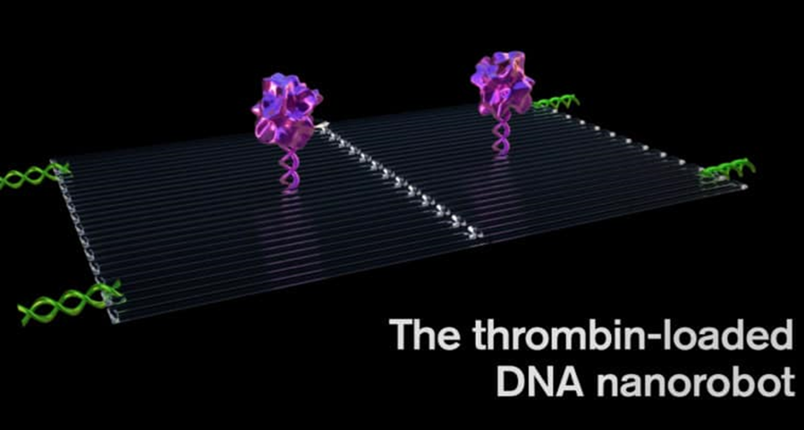
Fig. No.2 Thrombin loaded DNA nanorobot
Step -2:
The DNA aptamer payload could specifically target a protein called nucleolin, which is made in high amounts only on the surface of tumour endothelial cells and is not present on the surface of healthy cells. This was the key to programming a nanorobot that attacks only a cancer cell.
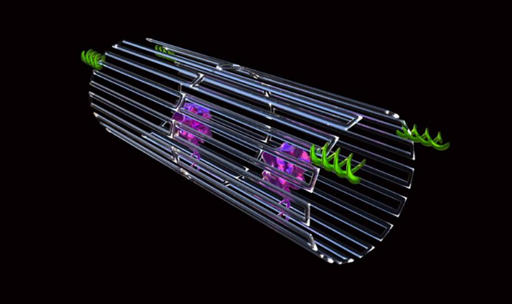
Fig. No.3 Nanorobot enclosed in DNA sheath with tumor targeting DNA
Step -3 :
The nanorobot was programmed, like the infamous Trojan horse, to transport its unwary drug cargo into the exact centre of the tumour, exposing the thrombin, once it had been bonded to the surface of the tumour blood vessels.
Fig. No.4 Illustrates Nanorobots killing the tumor cell .
Chemotherapy drug delivery using nanorobots in cancer treatment:
More effective targeted drug administration has been made possible by recent developments in medication delivery, which use nanosensors to identify specific cells and smart medications to control discharges.¹ Since rapidly replicating cells are a key characteristic of malignant cells, traditional chemotherapeutic medicines work by destroying them. Most anticancer medications have a limited therapeutic window and frequently cause cytotoxicity to healthy stem cells that divide rapidly, such as those found in the bone marrow, macrophages, gastrointestinal tract (GIT), and hair follicles. This has a variety of adverse effects, including organ malfunction, thrombocytopenia/anemia, alopecia, mucositis (inflammation of the GUT lining), myelosuppression (reduced production of WBCs, which results in immunosuppression), and haematological side effects.^{9,10}
When doxorubicin is combined with other antineoplastic medications to reduce its toxicity, it is used to treat a variety of cancers, including Hodgkin's disease. Breast cancer is treated with the intravenous injection of the medication paclitaxel. Bone marrow suppression and increasing neurotoxicity are two serious adverse effects. The intra-DNA binding filament is produced by the alkylating medication cisplatin.^{4,14,12} It can be nephrotoxic and has side effects including euphoria and violent vomiting. By blocking type 1 topoisomerases, an enzyme necessary for cellular duplication of genetic material, camptothecin is used to treat neoplasia.
Numerous projects have been started to use nanotechnology to create DDS that can lessen the side effects of conventional therapy. Doxorubicin was coated on the surface of single-walled carbon nanotubes (SWNTs). Metastatic cancer cells were treated with doxorubicin using a polymer prodrug/collagen hybrid. An innovative development in the field is the use of polymeric pro-drug nanotechnology in the treatment of aberrant cells that divide quickly.⁵
A nanorobot can help with smart chemotherapy for medication administration and provide an efficient early dissolution of cancer by specifically targeting the neoplastic-specific cells and tissues and protecting the surrounding healthy cells from the toxicity of the chemotherapy medications being used.^{12,13} Chemical molecules can be retained in the bloodstream for as long as necessary thanks to nanorobots acting as drug transporters, providing chemotherapy with the appropriate pharmacokinetic characteristics.
By injecting nanobots intravenously, it is possible to use them in clinical settings for diagnosis, treatment, and surgery. The recipient's body may be infused with the nanorobots intravenously. Chemotherapy's pharmacokinetics comprises absorption, metabolism, and excretion in addition to a rest period to allow the body to recover before the subsequent chemotherapy session. For tiny tumours, patients are frequently treated in two-week cycles.^{1,12} Using proteomic-based sensors, nanorobots can quickly examine and diagnose cancer as a primary time threshold for medicinal applications. The transport of protein medications to solid tumors can be predicted using the kinetics of the ingestion of a very small molecular weight magnetic resonance contrast agent. The study of nanorobotics must include testing and diagnosis.
The drug's efficacy will rely on how long it stays inside the tumour after nanorobots penetrate cellular membranes for targeted administration. Depending on the shape of the tumour, the medication transport channels from the plasma to the tissue affect the chemotherapy to provide a more effective tumour chemotherapy. The most current research indicates that site-specific functionalization, DNA generation of molecular-scale devices with enhanced shape control, and nanotechnology ensure exciting benefits in the development of nanomedicine.^{6,8} In vivo, deployment is still hampered by biological milieu unpredictability and innate immune activation, though. Therefore, the main advantage of using nanobots to administer cancer medications is that they lessen the adverse impacts of chemotherapy.
Carbon nanotubes and DNA, which are currently contenders for the newest types of nanoelectronics, are included into the nanorobot design in the most efficient way. For compound biosensors using sole-chain antigen-binding proteins, circuits of typical sizes in the tens of nanometers are made using a complementary metal oxide semiconductor (CMOS). This technique stimulates drug release by bioelectronics and proteomics signals. As a result, nano actuators are activated to modify drug delivery whenever the nanorobot detects predetermined alterations in protein gradients. Relevant variables directly linked to major medical target identification include thermal and chemical signal alterations. Examples of fluctuating protein aggregation in the body near a therapeutic target under pathological conditions are B cell lymphoma-2 (Bcl-2) and E-cadherin.⁵⁻⁷ Additionally, temperature changes typically occur in tissues that are inflamed. The framework incorporates chemical and thermal properties together with the most important clinical and therapeutic recommendations for nanorobot template testing. Additionally, it combines chemical and thermal qualities as the essential standards for assessing nanorobot frameworks for diagnostic and therapeutic purposes.⁸
Limitation of nanorobotics used in cancer therapy:
Nanorobots do, however, have several drawbacks, such as high design and development costs, high complexity, and interface issues. The drug-carrying nanorobots can hardly get through blood capillaries because of how thick blood is at the nanoscale. Due to molecular collisions brought on by Brownian motion in the molecules, the behaviour of the nanorobot becomes unpredictable and uncontrollable. One significant obstacle and significant issue that academics are working to overcome is this instability. The development of appropriate feedback sensors to enable autonomous control at a larger scale represents the other major problem.
In massive manufacturing, nanorobots must be fully operational with little supervision, extremely efficient, precisely controlled, and reasonably priced. To enter the body without physically destroying live tissues, they must be both large enough to process both endogenous and external input from numerous sensory systems and small enough to fit within. Due to a lack of efficient procedures in the realm of nanotechnology, the nanoscale structures needed for various applications have not been produced from a design perspective. Physicists embrace the bottom-up manufacturing method—the notion of developing gadgets atom by at om—but chemists do not favour it because of the high reactivity of the majority of atomic species.
Other difficulties for researchers include creating nanorobots with sizes below the nanometer range, as well as controlling huge groups of nanorobots (called swarms). Additionally, there are many unique design challenges in the realm of nanorobotics, including sensing, navigation, power communication, locomotion, and component manipulation. The ability to manipulate matter at the molecular level to change the behaviour (dynamics and characteristics) of nanorobots is another challenge related to their structural design. In general, the automation, power, and production of nanorobots is a difficult and extremely unique subject.
Future of nanotechnology in the area of medicine:
In order to combine the essential cooperative skills to create these unique technologies, numerous traditional scientific disciplines, including medicine, chemistry, physics, materials science, and biology, have come together to construct the burgeoning field of nanotechnology. Nanotechnology has a wide range of possible applications, from improving present processes to creating entirely new tools and skills. A cutting-edge subfield called nanomedicine has emerged as a result of the exponential growth in interest in nanotechnology research over the past few years, which has revealed novel applications for the technology in medicine. It discusses the science and art of diagnosing, managing, and preventing disease, traumatic injury, and pain relief; preserving and enhancing human health through the use of nanoscale architectured materials, biotechnology, and genetic engineering; and eventually, complex mechanical systems and nanorobots, or "nanomedicine."
Technology for in vivo diagnostics, which operate inside the human body to identify illnesses earlier and find and monitor dangerous substances and cancer cells, may be developed using nanomedicine. When inserted into the body via the intravenous route or cavities, a surgical nanorobot controlled or guided by a human surgeon may perform as an on-site surgeon with a degree of autonomy. A built-in computer may regulate the device's operations while maintaining communication with the supervising surgeon via coded ultrasonic signals. This might include screening for disease and using nanomanipulation to identify and treat injury. By transforming mechanical energy from human movement, muscle stretching, or water flow into electricity, scientists were able to develop a new generation of self-sustaining implanted medical devices, sensors, and portable gadgets.
Nanogenerators generate electricity by bending and then releasing piezoelectric and semiconducting zinc oxide nanowires. One day, it may be possible for portable gadgets to be powered by the movements of their users thanks to the creation of nanowires on polymer-based films and the usage of flexible polymer substrates. Fluorescent biological labelling, drug and gene delivery, pathogen detection, protein sensing, DNA structure probing, tissue engineering, tumour identification, separation and purification of biological molecules and cells, MRI contrast enhancement, and phagokinetic research are a few examples of the applications.
Application of nanorobots in medicine:
Nanorobots are anticipated to make it possible for people suffering from various ailments to receive new treatments, which will signal a significant advancement in medical history. Recent advancements in the field of biomolecular computing are a promising first step towards enabling more complicated nanoprocessors in the future. Studies aimed at developing the biosensors and nano-kinetic tools needed to enable the operation and movement of medical nano-robotics have also advanced.³
The use of nanorobots may advance biomedical intervention through minimally invasive operations, assist patients who require ongoing bodily function monitoring, or even increase treatment efficacy through the early detection of potentially fatal diseases.⁸
For example, the nanorobots may be used to attach to moving immune cells or white blood cells, enabling them to reach injured regions more quickly and aid in their recovery. Nanorobots will be used in chemotherapy to treat cancer by administering exact chemical dosages, and a similar strategy might be used to make nanorobots capable of delivering anti-HIV medications.^{10,11} Nanorobots could be utilised as auxiliary equipment for damaged organs to process certain chemical reactions in the human body. Nanorobots may be used for monitoring diabetes and regulating glucose levels for patients.³
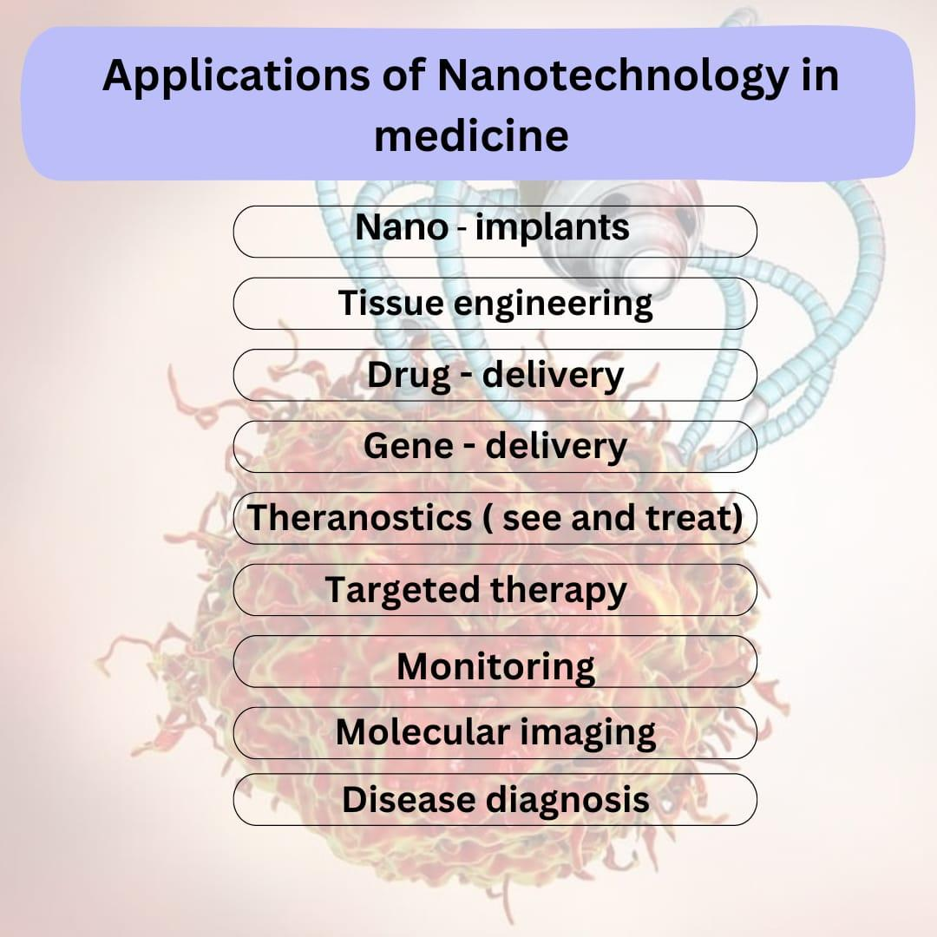
Fig. Illustrates applications of Nanotechnology in medicine
- Nanorobot used in gene therapy:
By comparing the molecular structures of the DNA and proteins found in the cell to desired or known reference structures, medical nanorobots can quickly correct hereditary disorders. Any deviations can then corrections may be made, or desired changes may be added. Chromosome replacement therapy may occasionally be more effective than CY to repair a damaged chromosome. A repair vessel created by an assembler resides in the nucleus of a human cell and performs specific genetic maintenance. The nanomachine stretches a super coil of DNA between its lower set of robot arms, and then carefully pulls an unwound strand of DNA through an aperture in its prow for analysis. While this is going on, the higher arms are removing the chain's regulating proteins and depositing them in an intake port. The data is compared to the molecular structures of DNA and proteins in a larger nano computer outside the nucleus that is connected to the cell-repair ship by a communications link.⁶ Despite being smaller than the majority of bacteria and viruses, the repair vessel would be able to perform treatments and cures that are unimaginable to modern medical professionals. The repair vessel would be smaller than most bacteria and viruses if flaws in either structure are fixed and the proteins are reattached to the DNA chain, which re-coils into its original form with a diameter of only 50 nanometers. Internal medicine would gain new significance when a patient's blood contained trillions of these devices.¹⁴ The molecular level of disease would be tackled, including viral infections, cancer, and arteriosclerosis might be eradicated.
- Nanorobot used for brain aneurysm:
A medical gadget prototyped using computational nanotechnology is the nanorobot for brain aneurysm prognosis. Prototyping of equipment, manufacturing methods, and inside-body transduction are the three key components of this. To produce nanorobots quickly and effectively, equipment prototyping is a critical component of computational nanotechnology. It aids in the exploration of essential issues related to medical instruments and device prototypes. The construction of race cars, aircraft, submarines, ICs, and medical equipment all used a similar strategy in the past. The same can now be applied to advance the study and development of medical nanorobots.^{2,3} The manufacturing technology used to create the nanorobot should be incorporated into the biochip. As a result, a description of the architecture of the nanorobot is offered together with new materials, photonics, and nanobioelectronics. Additionally, the parameters for the inside-body interactions and nanorobot morphology are based on cell morphology, microbiology, and proteomics. Medical prognosis is based on changes in chemical gradients and telemetric instruments, with the nanorobots activated depending on proteome overexpression.¹² These three ideas make up the essential components needed to enhance the creation and application of medical nanorobots, as they are described in the study. Nanorobots must monitor vessel endothelial damage before a subarachnoid haemorrhage happens to determine the prognosis of brain aneurysms.¹⁴
The early stages of a brain aneurysm are detected by nanorobots using these variations in chemical concentration. The robot uses chemical nano biosensor contact to detect the bio-molecules because they are too small to be detected accurately. The primary morphologic characteristics of brain aneurysms are used as models for the investigation of nanorobot interaction and sensing within the distorted blood artery. Intracranial NOS concentrations are low, and pNOS's positive interactions with N-oxide can even lead to occasional false positives.⁹
Along with the fluid flow, cells and nanorobots are constantly entering one end of the workstation. The setup for sensing and control activation can be changed for different values, such as modifying the detection thresholds, for the nanorobots to detect protein over-expression. Any nanorobots that are silent while inside the workplace are treated as though they have not detected any signals, and as the fluid departs the workspace, they are lowered with it. The electrochemical sensor on the nanorobot produces a feeble signal of less than 50 nA when it detects NOS in small quantities or within a typical gradient [23–25]. Because the NOS concentration in this case is within the typical range of intracranial NOS, the nanorobot ignores it. A significant indication of an intracranial aneurysm is considered to have been obtained whenever the cell phone has received at least a total of 100 nanorobots higher proteomic signal transduction as a practical threshold for medical diagnosis, to prevent noise distortions and generate a greater resolution. When the sensors on the nano robots are activated, they also give their positions at the precise moment that they detected a high concentration of NOS protein, providing crucial information on the location and size of the vessel bulb. ^{8,10}
- Nanorobots used in dentistry:
The development of a brand-new field called Nano dentistry is being fueled by the increased interest in the potential dental uses of nanotechnology. Nanorobots realign and straighten crooked teeth while also enhancing dental durability by using oral anaesthesia, tooth desensitisation, and tissue manipulation. It is further detailed how preventive, restorative, and curative procedures are carried out by nanorobots.⁹ For extensive tooth repair, nano dental techniques use a variety of tissue engineering approaches. A biologically autologous whole replacement tooth with both mineral and cellular components is created and placed largely utilising nanorobotics to replace the entire dentition.^{13,14,10}
Sapphire, a substance created by nanotechnology in dentistry, improves the durability and aesthetics of teeth. Upper enamel layers are replaced with artificial material that has been covalently linked, such as sapphire. This substance is 100 to 200 times harder and more resilient to failure than ceramic.^{8,9} Sapphire is somewhat vulnerable to acid corrosion, much like enamel. Sapphire offers the greatest conventional whitening sealant and cosmetic substitute. Nanocomposites are a new type of restorative material that improves tooth durability. Nanocomposites are created by nano-agglomerating discrete nanoparticles and evenly dispersing them in resins or coatings. The nanofiller contains an alumina silicate powder with a 1:4 ratio of alumina to silica and a mean particle size of about 80 nm. The nanofiller has great hardness, elasticity modulus, translucency, aesthetic appeal, excellent colour density, high gloss, and a 50% reduction in filling. It also has a refractive index of 1.503. They mix with a tooth's natural structure much better and are preferable to traditional composites.¹²
Conclusion:
The primary goal of producing this paper is to give an overview of the advancement of nanotechnology in medicine by creating a nanorobot and using it as a novel method of drug delivery in the treatment of cancer. A growing number of people are diagnosed with cancer each year, which is a group of diseases typified by the body's malignant cells developing and spreading out of control. Cancer treatment is most likely what inspired the development of nanorobotics; it can be successfully treated with current medical technology and therapeutic tools, with nanorobotics playing a vital role. The following considerations should be taken into account when determining a cancer patient's prognosis and chances of survival: If the progression of the disease is time-dependent and a prompt diagnosis is established, a better prognosis can be obtained. Another crucial element is developing effective targeted drug delivery methods to lessen the adverse effects of chemotherapy on patients.
Nanotechnology when used as a diagnostic and therapeutic tool for cancer and diabetic patients, nanotechnology demonstrated how actual advancements in new manufacturing technologies are permitting creative works that may aid in creating and using nanorobots most effectively for biomedical issues. The effectiveness, comfort, and speed of future medical treatments will once more increase significantly with the development of molecular nanotechnology, while also significantly lowering their risk, expense, and invasiveness. Nanorobotics has the potential to revolutionise healthcare and the way diseases are treated in the future, even though his science currently sounds like science fiction. It creates new opportunities for extensive, prodigious research. Nanotechnology will affect health care and human existence more fundamentally than other developments.
Acknowledgement:
The authors are thankful to the Principal, ASPM’s K. T. Patil College of Pharmacy for providing necessary facilities for study.
Reference:
- da Silva Luz GV, Barros KV, de Araújo FV, da Silva GB, da Silva PA, Condori RC, Mattos L. Nanorobotics in drug delivery systems for treatment of cancer: a review. J Mat Sci Eng A. 2016;6:167-80.
- Jaffray DA, editor. World congress on medical physics and biomedical engineering, june 7-12, 2015, Toronto, Canada. Springer; 2015 Jul 13.
- Ross JS, Schenkein DP, Pietrusko R, Rolfe M, Linette GP, Stec J, Stagliano NE, Ginsburg GS, Symmans WF, Pusztai L, Hortobagyi GN. Targeted therapies for cancer 2004. American journal of clinical pathology. 2004 Oct 1;122(4):598-609.
- Maeda H. The enhanced permeability and retention (EPR) effect in tumor vasculature: the key role of tumor-selective macromolecular drug targeting. Advances in enzyme regulation. 2001 May 1;41(1):189-207.
- Bhat AS. Nanobots: the future of medicine. International Journal of Management and Engineering Sciences. 2014;5(1):44-9.
- Sharma NN, Mittal RK. Nanorobot movement: Challenges and biologically inspired solutions. International journal on smart sensing and intelligent systems. 2008 Mar 1;1(1):87-109.
- Artemov D, Solaiyappan M, Bhujwalla ZM. Magnetic resonance pharmacoangiography to detect and predict chemotherapy delivery to solid tumors. Cancer research. 2001 Apr 1;61(7):3039-44.
- Sivasankar M, Durairaj R. Brief review on nano robots in bio medical applications. Adv Robot Autom. 2012 Feb 27;1(101):2.
- Frcitas RA. Exploratory design in medical nanotechnology: a mechanical artificial red cell. Artificial Cells, Blood Substitutes, and Biotechnology. 1998 Jan 1;26(4):411-30.
- Patil M, Mehta DS, Guvva S. Future impact of nanotechnology on medicine and dentistry. Journal of Indian society of periodontology. 2008 May;12(2):34.
- Acebes-Fernández V, Landeira-Viñuela A, Juanes-Velasco P, Hernández AP, Otazo-Perez A, Manzano-Román R, Gongora R, Fuentes M. Nanomedicine and onco-immunotherapy: from the bench to bedside to biomarkers. Nanomaterials. 2020 Jun 29;10(7):1274.
- Moghimi SM, Hunter AC, Murray JC. Nanomedicine: current status and future prospects. The FASEB journal. 2005 Mar;19(3):311-30.
- Soto F, Wang J, Ahmed R, Demirci U. Medical Robotics: Medical Micro/Nanorobots in Precision Medicine (Adv. Sci. 21/2020). Advanced Science. 2020 Nov;7(21):2070117.
- Salata OV. Applications of nanoparticles in biology and medicine. Journal of nanobiotechnology. 2004 Dec;2(1):1-6.

