Chromatography techniques for isolation of phytoconstituents from medicinal plants
Author information
Rustam Ekbbal¹, Mhaveer Singh², Gaurav¹*, Sapna Salar³
¹ Department of Pharmacology, IIMT College of Medical Sciences, IIMT University, O Pocket, Ganga Nagar, Meerut, Uttar Pradesh 250001.
²Pharmacy Academy, IFTM University, Lodhipur Rajput, Delhi Road, Moradabad-244102, Uttar Pradesh, India.
³Department of Pharmaceutical Sciences, Apex University, Jaipur, Rajasthan-302018

Rustam Ekbbal: rustamekbbal@gmail.com
Mhaveer Singh: maahishaalu7@gmail.com
Gaurav: gautamgaurav878@gmail.com
Sapna Salar: sapnasalar50@gmail.com

Dr. Gaurav
Assistant Professor
IIMT College of Medical Sciences,
IIMT University, O Pocket, Ganga Nagar,
Meerut, Uttar Pradesh 250001
Email: gautamgaurav878@gmail.com
Mob. No.: 9760477960
Abstract
Chromatography techniques play a pivotal role in the isolation of phytoconstituents from medicinal plants, facilitating the extraction and purification of bioactive compounds. This abstract review the diverse chromatographic methods employed in the quest for isolating and characterizing phytochemicals with therapeutic potential. Gas chromatography (GC) enables the separation of volatile compounds, while high-performance liquid chromatography (HPLC) offers versatile separation of a wide range of phytoconstituents. Thin-layer chromatography (TLC) provides rapid qualitative analysis and serves as a preliminary step in compound isolation. Preparative chromatography methods, such as flash chromatography and preparative HPLC, are crucial for obtaining larger quantities of pure compounds. Furthermore, liquid chromatography-mass spectrometry (LC-MS) and gas chromatography-mass spectrometry (GC-MS) are indispensable tools for compound identification and structural elucidation, aiding in the characterization of complex phytochemical profiles. The synergy of these chromatographic techniques allows researchers to navigate through the intricate chemical composition of medicinal plants, uncovering valuable bioactive molecules. By harnessing the power of chromatography, the isolation and purification of phytoconstituents become more efficient and accurate, contributing to the advancement of herbal medicine and drug discovery. The constant evolution and integration of chromatography methods with modern technology continue to expand the frontiers of phytochemical research, enhancing our understanding of the therapeutic potential hidden within nature's botanical treasures.
Keywords: Chromatography techniques, Phytoconstituents, Medicinal plants, Isolation, Bioactive compounds, Compound identification

Introduction
Medicinal plants have been a source of therapeutic agents for centuries, offering a vast array of bioactive compounds that hold the potential to address a wide range of health conditions. Phytoconstituents, the naturally occurring chemical compounds found in these plants, are the key drivers of their pharmacological properties. Isolating and characterizing these phytoconstituents is a critical step in harnessing the medicinal potential of plants, and chromatography techniques have emerged as invaluable tools for achieving this goal (Gaurav et al., 2023, 2022; Gautam, 2022).
Chromatography is a separation technique that exploits the differences in chemical properties between compounds within a mixture. It involves the distribution of a sample between two phases: a stationary phase and a mobile phase. As the mobile phase moves through the stationary phase, compounds in the sample are selectively retained, allowing for their separation and subsequent analysis. The versatility and precision of chromatography make it an essential methodology in the field of natural product isolation and analysis (Gaurav, 2022; Gaurav et al., 2023).
Medicinal plants are complex reservoirs of phytoconstituents, often containing a multitude of compounds with diverse chemical structures and polarities. Chromatography techniques offer the means to separate and purify these compounds, enabling researchers to isolate specific bioactive molecules of interest. Various chromatographic methods are employed based on factors such as the nature of the compounds being targeted and the intended purpose of the isolation process (Gaurav et al., 2020).
One of the most widely used chromatography techniques in the field of phytoconstituent isolation is high-performance liquid chromatography (HPLC). HPLC's ability to separate compounds based on their affinity for the stationary phase and their interaction with the mobile phase is particularly well-suited for the intricate task of isolating phytochemicals. Whether it's flavonoids, alkaloids, terpenoids, or other bioactive molecules, HPLC allows for the efficient separation and quantification of these compounds, laying the foundation for subsequent analyses and applications (Gaurav, 2022; Gaurav et al., 2023).
Thin-layer chromatography (TLC) is another essential chromatographic method frequently employed in the initial stages of phytoconstituent isolation. TLC's simplicity and speed make it an excellent choice for preliminary separation and identification of compounds in a mixture. It serves as a rapid qualitative tool, guiding researchers toward the fractions containing the desired bioactive constituents before proceeding to more rigorous isolation techniques (Gaurav et al., 2020; Khan et al., 2021).
Preparative chromatography methods, including flash chromatography and preparative HPLC, take the process a step further by enabling the isolation of larger quantities of purified compounds. These techniques are crucial for obtaining sufficient quantities of bioactive molecules for further biological testing and structural elucidation. They bridge the gap between analytical and preparative scales, facilitating the transition from compound identification to application (Lee et al., 2019).
In recent years, the marriage of chromatography with mass spectrometry (MS) has revolutionized the field of phytoconstituent isolation and characterization. Liquid chromatography-mass spectrometry (LC-MS) and gas chromatography-mass spectrometry (GC-MS) are powerful combinations that provide both separation and structural information. LC-MS, in particular, allows for the identification of compounds based on their mass-to-charge ratios and fragmentation patterns. This enables researchers to not only separate and isolate phytoconstituents but also elucidate their chemical structures, contributing to a deeper understanding of their biological activities (Gaurav, 2022; Gautam et al., 2023).
Moreover, chromatography techniques play an indispensable role in the isolation and characterization of phytoconstituents from medicinal plants. As the demand for natural products with therapeutic potential continues to grow, the significance of chromatography in drug discovery, herbal medicine, and nutraceutical industries becomes increasingly evident. The ability to selectively separate and purify bioactive compounds has propelled our understanding of the complex chemical composition of medicinal plants, opening doors to new possibilities for human health and well-being. The following sections will delve into specific chromatography methods and their applications in phytoconstituent isolation, highlighting their advantages, limitations, and contributions to the advancement of natural product research (Parveen et al., 2020; Zahiruddin et al., 2021).

Review findings

Chromatography
A technique enables that enables the isolation, purification and identification of the components of a mixture for qualitative and quantitative analysis. The various constituents of the mixture travel at different speeds, causing them to separate. The separation is based on differential partitioning between the mobile and stationary phases.
Based on this approach three components form the basis of the chromatography technique.
- Stationary phase: This phase is always composed of a “solid” phase or “a layer of a liquid adsorbed on the surface a solid support”.
- Mobile phase: This phase is always composed of “liquid” or a “gaseous component.”
- Separated molecules: phytochemicals or chemicals separated on/by stationary phase based on their polarity or molecular integrity
These are special techniques used in the separation of compounds from mixtures based on their size, shape, and charge. The concept of chromatography involves the use of the mobile phase, which is the solvent of extraction and the stationary phase such as silica gel and Sephadex mixed with calcium sulfate as a binder.

Chromatography techniques based on analysis
- Generally, chromatography may be Preparative “to separate the components of a mixture for later use, and is thus a form of purification”
- Analytical chromatography technique is used for identification of components present in smaller amount”. The chromatography method going to be used for the separation of plant constituents can be classified from different points of view are

The most used stationary phase in separation science
- Silica gel is used for parting amino acids, sugars, fatty acids, lipids, and alkaloids.
- Sephadex is applicable in the isolation of proteins and amino acids.
- Aluminum Oxide is useful in the separation of vitamins, carotenes, phenols, steroids, and alkaloids. Cellulose powder is used in the separation of amino acids, food dyes, and alkaloids.
- Celite is applicable in the separation of organic cations and steroids.

The physical state of the phases employed for separation
- If the mobile phase is a gas and the stationary phase
is a solid or liquid, the separation techniques are known as gas-solid chromatography or gas-liquid chromatography (GSC and GLC or often simply GC).
- In liquid chromatography (LC), the mobile phase is a liquid, ranging from a single pure solvent to a multi-component mixture. Supercritical fluid chromatography (SFC) uses a mobile phase (usually CO2) in the supercritical state at high temperature and pressure.

Types of chromatography based on mechanism of separation
In chromatography methods, the stationary phase facilitates separation depends upon four main basic mechanisms of separation are
Basis of shape
  - Column Chromatography: Open column, flash, vacuum
  - Planar Chromatography: TLC, HPTLC, OPLC, Centrifugal TLC
Mode of Separation
  - Adsorption (NPC, LSC): separates molecules based on polarity, least polar eluting first
  - Partition - (RPC, LLC): Separates molecules based on a combination of solubility parameters, partition coefficients, and polarity, most polar eluting first
  - Ion exchange: Separates molecules on basis of molecular charge
  - Size exclusion (GPC, GFC): separation based on molecular size, largest eluting first
  - Affinity: Based on affinity with ligand
Basis of Mobile Phase
  - Liquid Chromatography: LLC, LSC
  - Gas chromatography: GLC, GSC
  - Polarity relationship between the mobile and stationary phases
The separation of phytoconstituents depends upon their polarity and the relation of polarity between the mobile phase and stationary phase.
According to their relation, the stationary phase divides into main two parts.
    - Normal phase: First separation of non-polar compounds
    - Reversed-phase: First separation of polar compounds
Table 1: List of some different sorbents/solid phases used in chromatography
Sorbents | Mechanism | Applications
Silica gels | Adsorption | Amino acids, alkaloids, hydrocarbons, vitamins
Hydrocarbon modified silica | Modified partition | Nonpolar compounds
Cellulose | Partition | Amino acids, nucleotides, carbohydrates
Alumina | Adsorption | Hydrocarbons, alkaloids, food dyes, lipids
Kiselguhrs | Partition | Sugars, fatty acids
Ion-exchange celluloses | Ion-exchange | Nucleic acids, nucleotides
Polyamide | Adsorption  (H-bonding) | Anthocyanin's, aromatic acids, flavonoid

How to start isolation of natural products
- Know the nature of the compound to determine the approach to be followed
  - Solubility, hydrophobicity/hydrophilicity, acid-base properties, charge stability, size etc.
- What you want to isolate is important
- All metabolites of an organism – above info less useful
- Known compound? Most info is available –search literature
- Unknown molecule – no info available – best to determine nature
- Hydrophobicity/hydrophilicity – dry the sample and try dissolving in different solvents covering the whole polarity range
- Acid/base properties – adjust aqueous soln with acid/base pH 3, 7, 10 and do partitioning experiments
- Heat stability – heat at 80-90oC for 10 minutes
- Size- proteins can be eliminated by ultrafiltration membranes
- Localization of activity – leaves, stem, root, bark
- Microbial broth – free medium or associated with cells
General Isolation Procedure for Natural Products with associated techniques
The isolation process begins from extraction and fraction of plant matrix to get partially purified compound. Later, the yield of partially purified compounds can be accustomed to obtain pure isolated compounds through PTLC/HPLC/CC/CCC. Finally, the extract proceed to determine the chemical identity by using the analytical technique such as IR/MS/NMR etc. the schematic representation of a phytoconstituents from isolation to structure elucidation is summarised in figure

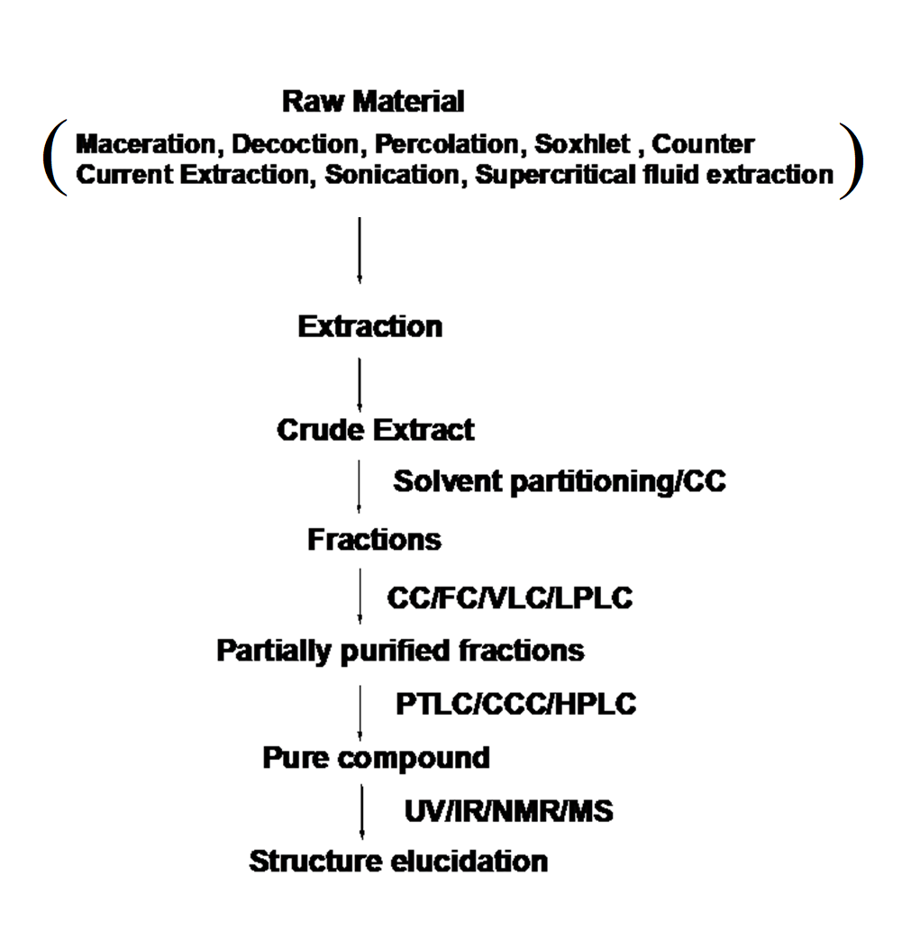
Figure 1: Schematic representation of compound isolation to elucidation with their involved techniques

Type of Chromatography techniques based on separation
Column Chromatography
- Prep Column Chromatography
- Flash Chromatography (FC)
- Vacuum liquid chromatography (VLC)
- Ion Exchange Chromatography
- Gel Chromatography
- Gel Filtration (GFC)
- Gel Permeation (GPC)
Pressure Liquid Chromatography
- Low-Pressure LC
- Medium Pressure LC (MPLC)
- High-Pressure LC (HPLC)
Normal Phase and Reverse Phase Chromatography
Liquid-liquid Chromatography
- Countercurrent Chromatography (CCC)
- Droplet Countercurrent Chromatography (DCCC)
Planar Chromatography
- Prepparative Thin Layer Chromatography (PTLC)
- Centrifugal TLC
- Overpressure layer Chromatography (OPLC)
Gas Chromatography
- Gas-Liquid Chromatography
- Gas-Solid Chromatography

Column chromatography
Column chromatography method used for isolation and purification of a compound from a mixture. Chromatography is able to separate substances based on differential adsorption of compounds to the adsorbent; compounds move through the column at different rates, allowing them to be separated into fractions. According to their relation, the stationary phase divides into main two parts.
- Normal-phase column chromatography
(NP) CC, the sorbent is more polar than the mobile phase and the interaction of polar compounds will be more than non-polar compounds. So it will elute non-polar than polar compounds. NPLC which has a good separation power – plays a very important role, especially in isolation strategies.
- Reversed-phase column chromatography
CC, the stationary phase is less polar than the mobile phase and interaction of non-polar compounds will be more than polar compounds and elute first than non-polar.

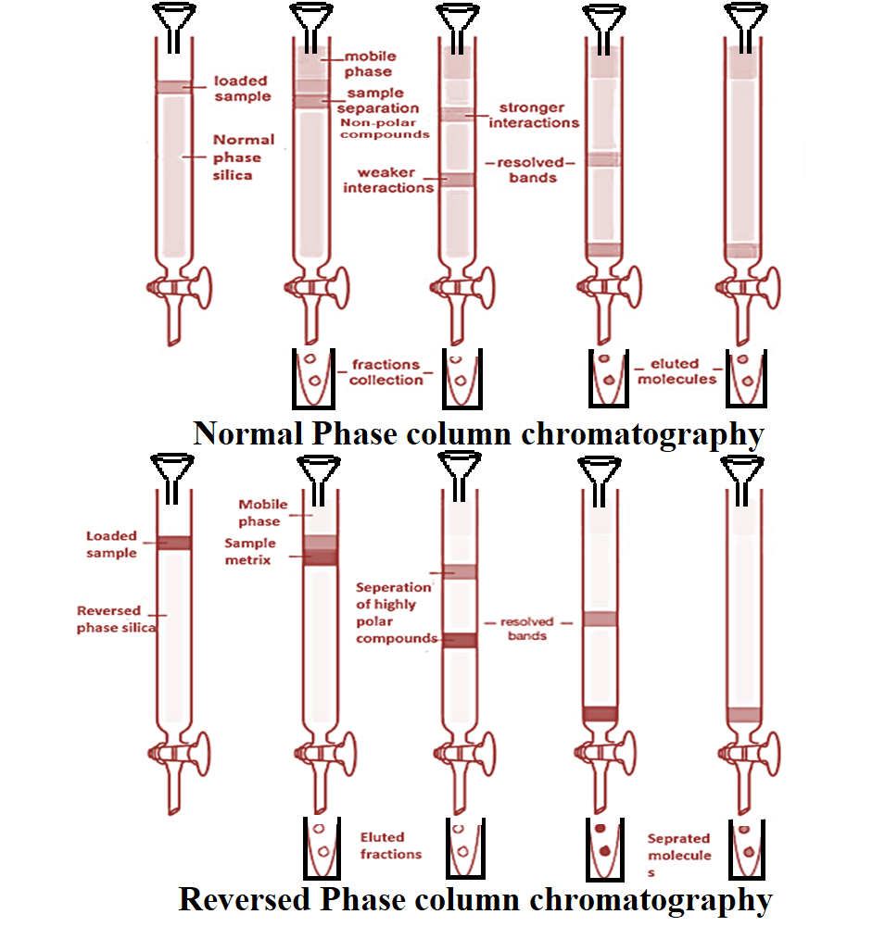
Figure 2: Systematic representation of normal and reversed phase chromatography

Elution Pattern of natural products in column chromatography based on the stationary phase
- Normal Phase
  - Alkanes olefins aromatics organic halogen compounds sulfides ethers nitro compounds esters/aldehydes/ketones alcohols/amines sulfones sulfoxides amides carboxylic acids.
- Reverse Phase
  - Carboxylic acids alcohols/phenols amines ethers/aldehydes ketones organic halogen compounds aliphatics
In RP, readily water-soluble substances are eluted more rapidly than hydrophobic ones. Aq. Solutions can be directly used, gives good separation for polar compounds. No deactivators are required.

Flesh column chromatography
A method for normal phase separation through purification. The chromatography is based on “ an air pressure driven hybrid of medium and short column chromatography optimized for rapid separation of biomolecules. FC Unlike with gravity column chromatography, using air pressure to force the solvent through the column reduces the chromatography time, therefore making the column and running the separation could take less than 10-15 minutes.
Principle
The principle is that the eluent which is a liquid, under gas/air pressure (normally nitrogen or compressed air) is rapidly pushed through a short glass column. The glass column is packed with an adsorbent of defined particle size with large inner diameter. The most used stationary phase is silica gel 40 – 63 μm, but obviously packing with other particle sizes can be used as well. Particles smaller than 25 μm should only be used with very low viscosity mobile phases because otherwise, the flow rate would be very low. Normally gel beds are about 15 cm high with working pressures of 1.5 – 2.0 bars. Originally only unmodified silica was used as the stationary phase so that only normal phase chromatography was possible. In the meantime, however, and parallel to HPLC, reversed-phase materials are used more frequently in flash column chromatography.
Selecting a Solvent System
The compound of interest should have a TLC Rf of ≈0.15 to 0.20 in the solvent system you choose. Binary (two-component) solvent systems with one solvent having a higher polarity than the other are usually best since they allow for easy adjustment of the average polarity of the eluent. The ratio of solvents determines the polarity of the solvent system, and hence the rates of elution of the compounds to be separated. The higher polarity of the solvent increases the rate of elution for ALL compounds. Common binary solvent systems in order of increasing polarity are dichloromethane/hexane, ether/hexane, hexane/ethyl acetate, and dichloromethane/methanol. Hexane/ethyl acetate can be used on the bench, all other solvents should be used in the hood. If your Rf is a ≈0.2, you will need a volume of solvent ≈5X the volume of the dry silica gel in order to run your column.
Application
- Separation, isolation and purification of natural products
- Role in pharmaceutical and agriculture industries to remove out impurities from finished products
- One of the most popular applications of the technique is in the drug discovery process

Vacuum Liquid Chromatography
VLC, a fast method in order to meet the needs of efficient purification of products from natural resources on both large and small scale under vacuum conditions. It is used for the fractionation of extract to meet desired components as per their polarity/category.
Principle
VLC is considered as a preparative thin-layer chromatography (PTLC) as separation is carried out on TLC grade silica gel or aluminum oxide and the column is dried after each fraction as in PTLC plates are dried and re-run to enhance the separation. The packed VLC columns can be reused for the same or similar separation thoroughly washing the column with methanol and scrapping away the decomposed polar material or band from the top of the adsorbent column. Gradient elution is very effective and can be used for the separation of small as well as large amounts of mixtures. The apparatus is suitable for the chromatography of extracts of reaction mixtures of less than 1 g. In this case, only 10-15 ml fractions are collected at each polarity step, and a complete chromatography can be readily contained. In our experience, the bed layer of silica gel should not exceed 5 cm in height for better optimistic outcomes. For small-scale separations (sample < 100 mg), a column of 0.5-1.0 cm internal diameter and 4 cm high should be used. For 0.5-1.0 g of the sample, a column approximately 2.5 X4 cm is appropriate, while for 1-10 g of sample for separation, a 5 cm diameter X 5 cm high column would be adequate. The continuous passes of solvent through VLC during the experimental process should be maintained if the column goes to dried, inadequacies will occur.
Application
- it is mainly used for the isolation and purification of chemical components from the mixture, pigments of natural or synthetic origin at large and small scale.
- Identification of a "target protein" which may have therapeutic value.
- industrial and institution application on large scale isolation of the therapeutic molecule

Planner chromatography
Planar chromatography is one branch of the discipline, defined by having the stationary phase of the process take place on a plane.

Paper chromatography
In paper chromatography, support material consists of a layer of cellulose paper highly saturated with water. A thick filter paper comprised the support, and water drops settled in its pores made up the stationary “liquid phase.” Mobile phase consists of an appropriate fluid placed in a developing tank. Paper chromatography is a “liquid-liquid” chromatography, and a planar chromatography system wherein a cellulose filter paper acts as a stationary phase on which the separation of compounds occurs.
Application
- It is used in scientific studies to identify unknown organic and inorganic compounds from a mixture.
- Separation of proteins, colored pigments and sequencing of DNA and RNA

Centrifugal Thin Layer Chromatography
A planner chromatography where the centrifugal force is generated by the spinning of the support disk and the mobile phase is applied at a constant flow rate. As the mobile phase elutes, it carries the sample along with it thereby creating spherical bands of the separated components. The separated components are then swirled off from the edge of the rotor together with the mobile phase.
Principle
A technique in which circular-shaped paper is about its center to speed up the motion of the mobile phase through the effect of centrifugal force thus it is called centrifugal chromatography. Its scaleup to a preparative technique eventually led to the construction of the "Chromatotron", which acts as the operational parameters of centrifugal thin-layer chromatography. Separation of compounds occurs in the direction of solvent flow.
Application
- CTLC is widely used in quality control standardization of herbal products or nature-derived medicines
- It is used in the separation of compounds that belongs to the same group in a plant matrix

Thin layer chromatography
Thin-layer chromatography is a type of adsorption chromatography, where the separation of compounds occurs at the stationary phase (silica gel/aluminum oxide) in form of a compounds library at different retardation factors (Rf). Separation of molecules occurs based on the nature of silica gel used as stationary phase. Basically, thin layer chromatography is classified in two major forms
- Preparative thin-layer chromatography (PTLC)
- Analytical thin-layer chromatography (HPTLC)

Preparative thin-layer chromatography:
Preparative thin-layer chromatography (PTLC) is used to separate and isolate compounds at a larger scale. The quantities processed range for PTLC is required at least 10 mg to 1 gram. In preparative TLC, materials to be separated are often applied as long streaks, rather than spots, in the sample application zone. After development, specific components may be recovered by scraping the sorbent layer from the plate in the region of Interest and eluting the separated material from the sorbent using a strong solvent. The material that is recovered from the layer may require further purification by TLC or other chromatographic methods, or the purity may be adequate for identification and structure determination by elemental analysis or spectrometry, for use in biological activity or chemical synthesis studies, or use as standard reference material for comparison with unknown samples.
Though being an old technique, TLC is still progressively associated for the analysis of phytoconstituents or a complex mixture of compounds obtained from the herbal matrix. This is due to the evolution of the instrumentation, automation, and the development of new adsorbents and supports (Shewiyo et al. 2012). Moreover, TLC features in a broad range of applications, such as the analysis of herbal medicines, dietary supplements, biological and clinical samples, food and beverages, environmental pollutants and chemicals

High-Performance Thin Layer Chromatography
HPTLC is an advanced form of instrumental TLC, which does not only include the use of high-performance adsorbent layers (e.g. silica gel with refined uniform particles, approximately 5 µm in diameter, as compared to 12 µmin TLC) but also adopted instrumentation, for example, the development chambers. It usually also implies a standardized methodology for development, optimization, documentation, and the use of validated methods. The HPTLC technique is applied in qualitative and quantitative estimation of compounds in mixtures, where the quantitative mode operates in a more optimized way (standardized with a known method).
In HPTLC, samples are being spotted by the automatic sampler on a TLC with the help of HPTLC and then the plate is kept inside the saturated TLC chamber for 30 min. After drying, the plate is monitored by the UV system or visualizing reagents. To make results comparable between different laboratories and literature references, several parameters like the saturation of the TLC chamber, mobile-phase composition, water content of the silica stationary phase, etc. have to be controlled. Meanwhile, HPTLC can be regarded as an established method with application in GMP-compliant quality control of medicinal plant

Application of TLC
- Phytochemical analysis
- Biomedical analysis
- Herbal drug quantification
- Analytical analysis,
- Fingerprint analysis

High-performance liquid chromatography
This technique uses the mechanism of adsorption to achieve effective separation. It is suitable for the partitioning of both organic and inorganic compounds. The mobile phase is a suitable solvent, whereas the stationary phase is solid particles tightly joined together. Separation is initiated via the interaction of the compounds in the mixture with the solid particle of the stationary phase. The apparatus consists of a solvent reservoir, sample injector, pressure pump, HPLC tube, and diode detector.
Principle
The process begins by injecting the mixture to be separated at the bottom of HPLC. In addition, a suitable solvent is poured into the solvent reservoir. The tap is now opened to allow the movement of solvent downward, which is then pushed by a pressure pump to mix up with the injected sample. Finally, the mixture moved into the diode detector, which separated the compounds, removed the waste, and pumped the final content to processing units.
HPLC Columns
 | Particle size | Column ID | Sample Load
Analytical | 3-5 m | 0.3-4.6 mm | ng-mg
Semi-prep | 10 m | 8-10 mm | 1-100 mg
Preparative | 10-30 m | 5-200 mm | Gram scale

An HPLC column consists of a stainless steel tube that is sealed with fittings on both ends. Steel frits in the end fittings keep the packing material in the column. Analytical columns have inner diameters of 1 - 10 mm and lengths of 25 - 250 mm. They are operated at flow rates of 60 µl - 5.0 ml/min. In preparative chromatography columns with an inside diameter of 200 mm and a length of 600 mm are used. To protect the actual separation column from chemical contamination, a guard column with the same packing material as the separation column is installed (Ujang et al., 2013).
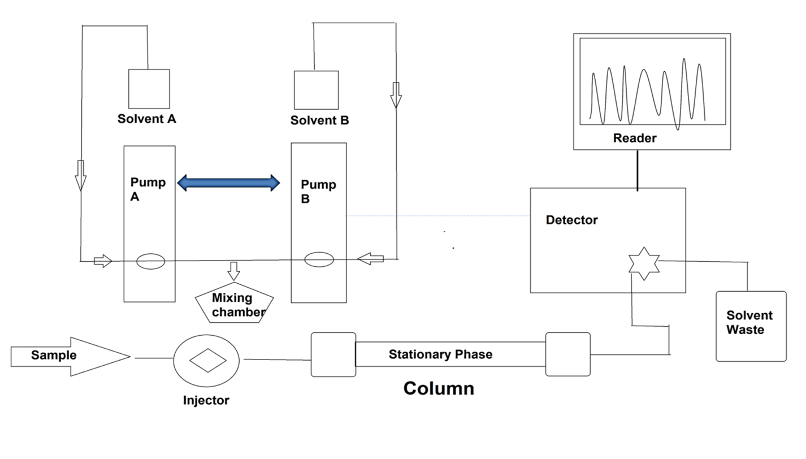
Figure 9: Instrumentation of HPLC
For example, in a study, polyphenols rich fraction was prepared of Tinospora cordifolia, the sample analysis was performed using RP-HPLC. Three major phenols were observed in the sample. The chromatogram of the analyzed sample is depicted as
Application
- Application of HPLC includes isolation, purification, and identification of the components from a complex biological sample, or of similar synthetic chemicals in research institutes and industries.
- Estimation and quantification of vitamins like Vit-D, C, E, etc.
- Assessment of drug in blood samples, determine loss or gain of an allele, quantitate the amount of RNA expressed, and detect a single nucleotide change.
- This technique is also used for the stability study of a drug molecule in the research industry.

Gas chromatography
Gas chromatography (GC) is a well-established analytical technique used in analytical chemistry for separating and analyzing compounds (qualitative and quantitative identification) that can be vaporized without decomposition. Typical uses of GC include testing the purity of a particular substance or separating the different components of a mixture.
Principle
It utilizes a capillary column which depends on the column's dimensions, as well as the phase properties between different molecules in a mixture and their relative affinity for the stationary phase of the column, which will promote separation of the molecules as the sample travels the length of the column. The separate compounds fall at the specific retention time in the proportion of their polarity index which may be further identifiable for the acquisition purpose. The most used carrier in GC used as helium and nitrogen as mobile phase.
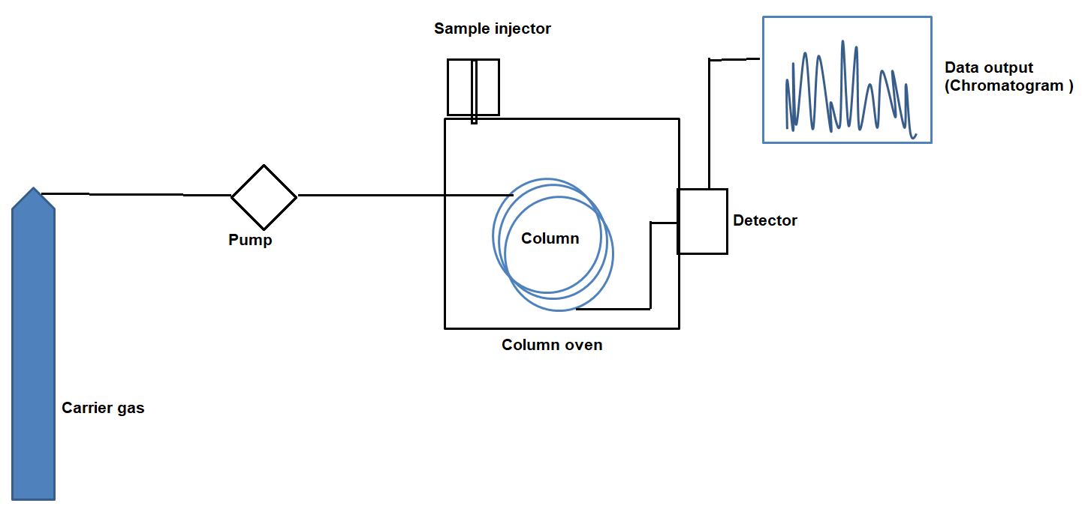
Figure 11: Instrumentation of GC
Advantages
- It is the most precise technique for the analysis of volatile/essential oils
- Qualitative and quantitative estimation of non-polar organic and inorganic compounds
- Assessment of GC in agriculture department for the analysis of pesticides
- Analysis of biological samples
- Analysis of blood sample in forensic science
Disadvantages
- Despite its advantages, the major limitation of GC is that it is restricted to volatile compounds, and the derivatization process is necessary to detect various metabolites which pose difficulties in sample preparation and identification due to multiple additives or derivative products.
- GC analysis of herbal products is usually limited to the essentials oils because of possible degradation of thermo-labile compounds and the requirement of volatile compounds makes GC unsuitable for many herbal compounds

Ion chromatography (IC)/ion-exchange chromatography
Ion-exchange chromatography (IEC) is part of ion chromatography which is an important analytical technique for the separation and determination of ionic compounds, together with ion-partition/interaction and ion-exclusion chromatography. The stationary phases used in ion chromatography are also known as ion exchangers that separate ions or polar molecules based on their affinity to the ion exchanger/charged molecule including large proteins, small nucleotides, and amino acids. The two types of ion chromatography are anion-exchange and cation-exchange.
Cation-exchange chromatography is used when the molecule of interest is positively charged.
Anion-exchange chromatography is used when the stationary phase is positively charged and negatively charged molecules.
Principle
Ion-exchange chromatography which is designed specifically for the separation of differently charged or ionizable compounds comprises mobile and stationary phases similar to other forms of column-based liquid chromatography techniques. Mobil phases consist of an aqueous buffer system into which the mixture to be resolved. The stationary phase is usually made from inert organic matrix chemically derivative with ionizable functional groups (fixed ions) which carry displaceable oppositely charged ion. Ions that exist in a state of equilibrium between the mobile phase and stationary phases giving rise to two possible formats, anion and cation exchange are referred to as counterion. Exchangeable matrix counter ions may include protons (H+), hydroxide groups (OH-), single charged monoatomic ions (Na+, K+, Cl-), double-charged monoatomic ions (Ca2+, Mg2+), and polyatomic inorganic ions (SO42-, PO43-) as well as organic bases (NR2H+) and acids (COO-). Cations are separated on cation-exchange resin column and anions on an anion exchange resin column [10]. Separation is based on the binding of analytes to positively or negatively charged groups that are fixed on a stationary phase and which are in equilibrium with free counter ions in the mobile phase according to differences in their net surface charge well as organic bases (NR2H+) and acids (COO-). Cations are separated on a cation-exchange resin column and anions on an anion exchange resin column. Separation based on the binding of analytes to positively or negatively charged groups that are fixed on a stationary phase and which are in equilibrium with free counterions in the mobile phase according to differences in their net surface charge
Application
- Ion-exchange chromatography has become one of the most important and extensively used of all liquid chromatographic technique
- The most significant development related to ion chromatography is to separation and purification of a charged biomolecule like proteins/amino acid nucleotides. And to improve stabilities and solubility properties of pharmaceutical active drugs molecules in research industries.
- In speciation analysis, for determination of metal and metalloid ions seems the most prospective.
- The advantages of ion chromatography in cation determinations include the following: simultaneous determination of alkaline and alkaline earth metals and ammonium ions.

Size-exclusion chromatography (SEC)
Size exclusion chromatography (SEC) is a form of chromatography that separates molecules by size. It is also known as gel-filtration chromatography (GFC) and gel permeation chromatography (GPC) which often refers to SEC with organic solvents.
Principle
It is a separation technique, difference in size and geometry of the molecules separated based on their size. The chromatographic column is packed with fine, porous beads which are composed of dextran polymers (Sephadex), agarose (Sepharose), or polyacrylamide. The pore sizes of these beads are used to estimate the dimensions of macromolecules. It is usually applied to large molecules or macromolecular complexes such as proteins, amino acids and industrial polymers.
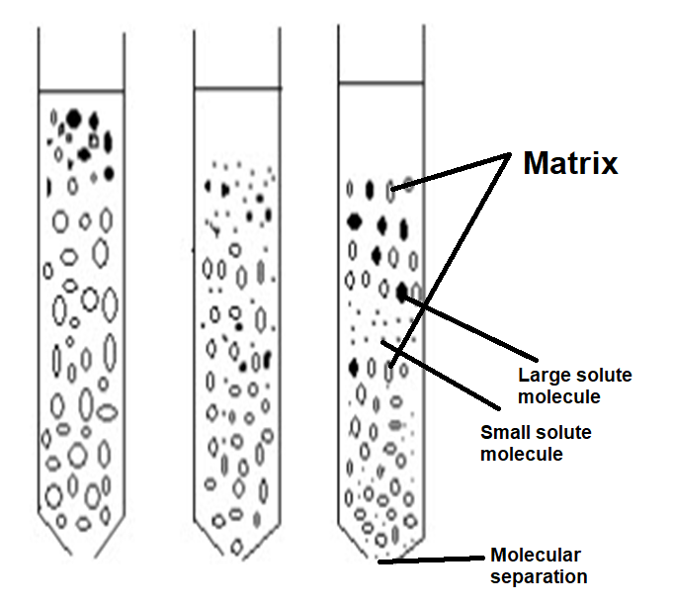
Figure 13: Size-exclusion chromatography (SEC)

For the separation of biomolecules in aqueous systems, SEC is referred to as gel filtration chromatography (GFC),
while the separation of organic polymers in non-aqueous systems is called gel permeation chromatography (GPC).
Application:
- The technique is used to separate and determine the proteins/amino acids and nucleotides as well as for large molecular weight drugs.
- SEC is also used for quantitative and qualitative analysis of polydispersity of a synthesized polymer in polymer/hydrocarbon industries

Countercurrent chromatography
Countercurrent chromatography is a form of liquid-liquid chromatography that uses a liquid stationary phase that is held in place by centrifugal force, and it is used to separate, identify, and quantify the chemical components of a mixture. In its broadest sense, countercurrent chromatography encompasses a collection of related liquid chromatography techniques that employ two immiscible liquid phases without solid support and the partition process takes place in an open column space where one phase (stationary phase) is retained and the other phase (mobile phase) continuously passes through it.
Principle
In this chromatography technique, separation of molecules is occurred based on their ionic affinity in the applied electric field for their chromatographic separation. The dynamic mixing and settling action allow the components to be separated by their respective solubility and selectivity of solvent systems.
Application of Countercurrent chromatography
- Countercurrent chromatography have been used on both industrial and laboratory scale to purify a wide variety of chemical substances like proteins,, antibiotics, vitamins, natural products, pharmaceuticals, pesticides, polyaromatic hydrocarbons from environmental samples.
- It also has the advantage of accommodating chemically complex samples with undissolved particulates.

Conclusion
In conclusion, chromatography techniques stand as indispensable tools in the realm of phytoconstituent isolation from medicinal plants. Their versatility and precision empower researchers to navigate the intricate chemical landscape of these plants, uncovering bioactive compounds that hold significant promise for therapeutic applications. The synergy between various chromatographic methods, coupled with mass spectrometry, has revolutionized our ability to isolate, purify, and elucidate the structures of phytoconstituents. This dynamic interplay between science and nature not only enriches our understanding of traditional herbal remedies but also paves the way for innovative drug discovery and the development of health-enhancing products. Chromatography's role in unraveling nature's pharmacological treasures remains pivotal in shaping the future of natural medicine and healthcare.
Conflict of interest
Authors declare no conflict of interest
Acknowledgement
Authors would like to thank IIMT College of Medical Sciences, IIMT University, O Pocket, Ganga Nagar, Meerut, Uttar Pradesh 250001.

References
Gaurav, 2022. GC–MS metabolomics and network pharmacology-based investigation of molecular mechanism of identified metabolites from Tinospora cordifolia (Willd.) miers for the treatment of kidney diseases. Pharmacogn. Mag. 18, 548–558. https://doi.org/10.4103/pm.pm_582_21
Gaurav, Khan, M.U., Basist, P., Zahiruddin, S., Ibrahim, M., Parveen, R., Krishnan, A., Ahmad, S., 2022. Nephroprotective potential of Boerhaavia diffusa and Tinospora cordifolia herbal combination against diclofenac induced nephrotoxicity. South African J. Bot. 000. https://doi.org/10.1016/j.sajb.2022.01.038
Gaurav, Sharma, I., Khan, M.U., Zahiruddin, S., Basist, P., Ahmad, S., 2023. Multi-Mechanistic and Therapeutic Exploration of Nephroprotective Effect of Traditional Ayurvedic Polyherbal Formulation Using In Silico, In Vitro and In Vivo Approaches. Biomedicines 11. https://doi.org/10.3390/biomedicines11010168
Gaurav, Zahiruddin, S., Parveen, B., Ibrahim, M., Sharma, I., Sharma, S., Sharma, A.K., Parveen, R., Ahmad, S., 2020. TLC-MS bioautography-based identification of free-radical scavenging, α‑amylase, and α‑glucosidase inhibitor compounds of antidiabetic tablet BGR-34. ACS Omega. https://doi.org/10.1021/acsomega.0c02995
Gautam, G., 2022. Network Pharmacology-Based Validation of Traditional Therapeutic Claim of Momordica Charantiain Alleviating Diabetic Nephropathy. J. CAM Res. Prog. 1, 1–10.
Gautam, G., Parveen, R., Ahmad, S., 2023. LC-MS-based Metabolomics of Medicinal Plants, in: Omics Studies of Medicinal Plants. https://doi.org/10.1201/9781003179139-9
Khan, A., Zahiruddin, S., Ibrahim, M., Basist, P., Gaurav, Parveen, R., Umar, S., Ahmad, S., 2021. Thin layer chromatography-mass spectrometry bioautographic identification of free radical scavenging compounds and metabolomic profile of Carica papaya linn. fruit and seeds using high-performance thin-layer chromatography, gas chromatography-mass spectro. Pharmacogn. Mag. https://doi.org/10.4103/pm.pm_326_20
Lee, Sunmin, Oh, D.G., Singh, D., Lee, H.J., Kim, G.R., Lee, Sarah, Lee, J.S., Lee, C.H., 2019. Untargeted metabolomics toward systematic characterization of antioxidant compounds in betulaceae family plant extracts. Metabolites. https://doi.org/10.3390/metabo9090186
Parveen, R., Khan, N., Zahiruddin, S., Ibrahim, M., Anjum, V., Parveen, B., Khan, M.A., 2020. TLC-Bioautographic Evaluation for High-Throughput Screening and Identification of Free Radical Scavenging and Antidiabetic Compounds from Traditional Unani Medicinal Plant: Citrullus colocynthis Schrad. J. AOAC Int. https://doi.org/10.5740/jaoacint.19-0287
Ujang, Z.B., Subramaniam, T., Diah, M.M., Wahid, H.B., Abdullah, B.B., Rashid, A.H.B.A., Appleton, D., 2013. Bioguided Fractionation and Purification of Natural Bioactives Obtained from&lt;i&gt;Alpinia conchigera&lt;/i&gt; Water Extract with Melanin Inhibition Activity. J. Biomater. Nanobiotechnol. https://doi.org/10.4236/jbnb.2013.43033
Zahiruddin, S., Parveen, A., Khan, W., Parveen, R., Ahmad, S., 2021. TLC-Based Metabolite Profiling and Bioactivity-Based Scientific Validation for Use of Water Extracts in AYUSH Formulations 2021.

