A BRIEF REVIEW ON CANCER: RADIOTHERAPY AS A TREATMENT MODALITY ALONG WITH ITS ASSOCIATED COMPLICATIONS

TABLE OF CONTENTS

I. Introduction

- Brief introduction to cancer and its types

- Different treatment modalities for cancer

- Purpose of the review article

II. Common Cancers in India

- Brief overview of the most common cancers in India

- Statistics on the prevalence of these cancers

- Importance of radiotherapy in the treatment of these cancers

III. Radiotherapy and Complications

- Explanation of radiotherapy as a treatment modality

- Discussion of potential complications associated with radiotherapy

- Acute complications, such as skin irritation, fatigue, and hair loss

- Late complications, such as fibrosis, secondary malignancies, and organ dysfunction

- Psychological complications, such as anxiety and depression

IV. Complications in Specific Cancers

- Analysis of complications associated with radiotherapy in breast cancer patients

- Risk of lymphedema, chest wall pain, and radiation pneumonitis

- Examination of complications in head and neck cancer patients

- Potential damage to salivary glands, swallowing difficulties, and other possible complications

Introduction

Cancer is a group of disorders where abnormal cells start growing at an exponentially high rate with or without initiation of the cell cycle, and not even checked at the different checkpoints of the cell cycle. Cell cycle comprises of two phases: interphase and mitotic phase. Interphase is the phase of growth of cell organelles, copying of DNA and preparatory phase for division. Mitotic phase is the phase of cell replication (Sia, 2020). This cell cycle has various checkpoints which are regulated by various factors and dysfunction of which may lead to uncontrolled cellular proliferation. Cancer can occur due to various reasons, the most common of which is the mutations. Radiation therapy may inhibit this dogma and helps in cessation of cell cycle along with other effects on cancerous cells.
All the abnormal cell growths are not classified as cancer. Actually, abnormal cellular growth is termed a tumour. Tumours are of two types: benign (non-cancerous) and malignant (cancerous) tumours. Malignant tumours are known to be notorious in terms of rapid progression and metastasis (spreading from one organ to any distant organ). The advances in medical sciences have successfully decoded certain specific patterns of metastasis of some of the cancers, for instance, the most common metastasis of an invasive breast carcinoma (IBC) whether ductal or lobular, follows bone, liver, lung, brain pattern in the respective order of involvement of the organ.
Benign tumours are slowly growing masses with regular surfaces, capsulated and presents as closely abutting the adjacent organ with low or no pressure effect on surrounding organs as compared to malignant masses which are rapidly progressive, non-capsulated, invading into other organs with connecting to deep structures thereon. Non-cancerous tumours are non-invasive, mostly painless, always well-differentiated while, cancerous presents as poorly/well differentiated depending upon type of organ involved, painful and may require palliation.

Cancer may require different modalities of therapeutic approaches, depending on the type of cancer and the stage at which it is intervened clinically. Different modalities of treatment for cancers are chemotherapy, radiotherapy, immunotherapy, stem cell transplantation, hormonal therapy, targeted therapy, surgery, hyperthermia and photodynamic therapy. (Fig.1) Each and every treatment modality is unique and have its own benefits and demerits.
Oncologists require a series of investigations to choose the best possible option available for the specific type of cancer, which involves radiological investigations, biochemical analysis, immunohistochemistry markers, cancer biomarkers analysis etc.

Radiotherapy (Radiation Therapy) is one of the widely accepted therapeutic approach for various cancers as it kills the cancer cells and shrinks the disease. Radiations used for oncological treatment are of high doses measured in Gray (Gy) while those used in Rontgen radiation and other radiological investigations are of lower dose.
Thus, this review article is going to focus on radiotherapy as a treatment modality for most common cancers prevalent in India and its effects on tissues- local and systemic.
Though unaffordability and individual resistance is still a big issue in developing country like India.
Recent advancements in Radiotherapy, that is making use of brachytherapy mandatory in cervical cancers after completing EBRT (External Beam Radiation Therapy) of 66Gy in 25# fractionated radiations, will be discussed with some case studies later in this review article.

Figure-1: This figure shows different treatment modalities in oncology. Chemotherapy (CT) uses drugs to kill cancer cells; Hormonal Therapy is mainly for treating cancers which uses hormones to grow like prostatic carcinoma in males and breast carcinoma in females; Hyperthermia is used to treat cancers by heating the body up to 113⁰ F to kill the cancerous cells with little or no harm to the normal tissues; Immunotherapy uses immune system by certain drugs like nimotuzumab/cetuximab etc, these drugs strengthens immune system so that it can fight cancer; Photodynamic therapy uses a drug activated by light which kills cancer; Radiation therapy uses high dose of radiation to kill the cancerous cells and shrink the tumour; Stem cell transplantation is mainly used for post chemo or post radiotherapy effects where fresh and healthy stem cells are employed which can further become healthy blood cells and fight cancer in those cases where blood cells are destroyed due to chemotherapy or radiations; surgery is to remove the tumour from the body with negative margins. It may be employed sometimes after chemo or radiations depending upon the feasibility of maximally negative resection possibility; targeted therapy is to target the changes occurred in cancerous cells and make them grow like normal cells.

Common Cancers: Worldwide

Cancer is one of the deadliest diseases. Although the latest advances in medicine is proven to be beneficial to stop this giant up to some extent worldwide, but still there is a long way to go. The incidence/prevalence rates of different types of cancers for developed countries differ from the developing ones.
Figure-2: This figure shows continent-wise cancer burden as per the data provided by GLOBOCON, 2020.
According to the latest data provided by Global Cancer Observatory, GLOBOCON in 2020, around 49.3% cases are from Asian continent, which constitutes around half the total number of cases all over the world while American continent constitutes about 20.9%; 22.8% by European continent and 5.7% by Africa. [Fig.2]
Amongst male population globally, the most commonly observed cancers are oral cavity/alveolar cancers, carcinoma of prostate gland, lung carcinoma (including both small and non-small cell carcinoma), colorectal carcinoma and other gastro-intestinal cancers. The detailed proportion-wise cases are described in fig.3

Radiotherapy and Complications
Radiotherapy is most accepted choice of treatment due to the fact that it may treat 2/5th cases of cancers solely by-passing radiations through cancerous cells in order to arrest the cell cycle by various pathways and programmed or unprogrammed death of affected cells.
Cell cycle comprises of two phases: interphase and mitotic phase. Interphase is the phase of growth of cell organelles, copying of DNA and preparatory phase for division. Mitotic phase is the phase of cell replication (Sia, 2020). Interphase is further divided into G₁, S, G₂ phases.
G₁ (First Growth Phase) is known for its role in various metabolic processes and growth of the cell; S (Synthesis) phase is known for DNA replication while G₂ (Second Growth Phase) is called as preparatory phase where cell prepares itself for replication.
3 well-known checkpoints are there in a cell cycle which are of utmost importance as downregulation of these checkpoints are chiefly responsible for arresting of cell cycle. These checkpoints are namely: G₁-S checkpoint, G₂-M checkpoint and spindle-assembly checkpoint.

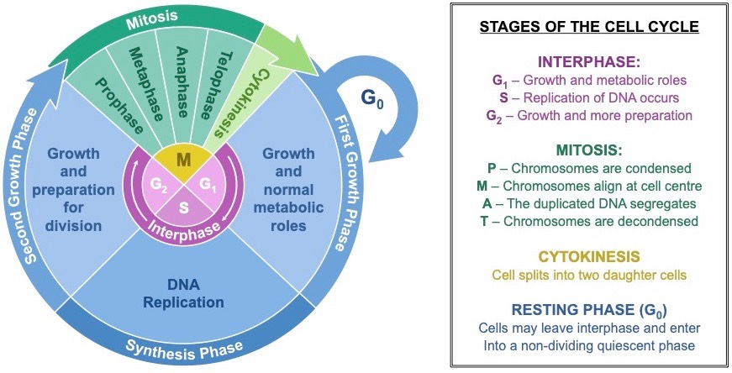

References
Sia, J. S. (2020). Molecular mechanisms of radiation-induced cancer cell death: a primer. Frontiers in cell and developmental biology, 8, 41.
Maier P, H. L. (2016). Cellular Pathways in Response to Ionizing Radiation and Their Targetability for Tumor Radiosensitization. nternational Journal of Molecular Sciences, 17(1):102.

