A PRACTICAL APPROACH TO PROTEIN SEPARATION USING SDS PAGE
Vishal Kumar Singh*, Priyam Kumari, Rupa Verma
MSc. Biotechnology, Department of Botany, Ranchi University, Ranchi, Jharkhand 834001
Corresponding author : vsevishal67@gmail.com*

ABSTRACT
SDS sodium dodecyl sulfate-polyacrylamide gel electrophoresis. It isolates proteins as indicated by their sub-atomic weight, in light of their differential paces of relocation through a gel affected by an electric field. Polyacrylamide gel electrophoresis (PAGE), depicts a procedure by and large used in regular science, criminal science, genetic characteristics, sub-nuclear science, and biotechnology to segregate normal macromolecules, typically proteins or nucleic acids, as shown by their electrophoretic compactness. Flexibility is a part of the length, consistency, and charge of the molecule. Moreover, with a wide range of gel electrophoresis, particles may be run in their nearby state, safeguarding the molecules' higher-demand structure or an engineered denaturant may be added to kill this development and change the iota into an unstructured direct chain whose flexibility depends just upon its length and mass-to charge extent. For nucleic acids, urea is the most customarily used denaturant. For proteins, sodium dodecyl sulfate (SDS) is an anionic cleaning agent applied to protein tests to linearize proteins and to give a negative charge to linearized proteins. This strategy is called SDS-PAGE. In numerous proteins, the restricting of SDS to the polypeptide chain gives an even movement of charge per unit mass, hence achieving a fractionation by assessed size during electrophoresis. SDS is additionally present in the gel to ensure that once the protein is linearized, they remain as such all through the run. Proteins with less sub-atomic weight travel more rapidly through the gel than those with more sub-atomic weight.
Keywords: - SDS, polyacrylamide, electrophoresis, anionic, consistency, linearized, fractionation.

INTRODUCTION
SDS-PAGE, or sodium dodecyl sulfate-polyacrylamide gel electrophoresis, is the method most frequently used to separate protein mixtures analytically with high resolution.[1, 2]. An anionic detergent that also binds to the component proteins is used in the technique to first denaturate them, giving each protein a negative charge corresponding to its molecular mass. The next stage is electrophoresis, which separates proteins with good resolution according to molecular mass through a porous acrylamide gel matrix. This approach, which has not evolved much since it was first used in the early 1970s, is effective in situations where it is not necessary to preserve the original characteristics of protein structure or function.[1, 3]. SDS-PAGE is therefore used in several techniques, including the immunochemical identification and quantification of proteins (western blotting), evaluating protein expression, and determining the purity of protein samples.[1, 2, 4,].
A method that precisely resolves individual proteins and does so in their natural state would be a welcome advancement. More particularly, such a technique would enable the appropriate separation of proteins while preserving their metal companions. By doing this, several of the present drawbacks and issues with employing PAGE in combination with metalloprotein analysis would be resolved.[5,6,7].
Proteins are polymers of amino-corrosive proteins that play a wide range of organic roles. Along these lines, proteins have been grouped by their natural jobs
Catalysts: The most fluctuated and exceptionally concentrated sorts of proteins are those with reactant movement of the chemicals. Chemicals stimulate every scientific reaction of natural biomolecules in cells.[8]
Transport proteins: Transport proteins in blood plasma dilemma and convey explicit particles or particles starting with one organ and then onto the next. Hemoglobin in erythrocytes ties oxygen to the blood as it goes through the lungs, conveys it to the fringe tissues, and there discharges it to take part in the energy-yielding oxidation of supplements. This plasma contains lipoproteins, which convey lipids from the liver to different organs. Different sorts of transport proteins are available in the plasma films and intracellular layers, everything being equal; these are adjusted to tie glucose, amino acids, or different substances together and transport them across the layer.[8]
Supplement and capacity proteins: the seeds of many plants store supplements of protein expected for the development of the sprouting seedling.[8]
Primary proteins: Numerous proteins act as supporting fibers, and sheets to give organic; structures strength or insurance. A significant part of ligaments is the sinewy protein collagen, which has exceptionally high elasticity.[8]

SDS-PAGE Based on differences in the speeds at which proteins migrate across a gel under the influence of an electric field, proteins are separated according to their molecular weight. SDS is a detergent that releases the non-covalent bonds and evenly applies a negative charge to the protein. Every two amino acids in the protein are bound by one molecule of SDS.
To ensure that the proteins linearize and remain that way during the run, SDS is also present in the gel. The protein is permanently denatured in this method by reducing these disulfide links using beta-mercaptoethanol.

Figure 1 : Protein folded structure
The standard of SDS-PAGE expresses that a charged particle moves to the cathode with the contrary sign when set in an electric field. The partition of the charged particles relies on the overall versatility of charged species. The more modest particles relocate quicker because of less obstruction during electrophoresis. The design and the charge of the proteins additionally impact the pace of movement. Sodium dodecyl sulfate and polyacrylamide wipe out the impact of the design and charge of the proteins, and the proteins are isolated in view of the length of the polypeptide chain.

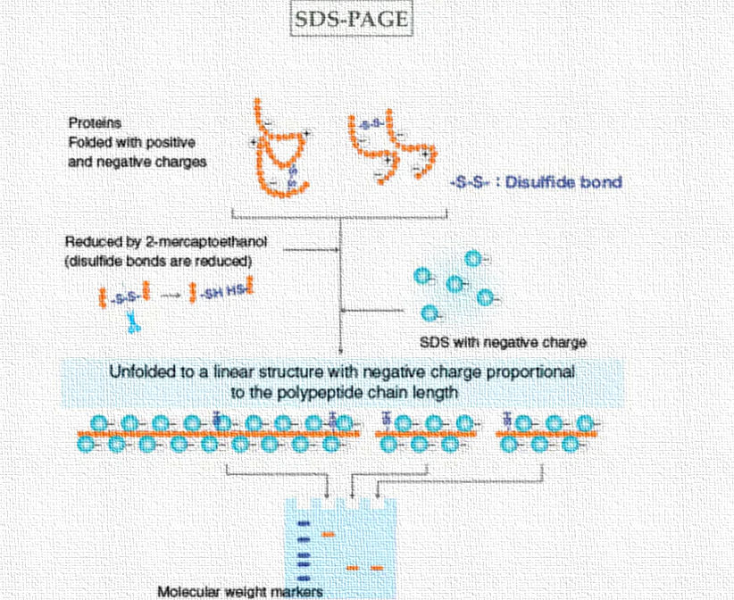
Figure 2 Flow chart diagram of SDS PAGE.(6,9)
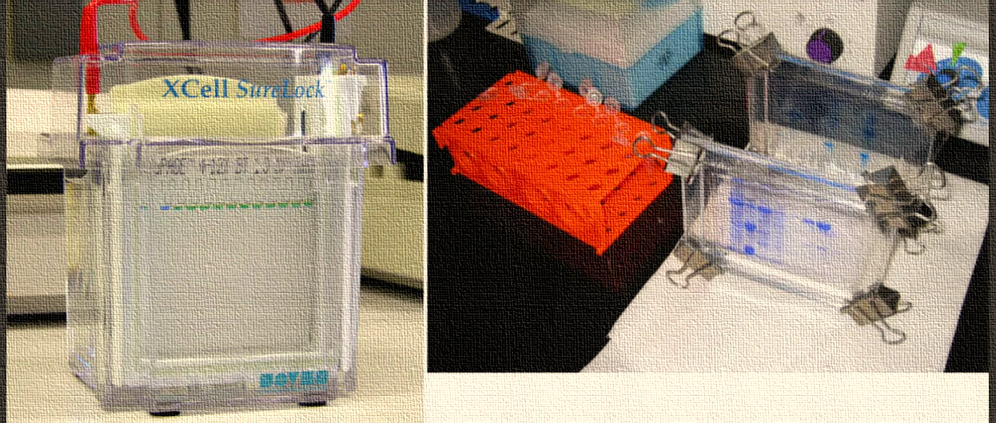
Figure 3 : PAGE UNIT(7,9)
Table1: Requirements of SDS PAGE
Stacking Gel | Resolving  Gel | Sample (Protein) | Running Buffer
Acrylamide  (conc. Less) | Acrylamide  (conc. More) | Bromophenol Blue (Dye) | Glycine
Tris HCL pH-6.8 | Tris HCL pH-8.8 | Tris HCL pH-6.8 | Tris HCL pH-8.3
SDS | SDS | SDS | SDS
DH2O | DH20 | DH20 | DH20
APS | APS | beta-mercaptoethanol
TEMED | TEMED | glycerol

APS (Ammonium per sulphate) & TEMED (Tetramethyl ethylenediamine):
TEMED acts like a catalyst for gel polymerization in SDS PAGE.
It is free radical stabilizer which works along with APS (ammonium persulfate). APS provides free radicals and TEMED stabilizes them in order to aid better polymerization of acrylamide gel

Glycerol: - increases the viscosity of sample, stabilize protein by preferential hydration

TRIS-HCL: Buffer solution in which PH is maintained by Tris [tris(hydroxymethyl)aminometane] and HCL solution

Preferential hydration is the excess of water in the immediate domain of a protein relative to the water concentration in the bulk solvent.
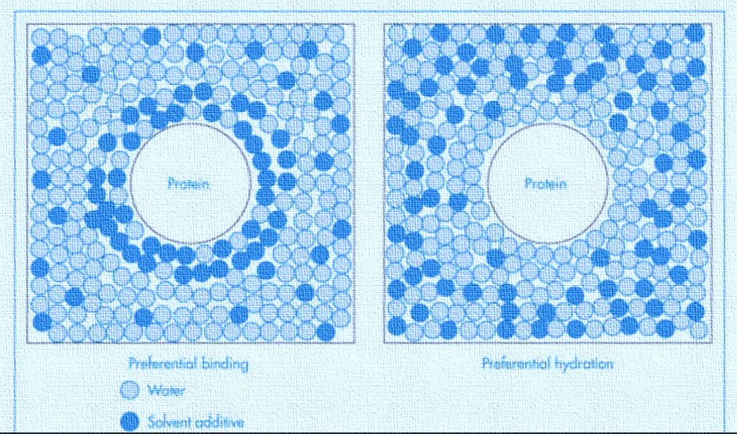
Figure 4: - preferential hydration [8,9]

Tris-Gly Ph 8.3

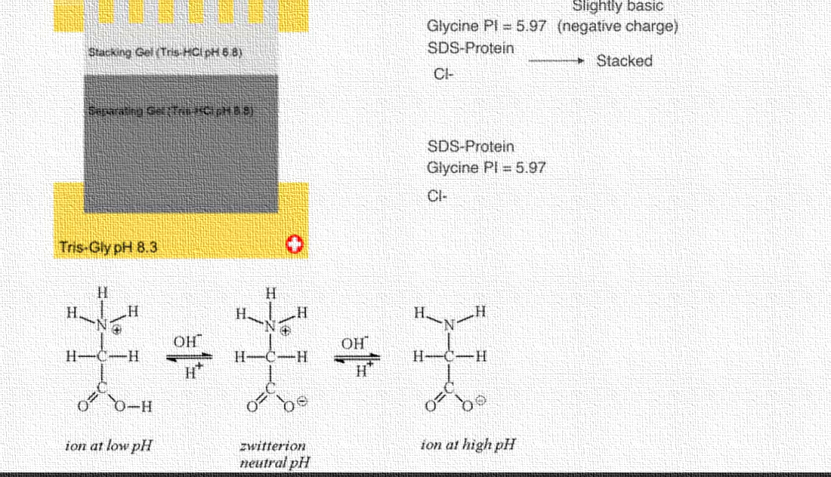
Figure 5 : PI of Glycine at different pH
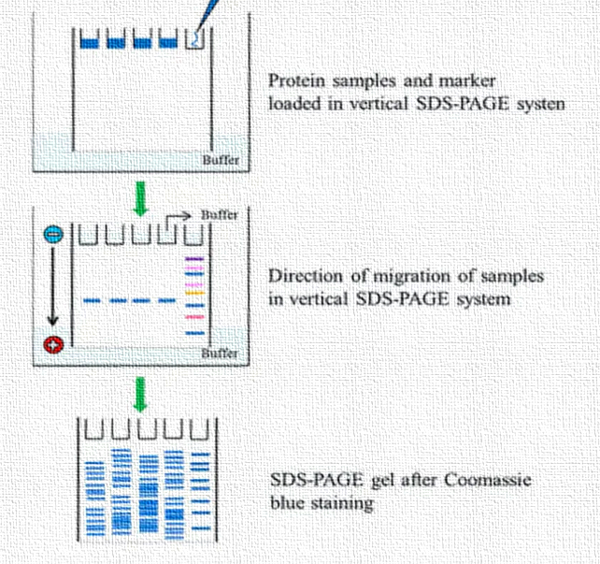
Figure 6 : - Process of SDS page [8,9]
Proteins with less molecular weight travel more quickly through the gel than those with more molecular weight.
The general overflow of emphatically charged amino acids like lysine and arginine will expand the limiting of SDS particles to your protein and will build its portability in SDS-gel.
Any post-translational alterations in the potential SDS-restricting destinations like phosphorylation of serine-threonine and tyrosine or sulfation of tyrosine (or glycosylation as referenced above) will dial back the versatility of your protein since they will change the neighborhood hydrophobicity (or charge)
SDS-page decreasing (w/B-ME): S becomes diminished, and protein is not yet denatured. I.e., If we had a heterotrimer, we would see three separate bands.
SDS-page non-diminishing (w/o B-ME): S is unblemished, yet protein is denatured, i.e., On the off chance that we had a heterotrimer, we would just see one band.
Local page: everything intact, isolated by size, charge, or shape. for example, On the off chance that we had a heterotrimer, we would just see one band.

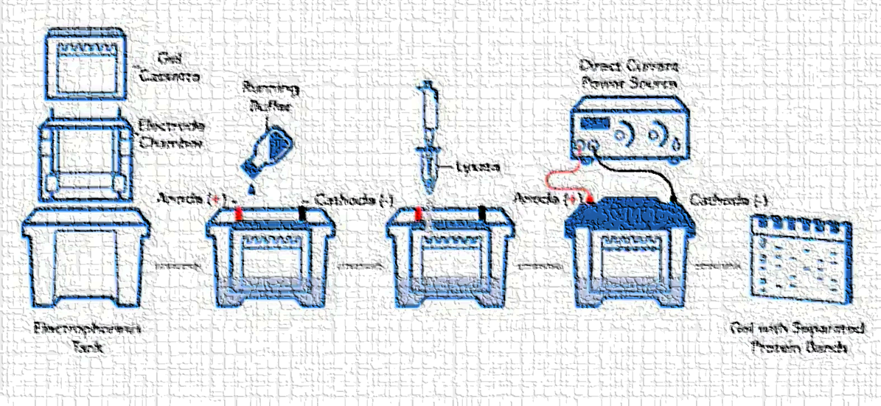
Figure 7: - loading of gel [8,10]
To get the ideal goal of proteins, a "stacking" gel is poured over the "settling" gel"
  - lower grouping of acrylamide (bigger pore size),
  - lower pH
  - different ionic substance
This permits the proteins in a path to be moved into a tight band before entering the running or settling gel
Reason for the stacking gel:
to focus every one of the proteins in the example into a slender band at the highest point of the settling gel
Makes it conceivable to utilize a weak test
The motivation behind the settling gel: to isolate the proteins based on size.
SDS PAGE STAINING
Different staining techniques are used on the SDS page
- high responsiveness,
- low foundation,
- enormous straight reach, and
- convenience
some staining dyes
Silver nitrate
Coomassie blue
Coomassie blue: G250 and R250
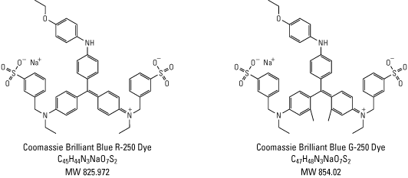

Figure 8: -The structure of Coomassie brilliant blue [8,9].
Coomassie Brilliant Blue
COMPARISON
The CBB staining can recognize around 0.5 µg of protein in an ordinary band.

Silver Staining
The silver stain framework is multiple times touchier, distinguishing around 10 ng of the protein.
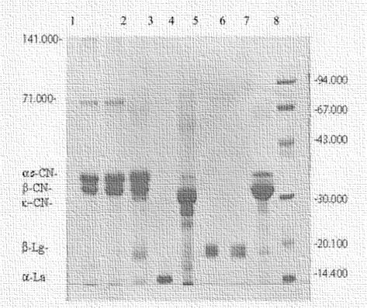
Figure 9: -separation of proteins on the SDS page [8,9]
WESTERN BLOTTING
Western blotting is a protein discovery procedure that joins the partition force of SDS PAGE along with high acknowledgment explicitness of antibodies.
An immunizer against the objective protein could be refined from the serum of creatures (mice, hares, goats) inoculated with this protein.
On the other hand, on the off chance that protein contains a usually utilized tag or epitope, an immune response against the tag/epitope could be bought from a business source (for example against 6 His counter-acting agent).

Application of SDS page
- Estimating the atomic load of the molecules is utilized.

- Assessing the size of the protein is utilized.

- Utilized in peptide planning

- Looking at the polypeptide organization of various structures is utilized.

- Assessing the immaculateness of the proteins is utilized.

- It is utilized in Western Smudging and protein ubiquitination.

- It is utilized in HIV tests to isolate the HIV proteins.

- Breaking down the size and number of polypeptide subunits.To dissect post-translational changes.

REFERENCES
[1] Walker JM. The Protein Protocols Handbook. Humana Press; 2002. [Google Scholar]
[2] Gallagher S, Wiley EA. Current Protocols Essential Laboratory Techniques. Wiley; 2008. [Google Scholar]
[3] Laemmli UK. Nature. 1970;227:680–685. [PubMed] [Google Scholar]
[4] Simpson RJ. Proteins and Proteomics: A Laboratory Manual. Cold Spring Harbor Laboratory Press; 2003. [Google Scholar]
[5] Sussulini A, Becker JS. Metallomics. 2011;3:1271–1279. [PubMed] [Google Scholar]
[6] Lasserre J-P, Beyne E, Pyndiah S, Lapaillerie D, Claverol S, Bonneu M. Electrophoresis. 2006;27:3306–3321. [PubMed] [Google Scholar]
[7] Finney L, Chishti Y, Khare T, Giometti C, Levina A, Lay PA, Vogt S. ACS Chemical Biology. 2010;5:577–587. [PubMed] [Google Scholar]
[8] Leininger, Nelson, cox, Principles of Biochemistry, Second Edition., pp.134-135
[9] source internet
[10] source internet, www.novusbio.com

