Review Article
Tissue engineering in dentistry
Ajay Pal Singh Kataria¹, Himanshu Sood²
¹Reader Department of Oral Medicine and Radiology , ²Reader Department of Conservative and Endodontics, Desh Bhagat Dental College & hospital Amloh Mandi Gobindgarh, Punjab, India .
Correspondence: Ajay Pal Singh Kataria Department of Oral Medicine and Radiology, Desh Bhagat Dental College & Hospital Amloh Mandi Gobindgarh, Punjab, India Email: ajaypalsinghomr@gmail.com

Abstract
Dental conditions such as periodontal diseases, dental caries, and bone loss are prevalent global oral health issues, significantly affecting quality of life. Tissue engineering represents a burgeoning biomedical technology that amalgamates engineering, material science, and biological principles to devise therapeutic strategies and biological substitutes aimed at restoring, maintaining, replacing, or enhancing biological functions. The integration of biomaterials, stem cells, growth factors, and differentiation factors has spurred the exploration of novel treatment possibilities across diverse biomedical domains, including dentistry. The objective of this paper is to expound upon the fundamental principles of tissue engineering, the current landscape, challenges, and future perspectives within the realm of Dentistry.
Keywords: Tissue engineering, biomaterials, stem cells, scaffolds, molecular biology, regeneration medical therapy.
Introduction
In the 1980s, Professor Joseph P. Vacanti and Robert Langer, both from the United States, commenced the exploration of tissue engineering research (Vacanti et al., 1988). In 1993, they defined tissue engineering as "an interdisciplinary field that employs the principles of engineering and the life sciences to advance the development of biological substitutes that restore, maintain, or enhance tissue function.”¹
Tissue Engineering is a collective term in biomedical disciplines aiming to facilitate cells in enhancing their proliferation, differentiation, and morphological organization to induce tissue regeneration, thereby enabling regenerative medical therapy for various diseases. To achieve this objective, it is crucial to create a local environment conducive to cell-induced regeneration by functionally integrating diverse biomaterials, proteins, and genes. The recent rapid advancements in molecular biology, coupled with the ongoing progress of genome projects, have furnished essential and groundbreaking information about genes, elucidating several biological phenomena at the molecular level. Leveraging this genetic information, gene manipulation has become a pivotal technology integral to the fundamental research in medicine and biology, paving the way for new possibilities in gene therapy for certain diseases and tissue engineering. Both gene therapy using virus vectors and cell therapy with genetically engineered cells have been implemented. While the biological and therapeutic outcomes with virus vectors show practical promise, their application in research and clinical therapy is often restricted due to challenges in handling and the inherent adverse effects of the virus vector, such as immunogenicity, toxicity, or potential cell mutagenesis.
Hence, it is crucial for the future advancement of research and clinical domains to devise non-viral vectors using synthetic materials, aiming to improve the transfection efficiency of genes into mammalian cells, both in vitro and in vivo.
Many patients face challenges associated with impaired or deficient tissues and compromised organ functions. In such cases, the existing therapeutic choices are confined to reconstructive surgery or organ and/or tissue transplantation. However, these methods present various clinical challenges, including the less-than-optimal biocompatibility of biomaterials and artificial organs, the limited availability of tissue and/or organ donors, and the eventual negative effects of immunosuppressive agents. To tackle these issues, the investigation of innovative therapeutic approaches is essential. A promising avenue involves regenerative medical therapy, where diseases are addressed by leveraging the innate healing capabilities of patients themselves.
Tissue engineering is a biomedical technology or approach that supports cell proliferation and differentiation, facilitating the natural process of tissue regeneration for disease therapy. In tissue engineering, cells are integrated with scaffolds or bio-signal molecules to accelerate their proliferation and differentiation, ultimately prompting tissue regeneration. Within these signaling molecules, growth factors and associated genes exhibit potential in cell-based tissue regeneration. It has been noted that growth factors are effectively employed to achieve regenerative therapy for various tissues.⁶
With the recent progress in basic molecular biology and genomics, genes have emerged as potential therapeutic agents. Gene therapy has been the focus of experimental and clinical efforts, primarily directed at treating tumors and immunologic diseases. However, its therapeutic applicability extends to various types of diseases. For instance, genes encoding biosignal molecules that stimulate cell proliferation and differentiation are anticipated to play a crucial role in tissue engineering for inducing tissue regeneration. Two carrier systems are employed in gene therapy: viral and non-viral carriers. The former, known for its high transfection efficiency, has been predominantly utilized.
Nevertheless, it is imperative to take into account the intrinsic toxic and safety concerns. Viral vectors, including adenovirus, retrovirus, and adeno-associated virus, have been predominantly employed due to their high efficiency in gene transfection, despite the constrained scope of clinical trials due to the adverse effects of the virus itself, such as immunogenicity, toxicity, or potential mutagenesis of transfected cells. Conversely, a significant challenge with non-viral vectors is the lower efficiency of gene transfection.

Principle of tissue engineering
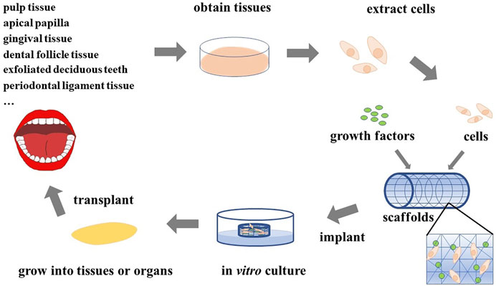
Application of tissue engineering. At present, tissue engineering has been widely used in many fields, including the heart, liver, kidney, spleen, bone, and teeth.
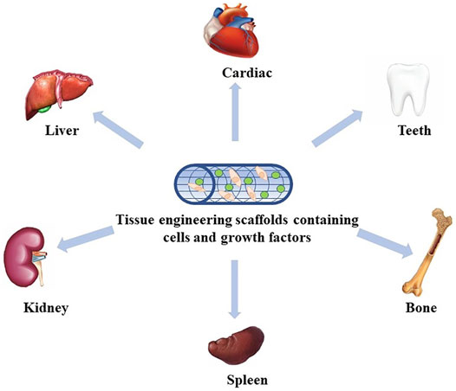
Stem cells are clonogenic cells characterized by their ability for self-renewal and the capacity to generate differentiated progenies. These cells play a crucial role in normal tissue renewal, as well as in the processes of healing and regeneration following injuries. Some stem cells are categorized as pluripotent, indicating their ability to differentiate into a diverse range of cell types, while others exhibit a more limited differentiation range. The inner cell mass of the blastocyst in the early stages of embryo development contains the most pluripotent cells. When exposed to appropriate stimuli, these cells can differentiate into each of the 200-plus cell types found in the adult body. While totipotent cells have significant potential applications, ethical concerns associated with the use of human embryos have sparked vigorous debate. This ethical consideration has strengthened the argument for the utilization of adult stem cells, which are present in every tissue formed post-embryonic development and can fulfill similar purposes as embryonic stem cells.
Research studies have demonstrated the feasibility of isolating clonogenic and highly proliferative cells from dental pulp using a research protocol similar to that employed for the isolation and characterization of bone marrow stem cells. ¹⁰
ental pulp stem cells (DPSC) exhibit the capability to undergo differentiation into various cell lineages, such as adipocytes, chondrocytes, neurons, and odontoblasts. Stem cells derived from human exfoliated deciduous teeth (SHED) have also been identified and isolated. An advantageous feature of SHED is their recoverability from naturally exfoliated teeth, representing one of the few disposable post-natal human tissues. Given that primary teeth serve as a viable source of post-natal stem cells, there is increasing interest in exploring the differentiation potential of SHED cells. Currently, it is well-established that SHED can differentiate into adipogenic, chondrogenic, osteogenic, endothelial, and odontoblastic lineages. The remarkable capacity of these cells to traverse lineage boundaries expands the potential therapeutic applications of SHED for tissues across diverse anatomical domains.
Conclusion
Tissue engineering presents considerable potential in the domain of stomatology, providing a promising direction for future research in tackling issues associated with tooth loss, periodontal defects, dental implants, cleft palate defects, as well as oral and maxillofacial skin or mucosal defects, and bone defects. The expectation is that through continued investigation into tissue engineering, optimal seed cells, enhanced scaffold materials, and growth factors will be identified and successfully applied in the clinical management of oral diseases in the future.
References
- Cao Y, Vacanti JP, Paige KT, Upton J, Vacanti CA. Transplantation of chondrocytes utilizing a polymer-cell construct to produce tissue-engineered cartilage in the shape of a human ear. Plast Reconstr Surg. 1997;100:297–302
- Cao L, Su H, Si M, Xu J, Chang X, Lv J and Zhai Y (2021) Tissue Engineering in Stomatology: A Review of Potential Approaches for Oral Disease Treatments. Front. Bioeng. Biotechnol. 9:662418. doi: 10.3389/fbioe.2021.662418.
- Abukawa H, Terai H, Hannouche D, Vacanti JP, Kaban LB, Troulis MJ. Formation of a mandibular condyle in vitro by tissue engineering. J Oral Maxillofac Surg. 2003;61:94–100.
- 8. Park CH, Rios HF, Jin Q, Bland ME, Flanagan CL, Hollister SJ, Giannobile WV. Biomimetic hybrid scaffolds for engineering human tooth-ligament interfaces. Biomaterials. 2010;31:5945–5952.
- 9. Hu B, Nadiri A, Kuchler-Bopp S, Perrin-Schmitt F, Peters H, Lesot H. Tissue engineering of tooth crown, root, and periodontium. Tissue Eng. 2006;12:2069–2075.
- 10. Sakai VT, Zhang Z, Dong Z, Neiva KG, Machado M, Shi S, Santos CF, Nör JE. SHED differentiate into functional odontoblast and endothelium. J Dent Res. 2010;89:791–796.
- Baum BJ, O’Connell BC. In vivo gene transfer to salivary glands. Crit Rev Oral Biol Med 1999;10:276-83.
- Baum BJ, O’Connell BC. The impact of gene therapy on dentistry. J Am Dent Assoc 1995;126:179-89.
- Baum BJ, Wang S, Cukierman E, Delporte C, Kagami H, Marmary Y, et al. Re-engineering the functions of a terminally differentiated epithelial cell in vivo. Ann N Y Acad Sci 1999;875:294-300.
- Arden RL, Rachel JD, Marks SC, Dang K. Volume-length impact of lateral jaw resections on complication rates. Arch Otolaryngol Head Neck Surg 1999;125:68-72.
- Oryan A, Alidadi S, Moshiri A, Maffulli N. Bone regenerative medicine: Classic options, novel strategies, and future directions. J Orthop Surg Res 2014;9:18. 15. Kumar A, Mukhtar UN, Zia A. Tissue engineering – The promise of regenerative dentistry. Biol Med 2011;3:108-13.
- Siddhartha VA, Sarthak B, Rashmi G, Shilpa S, Uzma B. Tissue engineering in periodontics – A novel therapy. Ann Dent Res 2012;2:1-7. 17. Vishakha G, Ranjan M, Anoop K, Nitin V, Jasjit KS. Future of periodontal regeneration. J Oral Health Commun Dent 2010;4:38-47.
- Koyama N, Okubo Y, Nakao K, Bessho K. Evaluation of pluripotency in human dental pulp cells. J Oral Maxillofac Surg. 2009;67:501–506.
- Miura M, Gronthos S, Zhao M, Lu B, Fisher LW, Robey PG, Shi S. SHED: stem cells from human exfoliated deciduous teeth. Proc Natl Acad Sci U S A. 2003;100:5807–5812.
- Sakai VT, Zhang Z, Dong Z, Neiva KG, Machado M, Shi S, Santos CF, Nör JE. SHED differentiate intro functional odontoblast and endothelium. J Dent Res. 2009 .
- Casagrande L, Demarco FF, Zhang Z, Araujo FB, Shi S, Nör JE. Dentin-derived BMP-2 and odontoblastic differentiation of SHED. J Dent Res. 2010;89:603–608.
- Shi S, Gronthos S, Chen S, Reddi A, Counter CM, Robey PG, Wang CY. Bone formation by human postnatal bone marrow stromal stem cells is enhanced by telomerase expression. Nat Biotechnol. 2002;20:587–591.
- Sonoyama W, Liu Y, Fang D, Yamaza T, Seo BM, Zhang C, Liu H, Gronthos S, Wang CY, Wang S, Shi S. Mesenchymal stem cell-mediated functional tooth regeneration in swine. PLoS One. 2006;1:e79.

