Multi-Dimensional Characterization Methods for Conductive Fabric Materials: Enabling AI-Enhanced Healthcare Applications

Teena Rajan
Research Scholar,
Karunya University
Assistant Professor, Dept. of Electronics and Communication Engineering, Mar Baselios College of Engineering and Technology, Trivandrum
teena.rajan@mbcet.ac.in
Dr. D Sugumar
Associate Professor, Dept. of
Electronics and Communication Engineering, Karunya University
sugumar@karunya.edu

ABSTRACT
This chapter delineates the methodologies employed for the comprehensive characterization of conductive fabric, encompassing their electrical, material, and biological attributes. Electrical characterization is achieved through impedance spectroscopy, providing insights into the electrodes' conductivity, impedance profiles, and signal fidelity in ECG applications. Material analysis techniques, including scanning electron microscopy and mechanical testing, unravel the physical properties and structural robustness of the electrodes, ensuring their suitability for prolonged use. Biological assessment employs skin-electrode impedance measurements, biocompatibility studies, and user comfort evaluations. In the context of AI-enhanced healthcare, conductive fabric-based sensors can seamlessly capture data such as electrocardiograms (ECGs) by being incorporated into wearable garments. This continuous data stream is then processed by AI algorithms, enabling real-time analysis and interpretation. These real-time insights, coupled with AI-powered analytics, empower healthcare providers to offer personalized interventions, early diagnoses, and timely recommendations.

Keywords—Impedance spectroscopy, Scanning Electron Microscopy, cytotoxicity, Conductive fabric electrodes, Cardiac monitoring

INTRODUCTION

In the field of smart textiles, the pursuit of precision and reliability demands a comprehensive understanding of their electrical, mechanical, and biological characteristics. This pursuit has led to the development and application of a diverse array of testing methods that collectively contribute to unveiling the multifaceted nature of the conductive material. Electrical characterization is important for assessing the capacity of electrode material to capture and transmit accurate cardiac signals. Techniques such as Conductivity Tests and Impedance Tests play a pivotal role in gauging their conductivity and signal quality, crucial for precise ECG monitoring. Moreover, Hipot testing is employed to ensure the electrodes' electrical insulation, safeguarding both patients and equipment. Mechanical aspects come to the forefront with tests like Gel Adhesion combined with Conductivity, which examines the durability of the electrode-skin interface[1]. The utilization of tools like Microscopic Inspection and Universal Testing Machines (UTM) for tensile testing offers insights into the electrodes' structural robustness and mechanical behavior under stress. Biological characterizations are equally imperative, considering the electrodes' intimate contact with human skin. Methods such as Scanning Electron Microscopy (SEM), Transmission Electron Microscopy (TEM), and Energy-Dispersive X-ray Spectroscopy (EDX) are employed for microscopic analysis of material surfaces. Absorbance, Leaching, and Irritation tests evaluate biocompatibility, ensuring the electrodes' safe interaction with the skin. Furthermore, assessments like Sensitivity, Cytocompatibility, Cytotoxicity, and Carcinogenicity delve into the electrodes' impact at the cellular and molecular levels, essential to ascertain their compatibility with biological systems. In the upcoming sections, each testing methodology is described. Conductive fabric materials offer a promising avenue for revolutionizing AI-based healthcare applications through their unique properties and versatility. Conductive fabric materials are utilized to develop wearable biosensors that monitor parameters like temperature, muscle activity, and respiratory patterns. The combination of conductive fabric materials and AI technologies holds immense potential in transforming the field of healthcare by fostering proactive and data-driven patient care approaches.

II CONDUCTIVE FABRICS
Conductive fabrics are textiles that are designed to conduct electricity. These fabrics are made by incorporating materials that have electrical conductivity, allowing them to carry and transmit electric currents.
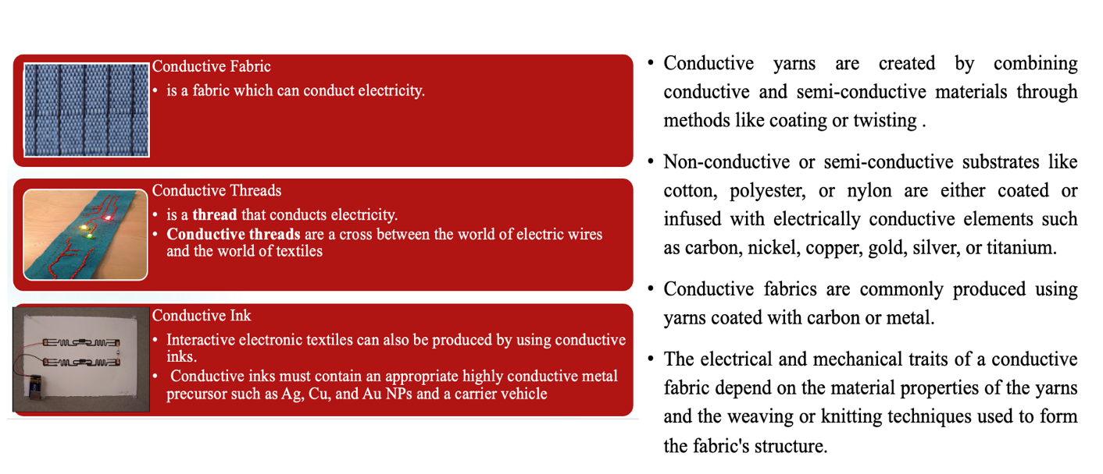

Figure1:Existing technologies
These fabrics are often used in various applications such as wearable technology, smart textiles, and electronic devices where the fabric itself can serve as a functional component for conducting electricity.

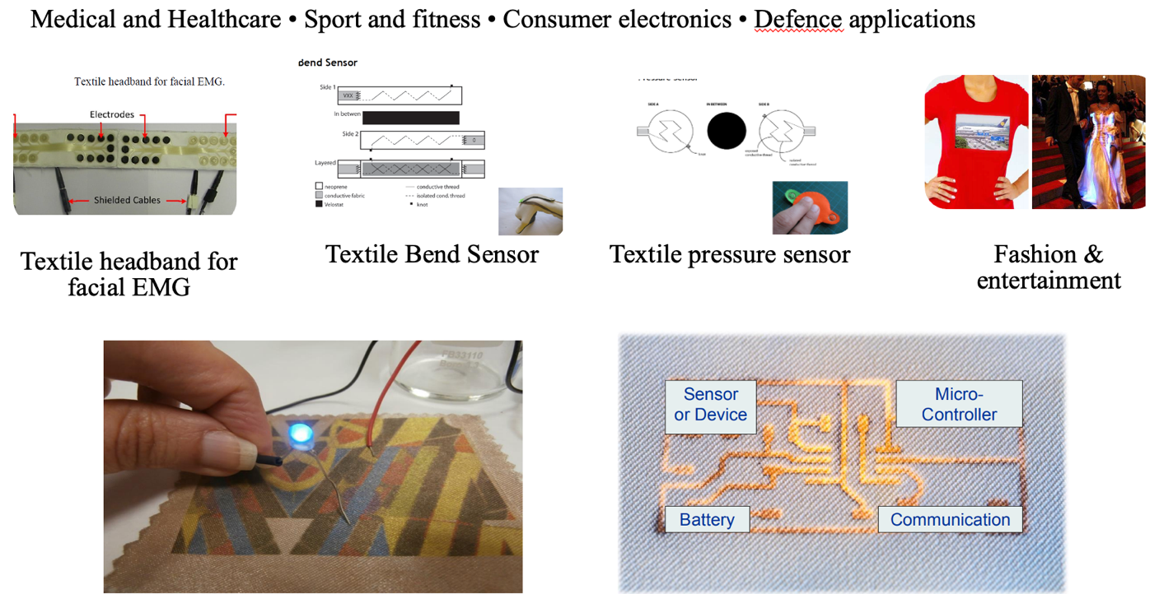

Figure2:Applications

III ELECTRICAL CHARACTERIZATION

Conductivity Test
Electrical characterization of conductive fabric, including conductivity testing, is important for understanding the fabric's ability to conduct electricity. Electrical resistivity represents a fundamental physical attribute of all substances. At room temperature, various materials can display differences in electrical resistivity spanning more than 20 orders of magnitude. The electrical resistivity of a substance quantifies its resistance to the passage of electric current. Measured in units of ohm·meters (Ω m), lower resistivity indicates ease of electric conduction within a material.
The Greek letter "ρ" symbolizes electrical resistivity, while the Greek letter "σ" represents electrical conductivity, being the reciprocal of resistivity.

$σ=\frac{1}{ρ}$ (1)

Commercial four-point probes are frequently employed to determine the resistivity of thin material films and sheets. For measuring resistances below 100 Ω, the 4-wire method offers greater accuracy compared to the 2-wire method. A four-point probe is composed of four electrical probes evenly spaced and aligned in a co-linear arrangement, as depicted in the diagram below.
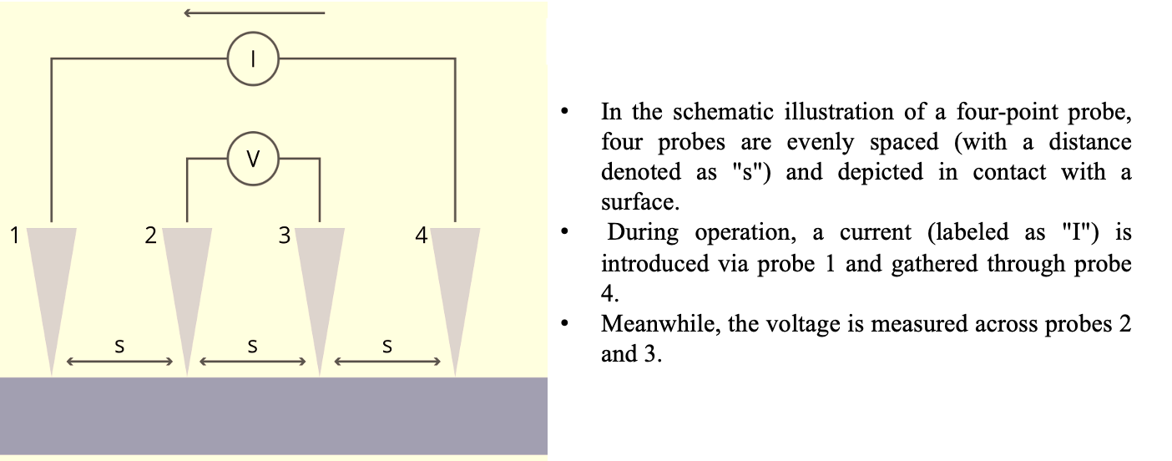
Figure 3: Four point resistance measurement set up
$R=\frac{ρl}{A}$ (2)
R=Resistance ;$ρ$=reistivity
l=length of the material; A=Area

Impedance Test
The electrical impedance is a combination of resistance and reactance, representing both its real and imaginary aspects[2]. Conductivity, shape, and size collectively determine the resistance, while permittivity, shape, and size collectively decide the reactance of a sample. The conductivity of the material is influenced by concentrations of mobile charges and their mobility. Permittivity is also a characteristic of a material that considers how it responds to electric fields and the interactions between tiny conductive parts. When making a conductive fabric, things like what it's made of, how it's woven, coated, and how tightly it's put together can all influence these qualities. If we want to create a fabric sensor, we can decide on its shape and size based on what we want to use it for.
- When a direct electric current (DC) flows through a conductive fabric, it seems to resist the current.
- When an alternating electric current (AC) is used, the fabric's behavior becomes more intricate. This is because the conductive threads in the fabric and the spaces between them create a mix of resistance and a responsive effect, somewhat like capacitance.
In electrical impedance spectroscopy (EIS), a sinusoidal current with a set strength and phase is introduced, and the resulting voltage is measured within a specific range of frequencies. By employing Ohm's law, we can derive the complex impedance spectrum, denoted as Z(ω), with ω representing the angular frequency[4].
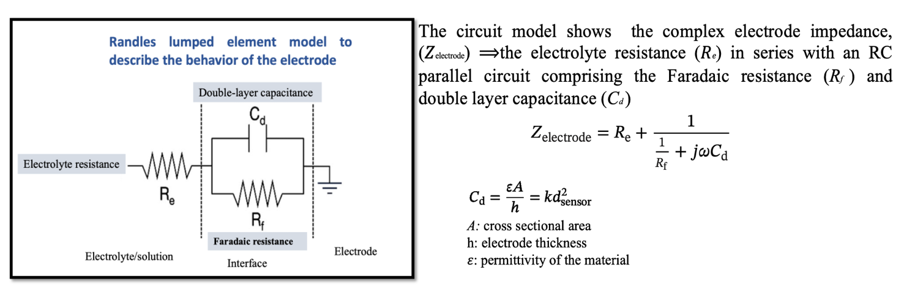
Figure 4: Randles lumped element model

Hipot Test

The term "Hipot test" is short for "High Potential test," which is also recognized as a "Dielectric Withstand Test." This test involves applying high voltage to the material under study to assess the sufficiency of its electrical insulation in withstanding voltage transients, ensuring the insulation is not marginal. Procedure includes connecting the electrode to the test equipment, setting the desired test voltage and duration followed by gradually increasing the voltage, monitoring for breakdown, record the results and address any failures. Do adhere to safety protocols throughout the process.

IV MATERIAL CHARACTERIZATION

Material characterization refers to the process of systematically investigating and understanding the properties,

structure, behavior, and composition of a material[3].
Microscopic Inspection: This provides a close examination of the fabric's surface and structure, revealing fine
details that impact its properties.
UTM-Tensile Test: This evaluates the fabric's mechanical strength and elasticity, helping us understand how it
behaves under tension.
Scanning Electron Microscopy (SEM):

Surface Morphology: Use SEM to closely examine the surface texture, patterns, and features of the conductive fabric. This helps you understand how the conductive elements are distributed, the alignment of fibers, and any surface irregularities.

Fiber Arrangement: Analyze the arrangement and orientation of individual fibers within the fabric. This information can be crucial in understanding the fabric's mechanical properties and its behavior under stress or tension.

Particle Distribution: If the conductive fabric includes particles or additives, SEM can reveal their distribution on the fabric's surface, providing insights into how these particles are dispersed.

Defect Detection: Identify defects, cracks, or imperfections on the fabric's surface. This is especially important for ensuring the fabric's quality and performance in applications where defects could affect its conductivity or structural integrity.

Quality Control: SEM can be used for quality control purposes, ensuring that the conductive fabric meets specific standards and requirements. It allows you to verify that the fabric's surface matches the intended design and specifications.

Composition Analysis: While SEM itself does not provide detailed compositional information; it can be used in conjunction with other techniques like Energy-Dispersive X-ray Spectroscopy (EDX) to determine the elemental composition of specific areas on the fabric's surface.

Material Interactions: If the conductive fabric interacts with other materials or coatings, SEM can help visualize these interactions at the microscale level, aiding in understanding compatibility and potential performance issues.
Absorbance Measurement: By assessing the fabric's ability to absorb light or other electromagnetic waves, we gain information about its optical and electromagnetic properties.
Leaching Test: This assesses whether the fabric releases any substances into its environment, helping ensure its safety and suitability for various applications.

V BIOLOGICAL CHARACTERIZATION

Biological characterization involves a series of tests aimed at assessing how materials interact with biological systems, which can include living organisms, cells, tissues, and biomolecules. The goal is to understand the material's impact on biological components and ensure its safety and suitability for specific applications[5].

Irritation: This test evaluates the potential of the conductive fabric to cause skin irritation. It involves applying the fabric to the skin, usually of rabbits or other test animals, and observing any adverse reactions such as redness, swelling, or other signs of irritation.
Sensitivity: Sensitivity testing determines whether the conductive fabric can induce allergic reactions in individuals. This is done by exposing a sample of the fabric to the skin and monitoring for any allergic responses.
Cytocompatibility: Cytocompatibility testing assesses how well the conductive fabric interacts with living cells. It involves exposing cells to the fabric and observing their behavior, including attachment, growth, and viability.
Cytotoxicity: Cytotoxicity testing examines whether the conductive fabric has toxic effects on cells. It measures the fabric's impact on cell viability, proliferation, and overall health.
Carcinogenicity: Carcinogenicity testing determines whether the conductive fabric has the potential to cause cancer. This is typically studied through long-term exposure of animals to the fabric and monitoring for the development of tumors or other cancer-related effects.

VI EXPERIMENTAL STUDY: MATERIAL AND METHODS

The woven conductive fabric under study, composed of Copper and Nickel-plated nylon with a silver-colored appearance, was characterized for its electrical properties under both dry and wet conditions. The material's electrical properties were evaluated using an Agilent 4263B LCR meter, and the measurements were taken in two distinct scenarios: (1) under dry conditions at normal room temperature and under wet conditions after being immersed in Phosphate-buffered saline (PBS) buffer solution with a pH of approximately 7.4. The fabric sample utilized for testing was cut to a square shape with an area of 5cm by 5cm.

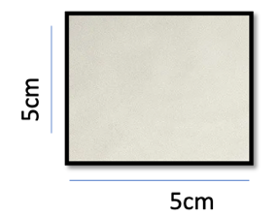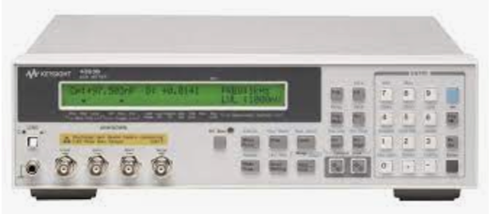

Figure 5: woven conductive fabric, LCR meter

VII RESULTS
One of the findings of this study is the distinct change in electrical behavior observed when the woven conductive fabric is exposed to the wet environment created by the immersion in the PBS buffer solution. Impedance is increased across the fabric. This phenomenon suggests that the conductive properties of the fabric are sensitive to the presence of moisture and ionic species present in the buffer solution. Consistent increase in impedance observed across the woven conductive fabric in both wet and dry conditions has been observed, particularly at higher frequencies. This frequency-dependent behavior indicates that the fabric's conductive properties are not well-suited for high-frequency applications. However, the converse of this frequency-dependent behavior is of notable significance. The experimental results clearly indicate that the conductive fabric is well-suited for very low-frequency applications. At 100Hz the observed resistance under dry and wet condition is 37.7m$Ω$and 101.27 m$Ω$ respectively. A standout application emerging from these findings is the fabric's potential use in ECG electrode applications. The fabric's impedance behavior aligns well with the frequency range typically encountered in ECG measurements.

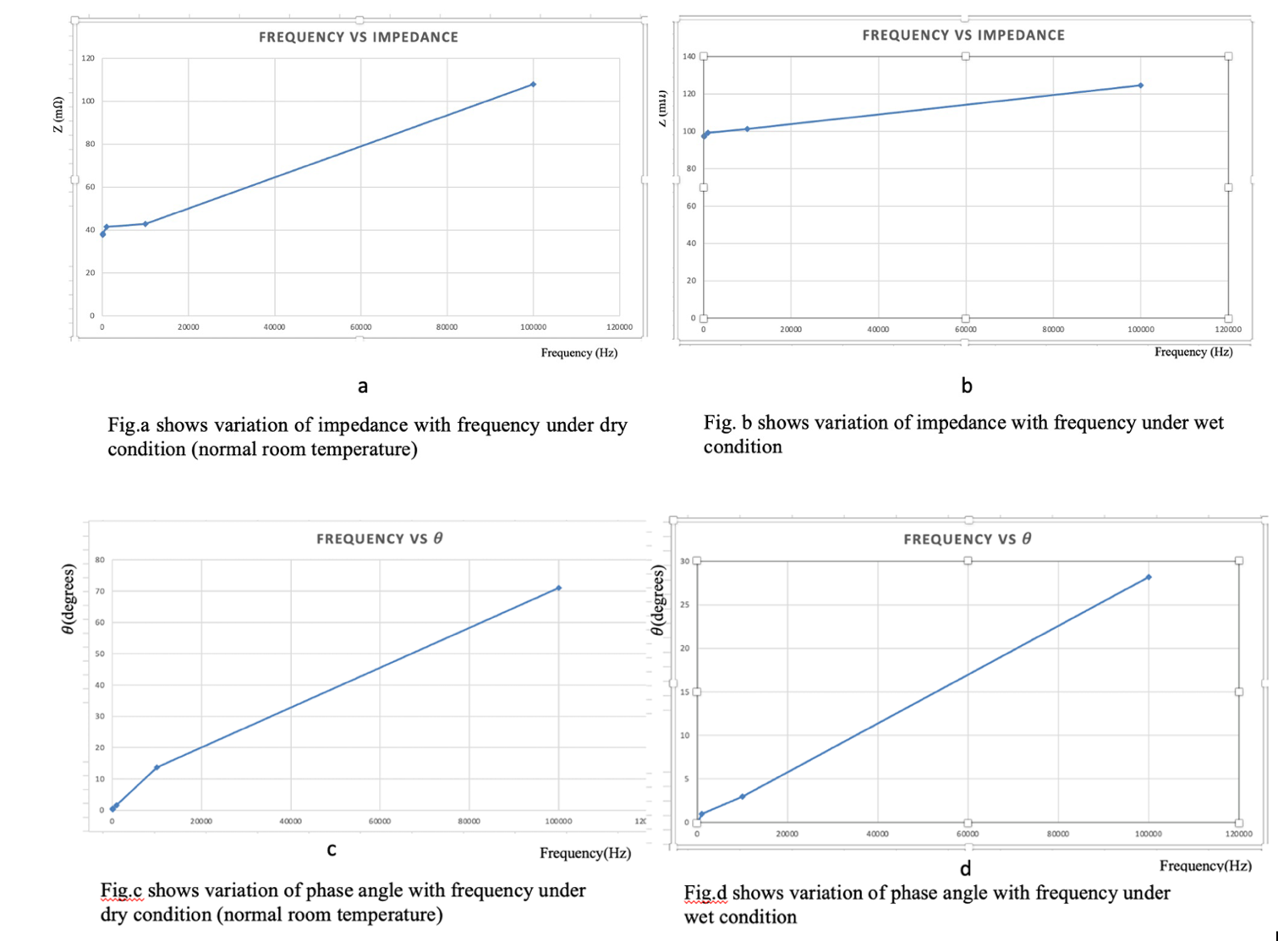

Figure 6:Results
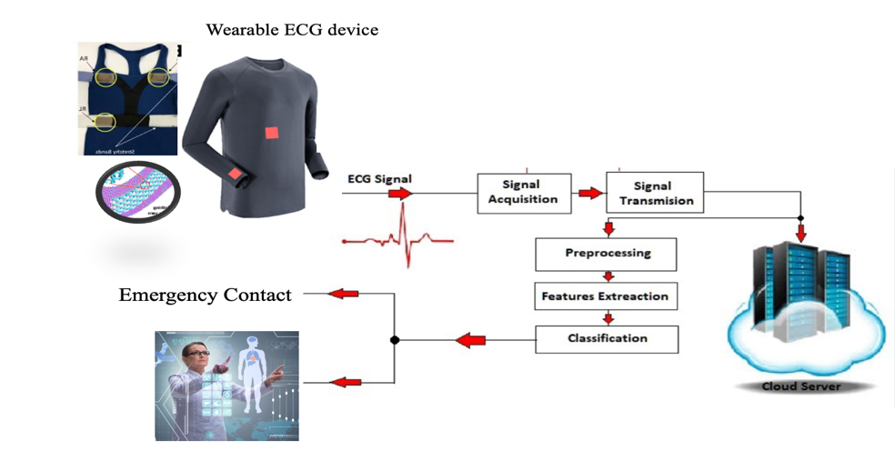

Figure 7:Smart healthcare system

VII FUTURE SCOPE

Looking ahead, the convergence of conductive fabric technology with artificial intelligence (AI) offers a realm of exciting opportunities that could revolutionize diverse fields and drive innovative applications.

- Enhanced Biomedical Sensing
Integrating AI algorithms with conductive fabric electrodes holds immense potential for biomedical sensing. By combining the fabric's conductivity and conformability with AI-powered signal processing, real-time health monitoring could reach unprecedented levels of accuracy and sensitivity. AI-driven analytics could identify subtle changes in physiological signals, empowering early detection of health anomalies.
- Intelligent Textile-Embedded Interfaces
AI-powered textile interfaces represent a novel frontier in human-computer interaction. By embedding conductive fabric electrodes in everyday textiles, AI could enable seamless interactions with technology. Fabric could detect touch, gestures, and even biometric signals, forming intelligent interfaces that adapt to users' preferences and intentions. The fabric's impedance behavior, as uncovered in this research, could be integrated into AI models to enhance accuracy in gesture recognition and touch-sensitive applications.

Cognitive Garments

AI-infused conductive fabric opens avenues for "cognitive garments" that contribute to mental well-being. The fabric's conductivity could capture physiological signals associated with stress or relaxation, while AI algorithms interpret these signals to provide real-time feedback

REFERENCES

- Lee, S.H., Jung, S.M., Lee, C.K., Jeong, K.S., Cho, G., Yoo, S.K. (2009). Wearable ECG Monitoring System Using Conductive Fabrics and Active Electrodes. In: Jacko, J.A. (eds) Human-Computer Interaction. Ambient, Ubiquitous and Intelligent Interaction. HCI 2009. Lecture Notes in Computer Science, vol 5612. Springer, Berlin, Heidelberg. https://doi.org/10.1007/978-3-642-02580-8_85
- Soumyajyoti Maji, Joshi Dookhy, Martin J. Burke, Electrical characterization of conductive textile based ECG recording electrodes, Measurement: Sensors, Volume 15,2021,100044,ISSN 2665-9174,
- Barudov and M. Ivanova, "Study of the parameters of conductive textile fabrics for protection against high-frequency electromagnetic radiation," 2021 13th Electrical Engineering Faculty Conference (BulEF), Varna, Bulgaria, 2021, pp. 1-5, doi: 10.1109/BulEF53491.2021.9690835.
- A. R. Iusan and N. -M. Bîrlea, "Measuring skin's electrical properties with ECG electrodes The skin's electrical properties under ECG electrodes," 2018 International Conference and Exposition on Electrical And Power Engineering (EPE), Iasi, Romania, 2018, pp. 0708-0711, doi: 10.1109/ICEPE.2018.8559663.
- A. Bosnjak, A. Kennedy, P. Linares, M. Borges, J. McLaughlin and O. J. Escalona, "Performance assessment of dry electrodes for wearable long term cardiac rhythm monitoring: Skin-electrode impedance spectroscopy," 2017 39th Annual International Conference of the IEEE Engineering in Medicine and Biology Society (EMBC), Jeju, Korea (South), 2017, pp. 1861-1864, doi: 10.1109/EMBC.2017.8037209

