Phytoremediation: A potential method for removal of heavy metals polluted soils
Jeetendra Verma¹*, Dinesh Mani², Vipin Sahu³, Himanchal Vishwakarma⁴, Manoj kumar⁵ and Rupesh Kumar Ojha⁶

¹ Ph.D. Research scholar Sheila Dhar Institute of Soil Science, Department of Chemistry, University of Allahabad, Prayagraj, Uttar Pradesh, India, 211002
² Professor, Department of Chemistry, University of Allahabad, Prayagraj, Uttar Pradesh, India, 211002
³ Ph.D. Research scholar Sheila Dhar Institute of Soil Science, Department of Chemistry, University of Allahabad, Prayagraj, Uttar Pradesh, India, 211002
⁴ Ph.D. Research scholar Sheila Dhar Institute of Soil Science, Department of Chemistry, University of Allahabad, Prayagraj, Uttar Pradesh, India, 211002
⁵ Ph.D. Research scholar Sheila Dhar Institute of Soil Science, Department of Chemistry, University of Allahabad, Prayagraj, Uttar Pradesh, India, 211002
⁶ Ph.D. Research scholar Sheila Dhar Institute of Soil Science, Department of Chemistry, University of Allahabad, Prayagraj, Uttar Pradesh, India, 21100
Email: jeetendravermajmv@gmail.com
Abstract:
The study of heavy metal and found of metallic is properties of heavy metals. Heavy metal contamination in the global warming caused by humans in phytoremediation is two ways of remediation that have advantages and disadvantages. The use of plants in polluted areas as a means of cleanup is known as phytoremediation. A form of ecological strategy is phytoremediation. And heavy metals effect in control of human diseases. We outline is the mechanisms of heavy metals uptake, migration, and detoxification by plant. They accumulation on the methods utilize to enhance are capability of phytostabilization and phytoextraction, such as the use on hereditary manufacturing, microbe-assisted, and chelate-assisted methods. Phytoremediation technique is an eco-friendly and chiefly methods, through which contaminated substrates are ameliorated by growing plants that have the ability to remove the polluted soils.

Introduction:
The expression of heavy metal translocation, to metalloid among moderately higher atomic number and mass (> 20 and 5 g cm⁻³ respectively,) and categorize because required and non required metalloid (Alloway 2012). May be defined as metalloid every outstanding is the high atomic weight or since of their more density these days, the wide metallic has been used to explain metallic chemical elements and metalloids which are noxious to the atmosphere or mans. The various heavy metal and too lighter heavy metal such while aluminium selenium and arsenic are toxic. They are having been term metallic while several heavy metal are naturally not contaminated such as the compound bullion. A list of metalloid according to their concentration of being $>$ 5 g/cm3 and which are maximum general in our daily life are: Cd, , Pb., Cr , Mn , Fe , Co , Ni , Cu , Zn As, Mo and Ag etc.
The main utilize of heavy metals enrichments plants to uncontaminated surroundings is the majority speedily increasing constituent of this ecological eco-friendly and commercial tools that has established significant attention in current time. The ever rising ecological contamination suitable to application of sewage and sludge, city refuse, and heavy metal contain pesticides, manures and fertilizers are attractive a main difficult inside current farming. Though present be a hazard of toxic waste if the food chain if not poisonous crops are utilize for the intention. Now more consideration has been compensated in the direction of the responsibility of attractive plant as a sustainable possible with profitable different. The not available crops are decreasing the hazard of the way in of metalloids in the food sequence (Liu et al. 2008). Many be crops variety has been flourishing in captivating polluteds such as Pb, Cd, Cr, As and different radio-nuclides from soils (Achal et al. 2012; Wojcik and Tukiendorf 2004), while several crops variety is the common to metallic ferrous soils and can be stand greater than natural qantity of metalloids or other poisonous complex (Niu et al. 2007).
Therefore is the plant group have been a predicament and respect into paired there are accumulation with maintain concentration if the metalloids in their tissues to manage with metalloids strain. Nevertheless, a metal-tolerant plant is the either group as metal accumulation or metal excluder basic on the bioconcentration of metals in their roots and areal parts respectively, (Mani et al. 2012).
There are main objectives are removing heavy metal by phytoremediation process. And phytoremediation is new technique and eco- friendly are minimum chastely. The heavy metals in properties are effect in human disease.
Sources of heavy metals:
There are metalloids set up in natural world on top of the Earth's outside as the Earth's development. Appropriate in the direction of the amazing enhance in the use of metalloids. It is the resulted in a coming up heave been metallic substance within is the global surroundings and marine atmosphere.
Metalloids contaminated has emerge suitable the anthropogenic action which are the major reason of toxic waste, principally unpaid on the way to mining the metal, smelting, foundries and extra manufacturing with the purpose of are metal-based, discharge of metals as of dissimilar sources such as landfills, waste dumps, emission, domestic animals and chicken manure, runoffs, automobiles and road works. Metalloids utilize in the Farming ground has been the inferior source of metalloids toxic waste, such as the use of pesticides, insecticides, fertilizers and more. Ordinary reason can also enhance Metalloids contamination such as volcanic action, metal deterioration, metal disappearance from soil and water and residue re-suspension, land attrition, geographical weathering.
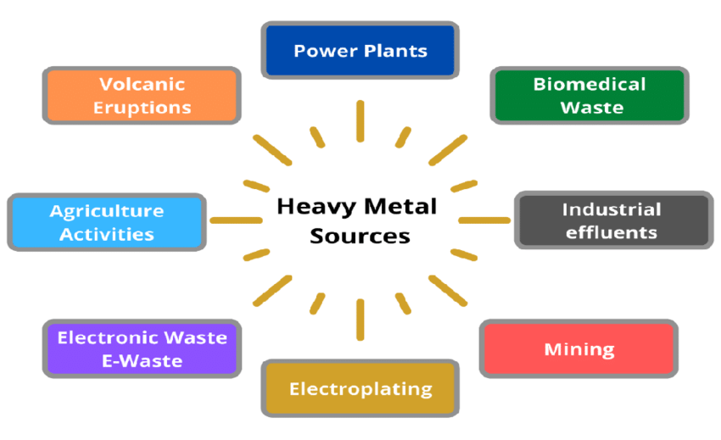
Fig. (1) Sources of heavy metal, Source ResearchGate
Table 1.
The heavy metals of Sources in contaminated soils
Name of the contaminant | Source
Cadmium | Fertilizers, smelting zinc, and using batteries batteries, e-waste, paint sludge, incinerations, and fuel combustion, among other things.
Arsenic | Processes that are geogenic or natural include smelting, wood treatment, paints, insecticides, geothermal, thermal power plants, and energy burning, among others.
Nickel | Thermal power plants, alloy smelting processes, the battery sector, and mine waste.
Zinc | Mine waste, smelting paints and dyes, treating wood, fertilizers, and electroplating are a few examples.
Lead | Preservatives, gasoline additives, paints, electronic waste, smelting processes, coal-fired power plants, batteries, metal goods, ceramics, and the bangle industry are just a few examples.
Chromium | Pesticides, dyes, tanning of leather, mining, chromium (Cr) in industrial coolants, treatment of wood, and production of chromium salts.
Copper | Treatment of wood, fertilizers, mine waste, fungicides for electroplating, electrical, paints, and pigments, as well as smelting processes.

Sources of heavy metals in to two types
- Heavy metals of anthropogenic sources.
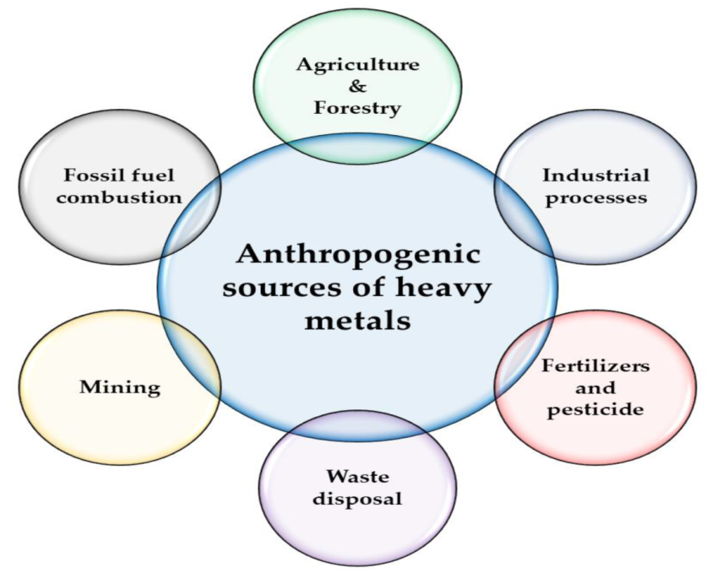
Fig. (2) Anthropogenic, Source of Research Gate

2. Heavy metals of natural sources.
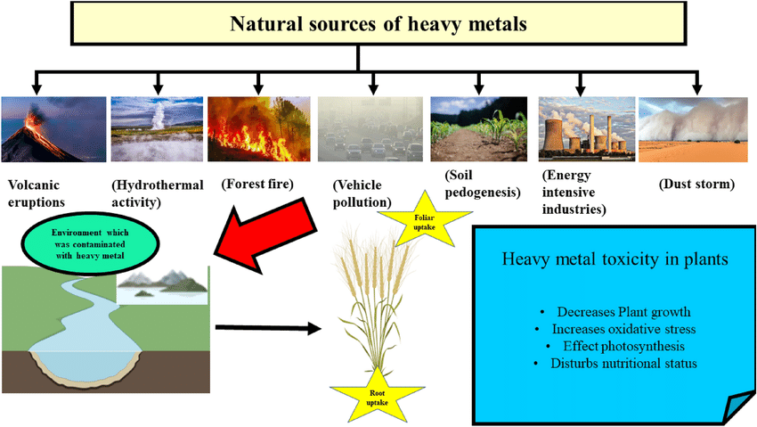
Fig. (3) Natural sources, Source of Research Gate

Heavy metals of Properties:
The heavy metals (HMs) are likely to appearance covalent bonds, manufacture these are represent toxic property. The majority significant penalty of their feature is with the purpose of they can bind covalently and unrefined groups. Therefore they outward appearance lipophilic ions and elements and they can create poisonous impact at what time they bind to non metallic compounds of cellular macro molecules. Suitable just before becoming lyophilic, heavy metals division in the atmosphere along with their noxious reply differ from the activity of uncomplicated ionic forms of the same elements. Examples of lyophilic compounds are tributyltin oxide and methylated forms of arsenic which are highly noxious. Examples of binding to non-metallic elements are the binding of lead (Pb) and mercury (Hg) to sulphur group’s protein. The entry of HMs in human takes place by four ways from; intake of impure food inhalation from the environment, drinking polluted water in addition to unpaid to contact of skin from farming sector, medical, industrialized, inhabited and factory area.
Metals are non-biodegradable in nature and ecologically toxic. Biomes may toxic metalic ions through thrashing the vigorous element inside a protein or deposit them in intracellular granules in an inexplicable form to be excreted in the organism's feces. When the metallic pollutants are swallowed or entered into our body system, then bioconcentration in our enivironment. The bioconcentration of these metals region biological addition to physiological complication. Several metal be essential for living-being and are called necessary elements which are compulsory used for diversity the bio-chemical with physico-logical function. They have been extensively used in farming, manufacturing, drug and various sector, effect of two they are have been disseminate interested in the surroundings counting with our environment, waters and lands.

Table2.
Some importance of heavy metals properties
1. Chromium uses and properties
Properties | Density: 7.15 g/cm3 Twenty one is the most abundant compound element in the Earth's upper layers, and it is extracted as chromite, which is described as Siberian red Pb, indestructible, shiny, steel-grey, and somewhat active metal. Reacts with the majority of acids to produce chromium (Cr) oxide, which builds up the heavy metals' mordant content.
Uses | Glass is colored green using alloys, heavy metal earthenware, electroplating, fleece tanning, artificial ruby production, colorants, and Cr salt.
Effects on People | Oral consumption of Cr typically results in acute poisoning and a variety of symptoms, including: nausea, vertigo, toxic nephritis, liver damage, coma, and death (generally at 1-3g).  Chronic poisoning can result from repeatedly coming into touch with the skin or breathing Cr. The following conditions are brought on by Cr: allergic contact dermatitis and eczema, gingivitis, mucous membrane irritation, bronchitis, liver and kidney illness, sinusitis, pneumonia, lung cancer, and chrome holes, particularly in the nose, forearms, hands, and fingers.
Food source | foods such grains, fruits, vegetables, meats, and shellfish.
2. Arsenic uses and properties
Properties | 55th most abundant metal, mass 5.75 g/cm3, found in three allotropic forms. Minerals discovered include: Arsenopyrite, which is composed of iron arsenic sulfide, Realgar, also known as the "ruby of arsenic," Orpiment, a mineral composed of arsenic sulfide, Energize, composed of a Cu, As, sulfate salt, and Bright silvery-grey in color Brittle.
Uses | Wood preservation, glass construction using specified types, formulations of insecticides, Gallium arsenide, for example, is a doping agent used in semiconductors to transform electric current inters laser light, pyrotechnics, and bronze manufacturing current.
Effects on humans | Lung discomfort, skin changes, and gastro-intestinal system irritation are all consequences of inorganic arsenic toxicity. increased risk of cancer, decreased generation of both white blood cells and red blood cells, miscarriages and infertility heart issues, Deoxyribonucleic acid (DNA) damage and brain damage Although organic arsenic does not alter DNA and is not carcinogenic, it may cause nerve damage and disturbances in the belly.
Food source | It is the fish and shellfish, Meat and poultry, Dairy products and Cereal.

3. Cadmium uses and properties
Properties | Green-ockite, a mineral composed of Cr and S silvery bluish tint metal, is the only mineral found. Its density is 8.69 g cm-1, making it the 64th most plentiful metal. It is frequently found in combination with zinc. DNA and does not cause cancer).
Uses | Fertilizer with phosphate Pesticides, nickel-cadmium batteries, glassware coloring, corrosion-resistant plating, plastic additives, and nuclear reactors are just a few examples.
Effects on humans | Nephrite toxicity, which predominantly affects the kidneys, infertility brought on by a malfunction of the reproductive system, changes in calcium metabolism, fractured bones psychological conditions, digestive system issues, problems with the central nervous system, DNA damage, deficits in the immune system, and Renal dysfunction, cancer, osteoporosis, and Itai-Itai disease is allegedly ecotoxic and genotoxic to animals.
Food source | Shellfish, Mussels,Dried seaweed, Shrimps ,Mushrooms and Liver.
4. Lead uses and properties
Properties | Mass: 11.3 g/cm-3, the 37th-richest metal, found in the lead sulfide-containing mineral ore known as galena, which can also contain silver, zinc, and copper. It is a dull silver-grey metal that can be easily handled.
Uses | second-hand in the past for: hair dyes, lead glazes for pottery, insecticides, and lead-acid batteries for automobiles coverings for computer screens that protect from radiation Ammunition and projectiles, Pb gemstone glass, cable sheeting, athletic equipment, diver weight belts, canisters for corrosive chemicals, roofing materials, stained glass windows, and Pb pipes are some examples of these products.
Effects on humans | High blood pressure, miscarriages, low birth weight babies, stillbirths, injuries to the kidneys, a brain damage, severe agony, and pica sperm injury, peripheral nerve damage indications of encephalopathy, iron shortage brought induced by a disturbance in the production of hemoglobin cognitive dysfunction, The development of the brain and central nervous system is disrupted in youngsters, and intellect is removed. decreasing educational
Food source | Fruit, vegetables, Grains, Seafood, Red meat and Wine and Soft drink.

5. Zinc uses and properties
Properties | Mass: 7.134 g/cm⁻³ Twenty four most abundant metal, Silvery-white metal with a blue tinge 2 of the most general ores are zinc blende, made up of zinc supplied, and calamine made up of zinc silicate, Tarnishes in air and necessary element.
Uses | 1. Die-casting and galvanization to prevent corrosion in metals.  2. Products made using zinc oxide include paint, cosmetics, soap, deodorant, anti-dandruff shampoo, weapons, electrical equipment, batteries, plastic, ink, textiles, and rubber, among others.  3. Fluorescent lights, X-ray screens, and luminescent paint all contain zinc sulfide.
Effects on humans | nausea, vomiting, and cramping in the abdomen Low levels of high-density lipoprotein (HDL) cholesterol, anemia, difficulties with the pancreas Epigastria discomfort, anemia, a lack of copper, fatigue, Neutrogena, and immune system impairment.
Food source | Lamb, beef, cheese, sunflower seeds, and herring

Phytoremediation:
Phytoremediation may be definite because the phenomenon of clearance impure areas from pollutants by emergent challenging plant. Plant obtains up, accumulation, stock up or break down this toxicant furthermore guarantee that polluted area is clean- up.
Phytoremediation are main as this is a sustainable, cheapest and global friendly system compared to other breeding methods. It is most imperative that the plants use in phytoremediation first endure in these areas impure with heavy metal and then improve these pollutants by reducing them from the area. Newly, it is aimed to carry out studies to examine efficiency of phytoremediation in numerous flower plants and just before estimate plant species suitable for this reason.
The plants commonly used in phytoremediation system are called hyper-accumulator plants. There are plants that build up 50 to 500 duration increase metallic pollutants than the metals contented in soil and water in their leaf kindling and shoot. In other words, these plants can contain 100 to 1000 times more organic matter than non-hyper accumulator plants with their organs situated above soil and water (Brooks, 1998; Clemens, 2006). For the example-some hyper-accumulator plants such as Thlaspi, Urtica, Taraxacum officinale, Chenopodium, Polygonum aviculare L. and Allyssim have the capability to accumulation of heavy metals such as Cd, Cu, Pb, Ni and Zn and endure when grown in the heavy metals polluted soil and water funds. Here for, the cultivation of these plants can be vigilant as an indirect method of sanitization of contaminated soil and water founds. (EPA, 1995; Raskin et al., 1997; Milner & Kochian, 2008; Yurdakul, 2015)
Methods of Phytoremediation
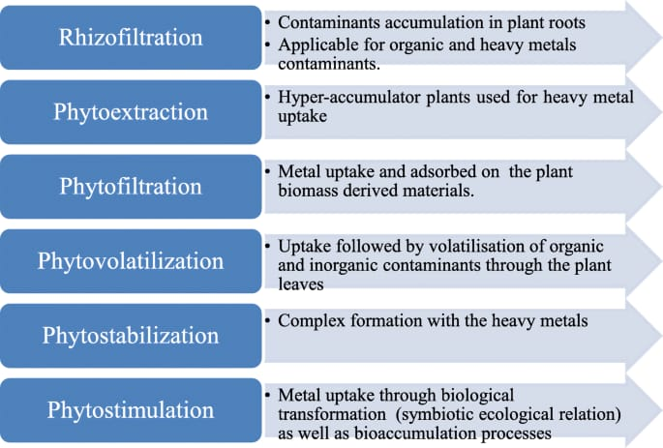
Fig. (4) Phytoremediation of methods
1. Phyto-extraction
The reducing of poisonous heavy metal through the contaminated lands by growing plant with the intention of accumulates metals. There are heavy metals to take plant from soil and water are very significant. Various plants that grown on top of waste land called vegetative cover up or in contaminated region can be helpful in preventing soil erosion. e.g.- Alyssum murale was recognized as the most excellent Cadmium (Cd) and Nickel (Ni) accumulator into a learn (Hansruedi, 1997; Yurdakul, 2015).
2. Rhizo-filtration
Filtration of root zone is the exclusion of poisonous metallic pollutants from Waste-water using roots of plant. It is stated that Indian mustard and Sunflower plants are valuable in Lead (Pb) exclusion, containing Lead (Pb) immersed by plants roots, in addition to is the main in reducing Lead (Pb) at maximum potential (Viatcheslav et al., 1995). It is the coastal area water polluted as Cd, As, Cu, Cr, Fe, Mn, Ni, Pb, V and Zn, Eichornia crazies was enhanced by Phyto-remediation, and Cr, Cd, Pb and As in the sprout and roots of E. crassipes. It was the report on the way to mount up the metals (Agunbiade et al., 2009; Yurdakul, 2015).
3. Phyto-stabilization
Vegetative passion are to cover-up is upper exterior of soil among vegetation in the order to remove the contaminated of lower surface is the check of contacts in the contaminated soil. Avoid injure in the plants by removing of bio-availability the noxious metallic pollutants. In the several trees, such as poplars acts as pump for moving the contaminated wastewater upwards by roots, and make sure the exclusion of contaminants from lower surface (Boisson et al., 1999; Astier et al., 2014; Yurdakul2015).
4. Phyto-degradation
A dreadful condition in the plants is the process of breach lower natural compound the plants obtain up and about in enzyme outstanding to their metabolic arrangement. Poverty found as the end result in entry, transfer, metabolic movement, and biome activity. Pb containing soil. Soil exclusive of Pb pollution be experienced by means of sunflower, sorghum and Chinese squash and ruin was experiential within the soils contain the heavy metal. (Komives & Gullner, 2005; Hamvumba et al., 2014, Yurdakul, 2015).
5. Phyto-volatilsization
The plant alters its constituent structure to be unconfined into the environment by transport various metallic elements which are Hg and Se of the soil from in the various sources (soil and water) on the way to the areal parts. For example in the study, this was observed with the purpose of many plant variety such as Brassica and Arabidopsis can be absorb heavy metal is the bodies within turn them addicted to gas outward appearance and expulsion them into the atmosphere (Terzi & Yıldız, 2011). Tree variety such as Populus and Salix are generally worn in this technique in the disappearance property (Pulford & Watson, 2003; Yurdakul, 2015). Biotechnolic method Nowadays, it is a very significant to reduce their dietary harms in human.

6. Rhizo-remediation
Degradation of soil pollution Plants quite than doing the degradation make a niche for rhizosphere microorganisms. Such plants shrab unique metal tolerant and anti microb community in their rhiz-osphere who secrete plant hormones substances siderophores or phyto-chelators to alleviate metallic poison.
7. Phyto-sequestration
Phyto-sequestration is the capability of plants to impound sure polluted soils in the rhizosphere for the exudation of phytochemicals and on the root through transportation proteins and cellular process. It removes the avidity of the noxious waste and prevents rearrangement to soil.
8. Rhizo-degradation
Rhizo-degradation anywhere plant severs down organic polluted the soil by inner and outer plant processes for microbial action. It is improved by the occurrence of the rhizosphere and much limit process than phytodegradation. The rhizodegradation is the plant surface enters to root hair.
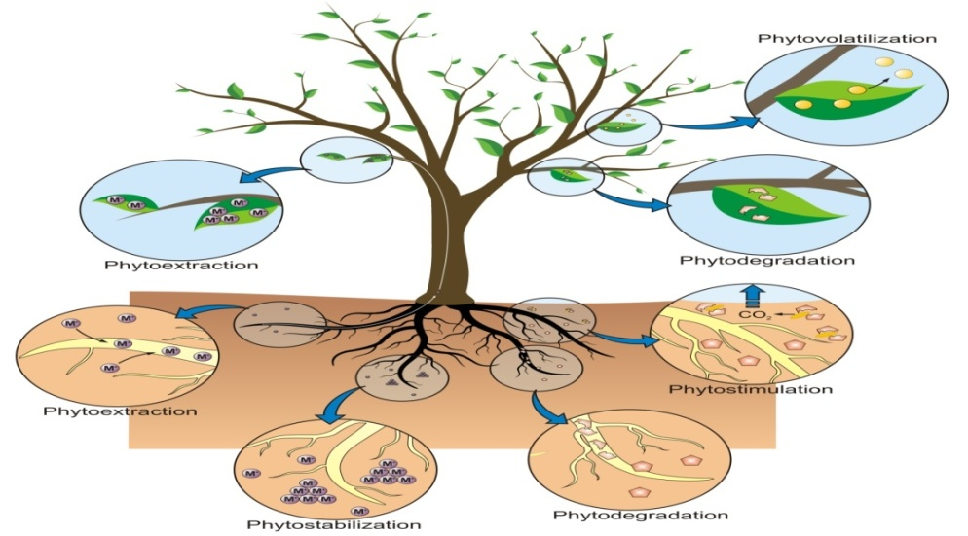
Fig (4) Methods of phytoremediation, Source Research Gate
Phytoremediation of Advantages and Disadvantages
The Phytoremediation like technologies has a range of advantages and disadvantages are described in bellow.
Advantages
1. It is a small disruptive to the atmosphere and economically viable.
2. The possible to speedy and appropriate for great extreme of exterior polluted.
3. It is the low expensive and condition properly managed is tow environmentally responsive and artificially gratifying to the community.
4. It is minimize the leaching of foul and stabilization.
5. It has relatively low continuation, easier achievement and self- variable.
6. They are ecofriendly environmental pollution.

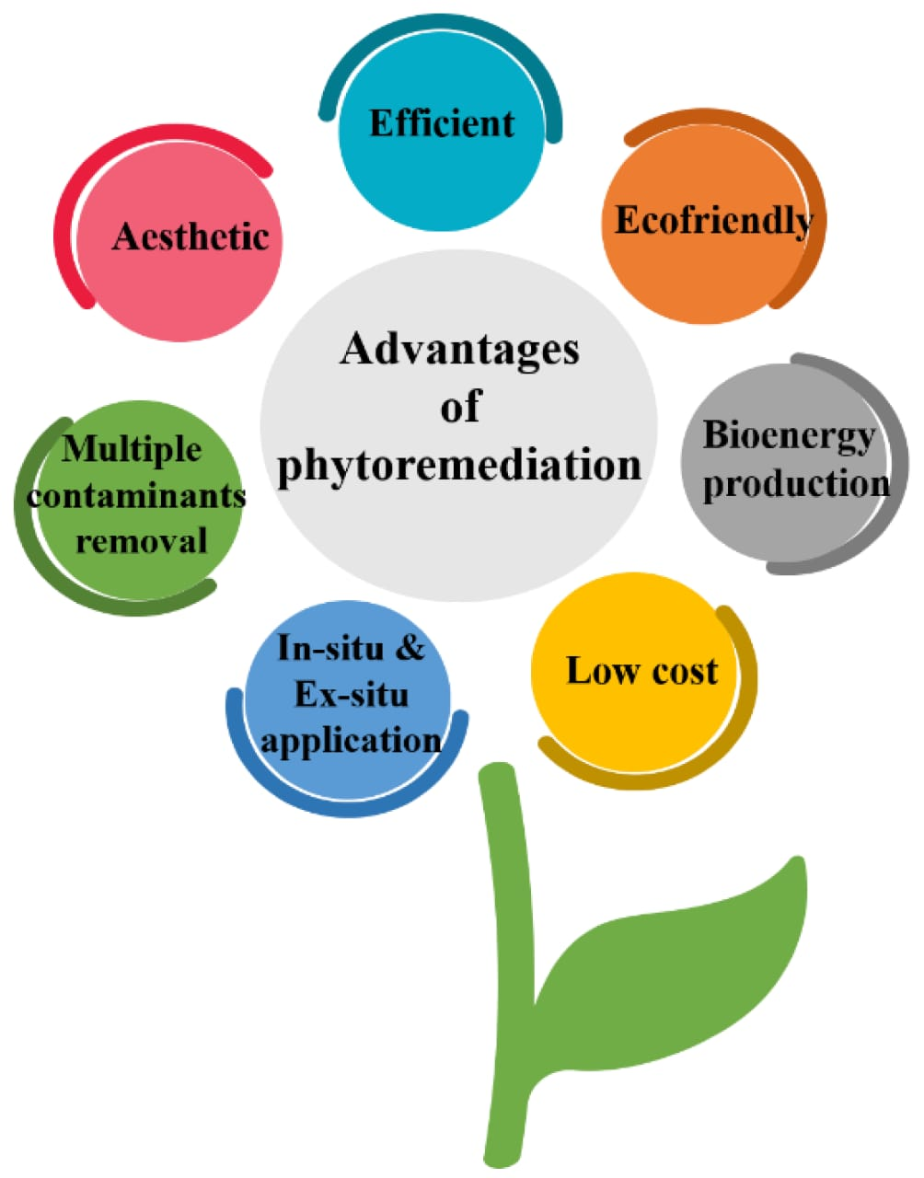

Fig. (5) Advantages of Phytoremediation

Disadvantages of Phytoremediation
1. The Phytoremediation strength necessitates utilize of a larger soil region than supplementary corrective process.
2. Plant varieties of one species can be different extensively is the efficiency for phytoremediation.
3. Phytoremediation is the majority flourishing only at areas with thin pollution in the land.
4. This procedure possibly will not be significant for exceedingly hydrophobic polluted due to the affinity of the contaminants near continue adsorbed to the soil particles.
5. Present may well be opportunity that the plant shows unfavorable impact such as possible move of polluted to an additional intermediate in the atmosphere or the food sequence and on preamble or spread of an unsuitable or invasive plant type.
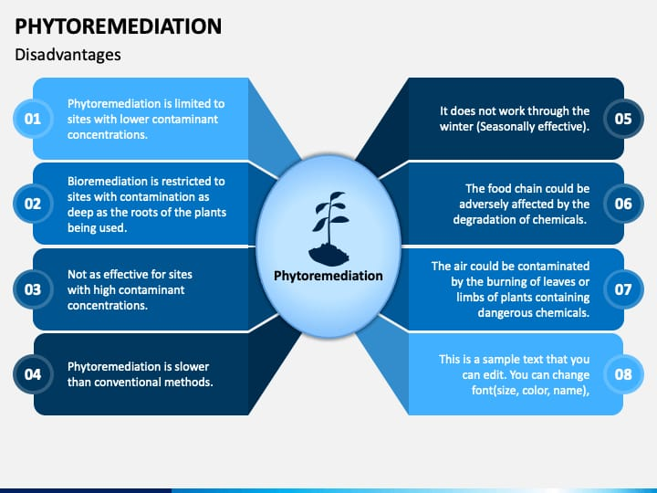
Fig. (6) Disadvantages of Phytoremediation

Conclusion
The study of matalloid toxicity and sources it’s some importance properties of heavy metals (HMs). And there are ecological impact are a universal issue due to their moving through air, soil and water. Based on deferent factors such as application and various main sources are the promising ways of incoming the heavy metals from beginning to end drinking water, air and food. Causes of deferent diseases in human body like- skin cancer, minimata, itai-iati and lunges diseases. Phytoremediation because assimilation green tools is going to convert as a developed treatment method for decontamination of pollutant removal from the human environment. Advantages and disadvantages of this technique partially depended on limitation of plants as main leading organism through the treatment process, meanwhile most of disadvantages related to proper application of this eco-friendly environment cleaning method. Another word both good organization and advantages the phytoremediation highly related to suitable operation of treatment process. This topic is main objective the study of heavy metals and reducing of heavy metals from the soil of phytoremediation methods. The main study of heavy metal in impact the human and properties of metallic are enter in food chan.

References
- Achal V, Pan X and Zhang D (2012). Bioremediation of strontium (Sr) contaminated aquifer quartz sand based on carbonateprecipitation induced by Sr resistant Halomonas sp. Chemosphere 89:764–768.
- Agunbiade, F. O., Olu-Owolabi, B. I. and Adebowale, K. O. (2009). Phytoremediation potential of eichornia crassipes in metal-contaminated coastal water. Bioresource Technology, 100(19): 4521-4526.
- Alloway B, (2012). Trace metals and metalloids in soils and their bioavailability: heavy metals in soils. Springer Press, Lossndon.
- Anderson D, Yu TW, Phillips BJ and Schmezer P (1994). The effect of various antioxidants and other modifying agents on oxygen radical-generated DNA damage in human lymphocytes in the comet assay. Mutat Res 307:261–271.
- Astier, C., Gloaguen, V. and Faugeron, C. (2014). Phytoremediation of cadmiumcontaminated soils by young douglas fir trees: Effects of cadmium exposure on cell wall composition. International Journal of Phytoremediation, 16: 790- 803.
- Boisson, J., Ruttens, A., Mench, M. and Vangronsveld, J. (1999). Evaulation of hydroxyapatite as a metal immobilizing soil additive fort the remediation of polluted soils. Part 1. Influence of Hydroxyapatite on Metal Exchangeability in Soil, Plant Growth and Plant Metal Accumulation. Environmental Pollution, 104: 225-233.
- Brooks R. R., (1998). Plants That Hyperaccumulate Heavy Metals: Their Role in Phytoremediation, Microbiology, Archaeology, Mineral Exploration and Phytomining, CAB International, New York, p. 380.
- Centeno JA, Tchounwou PB, Patlolla AK, Mullick FG, Murakat L, Meza E, Gibb H, Longfellow D and Yedjou CG (2005). Environmental pathology and health effects of arsenic poisoning: a critical review. In: Naidu R, Smith E, Smith J, Bhattacharya P (eds) Managing arsenic in the environment: from soil to human health. CSIRO, Adelaide.
- Clemens, S., (2006). Toxic metal accumulation, responses to exposure and mechanisms of tolerance in plants. Biochimie, 88(11): 1707-1719.
- Deaglio S, Canella D, Baj G, Arnulfo A, Waxman S and Malavasi F (2001). Evidence of an immunologic mechanism behind the therapeutic effects of arsenic trioxide on myeloma cells. Leuk Res 25:237–239.
- EPA (1995). Contaminants and remedial options at select metals-Contaminated Sites, EPA/540/R-95/512.6.
- Goyer RA (2001). Toxic effects of metals. In: Klaassen CD (ed) Cassarett and Doull’s toxicology: the basic science of poisons. McGraw-Hill, New York, NY, pp 811–867.
- Hamvumba, R., Mataa, M., and Mweetwa and A. M. (2014). Evaluation of sunflower (Helianthus annuus L.), sorghum (Sorghum bicolor L.) and Chinese cabbage (Brassica chinensis) for phytoremediation of lead contaminated soils. Environment and Pollution, 3(2): 65-73.
- Hansruedi, F. (1997). Field trials for in situ decontamination of heavy metal polluted soils using crop of metal-accumulating plants. Zeitschrift für Pflanzenernährung und Bodenkunde, 160: 525-529.
- Harris CC (1991). Chemical and physical carcinogenesis: advances and perspectives. Cancer Res 51:5023s–5044s.
- Herawati N, Suzuki S, Hayashi K, Rivai IF and Koyoma H (2000). Cadmium, copper and zinc levels in rice and soil of Japan, Indonesia and China by soil type. Bull Env Contam Toxicol 64:33–39.
- Liu Y, Guyton KZ, Gorospe M, Xu Q, Lee JC and Holbrook NJ (1996). Differential activation of ERK, JNK/SAPK and P38/CSBP/RK map kinase family members during the cellular response to arsenite. Free Radic Biol Med 21:771–781.
- Mani D, Sharma B, Kumar C and Balak S (2012). Cadmium and lead bioaccumulation during growth stages alters sugar and vitamin C content in dietary vegetables. Proc Natl Acad Sci India Sect B Biol Sci 82(4):477–488.
- Milner, M. J. and Kochian and L. V. (2008). Investigating heavy-metal hyperaccumulation using Thlaspi caerulescens as a model system. Annals of Botany, 102: 3-13.
- Morton WE and Dunnette DA (1994). Health effects of environmental arsenic. In: Nriagu JO (ed) Arsenic in the environment part II: human health and ecosystem effects. Wiley, New York, NY, pp 17–34.
- National Research Council (2001). Arsenic in drinking water.
- Niu Z, Sun L, Sun T, Li Y and Wang H (2007). Evaluation of phytoextracting cadmium and lead by sunflower, ricinus, alfalfa and mustard in hydroponic culture. J Environ Sci 19(8):961–967.
- NRCC (1978). Effects of arsenic in the environment. National Research Council of Canada, Ottawa, pp 1–349.
- Patlolla A, Barnes C, Yedjou C, Velma V and Tchounwou PB (2009). Oxidative stress, DNA damage and antioxidant enzyme activity induced by hexavalent chromium in Sprague Dawley rats. Environ Toxicol 24:66–73.
- Porter AC, Fanger GR and Vaillancourt RR (1999). Signal transduction pathways regulated by arsenate and arsenite. Oncogene 18:7794–7802.
- Pulford, I. D. And Watson C. (2003). Phytoremediation of heavy metal-contaminated land by trees: A review. Environment International, 29: 529-540.
- Raskin I., Smith R. D. and Salt, D. E. (1997). Phytoremediation of metals using plants to remove pollutants from the environment. Curr. Opin. Birstechnol, 8: 221- 226.
- Saleha Banu B, Danadevi K, Jamil K, Ahuja YR, Visweswara Rao K and Ishap M (2001). In vivo genotoxic effect of arsenic trioxide in mice using comet assay. Toxicology 162:171–177.
- Shallari S, Schwartz C, Hasko A and Morel JL (1998). Heavy metals in soils and plants of serpentine and industrial sites of Albania. Sci Total Environ 209:133–142.
- Soignet SL, Frankel SR, Douer D, Tallman MS, Kantarjian H, Calleja E, Stone RM, Kalaycio M, Scheinberg DA, Steinherz P, Sievers EL, Coutré S, Dahlberg S, Ellison R and Warrell RP Jr (2001) United States multicenter study of arsenic trioxide in relapsed acute promyelocytic leukemia. J Clin Oncol 19:3852–3860.
- Tchounwou PB, Ishaque A and Schneider J (2001). Cytotoxicity and transcriptional activation of stress genes in human liver carcinoma cells (HepG₂) exposed to cadmium chloride. Mol Cell Biochem 222:21–28.
- Tchounwou PB, Patlolla AK and Centeno JA (2003). Carcinogenic and systemic health effects associated with arsenic exposurea critical review. Toxicol Pathol 31:575–588.
- Wojcik M and Tukiendorf A (2004). Phytochelatin synthesis and cadmium localization in wild type of Arabidopsis thaliana. Plant Growth Regul 44:71–80.
- Yurdakul,I. (2015). Phytoremediation techniques and ımportance in contaminated soils and waters. TÜTAD-Turk J Agric Res., 2: 55-62.

