A GEOMORPHOLOGICAL OBSERVATION STUDY IN THIRUVANANTHAPURAM COAST KERALA, INDIA
Jerin Joe R J^{1,2}*, Stephen Pitchaimani V¹, Richard Abishek S¹, Seetha Sankar Narayanan M¹, Muthukumar P¹, Ashwin S K¹
¹PG and Research Department of Geology, V.O. Chidambaram College, Thoothukudi-628008
²(Reg.no: 22212232221012) affiliated with Manonmaniam Sundaranar University, Tirunelveli, India.
*Corresponding author: *Jerin Joe R.J^{1,2}
E-mail: jerinjoe621@gmail.com
Abstract
(Reg.no: 22212232221012) affiliated with Manonmaniam Sundaranar University, Tirunelveli, India.
The current study is conducted through a field observation in Thiruvananthapuram coastal village in Kerala, India. The coastal plain in this area is narrow, having an average width of about 6 km, and consists of depositional landforms. The coastal plain contains five depositional surfaces and one erosional surface, each with its own morphology and litho-stratigraphy. The strandlines and sand barriers revealed some details about the old coastal plain and marine regression. A palaeolagoonal habitat is evidenced by the shell-bearing black clay layer beneath the floodplain deposit. Laterite-capped plateaus that border the coastal plain to the east are relics of a past planation surface. This surface is seen to have evolved over both the Mio-Pliocene (Warkalli) Formation and the crystallines, and it is provisionally dated as Pliocene. Using geomorphic data, an attempt is made to discuss the neotectonic activity along the coastal plain.
Keywords: Barrier, Breakwater, Coastal plain, Scarps, Swale

- Introduction
The study of the physical elements and processes that shape the coastal zone is known as coastal geomorphology. To comprehend how coastal landscapes change over time as a result of natural processes and human activity, this multifaceted discipline combines elements of geology, oceanography, geography, and environmental science (Flemming, N. et.al 2014). The coastal process has been strongly influenced by sea level rise, climate change, and other geological events involving neo tectonic activities (Osland, M. J et.al 2016). Much of the world's coastal landforms and associated landforms evolved during the late Quaternary period (Maya, K et.al 2017). Coastal geomorphology knowledge and research are essential for developing sensible coastal zone management strategies, protecting vulnerable coastal environments, and understanding the broader effects of global environmental changes on coastal areas(Beatley,T et.al,2002). Small-scale and large-scale morphological features can be differentiated in coastal systems, and they are linked to depositional and erosional processes that occur along the shore under the impact of waves and currents. Small-scale beach features include beach cusps, breaker bars, rip channels, and sand waves. Large-scale shoreline characteristics include beach plains, headlands, bays, tombolos, spits, and forelands (Davis Jr. R. A. 1985).
The entire region where wave-driven sediment transport takes place is known as the littoral zone. The beach to its landward is also considered to be part of the littoral zone. The nearshore zone is defined as the area between the low tide line and the offshore limit of wave action on the bed. Unconsolidated sediments that have been carried and deposited by waves and currents, varying in size from fine sand to big cobbles, make up beaches (Hails, J. R. 1975). On sandy coasts, the beach is typically backed by a dune system, and both sandy and gravel/cobble beaches can have barriers and lagoon systems or cliffs as their backs (Finkl, C. W. 2004). Bays are bodies of coastal water that are partially surrounded by land and have a large opening to the sea. They are distinguished by their distinctive shape, sheltered waters, and relatively calm conditions in comparison to the open ocean. They can be caused by river valley submergence, erosion of headlands, or sediment accumulation in coastal depressions. Beach plains form as a result of the accumulation of sediments deposited along the coastline by the action of waves, currents, and tides (Oliver, T. S et.al 2017). As the waves approach the shore, they transport sand and gravel from the sea floor and deposit it on the coastal land, resulting in these flat and wide plains. The intertidal zone, or area of the shore that alternates between being submerged at high tide and being exposed at low tide, includes these plains. Lagoons are thin stretches of land like sandbars, barrier islands, or spits that separate the open ocean from shallow coastal bodies of water. They commonly occur near estuaries or other forms of coastal wetlands and are typically found in low-energy coastal locations (Calliari, et al. 2009). Lagoons are typically defined by brackish water, which is a combination of saltwater from the ocean and freshwater from rivers.
The tide has a significant impact on beach dynamics. The creation of sand waves on submerged bars near bay and estuary entrances and the transportation of sand in shoals are both significantly influenced by oscillatory tidal currents, whereas continuous straight shorelines, with the exception of very high tidal ranges, are almost completely unaffected. The tides in Kerala are semidiurnal, mixed tides that fall within the microtidal range (Silpa B.L. 2015). The primary factor in coastal evolution and change is waves. Along the Kerala coast, there has been an upsurge in wave activity with lengthy swells and large breakers due to the strong wind action during the south-west monsoon. The NNE to SSW orientation of the coastline means that wave orientations between 1800 and 3400 are more important for shore activities. During the south-west monsoon season, the predominant wave direction is between WSW and WNW (Sajeev, R 1993). The main effects of wave action in shallow water are the development of longshore current, which is critical for the longshore movement of material. According to Zarifsanayei, A. R. et al. (2020), there are two types of beach drift: 1) parallel to the shoreline, which is predominantly caused by the influence of longshore current; and 2) perpendicular to the shoreline, which is caused by swash.
- Study Area
The Kerala coast is a 580km long thin strip of land bordering the Arabian Sea in the south western section of Peninsular India, running from latitudes 8°15'N to 12°85'N and longitudes 74°55'E to 77°05'E, with a notable straight stretch of shoreline going in the NNW-SSE direction. The Kerala coast was divided into three wave energy system zones by Baba and Kurian in 1988: southern, central, and northern. The current study includes an observatory field work in the southern sector to record and study coastal dynamics and landforms in coastal villages from Poovar to Kappil (08° 20' 30"N & 76° 53' 10"E - 08° 44' 18"N & 76° 41' 59"E) (Figure 1). Thirteen different locations (Table 1) in the southern sector were visited over the course of two days. The geological and geomorphological features along the coastline were deduced. A tidal inlet, backwaters, sandy coast, pocket beaches, earth cliff, and rocky cliff/headland are among the morphologies found in the 78-kilometer long Poovar-Varkala sector. The development of breakwaters for fishing harbors, as well as coastal protection features like as seawalls and groynes, has drastically affected the coastline morphology along the sector (Noujas, V et al 2014). Table 1. Latitude and longitude of sites visited
S.no | Latitude | Longitude | Location
1 | 8°19'32.6"N | 77°03'15.5"E | Poovar Beach North
2 | 8°20'44.7"N | 77°01'44.8"E | Karumkulam
3 | 8°21'23.3"N | 77°00'43.1"E | Chowara Beach
4 | 8°22'35.5"N | 76°59'10.5"E | Vizhinjam harbour Beach
5 | 8°23'23.3"N | 76°58'30.9"E | Kovalam Beach
6 | 8°29'31.0"N | 76°54'01.0"E | Vettukadu Beach
7 | 8°30'32.8"N | 76°53'09.6"E | Veli Lake
8 | 8°33'05.3"N | 76°51'08.4"E | Thumba Beach
9 | 8°38'02.9"N | 76°47'07.3"E | Muthalapozhi Port
10 | 8°39'23.0"N | 76°46'06.4"E | Poothura
11 | 8°41'29.7"N | 76°44'21.6"E | Kayikkara Beach
12 | 8°44'38.9"N | 76°41'52.4"E | Varkala Beach
13 | 8°46'25.7"N | 76°40'43.1"E | Kappil Beach
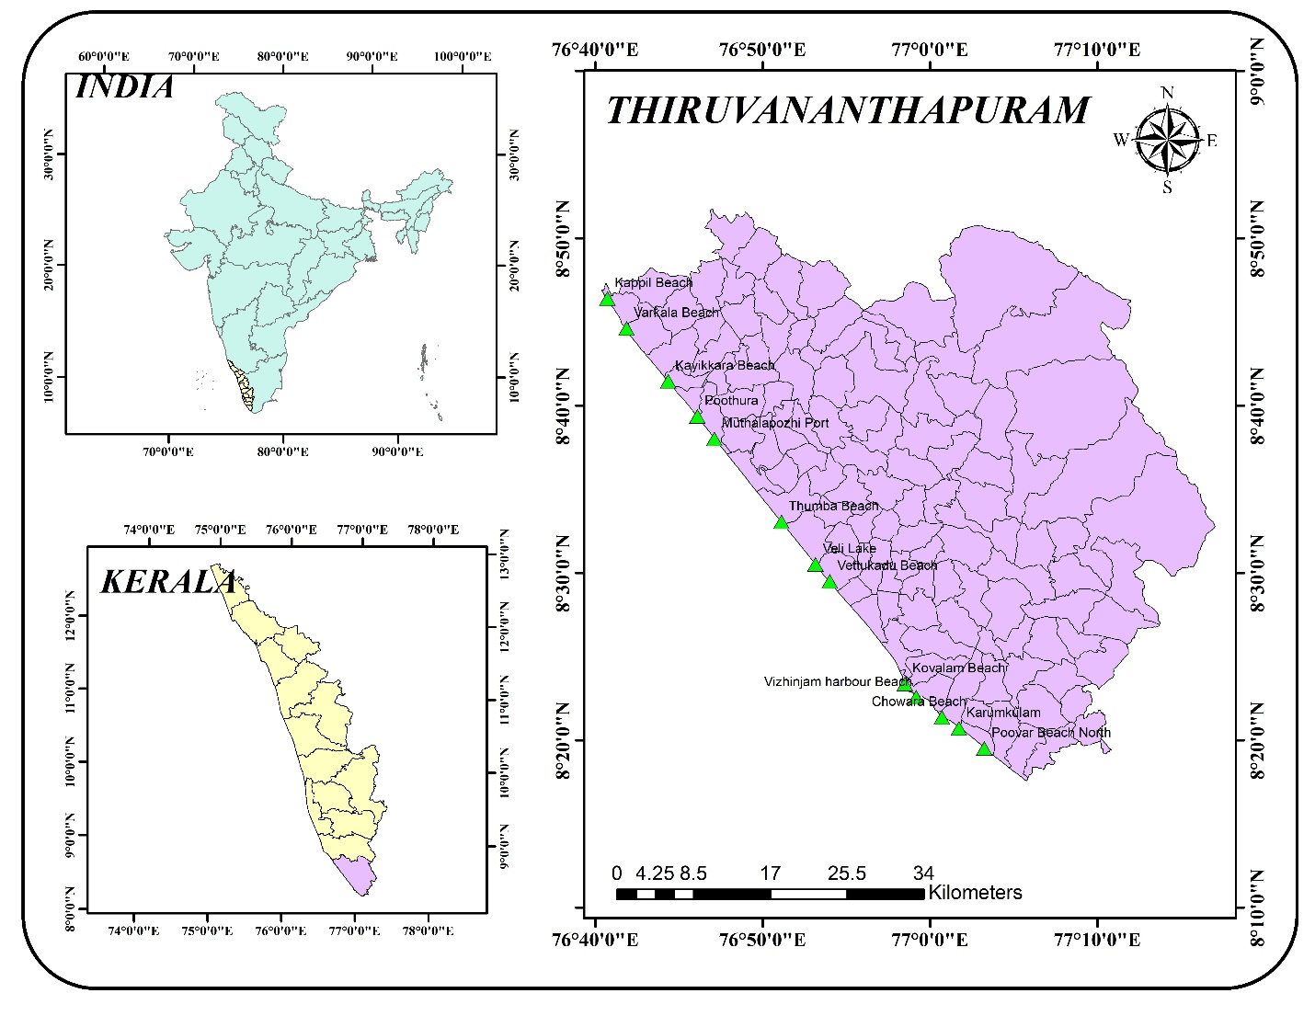Figure 1. location of the study area
- Geology
The geology of Kerala state is split into four primary geological units: i) Precambrian crystallines, ii) Tertiary sedimentaries, iii) Laterites formed over Precambrian crystallines and Tertiary sedimentary rocks, and iv) Recent to Sub-Recent sediments. Crystalline rocks include the gneiss-granulite suite of rocks and the newer igneous complexes (Soman, 1980). As a result of various episodes of tectonism and metamorphism, these rocks have been polydeformed and metamorphosed, resulting in the production of complex tectonites with numerous faults, fractures, and shear zones (Rao et al, 1976). Charnockite and khondalite rocks dominate the Precambrian crystalline rocks, which are intruded by granites, pegmatites, and basic dykes. The most common rock type is charnockite. Precambrian rocks cover more than 80% of Kerala's total land area.The majority of the Trivandrum district is composed of Archean gneisses (District Survey report,2016).
The prevalent rock varieties include charnockites, pyroxene granulates, gneisses containing granite and biotite, gneisses consisting of granite and sillimanite, gneisses with quartz and feldspar, with or without granite components, calc-granulates, and quartzites. All of these rock types have been traversed by doloritic and gabboric dykes. The gneisses are also traversed by collection of slender, inconsistent quartz and pegmatite veins. The Warkallis are composed of kaolin-containing sandstones, as well as pebble beds and iron-rich grits. Significant laterization can be seen in both crystalline and sedimentary rocks (Chandran, P et.al 2005). Additionally, Quaternary sediments like dunes, soils, terraces, black mud, and alluvium are present, filling the banks and estuaries of rivers. The beach sands found in Vizhinjam, Kovalam, and Veli exhibit elevated levels of sillimanite, garnet, quartz, rutile, and monazite. The main section of glass sands between Shangumugam and Veli is characterized by separate patches distributed along the coastline (Sundararajan, M. et.al 2009). The undulating upland region spanning Attingal-Neyyatinkara showcases slender bands of Quilon and Warkalli deposits extending from north to south, in addition to laterite-khondalite formations (Ramaswamy & Rao 1980).
- Geomorphology
The Thiruvananthapuram coast has emerged relatively recently in geological terms, consisting mainly of contemporary sediments. The coastal area is marked by the existence of both tertiary and recent sediment deposits. The Malabar and Kollam-Trivandrum coasts exhibit rocky terrain with laterite formations. The central Kerala coast, extending from Ponnani to Alappuzha, is predominantly characterized by recent alluvial deposits, featuring notable paleo strandlines and barrier beaches. When moving from the western to the eastern parts, the district can be categorized into three distinct topographic sections: (i) lowlands, (ii) midlands, and (iii) highlands. The lowland, which constitutes the coastal plain, is evident between Thiruvananthapuram and Anjengo, as well as between Vizhinjam and Poovar. The occurrence of crystalline formations in Veli, Kovalam, and Vizhinjam, along with laterite cliffs within the coastal plain regions, is notable. Particularly distinctive are the sections at Poovar and Varkala. The midland division is defined by valleys and hillocks, creating a rippling topographical landscape. The eastern part of the district displays exceptionally rough landscape, signifying the highland region that reaches heights of up to 1869 meters above mean sea level (Sheela Nair et al.2018). The coastal cliffs in rocky zones consist of crystalline rock and tertiary sediments, displaying both erosional and depositional attributes. The coastal region mainly consists of recent to sub-recent sediments characterized by sands ranging from fine to coarse grains (0.15 to 0.50 mm), along with an alluvial stretch concealed beneath laterite deposits (Figure 2). Along the beaches are significant economic reserves of heavy minerals such ilmenite, monazite, rutile, and zircon. The continental shelf extends 50 to 60 kilometres from the coast to a depth of 100 metres and has a muddy bottom. After this threshold, the shelf descends rapidly to a depth of 1000 meters (Chattopadhyay, S. 2010). The bathymetry of the nearshore and inner continental shelf along the south-west coast varies significantly throughout its extent.This region is drained by three significant drainage basins that come together and flow into the Arabian Sea (Mohan, S. V et.al,2014). All of these rivers are perineal, with a dendritic drainage pattern. These basins' flood plains have distinct morphological features such as levees and backswamps. Levees are parallel structures found along rivers that are formed by sediments, silts, and other materials pushed aside by flowing water (Thankappan, N et.al,2018). Back swamps are marshy landscapes that tend to occur in meandering river settings. The backwater system, locally referred to as "kayals," stands as a highly prominent morphological characteristic within the coastal plains. These formations are linked to the sinking of sea levels and the emergence of sand bars and spits. There are several brackish water lakes in the region, including Poovar Kayal, Poonthura Kayal, Veli Kayal, Kadinamkulam Kayal, Anchuthengu Kayal, and Edava-Nadayara Kayal (Shaji, J.2019). Vellayani Kayal stands as the singular freshwater lake. Beach ridge complexes can be found throughout the more recent coastal plain. Beach ridges develop when there is enough sand above the high tide mark. If a coastline is prograding, ridge crest heights are likely to rise towards the sea. Swales are ridges or sandbars on a beach that are narrow and shallow and run parallel to the shoreline. (AJ, Aran Castro et.al 2021). Coastal wetlands known as mudflats are formed when mud is deposited by rivers or tides. These are found in the old coastal plain region. Islands are found in the river mouths and backwaters.
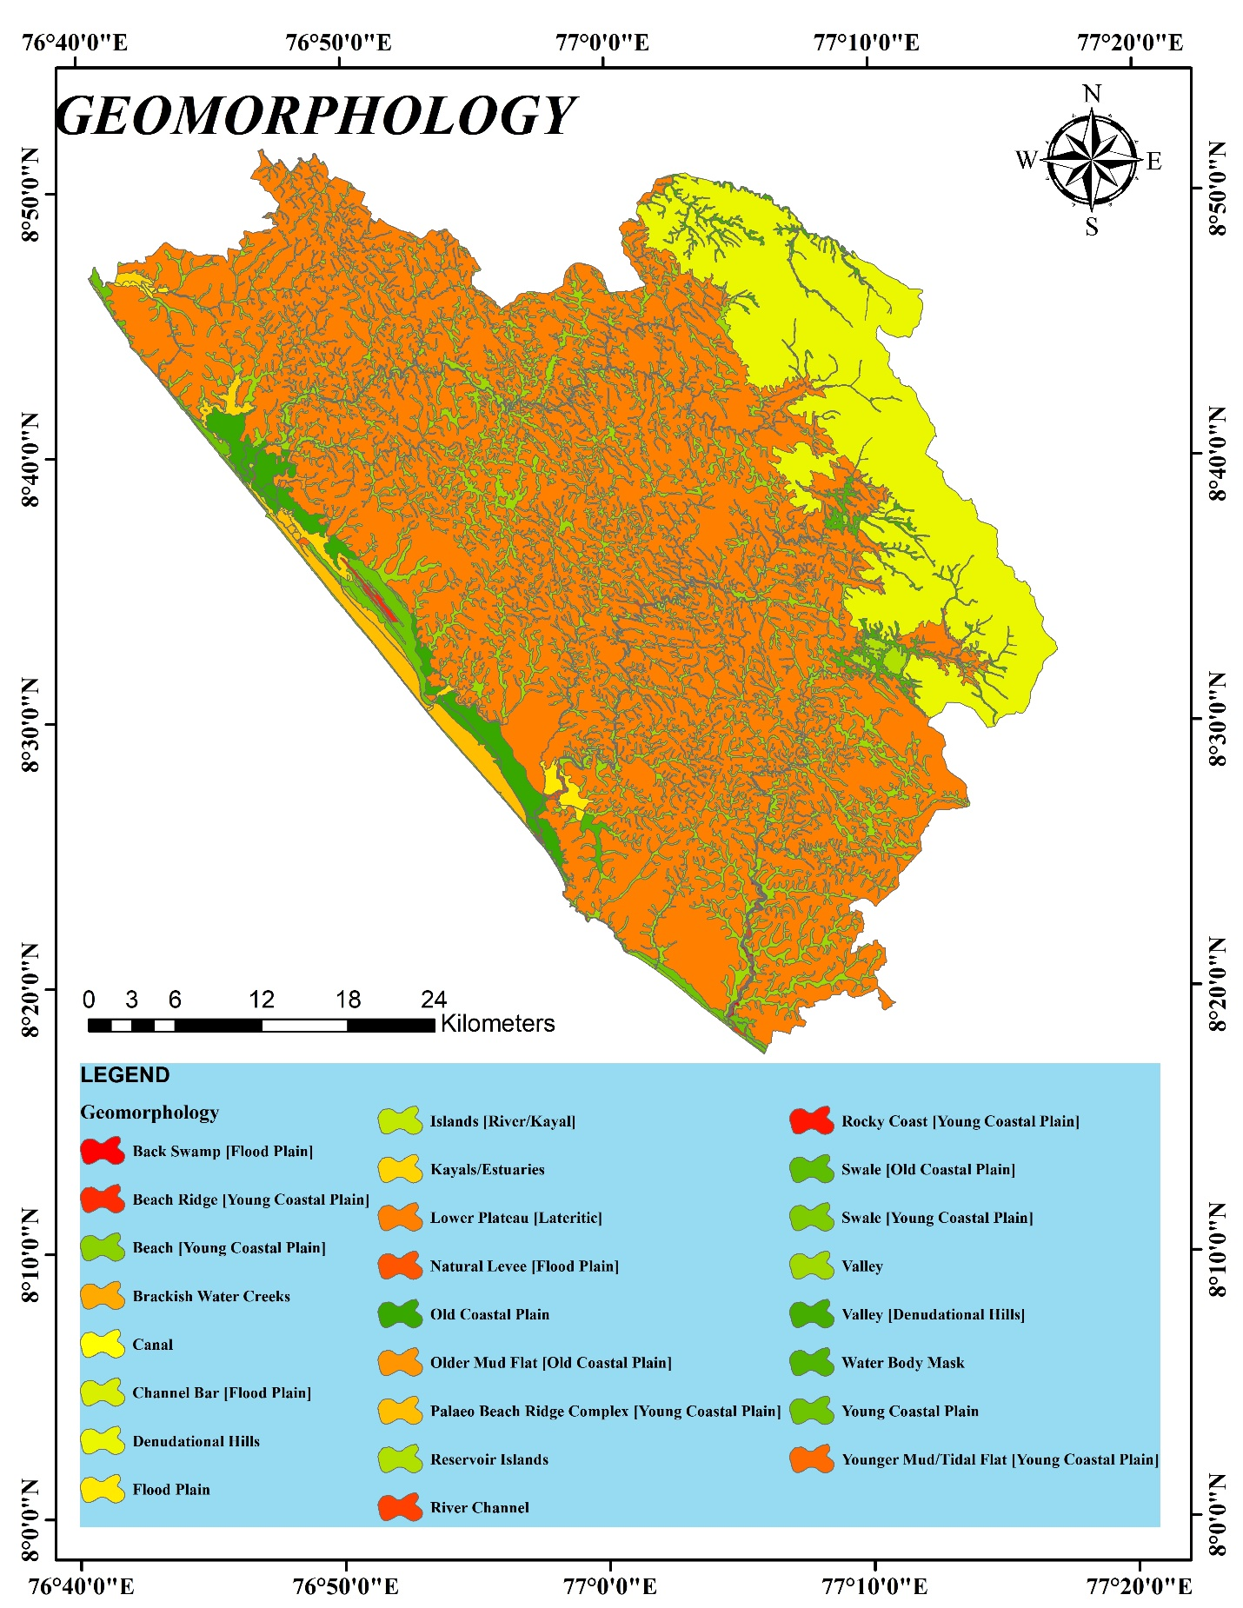
Figure 2. Geomorphology Map
- Field Observations
Thirteen beaches were explored along the Thiruvananthapuram coast from Poovar to Kappil, each with a distinctive geomorphic feature and characteristics.
- Poovar beach North
The beach at Poovar is covered in coastal alluvium with medium-sized sand particles. The interaction of waves with a sandy coastal substrate leads to the formation of sandy beaches(Short and Wright,1983). The neyyar river merges with the Arabian sea in here forming the Poovar backwater which is major tourist attraction. The AVM channel which brings water to all then coastal villages of the Kanyakumari district passes through here. The beaches are prone to much pollution due to the high tourist activity and fishing activities.
- Karumkulam
Karumkulam is a fishing village located to the north of Poovar. The Karichal canal comes to an end here, forming a sand bar. Sandbars are typically found near the estuary in the shallow depths of the sea (Figure 3). These shallow depth Sandbars shift over time as a result of offshore wave variability and climate variability (Murty, C. S,1985) Beach scarps are sand cliffs that are virtually vertical and face the sea as part of the beach profile. The scraps in this area are nearly a meter high and formed as a result of ripcurrents.

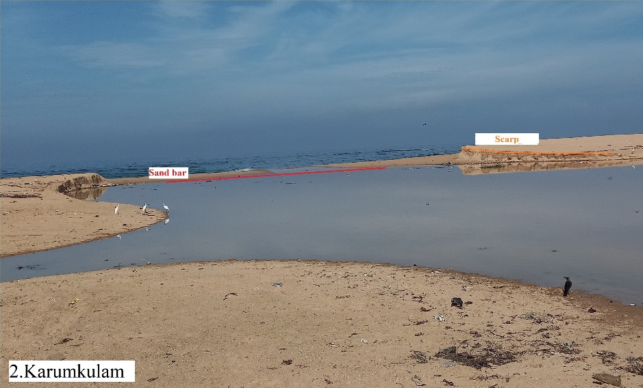
Figure 3. Karumkulam
- Chowara Beach
Chowara beach is located beneath the Azhimala Shivan temple. The beach has a lagoon and garniteferous rock cliffs. The lagoons are bodies of relatively shallow, calm water that are close to the shore and have access to the sea, but are shielded from the open sea by a barrier. A silted coastal alluvium separates the lagoon from the sea. Beach cup formations can be found on the beach's eastern side (Figure 4). Beach sediments are arranged into semicircular patterns or curving indentations with horns and embayments along the seaward slope of the beach to create beach cusps (Sathish, S et.al, 2018). Swash action of the waves has created the beach cusps in the chowara beach.

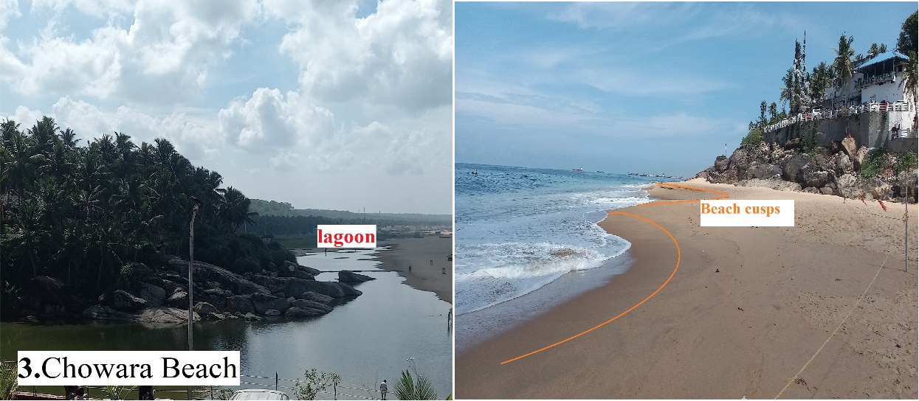
Figure 4. Cowara Beach
- Vizhinjam harbour Beach
The Vizhinjam harbour beach is mostly made up of rocky coast line. A pocket beach is typically a small beach tucked between two headlands. Normal sediment movement between the confined pocket beach and the nearby shorelines is negligible to nonexistent. The erosion of a cliff behind the pocket beach is the main source of sediments. The entire region is covered in rocky coast (Figure 5).
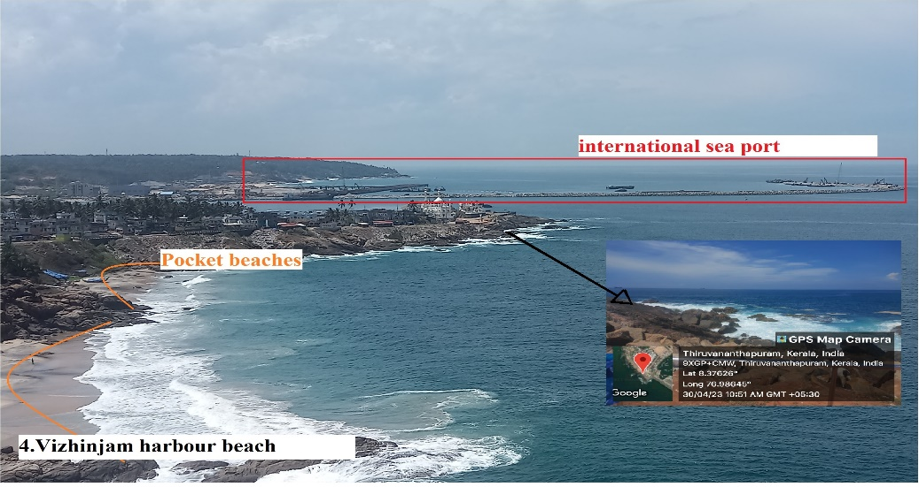
Figure 5. Vizhinjam harbour beach
- Kovalam Beach
The kovalam beach is a curved beach with illiminite sand patches.Kovalam has three beaches that are separated by rocky outcroppings and form the crescent of the Kovalam beach. These beaches are among India's most popular destinations for coastal tourism. Lateritic surfaces and flat valleys with alluvial fills characterise the beach's south west side (Figure 6). A skerry is found at one end of the curve. This small, rocky islet, also known as a low sea stack, could take the shape of a rocky reef. (Johnson and Webb, 2007). The skerry is called as Yongna konyak Rock.

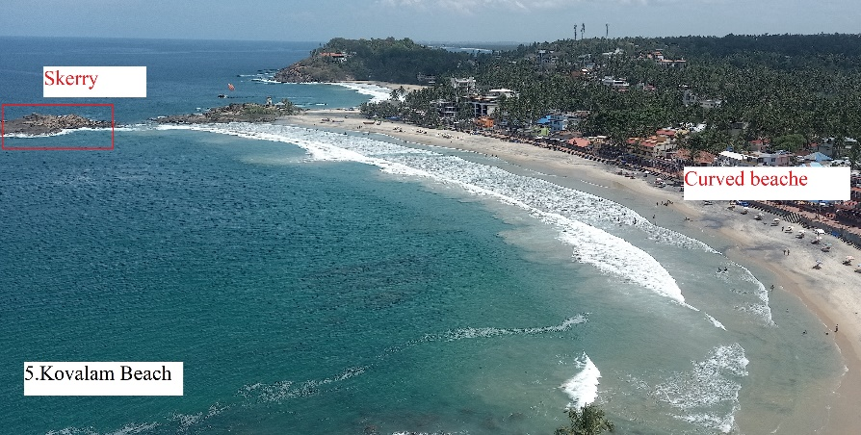
Figure 6. Kovalam beach
- Vettukadu Beach
The Madre De Deus Church is a famous Christian pilgrim located at the Vettukadu beach. Coastal alluvium with medium-sized sand particles covers the coastline. The coastal plains' soils are particularly deep and sandy in character. A narrow strip of land is formed by the coastal region that stretches from Vettukad beach to Shankumugam beach. The coastal plain of this region is mostly urbanized.
- Veli Lake
Veli Lake constitutes a brackish water backwater system that runs in parallel to the coastline.Its seaward end is next to the shore, and when it isn't raining, a sandbar separates it from the shore (Sheela, A. M 2010). Akkulam Lake and Veli Lake are connected. The unhindered flow of water from Akkulam Lake to Veli Lake was impeded by the accumulation of sediment in the lake (Moses, S. A. et al 2011). The sediments present in the coastal plain of the Veli lake region is of silt in nature due to the siltation process (Figure 7). Breakwaters has been built for a distance of 500 meter only on the north side of the Veli lake.
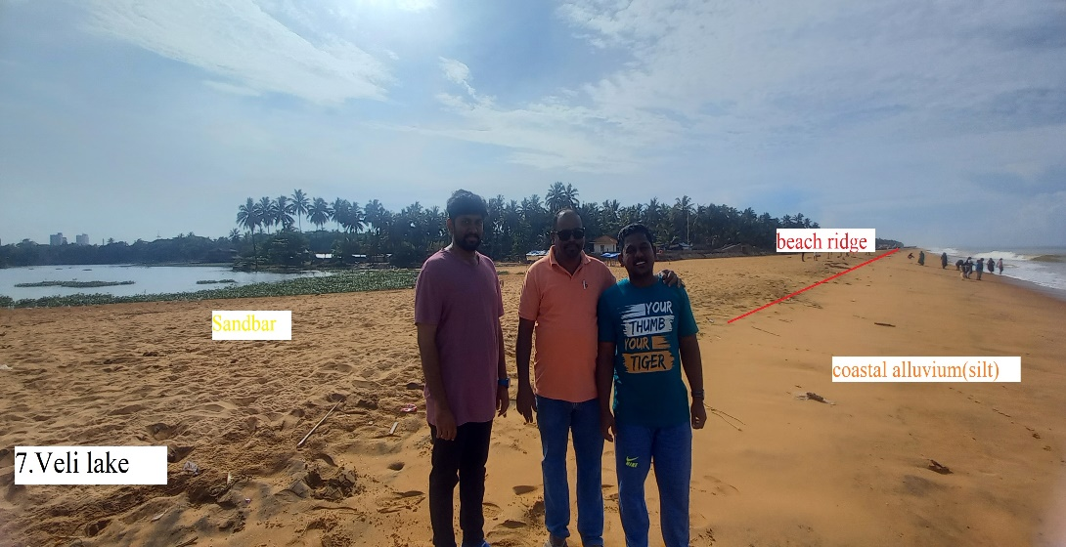
Figure 7. Veli lake
- Thumba Beach
The thumba beach is also a narrow strech of coastal plain with sediments ranging from medium to fine grained. The same morphologic feature extends till the muthalapozhi fishing port. The beach is flat at sea level, with tan-colored beach sand on the ground near the coast.This coastal plain is home to the Thumba Equatorial Rocket Launching Station (TERLS).
- Muthalapozhi Port
Mutha-lapozhi is a high energy sandy coast with a backwater/lagoon system into which the Vamanapuram River drains.It is one of the major fishing port in the district. The north west part of the port is filled with artificial dunes created by sediments dumped during the construction of the port (Figure 8). Due to river influx, the sediment in the coastal region ranges from silt to clay. Breakwaters on either side of the river mouth prevent sandbar growth, but a transient spit forms at the mouth, rendering the estuary inaccessible. The beach process along the Muthalapozhi port has been altered by the harbour breakwater, which divides the coastal stretch into two distinct sediment groups.

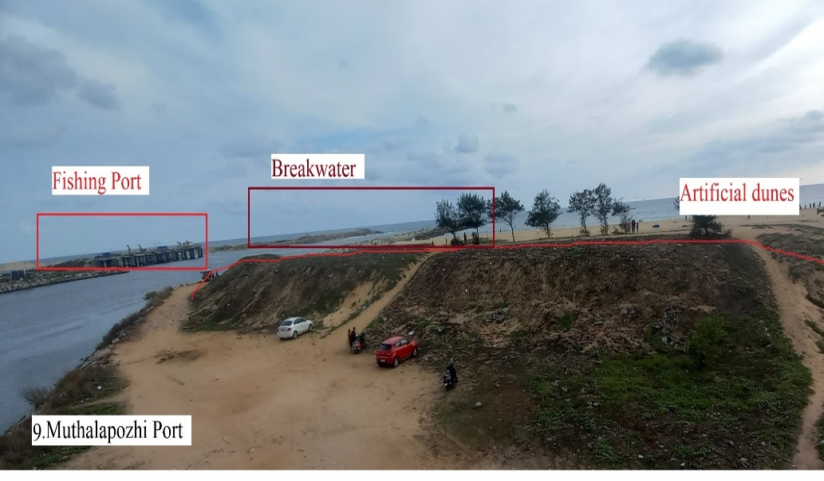
Figure 8. Muthalapozhi Port
- Poothura
The coast of Poonthura experiences rapid erosion (Figure 9). Even with the presence of seawalls and groynes, Poonthura remains extremely susceptible to erosion. While seawalls provide some support to the groynes, they get covered by beach sand and are visible only during monsoon-induced erosion. These structures are particularly vulnerable to erosion, demanding frequent upkeep and maintenance.

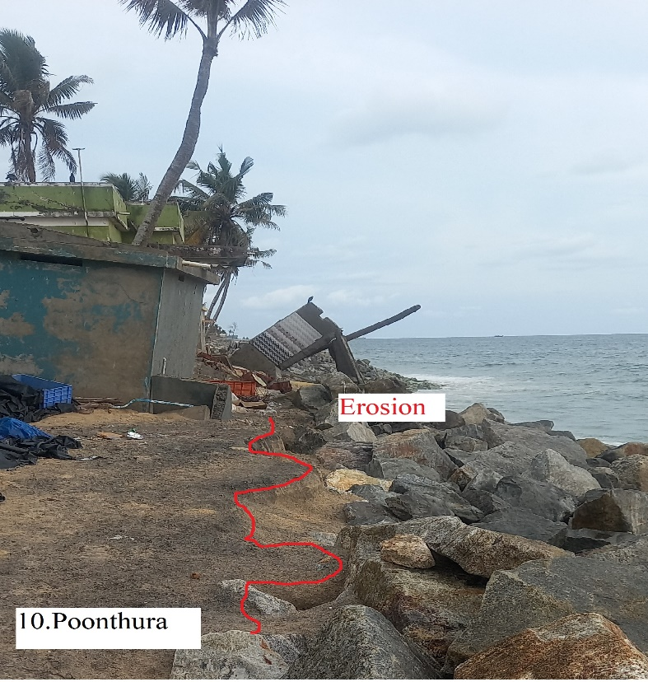
Figure 9. Poonthura
- Kayikkara Beach
The area between Muthalapozhi port and Kayakara is a barrier type of younger coastal plain formed by the Vamanapuram river backwater and the Arabian Sea. The coast is covered in medium-sized garnet and illuminate sand particles. The beaches are wider in this region until you reach the Varkala sandstone cliffs. Small beach ridges run along the coast and are covered in coastal vegetation.
- Varkala Beach
The Varkala beach is an important tourist location in the southern Kerala. The Varkala cliff has received recognition as a National Geoheritage site, a designation bestowed by the Geological Survey of India. The Varkala cliff serves as the designated location for the Mio-Pliocene Warkali Formation (Chandran, P et al, 2005), wherein the cliff exposes all the distinct litho-units of the formation. These units encompass unconsolidated sands, variegated clays, white plastic clays, and carbonaceous sandy clays that encase sporadic seams and layers of lignite (Arulbalaji, P., et al 2021). The creation of this cliff resulted from a blend of river-related and marine activities, prior to being lifted by tectonic influences. These Varkala cliffs are characterized as wave-eroded backshore cliffs, primarily composed of ferruginous laterite that transitions to underlying clays and sandstones (Sajinkumar, K. S et al., 2022) (Figure 10). The beach sand at Varkala is classified as a black sand placer deposit, due to the presence of ilmenite, rutile, zircon, monazite, sillimanite, and garnet. The north beach of the Varkala cliff is known as Black sand beach due to the abundance of black soil.
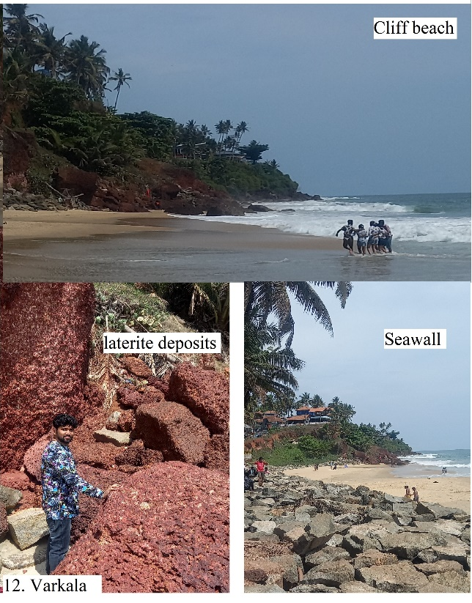
Figure 10. Varkala
- Kappil Beach
The Kappil backwater, which originates from the Ayiroor River, along with its estuary, is observable alongside the extensive Kappil beaches. Notable highlights of this location include the sand bar positioned at the kayal's entrance and the adjacent Kappil beach.. The floral diversity of the site is enhanced by the palm groves surrounding the wetland, the associated swamp vegetation, various species of fringing mangrove, and mangrove associated plants (Sreelekshmi, S et.al, 2022). The kappil beach's important morphological features include the barrier beach, backwater swamp, mangrove-vegetated areas, and shallow water canals.
- Conclusion
The current study inferred the geomorphologic features of the major beaches from Poovar to Varkala. The coastal region's wave dynamics have been studied by closely observing the grain size of the sand particles each coast.
- Due to high wave action, the Poonthura coast has been discovered to be a high erosion zone.
- The cliffs at Kovalam beach are made of crystalline rocks, whereas the cliffs at Varkala are made of laterite.
- Backwater systems have an ecological impact as well as a significant economic impact by increasing tourism, irrigation, and fishing.
- In the Kappil and Poovar region, brackish water kayals form marshy shallow wetland that aids mangrove vegetation.
- The beaches from Poovar to Kovalam are made up of illiminite and garnet placer deposits, which are missing from the beaches from Vettukad to Muthalapozhi port. These placer deposits can be found all the way from the north end of the Muthalapozhi breakwater to Kapil Beach. Varkala beach region contains a large amount of unmined black sand.
Reference
AJ, Aran Castro., RS, Kumar, Justine K. Antony, Pagare NS, and P. Raj Kumar. "Deli., Antony, J. K., NS, P., & Kumar, P. R. (2021). Delineation of coastal geomorphology along the coast of Kanyakumari district, southernmost coast of India. Turkish Online Journal of Qualitative Inquiry, 12(7).
Arulbalaji, P., Banerji, U. S., Maya, K., & Padmalal, D. (2021). Signatures of late Quaternary land-sea interactions and landform dynamics along southern Kerala coast, SW India. Quaternary International, 575, 270-279.
Beatley, T., Brower, D., & Schwab, A. K. (2002). An introduction to coastal zone management. Island Press.
BL, Silpa., & Srinivas, R. (2015). Morphodynamics in Tropical Beaches of Varying Energy Regimes (Doctoral dissertation, Cochin University of Science and Technology).
Calliari, L. J., Winterwerp, J. C., Fernandes, E., Cuchiara, D., Vinzon, S. B., Sperle, M., & Holland, K. T. (2009). Fine grain sediment transport and deposition in the Patos Lagoon–Cassino beach sedimentary system. Continental Shelf Research, 29(3), 515-529.
Chandran, P., Ray, S. V., Bhattacharyya, T., Srivastava, P., Krishnan, P., & Pal, D. K. (2005). Lateritic soils of Kerala, India: their mineralogy, genesis, and taxonomy. Soil Research, 43(7), 839-852.
Chattopadhyay, S. (2010). Geomorphology for integrated coastal zone management: A theoretical approach with examples from Kerala, India.
Davis Jr, R. A. (1985). Beach and nearshore zone. In Coastal sedimentary environments (pp. 379-444). New York, NY: Springer New York.
Department of Mining and Geology Kerala. (2016). District Survey Report of Minor. Minerals.
Finkl, C. W. (2004). Coastal classification: systematic approaches to consider in the development of a comprehensive scheme. Journal of Coastal research, 20(1), 166-213.
Flemming, N., Cagatay, M. N., Chiocci, F. L., Galanidou, N., Jons, H., Lericolais, G.,& Weerts, H. (2014). Land Beneath the Waves. Submerged landscapes and sea level change. A joint geoscience-humanities strategy for European Continental Shelf Prehistoric Rese.
Hails, J. R. (1975). Offshore morphology and sediment distribution, Start Bay, Devon. Philosophical Transactions of the Royal Society of London. Series A, Mathematical and Physical Sciences, 279(1288), 221-228.
Kurian, N. P., & Baba, M. (1988). Wave height and spectral transformation in the shallow waters of Kerala coast and their prediction (Doctoral dissertation, Cochin University of Science and Technology).
Maya, K., Limaye, R. B., Padmalal, D., & Kumaran, N. K. (2017). Geomorphic response to sea level and climate changes during Late Quaternary in a humid tropical coastline: Terrain evolution model from Southwest India. Plos one, 12(5), e0176775.
Mohan, S. V., Padmalal, D., Maya, K., & Baburaj, B. (2014). Sea level oscillations, climate change and landform evolution in the western coastal lowlands of Trivandrum block in Peninsular India.
Moses, S. A., Janaki, L., Joseph, S., Justus, J., & Vimala, S. R. (2011). Influence of lake morphology on water quality. Environmental monitoring and assessment, 182, 443-454.
Murty, C. S., & Veerayya, M. (1985). Longshore currents and associated sediment transport in the nearshore areas of Kerala and Goa, west coast of India. Mahasagar.
Nagabhushana, J. C., Vasudeva Rao, M., Sahasrabudhe, G. H., Krishnamoorthy, B., Suryanarayana Rao, C., & Rama Rao, Y. N. (1976). Geology and structure of major uranium-bearing zones in India and their exploration. In Exploration for uranium ore deposits.
Noujas, V., Thomas, K. V., Nair, L. S., Hameed, T. S., Badarees, K. O., & Ajeesh, N. R. (2014). Management of shoreline morphological changes consequent to breakwater construction.
Oliver, T. S., Thom, B. G., & Woodroffe, C. D. (2017). Formation of beach‐ridge plains: an appreciation of the contribution by Jack L. Davies. Geographical Research, 55(3), 305-320.
Osland, M. J., Enwright, N. M., Day, R. H., Gabler, C. A., Stagg, C. L., & Grace, J. B. (2016). Beyond just sea‐level rise: Considering macroclimatic drivers within coastal wetland vulnerability assessments to climate change. Global Change Biology, 22(1), 1-11.
Ramaswamy, G., & Rao, K. L. N. (1980). Geology of the continental shelf of the west coast of India.
Sajeev, R., & Neelakandan Nampoodiripad, K. S. (1993). Beach dynamics of Kerala coast in relation to land-sea interaction (Doctoral dissertation, National Institute of Oceanography).
Sajinkumar, K. S., Revathy, A., & Rani, V. R. (2017). Hydrogeochemistry and spatio-temporal changes of a tropical coastal wetland system: Veli-Akkulam Lake, Thiruvananthapuram, India. Applied Water Science, 7, 1521-1534.
Sajinkumar, K. S., Santosh, M., Rani, V. R., Anand, S., Pradeepkumar, A. P., Chavan, A., Thrivikramji, K.P & Ramachandran, P. V. (2022). The tertiary sequence of Varkala coastal cliffs, southwestern India: an ideal site for Global Geopark. International Journal of Geoheritage and Parks, 10(2), 308-321.
Sathish, S., Kankara, R. S., & Rasheed, K. (2018). Morphometric and sediment analysis of beach cusp in correlation to rip currents: a case study from tropical coast, West coast of India. Environmental Earth Sciences, 77(16), 578.
Shaji, J. (2019). Evaluating landuse change along Thiruvananthapuram coast, south west coast of India using geo-spatial techniques. Journal of Geography, Environment and Earth Science International, 21(4), 1-11.
Sheela, A. M., Letha, J., Joseph, S., Ramachandran, K. K., & SP, S. (2011). Trophic state index of a lake system using IRS (P6-LISS III) satellite imagery. Environmental monitoring and assessment, 177, 575-592.
Sheela Nair, L., Prasad, R., Rafeeque, M. K., & Prakash, T. N. (2018). Coastal morphology and long-term shoreline changes along the southwest coast of India. Journal of the Geological Society of India, 92, 588-595.
Sivakumar, K., Mathur, V. B., Pande, A., & Chandrabani, D. (2013). Coastal and marine protected areas in India: challenges and way forward. ENVIS bulletin: Wildlife & protected areas, 15, 292-298.
Soman, K. (2002). Geology of kerala (p. 335). Bangalore: Geological Society of India.
Sreelekshmi, S., Veettil, B. K., Nandan, S. B., & Harikrishnan, M. (2021). Mangrove forests along the coastline of Kerala, southern India: current status and future prospects. Regional Studies in Marine Science, 41, 101573.
Sundararajan, M., Bhat, K. H., Velusamy, S., Babu, N., Janaki, M. E. K., Sasibhooshanan, S., & Das, P. M. (2009). Characterization of ilmenite from Kerala coastline, India: implications in the production of synthetic rutile. J. Miner. Mater. Charact. Eng, 8, 427-438.
Thankappan, N., Varangalil, N., Kachapally Varghese, T., & Njaliplackil Philipose, K. (2018). Coastal morphology and beach stability along Thiruvananthapuram, south-west coast of India. Natural Hazards, 90, 1177-1199.
Wright, L. D., & Short, A. D. (1984). Morphodynamic variability of surf zones and beaches: a synthesis. Marine geology, 56(1-4), 93-118.
Zarifsanayei, A. R., Etemad-Shahidi, A., Cartwright, N., & Strauss, D. (2020). Long-term prediction of longshore sediment transport in the context of climate change. Coastal Engineering Proceedings, (36v), 15-15.

