STRAIN IMPROVEMENT BY CRISPR/Cas9 FOR ENHANCING BIOFUEL PRODUCTION
Bushra Khan¹; Shifa Ahmad^{2;} Miss Madhurima Tiwari³;Dr. Deepika Delsa Dean^{Co.}
Department of Biotechnology
Isabella Thoburn college
Uttar Pradesh, Lucknow, India
bk7682372@gmail.com

ABSTRACT
The rapid progress in synthetic biology and metabolic engineering presents significant opportunities for the development of advanced biofuels. These fuels offer higher yields and efficiency while reducing carbon emissions. The clustered regularly interspaced short palindromic repeats-CRISPR-associated proteins (CRISPR-Cas9) technology is one of the significant developments in molecular biology. Compared to prior techniques like zinc finger nucleases (ZFN) and transcription activator-like effector nucleases (TALEN), it allows more precise genome editing with increased precision. Despite research on microbial genome engineering tools for biofuel production, thorough assessments of CRISPR-Cas9-based methods for improving biofuel production are lacking. Techniques are needed in particular to assure the efficacy and safety of this method and reduce off-target impacts. With an emphasis on bioethanol, biobutanol, and other hydrocarbons, this study attempts to give a thorough explanation of the CRISPR-Cas9 mechanism and its use in the generation of microbial biofuels. It also looks at other suggestions for enhancing the effectiveness of targeted gene changes. The review also discusses how targeted genome editing (TGE) may be controlled through inducible on/off genomic circuits that react to environmental variables. By using this method, the metabolic load is reduced and fermentation efficiency is increased. When using CRISPR-Cas9 technology, the analysis highlights the significance of stringent regulatory standards to reduce off-target cleavage, increase efficacy, and ensure biosafety.

Keywords: CRISPR-Cas9; Biofuels; gene-editing; biodiesel; biobutanol; bioethanol; fermentation

INTRODUCTION
The demand for fuel is increasing nowadays due to its utilization in transportation, generation of energy, and industries. As of late, the interest in petrol-based fuel has brought about various financial and natural worries, and mindful endeavors are expected to support the arising elective powers [1]. The creation of biofuels from biomass is a practical and environmentally responsible solution to combat the depletion of fossil fuels. Industry, decision-makers, and scientists have started to pay more attention to these interchangeable and inexhaustible fuel sources, such biodiesel and bioethanol, because of their considerable benefits [2].While biodiesel is produced by transesterifying lipids taken from soybeans, canola seeds, and other crops, ethanol and butanol production is primarily dependent on the fermentation of sugar or starch feedstocks [3]. The financially savvy and boundless natural substances, for example, lignocellulosic feedstock got from farming squanders, (for example, sugar stick bagasse, sugar beet, or corn stalks) and energy crops, (for example, famous or switchgrass) are utilized to produce biofuels adding a benefit of not seriously influencing food supplies [4].
It has been demonstrated that a variety of microbial strains are capable of fermenting organic matter to create biofuels. One of the yeasts most commonly used for the large-scale commercial fermentation of monomeric carbohydrates into ethanol is Saccharomyces cerevisiae. Zymomonas mobilis, Clostridium thermosaccharolyticum, C. thermohydrosulfuricum, Thermoanaerobacter mathranii, T. brockii, and T. ethanolicus are among the bacteria employed in fermentation. The cutting-edge field of genomics known as site-specific genome editing looks to be successful in improving microbial strains for the generation of biofuels. Site-specific modifications in the genome, such as knocking down, knocking out, and knocking in genes, are routinely carried out through genetic engineering to influence a certain attribute in the native microorganisms. Contrary to conventional genetic engineering, which involves first isolating the gene to be altered, altering it in vitro, and adding it back to the host, or using genetic transformation techniques to introduce a heterologous gene to alter a specific trait of the organism [5].
The site-specific genome editing techniques RNA-guided endonuclease-mediated (REM) and modified endonuclease-mediated (MEM) have recently been used for strain enhancement. CRISPR-associated nuclease 9 (CRISPR/Cas9) is a well-known example of a REM-based genetic engineering technology and a flexible tool for genetic engineering. It is a natural bacterial defense mechanism that employs a guide RNA (gRNA) to lead Cas9 to a particular nucleotide. This simple RNA-guided genome-engineering technique has been hailed as a breakthrough in biology and offers various creative applications in producing biofuels [6]. The CRISPR/Cas9 method has been successfully utilized in industrial research to alter the genomes of several microbes, including bacteria, yeast, filamentous fungus, and algae. This technology has been changed into a versatile and trustworthy approach for genetic editing by CRISPR/developers Cas9. [7,8,9]
- Sources and generation of biofuel
Biofuels are liquid fuels produced from various biological elements including animal waste and plant waste [10] Biofuels are divided into 2 categories.
Primary biofuel-: Raw primary biofuels are frequently employed in the production of energy, heat, and cooking. Examples of primary biofuels include fuel wood, pellets, wood chips, agricultural waste, landfill gas, and fuel-wood pellets. [11]
Secondary biofuels-: Primary biofuels can be generated as gases, liquids, or solids (for example, biogas and hydrogen). These fuels include biodiesel, bioethanol, and bio-oil. Primary biofuels are transformed into secondary biofuels [12]. Biodiesel, bioethanol, and biogas are examples of secondary biofuels that are utilized in a variety of industrial operations in addition to being used in automobiles. These are produced when biomass is digested biologically [13] .
The categorization of secondary biofuels into different generations is determined by the specific biological processes employed and the raw materials utilized in their production. The four generations of secondary biofuels can be outlined as follows:
- Biofuels of the first generation
- Biofuels of the second generation
- Biofuels of the third generation
- Biofuels of the fourth generation
Biofuels of the First-generation- First-generation biofuels, including bioethanol and butanol, are primarily produced through the fermentation of starches or sugars derived from crops like wheat, barley, corn, potatoes, sugarcane, and sugarbeet. Bioethanol, particularly notable among first-generation biofuels, is produced by S.cerevisiae enzymes fermenting high-carbohydrate crops, mainly glucose. Biodiesel, another effective first-generation biofuel, is derived from trans-esterification or breakdown of vegetable oils sourced from plants such as palm, sunflower, rapeseed, soybeans, and coconut as shown in Figure 1 [14].
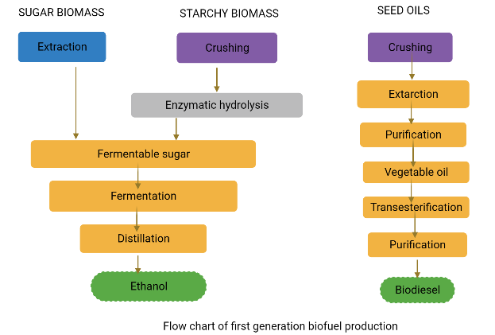
Figure 1: Flow chart for first-generation biofuel production
Biofuels of the Second-generation - Second-generation bioethanol and biodiesel are created using conventional technology from innovative sugar, starch, and fatty crops like miscanthus, jatropha or cassava. Biobutanol and SynDiesel® (produced from lignocellulosic materials including wood, grass and straw) are two other well-known second-generation biofuels [12]. Second-generation biofuels have the advantage of using inedible lignocellulosic biomass (the woody part of plants), which does not compete with food, and reduced raw material costs ^{[13]}. Examples of sources of lignocellulosic material include non-edible parts of maize or sugarcane, tree-harvest debris, garbage from agriculture, and leftovers of wood processing, such as leaves, straw, or wood chips. The conversion of lignocellulosic materials into sugars, as seen in Figure 2, is an expensive process that calls for the use of specialized enzymes. This merely shows that commercial production of second-generation biofuels is not currently feasible. [14]
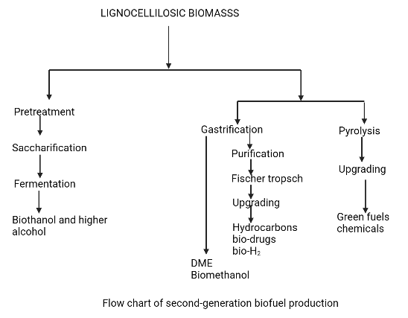
Figure 2: Flow chart for second generation biofuel production
Biofuels of the Third-generation - Third-generation biofuels are produced using microalgal biomass. Aquatic microalgae, like cyanobacteria, are autotrophic living forms [15].When compared to conventional lignocellulosic biomass, the growth yield of microalgal biomass is quite unusual [16]. Algae is the most potential component for use as third generation biofuel due to its high oil content. Due to their high oil content (between 60 and 70%), the three species of green algae Chlorella vulgaris, Chlamydomonas reinhardtii, and Dunaliella salina are most often used to produce biofuels [17]. Despite having numerous benefits, third-generation biofuel technology is still in its infancy and has a number of drawbacks. The primary drawbacks include its high anticipated cost and extensive use of fossil fuels during manufacture, which raises environmental concerns. [18]
Biofuels of the Fourth-generation - The fourth generation of biofuels are produced using contemporary techniques such as petroleum hydro-processing, geo-synthesis, enhanced biochemistry, and low-temperature electrochemical processes. These methods allow for the capture of environmental carbon to create fourth-generation biofuels. [19]
The fourth-generation biofuels have been defined in a variety of ways by various authors. For instance, Lü et al. (2011) [20] produced fourth-generation microalgae using metabolically modified forms. This concept has been applied to the chemical production of non-renewable fourth-generation biofuels. Fourth-generation biofuel, according to Demirbas (2009), is created by applying cutting-edge technology to transform biodiesel and vegetable oil into biogas.

CONVERSION OF RAW MATERIAL INTO BIOFUELS
The bioconversion of feedstocks into biofuels involves three processes: fermentation, hydrolysis, and pre-treatment. The pre-treatment stage of turning biomass into biofuel is the most important, difficult, and expensive.
There are four types of pre-treatment processes:
- Physical treatment
- Physiochemical treatment
- Solvent treatment
- Biological treatment
The majority of the time, they are employed to dissolve cell walls so that cellulose and hemicellulose can undergo additional processing. The feedstock is hydrolyzed with acid or an enzyme following pre-treatment. [21,22]. All pre-treatment methods are often combined for maximum effectiveness The polysaccharides included in the input material are transformed into fermentable sugars by the hydrolysis process. Finally, via microbial fermentation, monomeric carbohydrates like glucose, galactose, and mannose are transformed into ethanol or other alcohol [23,24].
Four process configurations have been created for the generation of biofuels: separate hydrolysis and fermentation (SHF), simultaneous saccharification and fermentation (SSF), simultaneous saccharification and co-fermentation (SSCF), and consolidated bioprocessing (CBP) [25].
Separate hydrolysis and fermentation (SHF):
This process requires the hydrolysis of the substrate in two stages:
- Saccharification
- Fermentation
Enzymatic hydrolysis and fermentation are carried out separately under ideal circumstances in separate hydrolysis and fermentation (SHF). Numerous advantages of this method include the fact that each phase is completed in an ideal environment and that little or no contact exists between fermentation and saccharification [26]. Cellulose is completely broken down into monomeric sugars as a result of the SHF. 50 °C and 35 °C, respectively, are the ideal temperatures for cellulases-mediated hydrolysis and fermentation [27].
Simultaneous saccharification and fermentation (SSF):
In this method, fermentation and saccharification are carried out simultaneously in a single vessel. By instantly converting monomeric sugars produced by the enzymatic hydrolysis process into ethanol through fermentation, simultaneous saccharification and fermentation (SSF) minimize difficulties such as sugar build-up, enzyme activity retardation, and contamination [27]. In SSF, the hydrolysis of raw materials containing starch is accomplished by first treating the material with an endoenzyme (glucoamylase in this case) at 90 to 110 °C for 30 minutes. While glucoamylase transforms dextrins into glucose, amylase hydrolyses starch into dextrins. The fermentation of hexose sugars is then carried out at a lower temperature (30–32 °C) to produce biofuel. The production of bioethanol has made extensive use of this technique.

Simultaneous saccharification and co-fermentation (SSCF):
Using the simultaneous saccharification and co-fermentation (SSCF) approach, five and six-carbon sugars may be fermented concurrently. The key prerequisite for this technique is the employment of co-fermenting bacteria that are compatible and have good pH and temperature tolerance. It is difficult to identify a single bacterium that can ferment both hexose and pentose sugar. Another limitation of this approach is the dearth of suitable co-fermenting microbial strains for the generation of commercial biofuel [28]. The entire conversion of monomeric sugars (generated from feedstock hydrolysis) into biofuel has been demonstrated to be possible using the mixed-culture technique, which combines both C6-fermenting and C5-fermenting bacteria. S. cerevisiae and Candida shehatae, which are recognized for their synergistic action, have reportedly been shown to be the most effective microorganisms for the SSCF procedure.

Consolidated bioprocessing (CBP):
Consolidated bioprocessing (CBP) is another method of process architecture in which a single microbe performs both the fermentation and saccharification processes. All phases of bioconversion, including fermentation and enzymatic hydrolysis, are carried out sequentially in a single reactor. The CBP procedure is a cost-effective method because it requires little capital input [27,29]. Numerous bacterial species, including C. thermocellum, and fungi, including Fusarium oxysporum, Neurospora crassa, and Paecilomyces sp., have been observed to exhibit these behaviours [30].

- GENOME ALTERATION: THE NEW UPSET IN GENOMICS
A single organism's genome can be modified effectively to impart desired traits. Advance genetic engineering precisely modifies the native genome of a microorganism to change its physiological characteristics and increase the production of a certain metabolite [31,32]. This method allows the introduction, deletion, and up-or-down-regulation of a gene at a particular location within an organism. Unlike traditional genetic engineering methods, this approach does not entail isolating genes, conducting in vitro engineering, and then re-introducing them to the host cell in order to modify the physiological characteristics of an individual.

Genome engineering can be achieved through two distinct approaches:
- RNA-guided endonuclease-mediated (REM) genome engineering
- Modified endonuclease-mediated (MEM) genome engineering

REM utilizes the CRISPR/CRISPR-associated protein 9 (Cas9) technology [33], while MEM relies on the zinc finger nucleases (ZFNs) system and transcription activator-like effector nucleases (TALENs) system [34]. The biological sciences and associated fields of study have been significantly impacted by these techniques. The CRISPR/Cas9 system has emerged as a viable alternative to ZFNs and TALENs, which have drawbacks such as ineffective delivery routes, off-target effects, toxicity, and low efficiency [35]. Table 1 summarizes the drawbacks associated with ZFNs and TALENs.
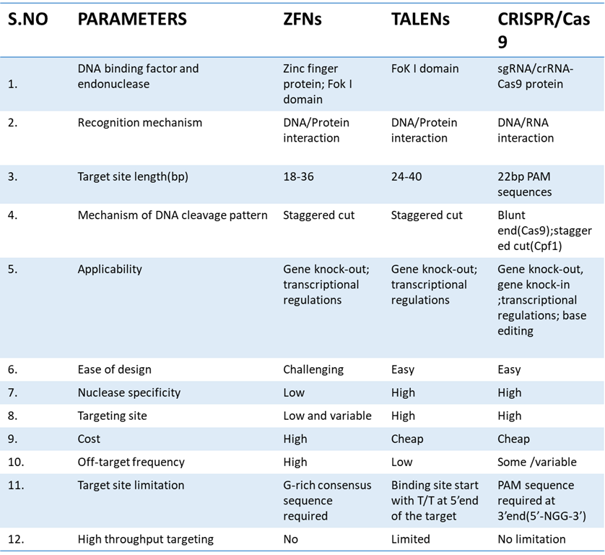
Table:1-Comparison between different types of genome editing tools[36]

CRISPR-CAS9: A PROMISING APPROACH IN GENE MODIFICATION
The biological sciences are being fundamentally changed by a succession of recent discoveries that use prokaryotes' adaptive immune systems to undertake targeted genome editing. Genetic research has grown in thousands of labs throughout the world thanks to the identification of Clustered Regularly Interspaced Short Palindromic Repeats (CRISPR) and CRISPR-associated (Cas9) proteins.
The bacterial CRISPR locus was first described by Francisco Mojica, and it was later determined that it constituted an essential part of the prokaryotic adaptive immune system. The locus consists of short palindromic repeat sequences called "spacers," which were found in between several viral or plasmid DNA pieces. The Cas9 protein was later discovered in Streptococcus thermophilus by Alexander Bolotin. Contrary to other known Cas genes, Cas9 was a large gene that encoded a single-effector protein with nuclease activity [36]. Additionally, they found a characteristic sequence that was later given the name protospacer-adjacent motif (PAM) in the spacer-nearby region of the target DNA. To find and bind its target DNA, Cas9 has to recognise this pattern. Later studies found that spacers were transcriptionally added to the CRISPR RNAs (crRNAs), which guide the Cas proteins to the target DNA sequence. Research has revealed that a crucial part of the CRISPR system is the trans-activating CRISPR RNA (tracrRNA), which combines with the crRNA to drive Cas9 to its target DNA. [37]. The introduction of a synthetic single-guide RNA construct (sgRNA), which combines crRNA and tracrRNA (figure 3), made this technology's potential applications simpler. [38].
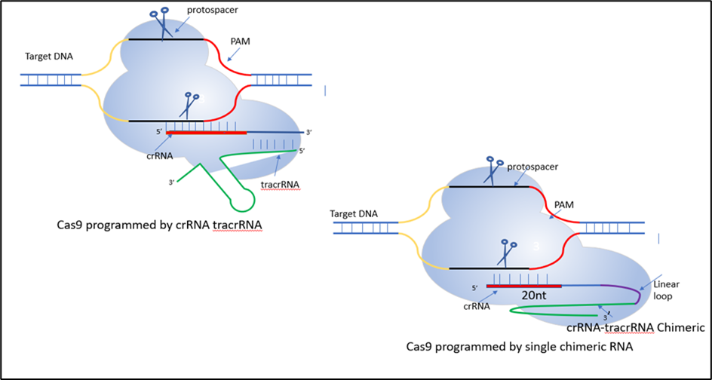
Figure 3: CRISPR/Cas9 System
The CRISPR/Cas9 method is a straightforward and precise approach for gene editing. It involves two essential components: the Cas9 protein, which contains the RuvC and HNH endonuclease domains. The RuvC domain cleaves the non-complementary DNA strand, while the HNH domain cleaves the complementary DNA strand, resulting in double-stranded breaks (DSBs) at the targeted DNA site. The second component is the single guide RNA (sgRNA), consisting of a scaffold sequence that facilitates Cas9 binding and a 20-base pair spacer sequence that is complementary to the target gene, positioned near the PAM region. The sgRNA guides the CRISPR/Cas9 system to the specific genomic region of interest. The gene editing process utilizes internal DNA repair mechanisms, as shown in Figure 4.
- Nonhomologous end-joining (NHEJ) or
- Homology-directed repair (HDR)
Most cell types experience NHEJ, which is far more frequent and includes the random insertion and deletion of base pairs, or indels, at the cut site. The frameshift mutations generated by this error-prone process are typically followed by an early stop codon and/or a non-functional polypeptide. This approach has shown to be particularly useful in functional genomic CRISPR screens and genetic knockout studies, but it can also be useful in the clinic when gene disruption presents a therapeutic opportunity. The second approach uses the error-free HDR route, which is very promising for therapeutic uses. This procedure results in error-free repair of the damaged DNA by using a homologous section of an unmodified DNA strand as a template. This approach can be used in an experiment to enable the necessary genome modification by combining an external donor template with CRISPR/Cas9 technology. [39]
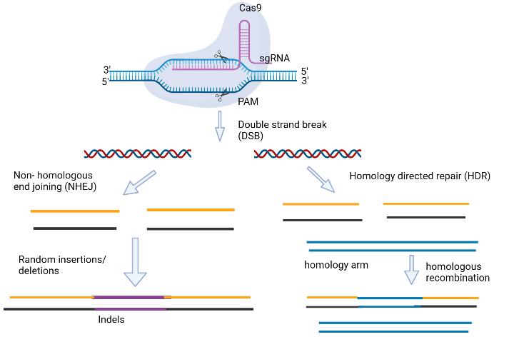
Figure 4: Gene editing carried out via CRISPR/Cas9. [65]
Site-directed mutagenesis has proven to be a valuable tool in both basic and applied research across various fields. In the realm of microbial cell genome editing for enhanced biofuel production, it serves as an advanced technology. Bacillus subtilis has been successfully modified by researchers using CRISPR/Cas9 technology, leading to the emergence of advantageous features such enhanced synthesis of b-cyclodextrin glycosyltransferase and resistance to spore formation. S. cerevisiae's genome has undergone similar changes in an effort to boost xylose utilisation and mevalonate or (R-R)-2,3-butanediol production. With the continuous publication of improved CRISPR/Cas9 protocols, we expect this approach to become increasingly integrated into routine laboratory procedures in the future. [40]

GENOME MODIFICATION OF MICROBIAL CELLS USING CRISPR/CAS9 FOR INCREASED BIOFUEL PRODUCTION
To enhance the production of biofuel, site-directed mutagenesis using CRISPR/Cas9 is required which can enhance the metabolic performance of the microbial cells. Recent studies on the use of CRISPR/Cas9-mediated genome engineering of microbial cells for improved biofuel production have surfaced in many publications [41].
The systems may be modified for the production of biofuel among a variety of traditional and non-conventional bacterial hosts due to the availability of several forms of CRISPR-Cas9 machinery with various capabilities. Because specialist CRISPR expression cassettes are now readily available from well-known genetic engineering companies like Synthego and Genscript, creating a CRISPR experiment is thought to be a straightforward and quick process.
Here are some changes that CRISPR has brought forth to increasing biofuel production:
Restricting competitive biofuel production pathways
A non-modal C.saccharohyperbutylacetonium N1-4 generating hyperbutanol was created in order to boost butanol synthesis and selectivity. The acetate and butyrate synthesis genes, pta and buk, were specifically targeted in this study. The Cas9 open reading frame (ORF) from Streptococcus pyogenes was expressed under the lactose inducible promoter to produce the buk and pta single and double mutants, while the sgRNA was produced using a short RNA promoter from C.beijerinkii. It was found that incorrect gRNA expression reduced the efficacy of genome engineering. As a result, a variety of promoters, including Pvegb, Pvegc, and PJ23119, were examined for their ability to strongly express gRNA. PJ23119 stood out among them with a high mutation rate of 75% at the pta gene and a transformation efficiency of 1.6 104 CFU/mg of DNA. Due to the double deletion mutant, the production of acetate and butyrate was decreased, and 19g/L of biobutanol was produced more selectively. [42,43].

Metabolic flux redirection for better solvent generation
The restoration of state and the diversion of carbon flux, along with the suppression of competing pathways, are thought to be additional effective methods for increasing the synthesis of biobutanol in a microbial system [44,45].
By overexpressing alcohol dehydrogenase (adhE2) from C. acetobutylicum, formate dehydrogenase (fdh1) from C. boidinii, and acetoacetyl-CoA thiolase (thl), E. coli EMJ50 strain was developed for biobutanol production from glucose. However, the oxygen sensitivity of C. acetobutylicum's aldehyde/alcohol dehydrogenase (adhE2) posed challenges under microaerobic conditions [46]. To overcome this, EMJ50 was modified by incorporating CoA-acylating propionaldehyde dehydrogenase (PduP) from S. enterica and alcohol dehydrogenase (adhA) from L. lactis, enabling butanol production of 0.82 g/L with a yield of 0.068 g/g glucose in microaerobic conditions [64]. The slight decrease in butanol yield compared to anaerobic conditions (0.082 g/g glucose) was attributed to carbon flux diversion towards citric acid production. To redirect carbon flux, CRISPR-Cas9 was utilized to downregulate the expression of citrate synthase (gltA) by modifying its 5'UTR using the UTR designer tool. The SacB gene promoter from Bacillus subtilis was employed for Cas9, crRNA, and tracrRNA expression during editing. Among the generated mutants, the gltA-deleted mutant exhibited the highest butanol yield of 0.120 g/g glucose, demonstrating successful redirection of carbon flux from the citric acid cycle to acetoacetyl-CoA, which was positively correlated with citrate synthase activity. [47]
Improvement in the ability to use substrates
An important step towards lowering production costs is the modification of commercial Clostridial strains for the use of cheap feedstock to improve alcohol fermentation [48]. The Clostridium species are unable to use other sugars due to carbon catabolite inhibition since glucose is present in the feedstock. This restriction can be lifted by altering the genes that control sugar intake [49]. Bruder et al. [50] focused on the carbon catabolite repression (CCR) of C. acetobutylicum DSM792 and C. pasteurianum ATC using SpCRISPR-dCas9. This was done by suppressing the kinase/phosphorylase (hprK) gene. This research on the suppression of carbon catabolite also shed information on the production of biobutanol using glycerol, an important by-product of the biodiesel industry. Xylose and glucose from lignocellulosic feedstock were both utilised as a result of C6013.
Huang et al. used the CRISPR-Cas9 technique created for E. coli to successfully show CRISPR-Cas9 genome editing in C. ljungdahlii in their work. An autonomous plasmid incorporating sgRNA, SpCas9, and DNA repair templates was created to prevent unwanted recombination [51]. The original C. ljungdahlii promoters were replaced with heterologous promoters from C. acetobutylicum, and a promoter-free lacZ reporter gene region was cloned. The studied promoters with the highest activity were Pthl and ParaE. Successful deletions of the pta, adhE1, ctf, and pyrE genes were obtained using sgRNA expression cassettes, with editing efficiency ranging from >50% to 100%. The production of a mixed population of wild types and mutants was 100% effective due to antibiotic selection. The study focused on C. ljungdahlii's chromosomal alterations' effects and CRISPR's ability to address problems with Clostridium species. Additionally, in order to get around problems with single-plasmid CRISPR-Cas9 genome editing in C. acetobutylicum ATCC 824, a two-plasmid technique was created, which enhanced isopropanol synthesis (Table 2). Figure 8 shows the possibility of adding novel biofuel pathways into Clostridium hosts used in biofuel production using the two-plasmid inducible CRISPR-Cas9 editing technique [52].
Expanding host-specificity in biofuel production by using endogenous CRISPR-Cas9
When employing the Type II CRISPR/Cas9 modified from S.pyogenes, numerous bacteria displayed mild to moderate degrees of toxicity. Due to the peculiarities of prokaryotic chromosomes, heterologous Cas9 expression is highly toxic and causes deadly chromosomal breakage, which simultaneously decreases the effectiveness of transformation and renders genome engineering ineffective. By employing host-encoded CRISPR/Cas9 machinery, Cas9 toxicity and poor transformation efficiency can be reduced [53]. The effectiveness of Type II CRISPR/Cas9 and host-encoded Type I CRISPR/Cas9 for genome editing in C.pasteuranium (convert glycerol to butanol) was studied by Pyne et al. This investigation demonstrated that the endogenous Type-I B CRISPR/Cas9, which is composed of 37 spacer, CRISPR tag rather than Type-II 3' PAM sequence, must be susceptible to interference from the host cell [54]. Comparing the endogenous Type-I B approach to the S. progenes CRISPR/Cas9 technology exhibited 100% editing efficiency in the C.pasterurianum, suggesting the robustness of this method to be applied in additional Clostridium species, including C. autoethanogenum, C. tetani, and C. thermocellum. In light of this, the sole prerequisites for applying this technique to any target organism that has an active Type-I CRISPR/Cas machinery are a functional PAM sequence located in 5' to the protospacers and the plasmid transformation procedure. [55].

The multiplex automated genome engineering (MAGE) platform for the generation of biofuels
A wide range of mutations in one particular gene can be produced while leaving other genes unmodified due to the high diversity of the mutants produced by MAGE, which can forego the screening and selection of modified mutants. The Cas9-based technology enables MAGE to expand the genetic variety of bacteria and maybe establish a pathway for the production of synthetic biofuels.
Liang et al. created CREATE (CRISPR enabled trackable genome engineering by combining MAGE with CRISPR/Cas9), to improve isopropanol production in E. coli. With the codon optimisation of 5 genes under the control of PJ23119 on a low copy number plasmid, the transformed strain of E. coli PA06 was discovered to produce isopropanol at the greatest productivity of 0.40 g/l/hr [56].
Using a single CRISPR array that codes a variety of spacer sequences, Cpf1 has also been utilised for multiplex CRISPR genome editing in numerous chromosomal loci, similar to how Cas9 is. Cas9-Cpf1's toxicity and longer spacer arms reduce its transformation rate, which limits its application in multiplex editing [57].
CRISPR toolkit optimization to increase biofuel production
- Off-target consequences in the CRISPR/Cas system
Off-target consequences can have a big impact, especially when CRISPR is used in gene therapy applications. The severe consequences of off-target impacts are far less frequently described in microbial energy biotechnology but cannot be readily ignored. As a result, this review looks at the implications of off-target effects on prokaryotic systems. The lack of a recognized eukaryotic function for Cas9 proteins, in contrast to ZFN and TALEN, raises the possibility that greater off-target effects may occur. The bacterial genome has less genetic variety simply because it is smaller, which leads to a lesser tendency for off-target mutations caused by Cas9 and, as a result, gives researchers another reason to create biofuels in prokaryotic platforms [58].

- Off-target effects are decreased by sgRNA design
Target genome editing (TGE) heavily relies on selecting a suitable target site with minimal or no closely related genetic sequences. Several algorithm-based tools, such as CHOPCHOP, E-CRISP, and CRISPR DESIGN, have been developed to aid in this process, offering varying degrees of effectiveness based on factors like sequence similarity, number and placement of mismatches, and more [58]. Additionally, studies by Ran et al. and Fu et al. established correlations between the ratio of gRNA to Cas9 and the occurrence of off-target effects [59]. Another important finding presented by Fu et al. was the relationship between gRNA length and reduced off-target effects. It was demonstrated that shorter gRNAs consisting of 17-18 nucleotides resulted in minimal off-target effects while maintaining on-target effectiveness. Furthermore, the study revealed that organisms with smaller and more complex genomes had fewer "incorrect" target sites for gRNA base pairing, contributing to improved specificity [60].

- Modifying Cas9 to reduce off-target effects
The success of a CRISPR process relies on the timing, locus-specificity, and spatial regulation of Cas9 protein expression. Continuous expression of Cas9 protein, particularly when co-expressed with gRNA on the same plasmid, can have drawbacks. Extended Cas9 production may lead to off-target effects or activate a DNA damage response, especially if the targeted genes are essential for host cell survival [61]. To mitigate Cas9 toxicity, transient expression of Cas9 and the use of inducible promoters are employed as preventive measures. Additionally, the "codon-optimized" approach can be applied to fine-tune Cas9 expression for different microbial species by considering their specific nucleotide composition [62]. Another effective strategy to minimize off-target effects involves modifying Cas9 by incorporating the Fok I nuclease domain, which is also utilized in ZFNs and TALENs. By fusing the catalytically inactive Cas9 (dCas9) with the Fok I nuclease domain, the specificity of targeted gene editing (TGE) has been observed to quadruple [63]. The enhanced specificity is attributed to the strict dimerization requirements of Fok I, which improves the effective binding of the Cas9-dCas9-Fok I complex to the target site.
High-fidelity Cas9 (SpCas9-HF1) was created by inserting precise alanine substitutions at places where Cas9-assisted hydrogen bonds connect to genomic DNA in order to increase the selectivity of Cas9. When there is even a single mismatch at the 5' end of the guide RNA (gRNA), which Cas9 employs to cleave DNA, the possibility of off-target cleavage increases. Cas9 that has been tweaked and referred to as "nickases" has been used to address this problem. Nickases, like RuvC or HNH, contain one inactive catalytic domain that aids in minimising off-target cleavage. A Cas9 nickase, in contrast to conventional Cas9, can only sever one strand of the target DNA, creating a single-strand break, or "nick" [63]. Similar to the inactive dCas9 (RuvC or HNH), a Cas9 nickase can still bind to DNA based on gRNA specificity but can only cleave one strand of the DNA. Most CRISPR plasmids are derived from S. pyogenes, and introducing a D10A mutation inactivates the RuvC domain, while an H840A mutation does the same for the HNH domain. A single-strand break is frequently quickly repaired via homology-directed repair (HDR) utilising the complementary DNA strand's intact template. The phrase "double nick" or "dual nickase" CRISPR system is frequently used when two nearby nicks on opposing DNA strands are handled by a Cas9 nickase as a double-strand break (DSB). Depending on the intended impact on the target genes, non-homologous end joining (NHEJ) or homologous DNA repair (HDR) can be used to repair a double nick-induced DSB. Slaymaker et al.'s research [64] led to the creation of eSpCas9, a better Cas9 variant with increased specificity. They discovered that Cas9's capacity to unwind and rewind DNA was what caused off-target cleavage. Based on crystallographic analyses of Cas9-gRNA and target DNA from Streptococcus species, they changed the non-target strand to address this by forming a positively charged groove.

II CONCLUSION
Microorganisms play a major role in the production of biofuel but the product obtained by native strains is not economical, thus it is necessary to develop and improve these strains in order to get better and high yield. The implementation of CRISPR-Cas9 can be used to overcome these issues. With the development of CRISPR-Cas9 technology, the possibility of widespread metabolic reprogramming for the sustainable generation of diverse biofuels has advanced quickly. This technique can be used to develop and design strains of microbes with improved and enhanced ability to generate biofuel by knocking in or knocking out the targeted gene. Incorporating Cpf1 into the editing process offers advantages in terms of cost and efficiency by eliminating the need for a tracrRNA, thereby reducing plasmid synthesis costs and expediting the procedure. This method allows for a notable reduction in the size of the expression plasmid without the requirement of large editing templates. Furthermore, by employing a twin plasmid approach, it is possible to carry out a number of modifications at once while also drastically lowering the expenses and labour necessary for recycling the selection marker. By integrating this approach with their understanding of microbial hosts, scientists worldwide can effectively convert non-edible energy crops such as Pinnata, Pongamia, Jatropha curcas, and Ricinus communis into biofuels and other value-added products.

REFERENCES

- Gowen, C. M., & Fong, S. S. (2011). Applications of systems biology towards microbial fuel production. Trends in microbiology, 19(10), 516-524.
- Xing, M. N., Zhang, X. Z., & Huang, H. (2012). Application of metagenomic techniques in mining enzymes from microbial communities for biofuel synthesis. Biotechnology advances, 30(4), 920-929.
- Munasinghe, P. C., & Khanal, S. K. (2010). Biomass-derived syngas fermentation into biofuels: opportunities and challenges. Bioresource technology, 101(13), 5013-5022.
- Bajpai, P., & Bajpai, P. (2017). General considerations on the use of lignocellulosic residues. Single cell protein production from lignocellulosic biomass, 11-16.
- Garneau, J. E., Dupuis, M. È., Villion, M., Romero, D. A., Barrangou, R., Boyaval, P., & Moineau, S. (2010). The CRISPR/Cas bacterial immune system cleaves bacteriophage and plasmid DNA. Nature, 468(7320), 67-71.
- Wiedenheft, B., Sternberg, S. H., & Doudna, J. A. (2012). RNA-guided genetic silencing systems in bacteria and archaea. Nature, 482(7385), 331-338.
- DiCarlo, J. E., Norville, J. E., Mali, P., Rios, X., Aach, J., & Church, G. M. (2013). Genome engineering in Saccharomyces cerevisiae using CRISPR-Cas systems. Nucleic acids research, 41(7), 4336-4343.
- Javed, M. R., Noman, M., Shahid, M., Ahmed, T., Khurshid, M., Rashid, M. H., & Khan, F. (2019). Current situation of biofuel production and its enhancement by CRISPR/Cas9-mediated genome engineering of microbial cells. Microbiological research, 219, 1-11.
- Wang, Y., Zhang, Z. T., Seo, S. O., Lynn, P., Lu, T., Jin, Y. S., & Blaschek, H. P. (2016). Bacterial genome editing with CRISPR-Cas9: deletion, integration, single nucleotide modification, and desirable “clean” mutant selection in Clostridium beijerinckii as an example. ACS synthetic biology, 5(7), 721-732.
- Rodionova, M. V., Poudyal, R. S., Tiwari, I., Voloshin, R. A., Zharmukhamedov, S. K., Nam, H. G.,& Allakhverdiev, S. I. (2017). Biofuel production: challenges and opportunities. International Journal of Hydrogen Energy, 42(12), 8450-8461.
- Doshi, A., Pascoe, S., Coglan, L., & Rainey, T. J. (2016). Economic and policy issues in the production of algae-based biofuels: A review. Renewable and sustainable energy reviews, 64, 329-337.
- Naik, S. N., Goud, V. V., Rout, P. K., & Dalai, A. K. (2010). Production of first-and second generation biofuels: a comprehensive review. Renewable and sustainable energy reviews, 14(2), 578-597.
- Nigam, P. S., & Singh, A. (2011). Production of liquid biofuels from renewable resources. Progress in energy and combustion science, 37(1), 52-68.
- Havlík, P., Schneider, U. A., Schmid, E., Böttcher, H., Fritz, S., Skalský, R., & Obersteiner, M. (2011). Global land-use implications of first-and-second generation biofuel targets. Energy policy, 39(10), 5690-5702.
- Schenk, P. M., Thomas-Hall, S. R., Stephens, E., Marx, U. C., Mussgnug, J. H., Posten, C., & Hankamer, B. (2008). Second generation biofuels: high-efficiency microalgae for biodiesel production. Bioenergy research, 1, 20-43.
- Brennan, L., & Owende, P. (2010). Biofuels from microalgae—a review of technologies for production, processing, and extractions of biofuels and co-products. Renewable and sustainable energy reviews, 14(2), 557-577.
- Lee, R. A., & Lavoie, J. M. (2013). From first-to third-generation biofuels: Challenges of producing a commodity from a biomass of increasing complexity. Animal Frontiers, 3(2), 6-11
- Scott, S. A., Davey, M. P., Dennis, J. S., Horst, I., Howe, C. J., Lea-Smith, D. J., & Smith, A. G. (2010). Biodiesel from algae: challenges and prospects. Current opinion in biotechnology, 21(3), 277-286.
- Azad, A. K., Rasul, M. G., Khan, M. M. K., & Sharma, S. C. (2014, May). Review of biodiesel production from microalgae: a novel source of green energy. In Int Green Energy Conf (pp. 1-9).
- Lü, J., Sheahan, C., & Fu, P. (2011). Metabolic engineering of algae for fourth generation biofuels production. Energy & Environmental Science, 4(7), 2451-2466.
- Alvira, P., Tomás-Pejó, E., Ballesteros, M., & Negro, M. J. (2010). Pretreatment technologies for an efficient bioethanol production process based on enzymatic hydrolysis: a review. Bioresource technology, 101(13), 4851-4861.
- Mood, S. H., Golfeshan, A. H., Tabatabaei, M., Jouzani, G. S., Najafi, G. H., Gholami, M., & Ardjmand, M. (2013). Lignocellulosic biomass to bioethanol, a comprehensive review with a focus on pretreatment. Renewable and Sustainable Energy Reviews, 27, 77-93.
- Liu, K., Atiyeh, H. K., Pardo-Planas, O., Ezeji, T. C., Ujor, V., Overton, J. C., & Tanner, R. S. (2015). Butanol production from hydrothermolysis-pretreated switchgrass: quantification of inhibitors and detoxification of hydrolyzate. Bioresource technology, 189, 292-301.
- Liu, K., Atiyeh, H. K., Pardo-Planas, O., Ramachandriya, K. D., Wilkins, M. R., Ezeji, T. C., & Tanner, R. S. (2015). Process development for biological production of butanol from Eastern redcedar. Bioresource Technology, 176, 88-97.
- Devarapalli, M., & Atiyeh, H. K. (2015). A review of conversion processes for bioethanol production with a focus on syngas fermentation. Biofuel Research Journal, 2(3), 268-280.
- Saini, J. K., Saini, R., & Tewari, L. (2015). Lignocellulosic agriculture wastes as biomass feedstocks for second-generation bioethanol production: concepts and recent developments. 3 Biotech, 5, 337-353.
- Zhao, X. Q., Zi, L. H., Bai, F. W., Lin, H. L., Hao, X. M., Yue, G. J., & Ho, N. W. (2012). Bioethanol from lignocellulosic biomass. Biotechnology in China III: Biofuels and bioenergy, 25-51.
- Talebnia, F., Karakashev, D., & Angelidaki, I. (2010). Production of bioethanol from wheat straw: an overview on pretreatment, hydrolysis and fermentation. Bioresource technology, 101(13), 4744-4753.
- Kang, Q., Appels, L., Tan, T., & Dewil, R. (2014). Bioethanol from lignocellulosic biomass: current findings determine research priorities. The Scientific World Journal, 2014.
- Sethi, A., & Scharf, M. E. (2013). Biofuels: fungal, bacterial and insect degraders of lignocellulose. eLS.
- Singhania, R. R., Patel, A. K., Pandey, A., & Ganansounou, E. (2017). Genetic modification: a tool for enhancing beta-glucosidase production for biofuel application. Bioresource technology, 245, 1352-1361.
- Ulaganathan, K., Goud, S., Reddy, M., & Kayalvili, U. (2017). Genome engineering for breaking barriers in lignocellulosic bioethanol production. Renewable and Sustainable Energy Reviews, 74, 1080-1107.
- Horvath, P., & Barrangou, R. (2010). CRISPR/Cas, the immune system of bacteria and archaea. Science, 327(5962), 167-170.
- Miller, J. C., Tan, S., Qiao, G., Barlow, K. A., Wang, J., Xia, D. F., & Rebar, E. J. (2011). A TALE nuclease architecture for efficient genome editing. Nature biotechnology, 29(2), 143-148.
- Kim, S., Lee, M. J., Kim, H., Kang, M., & Kim, J. S. (2011). Preassembled zinc-finger arrays for rapid construction of ZFNs. Nature methods, 8(1), 7.
- Gaj, T., Gersbach, C. A., & Barbas, C. F. (2013). ZFN, TALEN, and CRISPR/Cas-based methods for genome engineering. Trends in biotechnology, 31(7), 397-405.
- Deltcheva, E., Chylinski, K., Sharma, C. M., Gonzales, K., Chao, Y., Pirzada, Z. A., & Charpentier, E. (2011). CRISPR RNA maturation by trans-encoded small RNA and host factor RNase III. Nature, 471(7340), 602-607.
- Jinek M, Chylinski K, Fonfara I, Hauer M, Doudna JA, Charpentier E. A. (2012). Programmable dual-RNA-guided DNA endonuclease in adaptive bacterial immunity. Science. 337:816–21.
- Ran, F. A., Hsu, P. D., Wright, J., Agarwala, V., Scott, D. A., & Zhang, F. (2013). Genome engineering using the CRISPR-Cas9 system. Nature protocols, 8(11), 2281-2308.
- Ulaganathan, K., Goud, S., Reddy, M., & Kayalvili, U. (2017). Genome engineering for breaking barriers in lignocellulosic bioethanol production. Renewable and Sustainable Energy Reviews, 74, 1080-1107.
- Nymark, M., Sharma, A. K., Sparstad, T., Bones, A. M., & Winge, P. (2016). A CRISPR/Cas9 system adapted for gene editing in marine algae. Scientific reports, 6(1), 24951.
- Xu, T., Li, Y., Van Nostrand, J. D., He, Z., & Zhou, J. (2014). Cas9-based tools for targeted genome editing and transcriptional control. Applied and environmental microbiology, 80(5), 1544-1552.
- Jang, Y. S., Lee, J. Y., Lee, J., Park, J. H., Im, J. A., Eom, M. H., & Lee, S. Y. (2012). Enhanced butanol production obtained by reinforcing the direct butanol-forming route in Clostridium acetobutylicum. MBio, 3(5), e00314-12.
- Lim, J. H., Seo, S. W., Kim, S. Y., & Jung, G. Y. (2013). Model-driven rebalancing of the intracellular redox state for optimization of a heterologous n-butanol pathway in Escherichia coli. Metabolic Engineering, 20, 56-62.
- Saini, M., Li, S. Y., Wang, Z. W., Chiang, C. J., & Chao, Y. P. (2016). Systematic engineering of the central metabolism in Escherichia coli for effective production of n-butanol. Biotechnology for biofuels, 9, 1-10.
- Fontaine, L., Meynial-Salles, I., Girbal, L., Yang, X., Croux, C., & Soucaille, P. (2002). Molecular characterization and transcriptional analysis of adhE2, the gene encoding the NADH-dependent aldehyde/alcohol dehydrogenase responsible for butanol production in alcohologenic cultures of Clostridium acetobutylicum ATCC 824. Journal of bacteriology, 184(3), 821-830.
- Heo, M. J., Jung, H. M., Um, J., Lee, S. W., & Oh, M. K. (2017). Controlling citrate synthase expression by CRISPR/Cas9 genome editing for n-butanol production in Escherichia coli. ACS synthetic biology, 6(2), 182-189.
- Al-Shorgani, N. K. N., Isa, M. H. M., Yusoff, W. M. W., Kalil, M. S., & Hamid, A. A. (2016). Isolation of a Clostridium acetobutylicum strain and characterization of its fermentation performance on agricultural wastes. Renewable Energy, 86, 459-465.
- Y. Gu, Y. Jiang, S. Yang, W. Jiang, Utilization of economical substrate-derived carbohydrates by solventogenic clostridia: pathway dissection, regulation and engineering, Curr. Opin. Biotechnol. 29 (2014) 124e131, https://doi.org/ 10.1016/j.copbio.2014.04.004.
- M.R. Bruder, M.E. Pyne, M. Moo-Young, D.A. Chung, C.P. Chou, Extending CRISPR-cas9 technology from genome editing to transcriptional engineering in the genus Clostridium, Appl. Environ. Microbiol. 82 (20) (2016) 6109e6119, https://doi.org/10.1128/AEM.02128-16.
- Huang, H., Chai, C., Li, N., Rowe, P., Minton, N. P., Yang, S., & Gu, Y. (2016). CRISPR/Cas9-based efficient genome editing in Clostridium ljungdahlii, an autotrophic gas-fermenting bacterium. ACS synthetic biology, 5(12), 1355-1361.
- Jiang Y, Chen B, Duan C, Sun B, Yang J, Yang S. Multigene editing in the Escherichia coli genome via the CRISPR-Cas9 system. Applied and environmental microbiology. 2015 Apr 1;81(7):2506-14.
- Jacobs, J. Z., Ciccaglione, K. M., Tournier, V., & Zaratiegui, M. (2014). Implementation of the CRISPR-Cas9 system in fission yeast. Nature communications, 5(1), 5344.
- Pyne, M. E., Bruder, M. R., Moo-Young, M., Chung, D. A., & Chou, C. P. (2016). Harnessing heterologous and endogenous CRISPR-Cas machineries for efficient markerless genome editing in Clostridium. Scientific reports, 6(1), 1-15.
- Johnson, D. T., & Taconi, K. A. (2007). The glycerin glut: Options for the value‐added conversion of crude glycerol resulting from biodiesel production. Environmental Progress, 26(4), 338-348.
- Liang, L., Liu, R., Garst, A. D., Lee, T., i Nogué, V. S., Beckham, G. T., & Gill, R. T. (2016)., CRISPR Enabled Trackable genome Engineering for isopropanol production in Escherichia coli, Metabolic Engineering
- Zetsche, B., Heidenreich, M., Mohanraju, P., Fedorova, I., Kneppers, J., DeGennaro, E. M., & Zhang, F. (2017). Multiplex gene editing by CRISPR–Cpf1 using a single crRNA array. Nature biotechnology, 35(1), 31-34
- Chapman, J. E., Gillum, D., & Kiani, S. (2017). Approaches to reduce CRISPR off-target effects for safer genome editing. Applied Biosafety, 22(1), 7-13.
- Ran, F. A., Hsu, P. D., Lin, C. Y., Gootenberg, J. S., Konermann, S., Trevino, A. E., & Zhang, F. (2013). Double nicking by RNA-guided CRISPR Cas9 for enhanced genome editing specificity. Cell, 154(6), 1380-1389.
- Fu,Y., Sander,J.D., Reyon,D., Cascio,V.M., Joung,J.K.(2014) Improving CRISPR-Cas nuclease specificity using truncated guide RNAs, Nat. Biotechnol. 32 (3) 279e284,
- Cho, S. W., Kim, S., Kim, Y., Kweon, J., Kim, H. S., Bae, S., & Kim, J. S. (2014). Analysis of off-target effects of CRISPR/Cas-derived RNA-guided endonucleases and nickases. Genome research, 24(1), 132-141.
- Bolukbasi, M. F., Gupta, A., Oikemus, S., Derr, A. G., Garber, M., Brodsky, M. H., & Wolfe, S. A. (2015). DNA-binding-domain fusions enhance the targeting range and precision of Cas9. Nature methods, 12(12), 1150-1156.
- Tsai, S. Q., Nguyen, N., Zheng, Z., & Joung, J. K. (2016). High-fidelity CRISPR-Cas9 variants with undetectable genome-wide off-targets. Nature, 529(7587), 490-495.
- Slaymaker, I. M., Gao, L., Zetsche, B., Scott, D. A., Yan, W. X., & Zhang, F. (2016). Rationally engineered Cas9 nucleases with improved specificity. Science, 351(6268), 84-88.
- fonc-10-01387-g002.jpg (829×1165) (frontiersin.org)

