Biotechnological Interventions for Mineral Accumulation in Rice
Prachi Sakariya QC microbiologist
Gujarat Life Sciences Pvt. Ltd.
Gorwa BIDC, Vadodara Gujarat, India

ABSTRACT
Fighting against hunger is still a challenge for humanity because of the continuously growing global population and it cause food shortages. Millions of individuals have "hidden hunger" or a lack of micronutrients (Zn and Fe), especially in developing nations. Mineral accumulation in food grains is an effective strategy to tackle this issue and provide an affordable and feasible method for distributing micronutrients to a population through a diverse diet. The popularity and consumption of white/polished rice have increased and its resulting in a loss of nutritional value. As a result, to promote beneficial health effects to the population, enhanced nutrigenomic value of white rice by incorporating the gene of rice bran layer of brown rice through biofortification processes like agronomic practices, traditional breeding, gene overexpression, CRISPR technology, and RNAi techniques. Therefore, the focus of this chapter is on improving the nutritional properties of white or polished rice by mineral accumulation using biotechnological and molecular approaches.

Keywords- Biofortification, Rice, Anti-nutrient, Malnutrition, CRISPR technology, RNAi

INTRODUCTION

Due to "hidden hunger," or a diet lacking in iron and zinc, about 14.5 million males, 28.2 million pregnant women, and 85.7 million children in India experience anemia each year [1]. Increasing the amount of micronutrients in food crops is known as biofortification. Rice is the most essential food source for humans and will feed more people for longer than any other crop [2]. Rice is the primary source of calories for more than 3,500 million people worldwide. In the future, rice will remain an essential staple food for billions of people. It will become one of the world's most important agricultural products, close to the country's food security, employment, and economic development. The rice crop is estimated to cover 164.7 million acres [3]. In countries where human Fe deficiency is frequent, rice is a widely consumed staple food. The amount of Fe and Zn in polished/white rice is insufficient to meet human nutritional needs. The average grain Fe content in regularly grown rice cultivars must be increased by 7.5 times to reach the goal Fe concentration of 15 mg kg-1 for biofortification in polished rice. In contrast, there is only a small variance in the polished grain Fe contents in rice germplasm, which lie broadly between 1 and 11 mg kg-1 [5]. We need to produce more staple grains that should be of the highest nutritional value in sustainable ways.
There are three primary methods for incorporating vital micronutrients into agricultural plants through biofortification (Fig 1): Agronomical practices, Conventional breeding, and new breeding technologies (Molecular and biotechnological approach)
- Agronomic techniques: In this method we are applying fertilizer, foliar spray, nutrient primers and microbes’
base culture on plants for increasing their nutrients value. Also known as ferti-fortification.
- Conventional breeding: cross between two parents in which one is high yielding variety and one is mineral rich variety
- New breeding technologies: It includes Molecular Breeding & Transgenic Approach in which transfer genetic materials in plants.
There are many limitations of agronomic and breeding approaches. When we are applying fertilizer, small fraction of the applied fertilizer is absorbed by plants, and a large portion is lost, causing serious environmental pollution. Other disadvantages like, breeding approaches is depending on existing gene pool, takes a long time, in crosses no guarantee of particular gene combination, undesirable genes can be transferred (Linkage drag), effects of environment and genotype interaction, relies only on phenotypic selection and improvement of many traits is not possible [4]. Through these new molecular techniques, we are able to directly improve crops by insertion or deletion of a certain segment of a gene and in the end we get the desired plant without interference for other good characters, to be more productive and save time. These NBTs can be distinguished from other GMO plants due to their stable and definite mutation [2].

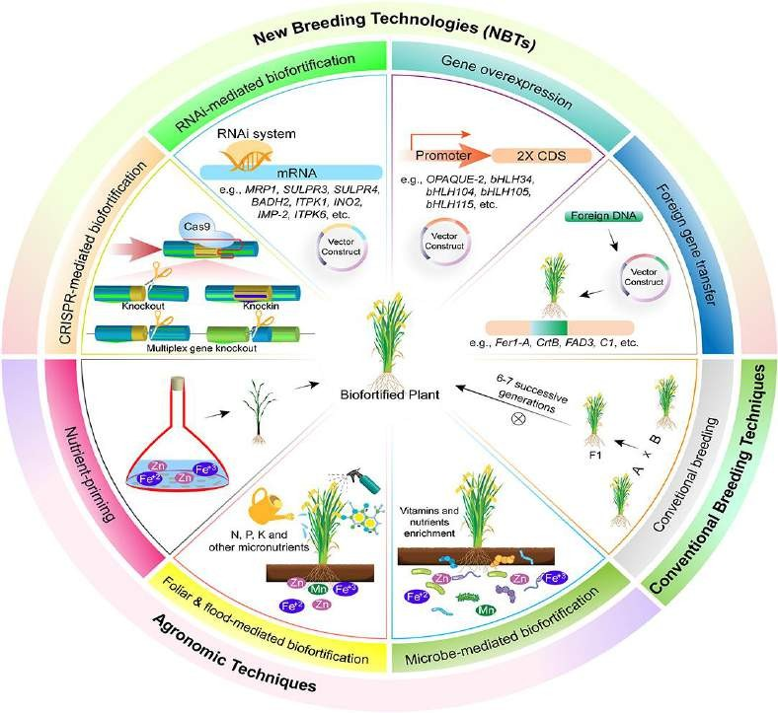

Image source: [15]

- WHY RICE?
- Rice is a staple food For more than half of the world's population
• India is the world's 2nd largest producer of rice and the 1st largest exporter of rice in the world
• Rice is the maximum cultivated crop in India. So, rice is major source of employment for our Indian farmers
• Rice is an excellent option to overcome malnutrition
• Rice plays an essential role in food security
• Time has come to play a role in nutritional security

LIMITATION FOR MINERAL ACCUMULATION IN RICE

Brown rice contains, on average 90% portion of endosperm, 6-7% rice bran and 2-3% embryo by weight [7]. Bran, unlike endosperm, is a large storehouse of lipids, vitamins, proteins, minerals, and dietary fiber [8], [9]. Recent X-ray micro fluorescence studies have shown that Zn, Fe, and potassium (K) concentrations reduced in the following order: bran > hull > whole grain > brown and polished rice [10], [11]. Zn and Fe are distributed throughout the endosperm, but the concentration in the bran is approximately three times higher than that in the rice husk and endosperm [12] [10], the husking and polishing of the rice removes the bran from the rice, thereby enabling the rice to be polished. It consumes elements that are not found in the food of many consumers. Therefore, it is vital to increase the Zn and Fe concentration in the rice endosperm [6]. The phytic acid in grains is another limitation due to their chelator nature. About 80% of the total phytic acid in most cereals builds up in the aleurone layer. Phytic acid stored as mixed salts and this complex called phytate. Due to its six negatively charged ions, phytate is a powerful chelator of divalent cations such Fe2+, Zn2+, Ca2+, Mg2+ and lowers their bioavailability [13]. Monogastric animals cannot secrete phytase enzyme so that they cannot digest or breakdown phytate minerals complex. It is necessary to reduce phytic acid for achieve enough availability of minerals from rice. NBTs improve the mineral content in grains by up regulating metal-storage proteins such lactoferrin, ferritin and down regulating phytic acid pathways [14].

- MOLECULAR AND BIOTECHNOLOGICAL APPROACHES
Along with fertile fortification, biotechnological approaches can be employed to incorporate genes that increase the content of micronutrients, their bioavailability and decrease of the concentration of antinutrients. This chapter focuses on three techniques: Overexpression of genes, RNA interference, and CRISPR-Cas9.

- Overexpression of gene
Gene over-expression is the process that leads to abundant target protein expression by adding constitutive/vital promoter regulatory elements before the target gene so that genes can be transcribed and translated efficiently. There are many ways of obtaining the target gene like getting from the gene libraries, PCR-amplification of the target gene, designing and synthesizing the target gene construct.

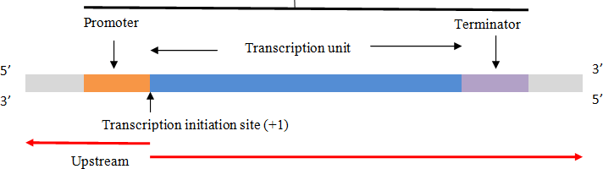
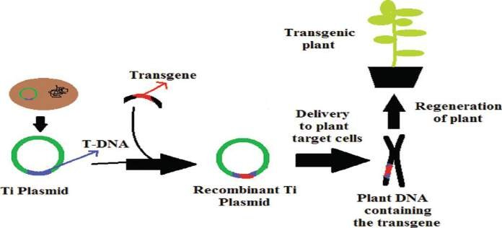
downstream

Figure 1: Schematic representation of transgenic plant development
Promoters are added to the upstream region of the gene and this transgene is inserted into the plasmid by restriction enzyme and ligase enzyme. This recombinant artificial Vector is transferred into a plant by many gene transformation techniques like Agrobacterium-mediated transfer, electroporation, particle bombardment method, microinjection, etc. It makes a transgenic plant with desired traits.

RNA Interference
Tissue-specific RNAi-mediated silencing of the phytic acid gene significantly reduced the phytate levels in seeds without interfering germination or plant growth. The short RNA molecule bind with the target mRNA and make it functionally inactivates target mRNA and sometimes its leads to the degradation for prevent translation. The small interfering RNA molecules (siRNAs) affiliated with the three catalytic core elements Dicer, Argonaute (AGO), and RNA-dependent RNA polymerase (RdRP). The ribonuclease enzyme, one of the several proteins in RISC which are responsible for enzymatic cleavage of double stranded RNA [16].
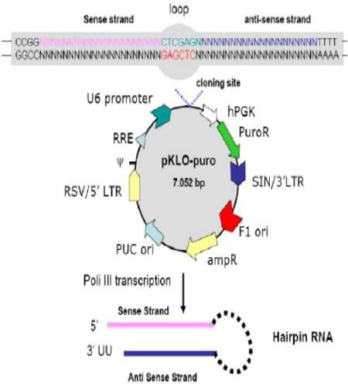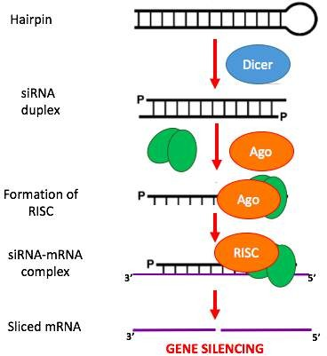

Figure 2: Mechanism of RNA interference through SiRNA biosynthesis
Double strand RNA with sense and anti-sense strands is inserted into a vector and makes an artificially constructed Vector. This Vector transforms into a plant cell and once this construct is rich in the plant cell cytoplasm, the dicer enzyme cuts this ds RNA strand (hairpin structure) and makes the duplex structure. Next, the RISC complex binds and this whole complex structure binds with targeted m-RNA and silences their function.

CRISPR-Cas9 Technique

This technique is one type of natural immunity system of bacteria for defense against viruses. When viruses attack on bacteria, a small DNA template inserted into the bacteria. Bacteria memorized it and that’s called RNA arrays. Now again this viruses attack, this RNA arrays guide and detected infectious DNA template. The cas9 enzyme of bacteria cut this infectious DNA template and disabled viruses

Figure 3: CRISPR-Cas9 gene editing
Nowadays in biotech research, this cas9 enzyme used in many experiments. Cas9 isolated from bacteria and guide RNA (gRNA) construct for target gene. This cluster called CRISPR and insert into target host for disable the target protein.

- CASE STUDIES OF MINERAL ACCUMULATION BY BIOTECHNOLOGY

- Increasing iron mineral in rice by molecular breeding method
- Objective: Overexpression of Osfer2 gene (endogenous Ferritin gene) for the development of cisgenic rice plants
  - Methodology:
• The gene Osfer2 from the Swarna rice variety was overexpressed in Pusa Sugandhi II.
• Total RNA was isolated from Swarna seeds and cloned the Osfer2 gene
• Genetic transformation via the biolistic method in Pusa Sugandhi II
• Total RNA was extracted from the transgenic plants (mature dehusked seeds) for semi-qRT-PCR
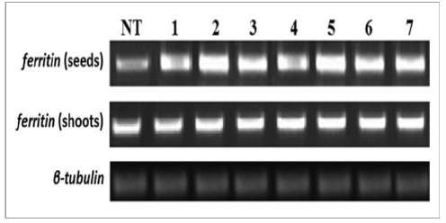
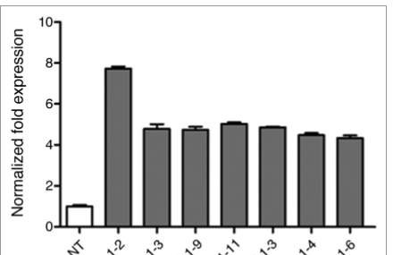
• Analysis of Fe & Zn concentration in grains histochemical localization of iron in grain tissues
- Results:

Figure 4: PCR and qRT-PCR analysis
The result shown that PCR analysis of different 7 transgenic plant seeds and roots sample compared with non-transgenic (NT) plants. As per the PCR analysis, NT plants showing lower ferritin genes with tubulin reference gene. Transgenic seeds showed greater ferritin transcript expression compared to other plant components (shoots). The qRT-PCR of 7 transgenic plants showed 7.8-fold overexpression of ferritin gene in transgenic rice seeds over NT rice seeds.

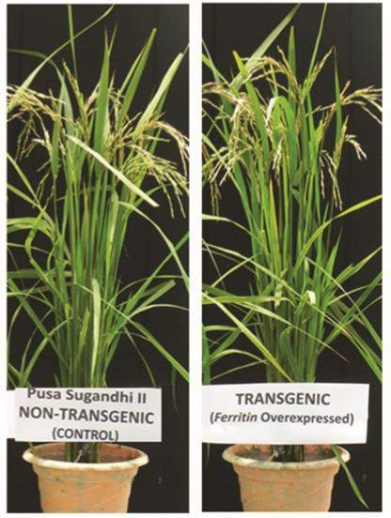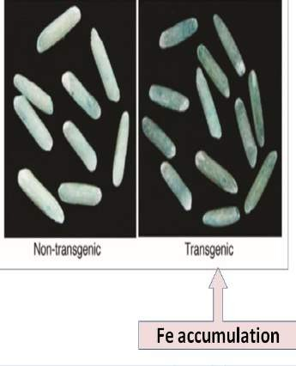

Figure 5: Morphology of T2 pusa sugandhi II and prussian blue staining

Morphology of transgenic and non-transgenic pusa Gandhi II showed that no any physical difference after gene transformation. The distribution of ferric ions in the endosperm of transgenic seed was validated by Pearl's Prussian blue staining of transgenic seeds. This distribution was revealed by the insoluble blue coloring of potassium ferric ferrocyanide complex due to ferric ion (Fe3+) interacting with potassium ferrocyanide. Due to the lack of iron in the endosperm, non-transgenic seeds were found to be lighter in color [17].

- Decrease anti-nutrient cadmium in rice by CRISPRCas9 genome editing technology
- Objective: Knockout mutants of OsCCX2 genes (Cadmium) are generated by the CRISPR/cas9 editing method
- Methodology:
• Genome editing technology (CRISPRCas9) to target the cadmium transporter gene (OsCCX2) in Nipponbare rice
• Genetic transformation of Agrobacterium cells EHA105 with CRISPR-Cas9CCX2 gene
• Rice seeds grow in a hydroponic solution, and the plants were harvested for Cd determination in WT, ccx2- 1 and ccx2-2
• Total RNA sample isolated for semi-qRT-PCR
• Analysis of Cd Concentration in grains was quantified by Spectroscopy
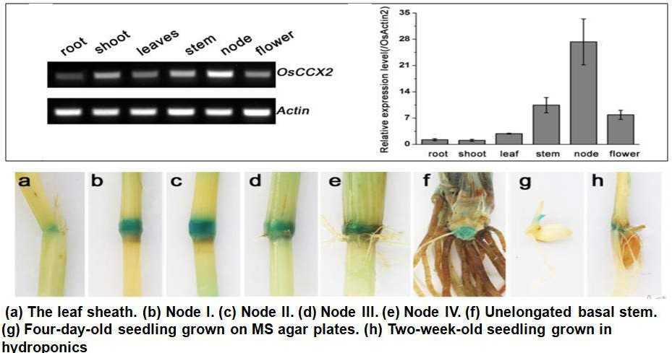
- Results:

Figure 6: The semi-quantitative-RT-PCR analysis of OsCCX2 transcript levels & Histochemical GUS staining of OsCCX2

They initially examined the expression pattern of OsCCX2 using a semi-quantitative RT-PCR technique and found a clear DNA band in the node tissue and weak bands in other tissues. Strong GUS signal was exclusively found in node tissues while weak GUS signal was seen in internode tissues. The OsCCX2 gene tends to be expressed near the nodes, which suggests a connection to cation buildup in grains.

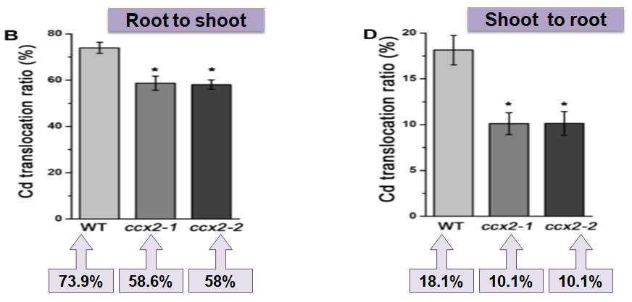

Figure 7: Translocation ratio of Cd
The calculated root-to-shoot and shoot-to-root translocation ratio of transgenic ccx2 mutants (average, 5.0%) much lower than those of the wild type plants [18].

Reduction of phytic acid for enhancing phosphorus concentration in rice by molecular breeding

Objective: Generate low phytic acid rice by over-expressing appA gene
- Methodology:
• Isolation and cloning of appA gene from E. coli
• Vector construction with pUC- zein-appA-nos gene
• Rice tissue culture and Agrobacterium-mediated genetic transformation
• DNA isolated from leaves of transgenic plants for PCR
• Total RNA isolated from transgenic seeds for cDNA synthesis and gene expression
• Determination of total phosphorus, inorganic phosphorus, and phytic acid by Spectroscopy

Figure 8: Semi qPCR analysis of transgenic seeds

The semi qPCR analysis results shown that the non-transgenic seeds (L2) did not exhibit any transgene amplification while L3 to L9 transgenic seeds shown positive results. The housekeeping gene β-tubulin showed amplification in both transgenic and nontransgenic plants.

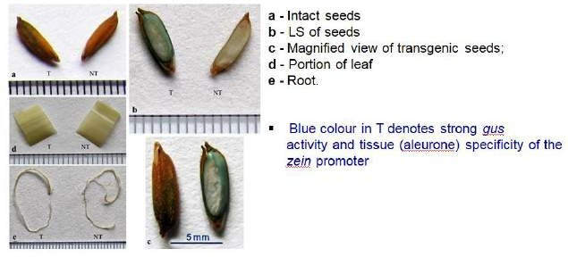

Figure 9: Histochemical gus analysis of transgenic rice lines

The phosphorus quantity increased four times whereas the phytate content of the transgenic seeds lowered by about 45%. Polished seeds from transgenic plants contained two and three times as much increased iron and zinc, respectively. Transgenic seeds' maturation behavior and other physical features remained unchanged. This finding demonstrates that appA gene reduce phytic acid in rice seeds without impairing the plant's other physiological functions or morphological cost [19].

RNAi technology use for reduces phytic acid content and enhance mineral distribution in rice seeds
- Objective: RNAi-mediated silencing of OsITP5/6K-1 gene
- Methodology:
  - Cloning of rice ITP5/6K-1 gene and RNAi vector construction
  - Tissue culture of rice plants and Agrobacterium mediated genetic transformation
  - DNA was extracted from transgenic leaves for PCR-based screening of transgenic plants
  - Total RNA isolated from transgenic seeds for qRT-PCR expression analysis
  - Determination of total phosphorus
  - Analysis of (Fe²⁺), (Mg²⁺), (Mn²⁺) and (Zn²⁺) content in milled seeds of non-transgenic (NT) and transgenic seeds by Atomic Absorption Spectroscopy

Results:
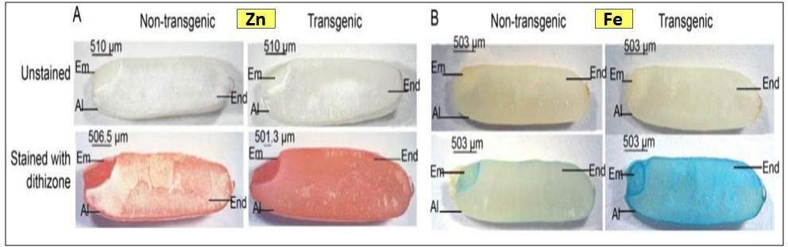
Figure 10: Histochemical localization of Zn and Fe
Dithizone and Perl's Prussian blue were used to stain NT and transgenic rice grains in order to evaluate the histochemical localization of Zn and Fe. μ-XRF imaging analysis, in which transgenic rice grains displayed higher color intensity indicating a greater accumulation of Zn and Fe in the endosperm region compared to NT rice grains.

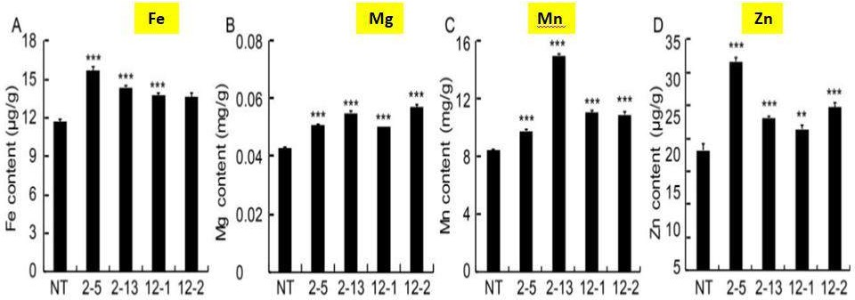

Figure 18: Analysis of iron, magnesium, manganese and zinc content in milled seeds by Atomic Absorption spectroscopy
Fe content increased by 1.3 times when compared to NT, whereas Mg, Mn, and Zn also increased by 1.4, 1.7, and 1.6 times, respectively. Iron and zinc concentration in the grain endosperm were both increased by 1.3 and 1.6 times in low phytate polished seeds, respectively. their findings demonstrated that RNAi technology of the OsITP5/6K-1 gene considerably decreased the amounts of phytate in seeds without impairing seed germination or growth of the plant [20].

CONCLUSION

Globally, more than a billion people experience Fe and Zn deficiency. In areas where human Fe insufficiency is frequent, rice (Oryza sativa) is a common staple [5]. But polished/ white rice does not provide enough Fe and Zn to match human nutritional requirements. In rice germplasm, there is only a limited amount of minerals due to polishing. The development of Fe and Zn in rice is considered the best way to solve these problems. However, biological enrichment of Fe and Zn by Fertilizer and breeding methods in rice is very difficult due to insufficient genetic modification. At the same time, biotechnological intervention has led to an increase in the amount of Fe and Zn in rice. The development of effective genetic biological amplification techniques relies on knowledge of the functions of different genes involved in the uptake, translocation and storage of Fe and Zn. Overexpression of Osfer2 (increase 3.4-fold higher Fe) and appA (increase Zn) genes by molecular breeding method, Knockout OsCCX2 anti-nutrient gene (decrease 32.41% Cd) by CRISPR/Cas9 technology and silencing OsITP5/6K-1 gene (decrease 46.2% phytic acid and 3, 1.3, 1.6-fold enhancement in Pi, Fe, Zn respectively) by RNAi technology. It has become evident with different case studies that molecular and biotechnological approaches do increase micronutrients and decrease antinutrients.

Table 1: Biofortified varieties of rice in India
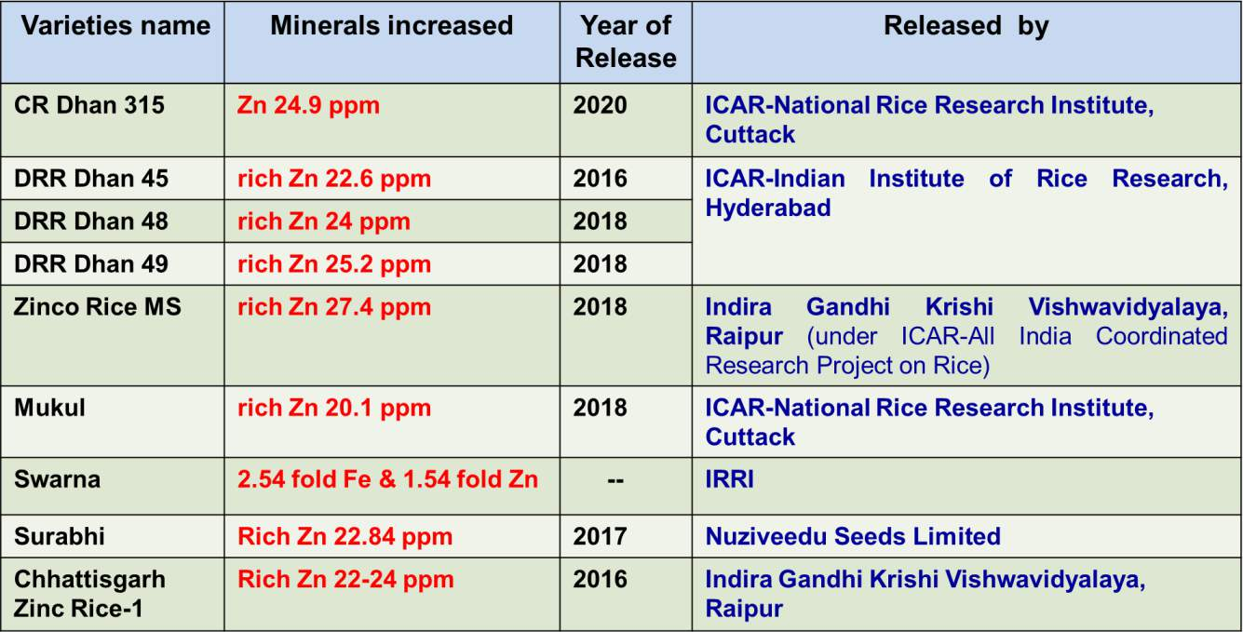
(Normal rice contain 12 ppm Zn)

REFERENCES
- Datta, S., & Bouis, H. E. (2000). Application of biotechnology to improving the nutritional quality of rice. Food and nutrition bulletin, 21(4), 451-456.
- Shahzad, R., Jamil, S., Ahmad, S., Nisar, A., Khan, S., Amina, Z., ... & Zhou, W. (2021). Biofortification of cereals and pulses using new breeding techniques: current and future perspectives. Frontiers in Nutrition, 665.
- Calicioglu, O., Flammini, A., Bracco, S., Bellù, L., & Sims, R. (2019). The future challenges of food and agriculture: An integrated analysis of trends and solutions. Sustainability, 11(1), 222.
- Cominelli, E., Pilu, R., & Sparvoli, F. (2020). Phytic acid and mineral biofortification strategies: from plant science to breeding and biotechnological approaches. Plants, 9(5), 553.
- Smith, M. R., Golden, C. D., & Myers, S. S. (2017). Potential rise in iron deficiency due to future anthropogenic carbon dioxide emissions. GeoHealth, 1(6), 248-257.
- Nakandalage, N., Nicolas, M., Norton, R. M., Hirotsu, N., Milham, P. J., & Seneweera, S. (2016). Improving rice zinc biofortification success rates through genetic and crop management approaches in a changing environment. Frontiers in plant science, 7, 764.
- Chen, H., Siebenmorgen, T. J., & Griffin, K. (1998). Quality characteristics of long‐grain rice milled in two commercial systems. Cereal chemistry, 75(4), 560-565.
- Shahzad, Z., Rouached, H., & Rakha, A. (2014). Combating mineral malnutrition through iron and zinc biofortification of cereals. Comprehensive Reviews in Food Science and Food Safety, 13(3), 329-346.
- Sun, G. X., Liu, X., Williams, P. N., & Zhu, Y. G. (2010). Distribution and translocation of selenium from soil to grain and its speciation in paddy rice (Oryza sativa L.). Environmental science & technology, 44(17), 6706-6711.
- Lu, L., Tian, S., Liao, H., Zhang, J., Yang, X., Labavitch, J. M., & Chen, W. (2013). Analysis of metal element distributions in rice (Oryza sativa L.) seeds and relocation during germination based on X-ray fluorescence imaging of Zn, Fe, K, Ca, and Mn. PLoS One, 8(2), e57360.
- Johnson, A. A. (2012). Enhancing the chelation capacity of rice to maximise iron and zinc concentrations under elevated atmospheric carbon dioxide. Functional Plant Biology, 40(2), 101-108.
- Trumbo, P., Yates, A. A., Schlicker, S., & Poos, M. (2001). Dietary reference intakes. Journal of the American Dietetic Association, 101(3), 294-294.
- Sparvoli, F., & Cominelli, E. (2015). Seed biofortification and phytic acid reduction: a conflict of interest for the plant, Plants, 4(4), 728- 755.
- Gupta, P. K., Balyan, H. S., Sharma, S., & Kumar, R. (2021). Biofortification and bioavailability of Zn, Fe and Se in wheat: present status and future prospects. Theoretical and Applied Genetics, 134, 1-35.
- Shahzad, R., Jamil, S., Ahmad, S., Nisar, A., Khan, S., Amina, Z., ... & Zhou, W. (2021). Biofortification of cereals and pulses using new breeding techniques: current and future perspectives. Frontiers in Nutrition, 665.
- Maqbool, M. A., Aslam, M., Beshir, A., & Khan, M. S. (2018). Breeding for provitamin A biofortification of maize (Zea mays L.). Plant breeding, 137(4), 451-469.
- Paul, S., Ali, N., Gayen, D., Datta, S. K., & Datta, K. (2012). Molecular breeding of Osfer2 gene to increase iron nutrition in rice grain. GM crops & food, 3(4), 310-316.
- Hao, X., Zeng, M., Wang, J., Zeng, Z., Dai, J., Xie, Z., ... & Li, D. (2018). A node-expressed transporter OsCCX2 is involved in grain cadmium accumulation of rice. Frontiers in Plant Science, 9, 476.
- Bhattacharya, S., Sengupta, S., Karmakar, A., Sarkar, S. N., Gangopadhyay, G., Datta, K., & Datta, S. K. (2019). Genetically engineered rice with appA gene enhanced phosphorus and minerals. Journal of Plant Biochemistry and Biotechnology, 28, 470-482.
- Karmakar, A., Bhattacharya, S., Sengupta, S., Ali, N., Sarkar, S. N., Datta, K., & Datta, S. K. (2020). RNAi-mediated silencing of ITPK gene reduces phytic acid content, alters transcripts of phytic acid biosynthetic genes, and modulates mineral distribution in rice seeds. Rice Science, 27(4), 315-328.

