An Overview of Anaesthesia Classification & Its Applications
¹Dr B.Durga* ²S.Harinipriya ³R Siva Sabitha

INTRODUCTION:

Anaesthesia is a temporary state consisting of unconsciousness, loss of memory, lack of pain, and muscle relaxants. It is a medical intervention which does not itself offers any particular medical benefits and instead enables the performance of other medications. The first demonstration of general anaesthesia was in 1846 by Boston dentist named William T.G. Morton at Massachusetts General Hospital, he gave ether anaesthetics to remove the neck tumor. On large, cocaine was the first discovered viable local anaesthetics. It can be administered via injection or through inhaled gases or vapors, which can affects the nervous system in different ways by blocking the nerve impulses and therefore, pain. Nowadays in hospitals and in surgery centers, highly trained professionals use a wide variety of safe, modern medications, and extremely capable monitoring technology. Anaesthesiologist is a doctor, who specializes in giving and managing anaesthetics – the medication that numbs an area of the body or helps to fall asleep. ^{[2]}
However, the scientific discoveries over late 18th and 19th centuries had paved the way for the development of modern anaesthetic techniques. In late 19th century, there was a two major advancement over the modern surgery: the advent of antiseptics which results in germ theory of disease, leads to reduced morbidity and mortality rates and also advancement in pharmacology and physiology that led to the development over general anaesthesia and pain control. In 20th century, with the use of tracheal intubation and improved airway management techniques made further development over general anesthesia’s safety and pain control. Moreover, in 20th and 21st centuries, the business administration of principles and application of economic to healthcare led to the initiation of management practices, such as transfer pricing, to improve the efficacy of anesthetics. ^{[1]}
A medical practice known as anesthesia renders patients painless during procedures like surgery, some screening and diagnostic tests, the removal of tissue specimens (such as skin biopsies), and dental treatments. It enables patients to undergo surgeries that improve their health and extend their lives.

CLASSIFICATION OF ANAESTHESIA
Anaesthesia is classified into four types (Image 1). They are,
- General anaesthetics
- Regional anaesthetics
- Sedation
- Local anesthetics
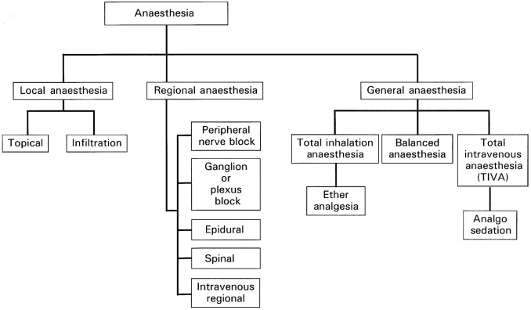

Image 1 Sub classification of Anaesthesia

General anaesthetics
A combination of drugs used in general anesthesia induces a state that is similar to sleep. The drugs, also referred to as anesthetics, are administered prior to and throughout surgery or other medical procedures. Inhaled gases and a mix of intravenous medications are typically used for general anesthesia. It suppresses the activity of the central nervous system, resulting in unconsciousness and lack of sensation. ^{[4]}

Types
- Inhalational anaesthetics
- Intravenous anaesthetics

Inhalational anaesthetics
It can be administered at determined concentration, since the brain is highly perfused organ it can be achieved very quickly. This state makes to reach the partial pressure of the brain and the lung becomes equal and makes it to monitor the anaesthesia ^{[5].}
For example: Nitrous oxide is a gas which consists of sweetish odour and can produce light anaesthesia without any depression of vasomotor centre. ^{[7]}

Intravenous anaesthetics
When the anaesthetics are administered through intravenous route, it helps to attain the higher concentration, which is especially important with drugs of narrow range of the therapeutic value. ^{[6]}
For example: Thiopentone sodium is a short acting drug and has rapid onset of action which acts over the cardiovascular and profound respiratory depression and it is known as ‘truth serum’ in medico legal use. ^{[7]}

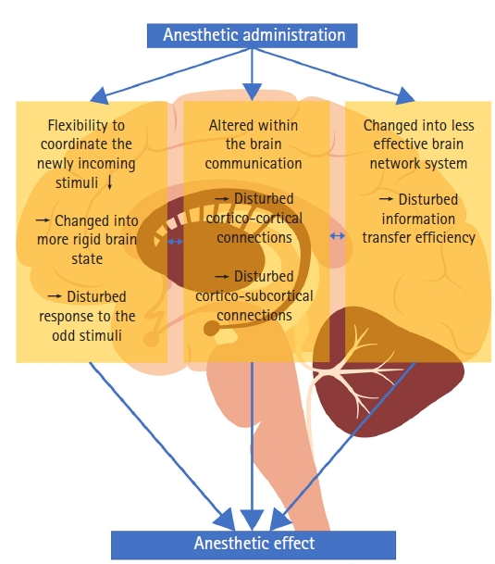
Figure 1: General Anaesthetic mechanism

Stages of General Anaesthesia based on Guedel's Classification:
It's generally accepted that wakefulness, awareness, and consciousness are all parts of a conscious state. A reversible loss of awareness, sensory function, and autonomic responses are all symptoms of general anesthesia. Along with drowsy effects, it also has antinociceptive, immobility-related, and reflex blockade effects. Several drugs may be administered to cause amnesia, analgesia, skeletal muscle relaxation, and the lack of reflexes in the autonomic nervous system (Image 2).
- Analgesia
- Delirium
- Surgical anaesthesia
- Medullary or respiratory paralysis

Stage: 1 – Analgesia
Analgesics, commonly known as painkillers, are drugs that treat many kinds of pains, especially headaches, injuries, and arthritis. Inflammation is reduced by anti-inflammatory analgesics, while pain perception in the brain is altered by opioid analgesics.
Analgesia is otherwise called as disorientation, this stage can be started in a preoperative anesthesiology retaining area when the patient receives the medicine and might begin to experience its effects but isn't yet fully asleep¹⁶. It is the period of time between the inhalation of anesthesia and the loss of consciousness, which is marked by a slight neuronal depression, which is ideal for simple surgical procedures.
Stage: 2 – Delirium
Delirium is otherwise called as Excitement. It starts from the loss of sensation to the surgical anaesthesia which is associated with exhilaration and leads to involuntary muscle activities. Disinhibition, irrational behavior, lack of the eyelid reflex, hypertension, and tachycardia are characteristics of this stage. Fast-acting drugs enhance progression to stage 3 by minimizing the amount of time spent in stage 2.

Stage: 3 – Surgical anaesthesia
For treatments requiring general anesthesia, this is the desired anesthetic level. Due to its suitability for the majority of procedures, it has been known as "true surgical anesthesia". This stage is characterized by reduced respiratory function and ceased ocular movements¹⁷ & stage is divided into four plane characterizes by increasing central nervous system depression: first, loss of spinal reflexes; second, decreased skeletal muscle reflexes; third, paralysis of intercostal muscles; and fourth, loss of most muscle tone.

Stage: 4 – Medullary or respiratory paralysis
This stage happens when a surgical stimulus is stimulated too much when compared to the amount of anesthetic administered, which worsens a brain or medullary depression, hence this stage is also called as overdose which is characterized by vasomotor and respiratory paralysis. Due to the inhibition of the cardiac pump and vasodilation in the peripheral circulation, blood pressure is often substantially lower than normal, with weak and thready pulses. This stage is fatal without support for the cardiovascular and respiratory systems. Nowadays, these stages are not preferred in the actual use of anaesthesia due to its related use of other drugs. ^{[4] [7]}

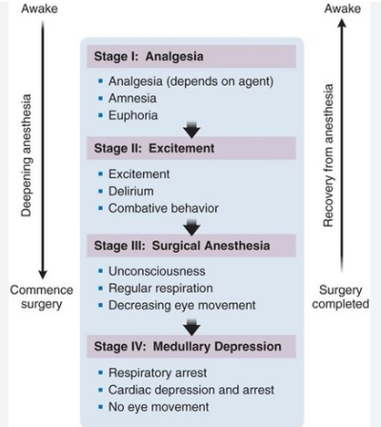

Image 2: Stages of Anaesthesia & its action

Mechanism of action
General anaesthetics binds on the GABA receptor chloride channels and activates the receptors (figure 2), which leads to inhibit the neurotransmission and depresses the CNS. The exact mechanism of action of general anaesthetics is not known. But the steps of the mechanisms of action are as follows:
- There is a nerve impulse.
- This results in the opening of calcium ion channels, which allows an influx of calcium ions into the terminal.
- As a result, synaptic vesicles fuse with the terminal membrane, releasing neurotransmitter into the synaptic cleft, the space between neurons.
- The ion channels in the postsynaptic membrane open when the neurotransmitters bind to their receptor sites.
- When a threshold level is reached, ions enter the postsynaptic neuron, where they cause it to produce an action potential.
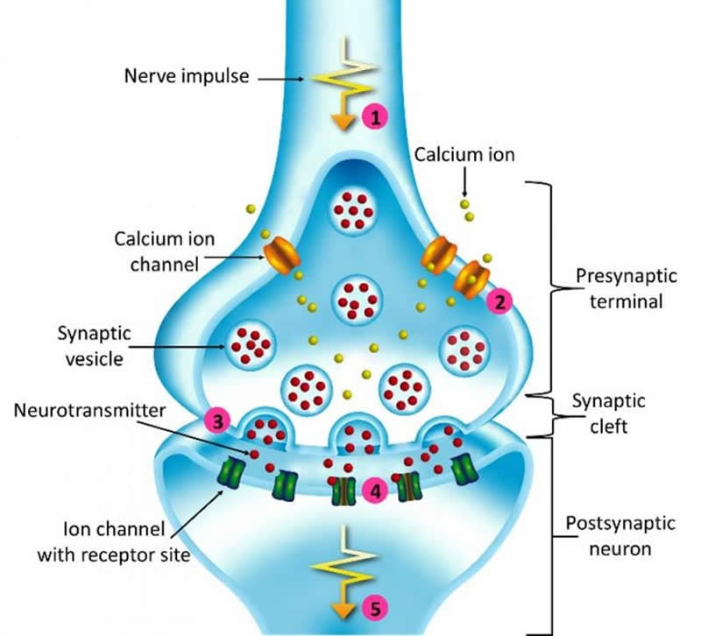
Figure 2 - GABA receptor complex

- For inhalational anaesthetics - Minimum Alveolar Concentration (MAC) is defined as the concentration (or partial pressure) of an anaesthetic in the alveoli is directly equal to that in the brain, which is closely reflects at the site of anaesthetic measures.
- For intravenous agents - Potency of IV is defined as the plasma concentration (at equilibrium) that produces loss of response to surgical incision in 50% of subjects. ^{[4]}

Regional anaesthetics
The goal of regional anaesthesia is to attain the loss of sensation in a specific extremity or area of the body (Image 3). Unlike general anesthesia, it does not impair the patient's state of consciousness as a means of numbing their discomfort¹⁸. There are various benefits to regional anesthetic over general anaesthetic, including the avoidance of airway manipulation, lower dosages, fewer systemic drug adverse effects, quicker recovery, and much less postoperative discomfort.
Regional anaesthesia is also used in orthopedic surgeries on an extremity such as arm, leg, hand, or foot and in female reproductive surgery such as gynecological procedures and cesarean section and in male reproductive surgery, and then it is used for operations on the bladder and urinary tract. ^{[8]} In addition to being used postoperatively, regional anesthesia can be combined with general anesthetic to treat a variety of acute and chronic pain disorders.

Types and its action
- Spinal anaesthetics
- Epidural anaesthetics
- Nerve blocks

Spinal anaesthetics
It is injected into the subarachnoid space between L2 – L4 or below the lower end of the spinal cord, which acts on the nerve roots. In this type of anaesthetics, the lower abdomen and lower limbs are get anaesthetized and paralyzed. The level of anaesthetics can be changed by the volume of injection, specific gravity of the solution and posture of the patients.
- Epidural anaesthetics
It is injected in the extradural spaces which is directly acts on the nerve roots whereas the small quantities get diffused into subarachnoid spaces. Minimal uses of epidural opioids may require comparing the oral dose, which produces better analgesia.

Nerve blocks
Injected about / around individual’s peripheral nerves or nerve plexuses produces larger areas of the anaesthesia with the smaller amount of the drug then the above techniques. Anaesthesia starts a few centimeters distal to the injection. ^{[7]}
Regional Anaesthesia

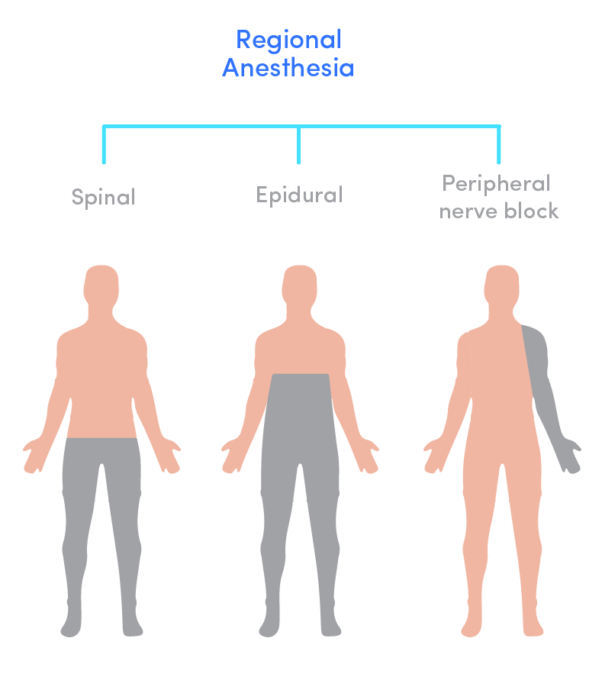
Nerve Blocks
Spinal
Epidural

Image 3 Action area for Regional Anaesthesia

Sedation
Sedation is defined as the relaxed state or temporary decrease in the level of consciousness. The levels of sedation and its action are showed in image 4

Levels of sedation:
- Mild sedation
- Moderate sedation
- Deep sedation

Mild sedation
It acts as relaxants when the patient is awake and can respond to the verbal commands. Example: antihistamines such as diphenhydramine (Benadryl), dimenhydrinate (Dramamine).

Moderate sedation
Sleepy and can be awakened or to respond to verbal tactile stimuli. Example: morphine, diazepam, ketamine, and midazolam.
- Deep sedation
Deep sleep can occur in this case and can be easily aroused; which is nearly in unconscious state. Example: oral ketamine and midazolam. ^{[9]}

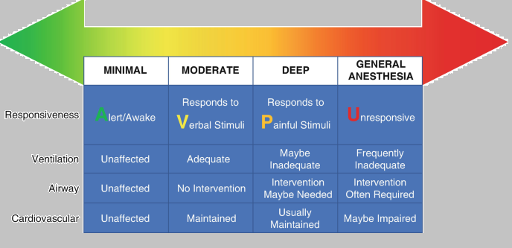

Image 4: Action Levels of sedation.

Local anaesthetics
Local anesthetics (LA) are a group of pharmacological substances that are commonly employed in modern medicine for a variety of operations, from minor surgery to more involved ones like reconstructive hand surgery or wound suturing ¹⁹. Local anaesthetic agents depresses the action potential in excitable tissues by blocking the sodium channels, which inhibits the action potential leads to blockade in the transmission of pain impulse (Image 5).
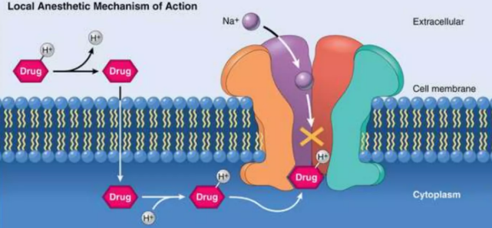
Image 5 Mechanism of Action of Local Anaesthetics
It can be either given by topical or administered directly into localized area to produce the state of loss of sensation or analgesia. ^{[7]} When the substances such as amide or ester local anaesthetics are applied or locally injected, they cause transient loss of pain perception in a specific body region by blocking sodium channel (Image 6). They work by obstructing both sensory and motor nerve transmission to cause momentary loss of sensation without consciousness. (Figure 3)

Image 6 local Anaesthetics blocks Na Channel

The amino-ester type LA are rapidly hydrolyzed by the plasma cholinesterase (also known as pseudo cholinesterase), which gets distributed all over the body tissues. Then it gets metabolized in the blood, kidneys and liver to lesser the extent, at the site of administration for the effect of anaesthetics. ^{[9]}

Figure 3: Steps involved in effect of local anaesthetics

Types of Local Anaesthetics:
- Surface anaesthesia
- Injectable anaesthesia

Surface anaesthesia
It is directly applied by topical application over the mucous membrane such as eye, nose, mouth, tracheobronchial tree, oesophagus and genitourinary tract. In topical applications, phenylephrine (but not adrenaline as its penetration is poor) causes vasoconstriction, which prolongs the duration of action. Local anaesthetics are also used on abraded skin. ^{[7]}
For example: Local anaesthetics used only on the eye are Benoxiate HCl within 60 seconds of administration, the cornea of the eye becomes anaesthetized. ^{[7]}

Injectable anaesthesia
It is the type of local anaesthetics which is directly injected into the body tissues. For example: Lignocaine is the widely used local anaesthetic which is rapid and long acting which causes drowsiness and mental clouding. It is also acts as a good corneal anesthetic.
Anaesthetic Management:
The administration of anesthesia is crucial to delivering standardized treatment and hastening recovery. The anaesthetist must provide great care when doing any of the major or minor surgery. There are many different concurrent medical conditions present in patients undergoing any sort of surgery. Anesthesiologists play a crucial role in all phases of patient management since the patient may need a surgical procedure or an invasive technique to control the cause of the infection ²⁰. Hence analysis of the patient's clinical characteristics that can affect the result of the surgical procedure should be considered.
- In Cardiovascular management
The primary site in the cardiovascular system is myocardium, in which the local anaesthetics are administered and can leads to decreased excitability, conduction rate and force of contraction. Whereas the inhalational anesthetics tends to reduce the myocardial contractility, oxygen requirement, arterial pressure and also produces some coronary vasodilation.

In Respiratory management
All inhalational anaesthetic agents are acts as respiratory depressants, which may leads to decreased tidal volume, ventilation and also mucociliary function and are widely used as bronchodilators.

In Central nervous management
Inhaled anaesthetics increase the cerebral blood flow by decreasing cerebral vascular resistance, they also decreases the metabolic rate of the brain and may increase intracranial pressure.
Local anaesthetics suppresses the cortical inhibitors pathway, thereby it allows the agonistic activity of excitatory components. When the central stimulation is followed by the generalized CNS depression, death may results from the respiratory failure.

In Renal and Hepatic management
Volatile anaesthetics decrease the Glomerular Filtration Rate, renal and hepatic blood flow. Halothane and its derivatives decrease cardiac output and arterial pressure. The effect on heart rate is viable and some may cause tachycardia and bradycardia. ^{[3]}

Adverse effect of Anaesthesia

Hypersensitivity reactions
It includes skin rashes, dermatitis, asthma or rarely anaphylaxis are more common with ester type of drugs. To manage such reactions, drugs should be kept read. Moreover, allergy is often occurs due to the preservative methylparaben.

In central nervous system
Dizziness, sedation, auditory and visual impairment, mental confusion and disorientation may occur. Higher doses may leads to anxiety, nystagmus, muscle tremors, convulsions and respiratory failure due to the depression in the cortical inhibitory pathways leading to CNS stimulant effects. LA including for infiltration, pre-medication with BZD helps.

In cardiovascular system
Blockade of sodium channels in the myocardium may results in myocardial depression with reduces in the force of contraction, bradycardia, excitability and conduction velocity; rarely cardiac arrest can occur. As the local anesthetics can cause vasodilation, hypotension may occur. Bupivacaine is the most cardiotoxic. Rarely cardiac arrest may occur.

Others
As a result of therapeutic error, local anaesthetics toxicity may occur generally. A situation leading to toxicity includes inadvertent venous or arterial injection or topically administered local anaesthetic containing preparations.
Repeated use of halothane may occasionally cause hepatitis, comparing to other inhalational agents. A metabolite of enflurane may leads to nephrotoxicity due to prolonged exposure.
Malignant hyperthermia and megaloblastic anemia are including adverse effects. ^{[5] [7]}
Current trends of Anaesthetic Applications:
Utilization of anaesthetics in Cancer.
An important component of routine clinical treatment for patients undergoing surgery is the use of anesthetic during the postoperative period. The perioperative period in cancer surgery is a crucial stage for the progression of the disease because circulating tumor cells from the primary tumor that are shed into the patient's circulation may cause new micro metastases even after the primary tumor has been completely removed ²¹. Numerous studies have looked at the rate of tumor recurrence in relation to various anaesthesia techniques and agents, as well as the significance of anesthesia's anti-inflammatory, anti-cancer, and anti-metastatic effects. The studies have shed light on potential mechanisms through which anesthesia might affect malignant cells (Image7).
General anesthesia is a composition of drugs that, prior to surgery, puts a patient into a sleep-like or unconscious condition and suppresses their autonomic neurological system's reactions to pain and drowsiness. The use of general anesthesia may affect the immune system through cellular and molecular (cytokine) modification, stimulation of the hypothalamic-pituitary-adrenal axis and sympathetic nervous system, and for a long time recurrence of the tumor following surgical removal ²⁵.
Patients with cancer may have a worsening of their prognosis as a result of the immunosuppression brought on by general anesthesia, which includes the malfunctioning of natural killer (NK) cells and lymphocytes. Hence the host's immune system being negatively affected by anesthesia, which could encourage tumor recurrence. Cancer does not directly arise as a result of general anesthesia. However, the immunological suppression brought on by anesthesia could accelerate the progression of cancer.
The effect of local anaesthesia during cancer surgeries, because of their potent anti-inflammatory effects, local anesthetics may have some indirect or direct effect on tumor cells that are shed during surgery. For instance, they might help to reduce the inflammatory stress response brought on by the surgical stimuli. However, several local anesthetics have been shown to protect immune cell function and have anti-metastatic effects.
According to in vitro studies²², the intravenous administration of lidocaine as part of the perioperative anesthetic regimen has the potential to lower the risk of cancer progression or recurrence in patients after cancer surgery, by increases the function of NK cells.
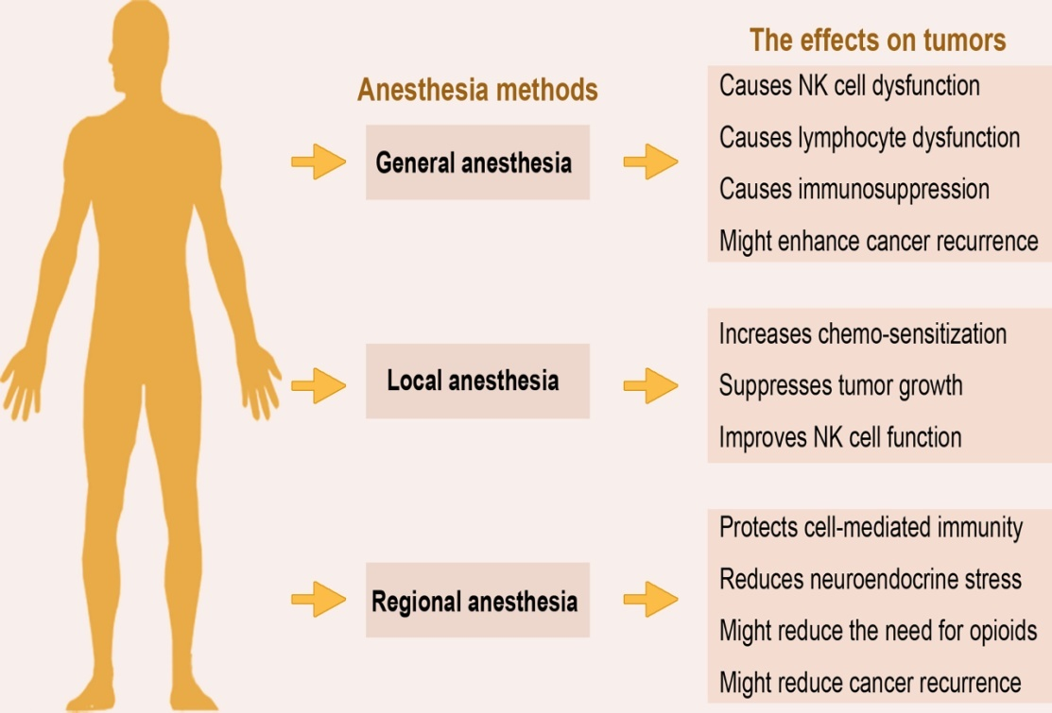
Image 7: Effect of Anaesthetics on tumor

Regional anesthesia is used to alleviate pain in a specific body location. According to certain research, localized anaesthetic techniques relieve perioperative pain, which lowers the need for systemic anesthetics and opioids. In order to cause analgesia or pain reduction, epidural anesthesia, a type of regional anesthesia, interrupts nerve impulses that originate from the lower spinal segments.
Preclinical and retrospective investigations indicate toward the possibly advantageous effect of regional anesthesia because it safeguarding cell-mediated immunity and diminishes the post-operative neuroendocrine system stress response by obstructing afferent neural signaling that stimulates the hypothalamic-pituitary-adrenal axis and the sympathetic nervous systems. This eliminates the need for opioids and volatile anesthetics, which in turn minimizes the risk of malignant tumor recurrence ²³.
In additional support of analgesic drug called Propofol believed to strengthen immune responses mediated by cells and reduce tumor angiogenesis²⁴, hence proven that the propofol has anti-cancer properties. In contrast to volatile analgesics and opioids, which often reduce cell-mediated immunity and increase the proliferation of cancer cells and angiogenesis hence thus strongly suggest for reducing the usage of opioids. Numerous studies have subsequently hypothesized that localized anesthetic may lower the probability of an extended cancer recurrence.
Clinicians may continue to select the optimal anesthetic-analgesic medicines and procedures in conjunction with their cancer patients, depending on their experience and current best practice, up until more evidence emerges that strongly connects anesthesia to clinical trials. It is necessary to do larger prospective trials to assess how anesthesia procedures can stop tumors from relapsing or spreading.
Anesthesia is the use of medicine to prevent the feeling of pain or another sensation during surgery or other procedures that might be painful. However, it causes some side effects, it is very important to both the minor and major surgeries. ^{[3]} Cancer is currently the most prevalent health issue in the globe. With the future perspectives, working together with oncologists and surgeons is crucial if patients with cancer are to receive the best care possible. For all patients with a history of cancer, preoperative evaluation to detect any treatment-related adverse reactions, a well-organized intraoperative management plan, and a postoperative treatment strategy are necessary. It is known that anesthetic methods and medications can reduce perioperative inflammatory and immunological alterations. Evidently, this could result in better outcomes for cancer patients in future generations. But more investigation towards perioperative "onco-anesthetic" and perioperative treatment for cancer is required.

REFERENCES:

- Kuntz, L; Vera, ( September 2005 ) ., Health Care Management Review
- Anaesthesia - a review ., AkshaySatwik et.al - 2015
- Morgan & Mikhail’s Clinical Anesthesia – 5th edition – 2013
- Anesthetic agents: General and local anesthetics ., Timothy J. Maher
- Inhalational Anesthetics: An update on mechanism of action and toxicology ., J Jedlicka – 2021
- Kinetics and dynamics of intravenous anesthesia by Gerland M. Woerlee
- Medical Pharmacology – 7th edition ., PadmajaUdaykumar – 2021
- Anesthetic agents and adjuncts C. Regional anesthesia ., Kim Kraft – 2014
- Anesthesia for medical students – Anesthesia University of Toronto., AhtshamNiazi et al – 2000
- Intravenous anesthetic agent ., Jaideep J Pandit
- Basic pharmacology of local anaesthetics., A Taylor et al - 2020
- Special article - Practice guideliness for sedation and analgesia by non- anesthesiologists .,Lippincott Williams & Wilkins -2002
- The journal of the American medical association - August 2011
- Anaeshesia at the dis. Hosp. - 2nd edition ., Michael B. Dobson - 2000
- Short textbook of Anesthesia ., Ajay Yadav - 6th edition., 2018
- Winterberg AV, Colella CL, Weber KA, Varughese AM. The Child Induction Behavioral Assessment Tool: A Tool to Facilitate the Electronic Documentation of Behavioral Responses to Anesthesia Inductions. J Perianesth Nurs. 2018 Jun;33(3):296-303.e1
- Hedenstierna G, Edmark L. Effects of anesthesia on the respiratory system. Best Pract Res Clin Anaesthesiol. 2015 Sep;29(3):273-84
- Li J, Lam D, King H, Credaroli E, Harmon E, Vadivelu N. Novel Regional Anesthesia for Outpatient Surgery. Curr Pain Headache Rep. 2019 Aug 01;23(10):69.
- Lazar, A.E.; Gurzu, S.; Kovecsi, A.; Perian, M.; Cordos, B.; Gherghinescu, M.C.; Enache, L.S. Cardio Protective Effects of Lipid Emulsion against Ropivacaine-Induced Local Anesthetic Systemic Toxicity—An Experimental Study. J. Clin. Med. 2022, 11, 2784. https://doi.org/10.3390/jcm11102784
- Carsetti A, Vitali E, Pesaresi L, Antolini R, Casarotta E, Damiani E, Adrario E and Donati A (2023) Anesthetic management of patients with sepsis/septic shock. Front. Med. 10:1150124. doi: 10.3389/fmed.2023.1150124.
- Müller SD, Ziegler JSH, Piegeler T. Local Anesthetics and Recurrence After Cancer Surgery-What’s New? A Narrative Review. J Clin Med (2021) 10:719. doi: 10.3390/jcm10040719
- Chamaraux-Tran T-N, Piegeler T. The Amide Local Anesthetic Lidocaine in Cancer Surgery—Potential Antimetastatic Effects and Preservation of Immune Cell Function? A Narrative Review. Front Med (2017) 4:235. doi: 10.3389/fmed.2017.00235
- Cata JP, Hernandez M, Lewis VO, Kurz A. Can Regional Anesthesia and Analgesia Prolong Cancer Survival After Orthopaedic Oncologic Surgery? Clin Orthop Relat Res (2014) 472:1434–41. doi: 10.1007/s11999-013-3306-y.
- Cakmakkaya OS, Kolodzie K, Apfel CC, Pace NL. Anaesthetic Techniques for Risk of Malignant Tumour Recurrence. Cochrane Database Syst Rev (2014) (11):CD008877. doi: 10.1002/14651858.CD008877.pub2
- Makito K, Matsui H, Fushimi K, Yasunaga H. Volatile Versus Total Intravenous Anesthesia for Cancer Prognosis in Patients Having Digestive Cancer Surgery. Anesthesiology (2020) 133:764–73. doi: 10.1097/ALN.0000000000003440

