STUDY OF BARYON ASYMMETRY WITH TBM NEUTRINO MASS MATRIX AND HYBRID TEXTURES MATRIX
Rupam Kalita
rupkalitaphy@gmail.com
Department of Physics, PDUAM Amjonga, Goalpara, Assam, India 783124
We study two types of neutrino mass matrices to connect baryon asymmetry of the Universe within the framework of a model where both type I and type II seesaw mechanisms can contribute to tiny neutrino masses. In this work we study the origin of matter–antimatter asymmetry through the mechanism of leptogenesis. Type I seesaw mass matrix considered to a tri-bimaximal (TBM) type neutrino mixing which always gives non zero reactor mixing angle. The type II seesaw mass matrix is then considered in such a way that the necessary deviation from TBM mixing and the best fit values of neutrino parameters can be obtained when both type I and type II seesaw contributions are taken into account. We consider type II seesaw matrix as hybrid textures matrix. We study different contribution from TBM and Hybrid textures mass matrix to study the effects of neutrino CP phases in the baryon asymmetry of the universe.

- INTRODUCTION
Neutrino masses and their large mixing [1-5] is one of the major observed phenomena in recent years. Standard Model of particle physics fails to account for. Various Neutrino oscillation experiments namely T2K [6] ,Double ChooZ [7] , Daya-Bay [8] and RENO [9] have made the earlier predictions for neutrino parameters more precisely and also predicted non-zero value of the reactor mixing angle $θ_{13}$. The latest global fit value for $3σ$ range of neutrino oscillation parameters are given in [10] and [11]. The neutrino oscillation experiments measure only two mass squared differences and therefore the lightest neutrino mass which are remains a free parameter can be constrained from the upper bound on the sum of absolute neutrino masses from cosmology $\sum{m_{i}}$ < 0.12eV [12]. With addition to the neutrino mass hierarchy problem recent neutrino experiments also have not found anything about the nature of the neutrino mass. Recently several new experiments have been proposed to solve these problems and India based neutrino observatory (INO) has proposed some idea to solve some of these issues.

Seesaw mechanism is the most popular BSM framework that can explain the origin of tiny neutrino masses and can be of three broad types: type I [13], type II [14] and type III. All these mechanisms include extra heavy fermionic or scalar fields into the SM. Apart from neutrino mass and mixing, the SM also fails to explain the observed matter-antimatter asymmetry which, according to the latest data available from Planck experiment [12] can be written in terms of baryon to photon ratio as
Y_{B}$≅(6.065±0.090)×{10}^{-10}$

In this present work we consider leptogenesis as the only mechanism of producing baryon asymmetry of the Universe, recent work has been studied [15-18] the possibility of generating non-zero $θ_{13}$ and also the Dirac CP phase $δ$ in some cases by considering a BSM framework where both type I and type II seesaw mechanisms contribute to neutrino masses.

This paper is organized as follows. In section II we discuss the TBM mixing matrix and Hybrid textures matrix. In section III we describe the numerical analysis adopted here and finally conclude in section IV.

- TBM mixing + Hybrid Textures

In this work, we consider type I seesaw mass matrix as a TBM type mixing which gives a approximation to observe neutrino mixing as $θ_{12}≅35.3°, θ_{23}=45°$ and $θ_{13}=0$. The necessary correction to TBM type neutrino mass matrix in order to generate non-zero but small $θ_{13}$can be given by the type II seesaw term. The Pontecorvo-Maki-Nakagawa-Sakata (PMNS) leptonic mixing matrix is related to the diagonalizing
Matrices of neutrino and charged lepton mass matrices $U_{ν},{ U}_{l}$ respectively, as

$$U_{PMNS}={U_{l}}^{+}U_{ν}$$

In this work we consider hybrid texture neutrino mass matrix as the origin of type I seesaw. There are six categories of hybrid texture matrix which make it 39 matrices. We choose only 6 out of 39 hybrid texture matrices in our work which is closely agreed with experimental values. Following are the structure of hybrid texture neutrino matrix we have used in our work.

A1: $\left(\begin{matrix}0 & 1 & 1 \\ 1 & a & b \\ 1 & b & 1\end{matrix}\right)$, B1: $\left(\begin{matrix}a & 0 & b \\ 0 & 1 & 1 \\ b & 1 & 1\end{matrix}\right)$ , C1: $\left(\begin{matrix}a & b & 0 \\ b & 1 & 1 \\ 0 & 1 & 1\end{matrix}\right)$, D1: $\left(\begin{matrix}a & b & 1 \\ b & 1 & 0 \\ 1 & 0 & 1\end{matrix}\right)$

E1: $\left(\begin{matrix}a & b & 1 \\ b & 0 & 1 \\ 1 & 1 & 1\end{matrix}\right)$, F1: $\left(\begin{matrix}a & b & 1 \\ b & 1 & 1 \\ 1 & 1 & 0\end{matrix}\right)$

Considering the type II seesaw term as hybrid texture matrix which is the necessary correction to TBM mixing, we write the neutrino mass matrix as

$M_{ν}=M_{I}+M_{II}=U_{TBM}{M_{I}}^{diag}{U_{TBM}}^{T}$+ A1 hybrid texture

Where $M_{I}$ is type I seesaw and $M_{II}$ is the type II seesaw neutrino mass matrices respectively. Since the diagonalizing matrix of $M_{ν}$ is $U_{PMNS}$and that of type I mass matrix $M_{I}$is $U_{TBM}$the above equation can be written as

$$U_{PMNS}{m_{ν}}^{diag}{U_{PMNS}}^{T}=U_{TBM}{M_{I}}^{diag}{U_{TBM}}^{T}+A1 hybrid texture$$

To vary the relative strength of type I and type II seesaw terms, we parametrize the diagonal type I mass matrix as ${M_{I}}^{diag}=Z{m_{ν}}^{diag},$. Where Z is a parameter which determine the contribution of type I seesaw.
For normal mass hierarchy, the diagonal mass matrix of the light neutrinos can be written as
$${m_{ν}}^{diag}=diag(m_{1}, \sqrt{{m_{1}}^{2}+Δ{m_{21}}^{2}}, \sqrt{{m_{1}}^{2}+Δ{m_{31}}^{2}})$$
whereas for inverted mass hierarchy it can be written as
${m_{ν}}^{diag}=diag(\sqrt{{m_{3}}^{2}+Δ{m_{23}}^{2}-Δ{m_{21}}^{2}}, \sqrt{{m_{3}}^{2}+Δ{m_{23}}^{2}}$, $m_{3}$)

- Numerical Analysis

We first write down the type I seesaw mass matrix in terms of $U_{TBM},,Z$using the expressions shown in the section II. Now we can write normal and inverted neutrino masses in terms of the lightest one and the mass squared differences, the free parameters available in the type I mass matrix are the lightest neutrino mass, the numerical factor $Z$and the parameters contained in hybrid texture mass matrix. Using the best fit values of three mixing angles, two mass squared differences, we then evaluate the neutrino mass matrix in terms of lightest neutrino mass, the numerical factor Z and the free parameters $a$ and $b$. We then calculate the baryon asymmetry following the procedure adopted in some earlier works [16-18]. Therefore we have not repeated the leptogenesis formula here. Here we consider type I seesaw as a TBM type matrix so we can write$=U_{TBM}{M_{I}}^{diag}{U_{TBM}}^{T}$. In this work we consider only A1 form of hybrid texture matrix given above. Summary of work model is given in table below.

The expressions for baryon asymmetry for all flavor regimes are given in [15-18] as well as our earlier work [17] and hence not repeated here. We choose the numerical factor Z to be $0.50,0.70,0.90$which includes the scenarios where type II dominating, type I - type II seesaw contribute equally as well as type I seesaw dominating respectively. We choose one value of lightest neutrino mass one corresponding to purely hierarchical type light neutrino spectrum and the other giving rise to a quasi-degenerate type spectrum. The largest possible value of the lightest neutrino is chosen in such a way that the Planck bound on the sum of absolute neutrino masses is satisfied. This value turns out to be around $0.07$ eV for normal hierarchy and $0.065$ eV for inverted hierarchy. The smallest value we choose to be ${10}^{-6}$ eV for both the hierarchies. In our work we consider a particular value of lightest neutrino which is lying between upper and lower limit set by Planck bound. In this work we choose the value of lightest neutrino mass is 0.001 eV. We choose three different scenarios to study the baryon asymmetry of the Universe as discussed earlier.

Model | Type I seesaw contribution | Type II seesaw contribution
A1 texture with NH | 50% | 50%
A1 texture with NH | 70% | 30%
A1 texture with NH | 90% | 10%
A1 texture with IH | 50% | 50%
A1 texture with IH | 70% | 30%
A1 texture with IH | 90% | 10%
%
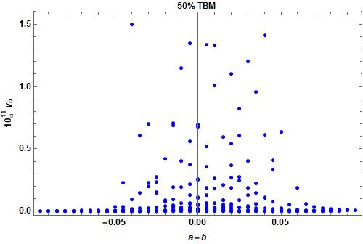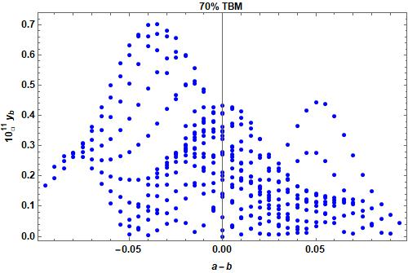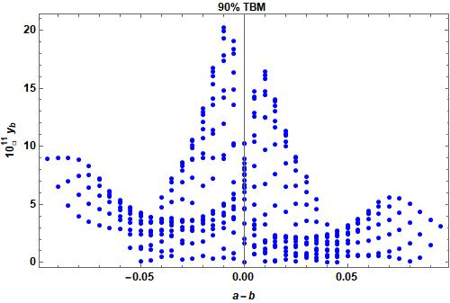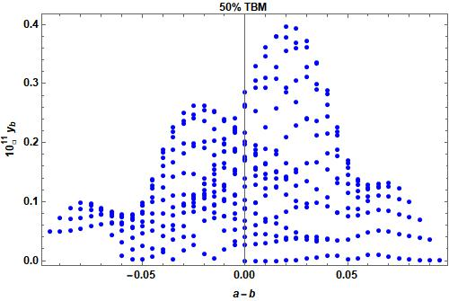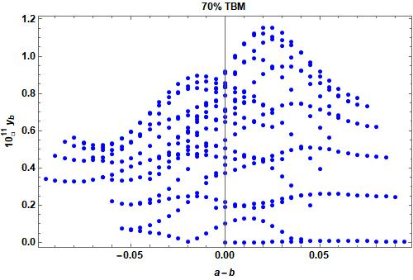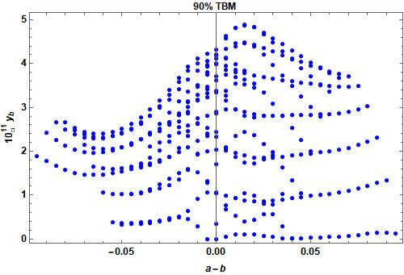

Fig1:Baryon asymmetry with the variation of parameter a-b

- Results and Conclusion

In this work without considering pure type I or pure type II seesaw, we consider numerical factor Z to be 0.50, 0.70 and 0.90 corresponding to $50\%$ type I contribution, $70\%$ type I –and $30\%$type II contribution and $90\%$type I contribution respectively. We consider type II seesaw mass matrix as hybrid textures given by [17-20]. In this work we choose only A1 structure of hybrid textures. We then compute the baryon asymmetry through leptogenesis due to the lightest right-handed neutrino decay by taking both type I and type II seesaw contributions into account. Using some specific values of leptonic CP phases, we constrain the Dirac and two Majorana phases by demanding correct baryon asymmetry. The allowed regions of parameter space in terms of the three leptonic phases are shown in the figure 1 for two flavor regime of leptogenesis. We have shown only few plots of leptogenesis in fig 1. From the above figures we observe in most of the cases close values are obtained. If we take more contributions from type I seesaw matrix that will give us more accurate result. The above results of baryon asymmetry constraint the values of parameters a and b in hybrid texture and we can make specified hybrid texture neutrino model based on above results. We can also give a specific value of lightest neutrino mass from above results. In future work we will try to study all the different hybrid model of neutrino mass matrix. We will try to choose the value of different lightest neutrino mass in future along with hybrid texture matrix to get correct baryon asymmetry and neutrino parameters. In this work we have not consider Majorana phases but we will try to study Majorana effects in future.

Currently ongoing Neutrino less double beta decay experiments might be able to expose the nature of neutrino masses. In future work it will be very interesting to constrain the Majorana CP phases further by computing other observables like neutrinoless double beta decay lifetime by taking contributions from multiple seesaw mechanisms operating at TeV scale or above and then taking the experimental bounds.

Acknowledgement

I would like to thank Dr. Debasish Borah from IIT Guwahati for useful discussion regarding this work and also my deep gratitude towards Dr. Mrinal Kumar Das from Tezpur University for giving some valuable time to discuss about this work.

References

- S. Fukuda, et al. “Constraints on neutrino oscillations using 1258 days of super-kamokande solar neutrino data”. Phys. Rev. Lett. 86, 5656-5660 (2001).

- Q.R. Ahmad, et al. “Direct evidence for neutrino flavor transformation from neutral current interactions in SNO,” Phys. Rev. Lett. 89, 011301 (2002).
- Ahmed, Q. R. Ahmad, et al. “Measurement f day and night neutrino energy spectra at SNO,” Phys. Rev. Lett. 89, 011302 (2002).
- J.N. Bahcall, et al. “Solar modes and solar neutrino oscillations,” New J. Phys. 6, 63 (2004).
- K. Nakamura et al. “ Review of particle physics,” Nucl. and part. Phys 37, 075021 (2010).
- K. Abe, et al. “Indication of electron neutrino appearance from an accelerator produced off-axis muon neutrino beam”, Phys. Rev. Lett. 107, 041801 (2011).
- Y. Abe, et al. “ Indication for the disappearance of reactor electron antineutrinos in the double chooz experiment,” Phys. Rev. Lett. 108, 13180 (2012).
- F.P. An, et al. “Observation of electron antineutrino disappearance in the daya bay experiment,” Phys. Rev. Lett. 108, 171803 (2012) .
- J.K. Ahn, et al. “Observation of reactor electron antineutrino disappearance in the RENO Experiment,” Phys. Rev. Lett. 108, 191802 (2012) .
- P.F. de Salas, P.F., et al.. “Status of neutrino oscillations 2018,” Phys. Rev. D98, 030001( 2018).
- I. Esteban, et al., “ Global analysis of three flavor neutrino oscialltion,” JHEP 01 106 (2019).
- N. Aghanim, et al. “Planck 2018 results. VI.” HEP 01, 106 (2019).
- , R.N. Mohapatra, et al.“ Neutrino mass and spontaneous parity violation ,” Phys. Rev. Lett 44, 912(1980).
- D.Borah, et al. “ Derivations from tribimaximal neutrino mixing using type II seesaw,” Nucl. Phys. B876, 575 (2013).
- R. N. Mohapatra and W. Rodejohann, Phys. Lett. B 644, 59 (2007).
- R. Kalita, D. Borah and M.K. Das , Nucl. Phys. B894, 307 (2015).
- S. Kaneko, H. Sawanaka and M. Tanimoto, JHEP 0508, 073 (2005);
- S. Dev, S. Verma and S. Gupta, Phys. Lett. B687, 53 (2010);
- S. Goswami, S. Khan and A. Watanabe, Phys. Lett.B693, 249 (2010).
- R. Kalita and D. Borah, Int. J. Mod. Phys. A31, 1650008 (2016).

