LI-FI BASED DATA TRANSMISSION SYSTEM
¹B Siva Kumar Reddy , ² G.Sainath^{, 3}G Sriram ,⁴K Parameshwari, ⁵K Poojitha,
Professor, Dept ,of ECE, student, Dept of ECE,
CMR Engineering College, Hyderabad CMR Engineering College, Hyderabad,
Telangana-501401, India Telangana-501401, India
Bsivakumar100@gmail.com gosikondasriram7@gmail.com

ABSTRACT
Communication is essential in now a day to day life.In present world people are using more Wireless and cable communication . We have two primary types of exchange. Wireless communication outperforms cable communication most of the time. Li-Fi is the upcoming, growing technology acting as competent for various other developing and invented technologiesLi-Fi stands for Light Fidelity. Li-Fi is a form of networking that avoids radio waves in favour of a pure spectrum.This notion was introduced in a TED(Technology, Entertainment and Design) Global Talk by German researcher Harald Haas in 2011. Li-Fi (Light Fidelity) uses the visible light band of the electromagnetic wave spectrum. Since it is ten thousand times larger than the RF (Radio Frequency) band, this band cannot be overcrowded. Light waves can be altered to concurrently hold large quantities of data when traveling at very high speeds. Li-Fi enables data transfer that is a hundred times quicker than Wi-Fi (Wireless Fidelity). This System has regulated the speed which human eye has not be perceived its blinking. At receiver by applying photosensitive detector, transmitted data can be received.
Key words: LED(light emitting diode),TED(Technology entertainment and design), LDR(Light dependent resistor) ,wi-fi(wireless fidelity).

- INTRODUCTION
A wireless system of communication known as Li-Fi . Uses light to send information and coordinates between devices. In 2011, Harald Haas first utilized the phrase in his Edinburgh TEDGlobal talk.Li fi is a light-based communication technology that has a high data transmission rate .many analysts anticipate a rise toward li fi in residential settings because it has the potential for faster speeds and offers security advantages owing to the way the technology runs .[1]. Because light transmits data,the network can de limited to a single physical room or building ,reducing the chance of a remote network attack the emergence of home automation,which demands the transmission of large amounts of data[2].our current world is made up of countless invisible, networked passageways that connect everything. They traverse residences, cities, nations, even continents. In the present generation the people are using the smartphone day to day life of the world are getting more in the network so the people are suffering in low speed data transfer so for the problem we using the li-fi .[3],[4].The world has advanced and adopted technology at an almost exponential rate, enabling us to carry highly sophisticated microcomputers in our pockets. Most of these gadget have wireless connections to internet service providers, who then have connections to the World Wide Web.[5]. Li-fi is a sort of wireless technology that uses visible light to enable quick data transmission between two Arduinos. Li-fi is comparable to wi-fi as its optical equivalent because it transmits by visible light rather than radio waves. Light emitting diode can be used for data transfer.[6].A LED bulb is used to send the high speed data. Li-Fi transmits data by using visible light as a communication medium. The photodiode serves as a transceiver that receives and transmits light signals, and an LED can work as a light source.[7]. we can communicate specific data patterns by managing the light pulse on the transmitter side. The human eye is unable to observe this event because it happens at such a rapid rate. [8].The data is then transformed into meaningful information at the receiver side by the photodiode or light dependent resistor (LDR)[9].

Li fi is a light-based communication technology that has a high data transmission rate. many analysts anticipate a rise toward li fi in residential settings because it has the potential for faster speeds and offers security advantages owing to the way the technology runs.[1]Because light transmits data, the network can be limited to a single physical room or building, reducing the chance of a remote network attack the emergence of home automation, which demands the transmission of large amounts of data.[2]our current world is made up of countless invisible, networked passageways that connect everything. They traverse residences, cities, nations, even continents.In the present generation the people are using the smartphone day to day life of the world are getting more in the network so the people are suffering in low-speed data transfer so for the problem we using the li-fi.[3]The world has advanced and adopted technology at an almost exponential rate, enabling us to carry highly sophisticated microcomputers in our pockets.[4]Most of these gadgets have wireless connections to internet service providers, who then have connections to the World Wide Web.[5]Li-fi is a sort of wireless technology that uses visible light to enable quick data transmission between two Arduinos. Li-fi is comparable to wi-fi as its optical equivalent because it transmits by visible light rather than radio waves. Light emitting diode(LED) can be used for data transfer.[6]
A LED bulb is used to send the high-speed data. Li-Fi transmits data by using visible light as a communication medium. The photodiode serves as a transceiver that receives and transmits light signals, and an LED can work as a light source.[7]we can communicate specific data patterns by managing the light pulse on the transmitter side. The human eye is unable to observe this event because it happens at such a rapid rate.[8] The data is then transformed into meaningful information at the receiver side by the photodiode or light dependent resistor (LDR).
Li-Fi is still a relatively new technology, but it has the potential to revolutionize wireless communications. It is already being used in a number of applications, such as:
- Museums: Li-Fi can be used to provide wireless internet access to visitors without the need for Wi-Fi hotspots.
- Factory automation: Li-Fi can be used to transmit data between machines in factories, which can improve efficiency and productivity.
- Healthcare: Li-Fi can be used to transmit medical data between devices, which can improve patient care.[10].
[11].As Li-Fi technology continues to develop, it is likely to be used in a wider range of applications. It has the potential to become a major force in the wireless communications market.
• Museums: Li-Fi can be used to provide wireless internet access to visitors without the need for Wi-Fi hotspots.[9]
• Factory automation: Li-Fi can be used to transmit data between machines in factories, which can improve efficiency and productivity.
• Healthcare: Li-Fi can be used to transmit medical data between devices, which can improve patient care.[10].
As Li-Fi technology continues to develop, it is likely to be used in a wider range of applications. It has the potential to become a major force in the wireless communications market.[11]
Here are they some additional details about Li-Fi data transmission system:
• The data is transmitted in the form of light pulses.
• The light pulses are modulated using a technique called on-off keying (OOK).
• The receiver decodes the light pulses and reconstructs the original data signal.
• Li-Fi can be used in a variety of environments, including indoor and outdoor environments.
• Li-Fi is a secure communication technology because it is difficult to intercept light signals.
• Li-Fi is a low-power communication technology, which means that it can be used to power devices that are battery-powered.[12]
In this research, the wireless data transmission using the Li-Fi technology, with a Arduino it acting as the transmitter and using the LED light to deliver data . Furthermore, it makes use of the ambient light sensor. At the receiver,which encourages us to investigate a LED to LED communication system based on the li-fi.[13].

Li-Fi is a form of networking that avoids radio waves in favour of a pure spectrum. Li-Fi is powered by visible laser light, whereas Wi-Fi runs on radio waves. It has a photodetector for capturing light signals and a data processing component for converting the data into accessible content, in other words.
Data will be converted to binary bits in the form of ones and zeroes, which are similar to the states “off” and “on”, in a digital communication system. Visible light is an electromagnetic wave that passes at high speeds and has an infinite bandwidth. Human eyes are unable to observe high-speed switching of light, but very sensitive photodiodes are capable of identifying how the light reacts with the detectors.
The visible spectrum has 1,000 times more bandwidth than radio waves that are used in usual wireless systems, which makes it one of the most effective solutions for applications that require massive amounts of data. Li-Fi technology is a quick, full-duplex, and both directional communication system capable of data rates up to 224 GB per second.

The motivation behind developing a Li-Fi based data transmission system
The technology’s main purpose is to use light to communicate data. You might be curious about its advantages and whether it is any better than current wireless and cellular connections. What follows may be of interest to you.
- High-Speed Wireless Connections: Li-fi technology is one of the best options for high-speed data transfer in small locations. It offers various advantages over cellular and Wi-Fi technology. For instance, it frequently has a bigger bandwidth and is simpler to use. Additionally, it is quite effective and safe. You'll find that Li-fi technology offers rates that are 100 times faster than those provided by Wi-Fi. Since light is the basis of this technology, you are already aware of its speed
- Highly Efficient :The efficiency that Li-Fi offers is another advantage that you might wish to take into account. Other connections require significant energy expenditures at various points. Li-Fi, on the other hand, uses far less energy and is quite energy-efficient. The VLC systems are used in this technology. These in turn rely on LED lamps with a great energy efficiency. As a result, you will experience dramatically reduced energy use. Additionally, the technology only calls for LED lights. And as you may already be aware, nearly every home and business have an LED light someplace. You won't have to pay installation fees, which equates to significant savings.
- Li-Fi Technology Offers Unbeatable Security:When it comes to data transmission and networking, security is among the most crucial factors to take into account. How Li-Fi can sustain secure connections in a world with more than 14 billion light bulbs may be a mystery to you. It becomes incredibly accessible this way, but doesn't that also risk security? Thankfully, it doesn't. The Li-Fi technology is quite safe. Opaque walls are one thing that life cannot break through. This means that the light will be contained inside the room and won't escape it as long as you are in an area with opaque walls. Additionally, it signifies that the connection will only be possible in the area where the light is present or shines. Aside from the security measures already in place for current internet
- Great Alternative to Wi-Fi and Cellular Technologies:If you want to increase connectivity, decrease downtime, and increase productivity, think about Li-Fi technology. Since Li-Fi doesn't rely on complex systems like cellular and Wi-Fi, it can keep you connected when other technologies can't. This is an excellent way to alter how you use the internet. It is easy to understand why Li-Fi would be the obvious choice if you had to select between speed, dependability, simplicity, efficiency, and low cost.
- Cost:There are occasions when you have to run over a mile of cable to get an internet connection in a room or building. This is not at all affordable. Li-Fi is independent of cables. To instantly communicate data, just beam an LED-powered link in the direction of your target. This is accomplished via a point-to-point array, one of Li-Fi's most amazing characteristics. It enables connections to be made between office buildings without adding more cables or spending money on infrastructure. All you require is a source of light.
- No Interference:Wi-Fi and other radio frequency-dependent technologies are susceptible to interference from several other devices. Microwaves, cordless phones, and other Wi-Fi networks are examples of this. On the other hand, the area of illumination defines Li-fi signals. This implies that avoiding interference or completely ceasing it is fairly straightforward. With the aid of such capabilities, Li-Fi can be used in places where RF is prohibited or unfriendly, such as power plants, hospitals, and aircraft.
- High Data Density:Additionally, Li-Fi solves this issue. Because of this, it provides a considerably better user experience. Li-Fi can achieve nearly a thousand times the data density of Wi-Fi. Any Wi-Fi connection cannot deliver this amount of data per square meter. When it comes to wireless efficiency, data density is one of the most important factors to take into account.
- Limitless Applications:Li-Fi allows you to connect to the internet in locations that were previously unimaginable. It can be applied to industrial operations, aircraft, transportation, safety and traffic management on roads, underwater communication, and establishing links in hazardous areas. Li-Fi technology is becoming increasingly popular because of its cutting-edgefeatures. It can be viewed on a variety of platforms, including laptops, smartphones, and other smart devices. Li-Fi connections rely on visible light technology, as was previously mentioned. Around the world, LED bulbs are already present in the vast majority of homes. This means that data transmission only requires the utilization of those same light sources. Li-Fi is hence very useful and effective. Where there is a source of light, there is a potential for internet.

Li-Fi Technology:
Bidirectional communication using visible light is the basis of the li-fi technology the basis of the Li-Fi technology. The infrastructure for such technology is already in place, allowing for the simultaneous use of lighting and communication from the same light source. Li-Fi can be thought of as an optical counterpart of Wi-Fi, as it transmits data using visible light rather than radio waves.
A comparison between Wi-Fi and Li-Fi technologies is necessary to understand the key distinctions between them in order to demonstrate the validity of Li-Fi. Therefore, based on research done in Li-Fi, it has many excellent advantages over Wi-Fi technology, including the ability to achieve high data rates. Additionally, Li-Fi uses less energy, is more effective, and has a global availability of light sources, whereas radio waves cannot be used in all environments, especially in airplanes, chemical and power plants, and hospitals because they seriously impair both people and the equipment they are connected to. Since light sources are already established, Li-fi technology doesn't require any additional infrastructure. Additionally, since light can't lie, Li-Fi might be the future of safe wireless communication.
Li-fi is a promising technology for secure ,scalable, and energy-efficient wireless communication .it is well positioned to become the dominant wireless communication technology of the future .
- Security: Li-Fi uses light to transmit data, and light cannot penetrate walls. This makes it much more difficult for hackersto intercept Li-Fi signals than Wi-Fi signals, which can be easily hacked.
- Scalability: Li-Fi is much more scalable than Wi-Fi. This is because Li-Fi uses a wider bandwidth than Wi-Fi, and it can support a much larger number of devices.
- Energy efficiency: Li-Fi is more energy efficient than Wi-Fi. This is because Li-Fi uses light, which is a more efficient form of energy than radio waves..

II.SYSTEM MODEL
The system model is shown in Figure 1, the purpose of each block is as follows
Data Encoder: The data encoder converts the data from the data source into a format that can be transmitted over Li-Fi. Thistypically involves encoding the data into a series of light pulses
LED Driver: The LED driver controls the intensity of the LED light source. This is used to modulate the light pulses so that they can be decoded by the receiver.
LED Lamp: The LED lamp is the physical medium that is used to transmit the data. The LED lamp is modulated by the LED driver to produce a series of light pulses that represent the data.
Photodiode: The photodiode is a sensor that converts light into an electrical signal. The photodiode is used to decode the light pulses from the LED lamp and recover the original data.
Data Decoder: The data decoder converts the electrical signal from the photodiode back into the original data format.
Data Destination: The data destination is the device that receives the data. This can be a computer, a smartphone, or any other device that can process the data.
Arduino:a single Arduino board is used for the power supply unit for the transmission and receiving system .
This is just a basic block diagram of a Li-Fi based data transmission system. There are many different variations of this system, depending on the specific application. For example, some systems may use multiple LED lamps to increase the data transmission rate. Others may use a different modulation scheme to improve the performance of the system.

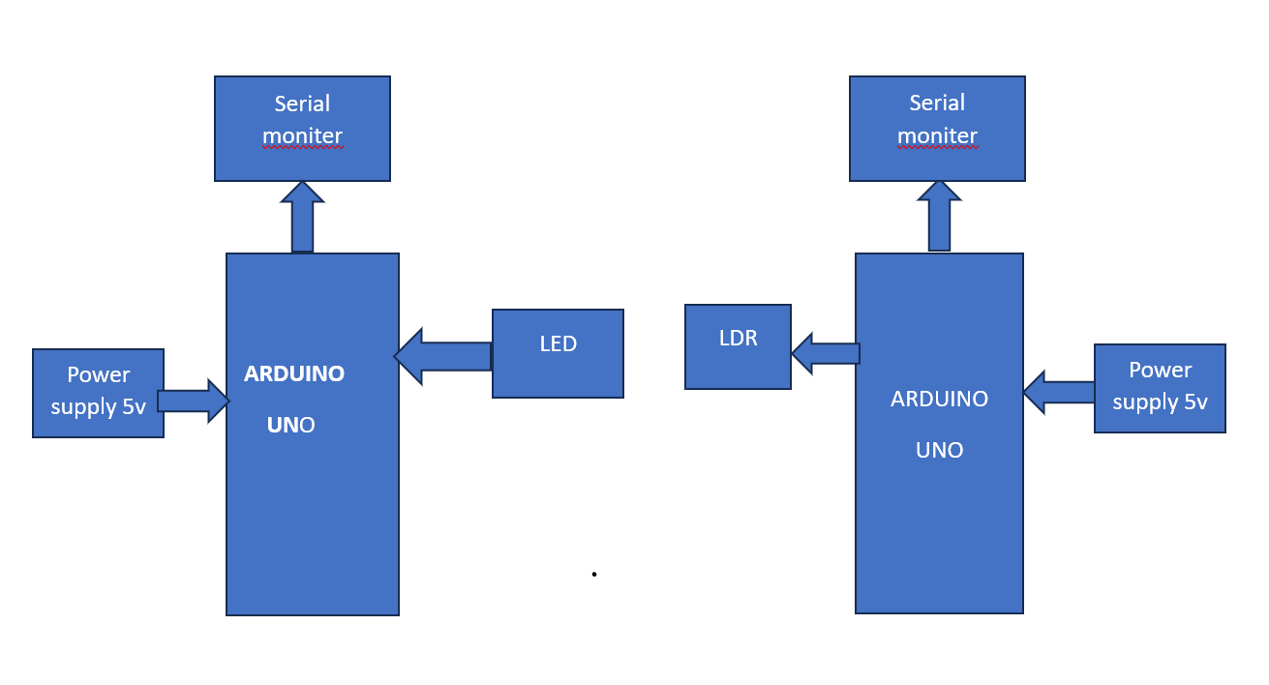

Fig1 [Block diagram]

The circuit diagram shown in Figure 2 in detail how the components of the system are connected for data transmission.
A single Arduino board is used to serve as the power supply unit for the transmitting and receiving system.Ardunio is a small micro controller board with a USB plug to connect to your computer and other number of jumper wires are to the external electronics. They can be either powered through USB connection from the computer or a 9V battery.
The Arduino uno is a microcontroller board based on the ATmega328.the microcontroller has 14 digital input/output pins .
(6 pins are used for the PWM output ),6 analog inputs and 16 MHZ external crystal oscillator. The most of 8-bit AVR boards run an instruction per seconds.the Arduino runs about 16 Mega instructions per second (MIPS). The
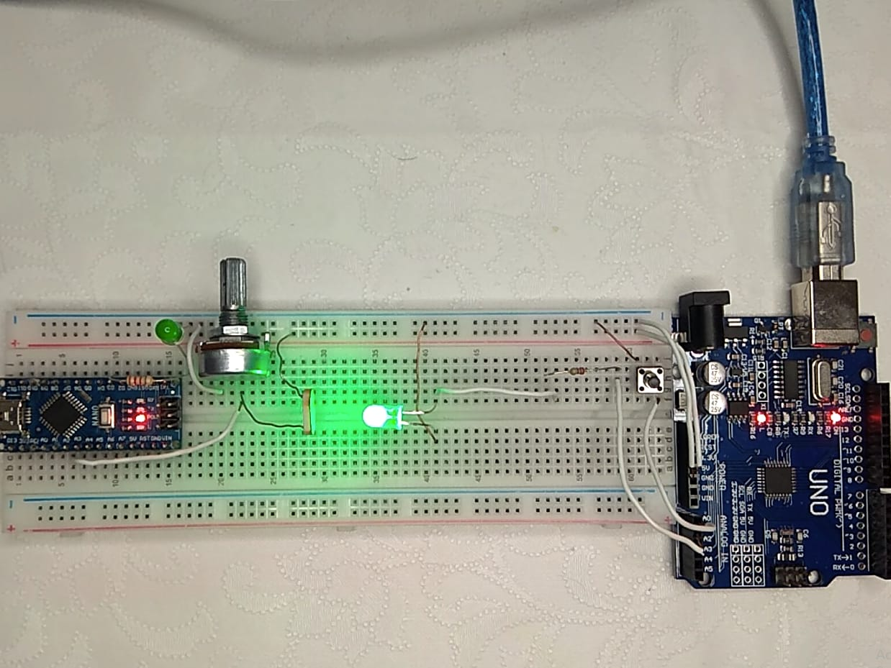
Fig2[circuit diagram]

III.RESULT & DISCUSSIONS
In this image [figure3] we can see the transmission data and recivied data from the Arduino .the lifi is used to transmission the data by led aand reivied by the LDR. The transmission is hello . then the output Data will be converted to binary bits in the form of ones and zeroes, which are similar to the states “off” and “on”, in a digital communication system

High Data transport Rate: According to our tests, Li-fi technology can transport data at rates that are noticeably higher than those of conventional Wi-Fi in perfect circumstances. Li-fi technology was able to produce speeds that were consistently higher than 1 Gbps, making it appropriate for applications needing huge data transfers.

Low Latency: Li-fi showed exceptionally low latency, allowing for real-time communication. This qualifies it for applications that require low latency, like video streaming, online gaming, and augmented reality/virtual reality (AR/VR).
restricted Line-of-Sight and Range Requirement Li-fi's dependency on direct line-of-sight communication is one of its drawbacks. The effective range of the device was limited to a specific area, and any blockage between the LED transmitter and photodetector interfered with the signal. The line-of-sight need can be reduced, though, by strategically positioning numerous light sources and receivers.
Immunity to Radio Frequency Interference: Because Li-fi employs light waves for communication instead of radio waves, it is immune to radio frequency interference. Due to this property, Li-fi systems can function dependably in places with significant electromagnetic interference, such as medical facilities, airlines, and commercial settings.

Li-fi has built-in security benefits since light waves, as opposed to radio waves, cannot pass through walls. This is because light waves are used in the technology. As a result, the system's overall security is improved because it is harder for unauthorized users to intercept or eavesdrop on data exchanges.

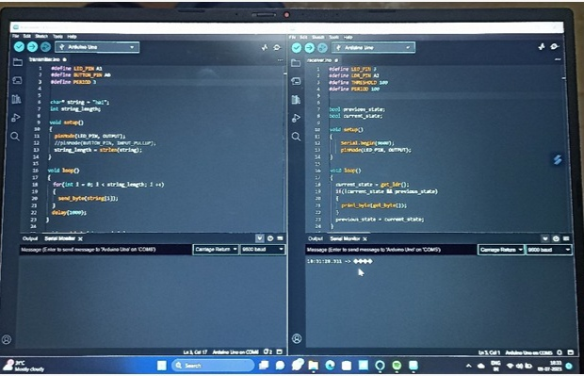

Fig:3[OUTPUT WINDOW]

IV.CONCLUSION
Li-fi data transmission system model based on the development of data security will the data is transmitted to receiver part .the operator will sign in the relevant application when the access is permitted to system .the perfromance of the li-fi system is determined by their ability and their performance .the li-fi system is mainly used for less wireless and it is used the more light source and it is very useful to high security data transmission also in future we can used more light source for data transmission it is helpful to as. By using the LED and LDR we not using any wire for connection between the transmission data and reciveringdata.

PROPOSED SYSTEM DESIGN
The proposed system is composed of two parts: the transmitter part and the receiver part. The transmitter part contains a light source, which is an LED flash of the built-in smartphone camera that is used to transmit data, and the receiver part is composed of a light detector sensor that is used to detect the light signal and convert it to original data.
The suggested model first explores how the smartphone's embedded light sensor can be used to construct a VLC-based smartphone-to-phone communication system, then determines whether the data rate achieved by this sort of communication is approved by the projected Li-Fi efficiency. Afterwards, the external light sensor was investigated to show how to enhance the data bit rate

FUTURE SCOPE:

Challenges and Future Considerations:

Standardization: Establishing industry-wide standards for Li-Fi is crucial to ensure interoperability and compatibility among different vendors and devices. Standardization efforts need to address issues related to data transfer protocols, network management, and security.

Interference and Line-of-Sight Limitations: Li-Fi heavily relies on direct line-of-sight communication, which can be hindered by obstacles. Future research should focus on developing robust signal processing algorithms and exploring non-line-of-sight solutions to overcome these limitations.

Security and Privacy: As Li-Fi signals can be easily confined to a specific area, the technology offers inherent security benefits. However, it is vital to develop robust encryption techniques and address potential vulnerabilities to ensure the privacy and integrity of Li-Fi-based communication systems

Over view :The future scope of Li-Fi-based communication systems holds immense potential for transforming the way we communicate and connect. With ongoing advancements and research efforts, Li-Fi is poised to offer faster and more secure wireless communication, enabling innovative applications in various domains. However, addressing the existing challenges and establishing standardized frameworks will be critical to realizing the full potential of Li-Fi technology in the future

V.REFERENCES

[1]Mugunthan, Dr SR. "Concept of Li-Fi on smart communication between vehicles and traffic signals." Journal of Ubiquitous Computing and Communication Technologies 2.2 (2020): 59-69.
[2] Lee, Carlos. "Light spark: As part of new series of articles on entrepreneurship, Carlos Lee, director general of the European Photonics Industry Consortium, speaks to pureLi-Fi founder Professor Harald Haas, who demonstrated and coined'Li-Fi'during a TEDGlobal talk in 2011 in Edinburgh." Electro Optics 292 (2019): 14-16.
[3]Luvizon, D. C., Carvalho, G. S. P., dos Santos, A. A., Conceicao, J. S., Flores-Campana, J. L., Decker, L. G., ... & Penatti, O. A. (2021). Adaptive multiplane image generation from a single internet picture. In Proceedings of the IEEE/CVF Winter Conference on Applications of Computer Vision (pp. 2556-2565).
[4] Walter, X.A., Greenman, J. and Ieropoulos, I.A., 2020. Microbial fuel cells directly powering a microcomputer. Journal of Power Sources, 446, p.227328.
[5] Fan W, Ma Y, Li Q, He Y, Zhao E, Tang J, Yin D. Graph neural networks for social recommendation. InThe world wide web conference 2019 May 13 (pp. 417-426).
[6]Cheung, Kelvin Pak Shing, Sumon Sarkar, and Vladimir Gevorgyan. "Visible light-induced transition metal catalysis." Chemical Reviews 122, no. 2 (2021): 1543-1625.
[7] Alqahtani, Jaber S., et al. "Prevalence, severity and mortality associated with COPD and smoking in patients with COVID-19: a rapid systematic review and meta-analysis." PloS one 15.5 (2020): e0233147.
[8] Schweibenz, Werner. "The virtual museum: an overview of its origins, concepts, and terminology." The Museum Review 4.1 (2019): 1-29.
[9] Schweibenz, W. (2019). The virtual museum: an overview of its origins, concepts, and terminology. The Museum Review, 4(1), 1-29.
[10] Dotoli, M., Fay, A., Miśkowicz, M., & Seatzu, C. (2019). An overview of current technologies and emerging trends in factory automation. International Journal of Production Research, 57(15-16), 5047-5067.
[11] Piran MJ, Suh DY. Learning-driven wireless communications, towards 6G. In2019 International Conference on Computing, Electronics & Communications Engineering (iCCECE) 2019 Aug 22 (pp. 219-224). IEEE.
[12] Matheus, Luiz Eduardo Mendes, et al. "Visible light communication: concepts, applications and challenges." IEEE Communications Surveys & Tutorials 21.4 (2019): 3204-3237.
[13]Michaels H, Rinderle M, Freitag R, Benesperi I, Edvinsson T, Socher R, Gagliardi A, Freitag M. Dye-sensitized solar cells under ambient light powering machine learning: towards autonomous smart sensors for the internet of things. Chemical Science. 2020;11(11):2895-906.

