5G TECHNOLOGY FOR HEALTHCARE: INCREASING THE EFFECTIVENESS OF HEALTHCARE
Divya Dwivedi¹
¹ Corresponding Author
Assistant Professor, Faculty of Pharmaceutical Sciences, Rama University, Kanpur

Abstract:
Health is a fundamental requirement. It is also a human right to receive quality health care. Because of limited resources, India is currently dealing with a slew of health issues.
Despite significant efforts, there are still significant challenges in providing healthcare services to an ageing population. Recent observations have raised concerns about rising healthcare costs, medical resource imbalances, inefficient healthcare system administration, and sinconvenient medical experiences. However, cutting-edge technologies, such as the Internet of Things (IoT), big data, artificial intelligence, and 5G wireless transmission technology, are being developed to meet these challenges in order to improve the patient experience and healthcare service quality while lowering total healthcare costs.

Introduction:
- Why smart healthcare matters-
Through the use of networks and smart devices (such as smartphones, smartwatches, wireless smart glucometers, and wireless blood pressure monitors), smart healthcare offers medical services (e.g., Body area network, wireless local area network, extensive area network) [1]. The smart devices analyse health data obtained from a variety of sources, including sensors and biological systems (i.e., the application having information about medical science such as diagnosis, treatment, and prevention of disease). In short, smart healthcare enables individuals from various backgrounds and spheres of society (such as physicians, nurses, patient caregivers, family members, and patients to access the appropriate information and find the appropriate solutions, which are primarily to reduce medical errors, increase efficiency, and cut costs when necessary [2].

- IoT: what is it?
There are various definitions of IoT; however, according to the IoT European Research Cluster (IECR) project definition, IoT is a dynamic network infrastructure with the potential to self-configure on the basis of open and standardized communication protocols [3]. Alternatively stated, IoT is a flexible, intricate, and dynamic network infrastructure that connects anybody, anything, anytime, anyplace, for any services. The internet of things has several uses in the healthcare industry, including remote monitoring, smart sensors, and medical device integration [4]. The synthesis of sensors and sensor-based systems with device-to-device (D2D) connections is currently on the rise. IoT is taking centre stage as devices are anticipated to make up a sizable component of this 5G network paradigm, which will usher in the era of 5G wireless systems (5G) [5]. However, technology is still advancing. While managing data from diverse sources is one of the problems of IoT in healthcare, the future of IoT applications in healthcare will depend on gaining insightful knowledge from obtained data [3].

Objectives for Smart Healthcare [6]-
Objective-1 | Optimization of resources | Techniques for resource optimization are utilised to maximise network longevity while minimizing energy consumption. Numerous network problems can result from improper resource optimization.
Objective-2 | Enhancing QoS | The term quality of service (QoS) describes a network's capacity to manage high bandwidth and other network performance metrics including error rate, latency, and uptime. Networks with low latency, dedicated bandwidth, controlled jitter, and improved loss characteristics should be given priority.
Objective-3 | Reducing interference | The smart healthcare system can leverage the notion of frequency reuse to achieve optimal resource usage.
Objective-4 | Enhancing energy efficiency | The network's energy consumption has increased as a result of the density of access points. Therefore, it is crucial for network operators to reduce a network's energy usage in order to lower operational costs. However, the capacity of batteries keeps growing, which is insufficient to meet consumer expectations. The lifespan of the devices placed in the network must therefore be increased by the use of energy-efficient techniques.

Features and Tools of 5G for Healthcare Practices:
To allow high-quality patient services, advanced healthcare practises look for appropriate and connected network facilities [7]. The various facets and key characteristics of 5G technology for medical practises are explored in Fig. 1 [6]. Wireless communications, quick and precise connective trends, virtual and augmented reality, remote surveillance, remote tracking, patient
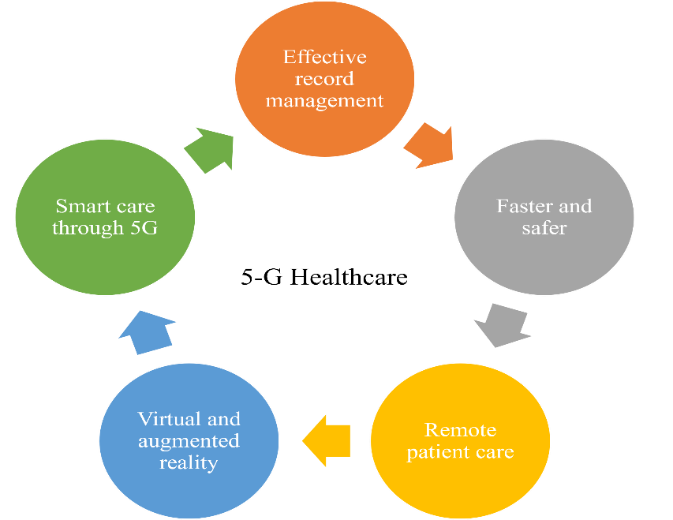
data support, and other characteristics and technologies all enable the 5G scenario for healthcare operations. Additional improvements in healthcare practices are made possible by 5G technology [8].

Fig-1 Features and tools of 5G for healthcare practices [6]

Healthcare practitioners can now treat patients who are chronically ill in real time over the fastest network available thanks to 5G. Using trustworthy, always-on mobile personal emergency response systems, patients with chronic illnesses can keep their independence and improve outcomes [9]. As technology develops, more medical gadgets will be accessible to patients, enabling them to test and monitor their health from the convenience of their homes. This medical technology collects, calibrates, and verifies data from reliable sensors [10]. A variety of medical and healthcare specialists can then receive this data for study. Clinicians can provide patients with a complete health picture and a personalized treatment plan by integrating many patients Internet of Medical Things (IoMT) devices and sensors [11].

Serviceable Pillars of 5G for Health care [12]:
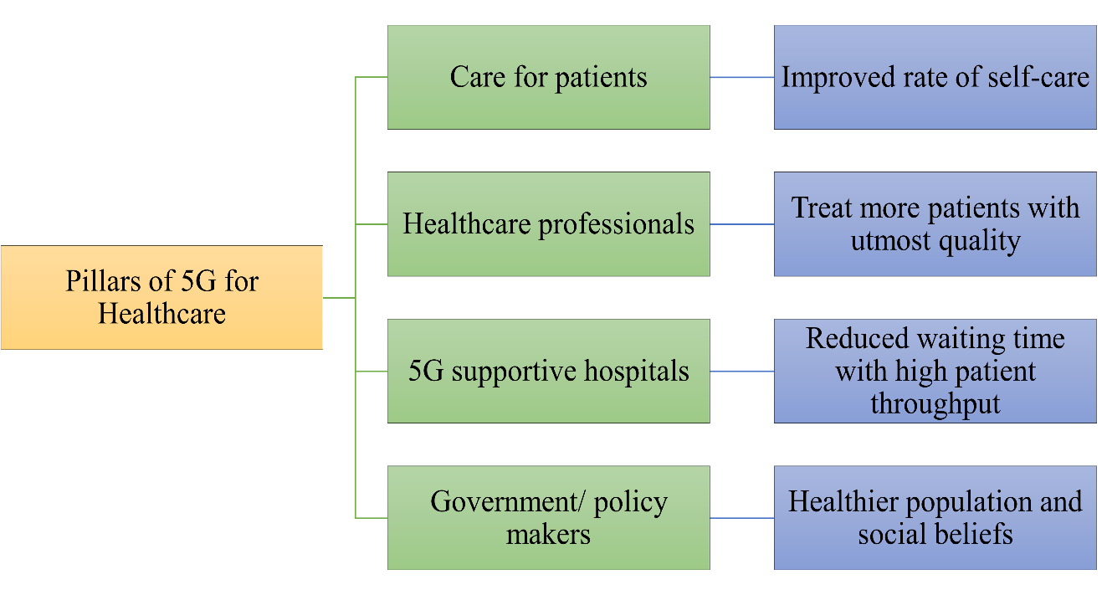
Existing Survey on Smart Healthcare:
For the IoT in Healthcare and the prediction of various sorts of diseases using various methodologies, a number of researchers have put forth several models. The work done in the same area is the emphasis of this section [13].
Ahn et al | A classic example of the use of IoT in healthcare is the implementation of a system for measuring physiological signals in sitting position such as ECG and BCG by using a smart chair that senses the non-constrained bio-signals and can be monitored using a monitoring system like the one they had developed.
Almotiri et al. | A system for m-health that uses mobile devices to gather real-time data from patients and store it on network servers connected to the internet, allowing access to only specific clients, has been proposed. Several wearable gadgets and a body sensor network are used to collect this data, which can then be used to help doctors diagnose patients.
Barger et al. | A prototype of the same smart home facility is also being tested. It uses a sensor network to detect and monitor the patient's movements inside the home. Their main goal in their study is to determine whether their system can outsmart behavioral patterns, and they have talked about this in their work.
Chiuchisan et al. | provided a framework to stop patient hazards in intelligent ICUs. The suggested method alerts the patient's loved ones, the patient's doctors, and anybody else who needs to know about any discrepancies in the patient's health, their bodily movements, or the environment of the room so that the appropriate safety precautions can be taken.
Dwivedi et al | Electronic Patient Record (EPR) systems have established a framework to secure the clinical data that must be communicated over the internet. They suggest a multi-layered healthcare information system architecture that combines Public Key Infrastructure, Smartcard, and Biometrics technologies.
Gupta et al. | developed a model that uses a Raspberry Pi to measure and record ECG and other important patient health indicators. This model might be very useful for hospitals, patients, and patients' families.
Gupta et al. | Present a method that uses the Intel Galeleo development board to gather various data, upload it to a database where it can be used by doctors, and lessens the discomfort patients have from having to visit the hospital each time they want to check their health parameters.
Lopes et al. | For the purpose of researching and identifying IoT solutions in the healthcare sector that can help disabled persons and their community, an IoT framework has been developed. To explore the most recent IoT technology and their applications, which can be utilized primarily for the disabled, they chose two use cases.
Nagavelli and Rao | an unique statistical methodology known as the degree of disease probability threshold was established to forecast the severity of the illness from the patient's medical information. They have also updated an algorithm that is mostly required to calculate the hyperlink weight of websites in order to achieve their goal.
Sahoo et al. | examined the healthcare management system and the substantial amount of patient data produced by numerous reports. To forecast the patient's or subject's future health issues, they further assessed the health parameters. They employ the utilization of probability to accomplish the same using a cloud-based big data analytics platform.
Tyagi et al. | analysed the role of IoT in healthcare, looked into its technical aspects to make it a reality, and identified the opportunities for which they proposed a cloud-based conceptual framework in which the patients' medical data and information can be securely transferred, with the patient's and their family's permission, by creating a network between the patient, hospital, doctors, Labs, etc. The main motivation behind this is to free patients from the costly clinical assistance, resolve the doctor shortage, and ultimately improve patient care and service.
Xu et al | a data model for storing and utilising IoT data was described. To gather and publish IoT data globally so that it may be accessible from anywhere at any time, they built and created a resource-based Ubiquitous Data accessing mechanism. Additionally, they demonstrate an IoT-based emergency medical service as well as how to gather and utilise IoT data across several platforms.
Qi et al. | The author of this review looked at several IoT applications in smart healthcare from diverse angles (i.e., Blood pressure monitoring, monitoring of oxygen saturation, heartbeat monitoring et.). The author also analyses current IoT work that supports technology for smart healthcare applications.
Islam et al. | The author of this review concentrated on Internet of Things (IoT) technologies and the current architecture for healthcare networks and platforms that provide access to the IoT backbone and enable the receiving and transmission of medical data. The study also provides specific examples of how the IoT might help with pediatric, geriatric, and chronic disease supervision, as well as fitness management.
Baker et al. | In this review, the author introduced a fresh framework for a future smart healthcare system that may be applied to both specialized (e.g., monitoring of unique conditions) and general systems. In addition, the author provided an overview of recent developments in the field of the component of the models that was presented (i.e., wearables and non-intrusive sensors that monitor vital signs such as blood pressure and blood oxygen levels).
Mahmoud et al. | In this article, the author conducted a survey on platforms for the Cloud of Things (CoT) and how to use it in applications for smart healthcare.

Schematic drawing illustrating applications of 5G technology in healthcare. VR, virtual reality.
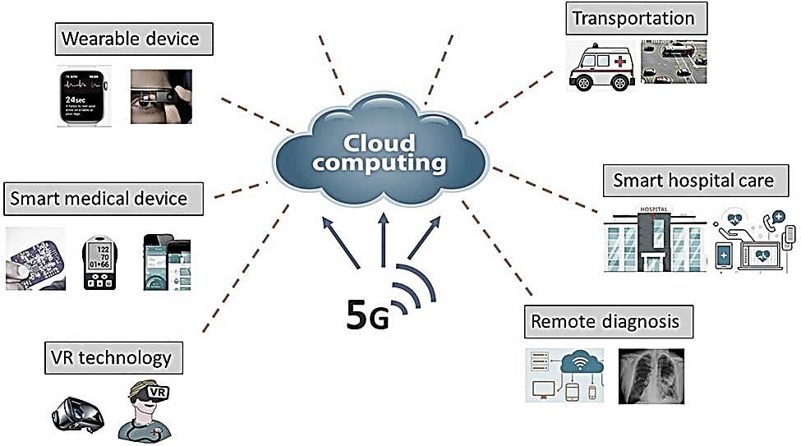
Fig-2 5G Technology Application for Healthcare [13]

Challenges of 5G [14]:
Availability | The 5G network will only considerably benefit urban areas, while coverage in rural areas may only last a few years.
Cost | Compared to other networks, building tower stations comes at a hefty price.
Weather | Rain can potentially affect 5G coverage, necessitating additional security.
Cellular devices | The battery life of a phone that has a 5G connection will be drastically reduced.
Cybersecurity | 5G-capable devices are also an easier target for cyberattacks and data theft due to the lack of encryption during connection.

APPLICATION OF 5G TECHNOLOGY FOR HEALTHCARE:
5G technology has the potential to revolutionize the healthcare industry by increasing the effectiveness of healthcare in various ways [15]. Here are some key applications of 5G technology in healthcare:
- Telemedicine and Remote Care: 5G's high-speed and low-latency capabilities enable real-time, high-definition video conferencing and data transmission. This facilitates seamless telemedicine consultations, remote monitoring of patients, and virtual care programs. Doctors can diagnose and treat patients in remote areas, reducing the need for physical visits and improving access to healthcare [16].

- Remote Surgery and Robotic Assisted Procedures: 5G's low latency is crucial in surgical procedures that require precise, real-time control. Surgeons can perform remote surgeries using robotic systems, which allows them to operate on patients from a distant location. This can be particularly beneficial for providing medical assistance in emergency situations and offering specialized care from experts who are not physically present [17].

- Internet of Medical Things (IoMT): 5G technology enables a vast network of interconnected medical devices and wearables, collectively known as the Internet of Medical Things. These devices can continuously monitor patients' vital signs, transmit data in real-time, and send alerts to healthcare providers in case of any anomalies. This proactive monitoring can lead to early detection of health issues and prompt interventions, reducing hospital admissions and healthcare costs [18].

- Enhanced Data Sharing and Collaboration: 5G facilitates secure and fast data exchange among healthcare providers, researchers, and institutions. This seamless data sharing improves collaboration, allowing for quicker access to patient records, test results, and research findings. It can also support medical professionals in making more informed decisions and delivering personalized treatments [19].

- Augmented Reality (AR) and Virtual Reality (VR) in Medical Training: 5G's high bandwidth and low latency enable realistic and immersive AR/VR experiences. Medical students and healthcare professionals can use AR/VR for training, simulations, and surgical rehearsals. These technologies enhance learning and skill development, ensuring that healthcare providers are better prepared for complex procedures and situations [20].

- Personalized Medicine and Genomics: With 5G, it becomes easier to process vast amounts of genetic data quickly. This helps in advancing personalized medicine by tailoring treatments based on an individual's genetic profile, increasing treatment efficacy and reducing adverse effects [21].

- AI-Enabled Healthcare: 5G's capabilities complement the use of artificial intelligence in healthcare. AI algorithms can analyze large datasets, such as medical images and patient records, to assist in diagnosis, treatment planning, and drug development. 5G's low latency ensures that AI-driven applications can deliver real-time insights to healthcare professionals [22].

- Mobile Health (m Health) Applications: 5G enhances the performance of mobile health applications, allowing patients to access healthcare resources, track their health conditions, and communicate with their healthcare providers more efficiently. This promotes patient engagement and proactive health management [23].

By incorporating 5G technology into various aspects of healthcare, the industry can experience significant advancements in efficiency, patient care, and outcomes. However, it's essential to address security and privacy concerns to ensure the safe and responsible adoption of these innovations [24].

Future Scope-
Future 5G technology will offer superior remote healthcare support while reducing patient exposure by doing away with in-person visits to doctors and medical facilities [26]. Patients who are unable to physically visit their doctors will be able to do so utilising 5G-enabled telepresence devices that feel natural. Therefore, a wireless network can deliver essential healthcare treatments to individuals who are restricted or chronically unwell [27]. The infrastructure of healthcare IT could be totally changed by 5G.A digital healthcare revolution will result from the increased viability of 5G technology. In order to remove any obstacles and prepare for a 5G future, healthcare organisations must evaluate their infrastructure and machinery [28]. Patient empowerment and home healthcare could both undergo radical change as a result of this technology. Businesses will be able to track consumer behaviour with the help of 5G networks, personalise marketing strategies, offer better services and deliveries, increase operational effectiveness, empower employees with readily accessible and seamlessly connected devices, and eventually use predictive analytics and better decision-making for a sustainable and lucrative future [29]. Doctors and other medical professionals will be able to perform tasks that they previously couldn't do with the help of 5G technology. The success of 5G in healthcare will be largely dependent on AI and machine learning [30]. The massively linked healthcare paradigm, wearables, imaging files, and electronic health records will all be sluicing large amounts of data over the network. Public safety personnel will be able to respond quicker and gain better situational awareness during emergencies because to 5G's improved command and administration of beyond-line-of-sight drones and other uncrewed vehicles [31].

Conclusion:
There are new choices for healthcare delivery thanks to 5G networks. Doctors will be able to monitor patients without costly inpatient care by integrating more medical equipment with IoT. The effectiveness of clinics and hospitals as well as patient monitoring and care at home can be improved by 5G. The creation of technology that assures secure and safe communications is required by wearable devices that transmit patient data through 5G networks. By choosing solutions that have proven successful in other sensitive areas, such as data centres and consumer electronics, the medical industry may benefit from cross-industry knowledge. This enables the specialist to oversee a critical surgical procedure using high-quality images and little latency to provide immediate feedback. Remote robotic-assisted surgery will be simple to perform in the future with a high-capacity 5G network.

References:
- 5G-PPP White Paper on E-Health Vertical Sector, document 5G-PPP, Sep. 2015/02/5G-PPP-White-Paper-one-Health-Vertical-Sector.pdf
- W. D. de Mattos and P. R. L. Gondim, ‘‘M-health solutions using 5G networks and M2M communications,’’ IT Prof., vol. 18, no. 3, pp. 24–29, 2016.
- S. Kraijak and P. Tuwanut, ‘‘A survey on IoT architectures, protocols, applications, security, privacy, real-world implementation and future trends,’’ in Proc. 11th Int. Conf. Wireless Commun., Netw. Mobile Comput. (WiCOM), Sep. 2015, pp. 1–6.
- W. Ejaz, A. Anpalagan, M. A. Imran, M. Jo, M. Naeem, S. B. Qaisar, and W. Wang, ‘‘Internet of Things (IoT) in 5G wireless communications,’’ IEEE Access, vol. 4, pp. 10310–10314, 2016.
- M. Elhoseny, G. Ramírez-González, O. M. Abu-Elnasr, S. A. Shawkat, N. Arunkumar, and A. Farouk, ‘‘Secure medical data transmission model for IoT-based healthcare systems,’’ IEEE Access, vol. 6, pp. 20596–20608, 2018.
- T. Umer, M. H. Rehmani, A. E. Kamal, and L. Mihaylova, ‘‘Information and resource management systems for Internet of Things: Energy management, communication protocols and future applications,’’ Future Gener. Comput. Syst., vol. 92, pp. 1021–1027, Mar. 2019.
- W. Mwashita and M. O. Odhiambo, ‘‘Interference management techniques for device-to-device communications,’’ in Predictive Intelligence Using Big Data and the Internet of Things. Hershey, PA, USA: IGI Global, 2019, pp. 219–245.
- S. Samarakoon, M. Bennis, W. Saad, M. Debbah, and M. Latva-Aho, ‘‘Ultra dense small cell networks: Turning density into energy efficiency,’’ IEEE J. Sel. Areas Commun., vol. 34, no. 5, pp. 1267–1280, May 2016.
- Mamun MI, Rahman A, Khaleque MA, Mridha MF, Hamid MA. Healthcare monitoring system inside self-driving smart car in 5g cellular network. In: 2019 IEEE 17th International Conference on Industrial Informatics (INDIN). 1. IEEE; 2019, July:1515–1520.
- Priya B, Malhotra J. 5GhNet: an intelligent QoE aware RAT selection framework for 5G-enabled healthcare network. J Ambient Intell Hum Comput. 2021:1–22.
- Pundziene A, Heaton S, Teece DJ. 5G, dynamic capabilities and business models innovation in healthcare industry. In: 2019 IEEE International Symposium on Innovation and Entrepreneurship (TEMS-ISIE). IEEE; 2019, October:1–8.
- Anwar S, Prasad R. Framework for future telemedicine planning and infrastructure using 5G technology. Wireless Pers Commun. 2018;100(1):193–208.
- Gupta A, Hasija Y. Next generation 5G wireless technologies in healthcare. In: ICT with Intelligent Applications. Singapore: Springer; 2022:393–402.
- G. Ahn, Y. H. Noh, and D. U. Jeong. Smart chair based on multi heart rate detection system. In 2015 IEEE SENSORS, pages 1–4, Nov 2015.
- T. S. Barger, D. E. Brown, and M. Alwan. Health status monitoring through analysis of behavioral patterns. IEEE Transactions on Systems, Man, and Cybernetics - Part A: Systems and Humans, 5(1):22–27, Jan 2005. ISSN 1083-4427.
- Dwivedi, R. K. Bali, M. A. Belsis, R. N. G. Naguib,P. Every, and N. S. Nassar. Towards a practical healthcare information security model for healthcare institutions. In 4th International IEEE EMBS Special Topic Conference on Information Technology Applications in Biomedicine, 2003., pages 114–117, April 2003.
- P. Gupta, D. Agrawal, J. Chhabra, and P. K. Dhir. Iot based smart healthcare kit. In 2016 International Con- ference on Computational Techniques in Information and Communication Technologies (ICCTICT), pages 237– 242, March 2016.
- P. K. Sahoo, S. K. Mohapatra, and S. L. Wu. Analyzing healthcare big data with prediction for future health condition. IEEE Access, 4:9786–9799, 2016. ISSN 2169-3536.
- S. Tyagi, A. Agarwal, and P. Maheshwari. A conceptual framework for iot-based healthcare system using cloud computing. In 2016 6th International Conference - Cloud System and Big Data Engineering (Confluence), pages 503–507, Jan 2016.
- B. Xu, L. D. Xu, H. Cai, C. Xie, J. Hu, and F. Bu. Ubiq- uitous data accessing method in iot-based information system for emergency medical services. IEEE Transac- tions on Industrial Informatics, 10(2):1578–1586, May 2014. ISSN 1551-3203.
- Qi, P. Yang, G. Min, O. Amft, F. Dong, and L. Xu, ‘‘Advanced Internet of Things for personalised healthcare systems: A survey,’’ Pervasive Mobile Comput., vol. 41, pp. 132–149, Oct. 2017.
- S. M. R. Islam, D. Kwak, M. H. Kabir, M. Hossain, and K.-S. Kwak, ‘‘The Internet of Things for health care: A comprehensive survey,’’ IEEE Access, vol. 3, pp. 678–708, 2015.
- S. B. Baker, W. Xiang, and I. Atkinson, ‘‘Internet of Things for smart healthcare: Technologies, challenges, and opportunities,’’ IEEE Access, vol. 5, pp. 26521–26544, 2017.
- M. M. E. Mahmoud, J. J. P. C. Rodrigues, S. H. Ahmed, S. C. Shah, J. F. Al-Muhtadi, V. V. Korotaev, and V. H. C. De Albuquerque, ‘‘Enabling technologies on cloud of things for smart healthcare,’’ IEEE Access, vol. 6, pp. 31950–31967, 2018.
- Javaid M, Haleem A, Rab S, Singh RP, Suman R, Mohan S. Progressive schema of 5G for Industry 4.0: features, enablers, and services. Ind Robot: Int J Robot Res App. 2022;49(3):527–543.
- Ali HM, Bomgni AB, Bukhari SAC, Hameed T, Liu J. Power-Aware fog supported IoT network for healthcare infrastructure using swarm intelligence-based algorithms. Mobile Network Appl. 2023:1–15.
- Georgiou, Konstantinos E., Evangelos Georgiou, and Richard M. Satava. "5G use in healthcare: the future is present." JSLS: Journal of the Society of Laparoscopic & Robotic Surgeons 25, no. 4 (2021).
- Berlet, Maximilian, Thomas Vogel, Mohamed Gharba, Joseph Eichinger, Egon Schulz, Helmut Friess, Dirk Wilhelm, Daniel Ostler, and Michael Kranzfelder. "Emergency telemedicine mobile ultrasounds using a 5G-enabled application: Development and usability study." JMIR Formative Research 6, no. 5 (2022): e36824.
- Seeliger, Barbara, Justin W. Collins, Francesco Porpiglia, and Jacques Marescaux. "The role of virtual reality, telesurgery, and teleproctoring in robotic surgery." In Robotic urologic surgery, pp. 61-77. Cham: Springer International Publishing, 2022.
- Hasan, Mohammad Kamrul, Shayla Islam, Imran Memon, Ahmad F. Ismail, Salwani Abdullah, Anil K. Budati, and Nazmus S. Nafi. "A novel resource oriented DMA framework for internet of medical things devices in 5G network." IEEE Transactions on Industrial Informatics 18, no. 12 (2022): 8895-8904.
- Lucivero, Federica, and Barbara Prainsack. "The lifestylisation of healthcare ‘Consumer genomics’ and mobile health as technologies for healthy lifestyle." Applied & translational genomics 4 (2015): 44-49.

