Soil Spectral Signature Analysis for Soil Property Estimation and Prediction
Prajakta Babasaheb Labade¹, Komal Gangaram Rokade²
¹ Ph.D Scholar at Department of Soil and Water Conservation Engineering, Dr.BSCAET, Dr. Balasaheb Sawant Konkan Krishi Vidyapeeth, Dapoli, 415712.
² Ph.D Scholar at Department of Soil and Water Conservation Engineering, Dr.ASCAET, Mahatma Phule Krishi Vidyapeeth, Rahuri, 413722.
Corresponding email: prajaktalabade98@gmail.com

Abstract
Soil is an important and necessary component of world ecosystem. The loosely packed organic or mineral substance that covers the earth's immediate surface and acts as a natural growing medium for land plants is referred to as soil. The expanding human population exerts pressure on natural resources, particularly soil. Humans have relied on the soil as a life-sustaining mechanism since the dawn of civilisation. As a result, comprehensive understanding of soil resources, including their potential, capabilities, and limitations, is required for a variety of initiatives, including command area development and catchment area development. Physical, biological, and chemical features are all important elements of soil. The soil's physicochemical properties are basic predictors of its efficiency, and they are similar to agronomic results in the form of production of crops. Soil characteristics are critical in understanding the changes that occur in environmental systems. Many soil parameters have been effectively examined in the spatial and temporal domains utilising remote sensing technologies. Numerous remote sensing applications in soils help to gain an understanding of soil spectral reflectance properties. Spectral imaging can be used to map and measure certain soil properties. Understanding soil spectral signatures will aid in the identification of soil types as well as future planning incorporating conservation measures in catchment area treatments.
Keywords: Spectral Signature, Soil, Reflectance, Spectroradiometer
1. Introduction
1.1. Spectral Reflectance and Spectral Signature of soil
The term signature refers to any remotely detected parameter that describes the nature or condition of the item being examined, either directly or indirectly. By combining the points, the amount of EMR, frequently intensity of reflected radiation or reflectance in percentage, emitted by the material is plotted against wavelengths to generate a spectral response curve or spectral fingerprints. The incident EMR and the region of the electromagnetic (EM) spectrum with which it interacts determine an object's spectral signature. The spectral reflectance curves indicate the spectral response in a certain wavelength region of the electromagnetic spectrum, which is affected by a number of factors such as the target's composition, the sun's direction in the sky, and its chemical and physical properties.
Soil reflectance can also aid in soil identification, chemical composition, and mapping. Soil texture (% of sand, silt, and clay), soil moisture (dry, moist, saturated), organic matter content, iron-oxide content, and surface roughness all affect soil reflectance (Jensen, 1983). The term "chromophores" refers to soil properties that influence spectral reflectance. Soil chromophores can be classified as chemical or physical chromophores based on how they alter the soil spectrum (Bhise et al.,2019). At specified wavebands, the chemical chromophores discretely absorb the entering EMR. Physical chromophores, on the other hand, have an effect on the entire EMR spectrum (Bhise et al., 2019). As a result, strong reflection and/or absorption peaks may be caused by the emergence or disappearance of chemical chromophores. The form of the reflectance spectra is influenced by the physical chromophores. The principal chemical chromophores that might influence the reflection and absorption peaks of soil spectra include iron oxides, clay minerals, soil moisture, and organic matter. As a result, physical chromophores such as sand, silt, clay, and geometry have the greatest influence on the shape of reflectance spectra (Swain et al., 2021).
2. Factors or soil properties effect on spectral reflectance
  - Soil Moisture
The moisture content of the soil indicates how much water is there. Soil moisture reduces surface reflectivity at all visible wavelengths (Jensen, 1983). This process is repeated until the soil gets saturated, at which point further moisture additions have little effect on reflection. Because of water (H₂O) and hydroxyl (OH) absorption properties, reflectance at NIR wavelengths is also adversely related to soil moisture; an increase in soil moisture causes a particularly rapid drop in reflectance at 0.9μm, 1.4μm, 1.9μm, 2.2μm and 2.7μm. Because clay soils contain a high concentration of bound water and hydroxyl absorption, the effect of water and hydroxyl absorption is more pronounced.
  - Soil Texture
The percentage of sand, silt, and clay in a soil is known as its texture. Texture is an important feature of soil that influences its reflectivity. A clay soil has a strong structure, resulting in a rough surface when ploughed; clay soils also have a high moisture content, resulting in a low diffuse reflectance. A sandy soil, on the other hand, has a weak structure, resulting in a reasonably smooth surface when ploughed. It should be mentioned that the effects of soil structure combine with other factors such as low moisture and organic matter content to increase the degree of reflection in sandy soil (Fig 1).
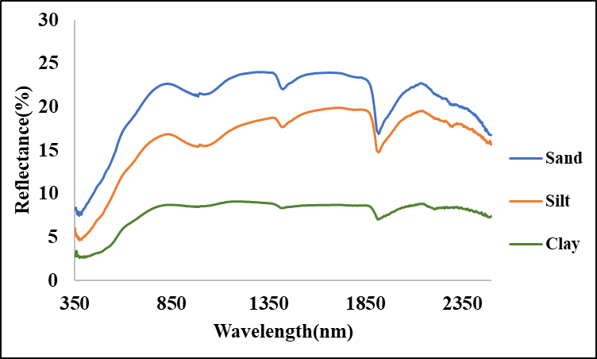
Fig 1. Variation in the spectral reflectance characteristics of soil according soil texture
  - Soil organic carbon and organic matter content
Soil organic carbon is a quantitative component of soil organic matter. Organic matter in soil is dark in colour, and its presence suppresses reflectivity up to a 4-5% organic matter content. When the organic matter content of the soil exceeds 5%, it appears black, and any additional increase in organic matter has no effect on reflectance (Curran, 1985).
  - Iron oxide
Iron oxide, which covers or states individual soil particles, gives many soils their 'rusty' red colour. Iron oxide primarily reflects red light (0.6-0.7μm). Researchers have employed a ratio of red to green bi-directional reflectance to determine iron ore concentrations from satellite altitudes.
- Details about spectroradiometer SVC HR1024i
3.1 Spectroradiometer
A spectroradiometer is a light measurement device that can determine both the wavelength and the amplitude of light emitted by a light source. Spectrometers differentiate wavelengths based on where light strikes the detector array, allowing the complete spectrum to be recorded in a single collection.
The spectroradiometer measures spectral response between 350 nm and 2500 nm in the UV, visible, and near infrared wavelength ranges. As a reference, a white 12.5 cm12.5 cm spectral on plate that can reflect almost all incident light is employed. The reflectance reading on that target was obtained using a spectroradiometer. Before taking the reflectance reading of the actual target, the spectroradiometer was used to obtain the reflectance of the spectral on plate. The reflectance of the target soil was calculated using the provided formula.
R (%) =$\frac{L(λ)}{S(λ)}$
Where, R (%) = Reflectance,
L(λ) =Target radiance,
S(λ) = Reference radiance.
The specifications of Spectroradiometer SVC HR 1024i model are in Table 1 and Fig 2.
Table 1. Specifications of Spectro-radiometer SVC-HR 1024i
Specifications | Description
Spectral Range | 350 nm – 2500 nm
Internal Memory | 1000 Scans
Channels | 1024
Bandwidth | ≤ 1.5 nm, 350 – 1000 nm
Wavelength reproducibility | 0.1 nm
Internal Digital Camera | Yes
Internal GPS | Yes
Reference Material | Spectralon
Software for spectral analysis | SVC HR-1024i
FOV (Optical Fibre) | 25⁰
Diameter of Scene | 44 cm for height 1m above surface
Height of Spectral measurement | 50 cm (Scene Dia. – 22 cm)
Fig 2. Spectroradiometer SVC HR 1024i
3.2 Operating Procedure
- Place a fully charged battery in the spectroradiometer and connect the Bluetooth antenna.
- If the connection is to be made via cable, the cable must be inserted into both the spectroradiometer and the PDA.
- Before using the instrument for the first time, turn it on for roughly 15 minutes (warm-up time).
- Launch the PDA data capture software, navigate to the 'File' menu, and select the 'AutoSave' option.
- This permits measurements to be stored to file automatically after each target acquisition.
- From the 'graph' option, select radiation graph type.
- Select 'Connect' from the 'Instrument' option. A list of COM ports that can be used to link the PDA to the spectroradiometer is provided. 'COM8' was chosen as the connecting port. Using Bluetooth, go to the 'Setting' menu and select optic to lens 4 for four optic drums to be used.
- Usually, the integration settings are left at factory default.
- Now, centre the spectroradiometer on the spectralon panel and click the 'Reference' button.
- Software button to start the reference scan. This reading will be used as a reference for all subsequent readings up until the following Reference scan.
- Once the reference scan is complete, simply click the 'Target' button for each subsequent scan.
- When the experiment is finished, detach the gadget from the PDA.
  - Processing of data
- Download and install the SVC HR 1024i software.
- Launch the SVC HR-1024i programme. GO TO THE 'File' menu and SELECT 'Open' to open the sig format files obtained from the spectroradiometer.
- SIG File Merge: Select 'SIG File Merge' from the 'Tool' menu to combine numerous SIG files into a single comma-delimited text data file.
Use the 'Browse' button in the dialogue box to pick the SIG format files to merge. Select the combined format as the 'SIG Format Output File' and then click the 'Process All Files' button.
- SIG files Overlap/Matching: Select 'SIG files Overlap/Matching' from the 'Tool' menu to apply the current overlap and matching settings to a set of input SIG format files. The SIG data files acquired by the PDA software have no overlapping data eliminated and no matching algorithm has been performed. Use this tool to reduce overlap and, if applicable, to apply the detector matching algorithm.
- Use the Browse button in the dialogue box to choose the SIG format input files to process. Begin processing the SIG files by reading and processing each one in turn, and writing the modified data to an output file with the string "_moc" (Matching Overlay Correction) appended to the original name. For example, if the input SIG file name is "gr062606_001.sig", the output SIG file name is "gr062606_001_moc.sig".
- Resample spectral data: Select 'Resample spectral data' from the 'Tool' menu to resample the input SIG format data files and write the resampled data to new output SIG format data files.
- Select either all wavelengths present in the input SIG file or a selected range of interest in the dialogue box.
- Select the SIG format input files to process using the Browse button. Begin processing the SIG files one at a time; each SIG file is read and linearly re- sampled at the chosen Resampling Interval, and the updated data is written to an output file with the string "_resamp" attached to the original name. For example, if the input SIG file name is "gr062606_001.sig", the output SIG file name is "gr062606_001_resamp.sig".
- Open these resample files in notepad format, and then copy them to an excel sheet. It provides observational reflectance readings.
  - The stepwise procedure for obtaining the spectral response in laboratory condition:
- Take a soil sample from the field.
- Using a holding platform, the spectroradiometer can be fixed at a single position.
- Soil samples were placed in 9 cm diameter petri dishes in a layer 2 cm thick.
- Scanning was performed after taking a spectral on reference reading.
- Observe soil samples with the SVC HR1024i spectroradiometer.
- The sensor's distance from the earth surface was held constant at the height.
- Once the observation was completed, the next soil sample was placed to the petri plate and observations were taken once more.
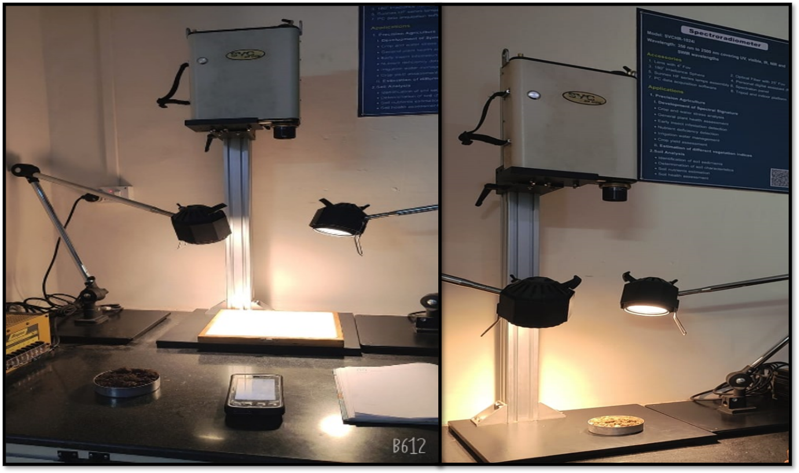
Fig 3. Experimental setup for recording reflectance of soil
- Conclusion
Soil spectral signatures are distinct and can be used to distinguish soil series. It is also useful for analysing soil qualities and for future planning involving conservation measures in watershed area treatments. Policymakers can benefit from understanding the types of soil in their area.
- References
Anonymous.2014. SVC HR-1024i / SVC HR-768i / SVC HR-640i / SVC HR-768si/SVC HR-512i User Manual Revision 1.12.29 Firemens Way, Poughkeepsie, New York 12603.
Bhise. P.R., Kulkarni S.B and Borole V.Y. 2019. Acquisition of Soil Spectral Signatures and Creation of Database for Vaijapur Taluka Using Spectroradiometer 4. International Conference on Adaptive Science & Technology.
Curran, P. J. (1985), Principles of Remote Sensing, Longman, 282p.
Hoffer, R.M. (1978), Biological and physical considerations in applying computer-aided analysis techniques to remote sensor data, in Remote Sensing: The Quantitative Approach, P.H.
Jensen J. R., (1983), Biophysical Remote Sensing – Review Article. Annals of the Associations of American Geographers, 73(1), 111-132p
Kaleita A. L., L. F. Tian, and M. C. Hirschi.2005. Relationship Between Soil Moisture Content and Soil Surface Reflectance. American Society of Agricultural Engineers. ISSN 0001−2351. 48(5):979−1986.
Lobell. D.B and G. P. Asner.2002. Moisture Effects on Soil Reflectance. Soil Science Society of American Journal. 66:722-727.
Mammadov.E., M. Denk, F.Riedel , K. Lewinska, C. Kazmierowski and C. Glaesser . Visible and Near-Infrared Reflectance Spectroscopy for Assessment of Soil Properties in the Caucasus Mountains, Azerbaijan. Communications in soil science and plant analysis. 51(16):2111–2136.
Mendes W. D., A.M. Dematte, N.A.Rosin , F.S. Terra, R .R. Poppiel , D.F. Urbina-Salazar , C.L.Boechat, E.B.Silva , N.Curi, S .G. Silva , U. J. Santos and G.S. Valladares.2022. The Brazilian soil Mid-infrared Spectral Library: The Power of the Fundamental Range. Geoderma .41(5):115-772.
Sahwan W., B. Lucke, T. Sprafke, K.Vanselow and R.Baumler.2020.Relationships between spectral features, iron oxides and colours of surface soils in northern Jordan. European Journal Soil Science.72: 80–97.
Sakin.E.2011.Organic carbon organic matter and bulk density relationships in arid-semi arid soils in Southeast Anatolia region. African Journal of Biotechnology.11(6):1373-1377
Sinha.A.K.1986.Spectral reflectance characteristics of soils and its correlation with soil properties and surface conditions. Journal of the Indian Society of Remote Sensing .14(1):1-9
Stoner E.R. and M.F. Baumgardner. 1981.Characteristic variations in reflectance of surface soils.Soil Science Society of American Journal.45:1161-1165.
Streck N. A., D. Rundquist and J. Connot.2003. Spectral signature of selected soils. ISSN 0104-1347, 11(1):181-184.
Swain. S.R., P. Chakraborty, N. Panigrahi, H. B. Vasava, N. N. Reddy, S. Roy, I. Majeed and B. S. Das .2021. Estimation of soil texture using Sentinel-2 multispectral imaging data: An ensemble modelling approach Soil & Tillage Research .21(3):105-134.
http://speclab.cr.usgs.gov/
http://theindoorbonsaitree.com

