Synthesis and Structural Overview of Some Intriguing Tellurium/Nitrogen-Containing Macrocycles
ParthaPratim Das
P. G. Dept. of Chemistry, Magadh University, Bodh-Gaya
Abstract:
Since the accidental discovery of crown ethers, the field of supramolecular chemistry has grown by leaps and bounds. O, S- based macrocycles were developed early and their chemistry is so vastly available. In comparison to that, the higher chalcogen (Se/Te) containing macromolecules are very less in number. Over the years, Te based macrocycles have been reported and due to their greater s-character and lower electronegativity than the rest, their chemistry has been fascinating. Due to, Toxic nature of Te and higher polarizability of Te-C bond owing to huge difference in size as well as electronegativity between Te and C, the growth of chemistry of Te-containing macrocycles has got hindered. Te being a soft center, there has been numerous attempts where hard N center has been included in the same macromolecule, just to create a surrounding which is capable to bind a wide range of metal ions with different dimensions and oxidation states. There are reports of Schiff base as well as –NH– group containing Tellura-aza-macrocycles, including cryptands also. In this chapter the chemistry of different types of tellura-zaz-macrocycles have been discussed, where focus has been given on their synthesis and metal complexation with structural details.

Introduction:
The manufacture of macrocycles possessing highly sensitive specificity for metal ions has continued since the landmark findings of Pedersen¹, Lehn², and Cram³. This entailed the synthesis of cation selective macrocycles like, crown ethers, cryptands, spherands etc. Numerous applications of macrocyclic ligands have been thoroughly investigated. Multiple investigations on macrocycles having the donating atoms O, S, Se, and Te are being conducted worldwide. O, S-containing macrocyces are quite prevalent, while their third and fourth group counterparts, i.e., Se, Te-containing macrocyles, respectively, have received less attention. Even amongst the two, Te-ether macrocycles are somewhat rare, even though there are now a number of macrocyclic Se-ethers known. If the larger Se and Te were included, the macrocycle cavity increases in dimensions, allowing some novel coordination behaviour. Se and Te's greater potential for σ-donating would also facilitate the coupling of different metal ions. A combination of its bigger size as well as the difference in electronegativity amongst Te and C, makes the Te-C bonds become more polarizable. The greater reactivity of the Te-C bond in compared to the S-C and Se-C bonds in addition to the toxicity of the organotellurium compounds have limited the research in this area. When combined with its greater σ-electron properties and lesser electronegativity compared to S and Se, Te produces ligands exhibiting extensive coordination chemistry. Because ¹²⁵Te NMR analysis is a potent architectural probe and is available, telluroether chemistry is considerably more tempting in this case. Incorporation of hard centers (O/N) into telluromacrocycles will be even more interesting. Since they are capable of combining with two metals having various characteristics as well as oxidation states within the same ring, macrocycles containing mixed hard and soft donors have become increasingly useful over time also. However, this chapter mainly discusses the chemistry of some interesting macrocyclic ligands that contain tellurium and nitrogen donor atoms or namely “telluroazamacrocycles”.
Tellurium-Nitrogen donor containing macrocycles:

Through an a single-step dipodal 2+2 condensing of bis(2-formylphenyl) telluride with a variety of diamines, unique Te-azamacrocycles of various dimensions as well as donating atoms are produced easily and with excellent yields without using templates [Scheme 1 and 2]^{4,5,6,7,8}. By lessening the unfavourable lone pair-lone pair repulsion amongst the N donors within the ring, the secondary intramolecular Te…....N interactions for these scenarios serve an integral part in building a macrocyclic ring. L¹ and L¹⁰ share an analogous framework, both are puckered macrocycles. Just one of the N atoms is linked, despite the fact that there's a same likelihood of two N donor atoms connecting with each Te donor. Thus, the molecule's crystal architecture points to the existence of just one attractive communication per Te donor, which is why it matches the framework of 10-Te-3 tellurane⁹. Because the transannular Te-Te separation is greater than the sum of their van der Waals radii, the bond arrangement at the Te donor is T-shaped^{4,7}.When combined with [PdCl₂(NCC₆H₅)₂, L¹ generates the stable 1:2 complex [Pd₂(L¹)Cl₄] [Scheme 1]. Nonetheless, there is an odd behaviour in the interaction of L¹ with HgCl₂. Ring opening resulted from the interaction of L¹ with HgCl₂, which produced a combination of bis(organotellurenyl) chloride as well as bis(organomercury) Lewis acid. The generation of a weakly coupled additive compound [Hg₂(L¹)Cl₄] and group migration are the two steps in this fascinating dismutation process⁴ [Scheme 1]. Compared against the hydrolysis end-product produced by a comparable process involving the Se-counterparts¹⁰, 1:1 Pd^{II} compounds of L¹ and L¹⁰ are formed^{5,6,7} [Scheme 2]. Two N donors from the same diaminoethane block along with two Te donors are linked to Pd^{II}, according to spectroscopic evidence along with crystal architecture. The remaining two N donors of the other diaminoethane unit are facing the Pd^{II} centre but long separated staying non-bonded. The soft-soft contacts are what cause reduced Pd-Te bond lengths. In this instance the Te donors function as both Lewis bases as well as lewis acids by acting as acceptors of N as well as donors of Pd^{II}. It's fascinating to note that a comparable interaction between L¹ and [Pt(COD)Cl₂] results in an unique fragmented product. This organoplatinum compound is the consequence of an easy transmetalation along with C-Te bond breakage^{5,6}. Intense N-Te intramolecular connections, that activate the trans- C-Te bond, cause the C-Te bond to easily break apart. The sp²-hybridized N-donor atom is largely to blame for this powerful intramolecular interaction. C, Te, and two N donors collaborate in order to bind Pt^{II} in the compound into a square planar configuration. Dimers are generated by mild Te.....Pt intermolecular interactions that connect the Pt^{II} ions. It represents the first instance of a structurally characterized organoplatinum compound with interactions between Pt and Te both intra- and inter-molecularly. The Ni^{II} paramagnetic compound, [Ni(L¹)](PF₆)₂, is produced via interaction with NiCl₂.6H₂O with L¹, which is followed by the incorporation of excess PF₆⁻, using NH₄PF₆. The existence of identical component in both the solution as well as solid form is indicated by bands that are identical in the UV-Vis spectra of the two states. The crystal framework demonstrates that the Ni^{II} resides within the macrocyclic cage and is attached to all available donors [two Te and 4 N] in distorted octahedral configuration. In this instance, Te atoms occupy cis- positions due to L¹'s flexibility. The Ni-Te average bond length is 2.66 Å, which is greater than the total of the single bond covalent radius of Ni^{II} within an octahedral surroundings (0.83 Å) and Te (1.37 Å), due to the hard-soft character of the Ni-Te bond.
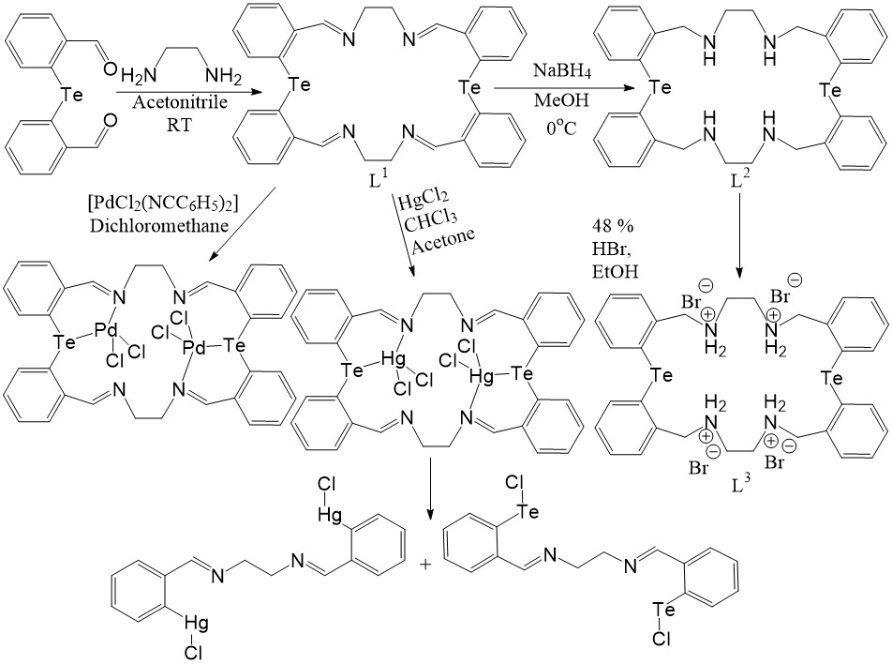
Scheme 1
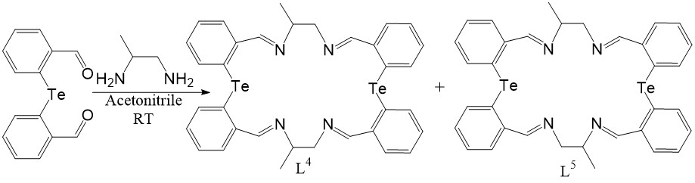
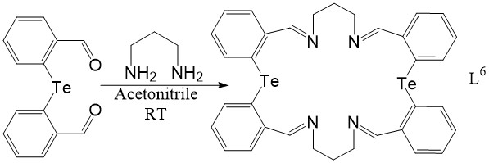
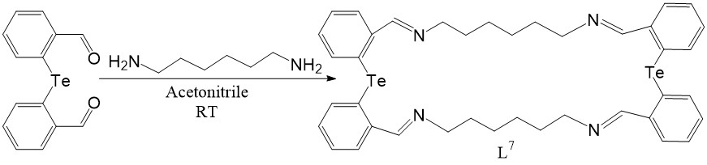
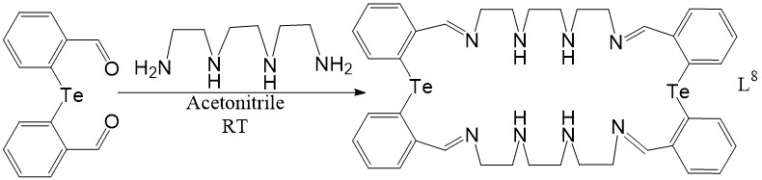
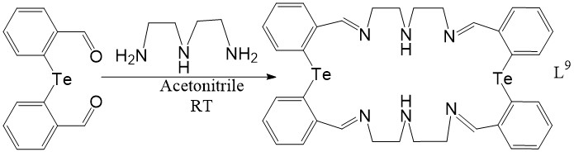
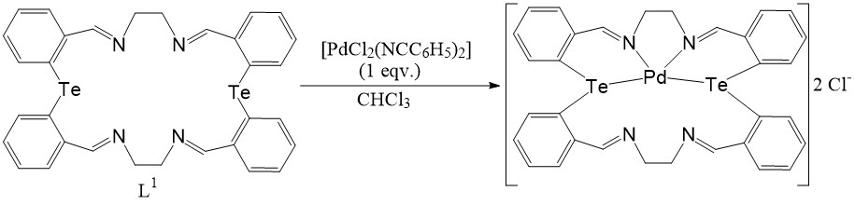
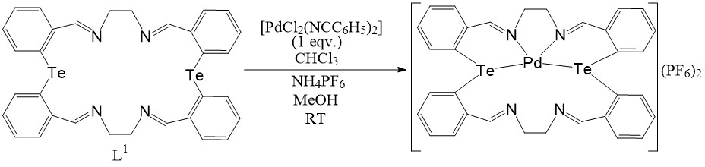
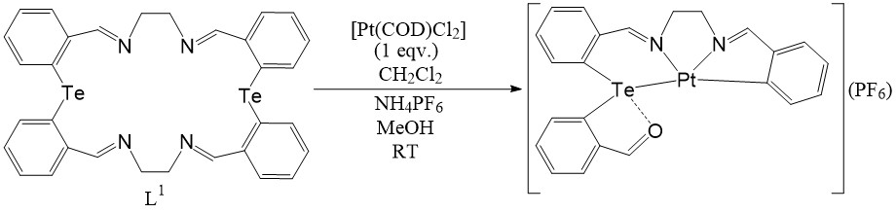
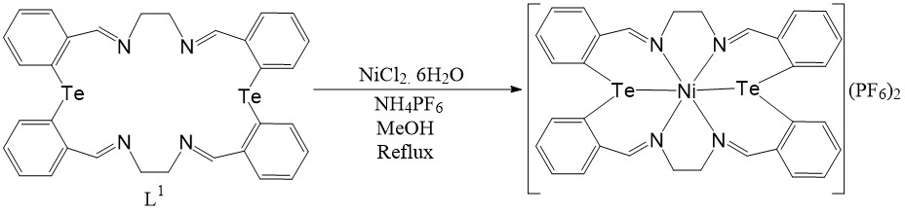
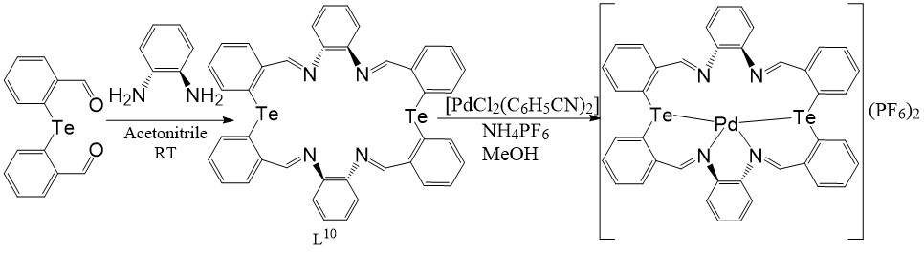
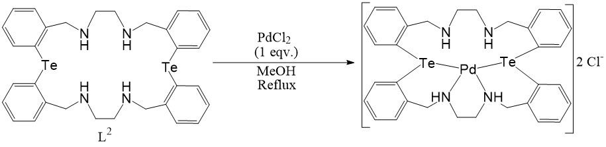
Scheme 2
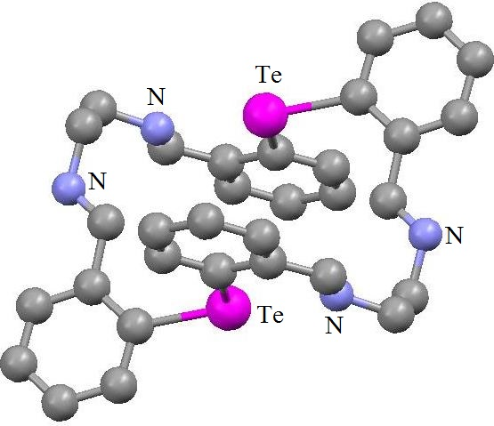 |  |  | 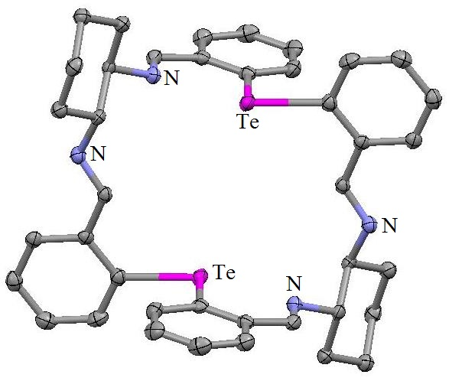
L¹ |  |  | L¹⁰
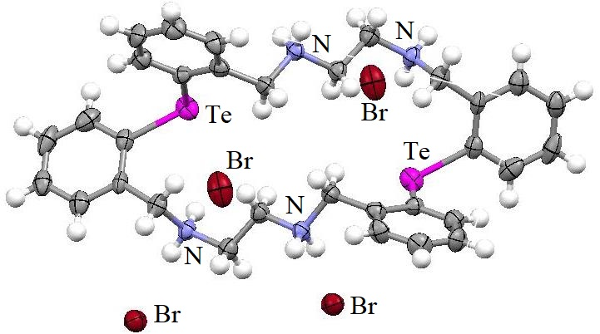  L³ |  |  | 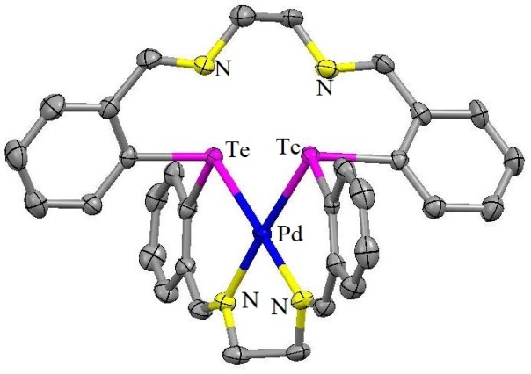  Cation of [Pd(L¹)](PF₆)₂
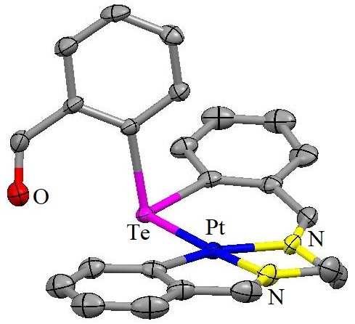  [Pt(Modified-L¹)](PF₆) | 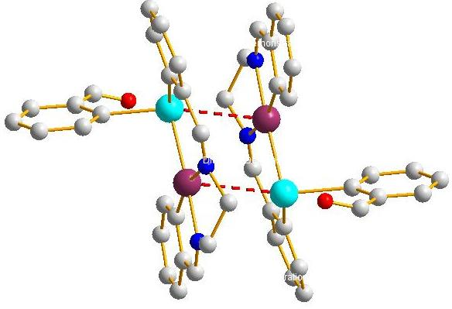  Dimeric form of [Pt(Modified-L¹)](PF₆)
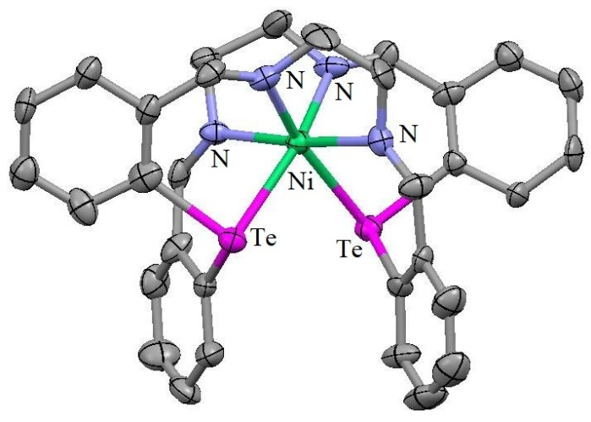  [Ni(L¹)](PF₆)₂ |  | 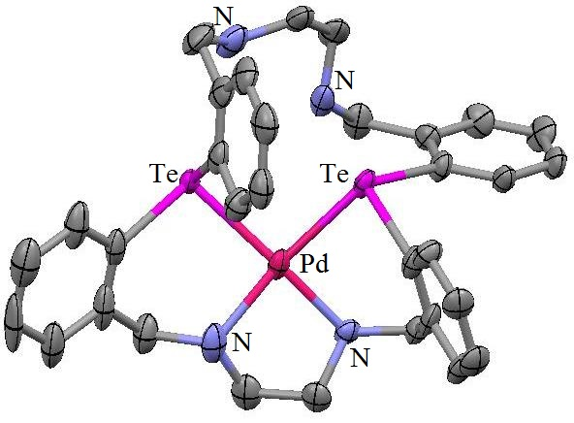  Cation of [Pd(L²)]Cl₂
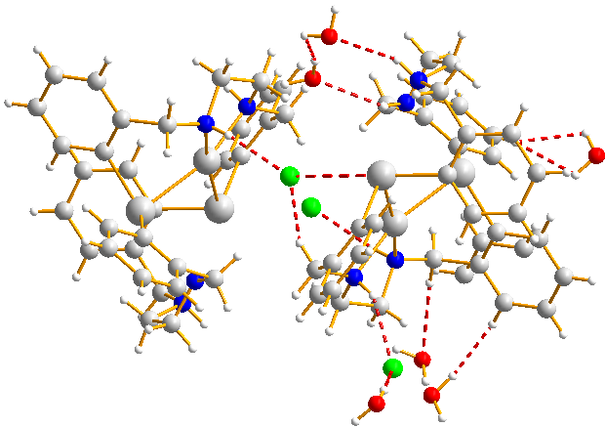
Packing diagram of L³
Figure 1
These Schiff base macrocycles are vulnerable to hydrolysis and transmetallation when exposed to metal salts, causing the macrocycle to cleave at times^{4,6,10,11}. In comparison with the original Schiff base macrocycles having sp² hybridised N-donors, the reduced versions containing just sp³ hybridised atoms is far more adaptable and is capable of supporting a broader variety of sizes and shapes. Method of producing reduced version L² from L¹ is shown in Scheme 1. L² and PdCl₂ combine to form the desired 1:1 compound, [PdCl₂(L²)] [Scheme 2, Figure 1]. In a manner analogous to the original Schiff base macrocycle compound [Pd(L¹)]Cl₂, two N along with two Te donors are coordinated to Pd^{II} in the molecular framework of [Pd(L²)]Cl₂. The other two N donors are apart enough to be non-bonding. Nevertheless, the molecular arrangement of the related Se-azamacrocycle's Pd^{II} compounds^{11,12} reveals that just the hard N donors are coordinated to Pd^{II}. This peculiar behaviour is brought about by the stronger soft-soft interaction along with stabilization of the six-member chelate ring caused by Te's larger σ-donor characteristic than Se's. A reduction in the overall number of donor sites in these ligands may result from the intramolecular Te-N connections, which lower the N donor's electron-donating ability. As depicted in Scheme 1, the protonated counterpart of L²; L³ is generated. One of the Br⁻ ions is located above the macrocycle, generating an intermolecular H-bond with the -NH- and water-H atoms, according to the crystal structure of L³, which demonstrates that none of the Br⁻ ions are located inside the macrocyclic cage^{4,5}. The packing diagram of L³ is shown in Figure 1. Given that none of the four N donor atoms occupy the same plane, the macrocycle is quite twisted. Te.......Te distances inside molecules are larger than Te.......Te distances within the parent L¹. By using 2,6-diacetyl-4-methylphenol and bis(aminoalkyl)tellurides, {NH₂(CH₂)_{n}}₂Te, where n = 2 or 3, (2+2) condensation with using no templates produce Te-macrocyclic Schiff base kind molecules L¹¹ and L¹², respectively, with O, N, and Te donors¹³. Their synthesis method is shown in Scheme 3.
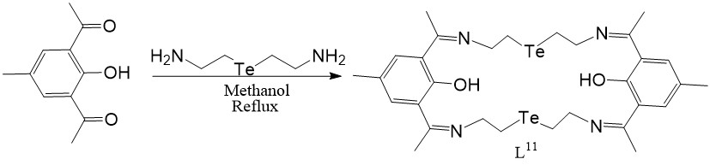
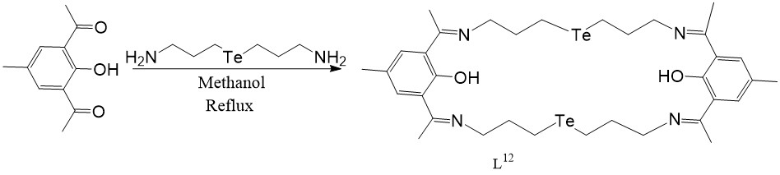
Scheme 3
A Te-containing N₄-macrocycle's [L¹³, L¹⁴, L¹⁵ and L¹⁶] octahedral Mn^{II}, Co^{II}, Ni^{II}, Cu^{II}, and Zn^{II} compounds are described and their synthesis is shown in Scheme 4 by via template condensation of 1,2-diaminoethane or 1,3-diaminopropane with R¹R²TeX₂[X = I/Br] and MCl₂ salts¹⁴.
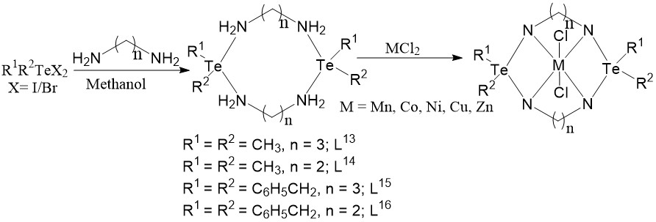
Scheme 4
Tellurium Cryptand:
Using the Cs⁺ as a template, the Te-containing cryptand (L¹⁷) was synthesised through the [2+3] fusion of tris(2-aminoethyl)amine (tren) and bis(o-formylphenyl)telluride¹⁵ [Scheme 5].
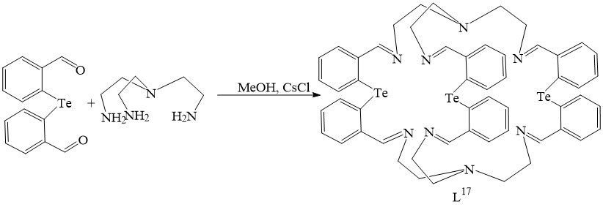
Scheme 5
Conclusion:
In conclusion, the Schiff base macrocycles are of the architectural family 10-Te-3. The molecules have two lone pair electrons essentially holding the equatorial locations of their TBP geometry, giving the compounds a somewhat twisted T-shaped arrangement around their Te centers. It is predicted that Te-N_{sp}³ kind intramolecular interactions are weaker over Te-N_{sp}² type intramolecular coordinating bonds based on a study of Te.......N distances for Schiff base macrocycles with its reduced version. The development of the anticipated 1:1 Pd^{II}-compound of L¹ is in contrasting to the synthesis of hydrolysis substance with Se-counterpart, indicating that the Schiff base macrocycle exhibits varied coordination behaviour but is susceptible to transmetalation involving Pt^{II} and Hg^{II} ions, resulting to the breakdown of the macrocycle. When compared to Se-counterpart, L² exhibits higher flexibility and functions as N₂Te₂ donating ligand for Pd^{II} ion. This demonstrates Te's superior σ-donor characteristic compared to Se's. Among the potential N₄Te₂ donors of the ligands, the crystal architectures of [Pd(L¹)](PF₆)₂ and [Pd(L²)]Cl₂ show N₂Te₂ connection only, with Pd^{II}; the additional two N donors stay at vast non-bonding ranges. The generation of intramolecular Te-N connections, that in turn reduces the electron-donating ability of the N donors, constitutes one of the factors contributing to the lower dentacity of the ligands. Anions may be recognized by the protonated analogue L³. At the end one Te-containing cryptand’s synthesis using Cs^{I} as template was shown.
References:
- C.J. Pedersen, “Cyclic polyethers and their complexes with metal salts”, J. Am. Chem. Soc., Vol. 89, pp. 7017–7036, 1967.
- (a) J.M. Lehn, “Design of organic complexing agents Strategies towards properties”, Struct. Bond. (Berl.) Vol. 16, pp. 1-69, 1973. (b) J.M. Lehn, “Supramolecular Chemistry—Scope and Perspectives Molecules, Supermolecules, and Molecular Devices (Nobel Lecture)”, Angew. Chem. Int. Ed. Engl., Vol. 27, pp. 89-112, 1988.
- D.J. Cram, “The Design of Molecular Hosts, Guests, and Their Complexes (Nobel Lecture)”, Angew. Chem. Int. Ed. Engl., Vol. 27,pp. 1009-1020, 1988.
- S. C. Menon, H. B. Singh, R. P. Patel and S. K. Kulshreshtha, “Synthesis, structure and reactions of the first tellurium-containing macrocyclic Schiff base”, J. Chem. Soc., Dalton Trans., Issue 7, pp. 1203-1207, 1996.
- S. C. Menon, A. Panda, H. B. Singh, R. P. Patel, S. K. Kulshreshtha, W. L. Darby and R. J. Butcher, “Tellurium azamacrocycles: synthesis, characterization and coordination studies”, J. Organomet. Chem., Vol. 689, pp. 1452-1463, 2004.
- S.C. Menon, A. Panda, H.B. Singh, R.J. Butcher, “Synthesis and single crystal X-ray structure of the first cationic Pd(II) complex of a tellurium-containing polyazamacrocycle: contrasting reactions of Pd(II) and Pt(II) with a 22-membered macrocyclic Schiff base”, Chem. Commun., Issue 2, pp. 143-144, 2000.
- U. Patel, H. B. Singh and R. J. Butcher, “Synthesis and Characterization of Some New 22-Membered ChalcogenoazaMacrocycles and Their Co^{II} and Ni^{II} Complexes”, Eur. J. Inorg. Chem., Issue 24, pp. 5089-5097, 2006.
- R. Kaur, S. C. Menon and H.B. Singh, “New aspects of intramolecular coordination in organochaicogen (Se/Te) chemistry”, Proc. Indian Acad. Sci. (Chem. Sci.), Vol. 108, pp. 159-164, 1996.
- S. Patai, Z. Rapport (Eds.), The Chemistry of Organic Selenium and TelluriumCompounds, vols. 1 and 2, John Wiley and Sons, New York, 1986, 1987.
- A. Panda, S. C. Menon, H. B. Singh, C. P. Morley, R. Bachman, T. M. Cocker and R. J. Butcher, “Synthesis, Characterization and Coordination Chemistry of Some Selenium-Containing Macrocyclic Schiff Bases”, Eur. J. Inorg. Chem. Issue 6, pp. 1114-1126, 2005.
- S. Panda, H. B. Singh and R. J. Butcher, “Contrasting coordination behaviour of 22-membered chalcogenaaza (Se, Te) macrocylces towards Pd(II) and Pt(II): Isolation and structural characterization of the first metallamacrocyle with a C–Pt–Se linkage”, Chem. Commun., Issue 6, pp. 322-323, 2004.
- S. Panda, S. S. Zade, H. B. Singh and R. J. Butcher, “The Ligation Properties of some Reduced Schiff Base Selena/Telluraaza Macrocycles: Versatile Structural Trend”, Eur. J. Inorg. Chem., Issue 1, pp. 172-184, 2006.
- S.K. Tripathi, B.L. Khandelwal and S.K. Gupta, “A New Family of Chalcogen Bearing Macrocycles: Synthesis and Characterization of N₄O₂E₂ (E = Se,Te) Type Compounds”, Phosphorus Sulfur Silicon, Vol. 177, pp. 2285-2293, 2002.
- S. Srivastava and A. Kalam, “Synthesis and characterization of manganese(II), cobalt(n), nickei(II), copper(II), zinc(II) complexes of a tellurium containing tetraazamacrocycle : A photoelectron spectroscopic study”, J. Ind. Chem. Soc., Vol. 83, pp. 563-567, 2006.
- A. Panda, S. C. Menon, H. B. Singh and R. J. Butcher, “Synthesis of some macrocycles/bicycles from bis(o-formylphenyl) selenide: X-ray crystal structure of bis(o-formylphenyl) selenide and the first 28-membered selenium containing macrocyclic ligand”, J. Organomet. Chem., Vol. 623, pp. 87-94, 2001.

