MACHINE LEARNING, DEEP LEARNING ALGORITHMS AND THEIR USES
ABSTRACT
Deep Learning has become a rapidly growing area of research and several promising research areas are expected to drive future advancements. This paper presents an overview of the algorithms, architecture, training techniques, and applications in deep learning. Deep Learning algorithms are grouping into two category such as supervised learning and unsupervised learning. Deep understanding needs different learning algorithms for various network architectures. This chapter will explore the rudimentary concepts of deep learning and provide a survey of deep learning algorithms and their associated advantages and disadvantages. Then, it will explore recent futuristic deep learning algorithms and their outstanding performance on various tasks. Finally, this paper provides a prominent standpoint on Deep Learning algorithms and future directions and opportunities for further research in deep learning.
Keywords:
Convolutional Neural Network, Recurrent Neural Network, Long Short-Term Memory, Evolved Gradient Direction Optimizer, Deep Belief Network.
INTRODUCTION
Machine learning algorithms are created to learn and acquire knowledge from data and improve their performance. The architecture of machine learning and deep learning is shown in Figure 1.1 and Figure 1.2
Fig. 1.2. Deep Learning architecture
Over the past ten years, deep learning, which falls under the umbrella of machine learning, has garnered considerable interest. In Deep learning, the development of deep neural networks with more than three layers can learn hierarchical representations of data. Deep Learning encompasses the process of training artificial neural networks, which consist of numerous layers of interconnected nodes, enabling them to autonomously acquire features and representations from extensive datasets.
The concept of deep learning is not new, but its recent popularity and success are due to a few factors. One factor is the growth of big data and the need for more advanced techniques to analyse it. Another factor is the development of more powerful hardware, particularly graphical processing units (GPUs), which can perform parallel computations needed for deep learning algorithms. In the application area, deep learning is often used for Speech recognition, computer vision and natural language processing.
Deep learning is often used for analysing and processing large amounts of data for business intelligence, predictive analytics, and other data-driven applications. Deep learning algorithms are used in edge computing, and they can be trained on huge datasets and can learn to make accurate predictions from complex data. Deep learning is also used in cybersecurity and fraud detection. This chapter endeavors to offer an all-compassing review of both current and cutting- edge algorithms within the realm of Deeplearning.We assess the obstacles and constraints associated with current methods and offer prospective insights into the future trajectory of Deep learning research.
OVERVIEW OF THE DEEP LEARNING ALGORITHMS
Convolutional Neural Network (CNN) is a forward- feeding artificial neural network that employs convolutional layers for the extraction of fundamental features from input images. In general, a CNN contains layers for convolution, pooling, and full connection. Recurrent Neural Network (RNN) is a type of neural network that can work sequential input data, such as time-series data or natural language text and it comprises a recurrent layer, activation function, and fully connected layers. Particularly CNNs and Long Short-Term Memory (LSTM) have highly effective for image classification tasks, Outperforming other traditional techniques. CNN, RNN, and Deep Belief Networks (DBNs) have shown hopeful results not only in computer vision and speech recognition but also in various other fields including agriculture.
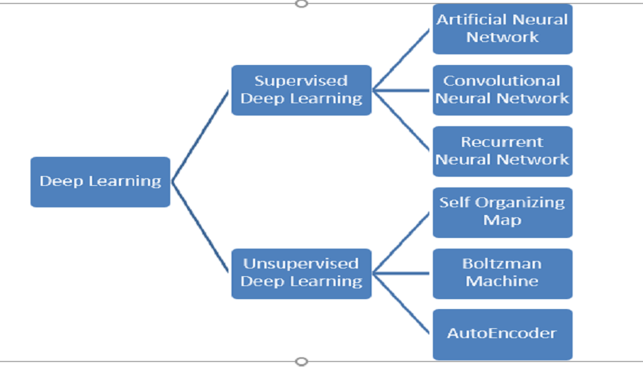
Fig. Deep Learning Algorithms
A CNN is used in agriculture for seed identification, pest detection, and identification of contaminants, and a Recurrent neural network is used for crop yield prediction and time series analysis. Though it is important to carefully design and train these models to avoid overfitting and ensure good generalization performance on new, unseen data. The prominence of having an appropriate dataset for increasing system performance. Combining CNN and LSTM networks performed better than using them alone and using multiple networks also increased performance. LSTM was able to learn long- term dependencies and the Bidirectional Encoder Representations from Transformers (BERT) model predicts the words from the undescribed text.
Multinomial naïve bayes algorithm used to classify the data. By hyper-parameter tuning, we can improve this classifier and it gives high accuracy on the same dataset after hyper-parameter tuning. Support Vector Machine (SVM) is a mathematical classification technique concentrating on increasing the edge between the instances and the separation hyper-plane. SVM, LSTM, BERT, and multinomial naïve bayes are classifiers to perform sentiment classification, though particularly LSTM and BERT deep learning techniques give high accuracy than machine learning techniques such as SVM, multinomial naïve bayes.
The prominent part of Deep Learning is the training algorithm for neural networks. Deep Learning has a higher number of layers, and each layer can be focused to extract particular features from data through training. In deep learning, multiple layers use to learn features and predict the label from the last hidden layer and fine-tune the feature detectors using back propagation without using label information.
Deep learning applications are trained to recognize patterns in a given dataset. Once the learning is complete, the model can then be used to make predictions on new instances of the same kind of data. The model uses the patterns it has learned during training to make these predictions. Researchers are facing a major challenge due to the extended duration required to train deep learning models.
The optimization algorithms are handed down to enhance the deep neural network by training and improving the performance of the network. A novel hyperplane evolving gradient direction optimizer is used to solve a vanishing gradient problem. Though there are some challenges in large-scale optimization.
COMPARISON OF PERFORMANCE AND LIMITATIONS OF DEEP LEARNING ALGORITHMS
The following table 1 shows the associated advantages and disadvantages of deep learning algorithms.
Deep Learning Algorithms Comparison Algorithm | Advantage | Disadvantage
Convolutional Neural Network | Outstanding performance on image and video data | High computational cost, and needs huge amounts of training data
Recurrent Neural Network | Can work well with sequential data | explosion gradient problems, slow to train
BERT | Futuristic performance in language understanding | High computational cost, and requires huge amounts of training data
Autoencoder | Useful for feature mining and | Overfitting Problem, needs huge

FUTURISTIC DEEP LEARNING ALGORITHMS
Following futuristic deep learning algorithms that have reached outstanding performance on a variety of tasks.
- GPT 3 is a language model algorithm developed by OpenAI, it can achieve state-of-the-art performance in such as language translation, question answering, and summarization.
- AlphaZero is developed by DeepMind, it is a reinforcement learning algorithm, that can learn to play chess and shogi.
- ViT is a transformer-based CNN developed by Google, it has achieved performance in image classification and object detection.
- DeBERT a is a language model developed by Microsoft, it achieves a variety of NLP tasks.
- EfficientNet is a family of the convolutional neural network developed by google, it achieves image recognition tasks.
APPLICATIONS OF DEEP LEARNING
Machine learning has become a prominent tern in contemporary technology, growing rapidly. It quietly infiltrates our daily routines through applications like Google Maps, Google Assistant, Alexa, without us always being aware.
Deep Learning is a branch of machine learning, plays a pivotal role in furnishing smart solutions to intricate issues. Modelled after the human brain’s structure and functioning, deep learning harnesses artificial neural networks to scrutinize data and formulate predictions. It has applications in practically every business industry.
Chatbots:
Chatbots can quickly solve consumer problems. A chatbot refers to an AI application designed for online communication, utilizing text or text- to-speech interaction. It can communicate with people and perform actions that would be performed by a human. Customer support, social media marketing, and instant messaging clients all often use chatbots. Automated responses are given in response to user input. It generates many types of reactions using machine learning and deep learning algorithms.

Audio and Speech Processing:
Machine learning enhances audio quality and speech recognition in entertainment. It's used for noise reduction, voice-controlled interfaces, and automatic transcription of audio content.
Finance:
Deep learning has the potential to significantly transform the financial sector, with a variety of applications that can enhance customer experience, risk management, decision-making, and fraud detection. Fraud detection is one of the main uses of deep learning in the financial sector. To recognize fraudulent transactions, lower false positives, and increase accuracy, deep learning models can be developed. Financial companies may reduce losses by millions of dollars and increase client happiness and trust by using deep learning algorithms.
As was previously noted, risk management is one of the financial applications of deep learning. Large datasets can be analysed using deep learning models to find patterns and connections that help predict future hazards and spot potential opportunities.
Financial institutions may be able to lower their risk exposure and make better judgments as a result of this. Deep learning may also enhance customer happiness by increasing the precision and effectiveness of customer data analysis and behaviour pattern identification. Deep learning models, for instance, can be used to forecast customer attrition and deliver personalized offers and promotions to keep clients. Financial institutions' operations and client interactions may change as a result of deep learning, which is positioned to play an increasingly significant role in the industry.
Predictive Analytics:
Studios and networks use predictive analytics to forecast box office performance, viewership ratings, and audience reception. This helps in decision-making related to content production and distribution.
Healthcare:
Deep Learning has found use in the healthcare industry. Deep Learning has empowered the computer-assisted detection and diagnosis of diseases. In the realm of medical imaging, it finds extensive use in medical research, pharmaceutical development, and the detection of critical ailments like diabetic retinopathy and cancer.
Amusement:
Machine learning algorithms power content recommendation engines in streaming services like Amazon prime video, Spotify, Netflix and YouTube. These systems analyse user preferences, viewing history and behaviour to suggest personalized movies, TV shows, music, and playlists. Deep learning algorithms are also used to automatically generate subtitles and to the silent films.

Video Summarization and Analysis:
Machine learning models can automatically generate video summaries or analyse video content for specific elements, like object recognition, sentiment analysis, or content moderation for user-generated content.
Gaming:
In the gaming industry, machine learning enhances game design, character behaviour, and player experience. It can create more realistic AI opponents, adapt gameplay to a player's skill level, and improve graphics rendering.
Virtual and Augmented Reality (VR/AR):
In VR and AR applications, machine learning helps in object recognition, gesture tracking, and creating immersive experiences. For example, it can be used in VR gaming for realistic hand and body tracking.
News Collection and Fake News Detection
Deep Learning enables you to tailor news to the personas of your readers. You may collect and filter news material based on social, geographical, and economic characteristics, as well as a reader's personal preferences. Neural networks aid in the development of classifiers capable of detecting fraudulent and biased news and removing it from your feed. They also notify you about potential privacy violations.
Computer Vision:
Object Recognition: Identifying and classifying the objects within images or videos, used in autonomous vehicles, security systems, and quality control in manufacturing.
Facial Recognition: Identifying and verifying individuals' faces, commonly used in security systems and authentication.
Image Captioning:
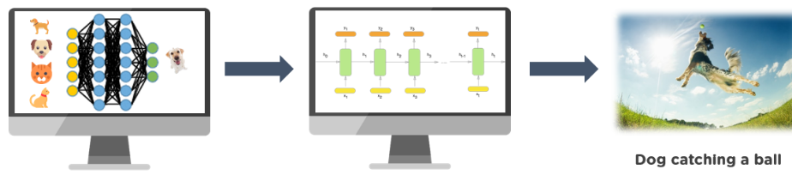
Image captioning is a method used to generate a written portrayal of an image. It tulizes computer vision to interpret the image’s content and employs a language model to convert this understanding into coherent sequence of words. To transform labels into a coherent sentence structure, recurrent neural networks like LSTM are employed. Microsoft has developed a caption bot that allows users to upload an image or its URL, providing a textyal description of the image. Additionally, AI- powered tools like ‘description AI’ generate descriptive text and relevant hashtags for photos.
Self-Driving Cars
Deep Learning serves as the driving catalyst behind the concept of self-driving and autonomous vehicles. These technologies, often referred to as 'learning machines,' leverage extensive datasets and training processes to determine optimal actions and responses. In a bid to diversify its business infrastructure, Uber's Artificial Intelligence laboratories are not only fueling the development of additional autonomous vehicles but also pioneering self-driving cars for on-demand food delivery services. Meanwhile, Amazon has ventured into the realm of using drones for the delivery of goods in select regions. Addressing the complexities of self-driving vehicles, the majority of designers are rigorously subjecting these vehicles to a multitude of scenarios to ensure their safe operation. Equipped with sensors that gauge object proximity and leveraging data from cameras, sensors, geo-mapping, and advanced models, these vehicles adeptly navigate through traffic. Tesla stands out as a prominent example in this domain.
Virtual Personal Assistant:
We are equipped with numerous virtual personal assistants, such as Google Assistant, Alexa, Cortana, and Siri, designed to help us access information through voice commands, as their names suggest. By simply listening to our spoken instructions, these assistants can provide a wide range of assistance, including playing music, making phone calls, opening emails, scheduling appointments, and more. Machine learning algorithms are at the core of these virtual assistants' operations. They record our voice commands, transmit them to a cloud server, decode them using ML algorithms, and subsequently respond as needed.
Human Resources:
- Resume Screening: Automatically screening and shortlisting job applicants based on qualifications and skills.
- Employee Engagement: Analysing employee data to improve workplace satisfaction and productivity.
Natural Language Processing
NLP, short for Natural Language Processing, represents another significant field where Deep Learning is demonstrating impressive advancements. This field involves the endeavour of instructing machines to comprehend and interpret human language. It's important to acknowledge that comprehending human language is an exceedingly complex task for machines. The challenges extend beyond mere alphabets and words, encompassing aspects like context, accents, handwriting, and more. Deep Learning-based NLP is making notable progress in overcoming many of these language comprehension hurdles by training computers, leveraging techniques such as Autoencoders and Distributed Representation, to generate contextually appropriate responses to linguistic inputs.
Machine learning can be used for real-time translation of subtitles and audio tracks, making content accessible to a global audience. Additionally, it aids in localization efforts, adapting content to different languages and cultures.

Detecting Developmental Delay in Children
The timely identification of developmental disabilities in children holds great importance because intervening at an early stage can enhance children's long-term outcomes. Simultaneously, an expanding body of research highlights a correlation between developmental challenges and motor proficiency, prompting the inclusion of motor skills assessment in the early diagnosis of developmental disorders. The diagnosis of a developmental issue, however, is often made through informal questionnaires or surveys to parents due to a lack of expertise and time constraints. Deep learning technology are making this possible. Scientists from MIT's Computer Science and Artificial Intelligence Laboratory, in collaboration with the Institute of Health Professions at Massachusetts General Hospital, have created a computer system capable of identifying language and speech deficiencies in children before they reach kindergarten age.
Automatic Machine Translation
In recent years, deep learning has transformed various disciplines. In light of these advancements, the domain of machine translation has shifted away from earlier approaches, such as rule-based systems or statistical phrase-based methods, towards the adoption of deep learning neural-based techniques. Thanks to extensive training data and unparalleled processing capabilities, neural machine translation (NMT) models can now access all available information within the source text and autonomously discern the relevance of each component during the text generation process. The substantial enhancement in translation quality primarily stems from the elimination of conventional independence assumptions, allowing neural translation to significantly narrow the quality disparity between human and neural translation.
Automated Handwriting Generation
This Deep Learning application produces new handwritten samples for a given set of words or phrases. It represents the handwriting as a series of pen movement coordinates used to create the samples. It uncovers the relationship between pen strokes and letter formation, subsequently generating additional instances.
Language Translations
Machine translation is gaining popularity among technological companies. The infusion of this investment, along with recent advancements in deep learning, has resulted in significant enhancements in translation quality. Google asserts that the transition to deep learning yielded a 60% boost in translation precision compared to the prior phrase-based method employed in Google Translate. Both Google and Microsoft are now capable of translating over 100 diverse languages with levels of accuracy approaching human proficiency.
Deep Dreaming
Deep Dream serves as a visualization of patterns learned by neural networks. Similar to a child examining clouds and trying to discern recognizable shapes, Deep Dream amplifies and intensifies the patterns it identifies within an image. It achieves this by transmitting an image through the network and subsequently calculating the gradient between the image and the activations of a designated layer. The image is then modified to amplify these activations, enhancing the patterns recognized by the network and producing a dreamy, surreal visual effect. This approach is commonly referred to as 'Inceptionism'. (After Inception Net and the film Inception).
Fraud Detection
Deep learning finds another compelling application in the realm of fraud detection and prevention, with major players in the payment industry currently exploring its potential. For instance, PayPal employs predictive analytics technology to identify and thwart fraudulent activities. The company reported a significant improvement in anomaly detection, up to 10%, by analysing user behaviour sequences with neural networks featuring enhanced short-term memory architecture. Ensuring sustainable fraud detection techniques is vital for fintech firms, banking applications, insurance platforms, and any entity handling sensitive data. Deep learning has the capability to enhance the predictability of fraud, thereby enabling proactive prevention.
Space Exploration:
Astronomy: Analysing vast amounts of astronomical data to discover new celestial objects and phenomena.
Planetary Exploration: Autonomous navigation and analysis for robotic missions.
Environmental Monitoring:
Climate Prediction: Modelling and predicting climate changes and their impacts.
Wildlife Conservation: Tracking and protecting endangered species through image analysis and sensor data.
CONCLUSION
In this chapter, we have covered the rudimentary concepts of machine learning and deep learning, applications, and common architectures such as CNN, RNN and also discussed the advantages and disadvantages of different deep learning algorithms. We have highlighted the challenges that are still essential to be overcome. Further new ways need to help farmers in the agriculture sector because combining two tasks such as image classification and object localization in object detection still need improvement. Optimizer deep learning algorithms still have challenges and require improvement in large-scale optimization. So, in future deep learning research, a new way can be uncovered to solve problems and enhance performance to minimize human tasks in all domains.

