Silk proteins – Biopolymers of Diverse Biotechnological Importance
Seerat Showkat*, Daima Salim, Z. I. Buhroo and Shahina A. Nagoo
¹College of Temperate Sericulture, Mirgund, Sher-e-Kashmir University of Agricultural Sciences & Technology of Kashmir, Shalimar Srinagar, J&K-190025
*Corresponding Author Email: seerat.showkat2808@gmail.com

Abstract
Silkworm proteins hold a prominent position among silk proteins due to their significant importance in various biotechnological applications. Silk produced by silkworms, specifically Bombyx mori, has been a valuable material for thousands of years, and its proteins have captured the attention of researchers and industries alike. The molecular structure and mechanical properties of silkworm silk make it an exceptional biopolymer. Its fibrous nature grants it high tensile strength, flexibility, and durability, rendering it an ideal material for constructing biomaterials and textiles. Silkworm silk's biocompatibility and biodegradability further enhance its potential in medical applications, including tissue engineering and drug delivery systems. The biotechnological production of silkworm proteins through genetic engineering has facilitated the development of advanced silk-based materials with tailor-made properties. This genetic manipulation allows for the incorporation of specific functional motifs, enhancing the versatility of silkworm silk in various applications, such as wound dressings and tissue scaffolds. In the context of nanotechnology, silkworm silk has been utilized to create silk-based nanoparticles and nanofibers. These nanostructures offer exciting prospects for targeted drug delivery and imaging applications. Silkworm silk also plays a crucial role in sustainable and eco-friendly practices. As a biodegradable and renewable resource, it holds promise in the development of environmentally friendly packaging materials and textiles. In summary, the importance of silkworm proteins lies in their exceptional mechanical properties, biocompatibility, and potential for diverse biotechnological applications. From medicine to nanotechnology to sustainable practices, silkworm proteins continue to inspire innovative solutions that harness the unique properties of this remarkable biopolymer for the betterment of various industries and human well-being.

1.1 Introduction
The natural world boasts a plethora of organisms with unique protective mechanisms, including remarkable physical structures found in various insects, particularly lepidopterans. These structures serve as defenses against potential predators (Geier, 1963; Johnson, 2001; Jones, 1985; Kauffman and Kennedy, 1989). Studying these structures allows researchers to explore the intricate relationships between their properties, compositions, and functions (Zhao, 2007). Silkworms, in particular, offer a compelling example of such protective mechanisms. During their metamorphosis from larvae to adults, silkworms spin protective cocoons that serve as secure shelters (Jolly et al., 1974). These cocoons are the source of commercial silk, often hailed as the "queen of fibers," renowned for producing luxurious textiles of the finest quality. In nature, evolution plays a crucial role in shaping the diverse silk structures and functions, depending on the environmental conditions and the needs of the organisms responsible for their production (Vollrath and Knight, 2001; Altman et al., 2003). Silk, a naturally occurring polymer, is not unique to silkworms alone. It is also produced by a wide variety of insects and spiders, each exhibiting its own variations and adaptations tailored to their specific habitats and survival strategies. By delving into the intricacies of these natural silk structures and their origins, researchers gain valuable insights that can inspire innovative biomimetic approaches in various fields, such as materials science, textiles, and biotechnology. The exploration of these diverse silk-producing organisms unveils a rich source of inspiration for the development of novel and high-performance materials that can address a myriad of challenges in our modern world.
Silk proteins are composed of fibroin, which forms the fibrous core, and sericin, the glue proteins that encapsulate the fibroin fibers. The sericin create successive adhesive layers that play a vital role in cocoon formation by binding the silk fibers together. This intricate system essentially represents a protein-fiber composite system, where the high-molecular-weight fibroin proteins constitute the fibers, and the sericin form the continuous glue-like phase surrounding them. The sericin is rich in glycine and aspartic acid. Fibroin has two sub-units. One is larger sub-unit having molecular weight of 3,50,000 and is rich in alanine, glycine, sericin and tyrosine while as the smaller sub-unit of fibroin is having a molecular weight od 25,000 and is rich in aspartic acid and glycine.
In recent years, the field of biomaterials research has experienced remarkable growth, marked by significant advancements and the introduction of numerous innovative materials (Ozkale et al., 2021). As a result, biomaterials have found widespread applications in medicine, owing to their unique blend of durability and biocompatibility. Their capacity to stimulate tissue and organ regeneration has rendered them an extraordinary choice for therapeutic interventions (Sun et al., 2021; Holland et al., 2019). Moreover, modern medicine has increasingly embraced diverse synthetic or natural materials, commonly referred to as "biomaterials," to enhance the quality of life and extend human longevity. Among biopolymers, silk fibroin and sericin has garnered increasing attention from researchers in diverse fields, including chemistry, physics, engineering, biology, and medicine. These proteins are recognized as an exceptional bioactive material, particularly in the context of tissue engineering applications, owing to its remarkable biocompatibility, biodegradability, and tunability. These unique properties make these a highly promising candidate for the development of innovative and effective biomedical solutions.
Biotechnological production of silk proteins offers several advantages over traditional methods, such as increased scalability, enhanced control over protein properties, and the potential for sustainable and eco-friendly production. These advancements open new possibilities for using silk proteins in a wide range of applications, from medical and pharmaceutical industries to materials science and beyond. As research continues in this field, we can expect further innovations and commercialization of silk-based biotechnological products.
Table 1: Properties comparison between Sericin and Fibroin
Comparison item | Sericin | Fibroin
Source | Silk cocoons, effluent of textile industries, silk glands | Raw silk, silk glands
Extraction procedure | Dissolve-dialysis-precipitate | Degum-dissolve-dialysis
Secretion site in silk gland | Middle | Posterior
Molecular weight | 20-400kDa | 350-415kDa
Top four amino acids | Serine, Glycine, Aspartic acid, threonine | Glycine, Alanine, Serine, Tyrosine
Mainly secondary structure | Randomized amorphous coil, several polypeptides consisting of 38 amino acid motifs | Semi-crystalline, two equimolar protein subunits of 395 kDa and 25 kDa covalently linked by disulphide bonds
Mechanical properties | Elastic stress: 500-800MPa,  Compressive strength: 0.01-300MPa,  Breaking strain: 6%(dry)/ 400%(wet),  Tensile modulus: 39.2-283.2kPa | Youngs modulus: 10-17GPa,  Ultimate strength: 300-740MPa,  Breaking strain: 4%-26%,  Toughness: 70-78MJ_{m}⁻³
Superior properties | Hydrophilic, biodegradable, insitu fluorescence, antioxidant | Controllable and robust mechanical strength, resistance to enzymatic degradation
Biocompatibility | Promotes proliferation in serum-free media, minimal immunogenicity | Good oxygen and water vapour permeability, bio-inert
Application | Skincare, haircare, healthcare, drug-delivery, wound dressing, tissue engineering | Textile, surgical suture, tissue engineering, drug delivery, optics and sensors, miniaturized device
(Source: Xiao et al., 2017)
1.2 Silk fibroin and sericin key properties
Silk fibroin possesses a multitude of properties that elevate it to the status of one of the most highly regarded biomaterials (Figure 1). Presently, silk fibroin is available in various processing forms, such as scaffolds, sponges, and films (Leem et al., 2020; Panda et al., 2018; Nogueira et al.,2011). Studies have revealed that the biocompatibility of fibroin is influenced by both the purification method and the purification process. These factors play a significant role in determining the material's interaction with biological systems and its suitability for specific biomedical applications. As researchers continue to explore the potential of silk fibroin, its versatility and bioactive properties continue to make it a compelling and sought-after material in the realm of biomaterials.
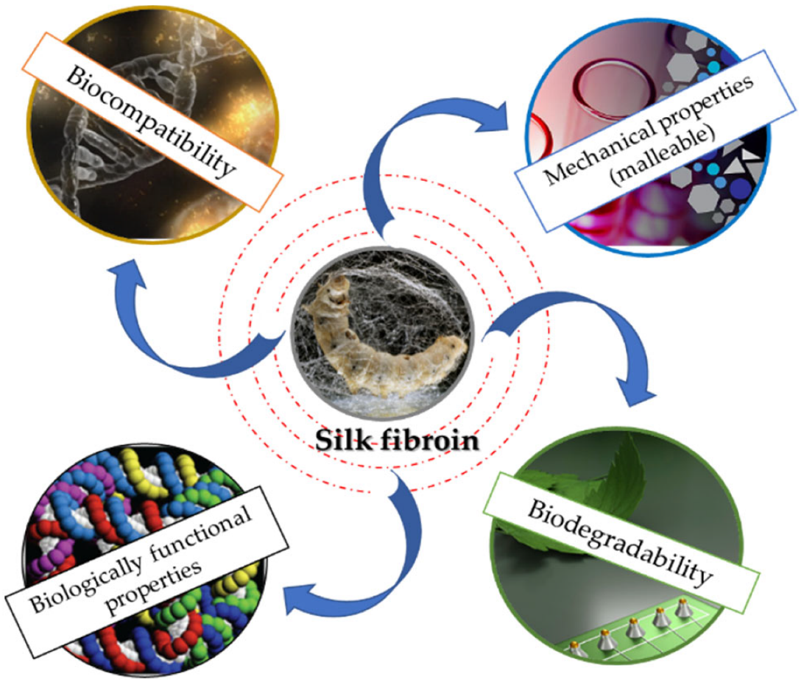
Figure 1. Schematic representation of silk fibroin properties
Sericin, aside from its textile applications, demonstrates a wide array of non-textile utilities, making it a versatile and valuable biomaterial (Dash et al., 2008; Zhang, 2002; Sasaki et al., 2000). These include applications in skin care, food, as an antioxidant, anti-apoptotic, tumour suppressor, anticoagulant, and wound healing agent (Figure 2). Moreover, sericin exhibits excellent biocompatibility and has been found to support cell attachment and growth without any cytotoxic effects (Minoura et al., 1995, Tsubouchi et al., 2005). It has also been shown to accelerate cell proliferation in various cell lines, including mammalian and hybridoma cells, making it a valuable additive in serum-free media (Sasaki et al., 2005, Ogawa et al., 2004). The diverse properties and functionalities of sericin make it a promising candidate for various non-textile applications in the fields of biomedicine, biotechnology, and cell culture research. The extensive research on sericin continues to unveil its potential and expand its utility in diverse industrial and scientific domains.
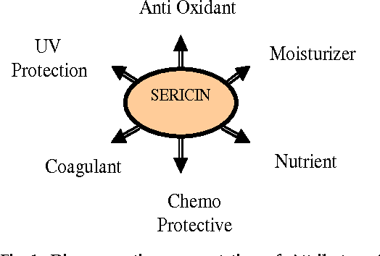
Figure 2. Schematic representation of silk sericin properties

1.3 Biocompatibility
The medical utilization of silk fibroin traces back to the 19th century. It found significant application as sutures during this period owing to its exceptional biocompatibility with the human body. A wealth of reports has substantiated this remarkable characteristic of silk fibroin, solidifying its reputation as a valuable material for medical purposes. In a study by Yin et al. (2022), they formulated hydrogels based on silk fibroin (SF) and introduced rhein into the hydrogel matrix. This incorporation was driven by rhein's noted antibacterial and anti-inflammatory properties. Following the creation of the desired biomaterial, the researchers assessed the biocompatibility of the hydrogel. They accomplished this by examining the haemolysis ratio subsequent to a one-hour exposure of the hydrogel to blood. The outcomes they obtained indicated a positive and favourable biocompatibility profile.
Interestingly, isolated sericin has demonstrated minimal inflammatory activity (Mandal et al., 2009). When solubilized sericin is extracted from silk fibers, it exhibits limited macrophage response, hinting that the presence of sericin-fibroin strands together might trigger such reactions. Consequently, utilizing silk as a biomaterial necessitates the segregation of these two proteins, allowing sericin and fibroin to individually maintain their favourable biocompatibility. Much like other materials, the incorporation of physical cues, such as micro- or nanoscale topography, that mimic natural tissue structures further augments the biocompatibility of silk biomaterials. Collectively, silk fibroin and sericin exhibit a variety of characteristics making them highly biocompatible.
1.4 Mechanical properties and degradability
Mechanical properties such as tensile strength and Young's modulus provide insights into the strength and durability of materials. These characteristics are often evaluated through methods like elongating silk fibers or employing techniques like nanoindentation (Perez et al., 1998; Kurland 2012). Silk fibers possess notable attributes such as high tensile strength, flexibility, and resistance to compressive forces, rendering them suitable for a range of applications. These span from those demanding significant tensile strength, like sutures, to those requiring flexibility, like load-bearing composites.
Additionally, silk fibers exhibit distinctive features, including resistance to cumulative deformation. For instance, silk fibers from the Bombyx mori silkworm display a remarkable tensile strength of 0.5 GPa at a 15% elongation. By eliminating the water-soluble sericin protein coating from the cocoon, the resultant degummed silk fibers demonstrate up to a 50% increase in tensile strength. Despite the impressive mechanical attributes of silk fibroin that make it suitable for load-bearing biomedical applications, certain factors such as non-uniform cross-sectional areas and microstructural defects can lead to decreased fiber reliability and reproducibility. These variations need to be considered when employing silk fibroin for applications demanding consistent and reliable mechanical performance.

1.5 Biodegradability
Biodegradation involves the breakdown of natural polymers into smaller compounds. In the context of medical applications, biodegradability is a crucial requirement for biomaterials. Silk fibroin (SF), owing to its biodegradable nature, has emerged as a prominent biopolymer for various applications in tissue engineering and beyond, often in conjunction with chitosan or collagen. Three primary proteolytic enzymes, namely chymotrypsin, carboxylase, and actinase, contribute to the degradation of silk fibroin. As the biodegradation process unfolds, both the structure and molecular mass of silk fibroin undergo significant transformations (Cao and Wang, 2009). This inherent biodegradable property enhances the suitability of SF for diverse biomedical applications, where the gradual breakdown of the material aligns with the natural processes of tissue remodeling and regeneration.

1.6 Biologically Functional Properties
Wound healing, one of the most intricate processes in the human body, unfolds through four distinct phases: hemostasis, inflammation, cell proliferation, and resolution. However, numerous variables impact this process (Guo and Dipietro, 2010) including factors such as oxygenation, infections, age, and gender (Chen et al., 2022). In response, substantial endeavors are dedicated to developing biomaterials that foster wound healing.
The exceptional properties of silk fibroin have piqued continuous interest for diverse medical applications, including wound healing. Mrowiec et al. (2012) delved into the influence of both fibroin and sericin on the wound healing process, elucidating the molecular basis of their biological functionalities. Their findings substantiated that silk proteins stimulate cell migration. Additionally, they identified fibroin and sericin as active participants in two signalling pathways. These revelations illuminate the potential of silk proteins in advancing wound healing strategies by influencing vital cellular mechanisms. Besides the fact that silk fibroin promotes cell migration, it has been shown that this protein improves cell adhesion. Due to silk fibroin’s great characteristics, it has been shown that it is a promising biomaterial as a coating agent in terms of drug delivery.
1.7 Silk fibroin and tissue engineering
The objective of tissue engineering is to integrate cells with scaffold materials and growth factors, facilitating the regeneration or potential replacement of damaged tissues or organs. The demand for a biomaterial matrix conducive to the creation of viable and biologically functional tissue, whether within the body or in controlled laboratory environments, has escalated in recent years. Extensive evidence has affirmed that silk fibroin fosters the attachment and proliferation of human cells (Kamalathevan and Loo, 2018.). Consequently, it is unsurprising that silk fibroin has attained Food and Drug Administration (FDA) approval as a biomaterial. Its distinct properties and intricate composition make it an apt candidate for scaffold applications in tissue engineering, a testament to its potential to support the intricate processes of tissue regeneration and repair.
In the realm of tissue engineering, silk fibroin has garnered escalating attention within the medical domain. It stands out as a particularly promising substance for scaffold (3D) construction, adept at emulating the intricate natural extracellular matrix. Moreover, the ease of manipulation during processing, coupled with its outstanding biocompatibility, noteworthy mechanical attributes, and customizable degradability, positions silk fibroin as a formidable contender in the domains of tissue engineering and regenerative medicine. Its multifaceted appeal makes it a compelling choice for crafting scaffolds that foster tissue growth and regeneration, offering a substantial contribution to the advancement of therapeutic solutions.

1.8 Biomedical

Sericin boasts a multitude of medical applications, ranging from its potential as antioxidants and anticancer agents to its use as anticoagulants. Investigations into the macrophage response towards silk proteins reveal that solubilized sericin generally demonstrates minimal inflammatory activity. However, the study of macrophage activation in relation to silk proteins indicates that when sericin is affixed to fibers, it triggers inflammatory responses (Panilaitis et al., 2003).

1.9 Bioconjugates

Bioconjugation with natural or synthetic polymers provides methods of delivering drugs such as peptides, enzymes, and oligonucleotides (Veronese and Morpurgo, 1999). Bioconjugation (e.g., polymer–protein) is advantageous because it leads to reduced immunogenicity and improved stability. Polymer conjugation with drugs promotes tumor targeting through enhanced permeability and retention. Several investigators have exploited sericin as a natural polymer for bioconjugation with therapeutic proteins, enzymes, and polysaccharides.

2.0 Sericin matrices

Both two-dimensional (films) and three-dimensional matrices (hydrogel and porous scaffolds) from sericin have been reported. Membranes of sericin are fragile in the dry state. Blending sericin with water-soluble polymers like polyvinyl alcohol (PVA) for making films has been investigated. Films derived from sericin-hope cocoons exhibit fibrous characteristics upon hydration and can serve as viable materials for drug delivery and tissue engineering, free from concerns of toxicity (Teramoto and Miyazawa, 2005). Films generated from sericin, whether extracted from cocoons or directly from silk glands, along with sericin cross-linked with polyethylene glycol diglycidyl ether, have undergone assessment in terms of their cytocompatibility and strength.

2.1 Production of recombinant bioactive proteins in sericin layer of cocoon of transgenic silkworms

Silk proteins are synthesized in substantial quantities, ranging from 0.5 to 2.2 grams, by silkworms, with production levels contingent on the species. Sericin, in particular, is synthesized within the silk gland's major secretory portion. This inherent production capability holds potential for large-scale generation of recombinant proteins. Researchers are actively involved in developing transgenic silkworms, capable of producing cocoons housing recombinant human collagen sequences integrated into the fibroin layer. This advancement showcases the intricate possibilities presented by manipulating silk-producing organisms for the efficient synthesis of desired biomolecules.
Novel developments in biotechnology have led to the creation of transgenic silkworms. These organisms have been engineered to express fusion proteins that combine fibroin L-chain and human basic fibroblast growth factor within the posterior silk gland, as demonstrated by Hino et al. (2006). Correspondingly, advancements have been made in expressing enhanced green fluorescence protein within the sericin layer of the cocoon (Tomita et al., 2007). This technology exhibits broad applicability for producing a diverse array of clinically significant recombinant proteins. This encompasses vital categories such as blood coagulation proteins, cytokines, growth factors, and peptide hormones. The innovative utilization of transgenic silkworms exemplifies the potential of biotechnological approaches in synthesizing intricate and valuable biomolecules for medical and therapeutic applications.

2.2 Conclusion

In the realm of biotechnology, silk proteins have emerged as remarkable and multifaceted biopolymers with immense significance. Their unique properties, derived from the intricate interplay of fibroin and sericin, offer a versatile platform for a plethora of applications across various sectors. From their historical cultural uses to the forefront of cutting-edge research, silk proteins have proven their mettle as valuable resources. These proteins exhibit exceptional biocompatibility, tunable mechanical characteristics, and the ability to support cellular growth and regeneration, making them pivotal in fields such as tissue engineering, drug delivery, and wound healing. Moreover, the advent of transgenic silk-producing organisms has opened doors to the production of recombinant proteins with therapeutic potential. As science continues to uncover the intricate potentials of silk proteins, their biotechnological importance remains unparalleled, offering a promising avenue for innovation and advancement in the realms of healthcare, materials science, and beyond.
References
Altman, G.H., Diaz, F., Jakuba, C., Calabro, T., Horan, R.L., Chen, J., Lu, H., Richmond, J. and Kaplan, D.L., 2003. Silk-based biomaterials. Biomaterials, 24(3): 401-416.
Cao, Y., and Wang, B. 2009. Biodegradation of silk biomaterials. International journal of molecular sciences, 10(4): 1514-1524.
Chen, Z. J., Zhang, Y., Zheng, L., Zhang, H., Shi, H. H., Zhang, X. C., and Liu, B. 2022. Mineralized self-assembled silk fibroin/cellulose interpenetrating network aerogel for bone tissue engineering. Biomaterials Advances, 134. Pp:112549.
Dash, R., Acharya, C., Bindu, P. C., and Kundu, S. C. 2008. Antioxidant potential of silk protein sericin against hydrogen peroxide-induced oxidative stress in skin fibroblasts. BMB reports, 41(3): 236-241.
Geier, P. W. 1963. The life history of Codling Moth, Cydia pomonella (L) (Lepidoptera: Tortricidae), in the Australian Capital Territory. Australian journal of zoology, 11(3): 323-367.
Guo, S. A., and DiPietro, L. A. 2010. Factors affecting wound healing. Journal of dental research, 89(3): 219-229.
Hino, R., Tomita, M., and Yoshizato, K. 2006. The generation of germline transgenic silkworms for the production of biologically active recombinant fusion proteins of fibroin and human basic fibroblast growth factor. Biomaterials, 27(33): 5715-5724.
Holland, C., Numata, K., Rnjak‐Kovacina, J., and Seib, F. P. 2019. The biomedical use of silk: past, present, future. Advanced healthcare materials, 8(1): 1800465
Johnson, C. D., Romero, J., and Raimúndez-Urrutia, E. 2001. Ecology of Amblycerus crassipunctatus Ribeiro-Costa (Coleoptera: Bruchidae) in seeds of Humiriaceae, a new host family for bruchids, with an ecological comparision to other species of Amblycerus. The Coleopterists Bulletin, 55(1): 37-48.
Jolly, M. S., Sen, S. K., and Ahsan, M. M. 1974. Tasar culture. 1st ed. Mumbai: Ambika Publishers.
Jones, D. 1985. The endocrine basis for developmentally stationary prepupae in larvae of Trichoplusia ni pseudoparasitized by Chelonus insularis. Journal of Comparative Physiology B, 155: 235-240.
Kamalathevan, P., Ooi, P. S., and Loo, Y. L. 2018. Silk-based biomaterials in cutaneous wound healing: a systematic review. Advances in skin & wound care, 31(12): 565-573.
Kauffman, W. C., and Kennedy, G. G. 1989. Toxicity of allelochemicals from wild insect-resistant tomato Lycopersicon hirsutum f. glabratum to Campoletis sonorensis, a parasitoid of Heliothis zea. Journal of Chemical Ecology, 15: 2051-2060.
Kurland, N. E., Drira, Z., & Yadavalli, V. K. (2012). Measurement of nanomechanical properties of biomolecules using atomic force microscopy. Micron, 43(2-3), 116-128.
Leem, J. W., Fraser, M. J., and Kim, Y. L. 2020. Transgenic and diet-enhanced silk production for reinforced biomaterials: a metamaterial perspective. Annual Review of Biomedical Engineering, 22: 79-102.
Mandal, B. B., Priya, A. S., and Kundu, S. C. 2009. Novel silk sericin/gelatin 3-D scaffolds and 2-D films: fabrication and characterization for potential tissue engineering applications. Acta Biomaterialia, 5(8): 3007-3020.
Minoura, N., Aiba, S. I., Gotoh, Y., Tsukada, M., and Imai, Y. 1995. Attachment and growth of cultured fibroblast cells on silk protein matrices. Journal of biomedical materials research, 29(10): 1215-1221.
Mrowiec, A., Martinez-Mora, C., García-Vizcaíno, E. M., Alcaraz, A., Cenis, J. L., and Nicolás, F. J. 2012. Fibroin and sericin from Bombyx mori silk stimulate cell migration through upregulation and phosphorylation of c-Jun.
Nogueira, G. M., de Moraes, M. A., Rodas, A. C. D., Higa, O. Z., and Beppu, M. M. 2011. Hydrogels from silk fibroin metastable solution: Formation and characterization from a biomaterial perspective. Materials Science and Engineering: C, 31(5): 997-1001.
Ogawa, A., Terada, S., Kanayama, T., Miki, M., Morikawa, M., Kimura, T., Yamaguchi, A., Sasaki, M. and Yamada, H. 2004. Improvement of islet culture with sericin. Journal of bioscience and bioengineering, 98(3): 217-219.
Ozkale, B., Sakar, M. S., and Mooney, D. J. 2021. Active biomaterials for mechanobiology. Biomaterials, 267: pp. 120497.
Panda, D., Konar, S., Bajpai, S. K., and Arockiarajan, A. 2018. Thermodynamically-consistent constitutive modeling of aligned Silk fibroin sponges: Theory and application to uniaxial compression. International Journal of Solids and Structures, 138: 144-154
Panilaitis, B., Altman, G. H., Chen, J., Jin, H. J., Karageorgiou, V., and Kaplan, D. L. 2003. Macrophage responses to silk. Biomaterials, 24(18): 3079-3085.
Perez‐Rigueiro, J., Viney, C., Llorca, J., & Elices, M. (1998). Silkworm silk as an engineering material. Journal of Applied Polymer Science, 70(12), 2439-2447.
Sasaki, M., Kato, Y., Yamada, H., and Terada, S. 2005. Development of a novel serum‐free freezing medium for mammalian cells using the silk protein sericin. Biotechnology and applied biochemistry, 42(2): 183-188.
Sasaki, M., Yamada, H., and Kato, N. 2000. A resistant protein, sericin improves atropine-induced constipation in rats. Food science and technology research, 6(4): 280-283.
Sun, W., Gregory, D. A., Tomeh, M. A., and Zhao, X. 2021. Silk fibroin as a functional biomaterial for tissue engineering. International Journal of Molecular Sciences, 22(3):1499.
Teramoto, H., and Miyazawa, M. 2005. Molecular orientation behavior of silk sericin film as revealed by ATR infrared spectroscopy. Biomacromolecules, 6(4): 2049-2057.
Tomita, M., Hino, R., Ogawa, S., Iizuka, M., Adachi, T., Shimizu, K., Sotoshiro, H. and Yoshizato, K. 2007. A germline transgenic silkworm that secretes recombinant proteins in the sericin layer of cocoon. Transgenic research, 16(4):.449-465.
Tsubouchi, K., Igarashi, Y., Takasu, Y., and Yamada, H. 2005. Sericin enhances attachment of cultured human skin fibroblasts. Bioscience, biotechnology, and biochemistry, 69(2): 403-405.
Veronese, F. M., and Morpurgo, M. 1999. Bioconjugation in pharmaceutical chemistry. Il Farmaco, 54(8): 497-516.
Vollrath, F., and Knight, D. P. 2001. Liquid crystalline spinning of spider silk. Nature, 410(6828): 541-548.
Xiao, X., Changsheng, C. H. E. N., Weiqiang, L. I. U., and Yeshun, Z. 2017. Structure, features and biomedical applications of silk sericin. Progress in Chemistry, 29(5):513.
Yin, C., Han, X., Lu, Q., Qi, X., Guo, C., and Wu, X. 2022. Rhein incorporated silk fibroin hydrogels with antibacterial and anti-inflammatory efficacy to promote healing of bacteria-infected burn wounds. International Journal of Biological Macromolecules, 201:14-19.
Zhang, Y. Q. 2002. Applications of natural silk protein sericin in biomaterials. Biotechnology advances, 20(2): 91-100.
Zhao, H. P., Feng, X. Q., Cui, W. Z., and Zou, F. Z. 2007. Mechanical properties of silkworm cocoon pelades. Engineering Fracture Mechanics, 74(12): 1953-1962.

