**Determination of Stable Zones of LFC for a Power System Considering Communication Delay**

**Dr.D.Venugopal1, Ch.Bhasker2, Dr.K.Madhulatha3**

**1Kamala Institute of Technology and Science, Singapur , Huzurabad. Karimnagar, Telangana State.**

**Email: venufacts20m@gmail.com**

**ABSTRACT:** In the present paper, stable and unstable regions of fractional based load frequency control(LFC) for a two area system have been estimated. The communication delay due to measurements and other reasons is also considered in the present system. A graphical technique has been utilized to find the locus of fractional controller parameters. The system with controller is examined in MATLAB environment by considering various controller parameter values from different regions. The simulation results show that fractional controller has wide range of stabilty regions as compared to simple PI controller.

Keywords: Power system, Delay, LFC, Stabilty regions

**1. Introduction**

In an electrical power system network, frequency is very important control parameter along with voltage control. This is because of several apparatures are operating at specified frequency range. Hence the frequency fluctuation need to be kept at predefined range. Active power is directly proportional to the frequency. Therefore, frequency fluctuations can be controlled by controlling the active power. [1-3]. In literature [4-5], different linear models of power system are considered for LFC issues. But in power system, delay in communication causes many problems. Therefore, communication delay need to be included in LFC problem. This delay may happen in two ways. The first one is due to measurement of frequency and active power. The second delay happens between control center and generator units [6-10]. This delay is defined by $e^{ST_{d}}$ (here *Td*is called approximated delay).

In the literature[11-12],different LFC methods are present for minimizing frequency and tie line power deviations. In the present paper, concept of fractional based LFC has been used due to its merits such as wide range of stability, design flexibility, etc.[13-15].A system said to be a stable if only it has the capability to attain its original state after clearance of any unwanted disturbance. Therefore, the controller parameters need to be selected very carefully in order to protect the power system entering into unstable zones.This work gives the unstable and stable areas of power system for various α value. From Fig.1., $T_{d1}$ is defined asarea1 communication delay, $T_{d2}$ is defined as area2 delay, $T_{g1}, T_{t1}, M_{1}, D_{1}, β_{1}, R_{1, }T_{g2}, T_{t2}, M_{2}, D_{2}, β_{2}\&R_{2}$ are the governor time constant and turbine time constant, governor moment of inertia, governor damping factor, frequency bias factor, governor speed regulation of area1 and area2 respectively. From Fig. 1, $K_{ps1}$ and $T_{ps1}$ are the area1 power system gain and time constant respectively. ${ΔF}_{1}$ is the frequency devition in area1, ${ΔF}_{2}$ is the frequency deviation in area2, ${ΔP}_{tie1}$ and ${ΔP}_{tie1}$ are thearea1 and area2 tie-line power deviations respectively. ACE1 is the area1 control error and ACE2 is thearea2 control error. The two area system parameters are considered from [8].



Fig.1: Two area LFC/AGC system.

**2. Stable and unstable areas of fractional LFC parameters**

The characteristics of LFC including,&, can determined from Fig. 1. The following assumptions are considered while determining the characteristic equation.

1. Deviation of tie line power is assumed to be nill.

2. Both areas are having same communication delay.

3. Both system parameters are identical i.e., ,,,,&

From Fig. 1., characteristic equation of LFC system can be obtained as (1).

==0 (1)

After simplification of (1),

 (2)

Here,

,,  , 

Substitute=and =  (3)

Real part of =0 is

 (4)

Imaginary part of=0

 (5)

Simplifying equations (4)and (5), we get (6) & (7)

 (6)

 (7)

Where

=;=

  
;



**3. Results & discussion**

Fig.2. shows various stable and unstable areas forat distinct values. Dynamic response analysis is carried out to investigate the controller behavior considering a point (,) in regions *R1, R2, R3*and *R4* for distinctvalues. AGC is absolutely stable in the zone for larger values.



Fig.2: stable and unstable zones of fractional PI-controller for*Td*=2.28sec.

Table: 1 Parameters of fractional calculus based controller

|  |  |  |  |  |  |  |  |  |
| --- | --- | --- | --- | --- | --- | --- | --- | --- |
| $$α$$ | **Region *(R1)*** | | **Region *(R2)*** | | **Region *(R3)*** | | **Region *(R4)*** | |
| ***Kp*** | ***Ki*** | ***Kp*** | ***Ki*** | ***Kp*** | ***Ki*** | ***Kp*** | ***Ki*** |
| 1 | 0.4 | 0.2 | 0.6 | -0.5 | 1 | 1 | 1.5 | 3 |
| 1.1 | 0.2 | 0.5 | 0.4 | -1 | 1 | 2 | 1.5 | 3.5 |
| 1.2 | 0.8 | 0.2 | 0.7 | -0.2 | 1 | 3.55 | 1.1 | 3.85 |
| 1.3 | 1 | 0.5 | 0.5 | -0.5 | 1 | 4 | 1.5 | 4.5 |
| 1.4 | 1.1 | 0.65 | -0.5 | -2 | 1.5 | 2 | 2 | 6 |
| 1.5 | 1 | 0.5 | 0.5 | -5 | 1 | 5 | 1.5 | 7 |

***Case*1:When α = 1**

It can be noticed from Fig. 3(a), Fig. 4(a) and Fig. 5(a) that AGC is absolutely stable in R1. Also it is clear from Fig. 3(b), Fig. 4(b) and Fig. 5(b) that power system is unstable in R2

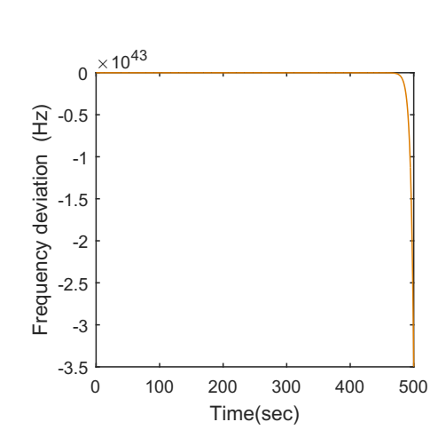

(a)&(Region R1) (b)&(Region R2)

Fig.3:Frequency deviations of area1(A1)

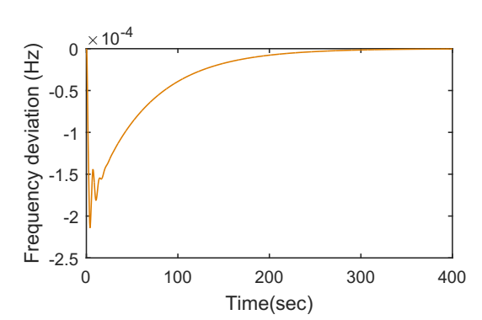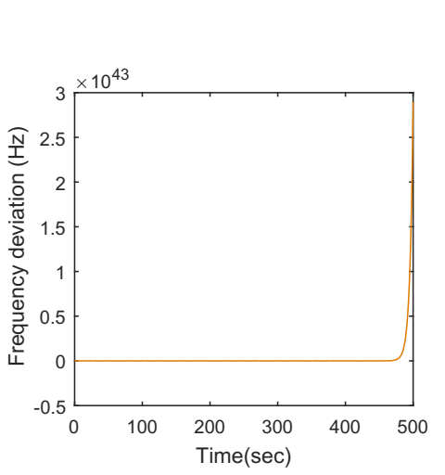

(a)&(Region R1) (b) &(Region R2)

Fig.4:Frequency deviations of area2(A2)

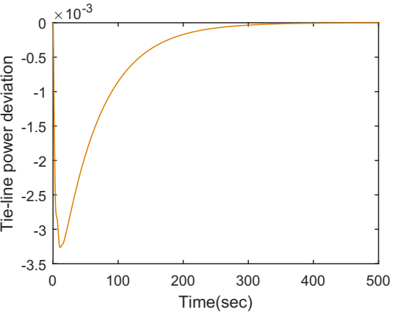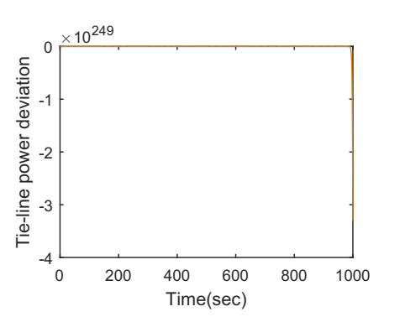

(a)&(Region R1) (b) &(Region R2)

Fig.5: Tie line power deviations

***Case2:* When α = 1.3**

It can be noticed from Fig. 6(a), Fig. 7(a) and Fig. 8(a) that AGC is stable in R1. Also it is clear from Fig. 6(b), Fig. 7(b) and Fig. 8(b) that power system is unstable in R2.

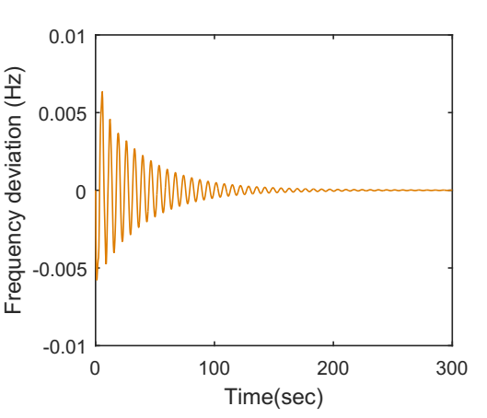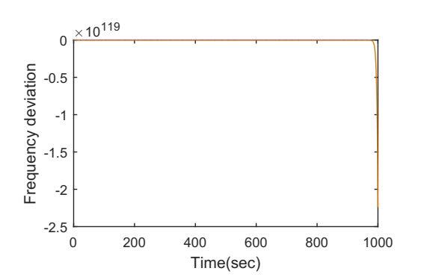

(a)&(Region R1) (b) &(Region R2)

Fig.6:Frequency deviations of area1(A1)

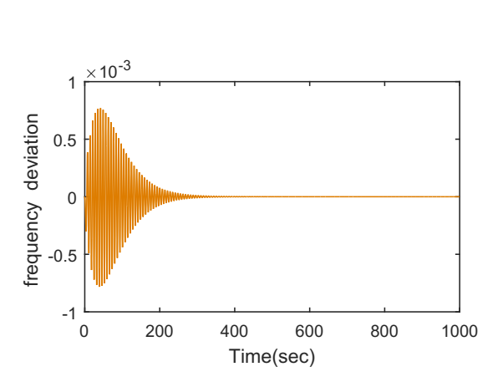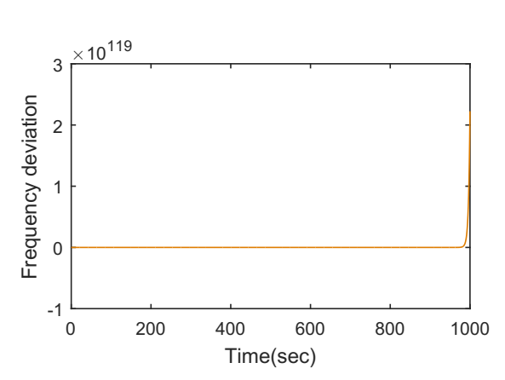

(a)&(Region R1) (b) &(Region R2)

Fig.7:Frequency deviations of area2(A2)

***Case 3:* When α = 1.5**

It can be noticed from Fig. 9(a), Fig. 10(a) and Fig. 11(a) that AGC is absolutely stable in R1. Also it is clear from Fig. 9(b), Fig. 10(b) and Fig. 11(b) that power system is unstable in R2.

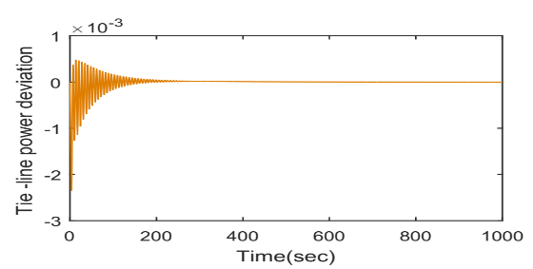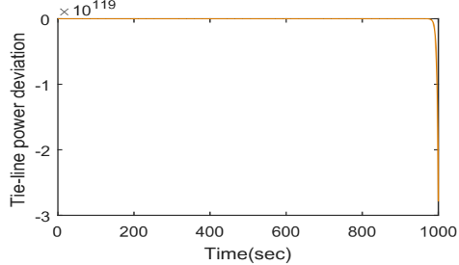

(a)&(Region R1) (b) &(Region R2)

Fig.8: Tie line power deviations

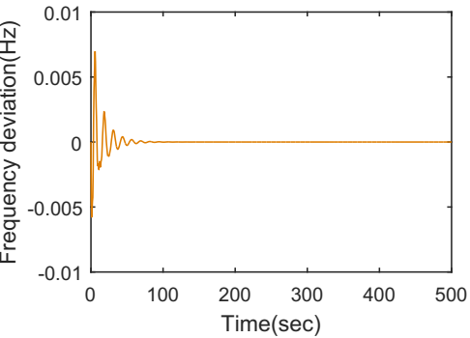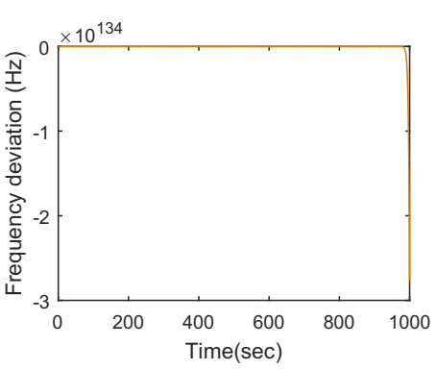

(a)&(Region R1) (b) &(Region R2)

Fig.9:Frequency deviations of area1(A1)

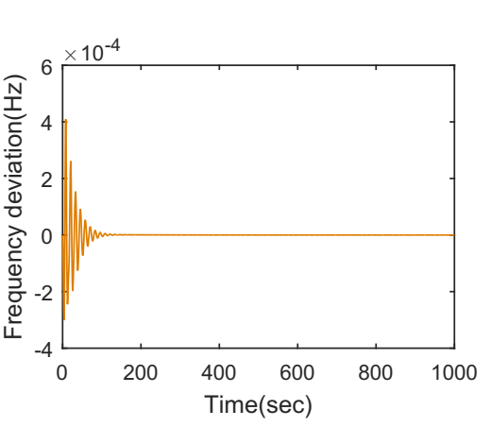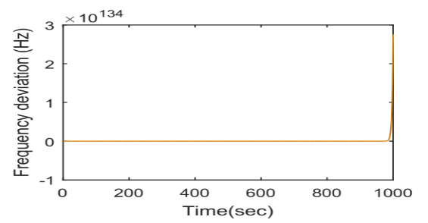

(a)&(Region R1) (b) &(Region R2)

Fig. 10:Frequency deviations of area2(A2)

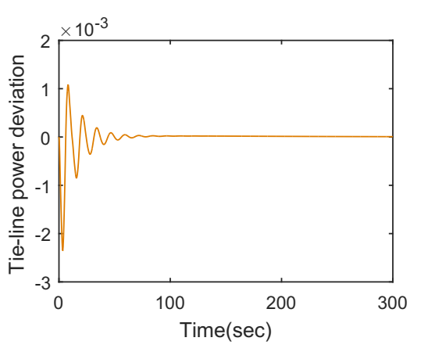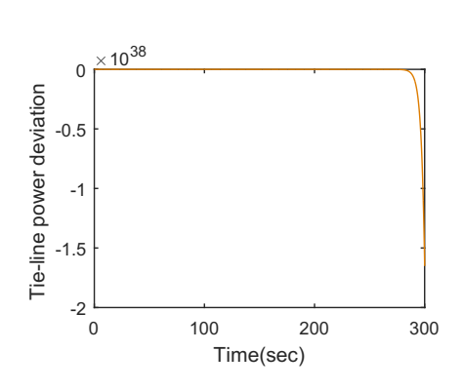

(a)&(Region R1) (b) &(Region R2)

Fig.11: Tie line power deviations

**4. Conclusion**

In the present work, the stable and unstable regions of controller parameters are determined by employing a simple graphical method. It is noticed from MATLAB simulations that the fractional controller has wide range of stable areas. Therefore, the fractional based controller can have more choices of controller gains in order to maintain the stability of the power system.

**References:**

[1] I.J. Nagrath, D.P. Kothari, power system engineering, 3rd ed., McGraw-Hill, Singapore, 2003.

[2]Olle I. Elgered, Electrical energy systems theory, Tata MCgraw -Hill ,1976.

[3] Prabha kundur, power system stability and control, Tata MCgraw –Hill, new York, 1994.

[4] Sahaj Saxena,Load frequency control strategy via fractional-order controller and reduced-order modeling,International Journal of Electrical Power & Energy Systems,Volume 104,2019,Pages 603-614,ISSN 0142-0615.

[5] I Kasireddy, A W Nasir and A K Singh, “Application of FOPID-FOF Controller Based on IMC Theory for Automatic Generation Control of Power System”, IETE Journal of research, Dec-2019.

[6]Hany M. Hasanien, Attia A. El-Fergany,Salp swarm algorithm-based optimal load frequency control of hybrid renewable power systems with communication delay and excitation cross-coupling effect,Electric Power Systems Research,Volume 176,2019.

[7]Gaber Magdy, G. Shabib, Adel A. Elbaset, Thongchart Kerdphol, Yaser Qudaih, Hassan Bevrani, Yasunori Mitani,Tustin's technique based digital decentralized load frequency control in a realistic multi power system considering wind farms and communications delays,Ain Shams Engineering Journal,Volume 10, Issue 2,2019.

[8]Sahin Sönmez, Saffet Ayasun, Stability region in the parameter space of PI controller for a single-area load frequency control system with time delay, IEEE Transactions on Power Systems, 31(1), 829-830, 2016.

[9] N. Tan, I. Kaya, C. Yeroglu, and D. P. Atherton, “Computation of stabilizing PI and PID controllers using the stability boundary locus,” Energy Convers. Manage., vol. 47, pp. 3045–3058, 2006.

[10]S. Sönmez, S. Ayasun, and U. Eminoglu, “Computation of time delay margins for stability of a single-area load frequency control system with communication delays,” WSEAS Trans. Power Syst., vol. 9, pp.67–76, 2014.

[11]Jianping Guo,Application of full order sliding mode control based on different areas power system with load frequency control,ISA Transactions,Volume 92,2019.

[12]Jitendra Sharma, Yogesh V. Hote, Rajendra Prasad,PID controller design for interval load frequency control system with communication time delay,Control Engineering Practice,Volume 89, 2019.

[13] Concepción A. Monje, Yang Quan Chen, BlasM. Vinagre, Dingyü Xue, Vicente Feliu, Fractional-order Systems and Control, Springer 2010.

[14]D Bensiker Raja Singh, R Suja Mani Malar,Implementation of Fractional Pi Controller for Optimal Speed Control of Induction Motor Fed with Quasi Z-Source Converter,Microprocessors and Microsystems,2020.

[15] C. Muresan, E. H. Dulf, and R. Both, “A novel tuning algorithm for fractional order IMC controllers for time delay processes,” Int. J. Mech. Eng. Robot. Res., Vol. 4, no. 3, pp. 218–221, 2015.