Sculpting Healthcare's Future: The Art of Integrating AI and Nanomedicine
Abstract
This chapter highlights the implications of integrating Artificial intelligence (AI) in nanomedicine, specifically catering to advocates of the trio medicine model: Nanomedicine, AI, and Precision medicine. This showcases constructive impact across these dimensions, spotlighting its instrumental role in refining diagnostics, facilitating targeted treatments, and enhancing personalized healthcare. It also considers ethical considerations, potential challenges, and prospects, emphasizing AI’s pivotal role in shaping a healthcare landscape that seamlessly aligns with the trio medicine model.
- Introduction
The integration of AI in Nanomedicine is driven by an increasing demand for innovative solutions in healthcare. AI’s computational prowess and pattern recognition abilities complement the precision and potential of nanotechnology, leading to groundbreaking advancements in medical diagnosis, treatment, and drug development. By harnessing AI’s capacity to optimize nanoscale processes, researchers and medical practitioners can unlock new frontiers in personalized medicine, targeted drug delivery (TDD), and enhanced therapeutic outcomes.
AI is a transformative concept involving the use of computer systems to stimulate intelligent behavior with limited human intervention. Its origin can be traced back to the invention of robots, a term derived from the Czech word ‘’robota’’ referring to biosynthetic machines used for forced labor. A remarkable contribution to the advancement of AI was made by LEONARDO Da Vinci, whose sketches of robots laid the foundation for innovations like robotic-assisted surgery in complex medical procedures, particularly in urology and gynaecology. [1]
AI is essential in nanomedicine because it can analyze vast biological and chemical data, accelerating drug discovery and development processes for nanomedicine. It enables personalized medication by predicting patient responses to specific treatments and optimizing drug delivery systems for enhanced targeting and reduced toxicity. AI also aids in image analysis for accurate diagnostics and real-time monitoring using Nanosensors. Overall, AI’s integration in nanomedicine drives advancements in precision medicine, patient care, and treatment effectiveness.
1.1 The Magical Alliance: Exploring AI’s spellbinding role in Nanomedicine refers to the fascinating collaboration between artificial intelligence (AI) and nanomedicine, where AI-driven techniques and algorithms are employed to revolutionize healthcare at the nanoscale level. This alliance holds immense potential in precision medication with unprecedented efficacy and accuracy (Figure 1).
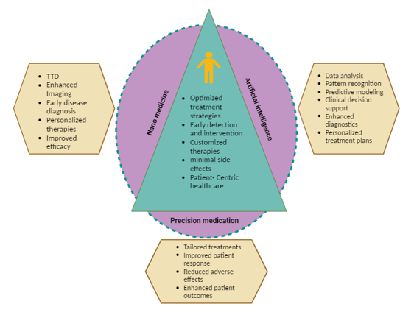
Figure 1: Synergies between Nanomedicine-AI and Precision medicine
2. Fundamentals of Nanomedicine
In the 20th century, scientific medicine radically transformed from a rational to a molecular basis. This led to groundbreaking discoveries like antibiotics that combat pathogens at the molecular level, reducing bacterial infections. Advancements in genomics proteomics, and bioinformatics provided detailed knowledge of human biology at the molecular level. Mapping the human genome opened up possibilities to design microscopic machines for cellular inspection and repair, aiming to maintain continuous health.
Though medical science achieved significant successes, some diseases still challenge us, with current pharmacological agents only providing control, not cures. The vision of nanotechnology in medicine, as proposed by Feynman, is gradually becoming a reality with the emergence of nanomedicine. Nanomedicine, through engineered nanodevices, aims to monitor, repair, and control human biological systems at the molecular level, offering hope to eradicate suffering, improve diagnostics, prevent diseases, and enhance human health while reducing healthcare costs. [2]
3. Unravelling the AI-Nano Marvels
In recent years, there has been a remarkable surge in the advancement of nanoparticles, leading to their widespread application in various clinical scenarios. These nanoparticles have been meticulously designed to surmount the limitations of conventional therapeutics and effectively navigate through the complex biological barriers encountered in diverse patient populations and diseases. Addressing such patient heterogeneity has been facilitated by the emergence of precision therapeutics, wherein personalized interventions have demonstrated heightened therapeutic effectiveness. Despite these advancements, the focus in nanoparticle development has predominantly been on creating standardized delivery platforms, lacking the necessary personalization.
To embark on the realm of precision medicine, there is a compelling need to shift nanoparticle development towards more individualized approaches. By engineering lipid-based, polymeric, and inorganic nanoparticles with greater specificity, a profound transformation can be achieved in drug delivery, embracing a more tailored methodology. This transformative endeavor marks the dawn of the precision medicine era. In a comprehensive review, Mitchell and Co. highlighted the intricacies of advanced nanoparticle designs employed in both non-personalized and precision medicine applications, with the goal of enhancing precision therapies [3].
Our main emphasis lies in highlighting the novel nanoparticle design breakthroughs that triumph over the heterogeneous barriers that hinder effective delivery. Our contention is that through ‘’intelligent nanoparticle design’’, not only can efficacy be improved across general delivery applications, but also personalized designs can be achieved for precision medicine applications, ultimately leading to ameliorated patient outcomes on a broader scale.
- AI Rise in Healthcare: From Algorithms to Augmented Intelligence
To comprehend and deal with the vast expense of data, scientists have harnessed algorithmic approaches from Machine learning (ML), a thriving domain within Artificial Intelligence (AI). Deep learning (DL), a subfield of ML, involves representation learning. In this approach, algorithms are fed raw data as input, and they generate representations that facilitate pattern recognition. In this era DL has become a norm, showcasing its applications in various domains such as self-driving cars, facial recognition systems, and deep fake technology [4]. IBM’s Watson, introduced in 2011, is a prime example of AI’s capabilities, triumphing in the jeopardy competition and later finding use in cancer case management at a New York Hospital. Additionally, the FDA’s approval of the AI-based device IDx-Dr in 2018 highlights its potential in diabetic retinopathy screening using retinal scans [5].
In this symbiotic relationship, AI’s prowess in intelligently analyzing complex data aligns perfectly with the intricate realm of neuroscience. With large-scale AI-based simulations, neuroscientists can test their hypotheses and gain deeper insights into brain functions. Beyond this, AI serves as an indispensable tool for neuroimaging data analysis, significantly easing the burden on radiologists and unlocking new possibilities in understanding the human brain [6].
Studies reveal the superiority of AI-driven Propofol administration over anaesthesiologists in achieving target anesthesia and reducing wake-up time. AI-integrated infusion shows promise in shortening post-operative complications and hospital stays. Scientists are exploring automatic sleep-analgesia and fluid administration for future clinical application. With AI’s proactive approach, it can detect biochemical, physiological, genetic, or epigenetic changes before visible disease symptoms, ushering in a proactive and preventive paradigm in healthcare [7]. A novel deep-learning model utilizing 2D parasternal long-axis videos from echocardiography has been created to detect severe aortic stenosis (AS) without Doppler imaging. This point-of-care approach shows interpretability through saliency maps highlighting key predictive regions like the aortic valve, mitral annulus, and left atrium. The model’s predicted probabilities even correlate with the severity of AS in non-severe cases, demonstrating the potential for effective automated screening in various stages of AS. This innovation offers promise for accurate and accessible severe AS diagnosis via single view 2D echocardiography [8].
- Al’s Serenade in drug discovery and development
Recently, the synergy of artificial intelligence (AI) and the quality by design (QbD) approach has been investigated to formulate a poorly water-soluble drug with the potential for treating liver cancer, using silymarin as a model drug. By applying a detailed QbD approach, the influence of critical process parameters on particle size, size distribution, and entrapment efficiency was analyzed. Response surface designs were used to optimize lecithin/chitosan nanoparticles, resulting in a formula with nanoparticles of 161 nm size, 0.2 polydispersity index, and 97% entrapment efficiency. Al-drive neural networks accurately predicted drug release from the optimized procedure, demonstrating the potential for enhanced cytotoxicity against liver cancer cells, thus advancing data-driving pharmaceutical research practices [9].
Researchers have traditionally examined hypertension using established drug-targeting methods such as ACE inhibitors, aldosterone inhibitors, and renin inhibitors. Yet, there is a recent focus on novel drug delivery methods, including nanoparticles, and emerging pharmacological approaches like ACE2 and APA inhibitors for treating hypertension. The exploration extends to managing hypertension via nanotechnology, approved and patented antihypertensive medications, and the promising integration of smart devices and artificial intelligence (AI) to improve therapeutic outcomes [10].
Artificial apoptotic cells loaded with itaconic acid (AI-Cells) possess engineered plasma membranes and surface features. Administered intravenously, Al-cells localize to the liver and target hepatic macrophages, mitigating inflammation in acetaminophen-induced acute liver failure (ALF). Mechanistically, AI cells inhibit caspase-1, curbing NLRP3 inflammasome activity and fostering anti-inflammatory memory-like macrophages, offering the potential treat diverse liver failures via controlled inflammation and homeostasis orchestration [11]
Diagnostic nanomaterials assemble patient-specific disease profiles, aided by therapeutic nanotechnologies for enhanced treatment outcomes. Challenges arise from cancer and patient heterogeneity, complicating platform design and analysis. AI integration offers a solution, utilizing pattern analysis and classification algorithms to enhance diagnostics (Figure 2). AI also optimizes nanomedicine design by predicting interactions with target drugs, biological elements, immune responses, vasculature, and cell membranes, ultimately impacting therapeutic effectiveness [12]. AI and nanotech synergy enhance patient data collection and customize nanomaterials for accurate cancer therapy. Personalized disease profiles are built with diagnostic nanomaterials, and AI-driven therapeutics refine treatment [13].
AI plays a pivotal role in cost reduction within drug development, optimizing research and development procedures. Machine learning algorithms aid in experimental design and forecasting drug candidate pharmacokinetics and toxicity. This ability facilitates lead compound prioritization and refinement, diminishing reliance on resource-intensive animal testing, thus curbing expenses. Persistent investments in and exploration of AI within the pharmaceutical sector hold promising potential for elevating drug development procedures and improving patient care [14].
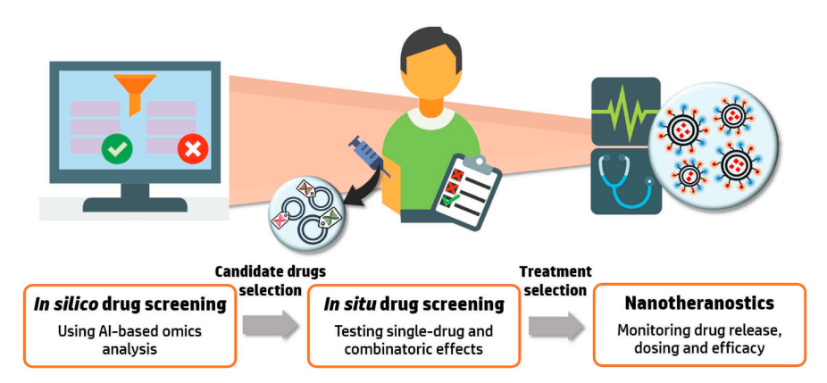
Figure 2: The integration of AI and nano-medicine tailors’ medication to enter a new paradigm. AI-driven drug screening utilizing patient’s omics profile. Reprinted [12]
Innovative AI-nanotechnology-based systems serve as therapeutics or carriers for active pharmaceutical agents. Marketed options encompass nanocrystals, liposomes, lipid nanoparticles, PEGylated polymeric nanodrugs, polymers, and protein-based, and metal-based nanoparticles. Addressing ethics, market potential, costs, and commercial viability is crucial during development. Few nano formulations that clear ethical and biological assessments, secure investor confidence, and promise profitability ultimately receive marketing approval.
- The Ethical Ensemble: Privacy and data security concerns in AI-Driven Healthcare
Accountability is a pressing concern In AI tech adoption in nanomedicine. A scenario is envisioned where an automated medical technology gains approval and enters the market, with trained medical professionals incorporating it into practice. AI is seen as a supportive tool that alleviates the burden on physicians, enhances precision, and minimizes errors. Despite numerous benefits, the question of accountability arises in the event of unwanted outcomes. Determining responsibility among scientists, corporations, regulatory bodies, hospitals, and doctors remains complex and requires legal adaptation to address evolving challenges [15].
The possibility of clinical inaccuracies and responsibility linked to algorithms, which is similar to human doctors, cannot ensure absolute precision. Ethical concerns, data security vulnerabilities, potential biases, and disparities in healthcare are among the other considerations that need attention [16]. While conveying AI-associated procedures to patients can also cause ethical dilemmas. Informed consent requires patients to grasp the procedure, alternative, rationale, risks, and complications. Should AI processes become opaque (‘black box’), eroding understanding for both doctors and patients, the consent’s significance diminishes. Despite obtaining consent, inadequate comprehension renders it un-informed. A vague explanation like our algorithm chose this procedure, but we can’t explain why, short of ensuring ethical consent.
While a future without human involvement in medical practice might seem far off, the current level of AI tech presents both utopian possibilities and dystopian challenges. Supervision and oversight of machines, as well as monitoring and rectifying data discrepancies, necessitate human presence. Although machines can work tirelessly, they are prone to algorithmic confusion and errors, unlike humans. Currently, AI operates in tandem with human medical practitioners, offering assistance while ethical concerns like patient privacy, data protection, cybersecurity, bias, and accountability loom. As AI advances, novel ethical dilemmas are likely to emerge in the field of nanomedicine.
- References
- Hamet, P. and J. Tremblay, Artificial intelligence in medicine. Metabolism, 2017. 69s: p. S36-s40.
- Meetoo, D.D., Nanomedicine: The Revolution of the Big Future with Tiny Medicine, in Bio‐Nanotechnology. 2013. p. 163-178.
- Mitchell, M.J., et al., Engineering precision nanoparticles for drug delivery. Nat Rev Drug Discov, 2021. 20(2): p. 101-124.
- Sana, M.K., et al., Artificial intelligence in celiac disease. Comput Biol Med, 2020. 125: p. 103996.
- Yang, W.-H., et al., An Evaluation System of Fundus Photograph-Based Intelligent Diagnostic Technology for Diabetic Retinopathy and Applicability for Research. Diabetes Therapy, 2019. 10(5): p. 1811-1822.
- Surianarayanan, C., et al., Convergence of Artificial Intelligence and Neuroscience towards the Diagnosis of Neurological Disorders-A Scoping Review. Sensors (Basel), 2023. 23(6).
- Naaz, S. and A. Asghar, Artificial intelligence, nanotechnology and genomic medicine: The future of anesthesia. J Anaesthesiol Clin Pharmacol, 2022. 38(1): p. 11-17.
- Holste, G., et al., Severe aortic stenosis detection by deep learning applied to echocardiography. Eur Heart J, 2023.
- Dawoud, M.H.S., et al., Integrating Artificial Intelligence with Quality by Design in the Formulation of Lecithin/Chitosan Nanoparticles of a Poorly Water-Soluble Drug. AAPS PharmSciTech, 2023. 24(6): p. 169.
- Sharma, G. and A. Sharma, Recent Insights on Drug Delivery System in Hypertension: From Bench to Market. Curr Hypertens Rev, 2023.
- Yin, N., et al., Artificial cells delivering itaconic acid induce anti-inflammatory memory-like macrophages to reverse acute liver failure and prevent re-injury. Cell Reports Medicine, 2023. 4(8): p. 101132.
- Adir, O., et al., Integrating Artificial Intelligence and Nanotechnology for Precision Cancer Medicine. Advanced Materials, 2020. 32(13): p. 1901989.
- Chen, S., et al., Use of Artificial Intelligence Chatbots for Cancer Treatment Information. JAMA Oncol, 2023.
- Vora, L.K., et al., Artificial Intelligence in Pharmaceutical Technology and Drug Delivery Design. Pharmaceutics, 2023. 15(7): p. 1916.
- Kaya Bicer, E., H. Fangerau, and H. Sur, Artificial intelligence use in orthopedics: an ethical point of view. EFORT open reviews, 2023. 8: p. 592-596.
- Grech, V., S. Cuschieri, and A.A. Eldawlatly, Artificial intelligence in medicine and research - the good, the bad, and the ugly. Saudi J Anaesth, 2023. 17(3): p. 401-406.

