Cryopreservation of Plant and Animal Tissues
Naveena Nazim, Mehreen Manzoor, Z.I. Buhroo, M. R. Mir and Shahina A. Nagoo,
College of Temperate Sericulture-Mirgund, Sher-e-Kashmir University of Agricultural Sciences and Technology of Kashmir Srinagar, J&K, India-190025.
Correspondence: naveenanazim08@gmail.com

ABSTRACT

Cryopreservation is derived from a Greek word Kryos meaning frost. Thus, it refers to the preservation of biological tissues at sub zero temperatures, typically at -196ºC. At these temperatures, all biological activities of cells and tissues are arrested and effectively stopped or ceased. It enables long-term storage, (Kleeberger et al., 1999; Hubel et al., 2014) maintaining functionality and viability. Cryopreservation virtually allows indefinite storage of biological material without any deterioration over a time scale of upto several thousands of years. Techniques are available for the preservation of microorganisms, isolated plant or animal tissues, small multicellular organisms, and even more complex organs such as embryos, liver, heart etc.
Key words: Biological material, Deterioration, Preservation.
- Introduction:
Cryopreservation is the technique of freezing cells and tissues at ultra-low temperatures typically at -196 ºC in liquid nitrogen. It can also be done in-
Over solid carbon dioxide (at -79 º C),
Low temperature deep freezers (at -80 º C),
In vapor phase nitrogen (at -150 ºC).
At these temperatures, almost all metabolic activities of cells are arrested (remains genetically stable and metabolically inert) and the sample can be preserved in such a state for extended periods. The technique of freeze preservation is based on the transfer of water present in the cells from a liquid to solid state. Due to the presence of salts and organic molecules in the cells, the cell water requires much more lower temperature to freeze (even up to -68°C) compared to the freezing point of pure water (around 0°C). When stored at low temperature, the metabolic processes and biological deteriorations in the cells/tissues almost come to a standstill. Low temperatures have defined effects on cell structure and function and it is the phase transition of water to ice that is the most profound challenge for survival (Fuller and Paynter, 2004). Some effects of cooling are frankly harmful: for example, cooling switches off the Na-pump, which is responsible for the regulation of cell volume, and as a result cooled cells swell (Leaf, 1959); membrane lipids undergo phase changes which may in themselves be harmful, and which also have dramatic effects on the reaction rates of membrane-bound enzymes (Lyons, 1972); poorly soluble materials may precipitate, and dissociation constants change, resulting in changes in the composition and pH of solutions (van den, Berg, 1959; van den Berg and Rose, 1959); some cells are damaged or even killed by a reduction in temperature per se, especially if cooling is rapid, a phenomenon known as thermal shock (Lovelock, 1955). Morphological and physiological conditions of the biological material influence its ability to withstand cryopreservation. Different types of plant and animal tissues can be used for cryopreservation such as- Ovules, anther/pollen, embryos, sperm, blood etc. Cryoprotectants (CPs) are macromolecules which are added to the freezing medium to protect the cells from the detrimental effects of intracellular ice crystal formation or from the solution effects. Cryoprotectants, simply increases the total concentration of all solutes in the system, reduce the amount of ice formed at any given temperature and decreases cryo-destruction of the preserved cells and tissues (Reed, 2008). On the other hand Katkov et al. 2006., Moskovtsev et al. 2012 reported that exposure to high concentrations of cryoprotectants can lead to toxic and osmotic shock, so in order to minimize it sometimes, buffers are added to balance pH and osmolarity of the solution. An ideal biological buffer should have a pH value between 6 and 8 (Mortimer, 1994). The role of the buffer in cryopreservation is to pick-up hydrogen ions in the surrounding media, thereby assisting in dehydration of the cell and maintaining a neutral pH.
PRINCIPLES OF CRYOBIOLOGY:
Cryopreservation is a process which maintains cellular life for an extended period of time at subzero temperatures. The aim of any cryopreservation protocol is to minimize cell membrane damage associated with exposure to low temperatures, regulate cell volume during the procedure and prevent lethal intracellular ice crystal formation. This can be achieved by controlling intracellular and extracellular movement of solutes and water (Meryman, 1956).
- Historical background:
- More than two centuries ago, in 1776, Lazaro Spallanzani was the first to report the maintenance of motility of human spermatozoa after exposure to low temperatures.
- In 1866, Montegazza proposed semen banking for veterinary practice and for soldiers going to battle field.
- In 1930, Shettels and Jahnel S. observed that sperm survives at temperatures as low as 269 ºC.
- In 1949, Polge Christopher, Smith and Parkes were the first English biologists to solve the mystery of how to preserve living cells at very low temperatures. They accidently discovered the cryoprotective properties of glycerol on fowl sperm.
- In 1953, Jerome K. Sherman a doctoral candidate at the University of Iowa, for the first time, succeeded in freezing and thawing the human sperm. He founded the world’s first sperm bank.
- Afterwards, Bunge and Sherman (1953) found that human spermatozoa treated with 10% glycerol and freezed with 'dry ice' survived in high percentage.
- In 1963, Sherman reported birth of Ist child born after insemination by sperms which had been frozen by using liquid nitrogen.
- In 1964 Sherman was the first to demonstrate the functional capacity of previously frozen sperm to fertilize an oocyte.
- In 1964, The term cryobiology was coined for the first time. It can be literally translated as: “cryo” = cold, “bios” = life, and “logos” = Science.
- In 1983, Alan Trounson and Linda Mohr, was credited for successfully achieving a pregnancy after freezing early human embryo one to three days after fertilization.
- 1986, Christopher Chen, another Australian biologist, was the first to successfully freeze and thaw human oocytes. A twin pregnancy was achieved after insemination and replacement in utero.
- 1988, Yves Menezo, a French biologist who gave his name to the first commercial culture media used in in-vitro fertilization. He also designed a new method of culture that would allow the embryos to successfully grow 5 or 6 days in incubator to reach the blastocyst stage. He introduced blastocyst freezing and thawing which have led to many viable pregnancies.
- In1995 – Edouard Servy and a biologist namely Zishu Liu were the first in the world to successfully transplant a cryopreserved blastocyst following intracytoplasmic sperm injection.
- In 2004 --The first live birth following the cryopreservation of ovarian tissue was reported. The tissue was regrafted to the patient’s uterus, following cancer treatment in which her fertility was lost.
- Now a days, the cryopreservation of single cells or small clumps of cells has been carried out successfully. However, preservation of whole live organs by freezing is more difficult and—as of the beginning of the twenty-first century—have largely failed.
- Cryopreservation requirements:
- A reliable source of liquid nitrogen
- Safety equipment (gloves, apron, face shield, pumps for dispensing liquid nitrogen from a large storage dewars, trolleys for the transport of dewar(s).
- Small (1-2 litre) liquid nitrogen resistant dewar(s)
- Dewar(s) for the routine storage of liquid nitrogen.
- Dewar(s) for the long term storage of specimens
- Cryovials, microscope, straws, boxes, canes, racks.
- A refrigerant (-20 degree)
- A programmable freezer with dewar and pump.
- Different types of cryoprotectants.
- A water bath for thawing at 40 to 50 degree etc.

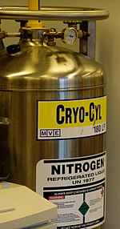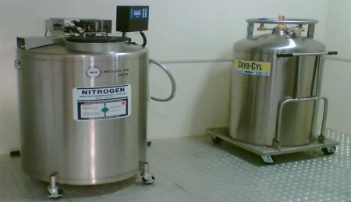
(Source of liquid nitrogen)

(Safety equipment’s)
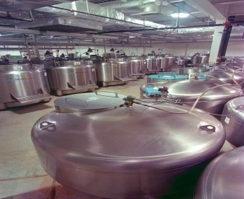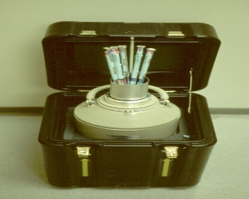
(Different types of Dewar’s)
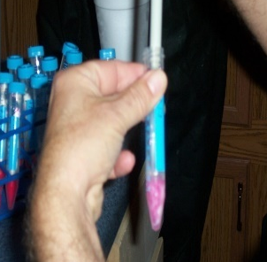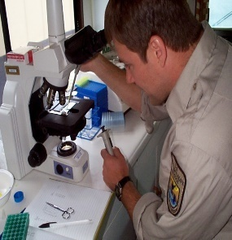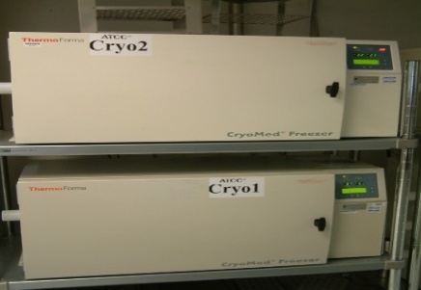
(Cryovials) (Microscope) (Freezers) (Cryoprotectant)
- Cryoprotectants:
Cryoprotectants (CPs) are macromolecules or chemicals which decrease cryodestruction and are added to the freezing medium to protect the cells from the detrimental effects of intracellular ice crystal formation that rupture cell organelles and cells itself (Bischof and Rubinsky, 1993., Takamatsu H, Rubinsky, 1999) or intracellular concentration of solutes that increases to toxic levels due to dehydration before or during storage. Cryoprotectants are usually sugars (sucrose, mannose, ribose, glucose), glycols (ethylene, diethylene, propylene), sugar alcohols, dextrans, and some amino acids like proline (Bajaj 1987).
- Types of Cryoprotectants:
- Permeating / Intracellular cryoprotectants: with low molecular weights that permeate cells. Intracellular cryoprotectants, such as glycerol, Propylene glycol (PG), Ethylene glycol (EG) and DMSO at concentrations from 0.5 to 3 molar, are effective in minimizing cell damage in many slowly frozen biological systems. They cause membrane lipid and protein rearrangement, resulting in increased membrane fluidity, greater dehydration at lower temperatures, reduced intracellular ice formation, and increased survival to cryopreservation (Holt, 2000).
- Non-permeating/Extracellular cryoprotectants: with relatively high molecular weights that do not penetrate cells. Extracellular cryoprotective agents, such as egg yolk, nonfat skimmed milk, trehalose, aminoacids, sucrose, dextrans, glycols, polyvinylpyrrolidone and hydroxyethyl starch, are more effective at protecting biological systems cooled at rapid rates. They do not
- cross plasma membrane and only act extracellularly (Aisen et al. 2000). Therefore, non penetrating cryoprotectant may alter the plasma membrane, or act as a solute, lowering the freezing temperature of the medium and decreasing the extracellular ice formation (Amann, 1999; Kundu et al. 2002).
- Methodology:
- Cryopreservation in Plants:
1. Selection of material.
2. Addition of cryoprotectant.
3. Freezing.
4. Storage in liquid nitrogen.
5. Thawing.
6. Washing and reculturing.
7. Determination of viability/ survival.
8. Regeneration of plants.
- Selection of plant material:
Selection of proper plant material is important, as the morphological and physiological conditions of the plant material influence the ability of an explant to survive freezing at extremely low temperatures of -196ºC. Any tissue from a plant can be selected for this purpose. e.g cultured plant cells, buds, seeds, ovules, etc.
(2) Addition of cryoprotectant:
In order to prevent the damage caused to cells by freezing or thawing, the material is treated with a particular cryoprotectant depending upon the type of tissues to be preserved. Dimethyl sulfoxide (DMSO), sucrose, glycerol, and proline are most frequently used cryoprotectants.
Glycerol is superior to dimethylsulfoxide (DMSO) or ethylene glycol as a cryoprotectant (Zimmerman et al., 1964). Glycerol has remained the cryoprotectant of choice for preservation of spermatozoa for most species (Hammit et al., 1988). The protective effects of glycerol are mediated by its colligative properties, depression of freezing point, alteration of cell membrane properties by inducing changes in lipid packing structure and the consequent lowering of electrolyte concentrations in the unfrozen fraction at any given temperature, which will help to counter the harmful ‘solution effects’ imposed during the freezing process (Mahadevan and Trounson, 1983 ). In order to improve cryosurvival rates, more complex diluents containing other mainly non-permeable cryoprotective agents, such as glycine, zwitterions, citrate and egg yolk were developed (Prins and Weidel 1986). In instances where application of a single cryoprotectant does not result in higher survival, a mixture of two cryoprotectants has proven beneficial.
Quick-reference chart
(To be used as a general guide line)
Cell type | Cryoprotectant | Minimum storage temperature | Number of cells
Animal cells | DMSO (5-10%) or Glycerol (5-10%) | -150°C | 10⁶ to 10⁷/mL
Bacteria | Glycerol (5-10%) | -60°C | 10⁷/mL
 |  |  | 10⁸ pfu /mL
Bacteriophage | Glycerol (10%) | -140°C
Protozoa | DMSO (5-10%) or Glycerol (10-20%) | -150°C | 10⁵ to 10⁷/mL
Plant cells | DMSO (5-10%) and Glycerol (5-10%) | -150°C | 3% to 20% cell volume
Animal viruses | DMSO (7%) + Fetal Bovine Serum (10%) | -10°C | 10⁶/mL
Yeast | DMSO (5-10%) or Glycerol (10-20%) | -150°C | 10⁷/mL
Algae | Methanol (5-10%) | -150°C | 10⁵ to 10⁷/mL
Plasmids | Glycerol (10%) | -150°C | 10⁶/mL
Plant viruses | None | -60°C | NA
Fungi (hyphae) | Glycerol (5-10%) | -150°C | NA
Fungi (spores) | Glycerol (5-10%) | -60°C | 10⁶/mL

- Freezing:
The crystal water within stored cells is very important for survival of the tissues. So, for this reason three different types of freezing procedures have been developed. These are –
- Slow freezing method - The tissues or plant material is slowly frozen with a temperature decrease of 0.5°C to 10°C/ min from 0°C to -100°C. Slow cooling permits the flow of water from the cells to the outside. This promotes extracellular ice formation rather than intracellular freezing. As a result of this, the plant cells are partially dehydrated and survive better. The slow-freezing procedure is successfully used for the cryopreservation of suspension cultures.
- Rapid freezing method- This method is very simple and involves plunging of the vial containing plant material into liquid nitrogen. During rapid freezing, a decrease in temperature of -300° to -1000°C/min occurs. The freezing process is carried out so quickly that small ice crystals are formed within the cells. Rapid freezing has been employed for cryopreservation of shoot tips of potato, strawberry, embryos etc.
- Stepwise-freezing method- This is a combination of slow and rapid freezing procedures (with the advantages of both), and is carried out in a stepwise manner. The plant material is first cooled to an intermediate temperature of about -20°C to -40°C and maintained there for about 30 minutes and then additional rapid freezing to -196°C is done by plunging it into liquid nitrogen. Stepwise freezing method has been successfully used for cryopreservation of suspension cultures, shoot apices and buds.
- Storage:
The main objective of storage is to stop all the metabolic activities of the cells and maintain their viability. To avoid biochemical reactions and recrystallization processes, the storage temperature should be below the glass transition temperature of -130ºC (Mazur et al, 1972; Mazur, 1963; Meryman, 1963; Friedler, 1988). However in most cases, the frozen cells/tissues are kept for storage at temperature ranging from -70 to -196°C. A liquid nitrogen refrigerator running at -150°C in vapour phase or -196°C in liquid phase is ideal for this purpose. Prolonged storage is done at temperature of -196 degree in liquid nitrogen. To prevent damage, continuous supply of nitrogen is ensured.
- Thawing:
It is usually carried out by putting the frozen sample in a warm water bath kept at a temperature of about 35 to 45°C, with a vigorous swirling action just to the point of ice disappearance. It is important for the survival of the tissue that the tubes should not be left in the warm water bath after ice melts. Just at the point of thawing, quickly transfer the tubes to another water bath maintained at room temperature (20-25°C) and continue the swirling action for about 15 sec to cool the warm walls of the tubes.
There could be the risk of ice formation during the thawing process, if conducted improperly. If samples are thawing slowly, ice crystals can form and/or grow causing more damage; however, if samples are thawed rapidly enough, there is little time for ice nucleation and growth to occur (Fabbri, 2006; Fabbri et al., 2006). After thawing, there is further risk of damage during the course of removing cryoprotectants. If cells are immediately put into a significantly lower concentration of cryoprotectant, water will rapidly move into the cell and the cells can swell and burst. Therefore, it is usually advised that a series of decreasing concentrations of cryoprotectant is used to slowly remove the cryoprotectants and gently rehydrate cells. As an alternative, it can also be very effective to use a non-penetrating cryoprotectant such as sucrose to reduce osmotic shock during the step-down process (Shaw, 2000).
- Washing:
The preserved material is washed to remove the cryoprotectant. When low toxic or non-toxic cryoprotectants are used, the cultures are not washed but simply recultured, therefore washing becomes necessary only when cryoprotectants have toxic effects on cells.
- Determination of viability/ survival:
There is possibility of death of cells due to storage stress. Regrowth of the plants from stored tissues or cells is the only realistic test of survival of plant materials. However, at any stage, the viability of frozen cells can be determined by important staining methods viz.,
- Evan’s blue staining.
Percentage of viable cells = | Number of fluorescent cells | ×100
 | Total no. of cells
- Triphenyl Tetrazolium Chloride (TTC) staining.

- Evan’s blue staining:
One drop of 0.1% solution of Evan’s blue is added to one drop of cell suspension on a microscope slide and observed under light microscope. Living cells remain unstained while dead cells are stained blue.
- Triphenyltetrazolium chloride (TTC) staining:
In this method, cell survival is estimated by the amount of formazan produced as a result of reduction of TTC. This reaction results in a pink colour. The procedure involves the following steps:
- About 150 mg of cell sample is put into 3 ml of TTC solution and incubated for 15 h at 30°C.
- The TTC solution is drained off and the cells are washed with distilled water.
- Cells are centrifuged and extracted with 7 ml of ethanol (95%) in a water bath at 80°C for 5 min.
- The extract is cooled and made to 10 ml volume with 95% ethanol.
- The absorbance (pink colour) is then recorded with a spectrophotometer at 530 nm.
- The amount of formazan produced by the frozen cells is expressed as a measure of survival.
- Plant regeneration:
The main purpose of cryopreservation is to regenerate the desired plant, so for this the viable cells/tissues are cultured on specific growth medium.
Addition of appropriate growth promoting substances, besides maintenance of suitable environmental conditions is necessary for successful plant regeneration.
( Diagramatic representation of Cryopreservation in Plants )
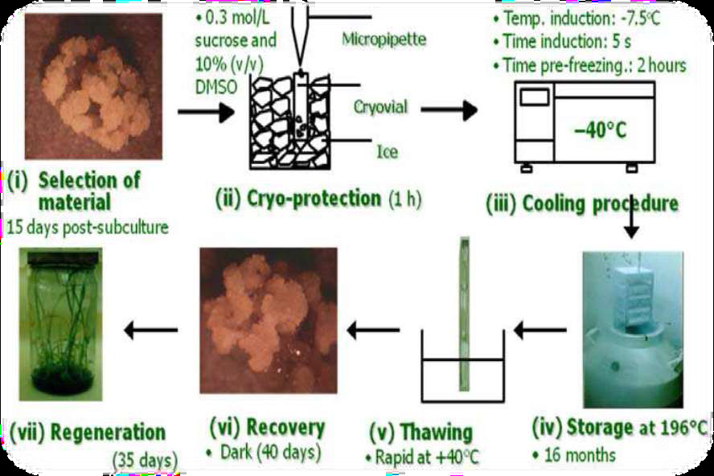
- Cryopreservation in animals:
In case of animals, cryopreservation is easier for thin samples and small clumps of individual cells, because these can be cooled more quickly and so require lower doses of cryoprotectants, e.g.-blood, semen etc. However, with the advancement of modern science, now-a-days complex structures like embryos (2, 4 or 8 celled), eggs (oocytes) etc can also be cryopreserved. Cryopreservation of spermatozoa, oocytes, and embryo offer a potential tool for rescuing genetic material from alive or dead males or females of endangered populations, both if they are (Ciani et al., 2008; Cocchia et al., 2009; 2010). Two basic techniques have currently been used in the field of female Germplasm cryopreservation, that is, slow freezing technique (Whittingham et al., 1972; Wilmut, 1972; Willadsen et al., 1976, 1978; Whittingham, 1977 and vitrification.
Cryopreservation below -130°C is widely used in clinical trials (Harris et al., 2014; Sanchez et al., 2014) multicenter studies, (Sarzotti et al., 2014) and in almost every biological and biomedical research field.
The Cryopreservation methodologies of most animal tissues are almost same, so, here we will discuss methodology of embryo cryopreservation only:
- Cryopreservation of Embryo:
Embryo cryopreservation or embryo freezing is a method used to preserve embryos, generally at blastocyte stage by cooling and storing them at low temperatures. It is one of the most common and well-established fertility preservation treatments, with proven successful pregnancy rates. Embryo freezing is a great way to preserve one’s fertility. Although women are most fertile from their teens until age 35, that time frame is not always ideal for a woman to start a family. Freezing embryos allows women to harvest their eggs when they are most viable and healthy.
Embryo cryopreservation has been proven method to preserve fertility. The first report on successful embryo cryopreservation was published in Whittingham et al. (1972), Wilmut (1972), Wilmut and Rowson (1973) and Whittingham (1977), more than two decades after Polge et al. (1949) reported their success in freezing spermatozoa.
- Process of Embryo Cryopreservation:
- Embryo collection: Egg retrieval is done under ultrasound guidance and subsequent fertilization and embryo culture is carried out. If there is surplus of embryos, then embryos of sufficient quality are collected for cryostorage.
- Embryo selection: While the embryos can be frozen at any pre implantation stage between one cell to the blastocyte stage, generally embryos at blastocyte stage are chosen to cryopreserve.
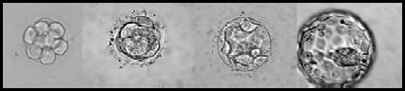

(Embryo selection at the blastocyte stage)

- Freezing: Selected embryos are transferred to freezing medium and kept for 20 mins at 20ºC for equilibration. Controlled-rate freezing technique is utilized that slowly cool embryos in cryoprotectant fluid from body temperature down to -196ºC at the rate of 0-4ºC/min. The embryos are contained within special labelled embryo straws or vials, that are sealed prior to freezing.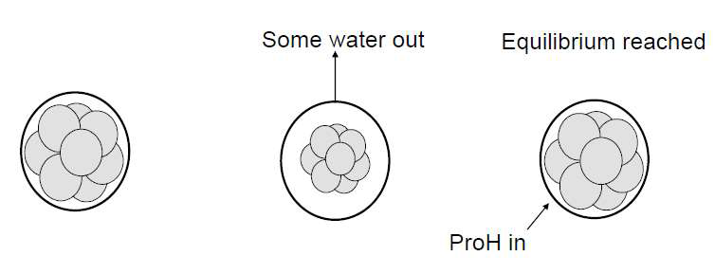

- Thawing: Embryo thawing is the reverse of the freezing process and involves warming the embryos. Embryo thawing takes approximately 2 hours. During the thawing process, embryo is placed in water bath.
When embryos return to room temperature, the embryos are washed to remove the cryoprotectant that is no longer needed. The thawed embryos are kept in the incubator until the embryo transfer, during this time they resume development and undergo cell division.

- ADVANTAGES AND DISADVANTAGES:
- Advantages -
- Conservation of genetic material: Used to preserve the genetic materials of the organisms which are on the verge of extinction (Holt, 1997).
- Long term preservation: Cryopreservation has been used successfully to store a range of tissue types, including meristems, anthers/pollens and embryos. Once the material is successfully conserved to particular temperature it can be preserved indefinitely.
- Maintenance of disease-free stock: Pathogen free stocks of rare plant material could be frozen, revived and propagated when needed. This method would be ideal for national and international exchange of such materials.
- Cold acclimatization and frost resistance: A cryopreserved tissue culture would provide a suitable material for selection of cold resistant mutant cell lines, which could later differentiate into frost resistance plants.
- In medical Science: It is used in fertility treatment (storage of sperms, oocytes), transport of human organs and the long- term storage of biological specimens.
- In animal husbandry: The introduction of cryopreservation technology leads a major breakthrough in animal husbandry. Since the 1st successful cryopreservation of bull semen has been used to propagate the rare and endangered species using assisted reproduction techniques. Every year, more than 25 million cows are artificially inseminated with frozen-thawed bull semen and many bovine calves have been produced using the transfer of cryopreserved embryos into cow.
- Disadvantages:
- Very expensive Technique: The lengthy process of slow-rate freezing and the subsequent long-term storage of these valuable cells can often be costly, consuming large amounts of energy to accurately maintain such low temperatures.
- Side effects: There are certain side effects associated with this technology e.g; women taking injectable hormone medications to stimulate the development of eggs in the ovaries (for cryopreservation purposes) causes ovarian hyper stimulation syndrome (OHSS) which can cause rapid weight gain, abdominal pain, vomiting and shortness of breath.
- Extracellular ice formation: When tissues are cooled slowly, water migrates out of cells and ice forms in the extracellular space. Too much extracellular ice can cause mechanical damage to the cell membrane due to crushing.
- Dehydration: Migration of water, causing extracellular ice formation, can also cause cellular dehydration. The associated stresses on the cell can cause damage directly.
- Intracellular ice formation: While some organisms and tissues can tolerate some extracellular ice, any appreciable intracellular ice is almost always fatal to cells.
- Denaturation of biomolecules:Temperature stresses of most preserved cells which leads to the denaturation of their proteins, enzymes and consequently changes in enzyme activity.

---------------------------------------

REFRENCES:
- Aisen, E.G., Alvarez, H.L., Venturino, A. & Garde, J.J. (2000). Effect of trehalose and EDTA on cryoprotective action of ram semen diluents, Theriogenology Vol.53:1053–1061.
- Alan Trounson and Linda Mohr (1983). Human pregnancy following cryopreservation, thawing and transfer of an eight- cell embryo. Nature; 305:707-709.
- Amann, R.P. (1999). Cryopreservation of sperm, In: Knobil E, Neill JD (eds) Encyclopedia of reproduction, Academic Press, Burlington, MA, pp 773–783.
- Bajaj YPS (1987). Cryopreservation of pollen and pollen embryos, and the establishment of pollen banks. Int Rev Cytol; 107:397–420.
- Berg, van den L. (1959). The effect of addition of sodium and potassium chloride to the reciprocal system: KH2, P04-Na2, HPO4-H20 on pH and composition during freezing, Arch Biochem, Vol.84, 305-315.
- Berg, van den, L. and Rose, D. (1959). Effect of freezing on the pH and composition of sodium and potassium phosphate solutions: the reciprocal system KH2PO4-Na2, HPO4- H20, Arch Biochem Vol.81, 319-329.
- Bischof J.C., Rubinsky B., (1993). Large ice crystals in the nucleus of rapidly frozen liver cells. Cryobiology; 30:597–603.
- Chen C. (1986). Pregnancy after human oocyte cryopreservation. Lancet 1: 884–886.
- Ciani, F., Cocchia, N., Rizzo, M., Ponzio, P., Tortora, G., Avallone, L. and Lorizio, R. (2008). Sex determining of cat embryo and some feline species, Zygote, Vol.16 (No.2):169-177.
- Cocchia, N., Ciani, F., El-Rass, R., Russo, M., Borzacchiello, G., Esposito, V., Montagnaro, S. Avallone, L., Tortora, G. & Lorizio, R. (2009). Cryopreservation of feline epididymal spermatozoa from dead and alive animals and its use in assisted reproduction, Zygote Vol.18 (No.1):1-8.
- Cocchia, N., Ciani, F., Russo, M., El Rass, R., Rosapane, I., Avallone, L., Tortora, G. & Lorizio, R, (2010). Immature cat oocyte vitrification in open pulled straws (OPSs) using a cryoprotectant mixture, Cryobiology Vol.60 (No.2):229-34.
- *Edouard Servy and Zishu Liu (1995).
- Fabbri, R. (2006). Cryopreservation of human oocytes and ovarian tissue, Cell Tissue Bank Vol.7 (No.2):113-122.
- Fabbri, R., Pasquinelli, G., Braconer, G., Orrico, C., Di Tommaso, B. and Venturoli, S. (2006). Cryopreservation of human ovarian tissue, Cell Tissue Bank Vol.7 (No.2): 123-133.
- Friedler S, Giudice L.C., Lamb E.J.(1988). Cryopreservation of embryos and ova. Fertil Steril; 49:743–764.
- Fuller, B. and Paynter, S. (2004). Fundamentals of cryobiology in reproductive medicine, Reprod Biomed Online Vol.9 (No.6):680-691.
- Hammit D.G., Walker D.L., Willamson R.A., (1988). Concentration of glycerol required for optimal survival and in vitro fertilization capacity of frozen sperm is dependent on cryopreservation medium. Fertil Steril; 49: 680-87.
- Harris SA, Satti I, Matsumiya M, et al. (2014). Process of assay selection and optimization for the study of case and control samples from a phase II b efficacy trial of a candidate tuberculosis vaccine, MVA85A. Clin Vaccine Immunol 21:1005–1011.
- Holt, W.V. (1997). Alternative strategies for long-term preservation, Reprod Fertil Dev Vol.9:309–319.
- Holt, W.V. (2000). Basic aspects of frozen storage semen, Anim Reprod Sci Vol.62:3–22.
- Hubel A, Spindler R, Skubitz A.P. (2014). Storage of human biospecimens: Selection of the optimal storage temperature. Biopreserv Biobank ; 12:165–175.
- Katkov II, Isachenkov, Isachenko E, Kin M.S, Lulat A.G.M., Mackay A.M. et al. (2006). Low- and-high- temperature vitrification as a new approach to biostabilization of reproductive and progenitor cells. Int. J. Refrig.; 29(3):346-57.
- Kleeberger CA, Lyles RH, Margolick JB, et al. (1999). Viability and recovery of peripheral blood mononuclear cells cryopreserved for up to 12 years in a multicenter study. Clin Diagn Lab Immunol; 6:14–19.
- Kundu, C.N., Chakraborty, J., Dutta, P., Bhattacharyya, D., Ghosh, A. &, Majumder, G.C. (2002). Effects of dextrans on cryopreservation of goat cauda epididymal spermatozoa using a chemically defined medium, Reproduction Vol.123:907–913.
- Leaf, A. (1959). Maintenance of concentration gradients and regulation of cell volume, Ann. N. Y. Acad. Sci. Vol.72:396-404.
- Lovelock, J.E. (1955). The physical instability of human red blood cells, Biochem J Vol.60 (No.4):692-6.
- Lyons, J. M. (1972). Phase transitions and control of cellular metabolism at low temperatures, Crvobiology Vol.9: 341-350.
- Mahadevan M, Trounson A., (1983). Effects of cryopreservation media and dilution methods on the preservation of human spermatozoa. Andrologia; 15:355-66.
- Mazur P, Leibo SP, Chu EH. (1972). A two-factor hypothesis of freezing injury. Evidence from Chinese hamster tissue culture cells. Exp Cell Res; 71:345–355.
- Mazur P. (1963). Kinetics of water loss from cells at subzero temperatures and the likelihood of intracellular freezing. J. Gen Physiol; 47: 347–369.
- Meryman H.T., (1956). Mechanism of freezing in living cell and tissues. Science; 124:515-21.
- Meryman H.T., (1963). Preservation of living cells. Fed Proc; 22:81–89.
- Montegazza J., (1866). “Fisologia Sullo Sperma Umano,” Rendic Real. Instit Lomb; 3:183-85.
- Mortimer D., (1994). Semen cryopreservation. In: Practical Laboratory Andrology. Oxford: Oxford University Press.
- Moskovtsev S.I., Lulat A.G.M., Librach C. L. (2012). Cryopreservation of human spermatozoa by vitrification vs. slow freezing: Canadian experience. In: Katkov II editor. Current frontiers in Cryobiology. Croatia: In Tech: p:77-100.
- Polge Christopher, Audrey Ursuka Smith, and Alan Sterling Parkes (1949). Revival of Spermatozoa after Vitrification and Dehydration at Low Temperatures. Nature 164 (4172): 666 –70.
- Prins G.S, Weidel L., (1986). A comparative study of buffer systems as cryoprotectants for human spermatozoa. Fertil Steril; 46: 147-49.
- Reed B.M. (ed) (2008). Plant cryopreservation: a practical guide. Springer, New York.
- Sanchez A.M, Denny TN, O’Gorman M. (2014). Introduction to a special issue of the Journal of Immunological Methods: Building global resource programs to support HIV/AIDS clinical trial studies. J Immunol Methods; 409:1–5.
- Sarzotti-Kelsoe M., Needham L.K., Rountree W, et al. (2014). The Center for HIV/AIDS Vaccine Immunology (CHAVI) multi-site quality assurance program for cryopreserved human peripheral blood mononuclear cells. J Immunol Methods; 409:21–30.
- Sherman J. and Bunge R., (1953). “Observations on Preservation of Human Spermatozoa at Low Temperatures.” Proceedings of the Society for Experimental Biology and Medicine; 82: 686-688.
- *Sherman J.K. (1953).
- *Sherman J.K. (1963).
- Spallanzani, L., (1776). Opuscali di Fisca, Amimali, e Vegetgabile, Opuscolo II. Osservazioni, e Speriencze intrno ai Vermicellli Spermatici dell’ Uomo e degli Amimali Modena.
- Takamatsu H, Rubinsky B., (1999). Viability of deformed cells. Cryobiology; 39:243–251.
- Whittingham, D.G. (1977). Fertilization in vitro and development to term of unfertilized mouse oocytes previously stored at K196 8C, Journal of Reproduction and Fertility Vol.49:89–94.
- Whittingham, D.G., Leibo, S.P. and Mazur, P. (1972). Survival of mouse embryos frozen to K196 8C and K269 8C, Science Vol.178: 411–414.
- Willadsen, S., Polge, C. and Rowson, L.E.A. (1978). The viability of deep-frozen cow embryos. Journal of Reproduction and Fertility Vol.52:391–393.
- Willadsen, S.M., Polge, C., Rowson, L.E.A. and Moor, R. M.. (1976). Deep freezing of sheep embryos, Journal of Reproduction and Fertility Vol.46:151–154.
- Wilmut, I. (1972). The effect of cooling rate, warming rate, cryoprotective agent and stage of development of survival of mouse embryos during freezing and thawing, Life Sciences Vol.11:1071–1079.
- Wilmut, I. and Rowson, L.E. (1973). Experiments on the low-temperature preservation of cow embryos, Veterinary Record Vol.92:686–690.
- * Yves Menezo (1988).
- Zimmerman S.J., Maude M.B, Modldawer M., (1964). Freezing and storage of human semen in 50 healthy medical students. A comparative study of glycerol and dimethyl sulfoxide as a preservative. Fertil Steril; 15: 505-10.

*original not found

