INTELLIGENT DEMAND RESPONSE FOR DOMESTIC LOADS IN SMART GRID

V.Umayal Muthu
Assistant Professor
Department of EEE
Velammal College of Engineering and Technology Madurai, India
uma@vcet.ac.in
Dr.A.Shunmugalatha
Dean (Academics)
Department of EEE
Velammal College of Engineering and Technology Madurai, India
asl@vcet.ac.in

M.Devaki R.Saranya
Assistant Professor Assistant Professor
Department of EEE Department of EEE
VelammalCollege of Engineering and Technology Velammal College of Engineering and Technology
Madurai, India Madurai, India
mde@vcet.ac.in rsy@vcet.ac.in

ABSTRACT

The demand for electrical energy has increased significantly, making it difficult not only to produce it but also to distribute it. As a result, grid complexity is increasing due to growing demands on issues of accountability, efficiency, security, and environmental and energy sustainability. These features help make the grid smarter, today known as the “Smart Grid” concept. This is an abstract approach in which all the beneficial features are implemented to expand the power distribution network. Smart grids, with alternative solutions and multiple perspectives on the power distribution sector, were introduced. Additionally, it is important to note that although these technologies are evolving, they have great potential to promote and strengthen distribution systems.

Keywords—Power supply ,demand response for smart grid and peak

INTRODUCTION:

Smart Grid is an integrated system that enhances electricity network reliability and supply through two-way electricity and data flow. It aims to address height issues through long-term communication between customers and utilities, combining renewable energy sources, and meeting increased customer demand without costly infrastructure.

METHODOLOGY:

The project features a system that alerts customers to busy and slow periods, guiding them to off-peak times reducing costs and overloading issues, and allows for the addition of small power units.

BLOCK DIAGRAM:
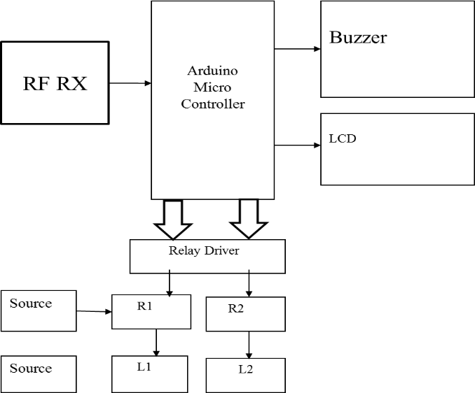
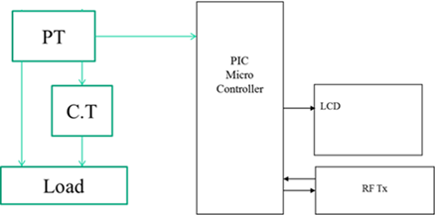

IV . HARDWARE REQUIREMENTS:

- PIC16F877A

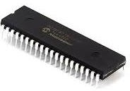
PIC16F877A series CMOS devices offer advantages like sensitivity to hazardous designs, voltage range, and power efficiency,while PIC stands for peripheral interface controller.

ARDUINO NANO

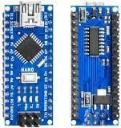
The board is compact, adaptable, and can be powered by batteries, 6-20V unregulated, or 5V regulated external power supplies, with the optimal voltage chosen for the facility

RF TRANSMITTER AND RFRECEIVER

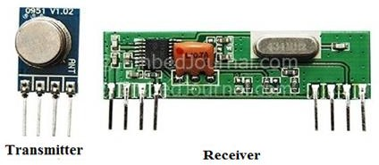
The transmitter and receiver operate at 433MHz, with an RF transmitter accepting serial data and broadcasting it wirelessly at speeds between 1Kbps and 10Kbps.

RELAY

Relays are controls that open and close in response to the state of another circuit. The switch in the original design is activated by a magnet to open or close one or more sets of contacts. Henry did, in fact, create it in 1835. A relay is frequently referred to, in an extremely wide sense, as a type of electrical electronic equipment since it can control an output circuit that is more powerful than the input circuit. Frequently, these contacts are change-over contacts or normally open (NO) or closed (NC) contacts. When the relay is turned on, normally-open contacts connect the circuit; when the relay is turned off, the circuit is detached.

BUZZER

Buzzers, or pagers, are audio devices using electricity or mechanical mechanisms, often used as timers, alarm clocks, and confirmation of human input. Early gadgets used mechanical systems similar to electrical bells, with contacts buzzing through a relay. The word "buzzer" originates from the rasping sound.
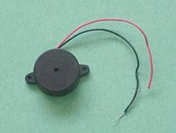

LCDDISPLAY

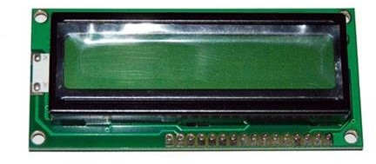
LEDs and liquid cell displays (LCDs) are employed in applications that are comparable to each other. These applications demonstrate segmental and matrix displays of numeric and alphabetic characters.

POWERSUPPLY

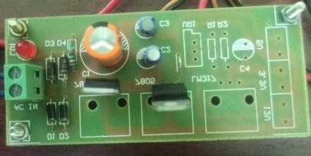
This source produces voltage and freight current ratings, requiring a low voltage regulated power supply of +5V for microcontroller, RS232, LM311, and liquid crystal display input voltages.

STEP DOWNTRANSFOMER
The secondary winding of a step-down transformer is smaller than the primary winding.To match the voltage of our device, we used a 220 vac stepdown transformer in this project to change the electrical output of a power supply.
. 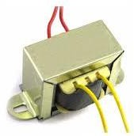

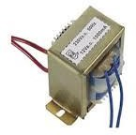
CURRENT TRANSFOMER
This device generates a secondary alternating current inversely proportional to the primary current, often used when monitoring high currents or voltages is insufficient.

POTENTIALTRANSFORMER

A voltage transformer is a device that reduces the voltage of a high voltage circuit for measurement purposes, often connected to or located across a monitored road.
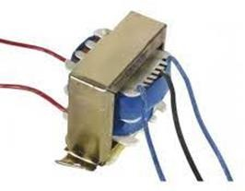

V . SOFTWARE REQUIRED:

1.SKETCH IDE – ARDUINO & NODE MCU MODULE PROGRAMMING SOFTWARE:

Arduino program is utilized in the project, which uses open source hardware and software under the GPL, typically using C and C++ programming languages.

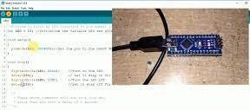

2 MPLAB ICD4
We selected a circuit debugger/programmer as the fastest debugging and programming tool for the peripheral interface controller.
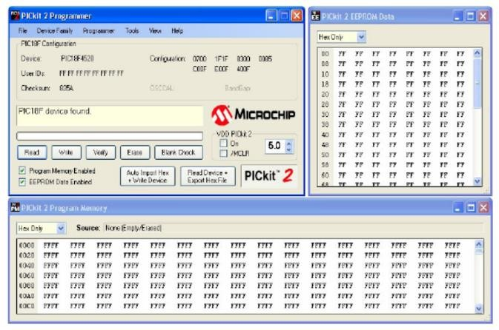

VI. RESULT AND CONCLUSION:
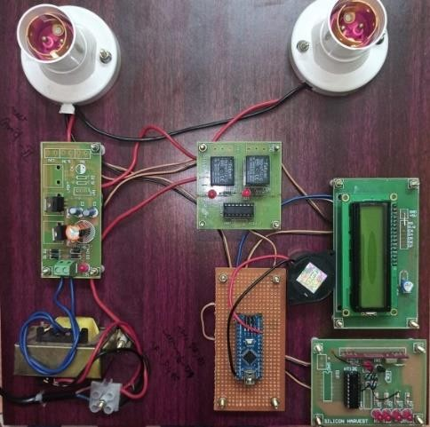
The project, focusing on home load management, has been successful and meets expectations. It uses RF transmitters, receivers, relay interfaces, and sensors. The project has potential for future development and can be used for real-time applications. It contributes significantly to power grid automation and is suitable for ongoing performance and upgrades in industrial settings.
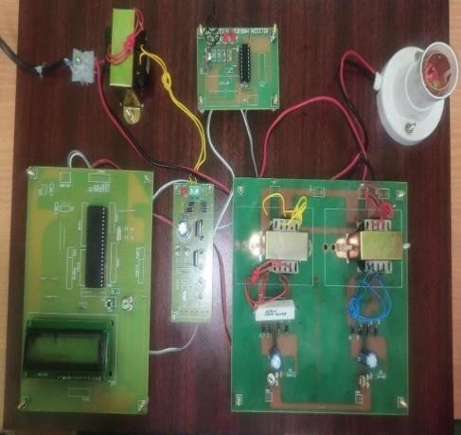

VII. REFERENCES:
[1] D.Gavrila,P.Marchal,andM.-M.Meinecke,"SAVE-U,Deliverable1-A:VulnerableRoadUserScenarioAnalysis,"technicalreport,Information Soc. Technology Programme of the EU,2020.
[2]W. Jones, "Building Safer Cars," IEEE Spectrum, vol. 39, no. 1, pp. 82-85, Jan.2019.
[3] United Nations—Economic Commission for Europe "Statistics of Road Traffic Accidents in Europe and North America,"2018.
[4] R. Bishop, Intelligent Vehicle Technologies and Trends. Artech House, Inc.,2019.
[5] L. Vlacic, M. Parent, and F. Harashima, Intelligent Vehicle Technologies. Butterworth-Heinemann, 2018.6. T. Heinrich, "Bewertung Von TechnischenMaßnahmenzumFußgängerschutz am Kraftfahrzeug," technical report, Technische Univ. Berlin,2019.

