SENSORS

Introduction

Developments in science and technology during the last century have resulted in an acceleration in emissions of anthropogenic pollutants into the environment, contributing to increasing incidences of chronic diseases. Toxic gases, metals, pesticides, and other dangerous chemicals have spread throughout our environment. Therefore, monitoring the composition of air, water, and soil has become an area of intense interest. In the health sector, for diagnosis and health monitoring, it is required to determine clinically important chemicals present in body fluids. Quantitative analysis of chemical species is the major requirement. These demands have led to the development of many important analytical approaches. These techniques are not suitable for routine online analysis. Therefore, there is a growing demand to develop new instruments and procedures this week so as to make analysis convenient, fast, reliable, and selective. To meet these demands, chemical sensors of various types have been intensively developed. These sensors have a number of advantages over other classical methods of analysis, like low cost, less time of analysis, probability of the device, non-destructive samples, and accuracy of results. Chemical sensors have numerous applications, like home safety, food freshness, and medical diagnosis. They are an engine for mental production and are therefore likely to have a positive impact on our lives in the near future.

Construction and Working of a Sensor

A chemical sensor is a device that is capable of giving real-time analytical information about a test sample. It interacts with a specific chemical or biological analyte, detects it, and produces a signal proportional to its quantity. Analyte is the target species that is being detected and measured using a sensor.
The main basic components of a sensor are:

A. Receptor
A receptor is the chemical or biological recognition element that is capable of interacting specifically and selectively. It produces a signal corresponding to interaction in the form of changes in potential, conductivity, current, mass, heat, pH, colour, etc. If the receptor is of biological origin [example, DNA, antibodies, and enzymes], the device is referred to as a biosensor. If the receptor is of chemical origin, the device is referred to as a chemical sensor.

B. Transducer
During the interaction of the sensing element with the analyte, certain physical or chemical properties of the sensing element change proportionately with the analyte concentration. A transducer is used to convert the signal created by the receptor-analyte interaction into a readable value or measurable physical quantity. In most chemical sensors, the sensing element and the transducer are packaged together, in direct spatial contact, in the same unit.

C. Electrical signals and display
The electronic system analyses the signal given by the transducer, helps in signal amplification, and converts the signal from analogue to digital form. These amplitude signals are then displayed. Signals are then displayed. Signals can be displaced in various forms, such as numeric values, graphs, images, etc.

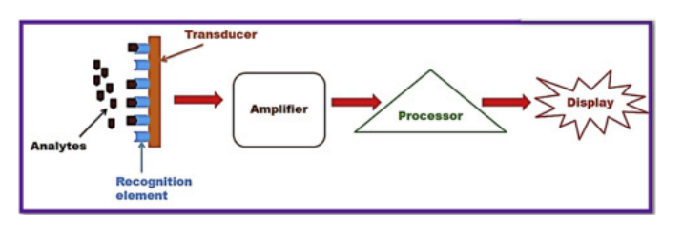

A schematic diagram illustrating the major components of a standard sensor

The interaction between the receptor and analyte can be monitored by several methods. Different parameters are measured in each method, like change in potential, conductivity, current, mass, heat, pH, colour, etc. For the measurement of each parameter, a different type of transducer is used. There are several types of sensors available depending on the type of transducer used, like electrochemical sensors, conductometric sensors, thermometric sensors, optical sensors, etc.

Electrochemical sensors

Electrochemical sensors use electrodes as transducers. The transducer of an electrochemical sensor consists of working or sensing electrodes, electrolytes, a count electrode, and a reference electrode. The sensing electrode has a chemically modified surface. This modification ensures selectivity, facilitating the reduction or oxidation of the analyte. The electrolyte is part of the electric circuit of an electrochemical sensor system. The role of the electrolyte is to transport charge within the sensor, contact all electrodes effectively, solubilize the reactants and products for efficient transport, and be stable chemically and physically under all conditions of sensor operation. The following steps are involved in the working of an electrochemical sensor:

- Diffusion of the analyte to the electrode/electrolyte interface (in the liquid phase)
- Adsorption onto the electrode surface
- Electrochemical reaction with electron transfer
- Detection of potential change.
- Desorption of the products.
- Diffusion of the products away from the reaction zone to the bulk of the electrolyte or gas phase

Applications of Electrochemical Sensors

Varieties of electrochemical sensors in unique geometrics or structures for large number of chemicals are available. They are used in diverse area as industrial safety, biochemistry, clinical chemistry, health and medicine, agriculture, food safety, and environment production, automotive technology, space exploration, military threat detection and process control. Few applications are even below:

- The oxygen sensor is used for detection of dissolved oxygen in water boiler and to monitor dissolved oxygen concentration in metal melts glasses in hydrogen fuel.

- They are used in security and defence application like detection of toxic gases, warfare agents etc.

- They are used in water analysis and environmental monitoring, like measurement of toxic metal concentration in water, detection of oxides of nitrogen and sulphur, CO, pH of water etc.

- They are used in diagnostic and health-care application, like in situ monitoring of glucose serum uric acid, blood, Calcium, Iron etc.

- They are used in soil parameter analysis evaluation, and in application of agriculture.

Types of electrochemical sensors

There are mainly three types of electrochemical sensors:

1. Potentiometric sensor

In this sensor, the changing potential during the chemical interaction between receptor and analyte is measured using a combination of an indicator electrode and a reference electrode. Commonly, platinum is used as an inert indicator electrode, whereas a saturated calomel electrode is used as a reference electrode. An indicator electrode is used to measure the change in potential due to a redox reaction occurring on the surface of the electrode. Using an ion-selective electrode as an indicator electrode, the concentration of a particular ion can be measured with good selectivity. A pH glass electrode is an example of this class of electrode. In potential metrics, sensor measurements are taken at zero current.

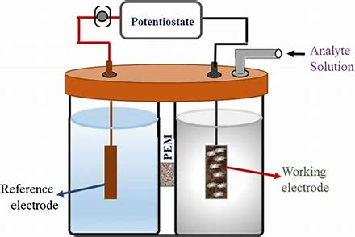

2. Amperometric sensor

An amperometric sensor is similar to a potentiometric sensor, consisting of an electrolyte solution in which the electrodes are immersed. But it is operated under an externally applied fixed voltage. This potential causes the electrolyte to react and appear to pass. At a fixed application potential, the magnitude of the current generated is directly proportional to the concentration of the analyte. Here, the current passing through the cell is measured.

In a simple amperometric sensor, muscle electrodes, namely the counter electrode and the working electrode, are used. Theoretically, in amperometry, the potential between two electrodes must be maintained constant. But in reality, redox reactions at each electrode surface result in potential. Therefore, to keep potential constant, a three-electrode system is commonly used. In the three-electron system, the current at the sensing electrode can be measured at constant potential. This is because no reaction occurs on the surface of the reference electrode. This helps in maintaining a constant potential and measuring the current at a constant potential using a counter and working electrode.

In potentiometry and amperometry, the surface of the sensing electrode is usually modified. A layer of catalysts and enzymes that can facilitate redox reactions is coated. This modification makes the sensor more selective. Recently, miniaturised microelectrodes have been used, which show fast response times and can measure small currents. Materials commonly used for these electrodes are noble metals, fluorine-doped tin oxide (FTO)-coated glass, indium-tin-oxide conductive glass (ITO), and different forms of carbon. Out of these electrodes, the manufacturing process of FTO and ITO-based electrodes is costly and more complex. Therefore, nanomaterials based on carbon, such as graphene carbon tubes, nanofibers, and graphitic carbon nitrates, are gaining more attention due to their low-cost, appealing electrochemical properties, case or functionalization, and wide potential window.

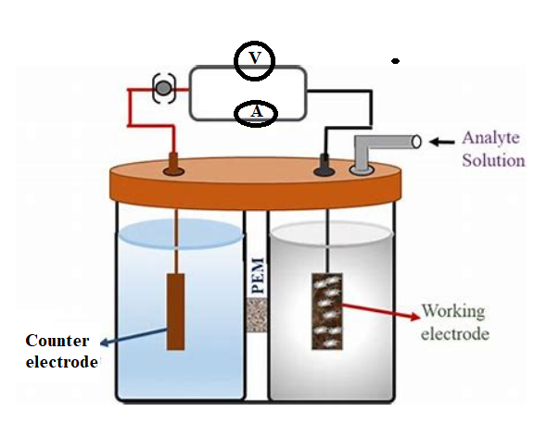
Amperometric Sensor with electrodes

- Conductometric Sensors
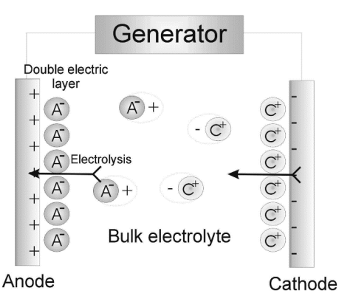
Conductometric sensor is considered as a type of electrochemical sensor, even though it is not used to measure electrochemical change. An electrochemical sensor measures the electrochemical process [redox reactions] at the surface of electrodes. But, a conductometric sensor is based on measurements of physical properties of a homogeneous bulk solution like Electrolytic conductance by aqueous electrolyte solutions. In conductometric sensor, determination of the concentration of analyte is based on measurement of changes that occur in electrolyte solution. Here the electrodes are just used to measure change in electrolytic conduction of an electrolyte and they do not provide surface for any reaction. Therefore, there surface is generally not modified. Conductance of solution is based on:
- The Concentration [number] of ions contributing to conductivity of solution.
- Mobility of each type of ion. Mobility of an ion depends on its size smaller the size higher is mobility and higher is electrolytic conductance.
Electrode used in conductivity sensor is called as conductivity cell. It is used to measure the change in electrolytic conductance of the solution during replacement of ions of a particular conductivity by ions of different conductivity. It is made of two platinum foils with unit cross section area and unit distance between them. Volume between two electrodes is 1 centimetre cube. Conductance of unit volume of the surface solution is known as specific conductance. There will be changing specific conductance of solution when there is change in number of ions or type of ions. This change is measured using conductivity cell. Like a metallic conductor, electrolyte solutions also obey Ohm’s law,
E=IR
where E is applied potential,
R is resistance, where R= s (l /a)
I is the current
s= specific resistance or resistivity
Special conditions (k) is given by, $k=\frac{1}{R }×\frac{1}{a}$
Where, $\frac{1}{a}$ known as cell constant and ‘R’ is the resistance of the solution.
The conductivity cell is dipped in the electrolytic solution taken in a beaker and it is connected to a conductance measuring device called as conductivity metre.

Applications of Conductometric sensors:

Conductometric sensors can be used to monitor any species which can change the electrolytic conductance of solution on chemical reaction.
  - It is used to estimate acids, bases and their mixtures in a sample.
  - It is used to check the amount of ionic impurities in water samples.
  - It is used in measuring acidity or alkalinity of sea water and fresh water.
  - Conductometric biosensors are used in biomedicine, environment monitoring, bio technology and agriculture related applications.

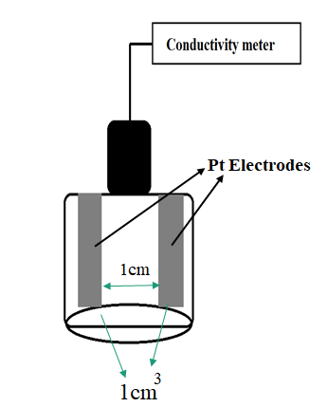
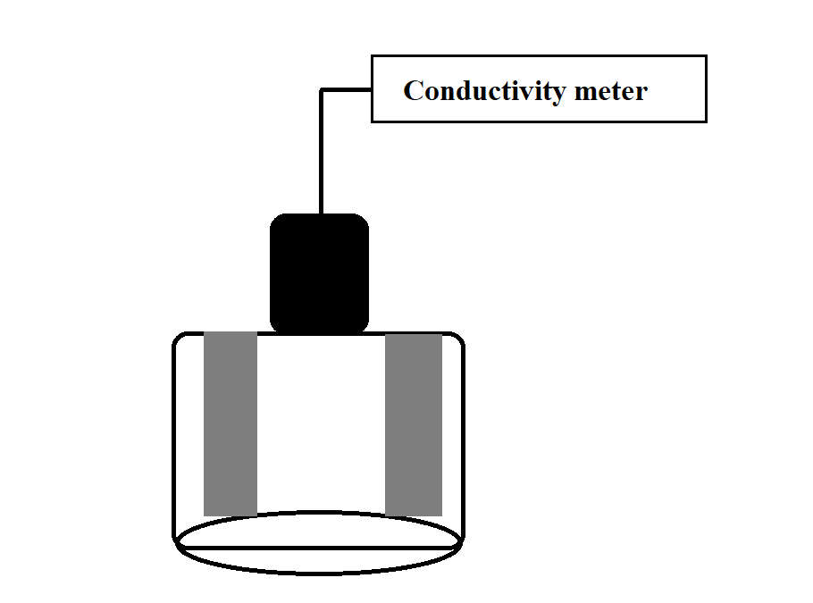
Optical Sensors (Colorimetry)

Pt Electrodes
1cm
1cm
3
An optical sensor converts light rays into an electronic signal. Interaction of electromagnetic radiation with matter forms the basis of a board range of analytical methods commonly known as spectrochemical methods of analysis. Commonly, electromagnetic radiation in the ultraviolet visible infrared domains is used for analytical process. A broad range of chemical sensors has been developed on the ground of interaction of sensing elements with electromagnetic radiation. Sensors based on the transduction of interaction of electromagnetic radiation with the chemical species are called as optical sensors.

Optical transduction can be based on emission, absorption, reflectance and scattering of light by the analyte. The optical sensor arises from the interaction of the analyte with an incident radiation. The interaction could result in absorption, emission, scattering or reflection of light. The type of interaction depends on the wavelength of this probing radiation and on the structure of the molecules in the analyte. The intensity of the radiation emanating from the analyte carries information on the concentration of the analyte. It is measured by the Optical electronic instrumentation.

A simple optical sensor used to measure absorption of light, main components used are light source, a wavelength selector, or photo detector and a display of the output.

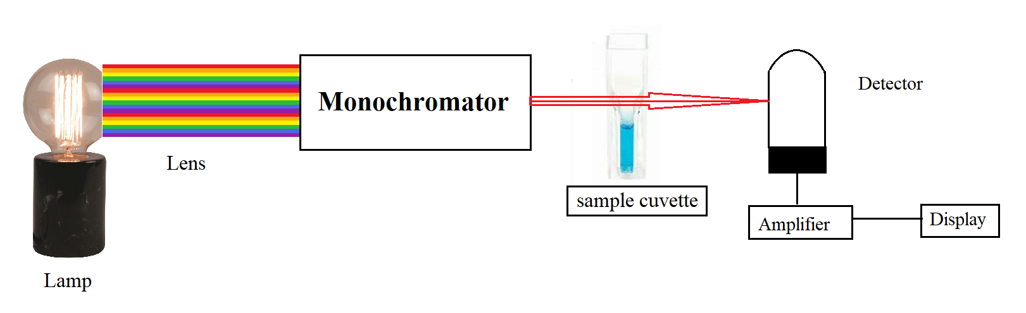
In modern optical sensors, optical components such as a lenses, optical couplers and connectors are used for coupling light into optical fibres and solid-state optoelectronic components. This has enabled the development of commercial portable optical sensor systems.
Simple optical sensors are used to determine the concentration of colour chemical species in solution. They are based on measurement of absorbance of transmittance of light of particular wavelength by coloured chemical species in the solution. They are governed by Beer Lambert law.

Working Principle:
Colorimetric analysis refers to a quantitative technique used to measure the concentration of a given substance in a solution. The working of colorimeters is mainly based on the Beer-Lambert’s Law. This law states that the light absorption when passes through a medium are directly proportional to the concentration of the medium. When a colorimeter is used, there is a ray of light with a certain wavelength is directed towards a solution. Before reaching the solution the ray of light passes through a series of different lenses. These lenses are used for navigation of the coloured light in the colorimeter. The colorimeter analyses the reflected light and compares with a predetermined standard. Then a microprocessor installed in the device is used for calculation of the absorbance of the light by the solution. If the absorption of the solution is higher than there will be more light absorbed by the solution and if the concentration of the solution is low then more lights will be transmitted through the solution.
When a beam of incident light of intensity Io passes through a solution, the following occur:
- A part of it is reflected which is denoted as I_{r}
- A part of it is absorbed which is denoted as I_{a}
- Rest of the light is transmitted and is denoted as I_{t}
Therefore, I_{o} = I_{r} + I_{a} + I_{t}

To determine I_{a} the measurement of I_{o} and I_{t} is sufficient therefore, I_{r} is eliminated. The amount of light reflected is kept constant to measure I_{o} and I_{t}. Colorimeter is based on two fundamental laws of photometry. As discussed below:
Beer’s law: According to this law the amount of light absorbed is proportional to the solute concentration present in solution.
Log₁₀ I_{o}/I_{t} = a_{s}c where, a_{s} is absorbency index, c is the concentration of solution

Lambert’s law: According to this law the amount of light absorbed is proportional to the length as well as thickness of the solution taken for analysis.
A = log₁₀ I_{o}/I_{t} = a_{s}l Where, A is the test absorbance of test, as is the standard absorbance, l is the length / thickness of the solution.
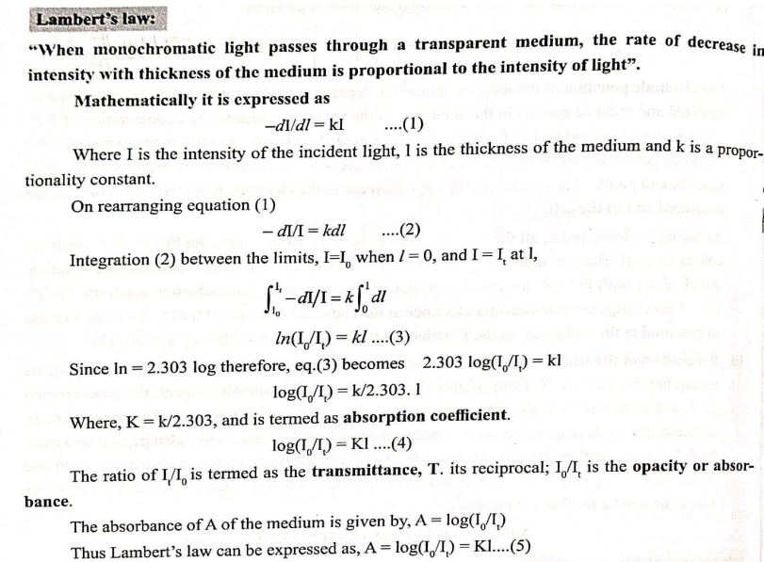
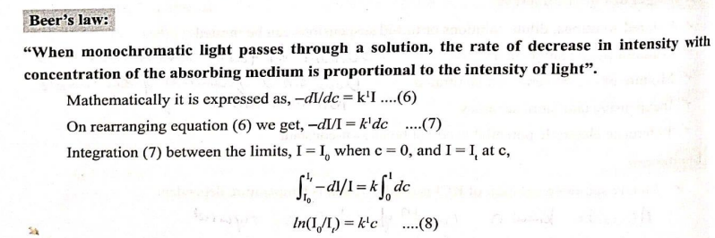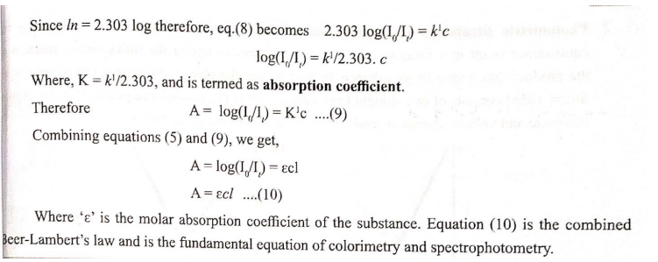

Applications of an Optical Sensors (Colorimetry)
- Optical Sensors can be used in the determination of any chemical species which can interact with electromagnetic radiation.
- Optical Sensors have been developed for a number of different types of chemical and biochemical molecules and ions. For example, Ions in solutions (e.g., metal ions, and anions) Gases (e.g.CO₂, O₂, NH₃, SO₂, NO, NO₂ etc.), Vapours (moisture, volatile organic compounds etc.) and Molecules (glucose, pesticides, DNA, bacteria, etc.) can be determined using optical sensors.
- Optical sensors find important and varied uses in environmental bio technological, food, pharmaceutical, medical and related applications.
- Optical fiber based biosensors are used in screening of drugs, reduction of foot borne pathogens, reduction of explosive and environmental monitoring.

Ambient Light Sensors:
Mostly we have seen this sensor on our mobile handsets. It will extend the battery life and enables easy-to-view displays that are optimized for the environment.
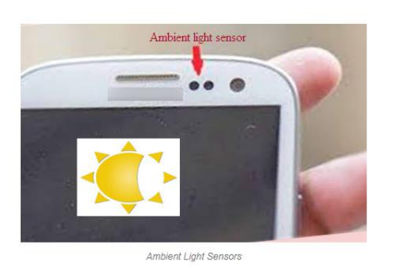
Biomedical Applications:
Optical sensors have robust applications in the biomedical field. Some of the examples Breath analysis using tunable diode laser, Optical heart-rate monitors an optical heart-rate monitor measures your heart rate using light. A LED shines through the skin, and an optical sensor examines the light that reflected back. Since blood absorbs more light, fluctuations in light level can be translated into heart rate. This process is called as photoplethysmography.
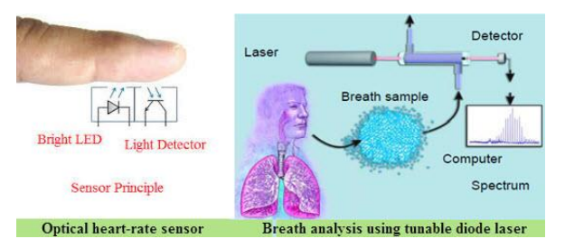

Optical Sensor Based Liquid Level Indicator
Optical Sensor Based Liquid Level Indicator consist of two main parts an infrared LED coupled with a light transistor, and a transparent prism tip in the front. The LED projects an infrared light outward, when the sensor tip is surrounded by air the light reacts by bouncing back with-in the tip before returning to the transistor. When the sensor is dipped in liquid, the light disperses throughout and less is returned to the transistor. The amount of reflected light to the transistor affects output levels, making point level sensing possible.
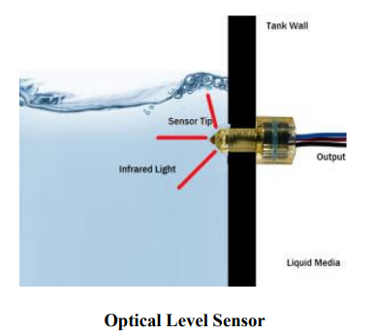

Thermometric Sensors

Thermometric sensor is based on the measurement of thermal changes during the interaction between analyte and receptor. Thermal changes are converted to measurable change in the temperature or potential.
Thermal sensors use transducers that convert temperature or heat to another form of energy and provide an output reading of the temperature.
Thermometric transduction is feasible easy only in those processes which generate sufficient heat to produce a measurable change of temperature. Chemical or biological species which undergo a catalytic chemical reaction and enzyme-catalyzed reaction liberating heat [exothermic reaction] can be determined by thermometric sensors.

Working Principle of Thermometric Sensors

Main Component of a thermometric sensor is a small tubular catalytic reaction fitted with a temperature transducer. Analyte (reactant) is fed in to the reactor where it undergoes reaction, liberating heat energy. Heat liberation results in change in temperature which is converted to the output voltage by transducer which is amplified and fed to the data storage and processing unit.
In order to convert change in temperature into electrical signal, a thermocouple is used as transducer which exhibit thermometric effect are used.

- Resistive transducer:

Most commonly used resistive transducer is the thermistor. It as a ceramic semiconductor device made of oxides of transition metals. Most transistors have a negative temperature coefficient. Most thermistors have a negative temperature coefficient .That is, their resistance decreases with increasing temperature. The decrease in resistance is converted to output voltage using a Wheatstone bridge resistance resistor.

- Thermocouple gauge:
A thermocouple couple is a device that converts the temperature difference directly into electrical voltage. It consists of a loop formed by two different materials (metal or semi conductance). The output voltage is proportional to the temperature between the two junctions.

- Thermometer – Measures absolute temperature or temperatures relative to absolute zero. There are many different types of thermometers. Two common thermometers are the mercury thermometer discussed previously and the infrared thermometer.
- Sensors using Resistance Temperature Detectors (RTDs) – Measures temperature and temperature changes by measuring the output of a RTD. A RTD is a coiled wire that exhibits a change in resistance when the temperature of the wire changes.
For each of these sensors, an output is provided indicating the value of the parameter being detected and measured.

Application of Thermometric Sensors:

- Thermal bio sensors are based on the temperature change induce by a simple enzymatic reaction. They are used in the determination of metabolites, bioprocess monitoring and environmental control. An example-is the determination of glucose using the glucose oxidase-catalyzed reaction.
- Thermometric chemical sensors are used for determination of combustible gases that react with oxygen at the surface of a suitable catalyst.

Electrochemical sensors for the pharmaceuticals:

Pharmaceuticals are basically organic compounds, which are used extensively by human beings as a solution for various health issues. After usage they are exerted or washed off their hosts and enter the environment through effluent of waste water. Even though use of pharmaceuticals for various health conditions are well understood and documented, there is limited knowledge about the unintended effects in the environment. Majority of these are complex organic molecules with lower biodegrability. Therefore, it is necessary to use sensors for the reduction of pharmaceuticals to monitor their concentration and know their toxic effects. Several electrochemical sensors are available for the detection of pharmaceuticals in lower concentration. These sensors are fast, low cost and sensitive and use disposals strips. These sensors can be used for on-the-spot analysis. One example is the electrochemical sensor used for the detection of Diclofenac.
Oxygen sensor:

Monitoring of oxygen is require in many area of industries, heat care, safety and environmental concerns. In few cases, high purity oxygen is used. For example, oxygen cylinder for welding contains minimum of 99.5 voltage O_{2.} There are few application where oxygen tolerance is in low ppm range. For example, hydrogen to be used as fuel in polymer electrolyte membrane fuel cell vehicles, the maximum allowable oxygen level should be 5ppm. The oxygen content in air is typically given as 20.9 vol %. The minimum oxygen content in breathing air must be mandatorily above 19.5 Vol%. Thus, depending on the application, oxygen measurements can be required from low ppm levels nearly 100vol% and also at concentrations in between these two extremes.

Several major sensor technologies are currently and routine used for gas phase oxygen measurements. The most common oxygen sensor types are Clark electrode, galvanic oxygen sensor and the Zirconia oxygen sensor. These all offer the ability for onsite, real-time detection of oxygen over a broad range of concentration and conditions.

Electrochemical sensors for detection of Diclofenac

Diclofenac with the chemical name 2-(2-((2, 6-dicholorophenyl) amino) phenyl) acetic acid, is one of the most frequently prescribed non-steroidal anti-inflammatory drugs (NSAID) with antipyretic and analgesic effects. It is safe in prescribed dose, but may cause adverse effects at higher dose. Due to wide usage and poor biodegradability, it can have serious effects on the ecosystem. Electrochemical sensor can be used to detect diclofenac in lower concentration.

In the electrochemical sensor used to detect diclofenac, the sensing (working) electrode is graphite carbon coated with multi walled carbon nanotubes (MWCNT) and gold nanoparticles. In the detection, along with sensing electrode, counter electrode and reference electrodes are used. When the sample containing diclofenac is out in the sensor, the following oxidation reaction of Diclofenac occurs on the surface of the sensing electrode. The change in potential of the reaction gives the concentration of Diclofenac.

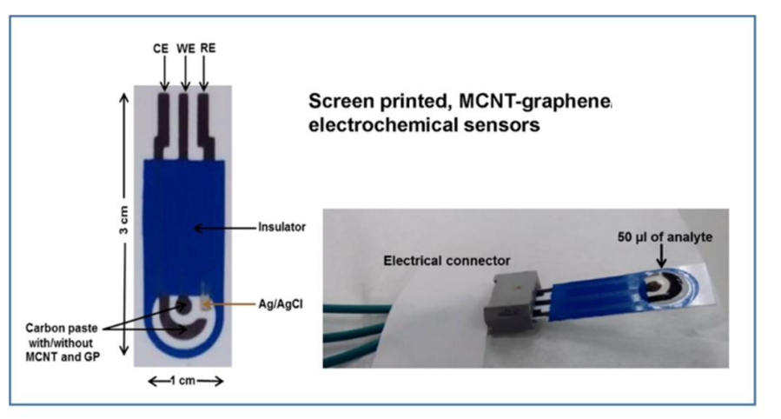
Electrochemical sensor with modified carbon electrode

Different sensors are developed for the detection of Diclofenac such as
1) Potentiometric sensor (low sensitivity)
2) Electrochemical sensor with unmodified carbon electrode
3) Electrochemical sensor with modified carbon electrode
4) Bio-sensor

Components of disposable screen printed Carbon paste electrode for diclofenac detection (Three electrode sensor)
Working electrode: Carbon Paste with MWCNT or Graphene
Counter Electrode: Carbon Paste with MWCNT or Graphene
Reference Electrode: Ag/AgCl
Process: Screen Printing Technique on PVC substrate. Insulating ink was printed on the remaining PVC surface.

Working:
- The electrochemical oxidation of DCF on carbon-based sensor at pH 7.0 is reversible reaction.
- Oxidation of Declofenac occurs at carbon electrode to release e-, to form radical intermediates and followed by hydrolysis of radical intermediate species.
- The products formed are 2,6- dichloro aniline and 2-2(- hydroxyphenyl) acetic acid.
- Reactions on the electrode cause the current to flow.
- The intensity of this current is a function of the number of oxidized / reduced molecules.
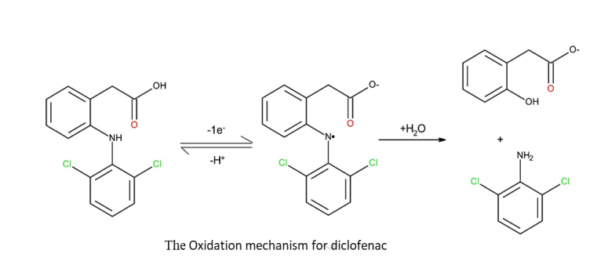
Products: 2,2 Hydroxy-Phenyl-Acetic Acid and 2,6 Dichloro Aniline

ELECTROCHEMICAL SENSORS FOR HYDROCARONS

Among the dangerous hydrocarbon pollutants, polycyclic aromatic hydrocarbons (PAHs) are widely found in the air, water, soil and food. PAHs are known carcinogenic and mutagenic compounds. They can enter the human body mainly through respiration and diet. Detection of PAHs are metabolised into hydroxyl PAHs (OH-PAHs), which are excreted with urine.1-hydroxypyrene is a commonly found hydroxyl PAH in urine sample. Therefore concentration of 1-hydroxypyrene is used as a biomarker to evaluate PAH exposure levels in the human body. Its concentration in urine, quantitatively reflect the extent of recent exposure to PAHs. Conventional methods used for the estimation of 1-hydroxypyrene like HPLC-MS, GC-MS and LC-MS/MS use large, expensive and difficult to operate instruments. It also require more time for laborious sample pre-treatment and analysis.

Therefore, electrochemical sensor are being developed for detection of 1-hydroxypyrene in urine sample. These sensors are fast, low cost and sensitive and use disposable strips. These sensors can be used for a\on the spot analysis.

In the electrochemical sensor used to detect 1-hydroxypyrene, the sensing (working) electrode is graphite carbon coated with chromium containing metal organic framework (Cr-MOF) and grapheme oxide. This material has excellent chemical and hydrothermal stability, a large surface area, large pore windows and numerous unsaturated chromium sites, making it suitable materials for electrochemical groups, which can be oxidized by the anode active material. This is used for electrochemical detection. In the detection, along with sensing electrode, counter electrode and reference electrodes are used. When the sample containing 1-hydroxypyrene is put in the sensor, the following oxidation reaction of 1-hydroxypyrene is determined from the change in potential of the reaction.

Electrochemical sensors for the detection of Hydrocarbon : 1- Hydroxypyrene
Working electrode: PAMAM/Cr-MOF/GO (Composite)
Counter Electrode: PAMAM/Cr-MOF/GO
Reference Electrode: Ag/AgCl
Operating Voltage: +0.7 to −0.5 V
PAMAM: Dendrimer polyamidoamine (Poly (amidoamine) (PAMAM) dendrimers are well-defined, highly branched macromolecules with numerous active amine groups on the surface)
Cr-MOF: Chromium-centered metal–organic framework
GO: Graphene Oxide

Working: When this electrode is used to detect the sample containing 1-Hydroxypyrene (water sample) the following changes takes place: At the electrode surface electro-oxidation takes place to yield several hydroxylated species and then hydroquinone by losing 2e⁻ and 2H⁺.Reactions on the electrode cause the current to flow. The quantity of this current is a function of the number of oxidized / reduced molecules. Current produced is directly proportional to the concentration 1-Hydroxypyrene.
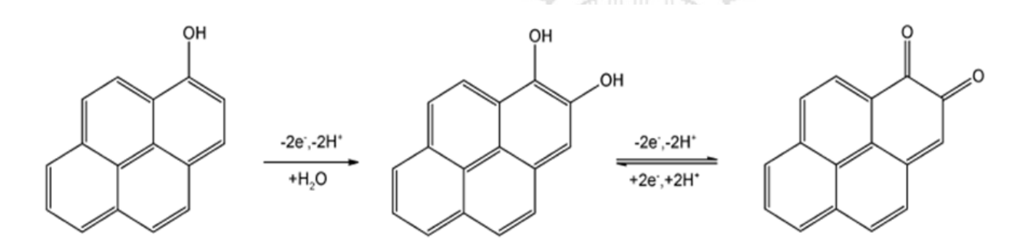
The electro-oxidation scheme of Hydroxypyrene

ELECTROCHEMICAL GAS SENSOR
Electrochemical gas sensor is used in monitoring of concentration of gases analytes. They are used mainly to monitor the concentration of air pollutants, Detection of leakage of chemicals in industries and in defence, military and space applications.

Schematic representation of a typical gas sensor is even below:

CONSTRUCTION OF AN ELECTROCHEMICAL GAS SENSOR:

The following are the main components of an electrochemical sensor
- FILTER:
The filter is used to prevent unwanted contaminants, mainly particulate matter from entering the sensor.
- MEMBRANE:
A gas permeable membrane is used to regulate the gas flow into the sensor. It selectively allows only the analyte gas to pass and also acts as a barrier to prevent leakage of the electrolyte from the interior of the sensor. Hydrophobic porous membranes are used with aqueous electrolytes. These pores are not wetted by the aqueous solution but allow the transport of dissolved gases to the electrode electrolyte interface. The sensitivity and response time of the sensor mainly depends on the nature of membrane, its pore size and thickness.
- ELECTRODES:
Two or three electrode system is used based on the requirement. Working or sensing electrode, counter electrode and reference electrodes are used.
- ELECTROLYTE:
Electrolyte used should be a good ionic conductor and chemically and physically stable under operation conditions of sensor. Main role of the electrolyte is to transport charge within the sensor, contact on electrodes effectively, solubilize the reactants and products for effective transport.

WORKING PRINCIPLE OF AN ELECTROCHEMICAL GAS SENSOR
The following steps are involved in the working of a typical electrochemical gas sensor.
- The diffusion of gas analyte through filter, membrane and then finally through electrolyte onto the surface of sensing electrode.
- Adoption of analyte gas molecule on the surface of sensing electrode
- Oxidisation of analyte on the surface of sensing electrode, liberating electrons. Transfer of liberated electrons from anode to character through external circuit. The surface of sensing electrode is the active part of the electrode. It is modified by coating with appreciate catalyst which can selectively interact with analyte gas and carry out its chemical change.
- Desorption of the products from the electrode surface.
- Diffusion of the products away from the reaction zone to the bulk of electrolyte or gas phase.

ELECTROCHEMICAL GAS SENSORS FOR SO_{X} AND NO_{X}:
Electrochemical sensors are used to measure the concentration of gases like an NO₂, NO and SO₂. In principle, any gaseous compound which can undergo redox reaction on the surface of electrode can be measured with an electrochemical sensor. Design of the sensor for each gas can be unique but the components (membranes, electrodes, electrodes electrolyte) and working principle is same as discussed in previous section.
But, receptor coated on surface of sensing electrode (working electrode) is different from each gas. Reaction that occurs on surface of the electrode is also different from each case.
Deduction of NO₂ in an amperometric gas sensor is aqueous electrolyte is based on the following electrochemical reduction reaction on the surface of sensing electrode. Au, Pt/Naf ion sensing electrode with 10M H₂SO₄ is used as electrolyte.
NO₂ +2H⁺ +2e⁻ -NO+H₂O
Deduction of NO in amperometric gas insulin and aqueous electrolyte is based on the following electrochemical oxidisation reaction on the surface of sensing electrode. Au/NASICON-NaNO₂ is used as sensing electrode and electrolyte.
NO+ 2H₂ONO²₃⁻ +4H+ 3e⁻

Deduction of SO₂ is an amperometric gas sensor in aqueous electrolyte is based on the following electrochemical oxidation reaction on the surface of sensing electrode. Au/Naf ion sensing electrode with 0.5M H₂SO₄ is used as electrolyte.
SO₂ + 2H₂O SO₄²⁻ +4H ⁺ + 2e⁻

Working principle with electrode reactions
The major contributors to traditional air pollution are NOx, SOx, and H₂S while NH₃ and Volatile organic compounds are of increasing concern recently. Traditional air quality monitors based on mass spec, infra-red spectroscopy and gas chromatography are expensive and not suitable for large scale deployment. Electrochemical gas sensors provide a cheap alternative option for widespread air quality monitoring. Electrochemical gas sensor interacts with a gas to measure its concentration and each gas has a unique voltage; the electric field at which it is ionized. Sensor identifies gases by measuring these voltages

Sensor for NOx:
Chemiresistive sensors based on graphene and its derivatives have been used to measure NOx. Chemiresistive sensors measure the change in resistance upon exposure to analyte gases and can detect toxic gases at very low concentrations. In general, the response obtained in a chemiresistive sensor is
𝑹% = (𝑹_{𝟎}−𝑹_{𝒈})/ 𝑹_{𝟎} * 100
R% is the reported sensor response
R_{o} is the resistance in dry clean air (Back ground Correction)
R_{g} is the new resistance observed under analyte gas
Reactions:

The concentration of electrons decreases due to the reaction between the electrons in the sensing materials and NOx gas, as shown and resistance offered by e- decreases and current increases. “Higher the concentration of NOx, lesser would be the resistance”.

Detection of SO₂ : The sulfur dioxide sensor works on the electrochemical principle.
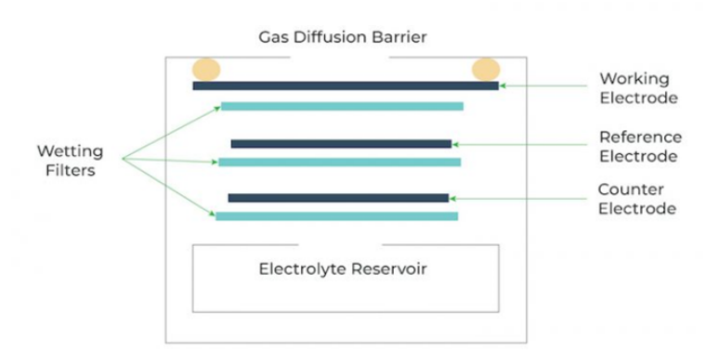

It works based on the diffusion of SO₂ gas into the sensor. Initially SO₂ oxidizes to produce oxygen free radical and converted to molecular oxygen. Electrons are consumed from sensor for the reduction of O₂ and number of electrons decreases on the electrode surface. Resistance of the electrode is a function of Concentration of SO₂.
𝑹% = (𝑹_{𝟎}−𝑹_{𝒈}) / 𝑹_{𝟎} * 100

R% is the reported sensor response,
Ro is the resistance in dry clean air (background condition),
Rg is the new resistance observed under analyte gas.

