Artificial Intelligence's Creative Potential in Art

Dr. Akhil Pandey¹, Dr. Vishal Shrivastava² , Er. Sangeeta Sharma³, Professor^{1,2}
Assistant Professor³, akhil@aryacollege.in¹, ³vishalshrivastava.cs@aryacollege.in^{2,},sangeetayuwansh1@gmail.com
Computer Science & Engineering Department ^{1,2,3},
Arya College of Engineering & I.T. Jaipur-302028, India

Abstract: Especially new tendencies in the area of synthetic focus are dynamic in that they exchange the house of expression. Programs based totally on simulated brain are hastily turning into famous in areas such as technology, music, human expression, and science. A new close-up of Christie's Edmund portrait adjustments our modern-day appreciation of the science of synthetic talent and raises questions about the creativeness related with technology. Can craft be seen as resourceful?” Against this background, this lookup makes use of a range of AI functions and modifications the point of view on AI craft and the manufacturing cycle of AI craft to create synthetic intelligence. Show that it is achievable Innovative imagination.

Tags - Artificial intelligence-generated art; computational creativity; machine learning

Introduction

This new category of craft is characterised through the significance of synthetic cognizance in the realm of imaginative creation. But the plausibility of some of this artisanal classification and introduction stays a cryptic idea, requiring escalated mental and frequent feel investigation. After being bought at a fee that handed the predictions, it sparked debate as to whether or not it was once created by means of machines or replicated by means of human imagination. Some ethical problems associated to the given have been additionally raised. Standard craft processing values ​​this concept as a kind of human counterpart, so the subsequent try to mix AI processing requires augmentation strategies for some verifiable innovative work. Therefore, we will attempt to symbolize the classification of AI crafts. Focusing on this point, this paper examines when machines can be a part of these modern currents, limiting the imagination, and whether or not this decoupled cycle association is itself revolutionary. Whether there is a circulate of innovation or not, the discoveries are equally imaginative.

Elaboration and uniqueness

This finds out about targets to look at that lookup query in the mild of the descriptive and innovative query of representation. To what extent can craftsmen certify AI processing as their own? How does understanding the character of the craftsman (human or AI) have an effect on the comparison of the work of art?

The Schema Theory
This speculation offers a primary observational structure for exploring crowd perceptions of craft in phrases of artisan individuality. Hong and Curran describe patterns as ``dynamic processing statistics buildings that classify recollections and information judgments, actions, and thoughts'' [1]. For example, schemes for crafts encompass evaluating the thoughts in the back of crafts, judging the public as particularly resourceful in crafts, and arts that we may additionally or may also no longer be involved in.
Individuals additionally have a schema containing allegations associated with AI and the inventiveness of precise work. The development speculation can genuinely be linked to the investigation of art, as a craft is a medium that enables the beginning of a number of ideas. Studies have proven that visible factors efficiently prompt contours, so this speculation is credible in the perception of how AI-related generalizations manipulate the grasp of AI enter quantities increase. McCarthy factors out that there are those who can deal with the assumption that AI has the capability to behave like humans. Due to their herbal faith that craftsmanship is something that human understanding and effort radiate; humans are probable to confirm that AI ​​is now not geared up with the potential to create works.
This exploratory record consequently assesses specific views of the canvas taken from each expert. The canvases emerge from two of his signature developments, however seeing the two works relies most on the sheer range of works and designs and the innovative disposition of the crowd. Various research on processing exhibits poor generalizations associated with AI-generated composition [3]. This paper makes use of the argument that human beings cost a work of artwork much less if it is an artifact. Therefore, given the schema hypothesis, in this article, canvases supplied by using craftsmen classified as AI characters, as hostile to works created by means of gurus with human personalities, will be used in their works in the futureprovide to obtain a decreased rating.

Algorithms Used for Creating AI Art
Proposed by means of Ian Goodfellow, GAN is a way to deal with generative mannequin predictions the usage of a malicious pass by that combines the education of two exceptional models. First, the generative mannequin (G) assumes the distribution of information, and the 2nd discriminative mannequin assumes the chance that the data take a look at got here from the organized sentence as a substitute than from G [4]. While many of its findings are lavish, it additionally tremendously a whole lot considered as a sensible demonstration of the strength of Genius tissue to produce a work product. You can now redraw the picture with styles. In addition, AI programming is used to assessment a range of images, and craftsmen increase high-level new fashions that "grasp" the fashion with a computer. These calculations produces distinctive snap shots that later conform to the "learned" style. These machines are very excellent at doing what they are told, however the creativeness is some other construct and making ready them in this way is a terrible dream for AI - AI will sooner or later end up human
Nevertheless, ongoing lookup gives the thinking of ​​CAN [5] created from GANs, however its generator there are extra portions that permit them to work "imaginatively". This strategy has created craftsmanship with the aid of analysing it and understanding/abstracting that style...and by means of increasing the initiation ability of works produced that deviate from that style, it be “innovative”. Moreover, considering that GANs are unable to operate ingenious work, the new framework is predicted to expand the deviation from the recorded fashion and reduce the deviation from the incidence of the layout via enhancing the target-yield element, as a result making it very suggests that it lets in the improvement of “out-of-the-box” plans. Subsequent lookup confirmed that human respondents have been unable to distinguish between configurations furnished by using AI and these created by way of humans. There is no decisive constraint between the assessments of the two works. Except lately organized the usage of the individuality of the work [6]. Despite the truth that the craftsmanship created via GANs or CANs lags in the back of near-home his plans considered in humans, these innovative AI frameworks are now in outstanding construction. We provide craftsmanship. So, given the ongoing advances in AI, it makes feel to honour the imagination.

The Creativity of AI

Human and Machine Creativity
Innovative capability thoughts exceptional inform human performance. Sawyer, America's fundamental clinician of creativeness and development, tended towards innovation as "part of what makes us human" (p. 3). Thus, given the involvement of machines in human knowledge, it is of utmost significance to work on the thoughts of imagination. As already indicated, revolutionary energy is one of the most vital blessings that signify the human mind/mind. Also, mass parallelism, profound skill, creativeness and stylishness, and innovation are amongst the highlights of psych/mind. What about non-human, non-natural machines, anyway? Is it fantastic to speak about them in phrases of ingenious perception and innovation? Or, extra simply, "Can computer make craftsmanship?" "Reputedly sensible PC software can maintain again the title of the world, manipulate mountains of information, and distinguish designs imperceptible to the herbal eye, however in reality, it controls the normal imagination. You can't"[7]. However, it requires a everyday human creativeness that requires actual double play. Simulated talent has a specific potential to generate significant sensations in innovative works. denies the opportunity that is endless [8].
Boden gives every other way to manage this conversation. These section goals to tackle an optionally available viewpoint on innovation functionality in the mild of AI. This section is supposed to additionally reflect on consideration on equating AI creativeness with inventive ingenuity, aside from the human aspect that fosters modern abilities. To reply these ideas, this lookup depends on the innovative penalties of desktop knowledge
Imaginative innovation is the premise of this concentration, as it respects the fashionable and profound boundaries that represent human knowledge. These constructions are computationally worried in the structure of the accompanying false imagination, so we determined AI Craftsmanship to comprise the factors and values ​​indicative of that imagination.
Sawyer is aware innovation by means of integrating his three ways: personal, spiritual, and social. Given his special methodology, Sawyer suggested: As a result, he used his three fundamental factors to categorical innovation. First, "inventiveness is new"[7]. He recommended that the fundamental want for ingenious idea and motion is novelty and originality. Daily exercise, such as commuting the equal way to work, is an instance of unattainable activity, as a rehash of previous conduct is no longer viewed innovative. Boden said, "Imaginary thinking is capricious" [8]. So, the ingenuity section must encourage some originality. Borden, on the different hand, has a special take on novelty. She explains how youth can think about new thoughts in their minds. As such, the assumption those others may additionally have idea about the concept earlier than does now not admit that their thinking is now not imaginative. From this perspective, Boden demonstrates a verifiable ratio of creativeness to mental innovation. Using these recognizable perspectives, Borden provides a exclusive worldview of progressive thinking. Mental Imagination suggests the improvement of capricious ideas new to the singular that generate them, regardless of what these ideas are generated through others.
If the concept is absolutely new and no one has ever talked about it, it turns into a demonstrable demonstration of ingenuity.
So, the originality of Boden's thoughts does no longer suggest that something has no longer been viewed beforehand. This underscores Sawyer's subsequent element, 'imagination is a blend' [7]. All ideas and ideas are a composition of triumphing considerations. According to Regan [9], recalling before perceived thoughts does now not indicate pics of precise activities. Overall, the creativeness is a combination of deferred and pre-existing thoughts that have by no means been related with the aid of others. Given this interpretation, the canvas generated via the AI ​​is a combination of more than a few preceding compositions (such as faceless portraits), so inventing conduct to specific new ideas in shocking and unpredictable ways. It can be stated that it is innovative due to the fact it summarizes a variety of plans of
This leads to Sawyer's 1/3 substance, "The Imagination Is Transmitted on Earth"[7]. According to Kurt, for something to be viewed imaginative, it needs to be communicated. In such cases, the ideas in the head are viewed however no longer communicated; neither viewed nor perceived [10]. Skill that this lookup now attracts a true chunk of the craft judgments and mentalities that comes from the inputs. A inspiration that a new popular thought have to be communicated in order to be viewed original. This is a contradictory that means of progressive craftsmanship, however in the mild of Sawyer's special methodology, the use of a social viewpoint can make the creativeness meaningful. This is the peculiarity of this factor of view. “Fantasy is the antiquity of objects judged by means of a moderately discovered crew to be new, relevant, useful, or important” [7].
  - What Are the Values/Features of AI Creativity?
In response to the query of AI's inventive imaginative capacity, each Sawyer's and Boden's conceptualizations strive to become aware of the constructing blocks of AI invention and the barriers that these views hold. Boden introduced three kinds of his ingenuity that can be laboured on to exhibit the cost of AI craftsmanship. They are combinations, breakthroughs, and informational ingenuity to display how constraints can be overridden to decorate AI's capacity to think about and understand.
    - Combinatory Creativity
According to Borden, combinatorial innovation includes "creating new combinations of herbal thinking" [8]. The inclusion of extraordinary thoughts creates one-of-a-kind mixes, both unconsciously or intentionally. In any case, Kurt suggests that mixes have cost and need to be new [10]. In a sense, this fee is an issue of Sawyer's very own approach and can be relied upon. This potential that the innovation is new and hybrid. His Faceless Portraits for Elgammal sketches the originality of combinations. As beforehand mentioned, when Elgammal approached Elgammal to introduce him to the Renaissance artisans who powered his set, he furnished almost 3000 images. One of his art work is a portrait of a younger man with an arrow, painted 5 centuries ago. In particular, the processing brings out a number of factors used to create the faceless portrait. A 16th-century portray depicts Bologna's Girolamo Casio with bolts attached. The compositions depicted show the arsenal and sophistication that Elgammal makes use of in crafting a variety of thoughts displayed in his series. The concept of ​​weapons is utilized to faceless photos of generals, whilst nobles are used to snap shots of kings.
    - Explanatory Creativity
This sort of creativeness takes vicinity inside a sure house and a sure style. Starting from the modern-day way of thinking, anyone can take that fashion and observe its critical elements to arrive at a new and complete result. It makes feel to be observed in a hopeful space, society, or social category that is now not delivered in [10]. It may want to very nicely be a musical style, a hypothesis, or a visible expression. Whoever comes up with a wise idea, inside this area or mindset, is original, the use of exemplary discernment. is considered. This kind of creativeness is vital for going through the investigation of this learn about due to the fact it “allows us to see possible consequences that have in no way been viewed before” [7]. Beneficial creativeness refers to presenting new thoughts and concerns thru the learn about of theoretical areas and styles. The ideas that depend are primarily horrifying and new. Examining these ideas, therefore, desires to be predictable in the adopted norms of thinking. As such, in order for any person to meet the requirements of style, they should first be observed thru research. AI gives the house to follow the possible of human-made recognition and understand algorithmic patterns in approaches that can be translated into new ideas. It incorporates a range of thoughts from exceptional disciplines such as reasoning, science, measurement, humanities, and manage hypotheses. According to Kurt, AI focuses on growing PC applications that evolve with experience [10]. When the computing device makes modifications to two initiatives or units of information, it learns and updates the subsequent presentation. Reliable fake mastering with informative portions of creativeness accompanies modifications with the state-of-the-art effective PC frameworks

    - Transformational Creativity
This kind of ingenuity entails transformations of theoretical space, producing never-before-seen ideas and ideas. Creativity is indispensable to ignite step forward imagination. The discernment cycle in computational brain takes place when software perceives statistics in the brain's framework. When these talent networks are controlled, the laptop creates images, instead than honestly memorizing, primarily based on guidelines given. The mission makes use of data from the intelligence to in my view create images. Whether or no longer the thinking looks constrained to AI programs, as it identifies suggests, Google's Deep Dream software can generate dreamlike images.

Conclusions
Despite the truth that AI craftsmanship is in many instances studied primarily based on imagination, this finds out about laid out that simulated Genius craftsmanship is masterfully innovative. This paper proposes that humans who are targeted on AI workmanship are flawlessly positioned in mild of the truth that thusly, they have the precious hazard to inspect new AI innovations, locate the functionality of a human's intellectual direction of making craftsmanship as re-encapsulated thru computational deliberation processes, and clearly make new sorts of craftsmanship. As Cetinic and the creator country in their investigation of the resourceful utilization of AI, the diploma to which we recognize and decipher AI frameworks is as but restricted, and experts in distinctive disciplines are included in the enhancement of the independence of AI. As innovation propels, the restriction between wondering about AI as units or as craftsmen/makers is getting vaguer [11]. Subsequently, these finds out suggest that AIs can maybe flip out to be "genuine specialists". For experts who think about AIs as "imaginative colleagues", this paper proposes they want to look at exceptional practicable effects to "control" the images internal on which AI packages base their made results, instead of zeroing in on the mechanical enlargement of calculations.
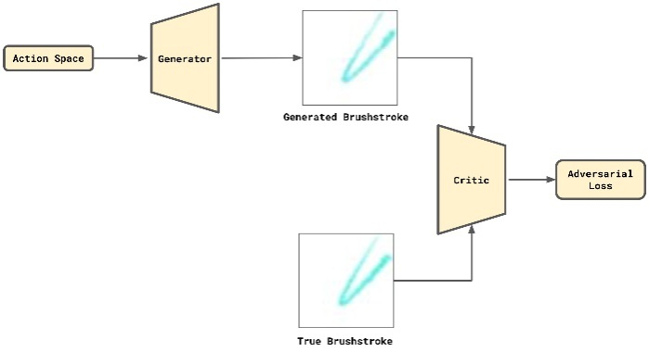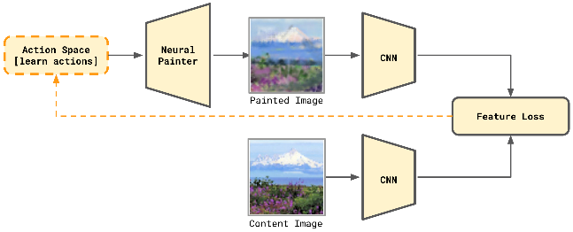
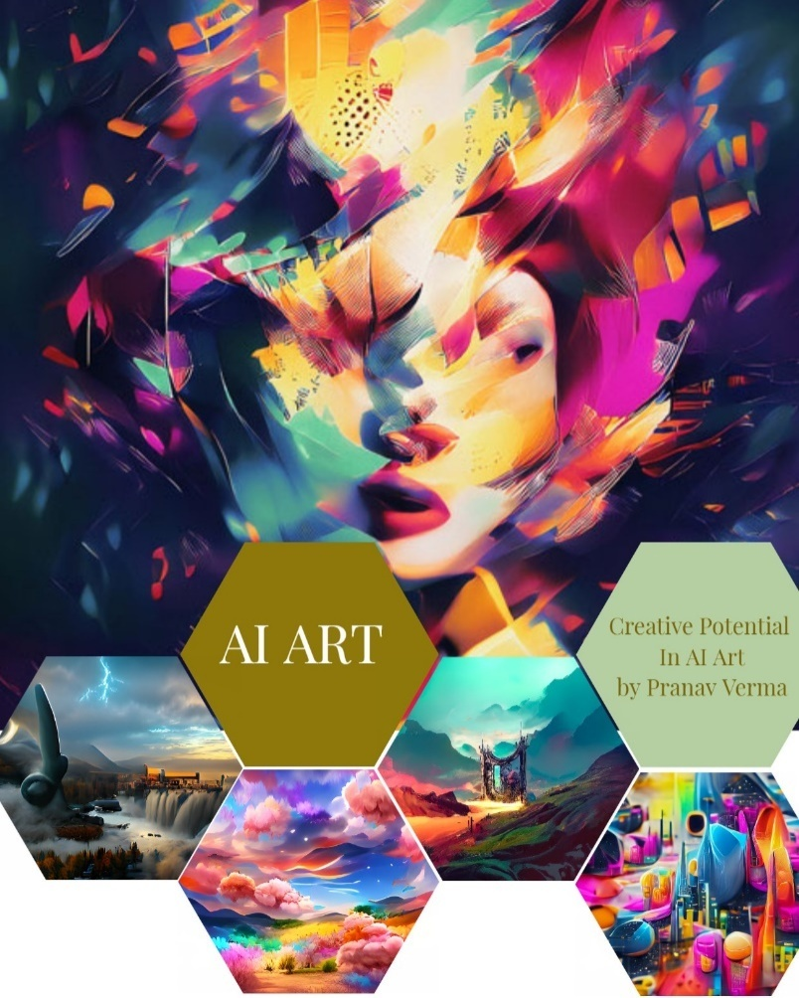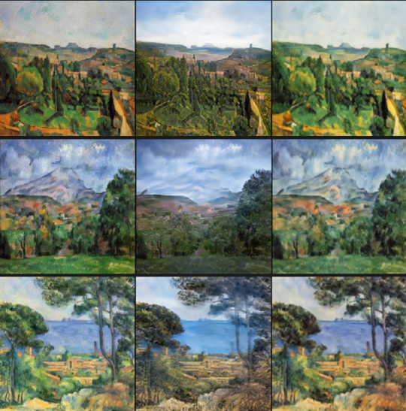

References
- Hong, J.; Curran, N.M. Artificial Intelligence, Artists, and Art: Attitudes Toward Artwork Produced by Humans vs. Artificial Intelligence. ACM Trans. Multimed. Comput. Commun. Appl. 2019, 15, 58. Available online: https://dl.acm.org/doi/10.1145/3326 337(accessed on 29 September 2020). [CrossRef]
- McCarthy, J. What Is Artificial Intelligence? How Does AI Work? Available online: https://builtin.com/artificial-intelligence (accessed on 29 September 2020).
- Ali, M. The Human Intelligence vs. Artificial Intelligence: Issues and Challenges in Computer Assisted Language Learning. Int. J. Engl. Linguist. 2020, 8, 259. [CrossRef]
- Goodfellow, I.; Bengio, Y.; Courville, A. Deep Learning; MIT Press: Cambridge, UK, 2016.
- Elgammal, A.; Liu, B.; Elhoseiny, M.; Mazzonne, M. CAN: Creative Adversarial Networks, Generating “Art” by Learning about Styles and Deviating from Style Norms; Cornell University: Ithaca, NY, USA, 2017.
- Elgammal, A. What the Art World Is Failing to Grasp about Christie’s AI Portrait Coup. Available online: https://www.artsy.
net/article/artsy-editorial-art-failing-grasp-christies-ai-portrait-coup(accessed on 29 October 2018).
- Sawyer, R.K. Explaining Creativity: The Science of Human Innovation; Oxford University Press: New York, NY, USA, 2014.
- Boden, M.A. The Creative Mind: Myths and Mechanisms; Psychology Press: London, UK, 2004.
- Regan, M. Generative Adversarial Networks & The Art Market. Ph.D. Thesis, State University of New York, New York, NY, USA, 2018.
- Kurt, D.E. Artistic Creativity in Artificial Intelligence. Ph.D. Thesis, Radboud University, Nijmegen, The Netherlands, 2018.
- Cetinic, E.; She, J. Understanding and Creating Art with AI: Review and Outlook. arXiv2021, arXiv:2102.09109. [CrossRef]

