Braking Framework Investigate Utilizing All-Electric Braking Framework

Dr. Hredeya Mishra¹)
Lecturer in MED
MVPS’s RSM Polytechnic Nashik
1002mishrahk@gmail.com

Dr. Pradnya Prakash More² )
Lecturer in MED
MVPS’s RSM Polytechnic Nashik
pradnya.more@rsmpoly.org

ABSTRACT
The braking system is a join effect of pneumatic as well as electric brakes. This system is the main cause of train sound of disc brake shoes when braking, causing noise as well as air pollution. Therefore, research paper shows a method of using the entire braking system as a static braking system to remove air-dust and other contaminants.
Keywords— brake shoes, static braking, method, entire braking system

INTRODUCTION

E-trains have become an important means of public transportation in recent years. As passenger comfort improves and electronics evolve, vehicle performance, handling and handling must also improve. The brake system manages a combination of pneumatic and electric brakes. This system is the main cause of train noise and disc brake shoes when braking. Causes environmental pollution.
Therefore, this article presents a method of using the entire brake system as a brake system to remove dust and other contaminants..

ELECTRIC BRAKE FRAMEWORK

The start and stop of the electric train is controlled by an inverter drive. The electric brake works at a speed of about 5 km/h. The air brake works at a speed of about 5 km/h. The system uses an encoder to sense the motor, which acts as a vector controller. Precise vector control is not possible due to the characteristic power of about 60-100 pulses per revolution of the encoder system.
For this reason, a hybrid electric and pneumatic braking system is used. This system is the main cause of train noise and disc brake shoes when braking. Causes environmental pollution. When the train speed drops below 5 km/h, the compressor causes noise, is not easy to maintain and the air brake is at risk of aging.
All electric brakes are normally used for electric brakes to reduce the risk of air brake failure. The benefits of using a fully electric brake frame are as follows:
1. Reduce the use of brake shoes by reducing the air brake
2. Reduce brake noise due to mechanical wear and tear
3. Save money on brake service
4. Increase energy consumption to develop regenerative braking.

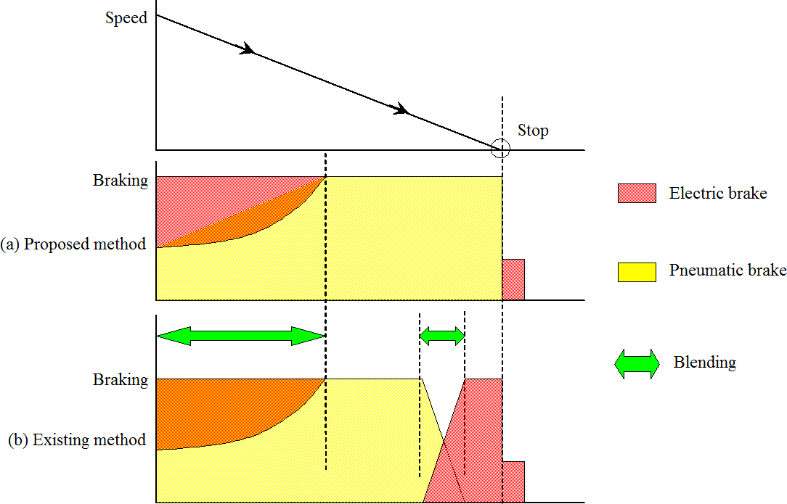
Figure 1. Electric brake framework

COMPOSITION OF FULLY ELECTRIC FRAMEWORK

The brake system consists of an inverter, a PWM control unit, a vector control unit, a drive control unit and a speed control unit. The inverter controls the speed of the motor by converting the DC voltage to DC voltage through the current collector.
The PWM control unit controls the gate displacement of the inverter. A PWM controller changes the voltage and frequency of the stepper motor input circuit. The vector control unit receives speed and current signals from the motor.
The vector control unit determines the voltage and frequency of the inverter. The drive control unit executes drive commands for acceleration, braking and deceleration.
The brake control controls the holding brake. The speed control unit determines the rotor speed for motor control. For motor control, the inverter starts holding the brake after the standby stops.
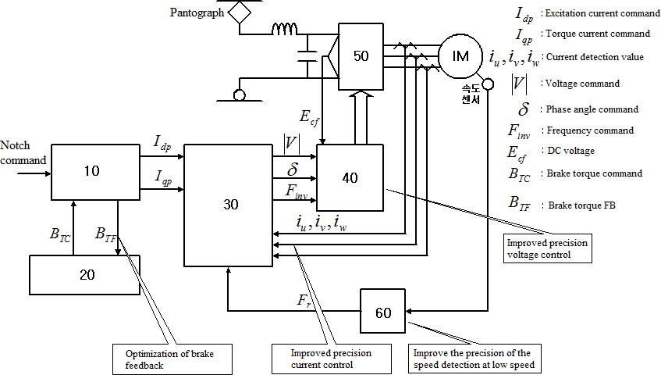
Figure 2. Control configuration for Brake Framework
The vector control unit receives the detection value of the motor current and speed to provide foot control and speed control from the foot motor. The balance of the stroke width changes to produce a control unit.
The vector control unit performs critical controls such as current and frequency vector control in response to the reference value of the drive control unit.
In this context, the solver is used to determine and accurately control the speed in the low speed range.
Figure 3 shows the brake control during deceleration. When the stop flag is detected, a torque current command (Iqp) is executed to apply the brake force.
When the gear speed enters the low-speed range (5 km/h or less), the electric braking force is reduced and the torque point is now set. When the vehicle stops, the air brakes are applied
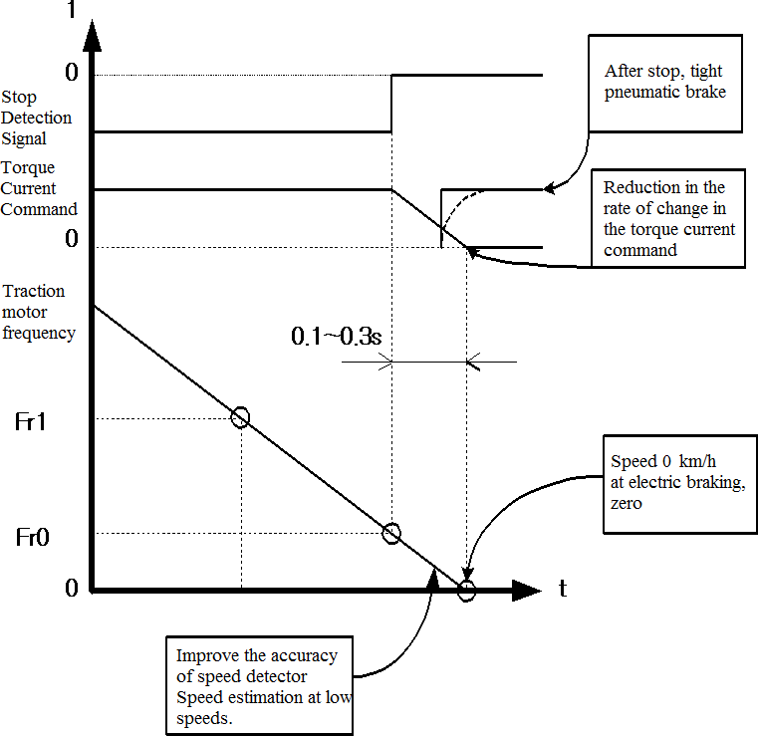
Figure 3. Control of brake graph at moo velocity

TEST

There are the following conditions to stop the engine.
4.1 Avoid rolling after you stop.
1. Air brake operation when the brake torque is 0
2. Braking torque is produced in the gradient. Brake using pneumatic brake force to prepare for stopping
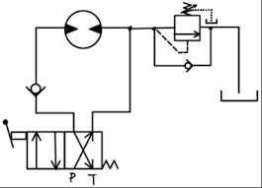
Figure 4: Braking Sequence

Electric motors for propulsion and regenerative braking. Figure 5 shows the engine speed starting at 360 [rpm] and the torque at 800 [rpm] 0. The braking torque is proportional to the stopping speed.
Figures 5 and 6 show the torque setting step change. It is possible to run slowly while stopping
The braking system is a combination of pneumatic and electric brakes

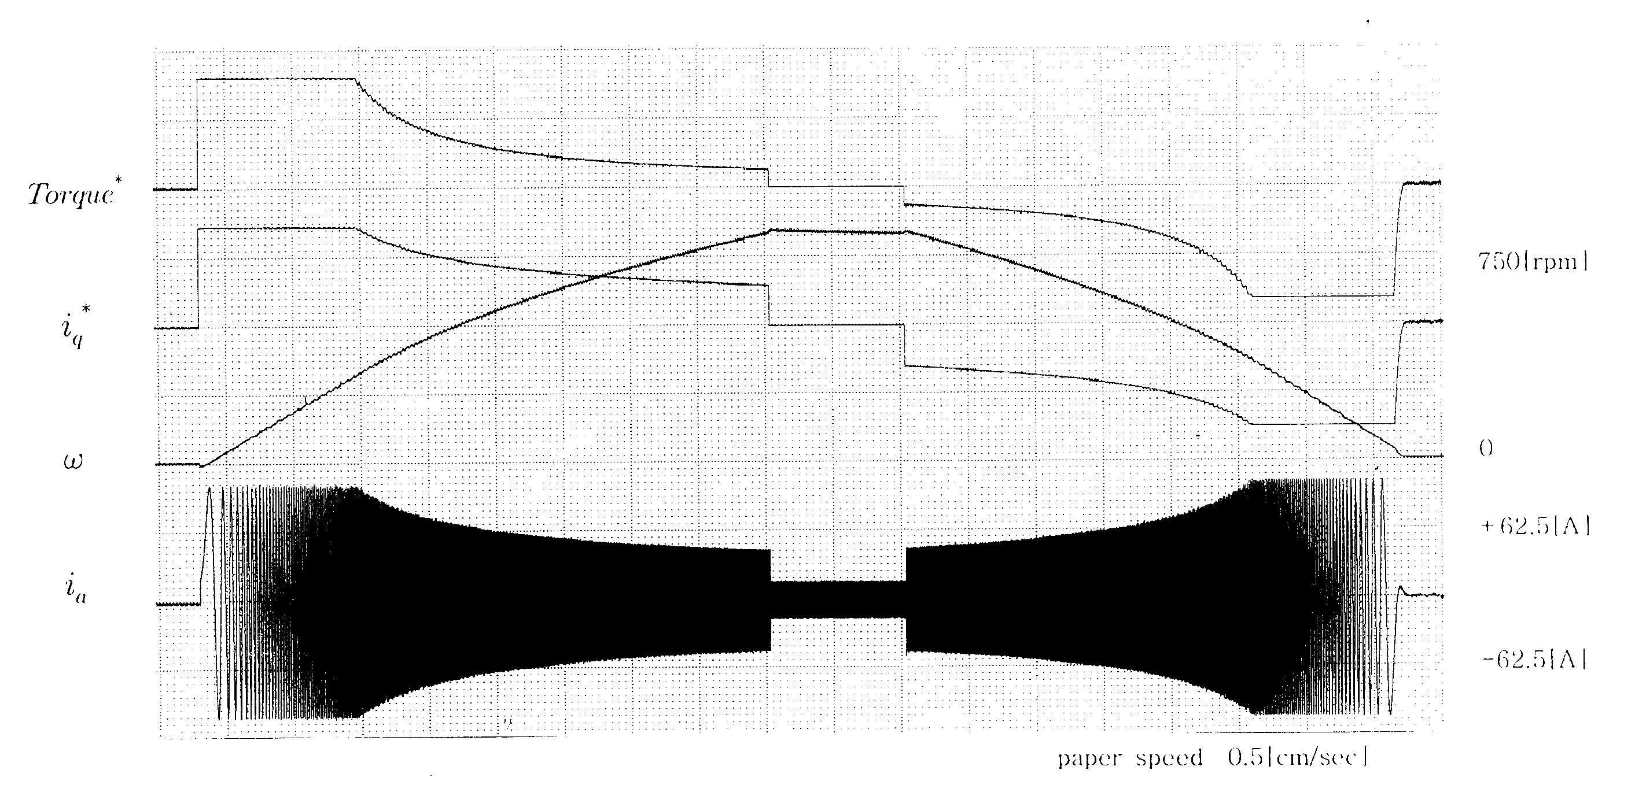
Figure 5. Driving test on given load

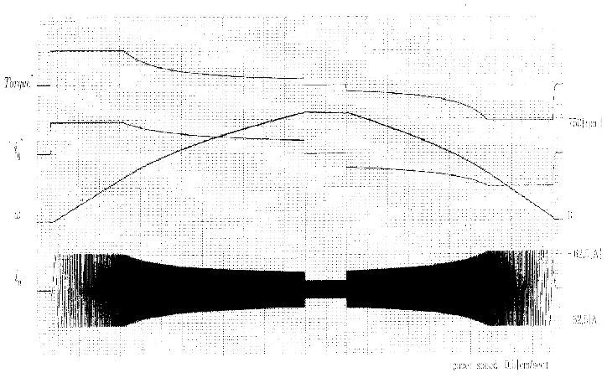
Figure 6. Testing of the rod in different load

CONCLUSION
The brake frame controls a combination of air brakes and electric brakes. The frame is the main reason for preparing the shock and brake shoe contact plate when the brake part is applied. causing natural pollution. Therefore, this paper presents a strategy to use the all-electric brake frame as a zero-speed brake frame to evacuate particulates and other pollutants. Advantages of using an all-electric car:
1. Reduce the use of air brakes and reduce shoes.
2. Can reduce the mess and clean from using the machine
3. Reserve for brake cost
4. Use the most prominent features to connect additional customization

REFERENCES

- Hanmin lee, Gildong Kim, Changmu Lee, Euijin Joung, “A study on Braking Control for Pure electric Brake of Electric Train”, The Korean Institute of Electrical Engineers conference, 2012
- Hanmin lee, Gildong Kim, “A Study on Electric Braking System to 0km/h”, The Korean Society for Railway conference,pp.178, 2007
- Sone, Ashiya, "Pure electrical brake of the railway electric vehicles",Railway cybernetics, vol.34,No.513, pp.194~197, 1997
- Ogasa, Nagai, Watanabe, "Plant-test Result of All Electrical Braking (Report 1)", National convention Record I.E.E.Japan, 1260,pp.5- 389~390, 1998
- Ogasa, Nagai, Watanabe, Toda, "Plant-test of Electrical Breaking to Zero Speed for Railway Vehicle", National Convention Record I.E.E.Japan-Industry Application Society-, No.77,pp.257~262, 1998
- Sato, Iida, Hisatomi, "Pure electric braking system test using stsrt", National Convention Record I.E.E.Japan-Industry Application Society-, No.78,pp.253~2666, 1998

