The Future Technological Outlook of the eCommerce Industry
Artee Bhadauria* and Richa Agarwal
Abstract:
Introduction:
The current problem of emerging trends in the e-commerce sector is examined in the current paper. E-commerce, which is built on virtual technological integration and the blending and coordinating of consumer connections, is one of the engines of the digital economy. At the current level of the eCommerce sector's technological revolution, introducing technological advances affects every aspect of an enterprise's operations and necessitates re-engineering its established business models.
Objective:
The purpose of the study is to examine how new technologies develop and what technologies are used most frequently in e-commerce.
Methodology:
To analyse the literature, systematic reviews are becoming more and more popular. In the current study, we adopted the preferred reporting items for systematic review and meta-analysis (prisma) quality assessment from Young et al. (2017).
Conclusion:
The list of technologies such as blockchain, the Internet of Things, and virtual shopping as futuristic leading technologies from the year 2013 to 2023 has been fragmented into three categories: core, adjacent, and transformational technologies leading the eCommerce industry.
Implications:
The study makes a contribution to the growing topic of e-commerce transformation (ET) in the literature on retail management and gives practitioners knowledge about the effectiveness of applying IT technologies in this sector.
Keywords: Internet of Things, Electronic commerce, Blockchain,
1. Introduction:
The primary forces influencing the worldwide market's rapid development include adjustments in manufacturing and consumption patterns, new technical advancements, novel business models, and legislative modifications. The speedy integration of all corners of the globe into one global marketplace is anchored by the great improvements in communications and transportation made possible by new technology, which is a major force behind these changes. An increasing number of nations will be progressively incorporated into broader international interaction through trade and foreign direct investment (FDI), as well as a more geographically diverse distribution of income growth and opportunities. This growth is supported by various technological advancements and innovations that are shaping the future of eCommerce.
One important trend to watch out for in the future of eCommerce is the focus on user data security and privacy assurance (Azzery, 2023). Ensuring that customer data is protected and safeguarded from unauthorized access or exploitation by irresponsible parties will be crucial for the success and trustworthiness of eCommerce platforms. Additionally, the government will play a pivotal role in guaranteeing data protection and enforcing regulations to prevent any data theft or misuse. Furthermore, the future of eCommerce will see an increased emphasis on the development of innovative 3D solution systems. These solutions will enhance the user experience by introducing new features and services. Promoting communication and collaboration with experts and stakeholders will be essential to stay at the forefront of technological advancements.
1.1 The factors promoting the development of technology in the e-commerce sector:
The advent of creative business models, improved consumer experiences, and extensive digitisation across the value chain have all led to considerable changes in the retail sector in recent years. Businesses must be able to adapt to the factors influencing the market in this dynamic environment if they are to survive and grow. These six key constraints offer insightful analysis into the shifting market dynamics, enabling businesses to foresee changes, synchronise their plans, and seize new possibilities (see Figure 1).
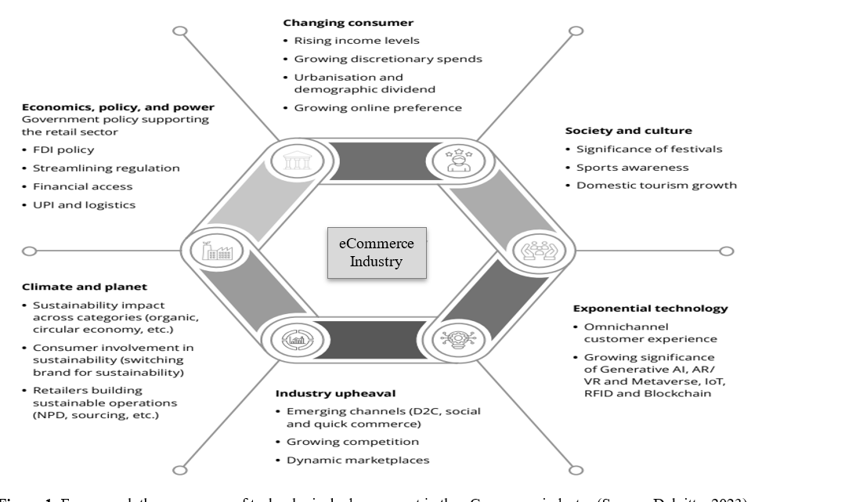
Figure 1: Forces push the emergence of technological advancement in the eCommerce industry (Source: Deloitte, 2023).
To further drive the rapid and sustainable development of e-commerce, it is imperative to invest more in science and technology. By prioritizing these investments, the industry can continuously create useful new features and services that cater to the changing needs and preferences of consumers. Moreover, the integration of artificial intelligence will revolutionize the eCommerce industry. Retailers will leverage AI technologies to provide personalized shopping experiences, improve customer service, and optimize supply chain management. Furthermore, the future of eCommerce will be shaped by the impact of big data. This process entails the collection, processing, and analysis of data on relevant variables to the business and applying them to update the marketing activities of firms in the most effective and targeted manner. The foreseeable future of the eCommerce industry will be determined by the integration of digital technology, big data, and artificial intelligence (Khrais & Alghamdi, 2021). This integration will pave the way for more efficient and personalized e-business transactions on a global scale. In conclusion, the future of the eCommerce industry is set to be shaped by various technological trends. These trends include a focus on user data security and privacy assurance, the development of innovative 3D solution systems, increased investment in science and technology to drive innovation, the integration of artificial intelligence for personalized experiences, and the utilization of big data for targeted marketing activities. The future of the eCommerce industry is promising, with trends pointing towards the continued growth and development of technology to enhance the user experience and streamline business operations.
The future of the eCommerce industry will be heavily influenced by advancements in digital technology, big data, and artificial intelligence. These three factors will play a pivotal role in shaping the way e-commerce transactions are conducted and how businesses operate in the digital marketplace. Moreover, the integration of artificial intelligence and augmented reality technologies will revolutionize the e-commerce landscape. AI-powered chatbots and virtual assistants will enhance customer service by providing personalized recommendations and assisting with purchase decisions. AR, on the other hand, will enable consumers to visualize products in a virtual environment, allowing for a more immersive and interactive shopping experience.
Future technological trends have been discussed for nearly 25 years and have been conceptually reviewed & and researched by many authors and researchers. Holbrook and Hirschman (1982) define marketing as the consumption of fun, feelings and fantasies which was further elaborated by Csikszentmihalyi (1991) as something beyond mere need satisfaction or something beyond stimulus-response. Building on these studies a comprehensive systematic literature review has been discussed. Thus, in this paper, we aim to systematically review the literature published on experiential marketing, the present study covers all the articles published on experiential marketing between 2013 and 2023.
To this end, our objectives are to review the following recent evidence by employing preferred reporting items for systematic review and meta-analysis (prisma) (Young et al., 2017) for quality assessment of selected recent studies to achieve the following goals:
- To analyse the increase in the usage of technology in the eCommerce industry
- To identify the list of emerging technological trends.
2. Method:
2.1 Screening Algorithm:
To analyse the literature, systematic reviews are becoming more and more popular. In the current study, we adopted the preferred reporting items for systematic review and meta-analysis (prisma) quality assessment from Young et al. (2017). Figure 2 displays a flowchart for PRISMA. Therefore, using specific search terms in five databases (Elsevier, EBSCOhost, Web of Science, Springer, and Mendley) and looking up cited references in these works, we were able to identify searches reviewed by experts' primary studies exploring futuristic technological trends in eCommerce that had been published since 2013. Finally, a thorough investigation on Google Scholar was done to commend these searches. Editorials, conference abstracts, opinion/theoretical fragments without empirical evidence, literature/systematic reviews, and any publications from the year 2013 were excluded from the current review. Primary studies combined with secondary analysis of a current dataset were retained as compatible with the insertion procedure. The only language for which search results were taken into account in the algorithm was English, however, any demographic group and study methodology (such as quantitative, qualitative, or mixed techniques) were acceptable as long as they supported the goals. The quality evaluation standards for previous research have been taken from Young et al., 2017 (Figure 2). The main filter criteria used in the current investigation were as follows:
- Filter I: An initial screening exercise involves identifying the records (n=10,500) through the database Google Scholar.
- Filter II: Thereafter the records’ titles only removed the records that were irrelevant after pre-screening by title (Elsevier: n= 73; EBSCOhost: n= 41; Web of Science: n= 86; Springer: n= 76; Mendley: n=71).
- Filter III: After integrating all of the records collected from repositories, records that are ready for screening are obtained.
- Filter IV: After removing dataset redundancy (n=82), screened abstracts are produced.
- Filter V: After removing book reviews and conference papers (n=167), full-text versions of the relevant articles were acquired.
- Filter VI: After removing papers with no mention of eCommerce or technology implementation in the eCommerce industry (n=77), a final list of acceptable pieces of literature was obtained.
Studies included in the review (n=21)
Full-text articles assessed for eligibility (n=98)
Screened Abstract (n=265)
Record Screened (n= 347)

Fig 2: Preferred Reporting Items for Systematic Review and Meta-Analysis (PRISMA) chart of screening process algorithm adapted from Young et al. (2017).
3. Findings:
3.1 Analysis of the increased use of technology in eCommerce:
A systematic literature review represents a lucid and reproducible set of studies that certainly curb the probability of reviewer biases in the literature selection process (Petticrew, 2001). The retail industry has transformed thanks to the digital revolution, which has given rise to "phygital" interactions that effortlessly incorporate both digital and physical components. As demonstrated in Figure 3, there has been a significant shift in the literature covering technological intrusion in the eCommerce industry. From the years 2013 to 2016, only 14% of all studies were conducted; however, commencing in 2017, there has been a significant upsurge observed accounting for a 15% increase in the number of studies. As a result of this shift, both traditional and online retail models have been challenged as brands and merchants use a wide range of technologies to improve the customer experience. The eCommerce sector has seen a significant pattern shift since the post-pandemic era, which has left its mark on industry history. The adoption of cutting-edge technologies like artificial intelligence, augmented reality, and data analytics, as shown in Figure 3, enables retailers to offer individualised, convenient, and immersive experiences that blur the gap between both digital and physical channels, ultimately empowering brands to thrive in the competitive Indian market.

Figure 3: Number of studies from the year 2013 till 2023 (Source: Researchers’ construct)
Figure 3 shows that 43 per cent of studies were carried out in the post-pandemic period as a result of the widespread implementation of ONDC (open network for digital commerce), which gave sellers and buyers better access to one another, better pricing options, a larger base of buyers and sellers, lower technology costs thanks to the buyer app, and new opportunities for logistics service providers to generate income (George & George, 2022). Recent studies demonstrate the continued growth of online commerce, and Kirana tech start-ups provide a range of solutions that strengthen Kirana retailers while competing with established e-commerce giants. Recent studies are an investment in empowering kiranas and facilitating their seamless entry into the digital era.
3.2 Emerging technological trend:
Technological intervention has always been purported as one critical means for creating a holistic experiential environment. From the review (see Figure 4) we have extracted only the literature which was exhibiting technological interposition from the year 2013 to 2019. Figure 4 shows lists of technologies used by the e-commerce sector in 2013, including information technology, virtual reality, HTML5, Ajax, social media, search engine optimisation, and information communication technology (Shouk et al., 2013; Dutta et al., 2013; and Bilgihan et al., 2013). Later, radio frequency identification, sophisticated computational techniques, online verification, social media, and websites (Shaltoni, 2017; Yadav & Rahman, 2017), mobile, blockchain technology, and online verification (Mackey and Nayyar, 2017) were the most popular technologies in 2017. In 2018, there was a 30-day replacement warranty, one-day delivery, cashback offers, mobile wallets, free trials, cash on delivery, 3-D technology, blockchain, and smart contracts (Chang et al., 2018), body scanning, virtual dressing rooms, visual technology, and virtual reality (Guercini et al., 2018). Then, in 2019, there will be big data, artificial intelligence, virtual reality, virtual assistants, and blockchain technology (Shin, 2019), followed by information technology and information communication technology (Kwak et al., 2019).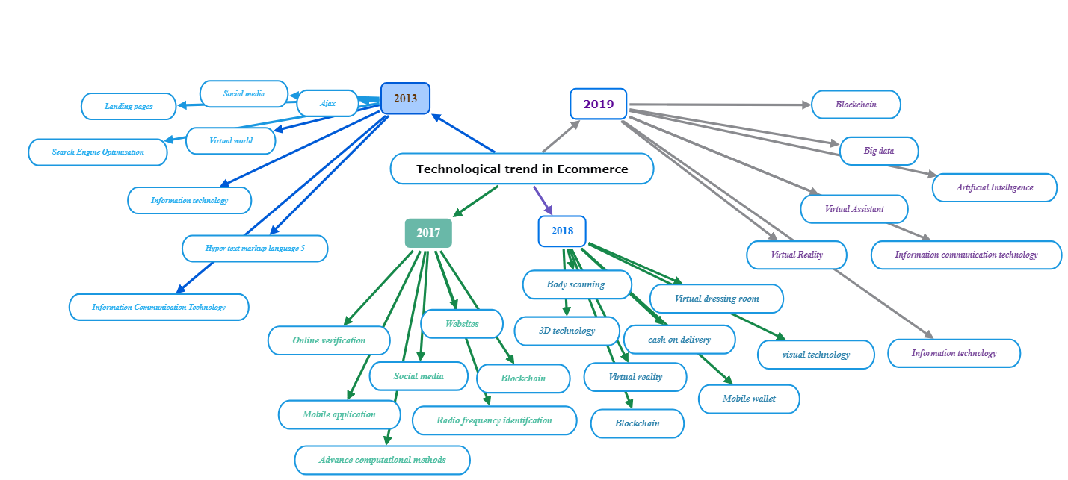
Figure 4: Technological trend from 2013 till 2019 (Source: Researchers’ construct)
Therefore, businesses must prioritise consumer data privacy and abide by government standards and laws given the rising usage of cutting-edge technologies and the acquisition of customer data. For the protection of client information, retailers should put in place strict data privacy safeguards, such as secure storage, the use of encryption, and access limits. Foreign luxury brand launches in India have increased dramatically in the wake of the pandemic. A tremendous change in the eCommerce industry has taken place, shifting the emphasis from the provision of merely transactional experiences to immersive and life-changing ones. The concept of experiential commerce has grown to be a potent strategy that alters both the perception of businesses and the physical and online purchasing experiences. Figure 5 prioritises the acquisition of fundamental technologies that customers now want as part of their complete shopping experience is important for businesses.
Technological trends in eCommerce
Figure 5: Recent technological trend from 2020 till 2023 (Source: Researchers’ construct)
From the review (see Figure 5) we have extracted only the literature which was exhibiting technological interposition from the year 2020 to 2023. Figure 5 shows lists of technologies used by the e-commerce sector in 2020, including chatbot and augmented reality (Moriuchi et al., 2020); Internet of Things security, blockchain, intrusion detection system, RFID security, (Dutta et al., 2020; Lia et al., 2020). Later, big data and cloud computing (Li and Zhang, 2021), app-based sales systems (Reardon et al., 2021) and were the most popular technologies in 2021. In 2022, there was a fintech, artificial intelligence, robotics, and blockchain (Sharma et al., 2022), and online payment, Blockchain (Hamidi et al., 2018). Then, in the year 20, there will be a website, a mobile application, and a customer experience (Bansal and Sharma, 2023), followed by the Internet of Things and artificial intelligence (Amiri et al., 2019). With the help of this technology-driven strategy, companies can discover new markets, develop cutting-edge products, and establish themselves as market leaders.
To foster growth and preserve a competitive edge, it is crucial to constantly examine developing technologies, recognise their potential effects, and proactively incorporate them into business initiatives.
4. Conclusion
There have been numerous research that have concentrated on the topic of technology forecasting, but systematic investigations such as PRIMA analysis might further support the outcomes of technology forecasting have not yet been investigated. Based on a methodical examination of technology predictions, this report identified future research trends in this area. Although the emergence of technology remains a contemporary of research within e-commerce sectors, this review has shown that the majority of researchers bifurcate the technology based on core, adjacent and transformative (see Figure 7).

Transformative Technology
Adjacent Technology
Core Technology
Figure 7: Future technological phases (Source: Researchers’ construct)
From 2013 to 2023, researchers need to prioritise acquiring the core technologies that consumers today take for granted as part of their whole purchasing process. This includes necessary features like same-day delivery, cash-back offers, virtual experiences, online shopping, and tools for managing customer relations. It is also vital for incorporating ancillary technologies like cyber security, virtual reality, augmented reality, electronic payments, smart contracts, and advanced analytics. Adopting these technologies enables businesses to launch transformative technologies that not only improve their present products but also open up possibilities for growth. blockchain, the metaverse, artificial intelligence, and the Internet of Things are examples of transformative technology. The studies reviewed suggest that virtual technology-led e-commerce content is highly targeted, both in terms of frequency and content. We reflect on the evidence covered by this review and offer recommendations for future research. In conclusion, three key technological approaches that are influencing the eCommerce industry's future in India are causing it to develop and evolve significantly. These forces include shifting consumer behaviour, industry disruption, sociological and cultural changes, exponential technological advancements, the effects of climate change, and economics, policy, and power.
The implications of future technology trends in the e-commerce industry are significant and far-reaching. As technology continues to advance, it will reshape the way e-commerce businesses operate and how consumers shop online. Here are some key implications of future technology trends in the e-commerce sector:
Enhanced Customer Experience:
Personalization: Advanced AI and machine learning algorithms will enable highly personalized shopping experiences, with product recommendations, tailored marketing, and individualized pricing. Augmented Reality (AR) and Virtual Reality (VR): These technologies will allow customers to visualize products in their real-world environments before making a purchase, improving confidence in online buying decisions.
Improved Convenience:
Voice Commerce: Voice assistants and voice-activated shopping will streamline the buying process, making it more convenient for customers to place orders and make inquiries.
Drone and Autonomous Delivery: Faster and more efficient delivery methods, such as drone and autonomous vehicle deliveries, will reduce shipping times and costs.
Supply Chain Efficiency:
Internet of Things (IoT): IoT sensors and devices will provide real-time data on inventory levels, helping businesses optimize their supply chains, reduce waste, and ensure product availability.
Blockchain: Blockchain technology can enhance transparency and traceability in the supply chain, which is especially important for verifying product authenticity and reducing counterfeits.
Payment Innovations:
Cryptocurrencies: Some e-commerce platforms are already accepting cryptocurrencies as payment. This trend may grow as cryptocurrencies become more mainstream.
Biometric Payments: Biometric authentication methods, such as fingerprint or facial recognition, will enhance the security and convenience of online payments.
Data Security and Privacy:
Enhanced Security Measures: With the rise in cyber threats, e-commerce businesses will need to invest in advanced security measures and encryption technologies to protect customer data.
Privacy Regulations: Compliance with data privacy regulations (e.g., GDPR) will be crucial. Companies that prioritize data privacy will build trust with customers.
Sustainability and Green Practices:
Eco-Friendly Packaging: E-commerce companies will adopt more sustainable packaging options to reduce environmental impact.
Green Supply Chain: Technology will help optimize supply chain operations to minimize energy consumption and reduce carbon footprints.
Mobile Shopping Dominance:
Mobile-First Approach: E-commerce businesses will increasingly prioritize mobile shopping experiences, with mobile apps, responsive websites, and mobile-friendly payment options.
Artificial Intelligence (AI) and Chatbots:
Customer Support: AI-powered chatbots will handle routine customer inquiries, providing quick responses and freeing up human agents for more complex issues.
Predictive Analytics: AI will help businesses anticipate customer preferences and trends, improving inventory management and marketing strategies.
Social Commerce:
Social Media Integration: E-commerce will become more integrated with social media platforms, allowing users to shop directly from their favorite social apps.
Global Expansion:
Cross-Border E-commerce: Technology will facilitate international expansion for e-commerce businesses, enabling them to reach a global customer base.
These implications highlight the transformative power of technology in the e-commerce industry. To stay competitive and meet evolving customer expectations, e-commerce businesses must embrace these trends and adapt their strategies accordingly. Those that effectively leverage technology will be better positioned to thrive in the dynamic e-commerce landscape of the future.
5. References:
- Azzery, Y. (2022). Analysis of E-commerce Growth in the Industrial Age 4.0 in Indonesia. International Journal of Engineering Continuity, 1(1), 1-8.
- Csikszentmihalyi, M. (1991). Design and order in everyday life. Design issues, 8(1), 26-34.
- Khrais, L. T., & Alghamdi, A. M. (2021). The role of mobile application acceptance in shaping e-customer service. Future Internet, 13(3), 77.
- Dutta, D. K., Gwebu, K. L., & Wang, J. (2015). Personal innovativeness in technology, related knowledge and experience, and entrepreneurial intentions in emerging technology industries: a process of causation or effectuation? International Entrepreneurship and Management Journal, 11, 529-555.
- Guercini, S., Bernal, P. M., & Prentice, C. (2018). New marketing in fashion e-commerce. Journal of global fashion marketing, 9(1), 1-8.
- Shaltoni, A. M. (2017). From websites to social media: exploring the adoption of internet marketing in emerging industrial markets. Journal of Business & Industrial Marketing, 32(7), 1009-1019.
- Chang, S. E., Chen, Y. C., & Wu, T. C. (2019). Exploring blockchain technology in international trade: Business process re-engineering for letter of credit. Industrial Management & Data Systems, 119(8), 1712-1733.
- Abou-Shouk, M., Megicks, P., & Lim, W. M. (2013). Perceived benefits and e-commerce adoption by SME travel agents in developing countries: Evidence from Egypt. Journal of Hospitality & Tourism Research, 37(4), 490-515.
- Kwak, J., Zhang, Y., & Yu, J. (2019). Legitimacy building and e-commerce platform development in China: The experience of Alibaba. Technological Forecasting and Social Change, 139, 115-124.
- Reardon, T., Heiman, A., Lu, L., Nuthalapati, C. S., Vos, R., & Zilberman, D. (2021). “Pivoting” by food industry firms to cope with COVID‐19 in developing regions: E‐commerce and “pivoting” delivery intermediaries. Agricultural Economics, 52(3), 459-475.
- Li, L., & Zhang, J. (2021). Research and analysis of an enterprise E-commerce marketing system under the big data environment. Journal of Organizational and End User Computing (JOEUC), 33(6), 1-19.
- Hirschman, E. C., & Holbrook, M. B. (1982). Hedonic consumption: emerging concepts, methods and propositions. Journal of Marketing, 46(3), 92-101.
- Dhir, S., & Dhir, S. (2018). Role of ambidexterity and learning capability in firm performance: A study of e-commerce industry in India. VINE Journal of Information and Knowledge Management Systems, 48(4), 517-536.
- Moriuchi, E., Landers, V. M., Colton, D., & Hair, N. (2021). Engagement with chatbots versus augmented reality interactive technology in e-commerce. Journal of Strategic Marketing, 29(5), 375-389.
- Shin, D. D. (2019). Blockchain: The emerging technology of digital trust. Telematics and informatics, 45, 101278.
- Dutta, P., Choi, T. M., Somani, S., & Butala, R. (2020). Blockchain technology in supply chain operations: Applications, challenges and research opportunities. Transportation research part e: Logistics and transportation review, 142, 102067.
- Yadav, M., & Rahman, Z. (2017). Measuring consumer perception of social media marketing activities in e-commerce industry: Scale development & validation. Telematics and Informatics, 34(7), 1294-1307.
- Bandara, R., Fernando, M., & Akter, S. (2020). Privacy concerns in E-commerce: A taxonomy and a future research agenda. Electronic Markets, 30(3), 629-647.
- Li, M., Shao, S., Ye, Q., Xu, G., & Huang, G. Q. (2020). Blockchain-enabled logistics finance execution platform for capital-constrained E-commerce retail. Robotics and Computer-Integrated Manufacturing, 65, 101962.
- Bilgihan, A., Okumus, F., Nusair, K., & Bujisic, M. (2014). Online experiences: flow theory, measuring online customer experience in e-commerce and managerial implications for the lodging industry. Information Technology & Tourism, 14, 49-71.
- Bansal, N., & Sharma, S. (2023). Post-purchase online customer experience with apparel retailing: a structural equation modelling approach. International Journal of Fashion Design, Technology and Education, 1-12.
- Amiri, Zahra, Arash Heidari, Mehdi Darbandi, Yalda Yazdani, Nima Jafari Navimipour, Mansour Esmaeilpour, Farshid Sheykhi, and Mehmet Unal. "The Personal Health Applications of Machine Learning Techniques in the Internet of Behaviors." Sustainability 15, no. 16 (2023): 12406.
- Hameed, I., Mubarik, M. S., Khan, K., & Waris, I. (2022). Can your smartphone make you a tourist? Mine does: Understanding the consumer’s adoption mechanism for mobile payment systems. Human Behavior and Emerging Technologies, 2022.
- Sharma, S., Tiwari, A. K., & Nasreen, S. (2022). Are FinTech, Robotics, and Blockchain index funds providing diversification opportunities with emerging markets? Lessons from pre and postoutbreak of COVID-19. Electronic Commerce Research, 1-30.
- Petticrew, M. (2001). Systematic reviews from astronomy to zoology: myths and misconceptions. Bmj, 322(7278), 98-101.

