ARTIFICIAL INTELLIGENCE AND ITS GREY ZONES IN HEALTHCARE
Author 1 Author 2
Muskan Dilip Hinduja Vaishnavi Ashok Nidarkar
Undergraduate Undergraduate
KLE Vishwanath Katti Institute of Dental Sciences KLE Vishwanath Katti Institute of Dental Sciences
Belagavi, Karnataka, India Belagavi, Karnataka, India
muskanhinduja77200@gmail.com vaishnavi.nidarkar13@gmail.com

Author 3
Dr. Veena Benakatti
Master of Dental surgery (MDS)
Reader
KLE Vishwanath Katti Institute of Dental Sciences
Belagavi, Karnataka, India
veenak20021@rediffmail.com
Editor ID- IIPER1681478061

We have all entered a new world, the world of technologies. The end result is soon going to be that Artificial Intelligence(AI) will help us in all aspects of life. From imaging to diagnosis health apps are being introduced for every possible step that is being carried out in healthcare. Optimization of the facilities provided by the doctors is suspected to revolutionize AI in healthcare to a larger level. In the coming years AI can be predicted to help doctors provide better facilities and improve the treatment quality for patients. This tremendous growth of AI comes with a lot of challenges to be faced in the healthcare sector. These are nothing but the “GREY ZONES OF AI” that need to be analysed and overviewed for ease of implementation of artificial intelligence in healthcare market.
- ARTIFICIAL INTELLIGENCE: WHAT IS IT?
A computer program with artificial intelligence performs actions or thinks in ways that are normally associated with human intellect. Both academic writing and legal papers may use it. Data is a fuel for artificial intelligence.
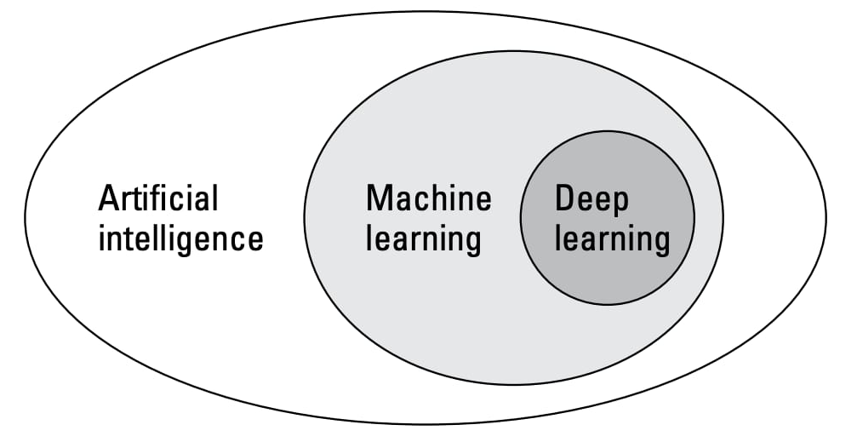
Figure 1: Subsets of AI

- DIVISIONS OF ARTIFICIAL INTELLIGENCE:
- MACHINE LEARNING
Machine Learning enables computational systems to gain knowledge from the supplied data.
Machine Learning can be:
- Supervised learning
It includes predicting a known output or target. This is task driven.
Example- undergraduate student who has been asked to check BP and is guided by the teacher.
- Unsupervised learning
It has no outputs to predict. To describe a structure, it divides the data into groups of clusters, which makes complex data appear simpler in an organized form.
Example- Diagnosis of tumours which starts with the demographic details of patient, chief compliant, to past and present history taking, examination and ultimately to the diagnosis.
- Reinforcement learning
It is based on every data point in which the algorithm selects an action and modifies its strategy to learn better over a period of time. This learning is based on reward system and trial and error experimentation. Extensive amount of diverse data is provided to the AI system for such kind of learning.
Example- Patients in ICU. If the patient is recovered or discharged the system may receive a positive reward however a negative reward is received if the patient does not survive.

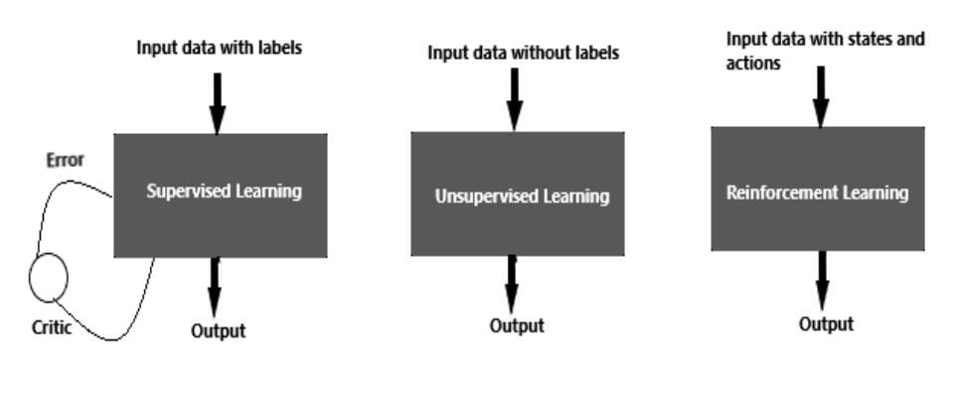
Figure 2: Different types of machine learning
- DEEP LEARNING
Deep Learning is a component of machine learning. Multiple-layer neural networking is employed to uncover patterns in a large database. It follows hierarchical learning and simulates the biological neurons in the brain. Every deep neural network will have 3 layers one input layer, one hidden layer and one output layer.
Example- interpretation of MRI scans. In these procedures previous images are being given as inputs. The hidden layer is where this information is stored and the output layer determines the diagnosis based on the information provided in the first two layers.

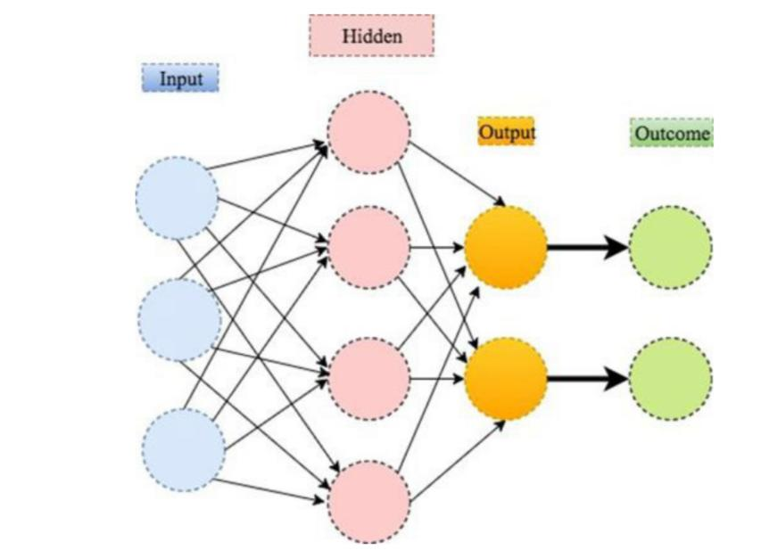
Figure 3: Illustration of deep learning with 2 hidden layers

Table 1: Difference between machine and deep learning
MACHINE LEARNING | DEEP LEARNING
Needs lesser data to be trained | Needs large data to be trained
Provides lesser accuracy | Provides higher accuracy
Takes lesser time to train | Takes longer time to train
Requires structure data | Does not require structure data
Requires few algorithms | Many algorithms required
Aims to make machine learn from the data provided to solve any problem | Aims to build network which discovers pattern for detection of features

- AIMS OF ARTIFICIAL INTELLIGENCE:
AI in healthcare seems to promise a “QUADRUPLE” aim namely,
- To provide better experience of care.
- To boost Health of populations.
- To refine work life of health care providers.
- To reduce per capita cost of healthcare.

- APPLICATIONS OF ARTIFICIAL INTELLIGENCE

- Diagnosis and treatment design
The data provided by previous patients can be used for treatment planning.

- Electronic health records
The likeliness of a condition or a disease can be predicted using electronic health records as they have patient’s information from the very past to the present.

- Drug interaction
Patients who are on multiple medications are prone to increased risk of drug interaction. AI algorithms make it possible to extract the information on the side effects of the drugs from the medical literature.

- Dermatology
Classification of various skin lesions or cancers.

- Radiology
MRI, CT SCANS, X-RAYS with more accuracy.

- Psychological conditions
Chat-bots that replicate human behaviour are being identifies for helping reduce depression and anxiety.

- Dental plaque and caries
Can be detected by AI software by previous images provided.

- POTENTIALS AND PROMISES OF ARTIFICAL INTELLIGENCE:
Various applications of AI in healthcare are being demonstrated by the increasing number of academic research studies, like interpretation of radiographs, detecting cancers, interpreting pathological lesions, improving genomics, etc. But is this immense volume of data that is being provided to the AI system in the form of electronic health records, that is not only helping to extract clinically relevant information but is also making diagnostic evaluation, reliable? Imagining a future hospital with AI machines and robots making accurate diagnosis, treatment planning reflects a question-
Can AI compete with human doctors in showing empathy, creativity and nonlinear thinking which are the superpowers of healthcare?
Despite the perception that actual machine learning deployments in clinical practices are uncommon and have several difficulties that are nothing more than the norm, AI may have a positive impact in the future.

- GREY ZONES OF ARTIFICIAL INTELLIGENCE:
The most prevalent issues with AI in healthcare, including getting informed consent, patient safety and transparency, algorithm bias and fairness, the privacy of the data provided to the systems, liability, cybersecurity, missteps and accidents, and data accessibility, are briefly discussed below.
- Informed consent
The integration of AI into clinical practice is facing an immediate challenge due to interface of informed consent and patient care principles. What circumstances necessitate the deployment of informed consent principles in AI space? needs to be examined. It is the responsibility of clinicians to educate the patient about the complexities of AI to some extent. In certain algorithms such as the black box algorithm are not interpretable and it is very difficult for the clinician to understand thus in such cases this lack of knowledge is worrisome and will also interfere with the so called Right to Explanation to the patient. Compared to the traditional informed consent process in case of AI health app and chat-bots which are popularly being used, user agreement is a contract to which a person consents without an in-person conversation. To what extent this user agreement is similar to the informed consent document and understanding the terms under which the clinician is going to provide the treatment is a difficult task to comprehend when information from patient specific AI health apps or chat-bots is reintroduced into clinical decision-making.

- Safety and transparency
Doctors can explore treatment options for their patients by using AI algorithms to evaluate information from patient’s medical records. Nonetheless, these algorithms have been criticised for allegedly providing unsafe and incorrect recommendations for cancer treatment. Rather than using actual patient data the software was only trained in a few synthetic cancer cases which led to errors in treatment planning of the patient. As demonstrated by this it is crucial that AI systems are both safe and effective. Stakeholders of AI developers should make sure that their promises are reliable, valid and transparent. The algorithms need to be defined in a such a way that the results generated are near to accuracy. Cases may require vast amount of data or very less amount of data depending on the AI system thus, data sharing is a big issue. The stakeholders of AI system should create a trust about the data provided by the ideal world in order to implement AI successfully into healthcare. According to the articles published, some examples of the AI systems developed show lack of transparency leading to an adjunct to intellectual property rights of the patients. Therefore, to avoid such misleads it is important to develop AI systems that are trustworthy and protect the patient’s information.

- Algorithmic fairness and biases
Capability of AI is not only to earn a high revenue but also to improve and expertise the healthcare facilities. The data quality provided to the system is the key factor in this. Prejudice and inequality are both risks in healthcare AI. AI systems learn from information they have received but there may be challenges if the data reflects inherent biases and disparities in the healthcare system. Any algorithm formed by humans will only be trusted, effective and fair if the data it is trained with has minimal risk of biases. A biased AI cloud can cause false diagnosis in healthcare sector where phenotype and genotype information are involved, resulting in ineffective treatment. Therefore, it is essential for AI manufacturers to be aware of these risks and avoid potential biases at every step of process and product development. By providing vast amount of data, the computers can be trained to provide all possible diagnosis and treatments efficiently. To overcome algorithmic biases, it is important to give more thought to the resource being provide.
- Data privacy
The cost of health data can be in the millions or even billions of rupees. Evidences show that public is not comfortable with the sale of patient data by the private sectors or government organisations for profit. It is fundamentally essential that the patients are properly informed about how their data is being processed. Establishing an open dialogue will help to build trust because if the patients and clinicians do not trust the AI system, its successful integration into clinical practice will be virtually impossible. Reciprocity doesn’t require mean ownership but those seeking to use patient data must promise to add value to the same patient’s health whose data they have used. There are some AI health apps that not only share patient data with the doctor but also with family and friends, this can have a negative impact on patient’s health, insurance premiums, job opportunities or even personal relationships. Therefore, it is imperative to protect patient’s data against its misuse outside of the doctor-patient relationship. Patients should also have the right to request the deletion of data that they are not ok to share with. Software update and defects at regular intervals are also additionally necessary to ensure transparency about the product that the AI technology discovers.

- Liability
Clinicians must treat patients with reasonable skill and care. The use of advanced AI does not currently appear to be a part of standard care. If an AI powered software makes an incorrect recommendation that a doctor would not have made without AI, the doctor would likely be held liable for medical malpractice. It now appears that clinicians too can be held accountable for relying on AI powered software, as the software is viewed as a tool under the control of health professional who makes the final decision. It is the professional who remains the captain of the ship and is responsible for its course. Therefore, to avoid liability of medical malpractice clinicians can use AI as a validation tool to support existing decision making by defying the need to follow recommendations for fear of liability. With the clinicians, AI developers and hospitals that buy and sell AI systems should also be held accountable as they should have similar responsibilities in properly deploying and hiring an AI system respectively. Thus, to ensure clarity, transparency and trust, a clear and predictable legal framework is needed to meet the technological challenge.

- Cybersecurity
This is an issue that must be taken into account when attempting to resolve legal issues related to the utilization of AI in healthcare. Healthcare related services, processes and products are susceptible to both cyber and physical threats and hazards. Hospital servers, diagnostic tools, wearables, wireless smart pills, medical devices can be considered as potential targets in health sector that could be infected with software virus that can compromise patient’s privacy and health. If the data is corrupted or algorithms are infected, it can lead to wrong and dangerous treatment recommendations. Hostile actors could get their hands on sensitive data or could even put patients at risk by misrepresenting their health. AI are in particular vulnerable to manipulation, which further emphasizes the need for cybersecurity due to the global nature of cyber-attacks.

- Missteps and accidents
AI systems will sometimes make mistakes. These mistakes can lead to patient harm and other healthcare problems. For example, an AI system may prescribe a wrong treatment, fail to detect a tumour or assign a medical bed to one person over another, potentially causing harm to a patient. Injuries to the patient caused by AI may be different from those injuries caused by human mistake. Patients and caregivers may choose different reactions to AI generated injuries. A single flaw in an AI system could result in thousands of patients being injured by a single provider’s error.

- Data accessibility
Patients often visit multiple healthcare professionals and switch insurance providers resulting in data being distributed across multiple systems and formats. Also, healthcare data is often spread across multiple platforms, increasing the risk of inaccuracy, making data less comprehensible and increasing data collection cost. All of which limits the types of entities that can build successful healthcare AI.
- DISCUSSION:
All the discussed grey zones of artificial intelligence can be classified under the headings of Ethical and Legal challenges.
Ethical challenges: Healthcare sector is a complex filed that requires high standards of ethics. Ethics in healthcare are basic principle concerned with moral decision making by the clinician. Autonomy, justice and beneficence are the important parameters for healthcare professionals to follow ethics. Informed consent, safety and transparency, algorithmic fairness and biases, data privacy, missteps and accidents are all ethical challenges that AI faces.
Legal challenges: Challenges that require judicial review and come under the rule of law are legal challenges. A legal challenge is very time consuming exercise which is expensive for everyone. The decision made by the law is the final result. Every agency developing an AI system should fear a legal challenge in order to avoid challenges such as liability, cybersecurity and data accessibility.

Table 2: Difference between ethical and legal challenges
ETHICAL | LEGAL
Informed consent | Liability
Safety and transparency | Cybersecurity
Algorithmic fairness and bias | Data accessibility
Data privacy
Missteps and accidents

- CONCLUSION:
All these challenges can affect thousands of patient at once and if these challenges are taken care of healthcare delivery can become more effective with improved diagnosis, enhanced quality of treatment and all the goals of AI can be achieved. Hence, it is the clinician who should always remain the captain of the ship and use AI system to assist in decision making, to avoid malpractice liability.
- REFERENCES:
[1] Kelly, C.J., Karthikesalingam, A., Suleyman, M. et al. Key challenges for delivering clinical impact with artificial intelligence. BMC Med 17, 195 (2019).
[2] Mohammed Yousef Shaheen. AI in Healthcare: medical and socio-economic benefits and challenges. ScienceOpen Preprints. DOI: 10.14293/S2199-1006.1.SOR-.PPRQNI1.v1
[3] Gerke S, Minssen T, Cohen G. Ethical and legal challenges of artificial intelligence-driven healthcare. Artificial Intelligence in Healthcare. 2020;295-336. doi:10.1016/B978-0-12-818438-7.00012-5
[4] Deo RC. Machine learning in medicine. Circulation. 2015 Nov 17;132(20):1920-30.
[5] https://dzone.com/articles/comparison-between-deep-learning-vs-machine-learning
[6] Manne R, Kantheti SC. Application of artificial intelligence in healthcare: chances and challenges. Current Journal of Applied Science and Technology. 2021 Apr 24;40(6):78-89.
[7] https://www.deepinstinct.com/glossary/deep-learning
[8] Jiang F, Jiang Y, Zhi H, Dong Y, Li H, Ma S, Wang Y, Dong Q, Shen H, Wang Y. Artificial intelligence in healthcare: past, present and future. Stroke and vascular neurology. 2017 Dec 1;2(4).
[9] https://www.microsoft.com/en-us/research/blog/using-reinforcement-learning-to-identify-hispgh-risk-states-and-treatments-in-healthcare/

