A Comparative Study on Machine Learning Algorithms for ECG Anomaly Detection
Aditi Mohapatra
Department of ETC Engineering,GP, Dhenkanal, Odisha
aditi.pkl.123@gmail.com

.
Abstract
Medical data often exhibit class imbalance, where the number of samples in different classes is not proportional. This imbalance can pose significant challenges to traditional classification algorithms. This report explores the application of Support Vector Machines (SVM) to imbalanced ECG classification, discussing the inherent issues, techniques for addressing classification, and experimental results showcasing the effectiveness of SVM in handling ECG datasets.
INTRODUCTION
According to the World Health Organization (WHO), cardiovascular disease is one of the main causes of mortality worldwide. Many heart attack victims die as a result of delayed diagnosis, which causes damage to another organ. An electrocardiogram (ECG) is a vital method for diagnosing and detecting problems in the human heart.As the number of cardiac patients grows by the day, so does the burden on physicians. Automation is necessary to reduce the physical workload through computerized systems, which is the current research scenario.
In normal conditions, the Sinoatrial (SA) node in the right atrium is the heart's natural pacemaker and begins the heartbeat. Electrical impulses from the SA node propagate across both atria, causing them to depolarize. The P-wave is used to illustrate atrial depolarization. The time it takes for electrical impulses to pass from the SA node to the Atrioventricular (AV) node located near the AV valve is represented by the PQ segment.The AV node acts as an electrical conduit to the ventricles, delaying electrical impulses that cause the atria to relax or repolarize. The QRS complex obscures atrial repolarization. The AV node sends electrical impulses to the His bundle, which is subsequently separated into right and left bundle branches. These branches carry electrical impulses to the apex of the heart. The electrical impulses are then carried to the Purkinje fibers and distributed throughout the ventricular myocardium, causing the ventricles to depolarize.The QRS complex represents ventricular depolarization. The next phase is ventricular contraction, which results in a plateau in the myocardial action potential and is depicted by the ST segment. The T-wave represents ventricular repolarization at this point.
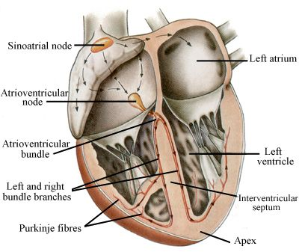
Fig.1.1. Anatomy of Heart
As a result, a normal ECG signal may be divided into the following fiducial points:
- The P-wave represents the depolarization of the atria.
- Q-wave is associated with the deflection immediately preceding ventricular depolarization.
- R-wave is related to the peak of ventricular depolarization.
- S-wave is associated with the deflection following ventricular depolarization.
- T-wave is related to ventricular repolarization.
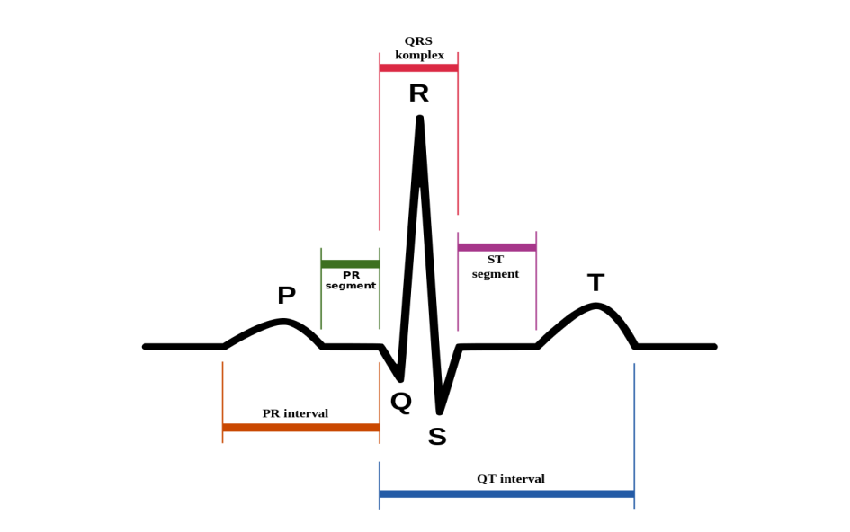
Figure 1.2: Normal ECG beat.

An ECG provides two types of information: First, a doctor can calculate how long the electrical wave traverses through the heart by monitoring time intervals on the ECG. The time it takes a wave to go from one portion of the heart to the next indicates if the electrical activity is normal, slow, rapid, or irregular. Second, a cardiologist can determine if sections of the heart are excessively big or overworked by evaluating the amount of electrical activity traveling through the heart muscle.

1.1. Atrial fibrillation (AF):
Arrhythmia is a common cardiovascular disorder that can develop alone or in combination with other heart conditions. The most frequent sustained arrhythmia is atrial fibrillation (AF).In individuals with AF, poor coordination of atrial activity may decrease the atrioventricular mechanism, ultimately leading to an increase in stroke, cardiovascular disease, and death [17]. Atrial fibrillation (AF) is an abnormal and typically highly fast heart rhythm (arrhythmia) that can result in blood clots in the heart. AF raises the chances of having a stroke, having heart failure, or having another heart-related issue.
1.2. First-degree atrioventricular block (I-AVB):
AVB I is a disease that causes a delay in impulse passage from the atria to the ventricles via the AV node. AVB I is linked to an increased risk of heart failure, atrial fibrillation, and death. There is also a greater chance that a more significant degree of AV block may occur [14].
1.3. Bundle branch block(BBB):
Bundle branch block (BBB) is one of the most prevalent conduction block illnesses, and it is often associated with consequences such as ventricular hypertrophy, pulmonary embolism, and ischemic heart disease. The right BBB (RBBB) and left BBB (LBBB) are two major subclasses of BBB induced by delayed activation of the right and left ventricles, respectively. The BBB can induce incomplete blood transport from the atria to the ventricle, lowering heart function efficiency. Therefore, early identification and real-time warning of BBB are critical for effective therapy. The automated ECG technique relies on identifying RBBB and LBBB [18].
1.4. Premature atrial contraction (PAC):
PAC occurs when an area other than the atria depolarizes before the SA node, causing a premature beat. The P-wave of the PAC occurs early in the cardiac cycle. Furthermore, the PR interval is reduced, indicating that the beat originated in the atria near the AV node. A compensating pause occurs when the time between the PAC and the following contraction is somewhat longer.
1.5. Premature ventricular contraction (PVC):
Sometimes, the electrical signals that govern the heart's muscle contractions get distorted. While these can occur in healthy persons occasionally, numerous occurrences might be a sign of heart disease. Premature ventricular contraction is the most prevalent kind of arrhythmia (PVC).
1.6.ST-segment depression (STD):
ST segment alteration is a critical sign of myocardial ischemia, and detecting ST deviation is critical in myocardial infarction diagnosis. ST-segment elevation is more common in individuals with transmural myocardial ischemia or variant angina pectoris. In contrast, ST-segment depression is more common in patients with subendocardial ischemia or stable or unstable angina. The electrocardiogram (ECG) is a non-invasive, easy, low-cost, and frequently used method of detecting ST deviation [11].
In an ECG, the ST segment is defined as the time between the QRS complex's end and the T wave's beginning. A reference point must be identified in order to determine an ST segment variation. J point is the starting point of the ST segment and is used to detect ST segment deviations by comparing it to the reference point for ST-segment change detection[18].
1.7.ST-segment elevated (STE):
STE is diagnosed by evaluating ECG abnormalities in the Q wave, T wave, and ST segment. The detection of the Q wave is straightforward; however, proper evaluation of the ST segment must be followed by precise extraction of the T wave and the J point. Although the amplitude of the T wave in the ECG signal is noticeably greater than that of the P wave, the T wave is more difficult to extract. Because obtaining a precise J point is complex, the ST segment is frequently retrieved by monitoring a certain limited portion following the R-peak (i.e., after a given number of milliseconds), when the ST segment is more likely to be spotted [14].
- METHODOLOGY
The proposed method designed for the accurate and automatic classification of the ECG signals is shown in Fig. 2.1.

Feature Extraction (Statistical, Wavelet, Wavelet entropy)
Preprocessing with Low Pass Filter and High Pass Filter(LPF & HPF)

Input
Output
Classification Model
(KNN, DT, SVM)

ECG
Signal

Figure 2.1: Block diagram of Proposed Methodology

2.1. Dataset Description
The openly available CPSC2018 challenge dataset [17] is considered for verification of the proposed method. The recordings of challenge ECG data were collected from 11 hospitals. The training set has 6,877 data, among them female: 3178 and male: 3699.12 leads ECG recordings with durations ranging from 6s to 60s; the test set has 2,954 ECG recordings with the same durations. This dataset is used to identify 12-lead ECG anomalies lasting several seconds to tens of seconds. The CPSC2018 used by 12-lead ECGs comprises one normal type and eight abnormal kinds.
2.2. Preprocessing
A low-pass filter is used to eliminate the abundant noise added to the ECG signals. The first step is to bandpass filter the raw ECG signal, which separates the major QRS energy centered at 10 Hz and attenuates the low frequencies related to the T waves, baseline drift, and higher frequencies associated with electromyography noise and power line interference. The essential goal is to avoid losing the information conveyed by the ECG signal after it has been filtered out. (1) and (2) show the different equations for the cascaded LPF and high-pass filter (HPF). The LPF filter has a cutoff frequency of 11 Hz and a delay of six samples, whereas the HPF has a cutoff frequency and delay of 5 Hz and 16 samples, respectively. The filter coefficients are all integers.

R
Detec-
tionl
R-Peak
ECG
Signal
Input
Low Pass Filter
High Pass Filter
Derivative Base Filter
Squaring
Moving Average FFiler

Figure 2.2: Block Diagram of Pan and Tompkins Algorithm.

2.2.1Low Pass Filter
The transfer function of the second-order low-pass filter is
$$\frac{{\left(1-Z^{-6}\right)}^{2}}{{\left(1-Z^{-1}\right)}^{2}}=H\left(Z\right) (1)$$
The amplitude response is
H (ᴡ T) = Sin2 (3ᴡT) / (Sin2Wt/2) (2)
Where T is the sampling period, the difference equation of the filter is
Y (n T) = 2 y (n T-T) – y (nT-2T) + x (n T) – 2 x (nT6T) + x (nT-12T) (3)
Where the cutoff recurrence is around 11Hz, and the gain is 36. The filter processing delay is six tests.
2.2.2. High Pass Filter
The work of the high-pass filter is designed to subtract the output of a second-order low-pass filter from an all-pass filter (i.e., the tests within the original signal). The transfer function for such a filter is
$$\frac{-1+32Z^{-16}+Z^{-32}}{1+Z^{-1}}=H(z) (4)$$
The amplitude response is
H(ᴡ T)=|H (ᴡ T)| = [256+Sin2(16ᴡT) ] 1/2 / (cos (Wt/2)) (5)
The difference equation is
Y (n T) = 32 x (n T – 16T) – [y (n T – T) + x (n T) – x (n T –32T)] (6)
The low cutoff frequency of this filter is about 5Hz, the gain is 32, and the delay is 16 samples.
2.2.3. Derivative
After filtering, the signal is separated to supply the QRS complex slop data. We utilize a five-point subsidiary with the exchange function
H (z) = (1/8T) ( Z-2 Z-1 - Z1 - Z2 ) (7)
The Amplitude response is
H (w T) = (1/4T) [sin (2wT) + 2 sin (w T)]. (8)
The difference equation is
Y (n T) = (1/8T) [-x (n T – 2T) – 2x (n T – T) +2 x (n T+T) + x (n T + 2T)]. (9)
2.2.4. Squaring
Squaring After differentiation, the signal is squared point by point. The condition of this operation is
Y (n T) = [X (n T)] (10)
This makes all information focused positive and does nonlinear amplification of the yield of the subsidiary emphasizing the higher frequencies (i.e., overwhelmingly the ECG frequencies).

2.2.5. Moving Average Window
Moving Window Integration: The purpose of moving-window integration is to get waveform feature data in expansion to the slant of the R wave. It is calculated from
Y (n T) = (1/N) [x (n T – (N-1) T) + x (n T – (N – 2) T) +………. + x (n T)] (11)
Where N is the number of tests within the width of the integration window, Graph 2 shows the relationship between the moving-window integration waveform and the QRS complex. The number of samples N within the moving window is vital. By and large, the width of the window ought to be around the same as the broadest conceivable QRS complex. If the window is vast, the integration waveform will consolidate the QRS and T complexes together. In case it is too narrow, a few QRS complexes will produce a few crests within the integration waveform. These can cause trouble in ensuing QRS location forms. The width of the window is decided observationally. For our sample rate of 200 tests/s, the window is 30 tests wide (150 ms).
When compared to others, Pan Tompkins' studies had a significant influence on QRS detection. A review of the literature suggests that this strategy is one of the most important algorithms for finding QRS peaks. The precision of any Electrocardiogram (ECG) waveform extraction is critical in providing a better diagnosis of any heart-related illness.
A typical ECG should have three parts: P wave, QRS complex, and T wave. These waves reflect the action of the heart, such as the P wave produced by muscular compression of the atria, and their duration indicates atrial extension. The Q wave provides the principal negative esteem and is routinely estimated to be 25% smaller than the R wave value. The Pan Tompkins Algorithm block diagram is illustrated in the picture below.
2.3. Feature Extraction
Instead of directly feeding the data to the classifying model, a few preprocessing steps are adopted for better training of the machine learning models. Mean, median, standard deviation, energy entropy, and wavelet features are evaluated.
2.3.1.Mean: Mean of each input data $x_{i}$is calculated as
$μ=\frac{1}{N}\sum_{i=0}^{N-1}{x_{i}}$ (12)
    - Median: The median for the signals with an even number of sizes is calculated as
$Median=\frac{{\left(\frac{N}{2}\right)}^{th}term+{\left(\frac{N}{2}+1\right)}^{th}}{2}$ (13)
For the odd number of data size, the following equation is adopted.
$Median=\frac{N+1}{2}$ (14)
2.3.3. Standard Deviation: Standard Deviation is calculated as another feature and is calculated as
$$σ^{2}=\frac{1}{N-1}\sum_{i=0}^{N-1}{{\left(x_{i}-μ\right)}^{2} (15) }$$
2.3.4. Energy and Entropy: Energy and entropy of the input signal are calculated using Eqn. (16) and (17).
$Energy=-\sum_{-∞}^{∞}{{\left|x_{i}\right|}^{2}}$ (16)
$H\left(x\right)=-\sum_{i-1}^{N}{P\left(x_{i}\right)logP\left(x_{i}\right)}$ (17)
2.3.5. Wavelet: In signal processing, the Statistical features of a signal depend on the amplitude or energy features of a signal. 'The advantage of using the wavelet model is that it provides frequency information according to scaling property along time variation. The decomposed signal is divided as detailed $\left(d_{i}\right)$ and approximation $\left(α_{i}\right)$, high to frequency components at i^{th level} comparatively, and is it presented as equation (18)
$$X\left(t\right)=α_{i}\left(p\right)+\sum_{p=1}^{1}{i\left(p\right)}$$
$=\sum_{k}{α_{γ}}\left(i,y\right)β_{jγ}\left(p\right)+\sum_{p=1}^{1}{\sum_{k}{d_{γ\left(i,y\right)}σ_{ik}(p)}}$ (18)
Where$β_{jy}$denotes the nested space’s $ω_{i}$scaling function, $δ_{ik}$ is presented as the mother wavelet, and coefficients $α_{i}(p)$approximate the signal$α_{i-1}(p)$ as$ω_{i}cω_{i-1 }$. The Calculation of the loss information during the transition between the approximation coefficient by $d_{i}\left(p\right)=α_{i-1}\left(p\right)-α_{i}(p)$ uses signal features .Simple frequency domain information cannot be used to detect the information regarding the temporal fluctuation of emotion; thus, the wavelet domain may be implemented for improved performance.
Along with the previously mentioned statistical features, the wavelet feature is also used to train the classifying model, and the result is also verified.
We have considered the hybridization of features with wavelet and entropy parameters.
2.4. Classification Models
2.4.1.K-Nearest neighbor (KNN):
The KNN is a statistical model that depends on a non-parametric machine learning classifier trained without the use of parameters. It is an instantaneous search technique that identifies the training patterns in the feature vector space that are closest. KNN uses iterative computing until classification results are obtained. For more discriminant classification using KNN, two qualities, 'K' and the 'distance metric,' are required: K and the distance metric. The value of 'K' is a constant user-defined throughout the whole program [24]. In this technique, K is set to 3, and the Euclidean distance metric is examined.
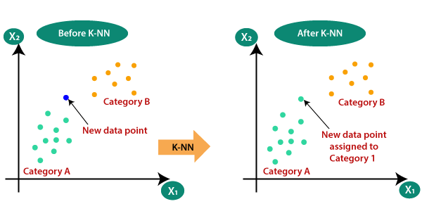
[ Figure.2.4.1. identify the class of a particular dataset]

Assume we have a new data point that has to be assigned to a category. Consider the following image:
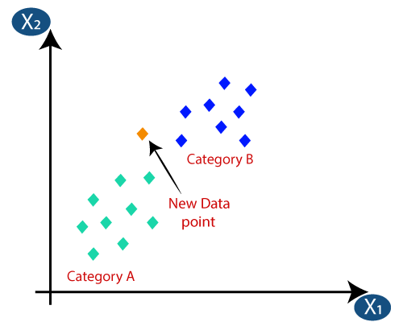
[ Figure.2.4.2. New data point of dataset]
First, we will select the number of neighbors. The Euclidean distance between the data points will then be calculated. The Euclidean distance is the distance between two previously studied locations in geometry. It may be computed as follows:
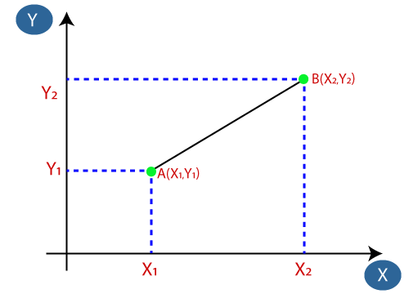
[ Figure.2.4.3. Euclidean distance]
Euclidean Distance between $A_{1 }$and $B_{2}$ = $\sqrt{{\left(X_{2}-X_{1}\right)}^{2}+{\left(Y_{2}-Y_{1}\right)}^{2}}$ (19)
2.4.2. Decision Tree:
The decision tree is a basic categorization approach that has many applications in data mining, expert systems, medical analysis, remote sensing, etc. They simplify a complicated process into simply interpretable modules of predictive decision-making. Attribute nodules in DT are connected to two or more sub-nodes or sub-trees, as well as decision leaves labeled as groups or classes. A testing nodule generates results based on the value of an immediate property, and each result is connected with a number of subtrees. The root node facilitates the categorization of all instances. If the node encountered is a test node and it has a suitable subtree, the leaf helps determine the instance's class label. In this study, a binary decision tree is employed. The block diagram of the different nodes is shown in Fig.2.4.2.
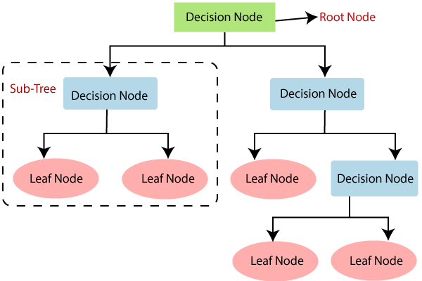
[Figure 2.4.2. The general structure of a decision tree]
Entropy in the DT model is calculated as follows:
$E\left(S\right)= \sum_{i=1}^{C}{-P_{i}\log_{2}{P_{i}}}$ (20)
Entropy for multiple attributes is calculated as
$E\left(T,X\right)=\sum_{CϵX}{P(C)E(C)}$ (21)
Information gain is the essential requirement of the DT model, and it is calculated as follows:
Information Gain = Entropy(T)-Entropy (T, X)
Gini =$1- \sum_{i=1}^{C}{{\left(P_{i}\right)}^{2}}$ (22)
The decision tree has several levels, making it complicated. It may have a problem with overfitting that may be addressed by the Support Vector Machine technique. The decision tree's computing complexity may rise as the number of class labels increases.
2.4.3. Support Vector Machine:
SVM is a prominent model for machine learning that performs well in the case of binary data classification. In the past survey, the statistical features of a signal were combined, and performance evaluation was presented in past works. Implementing a neural network with SVM to design a novel classifier is presented in [18-19]. If the selected features give complementary information that is advantageous for effective hybridization, feature combination may improve the amount of available information on an emotion.
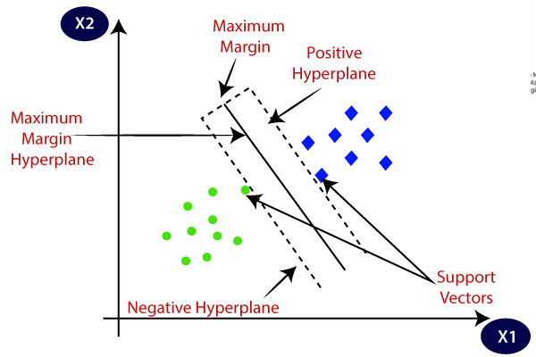
[Figure 2.4.3. The general structure of a Support Vector Machine]
It uses the structural risk minimization technique in which a decision boundary or hyperplane is created for separating the samples of a different class. Let us consider the training set ${\{\left(x_{m},d_{m}\right)}_{ m-1}^{N}$ for the SVM classifier. The input feature is represented by $x_{m}$and, and the target is $d_{m}$. These input features will be processed in the hyperplane and can be represented by
tx+ C =0 (23)

The class separation in the SVM model is represented by
t + C $≥0$ for $d_{j}= 0$ (24)
t + C$≤0$ for $d_{j}=1$ (25)
where the weight vector is t. The bias is represented in c. In the proposed linear classification problem, the classification is done by maximizing the decision boundary in the hyperplane [24, 25]. It can be represented by
$\sum_{m=1}^{N}{ω_{m}^{*}∅_{m}\left(x\right)+d}$ (26)
where$∅\left(.\right)$is the mapping function. The final output $d(x)$ of the SVM classifier is represented by,
$d\left(x\right)=\sum_{j=1}^{N}{k(x_{j,},x)}$ (27)
where $k(x_{j},x)$ The kernel function. The learning rate of the SVM is considered to be 0.001.
3. RESULTS AND SIMULATIONS
In this work, we have considered the cardiac signal detection. The data is collected from CPSC2018[17]. The data are of one normal and eight different abnormal conditions. The normal and the abnormal signals are shown in Fig(3.1) through Fig(3.9). The abnormalities are AF, I-AVB, LBBB.RB, PVC, PAC, STD, and STE are shown below, respectively. Here, the number of samples is 4500.
3.1. Normal and abnormal signals:

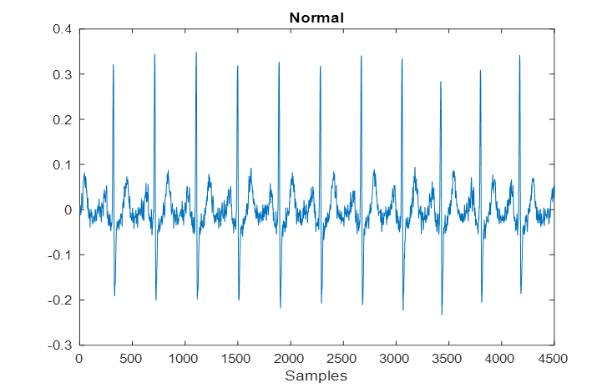
[ Fig.3.1: Sample of a normal ECG signal]
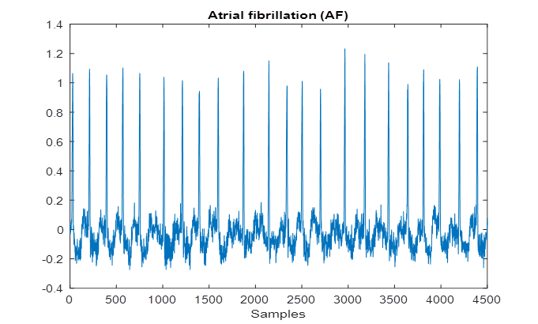
[Fig.3.2: Sample of Atrial fibrillation (AF)]
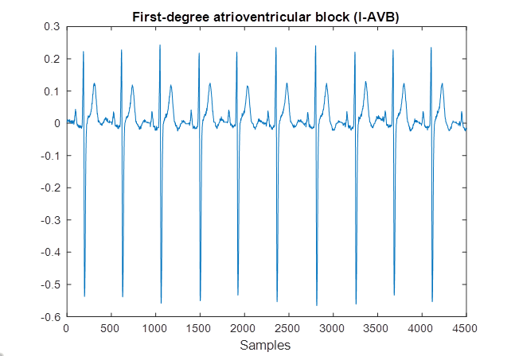
[Fig.3.3: Sample of First-degree Atrioventricular Block]
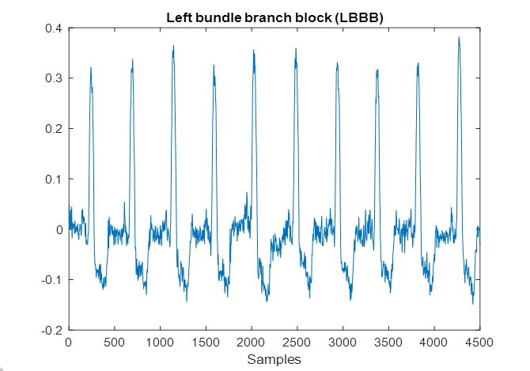
[ Fig.3.4: Sample of left bundle branch block (LBBB)]
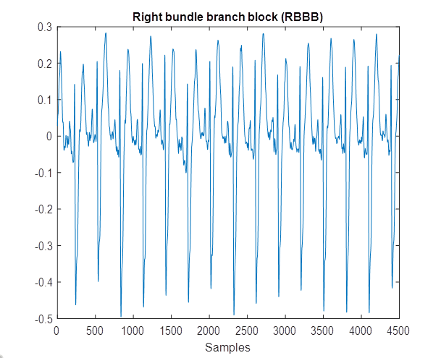
[Fig.3.5: Sample of right bundle branch block (RBBB)]
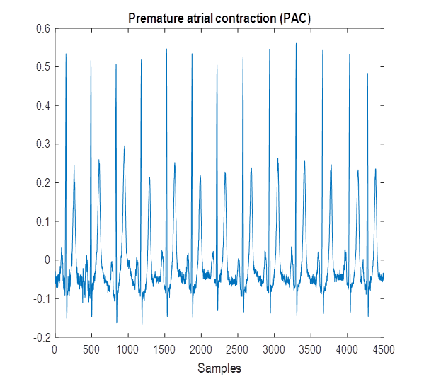
[Fig.3.6: Sample of Premature atrial contraction (PAC)]
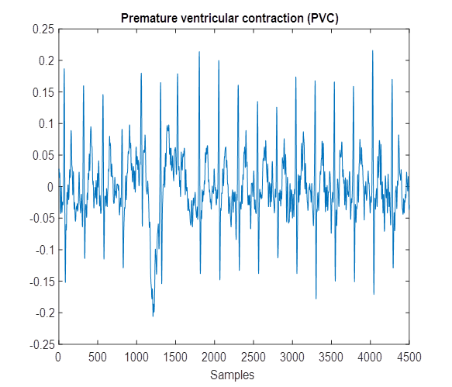
[Fig.3.7: Sample of premature ventricular contraction]
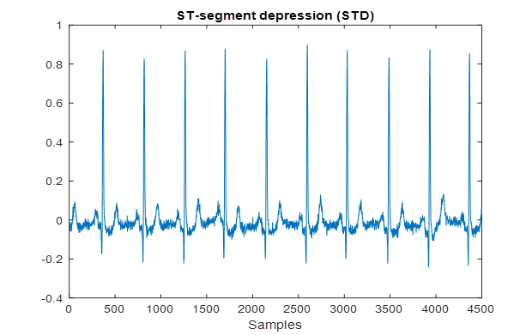
[Fig.3.8 Sample of ST-segment depression]
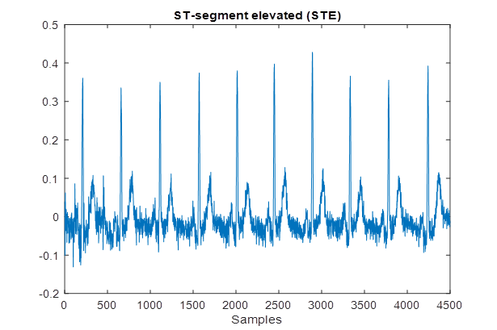
[ Fig.3.9: Sample of ST-segment elevated signal]
3.4.Feature Extraction Result
As the sample size is larger, the input ECG signals undergo five different feature extraction steps: mean, median, standard deviation, energy, and entropy. Fig.3.4.1 to Fig.3.4.5 represent the histogram plots for considered features, respectively. These features are helpful for the model to detect abnormal signals. For comparison, these features are used in three different classifiers, KNN, DT, and SVM. However, the hybridization of features provides better results than the individual feature use.

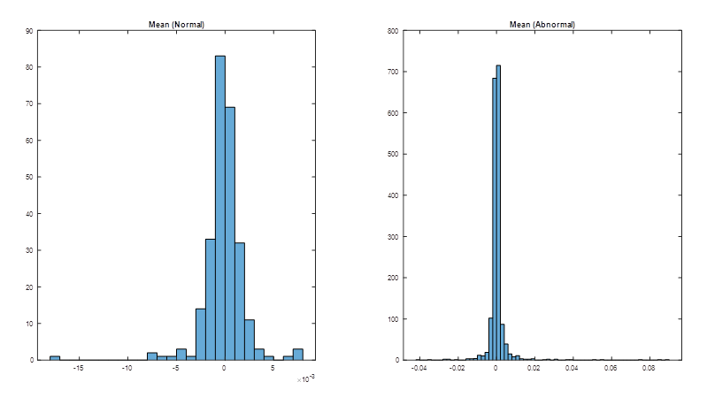
[Fig.3.4.1. Histogram of the mean of normal and abnormal signals]
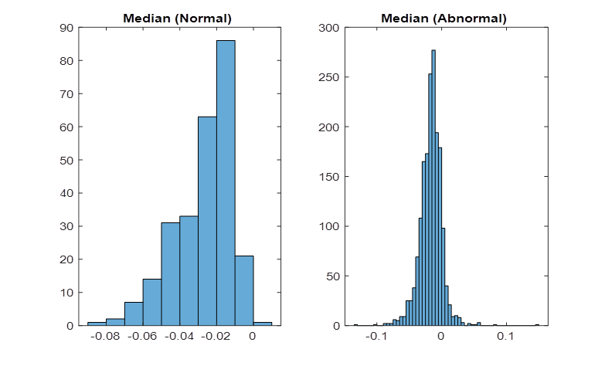
[Fig.3.4.2. Histogram of the median of normal and abnormal signals]
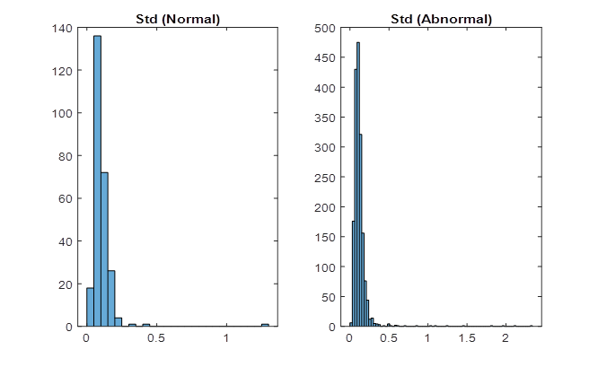
[Fig.3.4.3. Histogram of the standard deviation of normal and abnormal signals]
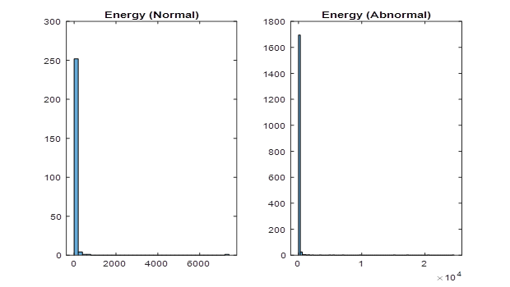 [Fig.3.4.4. Histogram of energy of normal and abnormal signals]

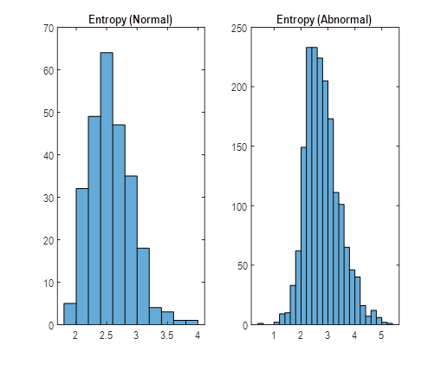[Fig.3.4.5. Histogram of entropy of normal and abnormal signals]
Performance Evaluation
3.5. Classification Result:
The signals from the dataset are directly fed to the machine learning classifiers for verification purposes. KNN, DT, and SVM are tested for performance evaluation. The results of classification by these models are given in Table I. It can observed that the training accuracies are 68.3%,71.22%, and 76.54%, respectively. From the testing point of view, the testing accuracy becomes 78.07% and 80.42%.87%, respectively.
Table-3.5.1. Performance of the considered classifiers
 | Training | Testing
Classifier | ACC % | ACC % | Sens % | Spec % | Prec % | Rec % | F-Score % | G-Mean %
KNN | 68.3 | 78.07 | 16.48 | 87.27 | 16.21 | 16.48 | 16.34 | 37.92
DT | 71.22 | 80.42 | 30.93 | 87.77 | 27.31 | 30.93 | 29.01 | 52.11
SVM | 76.544 | 87 | 75.93 | 100 | 57.21 | 68.41 | 86.12 | 67.1
From this table, it is found that the testing accuracy is better than the training accuracy. However, the training accuracy needs to be improved so the features are compared and combined accordingly. The features combination of wavelet and entropy formed better in the Support Vector Machine model as better training and testing accuracy are shown in Table II.
Table-3.5.2. Performance of SVM with different features
Feature-based | Classifiers | Training | Testing
Statistical | SVM | 95.3 | 91.67
Wavelet | SVM | 96.1 | 92
Proposed Wavelet Entropy | SVM | 98.2 | 96.01
Performance comparison of the proposed model with recent works developed in the field of abnormality detection from ECG signals is shown in Table III and is well observed.
Table-3.5.3. Comparison of the proposed model with state-of-the-art models
Works | Method | Accuracy%
Gad et al. [20] | DSNT + SVM | 92.16
Amna et al. [21] | ESBMM + CNN | 93.58
Liu et al. [22] | CNN + LRSVM | 95.63
Li et al. [23] | WPE + RF | 95.63
Amna et al. [24] | ESBMM + CNN | 93.58
Osowski et al. [25] | HOS features | 94.26
Kamath [26] | Teager energy function features | 95.0
Fei [27] | Time intervals features | 95.65
Ayar and Sabamoniri [28] | Genetic algorithm | 86.96
Proposed Wavelet Entropy method | SVM | 96.1%
Automatic and accurate detection of any abnormality in brain signals can save a person's life. In order to detect abnormalities from ECG signals, this study employs a machine learning technique with enhanced features. To select the optimal model, the performance of the three machine learning models, KNN, DT, and SVM, is evaluated. SVM proved to be a better model than the other two models. The performance of SVM is also improved by applying feature extraction steps, and it is observed that SVM provides better results when trained with the proposed wavelet entropy features. 96.1% testing accuracy is obtained, which is competitive with the state-of-the-art methods. In the future, the performance will be further improved with other features, and the adoption of deep learning models will be considered for verification purposes.
Conclusion
Support Vector Machines offer a promising approach to dealing with imbalanced medical data classification. By utilizing proper techniques such as cost-sensitive learning, resampling, and synthetic data generation, SVM can mitigate the challenges posed by class imbalance, leading to improved classification performance .Future research could explore the combination of SVM with advanced techniques like ensemble learning or deep learning architectures to enhance the handling of imbalanced medical datasets further.

Reference
- VijayaArjunan, R. (2016). ECG signal classification based on statistical features with SVM classification. Int. J. Adv. Sig. Img. Sci, 2(1).
- Smíšek, R., Hejč, J., Ronzhina, M., Němcová, A., Maršánová, L., Chmelík, J., ...&Vítek, M. (2017, September). SVM based ECG classification using rhythm and morphology features, cluster analysis and multilevel noise estimation. In 2017 Computing in Cardiology (CinC) (pp. 1-4). IEEE.
- Sahoo, S., Subudhi, A., Dash, M., &Sabut, S. (2020). Automatic classification of cardiac arrhythmias based on hybrid features and decision tree algorithm. International Journal of Automation and Computing, 17(4), 551-561
- Latif, G., Al Anezi, F. Y., Zikria, M., &Alghazo, J. (2020, January). EEG-ECG Signals Classification for Arrhythmia Detection using Decision Trees. In 2020 Fourth International Conference on Inventive Systems and Control (ICISC) (pp. 192-196). IEEE.
- Ramkumar, M., Mathankumar, M., &Manjunathan, A. (2020). Classification of Electrocardiogram Cardiac Arrhythmia Signals Using Genetic Algorithm-Support Vector Machines. Bioscience Biotechnology Research Communications (BBRC), Special Issue, 13(11), 138-146.
- [6] Padilla-Navarro, C., del Rosario Baltazar-Flores, M., Cuesta-Frau, D., Garza, A. A., & Rodríguez, V. M. Z. (2013, July). Cardiac Arrhythmia Classification Using KNN and Naive Bayes Classifiers Optimized with Differential Evolution (DE) and Particle Swarm Optimization (PSO). In Intelligent Environments (Workshops) (pp. 36-46).
- Kasar, S. L., & Joshi, M. S. (2016). Analysis of multi-lead ECG signals using decision tree algorithms. International Journal of Computer Applications, 134(16).
- Alarsan, F. I., &Younes, M. (2019). Analysis and classification of heart diseases using heartbeat features and machine learning algorithms. Journal of Big Data, 6(1), 1-15.
- Smisek, R., Viscor, I., Evora, A., Bulova, V., Marinova, L., Nejedly, P.,&Plesinger, F. (2021, September). Wavelet Transform Based Detection of the First-Degree Atrioventricular Block. In 2021 Computing in Cardiology (CinC) (Vol. 48, pp. 1-4). IEEE.
- Mostayed, A., Luo, J., Shu, X., & Wee, W. (2018). Classification of 12-lead ECG signals with bi-directional LSTM network. arXiv preprint arXiv:1811.02090.
- Clark, N., Sandor, E., Walden, C., Ahn, I. S., & Lu, Y. (2018, August). A wearable ECG monitoring system for real-time arrhythmia detection. In 2018 IEEE 61st International Midwest Symposium on Circuits and Systems (MWSCAS) (pp. 787-790). IEEE.
- Abubakar, S. M., Saadeh, W., &Altaf, M. A. B. (2018, March). A wearable long-term single-lead ECG processor for early detection of cardiac arrhythmia. In 2018 Design, Automation & Test in Europe Conference & Exhibition (DATE) (pp. 961-966). IEEE.
- Liu, F., Liu, C., Zhao, L., Zhang, X., Wu, X., Xu, X., ...& Yin Kwee, E. N. (2018). An open-access database for evaluating the algorithms of electrocardiogram rhythm and morphology abnormality detection. Journal of Medical Imaging and Health Informatics, 8(7), 1368-1373.
- Hu, J., Zhao, W., Jia, D., Yan, C., Wang, H., Li, Z., & You, T. (2019, July). A novel detection method of bundle branch block from multi-lead ECG. In 2019 41st Annual International Conference of the IEEE Engineering in Medicine and Biology Society (EMBC) (pp. 79-82). IEEE.
- Palo HK, Mohanty MN, Chandra M. Efficient feature combination techniques for emotional speech classification. Int J Speech Technol 2016; 19:135–50. pp. 167–175, 2018. DOI: 10.1016/j.imu.2018.06.002.
- M. M. A. Gad, “Feature extraction of electrocardiogram signals using discrete sinc transform,” in 2016 9th Biomedical Engineering International Conference (BMEiCON), pp. 1–4, LuangPrabang, Laos, 2016.
- A. Nasim, A. Sbrollini, M. Morettini, and L. Burattini, “Extended segmented beat modulation method for cardiac beat classification and electrocardiogram denoising,” Electronics, vol. 9, no. 7, p. 1178, 2020.
- J. Liu, S. Song, G. Sun, and Y. Fu, “Classification of ECG arrhythmia using CNN, SVM and LDA,” Artificial Intelligence and Security., pp. 191–201, 2019.
- T. Li and M. Zhou, “ECG classification using wavelet packet entropy and random forests,” Entropy, vol. 18, no. 8, article e18080285, p. 285, 2016.
- A. Nasim, A. Sbrollini, M. Morettini, and L. Burattini“Extended segmented beat modulation method for cardiac beat classification and electrocardiogram denoising,” Electronics, vol. 9, no. 7, p. 1178, 2020.
- S. Osowski, L. T. Hoai, T. Markiewicz. Support vector ma-chine-based expert system for reliable heartbeat recognition. IEEE Transactions on Biomedical Engineering, vol. 51, no. 4, pp. 582–589, 2004. DOI: 10.1109/TBME.2004. 824138.
- C. Kamath, "ECG beat categorization utilising characteristics taken from Teager energy functions in time and frequency domains." 2011's IET Signal Processing, volume 5, issue 6, pages 575–581. DOI: 10.1049/iet-spr.2010.0138
- S. W. Fei. Diagnostic investigation on arrhythmia cordis based on support vector machine-based particle swarm optimization. Expert Systems with Applications, 2010, pp. 6748–6752, vol. 37, no. 10.1016/j.eswa.2010.02.126 is the DOI.
- S. Sabamoniri and M. Ayar, "An ECG-based feature selection and heartbeat classification model employing a hybrid heuristic algorithm," Information systems in Medicine Unleashed, vol. 13, pp-167-175, 2018.

