IOT Aadhaar Identity Processing using Integrated Model

Prof.PRIYANKA M R
Assistant Professor, Dept of ISE, Sapthagiri College of Engg,
Bengaluru-560057,Karnataka(India). Email: priyankamr@sapthagiri.edu.in
Prof Veena Dhavalgi
Assistant Professor, Dept of ISE, Sapthagiri College of Engg, Bengaluru-560057,Karnataka(India).
Email:veenadhavalgi@sapthagiri.edu.in

Abstract-In India with the population of 1.39 billion a Unique Identification i.e. AADHAAR Identification is a major project. This ID is common for personal and Business usage. In 2009 Government of India by Ministry of Electronic & Information Technology established UIDAI(Unique Identification Authority of India). An Integrated approach to secure Aadhaar Identity using Block chain Technology and Convolution Neural Networks. Model is being proposed using Distributed Ledger Technology(DLT) of Block chain Technology(BT) comprised of 3 phases, In first phase Biometric data and Demographic data of AADHAR is used and data reduction is done. In second phase Convolution Neural Networks( CNN)of Deep Learning with ReLU model to secure biometric data from data cloning and face verification. In 3rd phase Block chain Technology(BT) using Distributed Ledger Technology( DLT) is added to have more security to the proposed model. Thus the Security in Aadhaar Identity can be achieved.

Index Terms— Blockchain, Distributed Ledger Technology(DLT), Convolution Neural Networks(CNN), UIDAI(Unique Identification Authority of India )

1.1 How the Blockchain works?
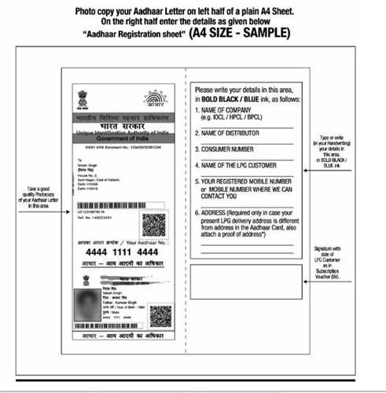
The term Blockchain first coined from a paper “Bitcoin: A peer to peer electronic cash system” published by a scholar or a group aliased as “Satoshi Nakamoto” at the end of 2008.[8] who is a introducer of Bitcoin Crypto currency to the world.

1.0 Introduction to Aadhaar Identification
The need for Official Identification emerged with the Digital era. For the Financial services, Banking Systems, Social benefits, Online Transactions, Healthcare, Education etc. needed Citizen Identification. In 2009 Government of India established a statutory body called UIDAI. A Unique Identification of 12 Digit Number with collection of

Source:Internet

Fig 1.1. Aadhaar Card Mock up

biometric and demographic data was given to every citizen of India. Aadhaar number always with a 2-9 digits it is not by binary digits and it’s a random digits which is not fraudulent , thefting of data and better privacy.[2]

The UIDAI with collaboration of Government of India uses CIDR (Central Identities Data Repository) to issue Aadhaar number to every resident of India. Its robust in pattern Identification and can be authenticated in nearby Trusted Parties deployed by Government. Verification and card issue is postal facilitated. The Letter format comprised of Name, Age, Gender, Address and details to validate document. The mock up copy of Aadhaar card [2] as shown in Fig 1.1

An Aadhaar survey has started in year 2009 till march 2017, with a budget spent on making UIDAI project is approximately 87.939 crore(US $ of 1.4 Billion). [2]

Aadhaar Id Identification method is proposed by the author [1] using supervised learning of Extreme Learning Process and Decentralized application of alternative multiplier path of ADMM.
A Blockchain Technology (BT) is a contemporary approach of Decentralised database System contradictory to the centralized data architecture as CIDR which is governed by Authenticated Agency of India. BT has a DLT to share data or Transaction of currency among all the participants in the Blockchain.

Every transaction in public ledger is subjected to consensus by all the participants in the system of blockchain. The data are permanent and immutable in nature. Each transaction data is updated through verification process so data loss is ruled out.

Bitcoin and Ethereum are the most popular Incentives of blockchain Technology. The important characteristics of blockchain technology are distributed consensus and anonymity.

Keyless Security Infrastructure (KSI) is a feature that helps to overcome the limitations of Public key Infrastructure which is compromised in Securing the Transaction. This is one of the major concepts of Blockchain. KSI uses cryptographic hash function i.e., SHA-256 Hash Algorithm used in Blockchain, security and

availability of blocks are verified and updated when each node is introduced.[4]

Fig.2 shows the Model of Blockchain [4] which has owner signature to every hash key which is Private and verified the document for signature i.e. sent to next node/ block, this is repeated process and links of block chains appended at end.

Transaction 1 Transaction 2
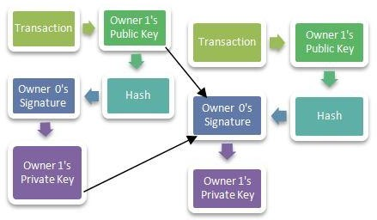

Fig 1.2: Structure of blockchain

1.2 Convolution of Neural Networks (CNN)
Convolution neural networks is a core Artificial Intelligence Technology and Machine Learning(ML). The Deep Learning (DL) has structured way of representative learning.
Franck Rosenblatt considered being notable for his works in Deep Learning. In 1958 The perceptron written by Frank Rosenblatt was first published. 3 major Architectures of DL are Supervised, Semi-Supervised, Unsupervised Learning. Deep Neural Networks(DNN) and Artificial Neural Networks(ANN) are coagulation of Neural Networks. Deep Network has recurrent and convolution neural networks(CNN). Computer Vision , Speech recognition, Natural language Processing (NLP), Machine Translation, Medical Image Analysis are the application fields of neural network.
An unbound layer of numbers of unbounded size shows the depth of deep learning with many hidden layers. As the human neurons have structural analysis, the CNN has generative models like Deep Boltzman machine, deep belief networks. Alex Krizhevsky used computer vision for ImageNet competition . error record from 26% to 15%,one of the major improvement in 2012. K means clustering, bagging, and Deep Learning (DL) algorithms are widely used in Machine Learning(ML). Deep Learning algorithms such as Convolution Neural Network (CNN), Long short- term memory (LSTM) can be used to check for the security breaches in Blockchain.[6]

Literature Survey
India Chain is a central government’s project by NITI Aayog, Use cases and prototypes of the blockchain technology is calibrated through this project. Creating a protocol using national infrastructure for problems using
blockchain is challenging. Identity and incentive platform is major role play.

India as blockchain hub: Is the Promotion and Work propagation in BT. Gartner, the research and advisory firm consists of the 5 elements of the true Blockchain: distribution, encryption, immutability , tokenization and decentralization. Blockchain participants are find local connections apart and are connected on a network is defined as distribution, and no single entity controls are achieved in decentralization showing all nodes follow the rules to be clustered. [6]
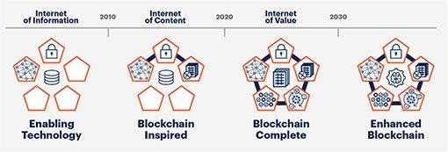

Fig 2.1. Blockchain Spectrum by Granter

Fig 2.1 shows that Gartner Blockchain Spectrum has 3 Phases i) Blockchain-inspired solutions ii) Blockchain- complete solutions iii) Enhanced-blockchain solutions. In the ‘Ease of Doing Business’ rankings, released annually by the World Bank, India, specifically, has not fared well in indicators to measure the efficiency and Performance of processes to gain trust. While India has settled in the phenomenal progress and has acquired 79 positions since 2015 to 63rd in the 2020 position[7].[8]
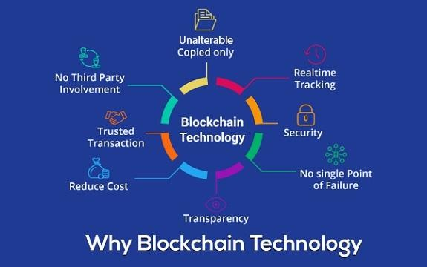
Fig 2.2 Internet of Value Source: businesstimes.co.zw

Security Threat of Aadhaar ID.
- Privacy Concern for Individual:
The biometric data record of each AADHAAR ID having 12 digits Numerical. Government mandated Id information is linked with users of all banks, voter ID, PAN card. If this very private information of these users is used for any unintended legal purpose, The Security threat is for sure. Each Id risks the information can be leaked.

- Centralization Power Problems:
Centralized data collection in CIDR of Aadhaar or Unique Identification Scheme is managed and operated by Supreme Authority of Nation. As the centralization of power can be manipulated and used for Anti Social Networking Purpose

- Misuse of Aadhaar in Bank Transactions:
All bank accounts need to be linked with Aadhaar, which will be used in the processing of ATM, as well as in Credit and Debit Cards. This bit will give the access to reach and trace financial transaction of the masses in the country.
Thus the Distributed Ledger Technology (DTL) of Blockchain comes into the picture. The database of the blockchain can be treated as list of transaction among peer nodes of Distributed Ledger. However, instead of maintaining the records in a table, it groups the records into a block in a ledger.
Each new block is chained to a previous block with the use of cryptographic hash; hence the name Blockchain is created. The ledger can be shared with all nodes within the network where it can be verified and validated as well. This provides an audit trail for reliable verification. As larger blockchains require more resources, processing speed is also adversely affected as more time is required to verify and approve transactions. This would be major disadvantage of securing Unique Identification such as Aadhar ID.

The process of generating a block and validating it is called “Consensus” which is invoked by all the participants in the chain. There is an inhibited advantage of blockchain technology - its immutability. Once a transaction is recorded and propagated to the network, it becomes permanently stored on the blockchain and can be accessed subsequently for verification. [2][10]

Existing Works on BC and CNN.
    - Smart contracts of Block Chain

      - Smart contracts, by using digital signatures, could considerably improve the whole process.

      - Verification and Validation of Block a small set of code with High Level Language and added that contract to that particular Node.

      - Security of data is ensured using blockchain technology, smart contracts can be programmed to directly send the data for building machine learning models.

      - This means that this fusion of machine learning and blockchain technology can be a game-changer for numerous other technologies.

      - Similarly, industries like finance and insurance have a lot to gain from this amalgamation because together they can be used in designing tools for identification and prevention of fraud.
      - Using machine learning, supply chain solutions can be improved and billions of dollars can be saved every year by reducing theft and wastage.[16]

The figure 2.3 illustrates such a combo (GAN-FD architecture), where the generator is founded on LSTM, which applies to predict Yt+1. The discriminator is based on CNN for the purpose of estimating the probability of whether a sequence is real (Y) or being predicted (Y).

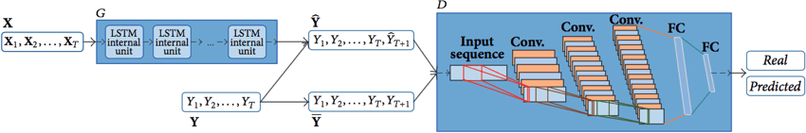

Fig 2.3: GAN with LSTM and CNN

The paper [14] shows that the generative Adversial Network (GAN) has a single Image dehazing algorithm based on feature pyramid network(FPN). FPN is end to end image dehazing method, avoiding the physical model dependency. The results of this work shows that algorithm is obtaining satisfactory results in terms of spped and quality.

The Ethereum crypto currency is invented by Vitalik Buterin. Ethereum solved the major problem of double spending(Spending the same coin twice) in the mainstream bitcoin. This promising technology using Distributed network platform to enable secure Blockchain-based financial and business transactions. However, many identified bugs and vulnerabilities in smart contracts have led to serious financial losses, which raises serious concerns about smart contract security. Significantly required to better maintenance of smart contract code and ensure its high reliability. In this research paper [14] we propose an automated deep learning based approach to learn structural code embeddings of smart contracts in Solidity, which is useful for clone detection, bug detection and verification of smart contracts.[14]

Since Blockchain and CNN are considered as two of the most promising and powerful technologies, there are some research work on ML and BC on various applications as well.

Proposed System
In 2009 Government of India using AADHAAR ID facing many issues so related to Aadhaar card ID data set for Image maintenance. An Integrated approach to secure Aadhaar Id data using Block chain Technology and Convolution Neural Networks.
Model is being proposed in Distributed Ledger Technology(DLT) of Block chain(BC) having 3 phases, In first phase Biometric data and Demographic data of AADHAR is used and data reduction is done in second

phase Convolution Neural Networks( CNN) ReLU model to secure biometric data from cloning and face verification and in 3rd phase BT using Distributed Ledger Technology( DLT) is provided more security to the proposed model. Using this Hybrid model Security of Aadhaar ID can be achieved.
Proposed system a concept of integrating BT shows the DLT (Ledgers have report keeping mechanism) of Blockchain in Decentralized system and CNN takes Image datasets of every user of Aadhaar holder Aadhaar authentication can authenticated by themselves using the system. At a high level, authentication can be using Demographics data and/or Biometric (FP/Iris/Face) data, and/or OTP. Face authentication is currently not supported. So provides security by using Maxpool, Flattening , Hidden layer with 3 filters to check for the image detection &verification. Dense classifiers and convolution 2D for ReLU Conv Nets can achieve more security of biometric data in AAdhaar.
Using a Private Blockchain for organizations can give more stable, immutable and secure data in DLT. Integration BT and CNN for more security of Bank data, PAN card Details which are linked through AADHAAR ID. The Biometric data with CNN-ReLU model can also detect data cloning and face verification which is discussed in section
  - of the paper. Convolution and batch normalization layers are usually followed by a nonlinear activation function such as a rectified linear unit (ReLU), specified by a ReLU layer. A ReLU layer performs a threshold operation to each element, where any input value less than zero is set to zero. Fig 3.1 shows the Integrated Hybrid Model.

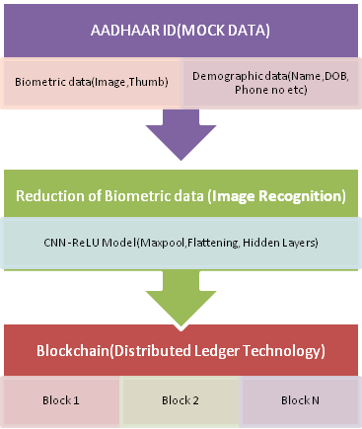

Distributed Ledger of all Block/Nodes.
Secured Aadhaar Id

Fig 3.1 Hybrid Integrated Model.

Practical Implementation of Convolutional Neural Network(CNN)

    - Image Recognition
A Convolution Neural Network (CNN) that can detect various objects in images. Implementation of Deep Learning model to recognize a cat or a dog in a collection of images. However, using different set of images we can detect anything using CNN Models simply changing the pictures in the input folder. Dataset sample: The dataset contains 10k images of cats and dogs.
Initial step-up is to import Keras Library functions and packages for building the CNN Model. Then first and foremost to import sequential model for Initialization. Second is Convolution2D packages used to make first step using convolution layers. Likely working on 2D images using convolution2D Image format. Convolution3D for video format for recognizing images of video frames. Further steps like maxpooling, flattening and filters in hidden layer of CNN is used with Rectified Linear Unit Model to show sample coding steps as shown below. At last dense package is used to add fully connected layer.[18]
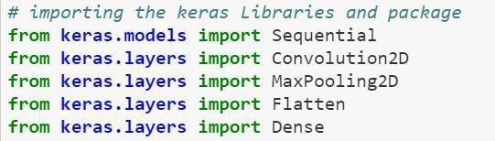
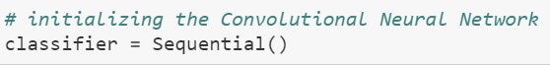

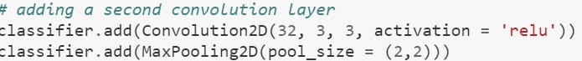
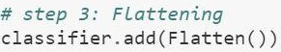

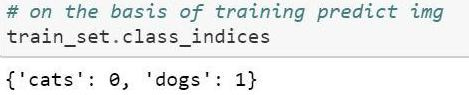

(Images Source: Medium.com) Coding samples of how CNN –ReLU model.

Thus the CNN Model fits in Actual Image Prediction.
With a blockchain ledger for independent verification of datasets and models used (hash values).The research paper proposed [18] documentation of classification thresholds, and performance results potentially leverage of AI algorithms, rather than using independent contracted research

algorithms. Blockchain provides facility to test AI models. Data sets and hash values validated on blockchain. Blockchain potentially be compatible with the collaborative training cycle in a federated learning approach too. The blockchain ledger have detailed record of data i.e. who accesses it, at what time, and with which algorithm to ensure secure data use and to allow Monitoring behaviour, activities, or information for the purpose of information gathering, influencing, managing or directing.
The author in paper[19] proposed Aadhaar ID Clone/Duplicate Identification of facial image in one of the classes defined by all person IDs, included in a facial image database. Face verification is a binary problem, where the objective is to distinguish one class (called positive class) defined by the ID of the person of interest from the rest of the world (called negative class got through the IDs of all other persons, not included in the facial image DB). An illustration of the face recognition and face verification problems is shown in Fig 3.1 [19]

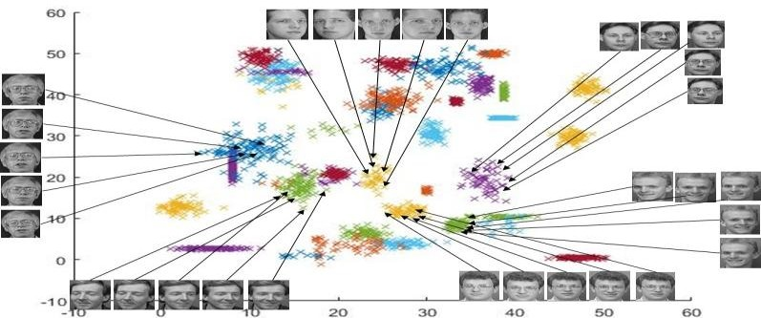

Fig 3.1 Illustration of face recognition and face verification problems.
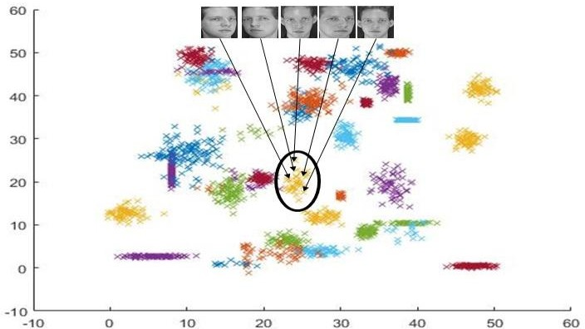

Fig 3.2. Face recognition for Depicted Person Source:Reference Paper [19]
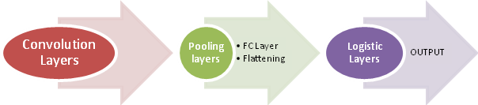

Fig. 3.3 Model building blocks of CNN
Face verification is a binary problem, where given a new facial image the answer is whether the image depicts the ID of interest or
not. Here we show the 2-D representations of the facial vectors in ORL dataset. Fig 3.1 & 3.2 sourced by Neural Class-Specific Regression for face verification [19]

CONCLUSION
The proposed review work on introducing a integrated model using Blockchain and CNN in securing Biometric Data set of AADHAAR Id as well the security system of face recognition , data cloning using the ReLU model of CNN. The distinguishing features of the presented technique can be that method utilizes the layer normalization at the initial layer and it provides a method to leads to a better performance rate. ReLU model can be employed for the purpose of detecting images Cloning and Verification. By this we can achieve faster Data Transaction and Security of Image in large Blockchains of Distributed Ledger.

REFERENCES
- Kavya. A PES College of Engineering,Sparse Supervised Learning using Extreme LearningMachineInternational Journal of Engineering Research & Technology (IJERT) ISSN: 2278-0181,Published by, www.ijert.org NCETESFT - 2020 Conference.
- Karan Sachan, “Aadhaar & Blockchain: Opportunities and Challenges for India” Thesis granted at the Massachusetts Institute of Technology February 2018.
- Yi Liu, Ruilin Li, Xingtong Liu, Jian Wang, Chaojing Tang and Hongyan Kang, “Enhancing Anonymity of Bitcoin Based on Ring Signature Algorithm”, 2017 13th International Conference on Computational Intelligence and Security .
- Michael Crosby, Google, Nachiappan, Yahoo, Pradhan Pattanayak, Yahoo, Sanjeev Verma, Samsung Research America, Vignesh Kalyanaraman, Fairchild Semiconductor, Sutardja Center for Entrepreneurship & Technology Technical Report ,Oct 2015.
- Amir Al , Muhammad Zain “A Briefly Explanation of Convolutional Neural Network with Practical Implementation in Keras & Tensorflow “Machine Learning & Deep Learning Researcher Co-Founder of Wavy AI Research Foundation.

- Sudeep Tanwar1, Qasim Bhatia1, Pruthvi Patel1, Aparna Kumari1, Pradeep Kumar Singh2, Wei-Chiang Hong3, Senior Member, IEEE Machine Learning adoption in Blockchain-based Smart Applications: The challenges, and a way forward Digital Object Identifier 10.1109/ACCESS.2017.DOI .

- Blockchain: The India Strategy Part 1- January2020 by Niti Aayogh of India .

- Survey report from World Bank Ease of Doing Business Ranking 2020.

- Nakamoto, S., 2019. Bitcoin: A peer-to-peer electronic cash system. Technical Report. Manubot.

- Ahmed Alketbi, Dr. Qassim Nasir, Dr. Manar Abu Talib“Blockchain for Government Services – Use Cases, Security Benefits and Challenges”
University of Sharjah Sharjah, UAE-2018

[11] DOI 10.1109/ACCESS.2019.2961372, IEEE Access

- Cao, Guanqun & Iosifidis, Alexandros & Gabbouj, Moncef. (2017). Neural Class-Specific Regression for face verification. IET Biometrics. 7. 10.1049/iet-bmt.2017.0081.

- Aadhaar - Wikipedia. (n.d.). Retrieved January 25, 2018, from https://en.wikipedia.org/wiki/Aadhaar
- X. Cao, J. Dong, S. Zhou, S. Zhao and D. Zhang, "Single image dehazing algorithm using generative adversarial network based on feature pyramid network," 2020 International Conference on Computer Vision, Image and Deep Learning (CVIDL), 2020, pp. 48- 53, doi: 10.1109/CVIDL51233.2020.00017.
- Z. Gao, "When Deep Learning Meets Smart Contracts," 2020 35th IEEE/ACM International Conference on Automated Software Engineering (ASE), 2020, pp. 1400-1402.

- Sharmistha Chatterjee “Traditional vs Deep Learning Algorithms used in BlockChain in Retail Industry” Posted by on July 26, 2020.
- Andrew Zola What Happens When You Combine Blockchain and Machine Learning - Intersog
- Tien-En Tan, Ayesha Anees, Cheng Chen ,Shaohua Li et al. "Retinal photograph-based deep learning algorithms for myopia and a blockchain platform to facilitate artificial intelligence medical research: a retrospective multicohort study", The Lancet Digital Health,2021.
- Guanqun Cao, Alexandros Iosifidis, Moncef Gabbouj “Neural Class- Specific Regression for face verification” Article in IET Biometrics
· August 2017
- Samaria F., Harter A., ‘Parameterisation of a stochastic model for human face identification’, IEEE Work. Appl. Comp. Vis., 1994
- https://rubikscode.net/2018/02/26/introduction-to-convolutional-neural- networks/

