Website Automation using Machine Learning and Flask for e-commerce

Apoorva Barapatre¹
Computer Technology, PCE, Nagpur, India
apoorva.patrey22@gmail.com
Minal Baghele²
Computer Technology, PCE, Nagpur, India
minalbaghele2002@gmail.com
Ayushi Mandlekar³
Computer Technology, PCE, Nagpur, India
ayushimandlekar04@gmail.com
Piyush Donge⁴
Computer Technology, PCE, Nagpur, India
piyushdonge844@gmail.com
Rajat Darvhekar⁵
Computer Technology, PCE, Nagpur, India
rajatdarvhekar123@gmail.com

Abstract— The fashion and entertainment sectors are in high demand in today's society. Users are continually looking for new data and up-to-date trends in these industries. Therefore, it is essential to develop a system that would regularly alert consumers of the same. Today, there are many different recommendation systems that make use of technologies like collaborative filtering, the Bayesian interface, etc. to automatically identify user preferences and create recommendations based on the user's interests. One of the major technologies for delivering personalized services, these recommendation systems should be able to comprehend the context in an environment where IT is omnipresent. In this paper, a machine learning model that combines Random Forest and Gradient Boosting approaches is proposed. A website will be developed that will present the most recent information on the newest trends and upgrades in the fashion and educational sectors, depending on the user's interest.

Keywords—Auto Suggest, Machine Learning, Flask, Front End, Data collection.

INTRODUCTION

In today's society, there is a strong demand for the fashion and entertainment industries. Users are constantly looking for new information and the most recent developments in these sectors. Therefore, it is crucial to create a system that would notify customers of the same on a regular basis. There are numerous recommendation systems available today that automatically detect user preferences and generate recommendations based on the user's interests by utilizing technologies like collaborative filtering, the Bayesian interface, etc. These
recommendation systems, one of the key technologies for providing personalized services, ought to be able to understand the context in a setting where IT is pervasive. This is primarily due to the recommendation engine's ability to offer consumers specific product suggestions based on their browsing habits and previous purchasing behavior.

Users will be enticed to return and make additional purchases in our system's dynamic environment because it offers these individualized recommendations. The more frequently a consumer visits our website, the more information we may gather about them and the items, giving us the opportunity to identify areas where the product needs to be improved. The likelihood of gaining more consumers increases with the quality of the product we have. The image below [1] illustrates this entire continuous cycle process. The suggestion algorithm also aids in boosting sales of goods connected to a specific product. For instance, if a customer purchases a monitor from our website, our referral system will make various keyboard and mouse suggestions to him. In this sense, it aids in boosting sales of specific goods that a user might not otherwise be looking for. Because each user receives a customized recommendation instead of seeing the entire inventory, this recommendation system lessens the strain on the database.

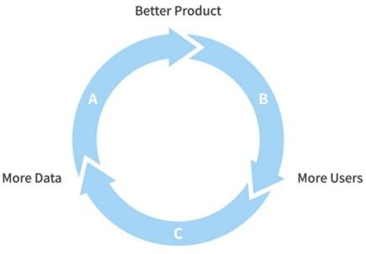

Fig. 1 Illustration of recommendation system

- LITERATURE REVIEW

L. Haihan et al [1], the system uses neural network methods to extract the characteristics of consumers and goods, then proposes a linked recommendation algorithm known as the U-S recommendation algorithm based on consumer attributes and product similarities. The algorithm determines the user and commodity match rate that is optimal. The findings demonstrate that, when compared to an algorithm based on product similarity, the suggested method can increase the effectiveness of something like the recommendation system.

E. Kantepe et al [2], the MovieLens dataset, and one of the deep learning techniques, autoencoders, were used to create the study's recommendation system. Gradient Descent, Gradient Heritage with Momentum, RmsProp, and Adam (Adaptive Momentum Optimization) were among the optimization algorithms that were tested during the system design process utilizing TensorFlow in the language of Python programming. Additionally, the impact of increasing the data volume on the optimization technique was examined. The Adam method, which had a test loss of 1.363, was thus successfully shown to be the most effective. Additionally, it was discovered that less sparse training data results in lower test error.

M. K. Delimayanti et al. [3] used the KNN method and the cosine similarity notion to increase this system's accuracy. The accuracy of the system, which used the Movie Lens dataset, was over 87%. Additionally, using Python data analysis tools and the Django web framework, this research successfully created a client movie recommendation system (RS). Additionally, this technology is accessible through a web page and has an accuracy rate of over 87% when recommending movies based on certain elements or traits of the film.
Jatin Sharma et al [4], in essence, is a scanning system that aims to anticipate and display the products that a customer would like to buy. Companies can choose which product to launch in the market to gain more benefits by looking at user preferences. These systems have been shown to be very helpful in a number of fields, including those that involve music, literature, movies, research articles, and items in general. In this work, the authors cover a number of methods and methodologies that are necessary for recommendation engines to recommend goods or services in the fields of books and fashion.

Ketki Kinkar et al [5], in this essay, a variety of recommendation techniques are reviewed along with their benefits and drawbacks and several performance metrics. We've looked through a number of articles, assessed their methods and approaches, key aspects of the algorithm they used, and possible areas for development. Cooperative, hybrid, content-based, and recommendation system—are some of the keywords. The most pertinent information is recommended to the user via a recommender system, which is a framework that filters data using various methods. Systems that make a recommendation based on current consumer preferences are effective customization methods that are frequently up to date. These systems have shown to be very beneficial in a variety of fields, including e-commerce, education, media, books, films, music, and diverse products like movies, music, books, and films.

Fátima Rodrigues et al [6], consumers are now exposed to a wider range of goods and information than ever before. As a result, consumer demand becomes more diverse, making it difficult for a retail establishment to stock the appropriate goods in line with customer preferences. The solution to this problem is to use recommender systems. By recommending products, it is feasible to meet the wants and expectations of clients while also luring in new ones. The effectiveness and quality of predictions are nevertheless diminished by the enormous transactional databases that are typical of the retail industry. To overcome these challenges, a joint optimization system that incorporates content- based collaborative filtering, data mining, and other techniques is described in this study. Utilizing customer lifetime value, the recommendation system begins to identify comparable groupings of consumers.

J. Chen et al [7], In e-commerce, recommendation systems have evolved into crucial tools for assisting companies in boosting sales. The authors describe in this study how a product recommendation strategy for small internet businesses was designed. Our solution is assessed on its accuracy, productivity,

and scalability using actual conducted on a small online marketplace in order to answer the demands of businesses with limited memory pools and low computational resources.

Mayuri G. Dabhade et al [8], a novel Domain- sensitive Selection (DsRec) algorithm is proposed in response to the observation in order to make the rating prediction by simultaneously exploring the usage subgroup analysis. A user-item subgroup is defined as a domain made up of a subset of items with similar character traits and a small minority of users who have interests in these items. CF, or collaborative filtering, is a successful and often-used recommendation approach. CF methods produce predictions by just using the user-item interaction information, such as transaction history or item satisfaction represented in ratings, in contrast to content-based recommender systems that rely on the profiles of users and products.
Reference No. | Advantage | Disadvantage
[1],[6] | The suggested method can increase the effectiveness of something like the recommendation of the system by using the neural network method. | When compared to an algorithm based on  product similarity, The findings demonstrate that the  algorithm determines the user and  commodity match rate that is optimal.
[2] | So, it was convincingly demonstrated that the Adam technique was the most efficient, with a test loss of 1.365. It was also found that test error decreases with less sparse training data. | The dataset used in this study was unrelated to recommendatio ns, and numerous algorithms were evaluated on various datasets, leading to data loss.
[3], [4] | When proposing movies based on certain aspects or qualities of the film, system, which is available through a web page, and has a prediction performance of over 87%. | No advance or rare algorithm is used here it is just a simple recommendati on a system created on the web.

[5],[7] | E-commerce, education, media, books, films, and music are just a few examples of fields where systems that offer recommendations based on current customer preferences are efficient and often updated. These fields also include different products like movies, music, books, and films. | It is not particularly advantageous for small businesses because it demands substantial processing resources and small memory pools.
[8] | In response to the discovery, a prediction system is put out that simultaneously examines the usage subgroup analysis and attempts to anticipate the rating. | Prediction of the rating depends upon the selling of the product among consumers, to predict the reviews and rating one needs to explore the selling of the product first. So to make the system use this system needs to predict the selling of a particular product so that higher revenue can be generated.

EXISTING SYSTEM

There are numerous sorts of recommender systems that are useful in a variety of circumstances. In- depth reviews of several of the current recommendation systems are provided in this section. Like, in the system of recommendations on Amazon.com, the product-to-product collaboration technique utilized by the Amazon.com recommendation system can be applied to e- commerce websites. They customize the online store for each consumer using recommendation algorithms. Similarly, in Invocation Agent Systems, the Remembrance Agent is a piece of software that improves memory by presenting a list of papers that can be pertinent to the user's current situation. Without user input, it operates. It constantly keeps track of user activity and spots information demands.

PROBLEM STATEMENT

In order to improve consumers' experiences with the business, personalized solutions in the online store is based on tailoring the content displayed on the company's website to the customer's requirements and expectations. Never before have personalized recommendations been more crucial for companies trying to draw in and keep clients. Nine out of ten customers, according to research, are more likely to make purchases from companies that offer useful offers and suggestions. Some of the available recommendation systems only work for some selected brands and only tend to show the latest products or do marketing of the products from where they are getting higher revenue. This problem statement is chalked out and no ads system is proposed in our project so that user gets personalized experience according to their field of interest.

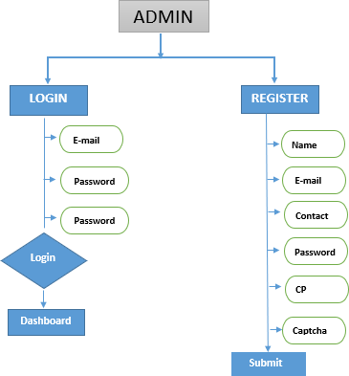

Figure 1: Admin Panel View

V.. PROPOSED METHODOLOGY

One of the most effective personalization tools in the modern digital world is a recommendation engine. The product suggestion engine is a straightforward solution, despite appearances. It suggests products that consumers might find interesting, as the name would imply. The recommendation system's utilization of machine learning, artificial intelligence, and other technology is crucial to its effectiveness. Because the approach uses machine learning, the hypotheses will get better as more data is gathered. In other words, the recommendations are more accurate the deeper the engine runs and gathers data.

We propose to develop a recommendation website using the Flask application. The website design will be as follows:

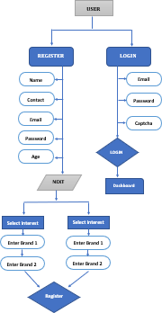

Figure 2: User Panel View
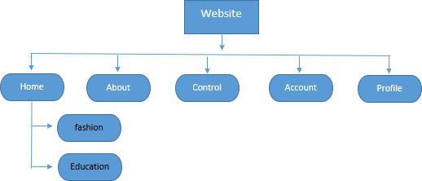
Figure 3: Landing Page View

Algorithms:

In this auto recommendation system, we are using three algorithms for the accuracy purpose, the short description of the algorithms is given below:

Random Forest (RF): This is a classifier algorithm that works on the basis of decision trees on the given dataset. It is declared that the more the number of trees than more the accuracy is obtained. The RF takes less training time and predicts output with higher accuracy.
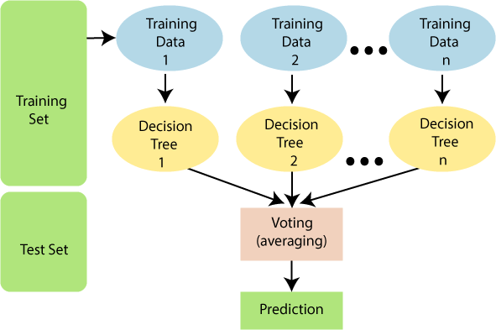

Figure 4: Working Module of RF

Support Vector Machine (SVM): It is a very popular supervised algorithm amongst others. It is highly used for classification and regression-related tasks. Basically, its work is to draw a boundary line between the subsets or datasets passed to categorize them accordingly. And the decision boundary made by SVM is known as hyperplanes.
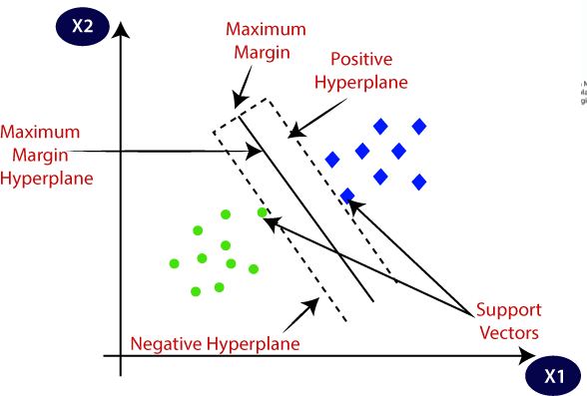

Figure 5: Working Module of SVM

K-Neaest Neighbour (KNN): This is the simplest and easy-to-use algorithm that is again used for classification and regression-related problems. It does not learn at the time of training instead it runs the program and then passes its decision to the subsets. This can be used when we have two similar- looking categories and are confused about which to switch then KNN can make a new x point or category to make a decision and predict the original category.

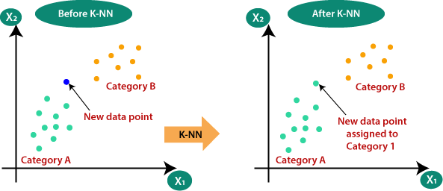

Figure 6: Working Model of KNN

CONCLUSION

An algorithm with the best results on the accuracy, F1 Score, Recall, and Precision will be considered the final model for the website. Depending on the user's interest, the website will give the most updated information on the newest trends and advancements in the fashion and educational sectors. The user will also be editing his/her interest timely and will get notifications and updates accordingly.

REFERENCES

- L. Haihan, Q. Guanglei, H. Nana and D. Xinri, "Shopping Recommendation System Design Based on Deep Learning," 2021 6th International Conference on Intelligent Computing and Signal Processing (ICSP), Xi'an, China, 2021, pp. 998-1001, doi: 10.1109/ICSP51882.2021.9409009.

- E. Kantepe, Z. A. Altikardes, and H. Erdal, "Product Recommendation System with Explicit Feedback Using Deep Learning Methods," 2020 Innovations in Intelligent Systems and Applications Conference (ASYU), Istanbul, Turkey, 2020, pp. 1-6, doi: 10.1109/ASYU50717.2020.9259814.

- M. K. Delimayanti et al., "Web-Based Movie Recommendation System using Content- Based Filtering and KNN Algorithm," 2022 9th International Conference on Information Technology, Computer, and Electrical Engineering (ICITACEE), Semarang, Indonesia, 2022, pp. 314-318, doi: 10.1109/ICITACEE55701.2022.9923974.

- Jatin Sharma et al 2021 IOP Conf. Ser.: Mater. Sci. Eng. 1022 012021

- Ketki Kinkar, Anuj Zore, Prof. Pradnya V. Kulkarni,” Product Recommendation System: A Systematic Literature Review”,

International Journal for Research in Applied Science & Engineering Technology (IJRASET) ISSN: 2321-9653; IC Value:
45.98; SJ Impact Factor: 7.429 Volume 9 Issue VII July 2021

- Fátima Rodrigues, Bruno Ferreira, “Product Recommendation based on Shared Customer's Behaviour”, Procedia Computer Science, Volume 100, 2016, Pages 136-146, ISSN 1877-0509,
https://doi.org/10.1016/j.procs.2016.09.133.

- J. Chen, C. Miller and G. G. Dagher, "Product recommendation system for small online retailers using association rules mining," Proceedings of the 2014 International Conference on Innovative Design and Manufacturing (ICIDM), Montreal, QC, Canada, 2014, pp. 71-77, doi: 10.1109/IDAM.2014.6912673.

- Mayuri G. Dabhade, Prof. Nitin R. Chopde, “A Result Review Analysis of Product Recommendation System in Domain Sensitive Manner”, International Research Journal of Engineering and Technology (IRJET) e-ISSN: 2395-0056 Volume: 07 Issue: 07 | July 2020

- Yu Liu, Shuai Wang, M. Shahrukh Khan, and Jieyu He,” A Novel Deep Hybrid Recommender System Based on Auto- encoder with Neural Collaborative Filtering”, Big Data Mining and Analytics,ISSN, 2096-0654 03/06,pp211– 221, Volume 1, Number 3, September 2018.

- Gang Wu, Viswanathan Swaminathan, Saayan Mitra and Ratnesh Kumar,"Digital Content Recommendation System Using Implicit Feedback Data",IEEE International Conference on Big Data 2017.

- Driskill, R. & Riedl, J., 1999. Recommender Systems for E-Commerce: Challenges and Opportunities. American Association for Artificial Intelligence, pp.73– 76. Available at: http://aaaipress.org/Papers/Workshops/1999
/WS-99-01/WS99-01-012.pdf.

12.L.C. Wang, X.Y. Zeng, L.Koehl, and Y. Chen “Intelligent fashion recommender system: Fuzzy logic in personalized garment design,” IEEE Transactions on Human-Machine Systems, vol.45 no.1 pp 95-109, 2015.

