Recent advances in the field of Optometry
Hiba Khan¹ and Dr. Anshu Kumar Singh²
Assistant Professor, Department of Paramedical Sciences, Subharti Medical College, Swami Vivekanand Subharti University
Associate Professor, Department of Paramedical Sciences, Subharti Medical College, Swami Vivekanand Subharti University

Abstract
Optometry is a specific medical service calling that includes inspecting the eyes and related structures for deformities or irregularities. Optometrists are medical services experts who normally give extensive essential eye care. The World Gathering of Optometry, World Wellbeing Association and around 75 optometry associations from more than 40 nations have taken on the accompanying definition, to be utilized to portray optometry and optometrist. Optometry is a healthcare profession that is autonomous, educated, and regulated (licensed/registered), and optometrists are the primary healthcare practitioners of the eye and visual system who provide comprehensive eye and vision care, which includes refraction and dispensing, detection/diagnosis and management of disease in the eye, and the rehabilitation of conditions of the visual system. Optics started with the improvement of focal points by the antiquated Egyptians and Mesopotamians, trailed by hypotheses on light and vision created by old Greek thinkers, and the advancement of mathematical optics in the Greco-Roman world. Optics was fundamentally transformed by the improvements in the archaic Islamic world, like the starting points of physical and physiological optics, and afterward altogether progressed in early present day Europe, where diffractive optics started. These previous investigations on optics are presently known as "old style optics". The expression "current optics" alludes to areas of optical examination that generally evolved in the twentieth 100 years, like wave optics and quantum optics. In addition to the more conventional approaches that are currently in use, new technologies for multifocal contact lenses and spectacles are being developed to address the worldwide rise in myopia. New effective drops both remedy and over the counter, add to the optometric restorative armoury. An as of late endorsed fundamental medication might change the board designs for thyroid eye sickness. We are seeing a dramatic flood in recent fads, innovations, and medicines in optometry and expect to rouse some further examination by giving you an undeniable level prologue to a portion of the promising newcomers in eye care.

Key Words: - Optics, Visual System, Refraction, Primary Health care Practitioners

Introduction
Optometry is a profession field loaded up with potential outcomes. Optometry offers adaptability, assortment, delight, great pay, and opportunity in picking an area to rehearse - all while accomplishing significant work in medical services. Specialists of optometry, the forerunners in essential eye medical services, assist patients and their families with venturing out toward better eyes and better bodies. In the event that an illness or different circumstances are recognized, specialists of optometry can assist with exploring patients to the right counteraction plans or the subsequent stages in true conclusion and treatment. An emphasis on the initial 3, paediatrics, vision treatment/binocular vision, and neuro-optometry have a lot of cross-over. Optometrists that work in this field are once in a while alluded to as a formative optometrist, vision treatment optometrist (VTOD), or neuro-optometrist. The kind of persistent tended to by optometrists in this field is very assorted - yet frequently these patients battle with binocular vision for reasons unknown or another. This could be because of amblyopia, strabismus, vergence messes, a horrendous mind injury, visual handling problem, and others. Optometrists that emphasis on specialty contact focal points frequently work with troublesome contact focal point cases. Frequently their patients have some kind of inconsistency to the cornea, the front, clear window tissue of the eye. This could be because of an issue like keratoconus, translucent degeneration, or other corneal illnesses, or could be because of injury from a mishap or medical procedure. Albeit by far most of optometrists fit contact focal points, optometrists that work with patients such these frequently use specialty-made focal points called scleral or semi-scleral. These are truly enormous, hard contact focal points that are fit to vault (or ascend over) the harmed tissue and fit on the white piece of the eye (the sclera). The focal point is loaded up with saline, which is then blended in with tears throughout the span of wear. This, fundamentally, makes another surface for the visual framework when the patient is wearing the focal point and can have a major effect in some quiet's vision. Numerous optometrists are fit for diagnosing, making due, and treating problems of the eye. A few optometrists work in facilities that emphasis principally on visual illness - and as you can envision, geriatric consideration. Many of these optometrists collaborate with ophthalmologists, or they may work in hospitals or Veteran's Affairs clinics that treat a greater number of patients with eye diseases. The eye care industry is continually changing and adjusting as new advances and patterns arise. There's continuously something creating, whether it's medicines for eye sickness or new glasses and contact focal points.
Glasses were the first medical device for people with poor eyesight. Over the past two decades, eyewear has been at the forefront of technological progress, forming the foundation for the high-tech version we know today. Augmented reality is in the glasses of technology companies such as Google. Google's version, Google Glass, was discontinued, but it paved the way for the evolution of AR technology into everyday wearable accessories. Google Glass was launched in 2013 and was discontinued in 2015. In recent years, lenses have been developed that automatically adjust to focus on objects for wearers with vision problems such as presbyopia. One way she does this is by having the sensor unit measure the distance between the pupils and knows when the wearer is trying to focus on an object. One of these specialty lens brands, Eyejusters, launched a line of self-adjusting eyewear in 2016.

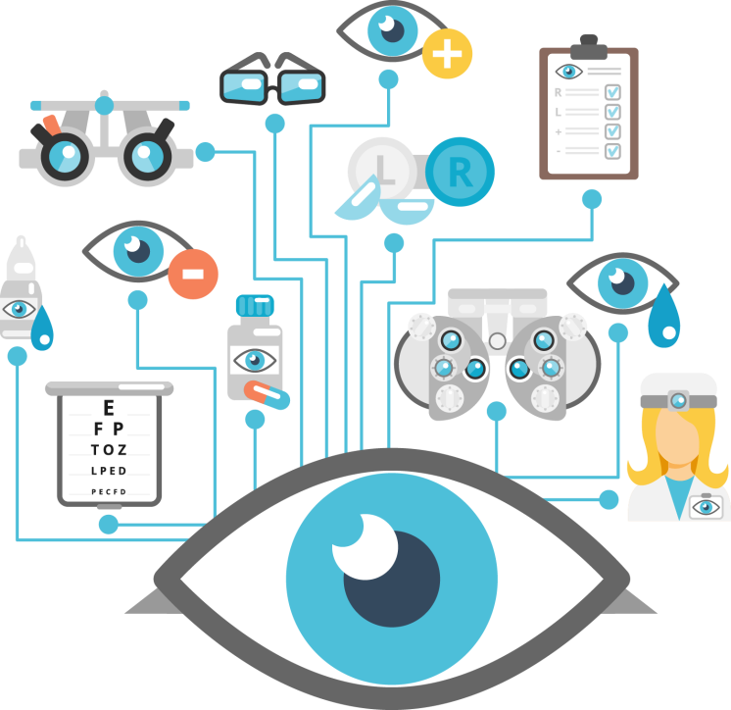

History
Since the early 1300s, when the first glasses that could be worn were made of blown glass, wood, or leather, optometry has existed. These crude structures were generally handheld and thought about an image of status or riches. Through the 1700s, glasses became sans hands with improvements of the over-the-ear connection that permitted them to sit serenely on the face. Benjamin Franklin has additionally been noted as the creator of reading glasses, permitting one to see both all over located with one sets of glasses. The 1800s bore the presentation of round and hollow focal points for adjusting astigmatism. Plastic frames made glasses more customizable, making them more accessible and fashionable in the 1900s. In order to shield the eyes from the sun and reduce glare during everyday activities, sunglasses were developed in the 20th century. Plastic focal points came to fruition in the late twentieth 100 years and immediately filled in notoriety due to being lighter, more slender, and more solid. The early research on optics and the eye's ability to create images can be seen in the history of optometry. The beginnings of optical science (optics, as shown in a fundamental physical science class) date back a couple thousand years as proof of the presence of focal points for enrichment has been tracked down in Greece and the Netherlands. It is obscure when the main exhibitions were made. The English researcher and antiquarian Sir Joseph Needham, in his Science and Progress in China, detailed the earliest notice of scenes was in Venetian society guidelines c. 1300. He recommended that a periodic case that scenes were imagined in China might have come from a paper by German-American anthropologist Berthold Laufer. According to Needham, Laufer's paper was inconsistent in many ways and contained references that were added during the Ming dynasty rather than in the original copies. Early Chinese sources notice the eyeglasses were imported. A study by David A. Gosse in the United States indicates that spectacles may have been made in Italy in the late 13th century, as indicated by a 1305 manuscript in which Rivart, a monk from Pisa, remarked that "the art of making spectacles was discovered there less than 20 years ago."[4] Eyeglasses were made in Italy, Germany and Holland around 1300. Needham states that glass was first made, he said shortly after 1286. In 1907, Laufer wrote in his book A History of Spectacles, "The most likely opinion is that spectacles originated in India and that in India spectacles must have been known earlier than in Europe." Not supported. In the 5th century BC Empedocles postulated that all things consist of four elements. Fire, air, earth, and water. He believed that Aphrodite created the human eye out of her four elements, and that she ignited fire in her eyes, emanating from her eyes enabled her sight. If that were true, then Empedocles postulated an interaction between the rays of the eye and the rays of a light source such as the sun, since a person could see at night as well as during the day. He discovered that light has a finite speed. Great advances in optical technology were also made in ancient China. The Greek mathematician Euclid said in his book Optics, ``Those seen at larger angles appear larger, those seen at smaller angles appear smaller, but those seen at the same angle appear the same.'' In his 36 papers below, Euclid relates the apparent size of objects to their distance from the eye and examines the apparent shapes of cylinders and cones when viewed from different angles. Pappus considered these results important for astronomy, and included Euclid's optics and its phenomena in his Kleine Astronomy, a compilation of minor works to be considered before Ptolemy's Syntactics (Almagest).

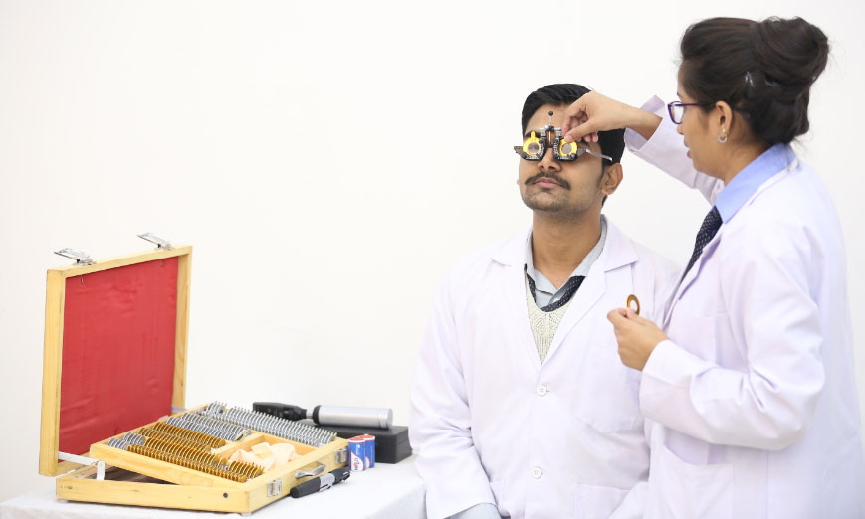
Old method for Refraction

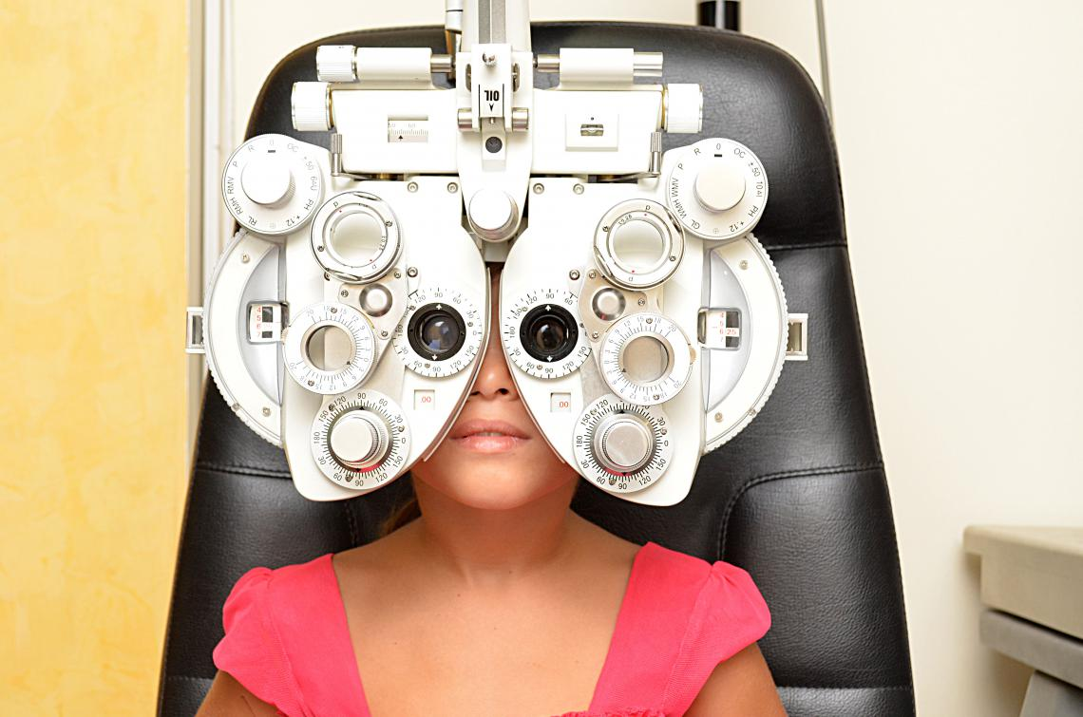
New Method for Refraction

Advances
Dry Eye
Treating dry eye can be difficult because many factors influence the condition. The effectiveness of treatment may vary from patient to patient. Experts are always looking for new ways to reduce the symptoms of dry eye. His two new treatments for dry eye are intense pulsed light (IPL) therapy and heat pulse therapy. IPL is a dry eye treatment in which an optometrist uses pulses of light to treat blood vessels around the eye to reduce inflammation. These light pulses reduce the inflammation that causes dry eye symptoms while also heating the meibomian glands that release oil within the tear film. Warming these glands clears blockages that cause tears to evaporate quickly and dry out the eyes. Thermal pulsation is another dry eye treatment that aims to heat the meibomian glands to stimulate the release of oil. The thermo pulsation device consists of her two components that support eye treatment. A lenticular device heats the eyelid to warm the meibomian glands, and another part of the device applies pressure to the eyelid to facilitate manual pumping.

Tele Health
A new trend in the eye care industry is the rise of telemedicine to replace traditional doctor visits. Telemedicine can help preventive care if you get sick. In some cases, it may be beneficial to consult an optician instead of driving to the office. Telemedicine is a virtual approach to eye examinations. You can safely and conveniently use various optometry services from your home. Not all ophthalmologist services can be accessed via telemedicine, but it can be beneficial in many situations. If you wake up in the morning with red eyes or other symptoms of conjunctivitis, do you need to see an ophthalmologist or will taking time to care at home fix this problem? This situation is perfect for telemedicine. Talk virtually with an expert and get advice on what to do. Telemedicine is not always ideal. If your ophthalmologist needs to dilate your pupils or use diagnostic techniques, you can visit their office in person. However, telemedicine is a new way to receive quality eye care from the comfort of your own home.

Myopia Control
If this refractive error is not treated, myopia can pose a threat to a child's eye health and vision. Because children's eyes grow as they grow, myopia may worsen and vision deteriorates with age. In addition, more severe myopia may increase the risk of eye diseases in adulthood, such as: Glaucoma, cataracts, retinal tears, myopic macular degeneration. There are many ways to treat the progression of myopia, but experts are always looking for new ways to treat the condition. Your child can receive a variety of treatments depending on their needs, such as eye drops, contact lenses, and glasses. Patients will soon be able to experience a new type of lens designed to control the progression of myopia: sight glasses. Sight glasses are a new way to control and correct myopia in children. The lenses of these glasses have thousands of microdots that help diffuse light and reduce contrast on the retina.
Myopia is an old problem, but the increasing prevalence of myopia worldwide is a new one. In 2000, the prevalence of myopia in the world's population was estimated at 22.9%, and by 2050 this figure is projected to rise to 49.8%. 1 There are several theories as to what caused this increase, including more time spent looking at screens and less time spent outdoors by young people. Fortunately, there is also a steady stream of evidence-based, validated treatment options for controlling myopia.

Contact Lenses
The contact lenses worn daily by most patients are made from silicone hydrogels and were first introduced to the market in 2002. Since then, contact lenses have been at the forefront of innovation in optometric technology. Multifocal lenses are gaining popularity as an attractive treatment option for patients who require both near-sightedness and hyperopia correction options. These lenses are also a good option for patients with presbyopia or those who have difficulty focusing at close range as they age. One of Time magazine's "Best Inventions of 2018" was his introduction to contact lenses with transition lenses that block harmful UV rays from entering your eyes. The light-adaptive lens is the first of its kind and will lay the foundation for future advances. Contact lenses are constantly evolving with new technologies, modern parameters, new lens materials, etc. With recent developments, there is some news about disposable contact lenses. Disposable contact lenses are soft contact lenses that can be replaced daily, so you can use new lenses every morning. Contact lens manufacturer Alcon recently launched a new daily lens for astigmatism, Precision 1 for Astigmatism. It is a lens that keeps your eyes comfortable with a water-retaining design. Another company, Bausch & Lomb, has received FDA clearance for a new everyday lens, the Infuse one-day contact lens. These silicone hydrogel lenses correct astigmatism while providing uniform moisture to the wearer.

Soft Contact Lens - In 2020, the FDA approved the MI Sight 1-day contact lens (Cooper Vision), making it the first daily soft contact lens designed to slow the progression of myopia. In clinical studies, MI Sight daily disposable lenses showed a 59% reduction in myopia progression (measured in spherical equivalent) and a 52% reduction in average axial distortion compared to single vision daily disposable lenses.

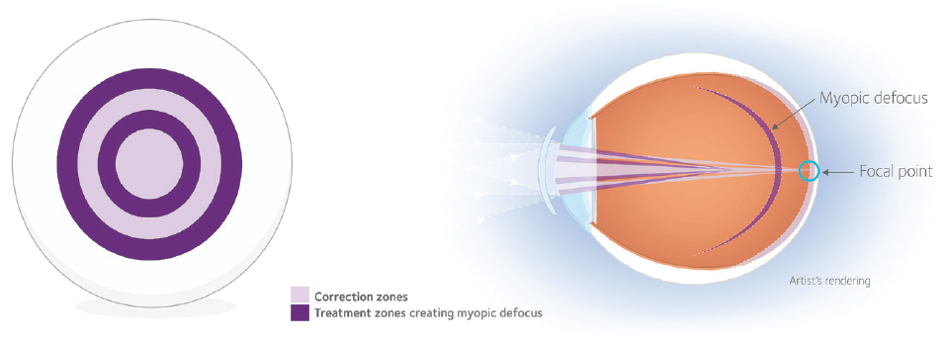
The Active Control technology in MI Sight 1 day lenses uses an optic zone concentric ring design with alternating vision correction zones and treatment zones.

Gas Permeable Contact Lenses - Orthokeratology (Ortho-K) has been used to treat myopia since at least the 1960s. The first rigid gas permeable lens for Ortho-K, Paragon CRT (Cooper Vision Specialty Eye Care), he received his FDA clearance3 in 2002, and the range of products and options has continued to grow since then. In May of this year, Johnson & Johnson Vision announced FDA clearance for Acuvue Ability Overnight Therapeutic Lenses for the treatment of nearsightedness4In the same month, Cooper Vision announced that Procornea Dream light Night Lenses for Ortho-K received CE Mark approval from European regulators to slow the progression of myopia in children and young adults5CooperVision also announced the launch of Paragon CRT and CRT dual-axis lenses earlier this year Myopia Management Strategy Adjust the posterior optic zone diameter by 5 mm to increase the effectiveness of the lens in myopia management strategies.

Antimicrobial Coatings for contact lenses - Protects the lens surface itself from bacteria without using disinfectant. The University of New South Wales is developing a contact lens coating made from a material called merimin. It is a peptide that is applied to contact lenses and has a lasting effect even when worn on the eyes. Safe and stable when exposed to heat and liquids. Antimicrobial peptides are a class of antimicrobial agents that are active against a wide range of microorganisms. Melitmin is a synthetic peptide consisting of 29 amino acid residues derived from melittin and protamine. Merrimin has a high potency that surpasses the mixture of its parents. Previous studies have shown that merimin-coated contact lenses can reduce Pseudomonas aeruginosa adherence to contact lenses. The study also demonstrated a reduction in the frequency and severity of non-infectious keratosis in a guinea pig model.

Spectacle Correction
Glasses don't help control myopia, right? It may be time to think again. Essilor announced in May that the FDA granted breakthrough device designation to its Stellest lenses, which correct and slow the progression of myopia. 8 Data from a pivotal clinical study presented at this year's Society for Vision and Ophthalmology Research Conference showed that, after two years of follow-up, Essilor's Advanced Aspheric Lens let Targeting (HALT) technology can be used when worn slowly for at least 12 hours per day. Compared to using monofocal lenses, his myopia progression is reduced by 67%. One year into the three-year study, the eyes of children wearing Stellest lenses grew as fast or slower than non-myopic children, Essilor said. 9 Also in May, researchers from HOYA and the Centre for Myopia Research in Hong Kong released tracking data for the company's MiyoSmart lenses, which feature patented defocus with integrated multi-segment technology (DIMS), showing that wearing DIMS lenses slowed myopia progression by 52%. At 2 years he increases his axial length by 62% compared to when wearing monofocal lenses.

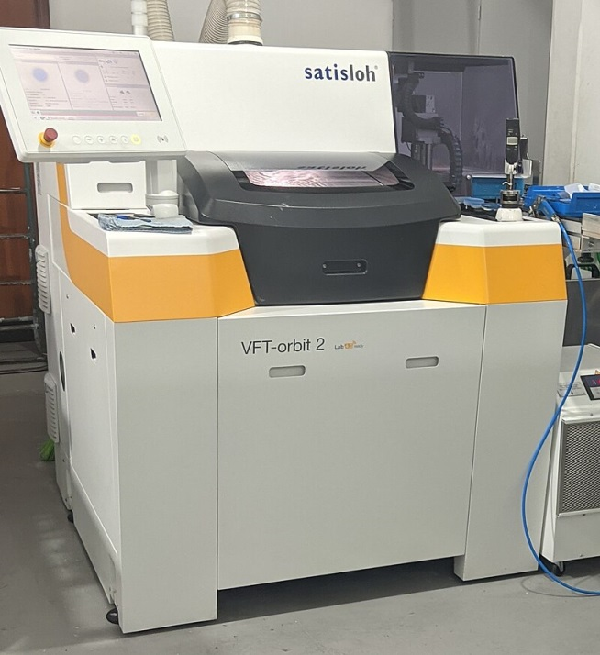
Modern ophthalmic lens making machine

Refractive Surgery
Refractive surgery began in the 1940s and has since grown to become the most common procedure we know today. In the late 1990s and his early 2000s, the introduction of excimer lasers improved refractive surgery and ushered in LASIK surgery. This process is perfected beyond the quality of vision found with spectacles or contact lenses. Biomedical engineers then introduced femtosecond lasers to further improve the procedure, making it more widely available and affordable. Due to the COVID-19 pandemic, many patients are unable to undergo surgery or other treatments, delaying regular eye care. As more places lower or lift COVID-19 restrictions, we can expect an increase in eye surgeries such as refractive surgery. Refractive surgery can help people who don't wear glasses see more clearly, but it's an elective surgery. Surgical visits declined significantly in the early stages of the pandemic, but this number is likely to increase in the future.

New IOLs
Cataract surgery is becoming an increasingly popular method of improving a patient's vision and treating other eye ailments. Multifocal IOL technology is constantly evolving and improving to provide new options to meet patient vision needs. The biggest trend seems to be towards lenses that offer improvement at mid-range but don't provide enough power for sharp vision at typical close working distances. By omitting the difficult close-up focusing of conventional multifocal IOLs, these extended-range lenses seem to avoid some of the glare and halos sometimes experienced with full-field multifocal options.

Technologies and Diagnostic Tools
In the 21st century alone, we have witnessed incredible technological advances that have made our lives more comfortable. New technologies improve the quality of service optometrists can provide, from recording to medical procedures. One of the greatest innovations of the last two decades was the completion of the Human Genome Project in 2003, ushering in a new era in ophthalmic diagnosis and treatment. This project has had a major impact on the development of diagnostic strategies and procedures, paving the way for future technologies. Electronic, computerized and automated data collection technology has made it possible to begin archiving the most complex medical and business records, simplifying filing procedures and enabling a greater focus on patients. As the optometry practice continues to grow and change, so does automation technology, which has grown and changed to become a routine part of eye care practice around the world.

Corneal Topography - Corneal topography, also called photokeratoscopy or videokeratoscopy, is a computer-assisted diagnostic and congenital imaging procedure that creates a three-dimensional map of the surface curvature of the cornea. 3D charts are very important to opticians and are a valuable aid in inspecting and diagnosing defects. It can help treat a variety of conditions, including refractive surgery such as LASIK and evaluating contact lenses for beautiful eyes. Corneal topography provides a detailed description of the shape and thickness of the cornea. Corneal topography is necessary and often recommended for certain injuries and conditions such as corneal deformities, abrasions, irregular astigmatism, and post-operative cataract extraction. This is a very painless and quick procedure that can be done in seconds.

Digital Retinal Imaging - We use the latest technology to examine your eyes and treat any eye disease that is diagnosed. Store retinal images electronically so that the optician can keep a permanent record of the condition of the retina. These records are very helpful for ophthalmologists to measure the retina at each examination and diagnose diseases that may develop later. Retinal imaging allows optometrists to create digital images of the back of the eye showing the retina, optic nerve, and blood vessels. And assess the person's health. Even with high-resolution digital images, it can be difficult to ascertain health status. Nonetheless, it is useful for investigating and tracking future changes.

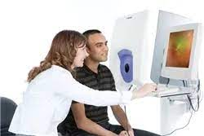

Optical Coherence Tomography - Optical coherence tomography is another natural imaging tool that produces cross-sectional images of one's own retina. Modern technology is enhancing patient care by detecting eye problems before symptoms appear. This technology uses three-dimensional images of the characteristic layers of the retina to help opticians create maps and measure thickness to detect eye defects such as macular degeneration, glaucoma and diabetic retinopathy that can lead to blindness. OCT is beneficial because it enables the rapid detection of diseases that would otherwise be slow to detect or might not be detected at all, leading to treatment failure or reduced cure success. Dr. Moore of the Centerville Eye Care Centre in Virginia confidently explains, "OCT is used to scan the retina and optic nerve at very high resolution down to digital sections as small as 5 microns (1/10,000,000 of an inch) of the eye." OCT gives doctors insight into areas of the eye that are thinner than a human hair. OCT is thus a new way of treating patients painlessly with the deepest scans.

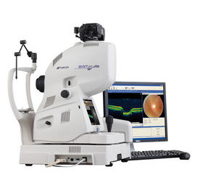

Reference

- https://eyerx.com/eye-care-then-now-optometry-advancements-over-the-last-20-years/
- https://en.wikipedia.org/wiki/Optometry
- https://en.wikipedia.org/wiki/History_of_optics
- https://modernod.com/articles/2021-sept/latest-innovations-and-future-directions-in-optometry?c4src=article:infinite-scroll
- https://www.itrust.io/what-is-the-latest-technology-in-optometry/
- https://www.slideshare.net/puneet9643/recent-advancements-in-optometry-129582254
- https://optometrycouncilofindia.org/
- https://en.wikipedia.org/wiki/History_of_optics#/media/File:Orbit_2.jpg
- https://visionsource-visionhealthinstitute.com/vision-care-products/advanced-diagnostic-testing/optical-coherence-tomography-oct/

