Connectivity concepts of an Arithmetic Graph
1.Introduction
Number theory is one of the oldest branches of mathematics which inherited rich contributions from almost all greatest mathematicians ancient and modern. The theory of congruences in Graph theory by Melvyn Bernard Nathanson in [3], paved the way for the emergence of a new class of graphs, namely Arithmetic Graphs. Inspired by the interplay between number theory and graph theory several researches in recent times are carrying out extensive studies on various arithmetic graphs in which adjacency between vertices is defined through various arithmetic functions. Vasumathi and Vangipuram defined the arithmetic graph in such a way that the adjacency between the vertices of same parity is considered in [6]. Suriyanarayana Rao and Sreenivasan.V in [5] defined the arithmetic graph by excluding the condition of adjacency between the vertices of same parity. By the fundamental theorem of arithmetic, every positive integer greater than one can be uniquely represented as a product of primes (i.e) $n={p_{1}}^{a_{1}}×{p_{2}}^{a_{2}}×……×{p_{r}}^{a_{r}}$where a_{i} ≥ 1 . Here we discuss about the positive integer $n>1$other than $n=p^{a_{i }}$where p is prime and a_{i} ≥ 1 .
2.Arithmetic graph
Definition2.1. The arithmetic graph V_{n} is defined as a graph with its vertex set is the set consists of the divisors of n (excluding 1) where n is a positive integer and $n={p_{1}}^{a_{1}}×{p_{2}}^{a_{2}}×……×{p_{r}}^{a_{r}}$ where p_{i} ′ s are distinct primes and a_{i} ′ s ≥ 1 and two distinct vertices a, b which are not of the same parity are adjacent in this graph if (a, b) = p_{i} , for some i , 1 ≤ i ≤ r. The vertices u and v are said to be of same parity if both u and v are the powers of the same prime, for instance u = p ² , v = p ³ . In this graph, vertex 1 becomes an isolated vertex. Hence, we consider arithmetic V_{n} graph without vertex 1. Therefore, each vertex of V_{n} is connected to some vertex in V_{n} . Clearly, V_{n} is a connected simple graph.
Example 2.2. Consider an arithmetic graph G = V₂₁₀ where 210 = 2 × 3 × 5 × 7. The vertex set V (G) = {2, 3, 5, 7, 2×3, 2×5, 2×7, 3×5, 3×7, 5×7, 2×3×5, 2×3×7, 2× 5×7, 3×5×7, 2×3×5×7}. Since (2, 2×3) = (2, 2×5) = (2, 2×7) = (2, 2×3×5) = (2, 2×3×7) = (2, 2×5×7) = (2, 2×3×5×7) = 2 there exist edges between the vertex 2 and the vertices such as 2×3, 2×5, 2×7, 2×3×5, 2×3×7, 2×5×7, 2×3×5×7. Also, since the (2 × 3, 2 × 3 × 7) = 2 × 3= 6≠ pi , 2 × 3 and 2 × 3 × 7 are non-adjacent vertices. Similarly for the other vertices. This can be shown in Figure 2.1
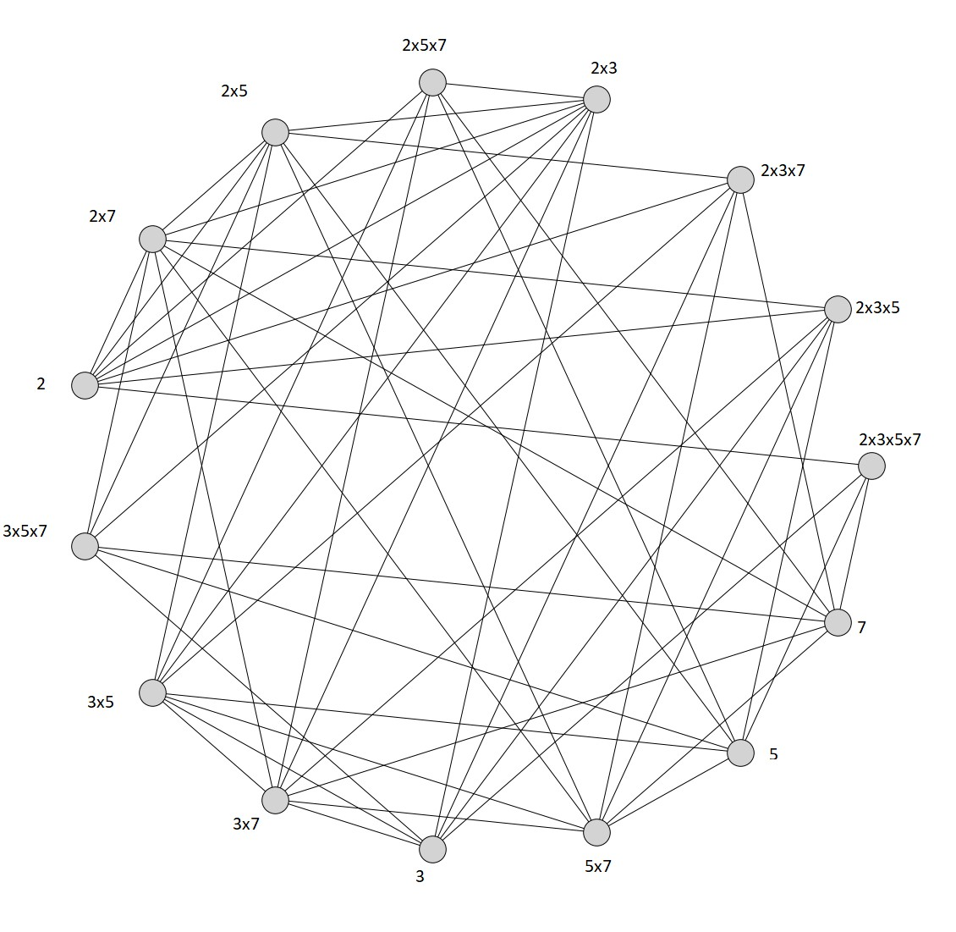
Figure 2.1: Arithmetic Graph G=V₂₁₀
Theorem 2.3.[4] If G = V_{n} is an arithmetic graph, where $n={p_{1}}^{a_{1}}×{p_{2}}^{a_{2}}×……×{p_{r}}^{a_{r}}$, a_{i} ≥ 1 for i ∈ {1, 2, . . . , r} , then the number of vertices of G can be calculated using the formula $\left|V\right|=\prod_{i=1}^{r}{\left(a_{i}+1\right)-1}$ .
Example 2.4. Consider the graph G = V₂₁₀ where 210 = 2 × 3 × 5×7 given in Figure 2.1. By Theorem 2.3 the number of vertices is |V₂₁₀| = (1 + 1)(1 + 1)(1 + 1)(1 + 1) − 1 = 15.
Theorem 2.5. Let V_{n} be an arithmetic graph with $n=\prod_{i=1}^{r}{{p_{i}}^{a_{i}}}$, for any vertex$u=\prod_{i∈B}{{p_{i}}^{∝_{i}}}$ where B ⊆ {1, 2, 3, . . . r}, 1 ≤ α_{i} ≤ a_{i} , and B ′ ⊆ B, one has deg(u) = (|B − B′ | +$\sum_{i∈B^{'}}{a_{i}}$) $\prod_{i∉B}{(a_{i}+1)}$ − δ_{1|B|} − ( $\sum_{i∈B^{'}}{a_{i}-1)}$ δ_{1B′}, where B is the number of distinct prime factors in a chosen vertex u, B′ is the number of prime factors having power 1 in chosen vertex u, empty summation equals zero and δ is the Kronecker’s delta function defined by δ_{ij} = $\left\{\begin{matrix}0 for i≠j \\ 1 for i=j\end{matrix}\right.$
Note 2.6. For an arithmetic graph the vertices are divisors of n, hence the degree of all types of vertices say primes, power of primes, product of primes, product of powers of primes can be calculated using the formulae given in Theorem 2.5.
Theorem 2.7. Let G = V_{n} be an arithmetic graph where $n={p_{1}}^{a_{1}}×{p_{2}}^{a_{2}}$ , then
∆(G) = $\left\{\begin{matrix}[a_{j}\left(a_{i}+1\right)-1]-|a_{j}-1| & for a_{j}≥a_{i}≥2 \\ a_{i}+a_{j} & for a_{i} or a_{j}=1\end{matrix}\right.$
δ(G) = $\left\{\begin{matrix}2 & for{ a}_{i} , a_{j}>1 \\ 1 & for a_{i} or a_{j}=1\end{matrix}\right.$ .
Theorem 2.8.[4] Let G = V_{n} be an arithmetic graph where $n = p_{1} × p_{2} × p_{3} × · · · × p_{r}$ , then (i) ∆(G) = 2r−1
(ii)δ(G) = $\left\{\begin{matrix}r & if r≥3 \\ 1 & if r = 2\end{matrix}\right.$
Theorem 2.9. Let G be a V_{n} arithmetic graph, where $n={p_{1}}^{a_{1}}×{p_{2}}^{a_{2}}×……×{p_{r}}^{a_{r}}$, such that at least one of i ∈ {1, 2, . . ., r} does not equal one. Then,
(i) ∆(G) = a_{j} $\prod_{i=1,i≠j}^{r}{\left(a_{i}+ 1\right)-1}$ where a_{j} is the maximum exponent of p_{i}, i ∈ {1, 2, . . ., r}
(ii)δ(G) = r.
Results 2.10.
1) It is identified that given arithmetic graph G = V_{n}, $n={p_{1}}^{a_{1}}×{p_{2}}^{a_{2}}$ ; a_{i} ≥ 1 are bipartite.
2) The size of the arithmetic graph G = V_{n}, $n={p_{1}}^{a_{1}}×{p_{2}}^{a_{2}}$ where a₁, a₂ ≥ 1 is determined using the formula $ϵ$ = 4$a_{1}a_{2}$ $-a_{1}-a_{2}$.
3)The diameter of an arithmetic graph is diam(G) ≤ 3 and its radius is radius(G) ≤ 2 .
4)Arithmetic graph G = V_{n}, is Hamiltonian, if $n={p_{1}}^{a_{1}}×{p_{2}}^{a_{2}}×……×{p_{r}}^{a_{r}}$, 3 ≤ r ≤ 6 .
5)All arithmetic graphs G = V_{n} is not a Eulerian graph.
3.Connectivity Number of an Arithmetic graph G = V_{n}
Connectedness plays an essential role in graph theory, the graph representing a communication network needs to be connected for communications to be possible between all nodes(vertices). Numerous networks such as transport networks, road networks, electrical networks, distributed computing, block chain network, telecommunication systems or networks of servers can be modelled by a graph. Many researchers are made to determine how well a network is connected or can be splitted for sake of effectiveness. Two classical measures that indicate how the graph G is reliable are the edge-connectivity κ′(G) and the vertex-connectivity or simply the connectivity κ(G) of G. The connectivity of G, written κ(G), is the minimum order of a vertex set S ⊂ V (G) such that G − S is disconnected or has only one vertex.
Definition 3.1. The connectivity or vertex connectivity κ(G) is the number of vertices of a minimal vertex cut. A graph is called k − connected or k − vertex connected if its vertex connectivity is k or greater. Any graph G is said to be k-connected if it contains at least k vertices, but does not contain a set of k −1 vertices whose removal disconnects the graph and κ(G) is defined as the largest k such that G is k − connected. Thus κ(G) = 0 if G is either trivial or disconnected. All non-trivial connected graphs are 1 − connected.
Definition 3.2. An edge cut of G is a set of edges whose removal renders the graph G disconnected. The edge-connectivity κ ′ (G) is the size of a smallest edge cut. A graph is called k − edge − connected if its edge connectivity is k or greater. All non-trivial graphs are one edge connected.
Theorem 3.3. For an arithmetic graph G = V_{n}, $n={p_{1}}^{a_{1}}×{p_{2}}^{a_{2}}$ where $p_{1 }$and $p_{2 }$ are distinct primes, then $κ(V_{n}) = κ ' (V_{n}) =\left\{\begin{matrix}1 for a_{i}=1\&a_{j}>1 \\ 2 for a_{i}>1;i=1,2\end{matrix}\right.$
Theorem 3.4. For an arithmetic graph G = V_{n}, $n={p_{1}}^{a_{1}}×{p_{2}}^{a_{2}}×……×{p_{r}}^{a_{r}}$where p_{i} , i = 1, 2, . . . , r, r > 2 are distinct primes and a_{i} = 1 for all i = 1, 2, . . . , r, κ(V_{n}) = κ ′ (V_{n}) = r
Theorem 3.5. For an arithmetic graph G = V_{n}, $n={p_{1}}^{a_{1}}×{p_{2}}^{a_{2}}×……×{p_{r}}^{a_{r}}$ where $p_{1,}p_{2},…p_{r }$are distinct primes and a_{i}′ s ≥ 1 for all i = 1, 2, 3, . . . , r and r > 2 then κ($V_{n}$) = κ ′ ($V_{n}$) = r.
Proof. We prove the theorem by considering the following four cases
Case (i) All the a_{i}’s, i = 1, 2, 3, . . . r is equal to one. By Theorem3.2., the result follows.
Case (ii) Some of the a_{i}’s are equal to one and the others are greater than 1. Consider the vertex set of V_{n} as V (V_{n}) = {p₁, p₂, . . . , p_{r}, p₁ × p₂, . . . , ${p_{1}}^{a_{1}}×{p_{2}}^{a_{2}}×……×{p_{r}}^{a_{r}}$}. Let the last vertex be ${p_{1}}^{a_{1}}×{p_{2}}^{a_{2}}×……×{p_{r}}^{a_{r}}$ say v₁, where a_{i} ’s are the maximum powers of the given distinct primes. By the definition of an arithmetic graph, we see that the only vertices which are adjacent to v₁ are p₁, p₂, . . ., p_{r}. Hence d(v₁) = r. Also, the minimum degree of V_{n} occurs at the vertex v₁. That is, δ(V_{n}) = r = d(v₁). Hence, κ(V_{n}) = κ ′ (V_{n}) ≤ δ(V_{n}) = r. But the removal of r vertices adjacent to v₁ makes the graph disconnected. Hence, we obtain the result κ(V_{n}) = r. The edge connectivity κ ′ (V_{n}) = r is same as Theorem 3.2.
Case(iii) All the a_{i} ’s are equal and greater than 1. Here also consider the last vertex of V (V_{n}), say ${p_{1}}^{a_{1}}×{p_{2}}^{a_{2}}×……×{p_{r}}^{a_{r}}$ where the a_{i}’s are the maximum power of given distinct primes. By the definition of an arithmetic graph, it is clear that p₁, p₂, . . . , p_{r} are the only vertices which are adjacent to the vertex ${p_{1}}^{a_{1}}×{p_{2}}^{a_{2}}×……×{p_{r}}^{a_{r}}$. The remaining proof is similar to case (ii).
Case (iv) All the a_{i}’s are distinct and greater than one. Consider the last vertex in the vertex set of V_{n}, say ${p_{1}}^{a_{1}}×{p_{2}}^{a_{2}}×……×{p_{r}}^{a_{r}}$where the a_{i}’s are the maximum power of the given distinct primes. By the definition of an arithmetic graph, this vertex is adjacent to exactly r vertices namely p₁, p₂, . . . , p_{r}. Suppose it is adjacent to any other vertex except p_{i} then, it contradicts the definition of an arithmetic graph. The remaining proof is similar to case (ii).
Example 3.6. Consider an arithmetic graph G = V₂₃₁₀ where 2310 = 2 × 3 × 5 × 7 × 11, given in Figure 3.1. The set S = {2, 3, 5, 7, 11} is a minimum vertex cut so the cardinality of the set S is a connectivity number κ(G) which is equal to 5. Also, the removal of the set of edges say F = {2 × 3 × 5 × 7 × 11 2, 2 × 3 × 5 × 7 × 11 3, 2 × 3 × 5 × 7 × 11 5, 2 × 3 × 5 × 7 × 11 7, 2 × 3 × 5 × 7 × 11 11} makes the graph disconnected, since F is a minimum edge cut, cardinality of F is the edge connectivity number. Thus, we have κ′(G) = 5

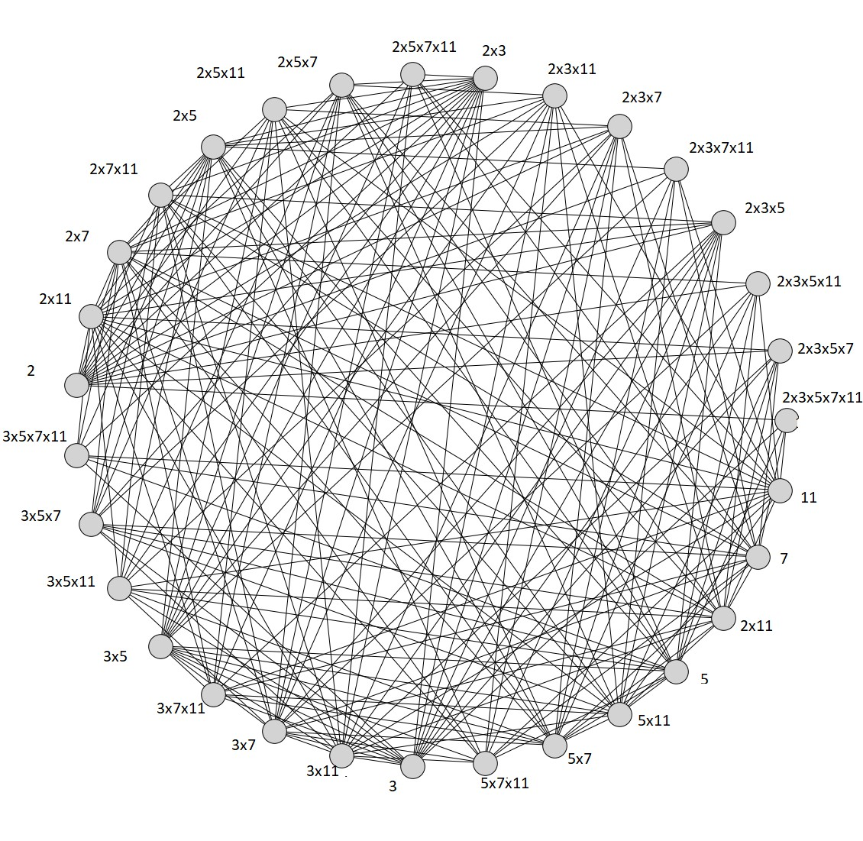
Figure 3.1: Arithmetic graph G = V₂₃₁₀
Remark 3.7. The arithmetic graph V_{n} is a maximally connected graph
4. The connectivity number of complement of an arithmetic graph
In this section, we identified the connectivity number for complement of an arithmetic graph G = V_{n}, where n is a product of two primes, product of powers of two primes, product of r primes, product of powers of r primes.
Definition 4.1 Let G be a graph, The complement $\overline{G}$ of a graph G is the graph with vertex set V ($\overline{G}$) such that two vertices are adjacent in $\overline{G}$ if and only if they are not adjacent in G
Theorem 4.2 For an arithmetic graph G = V_{n}, $n={p_{1}}^{a_{1}}×{p_{2}}^{a_{2}}$ where a_{j} > 1; $i≠j$ , κ ($\overline{G}$) = a_{j} – 1
Theorem 4.3 For an arithmetic graph G = V_{n}, $n={p_{i}}^{a_{i}}×{p_{j}}^{a_{j}}$where a_{j} ≥ a_{i} ≥ 2, κ ($\overline{G}$) = a_{i} + a_{j} – 1
Example 4.5 Consider the graph G = V₃₆, 36 = 2² × 3² given in Figure 4.1. The set S₁ = {2, 3} is a minimum vertex cut, and the Figure 4.2 shows the complement of an arithmetic graph V₃₆ and the set S₂ = {2² , 3, 3²} is the minimum vertex cut of G. Thus κ ($\overline{G}$) = 3 which satisfies the value of a_{i} + a_{j} − 1 = 2 + 2 − 1 = 3

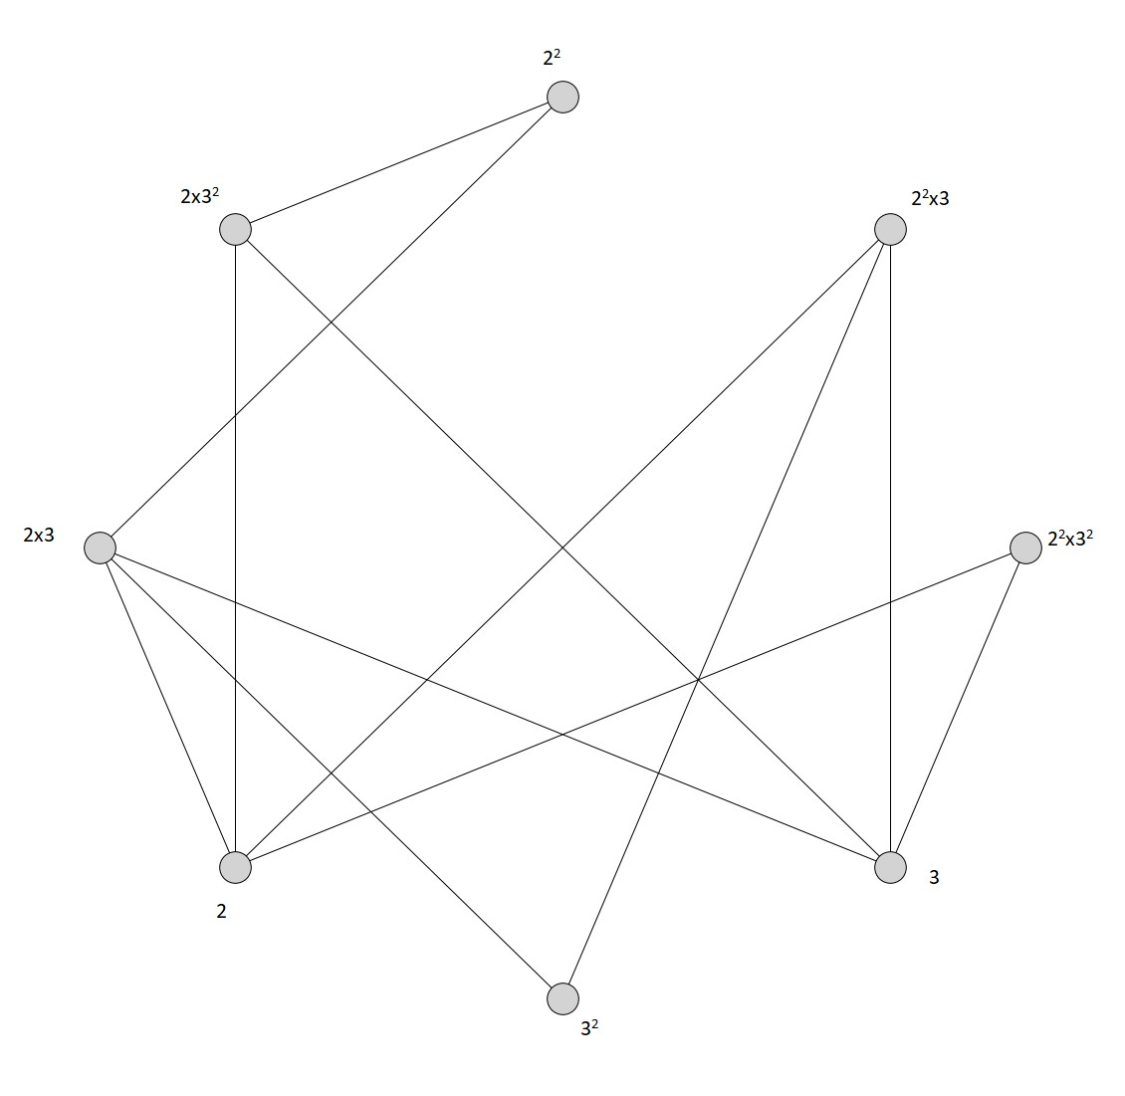
Figure 4.1: Arithmetic Graph G=V₃₆

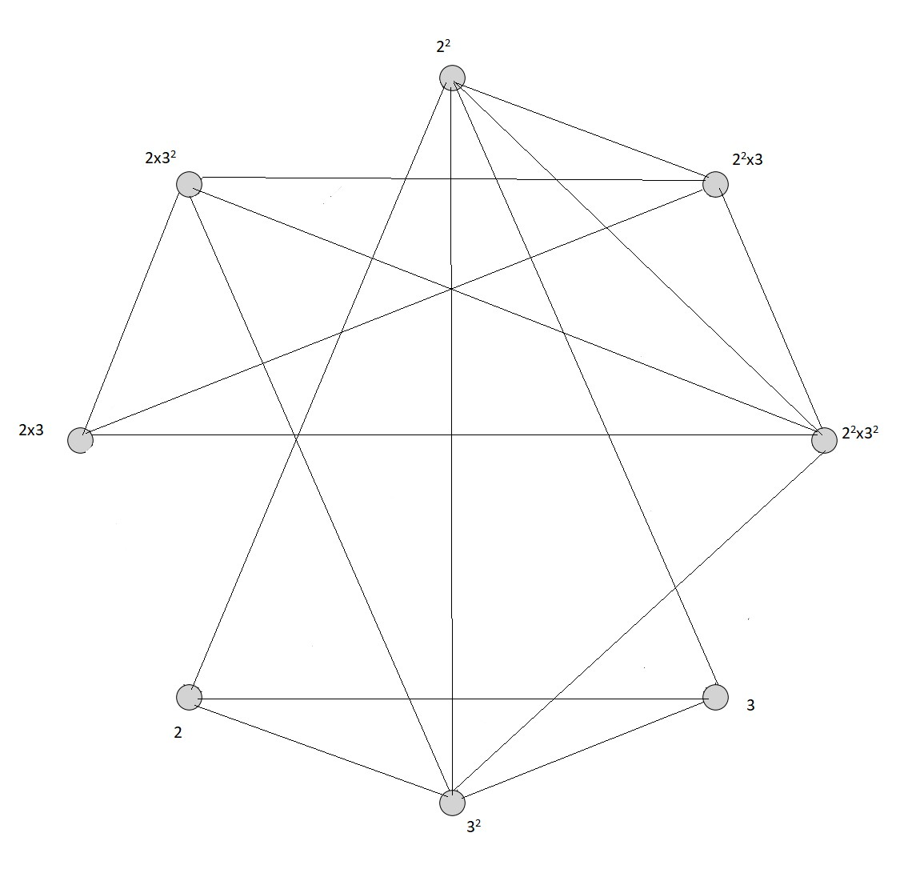
Figure 4.2: Arithmetic graph $\overline{G}$ = $\overline{V_{36}}$
Theorem 4.6 For an arithmetic graph G = V_{n}, $n = p_{1} × p_{2} × p_{3} × · · · × p_{r}$, r > 2, κ ($\overline{G}$) = (2r − 4) /2.
Proof. Let G = V_{n} be an arithmetic graph. The vertex set V (G) = V ($\overline{G}$) = {$p_{1}$, $p_{2}$, . . . , $p_{r}$, p₁×p₂, . . . , p₁×p_{r}, . . . , p_{r−1}×p_{r}, p₁×p₂×p₃, . . . , $p_{1} × p_{2} × p_{3} × · · · × p_{r}$}. By Theorem 2.2.4, the maximum degree of the graph G is ∆(G) = 2r−1 . The vertices which are of having maximum degree is p_{i} × p_{j} ;i, j ∈ {1, 2,. . . , r}, $i≠j$. Hence the number of vertices having maximum degree is rC₂. These rC₂ vertices will have minimum degree in $\overline{G}$. Thus, there are rC₂ set of minimum vertex cuts. Also, the minimum degree δ($\overline{G}$) = |V (G) − 1| − ∆ (G) = (2r − 4) /2. Thus d (p_{i} × p_{j} ) = (2r − 4) /2. So we have κ($\overline{G})$ = (2r − 4) /2.
Theorem 4.7 For an arithmetic graph G = V_{n}, $n={p_{1}}^{a_{1}}×{p_{2}}^{a_{2}}×……×{p_{r}}^{a_{r}}$ , r > 2 and at least one of a_{i} , i ∈ {1, 2, . . . , r} does not equal to one, $κ\left(\overline{G}\right)=\prod_{i=1,i≠j}^{r}{\left(a_{i}+1\right)+a_{j}-2}$ where a_{j} is the maximum exponent of p_{i} , _{i} ∈ {1, 2, . . . , r}.

References
[1] Mary Jenitha.L and Sujitha.S ,The connectivity number of an arithmetic graph, International journal of Mathemaical combinatorics, special issue 1,(2018)132-136.
[2]Mary Jenitha.L and Sujitha.S, The connectivity number of complement of an arithmetic graph G = Vn , Proceedings of the national conference on scientific approaches to multidisciplinary research, (2020),226-230.
[3] Nathanson and B.Melvyn, -Connected components of arithmetic graphs, Monat.fur.Math, 29, (1980), 219- 220 .
[4]Rangarajan. R, Akram Alqesmath, Anwar Alwardi, On Vn- Arithmetic graph, International Journal of Computer Applications (0975-8887), Volume125-No.9,(2015).
[5]Suryanarayana Rao and Sreenivasan.V, The Split Domination in Arithmetic Graphs, International journal of computer applications (0975- 8887), Volume 29-No.3, September 2011.
[6]Vasumathi. N., and Vangipuram. S., Existence of a graph with a given domination Parameter, Proceedings of the Fourth Ramanujan Symposium on Algebra and its Applications; University of Madras, Madras, 187-195 (1995) .

