Graphene nanopowder-dispersed propylene glycol-water solutions as cutting fluid in metal cutting process on CNC milling machine
¹Raviteja Surakasi, ¹Ravi Ganivada, ¹Gangadhar Manyala, ¹Haribabu Akula,
¹Department of Mechanical Engineering, Lendi Institute of Engineering and Technology, Jonnada, Vizianagaram, Andhra Pradesh, India.
Address for correspondence: Raviteja Surakasi (ravitejasurakasi@gmail.com)

ABSTRACT:
The primary goal is to study the behaviour of nanofluids containing graphene powder distributed in propylene glycol-water when they are used as cutting fluids in the metal cutting process. Nano fluids with compositions of 100:0, 75:25, and 50:50 were made from Propylene Glycol and Water. Graphene was mixed into the base fluids at concentrations of 0.25 and 0.5 percent, respectively. The work piece make of aluminium is fixed to CNC machine and metal cutting process was done where nanofluids are used as cutting fluids. Several characteristics such Arithmetic mean roughness (R_{a}), Root mean square roughness (R_{q}) and Ten Point height roughness (R_{z}) have been evaluated using Talysurf apparatus and it is found that with the increase in the depth of cut there is an increase in the value of cutting time and decrease in the values of roughness values. It can be concluded that the prepared nanofluid solutions can be used as cutting fluid in metal cutting process.
Keywords: Graphene nanopowder, cycle time, Talysurf, arithmetic mean roughness, root mean square roughness, ten point height roughness.
- INTRODUCTION:
As a 21st-century innovation, nanotechnology has the capacity to alter numerous features of a material. Nanoparticles are emerging as a promising new addition for use in cooling systems. Recent progress in nanotechnology has included the creation of nanofluids. When it comes to movement and attributes, a particle is defined as a discrete unit. However, the size of ultrafine particles is between 1 and 100 nanometers. It is possible, but not certain, that nanoparticles will exhibit size-linked characteristics that significantly vary from those of tiny particles or complete materials. Due to its potential mechanical, biochemical, and electrical applications, research on nanoparticles is now a topic of high scientific relevance.
Over the course of many decades, several fields have shown nanofluids' usefulness. They may increase the heat transmission efficiency of industrial machinery. Since nanofluids came along, scientists have focused more on making them better at transferring and conducting heat than on making them less thick. When one or even more nanoparticles are spread throughout a base fluid, the resulting mixture is called a nanofluid. According to research [1] on the physic-thermal effects of graphene nanopowder on nanofluids, both specific heat as well as thermal conductivity increase with temperature. Viscosity and density both dropped as temperature climbed.
Due to their poor thermal conductivity and extremely high viscosity [2], nanofluids are notoriously difficult to research. Thermophysical studies of base fluids were the subject of several studies over the past two decades. The experimental results imply that the base liquid's heat conductivity and viscosity may be improved by the addition of nanoparticles. The present study explains about how graphene nanopowder-dispersed propylene glycol-water solutions can be used as cutting fluid in metal cutting process.

- Materials and Methodology:

Propylene glycol, which is used in these formulations as the fundamental liquid component, was sourced from Naveen Chem. According to the International Union of Pure and Applied Chemistry (IUPAC), propylene glycol is a viscous liquid that is colourless and has a flavour that may be described as slightly pleasing. Another name for propylene glycol is propane-1,2-diol. This substance may be represented by the chemical formula CH₃CH(OH)CH₂OH. Because it has two different alcoholic functional groups, it is classified as a diol. It may be dissolved in a wide range of solvents, including water, acetone, and chloroform, among others. In their natural state, glycols do not cause irritation and have a minimal volatility [3]. Propylene glycol has several applications, such as in the creation of polymers, in the food and beverage industry, and in the medical field. The properties of propylene glycol are shown in table 1.

Properties
Chemical formula | C₃H₈O₂
Density | 1016 kg/m³
Melting point | −59 °C
Boiling point | 188.2 °C
Thermal conductivity | 0.491 Kw/h
Viscosity | 1.4 m²/s * 10⁻⁶

Table 1: Properties of Propylene Glycol
Graphene is a two-dimensional honeycomb crystal lattice of atoms. Graphite's numerous double bonds inspired the "-ene" suffix. Every atom in a graphene sheet adds an electron to a valence band which spans the sheet, and every atom has a strong link with its three neighbours. PAHs, fullerenes, carbon nanotubes, and even glassy carbon show this connection [4]. Since the conduction and valence bands are connected, graphene, a semimetal with exceptional electrical properties, may be characterised using massless relativistic particle theories. These ideas explain graphene. Graphene field-effect transistors may conduct bipolarly because charge carriers' energy depends linearly on momentum. The material has massive quantum oscillations, nonlinear diamagnetism, and ballistic charge transfer over long distances. Graphene conducts heat and electricity well [5]. Graphite absorbs visible light, making it black, yet a single sheet of graphene is practically transparent. This combination is 100 times stronger than the hardest steel. Graphene's tensile strength, electrical conductivity, opacity, and status as the world's strongest material have made it a lucrative nanomaterial [6]. Graphene is the strongest and thinnest two-dimensional material. In 2012, the semiconductor, electronics, electric battery, and composites industries' research and development sectors drove graphene's $9 million worldwide market. Graphene nano powder was procured from Ultrananotech Pvt.Ltd. Table 2 gives the description of Graphene and Table 3 shows the properties of Water.

TestItem | TestResult
Purity | >99%
Thickness | 5-10nm
Length | 5-10 micron
Density | 3.1 g/cm3
Number of Layer | Average No. of Layer 4-8
Surface Area | - /g
Table 2: Description of Graphene

Density | 992.25
Specific heat | 0.9980
Thermal conductivity | 0.540
Viscosity | 0.658
Table 3: Properties of Water
  - Preparation of base fluids and nano fluids:

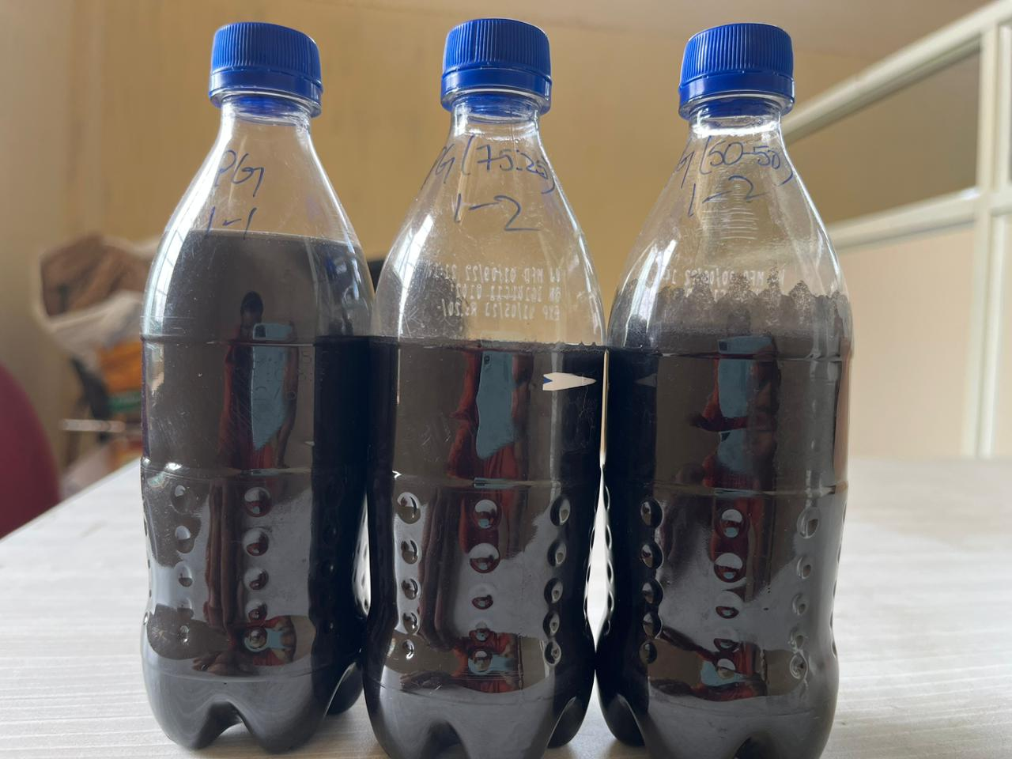
Fig. 1.Propylene Glycol-Water samples.

Propylene glycol-water samples of three kinds (50:50), (75:25), and (100:0) are prepared in this experimentation [7]. The graphene nanoparticles are dispersed in the designed solutions with the help of an ultrasonic probe sonicator at 0.25 and 0.5 wt%. Fig. 1 shows the prepared nanofluid samples [8].

3. EXPERIMENTAL SETUP AND PROCEDURE:
3.1. CNC Milling machine:
A CNC milling machine is a versatile and precise tool used in modern manufacturing industries to create complex and precise parts and components. Unlike traditional milling machines, which require manual operation and adjustment, CNC milling machines are controlled by computer programs that allow for highly accurate and repeatable machining operations [9]. Here are some features and components of a typical CNC milling machine:
Bed: The bed is the base of the machine that supports all other components. It is usually made of cast iron or steel and is designed to be rigid and stable to ensure accuracy during machining.
Spindle: The spindle is the rotating component of the machine that holds the cutting tool. It is typically driven by an electric motor and can rotate at high speeds, allowing for precise and efficient machining.
Cutting tool: A cutting tool is a rotating tool that is used to remove material from the workpiece. It is usually made of high-speed steel or carbide, and is selected based on the specific material being machined and the desired surface finish.
Tool holder: The tool holder is the component that holds the cutting tool and attaches it to the spindle. It is designed to be easy to replace, allowing for quick tool changes and increased productivity.
Worktable: The worktable is the component that supports the workpiece during machining. It is typically adjustable in height, angle, and position, and may be equipped with various clamps and fixtures to hold the workpiece securely in place.
Control panel: The control panel is the interface between the operator and the machine. It typically consists of a computer screen, keyboard, and other input devices, and allows the operator to program and control the machine's movements and operations.
CNC controller: The CNC (Computer Numerical Control) controller is the brain of the machine. It reads the operator's instructions and converts them into electrical signals that control the machine's movements and operations.
Axis system: The axis system is a set of linear or rotary motion components that control the machine's movements along different directions. The most common axis system is a three-axis system, consisting of the X-axis (horizontal), Y-axis (vertical), and Z-axis (depth).
Coolant system: The coolant system is a component that cools and lubricates the cutting tool and workpiece during machining. It helps to prevent overheating and prolong the life of the cutting tool, and may also help to remove chips and debris from the work area. Figure 2 shows the CNC milling machine.
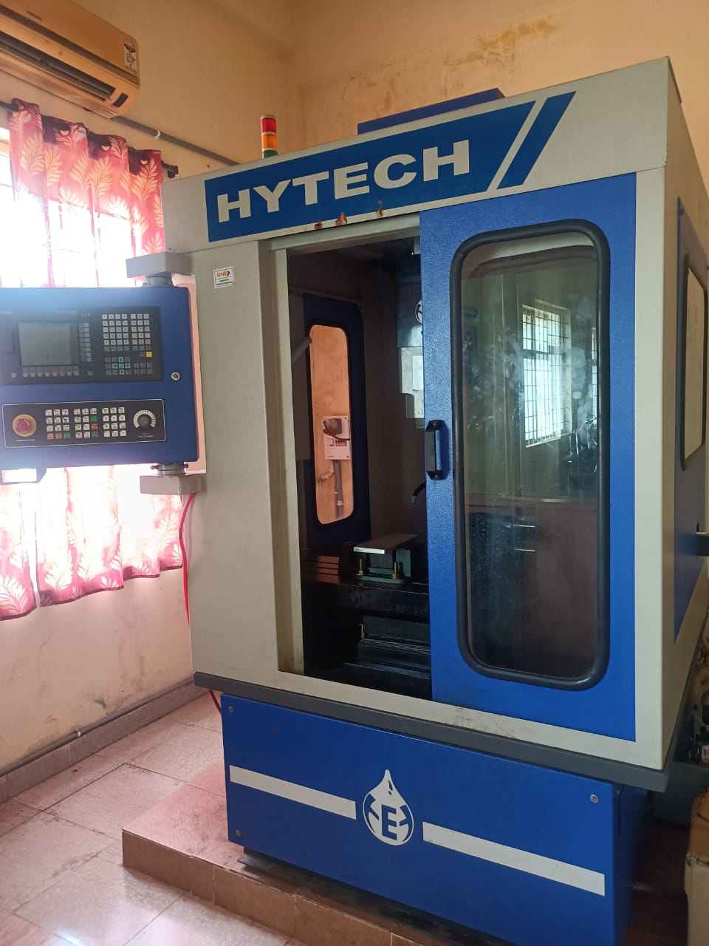
Fig.2. CNC Milling Machine
3.1.1. Cutting tools Used:
- Flat-end mill cutter:
A flat-end mill cutter is a tool used in milling machines to shape and cut various materials. It has a cylindrical body with a flat cutting edge at the end, which is often made of carbide. This cutting edge is used to create flat surfaces, slots, keyways, and other shapes in a workpiece. Flat-end mill cutters come in different sizes and can be used for both horizontal and vertical milling operations [10].
The flat-end mill cutter is an important tool for producing smooth finishes on workpieces, especially if the cutter is sharp and well-maintained. However, it has limited versatility in creating complex shapes due to its single-plane cutting edge. In such cases, other types of milling cutters with specialized cutting edges may be more appropriate [11]. Overall, the flat-end mill cutter is a versatile and useful tool for a range of milling applications. Fig 3 shows the flat end mill cutter.
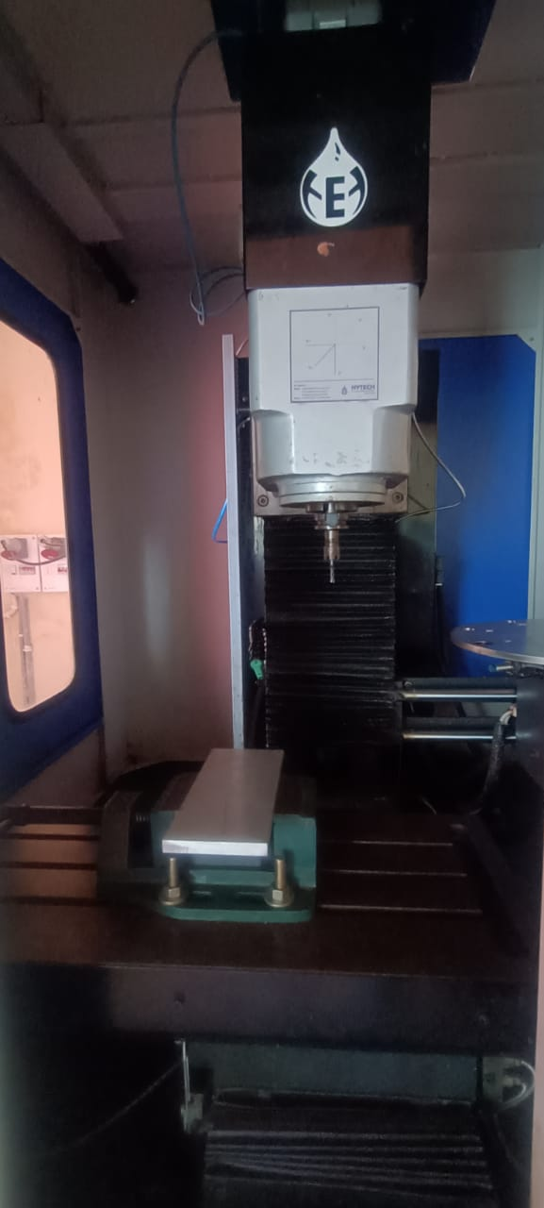
Fig 3: Flat end mill cutter
3.1.2. Machinespecifications:
  - Model – SPM 250
  - Controller- Siemens 808D
  - Axis movement:
    - x- 300 mm
    - y-250 mm
    - z-250 mm
  - Axis motor and drive- SIEMENS V90
SERVO MOTOR WITH SERVO DRIVE
  - Distance between table top and spindle nose – 70-370mm
  - Distance between spindle to column- 270mm
  - Feed rate – 0- 5000 mm/min
  - Rapid travel – 5000mm/min
  - Table size – 700 ×300mm
  - Load on Table – 120 Kg
  - Spindle motor capacity – 3HP
  - Motor type- AC motor with VFD
  - Spindle rpm- 100 to 3000 rpm
  - type of magazine -Disc type
  - Capacity of magzine - 8 tools
3.2. Talysurf Experimentation setup:
Specimen: The specimen is the surface that will be measured for roughness using the Talysurf apparatus. We have taken Aluminum specimens of 100mm×100mm which should be prepared by cleaning and removing any debris or contaminants.
Instrument: The Talysurf surface roughness apparatus is the main instrument used to measure the roughness of the specimen. It typically consists of a stylus that moves across the surface of the specimen, tracing its contours and recording roughness values. The instrument is calibrated before the experiment to ensure accurate readings. Fig 4 shows the Talysurf set up

Fig 4. Talysurf setup
3.3. EXPERIMENTAL PROCEDURE:
3.3.1. Experimental Procedure on CNC Milling:
- Select the appropriate cutting tool: Choose a cutting tool that is suitable for the material being machined and the size and shape of the slot to be cut [12]. The tool should be securely mounted in the spindle.
- Position the workpiece: Mount the workpiece securely on the worktable and position it so that the slot is aligned with the cutting tool.
- Set the cutting parameters: Set the machine's cutting parameters, such as the spindle speed, feed rate, and depth of cut. These parameters will depend on the material being machined and the size and shape of the slot [13].
- Enter the Program: Create a program using G and M codes in edit mode, that instructs the machine to cut the slot. This program will include the cutting path, cutting parameters, and any other instructions necessary to complete the operation [14].
- Start the machine: Put auto mode and control the rapid rate and feed rate with 100% and press the cycle start button once [15]. Now the machine will run. The cutting tool will move along the designated path, removing material from the workpiece to create the slot.
- Monitor the process: Keep an eye on the machining process to ensure that everything is running smoothly [16]. Check the workpiece periodically to ensure that the slot is being cut to the correct dimensions.
- Finish the slot: Once the slot has been cut to the desired depth and width, stop the machine and remove the workpiece [17]. If necessary, use pressurized air to remove the chips.
- Clean up: Clean up the work area and return the machine and cutting tool to their proper storage locations [18]. Fig 5 shows the work piece which is machined using CNC milling machine
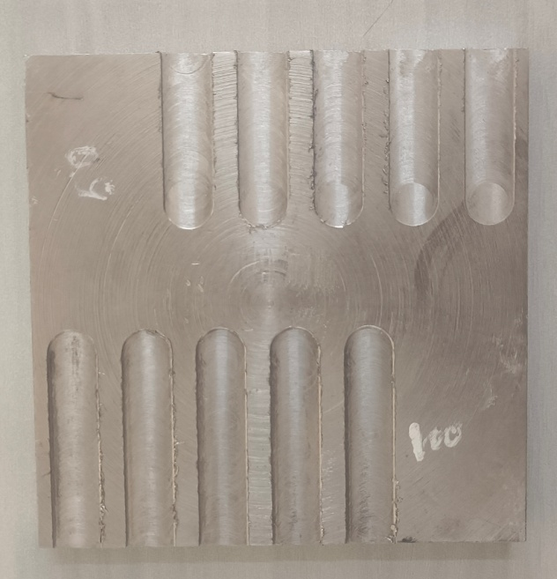
Fig 5 : Machined work piece
3.3.1.1. PROGRAM:
O123;
N1 G75 Z0;
N2 T5 D1 M6;
N3 M03 S250;
N4 G54 G90 G17 G00 X8 Y-10;
N5 G00 Z3;
N6 G01 Z-0.2 F200;
N7 G01 X25 Y-10;
N8G01 Z0.5;
N9 G00 Z50;
N10 G75 Z0;
N11 G75 Y0;
N12 M30;
3.3.2. Experimental Procedure on Talysurf apparatus:

- Thepowersupplytothetallysurfmeasuringinstrumentisgivenanditischeckedwiththereferencesampleforcurrentroughness
- Theinstrumentisboundonthespecimenproperlyandthenthemeasurementisstoredbypressing the start/stopbutton.NotedownRa, R_{q}&Rzvaluesusing the parameter button.
- Repeattheexperimenton the specimenby changingthedistribution.
- Repeat the processfortheremainingspecimenandtabulatethereadings.

4. Results:
4.1. Arithmetic Mean Roughness (R_{a}):
Fig.6(a) graph drawn between depth of cut and Arithmetic Mean Roughness (Ra). The arithmetic mean roughness (R_{a}) decreases with increase of depth of cut. The minimum value is 0.418 µm for PG+ 0.5 % Grapheneat 0.5 mm depth of cut. Fig.6(b) graph drawn between depth of cut and Arithmetic Mean Roughness (Ra). The arithmetic mean roughness (R_{a}) decreases with increase of depth of cut [19]. The minimum value is 0.644 µm for PG+WATER (50:50) + 0.5 % Grapheneat 0.5 mm depth of cut. Fig.6(c) graph drawn between depth of cut and Arithmetic Mean Roughness (Ra). The arithmetic mean roughness (R_{a}) decreases with increase of depth of cut. The minimum value is 0.53 µm for PG+ WATER (75:25) + 0.5 % Graphene at 0.5 mm depth of cut [20]. While comparing arithmetic mean roughness for above samples, the minimum arithmetic mean roughness is 0.53 µm for PG+ WATER (75:25) + 0.5 % Graphene at 0.5 mm depth of cut.

(a) (b)

(c)
Fig.6 (a) graph drawn between the Arithmetic Mean Roughness (R_{a}) and the depth of cut for PG (100%). Fig.6 (b) graph drawn between the Arithmetic Mean Roughness (R_{a}) and the depth of cut for PG + Water (50:50). Fig.6(c) graph drawn between the Arithmetic Mean Roughness (R_{a}) and the depth of cut for PG + Water (75:25).

  - Root Mean Square Roughness (R_{q}):
Fig.7(a) graph drawn between depth of cut and Root Mean Square Roughness (R_{q}). The Root Mean Square Roughness (R_{q}) decreases with increase of depth of cut. The minimum value is 0.557 µm for PG at 0.5 mm depth of cut [21]. Fig.7(b) graph drawn between depth of cut and Root Mean Square Roughness (R_{q}). The Root Mean Square Roughness (R_{q}) decreases with increase of depth of cut. The minimum value is 0.716 µm for PG+WATER (50:50) + 0.5 % Graphene at 0.5 mm depth of cut. Fig.7(c) graph drawn between depth of cut and Root Mean Square Roughness (R_{q}). The Root Mean Square Roughness (R_{q}) decreases with increase of depth of cut [22]. The minimum value of is 0.64 µm for PG+ WATER (75:25) + 0.5 % Graphene at 0.5 mm depth of cut. While comparing root Mean Square Roughness for above samples, the minimum arithmetic mean roughness is 0.557 µm for PG (100%) at 0.5 mm depth of cut.

Rz

(a) (b)

(c)
Fig.7 (a) graph drawn between the Root Mean Square Roughness (R_{q}) and the depth of cut for PG (100%). Fig.7 (b) graph drawn between the Root Mean Square Roughness (R_{q}) and the depth of cut for PG + Water (50:50). Fig.7(c) graph drawn between the Root Mean Square Roughness (R_{q})and the depth of cut for PG + Water (75:25).
  - Ten Point Height Roughness (R_{z}):
Fig.8(a) graph drawn between depth of cut and Ten Point Height Roughness (R_{z}). The Ten Point Height Roughness (R_{z}) decreases with increase of depth of cut [23]. The minimum value is 3.752 µm for PG+ 0.5 % Graphene at 0.5 mm depth of cut. Fig.8(b) graph drawn between depth of cut and Ten Point Height Roughness (R_{z}). The Ten Point Height Roughness (R_{z}) decreases with increase of depth of cut [24]. The minimum value is 2.279 µm for PG+WATER (50:50) + 0.25 % Graphene at 0.5 mm depth of cut. Fig.8(c) graph drawn between depth of cut and Arithmetic Mean Roughness (Ra). The arithmetic mean roughness (R_{a}) decreases with increase of depth of cut.

(a) (b)

(c)
Fig.8(a) graph drawn between the Ten Point Height Roughness (R_{z}) and the depth of cut for PG (100%). Fig.8(b) graph drawn between the Ten Point Height Roughness (R_{z}) and the depth of cut for PG + Water (50:50) . Fig.8(c) graph drawn between the Ten Point Height Roughness (R_{z}) and the depth of cut for PG + Water (75:25).
The minimum value is 2.99 µm for PG+ WATER (75:25) at 0.5 mm depth of cut [25]. While comparing ten point height roughnessfor above samples, the minimum arithmetic mean roughness is 2.279 µm for PG+ WATER (50:50)+0.25% graphene at 0.5 mm depth of cut.
- CONCLUSIONS:
- The essential fluids were propylene glycol and water, which were mixed in the following proportions: 100:0, 75:25, and 50:50 to form nanofluids.
- Both base fluids had 0.25 or 0.5 graphenes added.
- The prepared nanofluids were used as coolant in a CNC milling machine and the surface roughness values have been measured using Talysurf apparatus.
- While comparing arithmetic mean roughness for the prepared samples, the minimum arithmetic mean roughness is 0.53 µm for PG+ WATER (75:25) + 0.5 % Graphene at 0.5 mm depth of cut.
- While comparing root Mean Square Roughness for the prepared samples, the minimum arithmetic mean roughness is 0.557 µm for PG (100%) at 0.5 mm depth of cut.
- While comparing ten point height roughnessfor the prepared samples, the minimum arithmetic mean roughness is 2.279 µm for PG+ WATER (50:50)+0.25% graphene at 0.5 mm depth of cut.
- Future Scope:
Different nanofluids can be prepared and can be used as coolant on CNC milling machine, CNC late machine and also CNC drilling machine. Further along with surface roughness the cutting forces can also be measured.
Data Availability:
The article contains all of the data needed to prove the study's claims.
Conflicts of Interest:
All authors have stated that they have no competing interests related to this research.
- REFERENCES:
- Baby, T.T., Ramaprabhu, S. Enhanced convective heat transfer using graphene dispersed nanofluids. Nanoscale Res Lett 6, 289 (2011).https://doi.org/10.1186/1556-276X-6-289
- Murshed, S. M. S., K. C. Leong, and C. Yang. "Thermophysical and electrokinetic properties of nanofluids–a critical review." Applied thermal engineering 28.17-18 (2008): 2109-2125.
- Leena, М., Srinivasan, S. Experimental Investigation of the Thermophysical Properties of TiO₂/Propylene Glycol–Water Nanofluids for Heat-Transfer Applications. J Eng Phys Thermophy 91, 498–506 (2018).https://doi.org/10.1007/s10891-018-1770-7
- RavitejaSurakasi, K. Ch. Sekhar, EkremYanmaz, G. Yuvaraj, Jayaprakash Venugopal, S. Srujana, Naziya Begum, "Evaluation of Physicothermal Properties of Silicone Oil Dispersed with Multiwalled Carbon Nanotubes and Data Prediction Using ANN", Journal of Nanomaterials, vol. 2021, Article ID 3444512, 11 pages, 2021. https://doi.org/10.1155/2021/3444512
- Surakasi, R., Sekhar, K.C., Kavitha, E. et al. Evaluation of physico-thermal properties of TiO₂–water mixture dispersed with MWCNTs. Nanotechnol. Environ. Eng. 7, 325–331 (2022).https://doi.org/10.1007/s41204-022-00242-4
- RavitejaSurakasi, SrujanaSripathi, Sarada Purnima Nadimpalli, Sibtain Afzal, Bharat Singh, Manoj Tripathi, Rahel Alemu Hafa, "Synthesis and Characterization of TiO₂-Water Nanofluids", Adsorption Science & Technology, vol. 2022, Article ID 3286624, 9 pages, 2022. https://doi.org/10.1155/2022/3286624
- K. Ch. Sekhar, RavitejaSurakasi, ilhanGarip, S. Srujana, V. V. Prasanna Kumar, Naziya Begum, "Evaluation of Physicothermal Properties of Solar Thermic Fluids Dispersed with Multiwalled Carbon Nanotubes and Prediction of Data Using Artificial Neural Networks", Journal of Nanomaterials, vol. 2021, Article ID 7306189, 13 pages, 2021. https://doi.org/10.1155/2021/7306189
- Haribabu, A., Surakasi, R., Thimothy, P. et al. Study comparing the tribological behavior of propylene glycol and water dispersed with graphene nanopowder. Sci Rep 13, 2382 (2023). https://doi.org/10.1038/s41598-023-29349-7
- Sudhansu, R.D.; Asutosh, P.; Debabrata, D. Hard turning of AISI 4340 steel using coated carbide insert: Surface roughness, tool wear, chip morphology and cost estimation. Mater. Today Proc. 2018, 5 Pt 2, 6560–6569.
- Vipindas, K.; Jose, M. Wear behavior of TiAlN coated WC tool during micro end milling of Ti-6Al-4V and analysis of surface roughness. Wear 2019, 424–425, 165–182.
- Gyanendra, S.G.; Prabir, S. Dry machining: A step towards sustainable machining-Challenges and future directions. J. Clean. Prod. 2017, 165, 1557–1571.
- Krolczyk, G.M.; Maruda, R.W.; Krolczyk, J.B.; Wojciechowski, S.; Mia, M.; Nieslony, P.; Budzik, G. Ecological trends in machining as a key factor in sustainable production—A review. J. Clean. Prod. 2019, 218, 601–615.
- Oyinbo, S.T.; Ikumapayi, O.M.; Jen, T.C.; Ismail, S.O. Experimental and Numerical prediction of extrusion load at different lubricating conditions of aluminium 6063 alloy in backward cup extrusion. Eng. Solid Mech. 2020, 8, 119–130.
- Pay, J.L.; Ainusyafiqah, S.; Nor, A.C.S.; Jiwang, Y. An overview of current status of cutting fluids and cooling techniques of turning hard steel. Int. J. Heat Mass Transf. 2017, 114, 380–394.
- Margheritini, L.; Colaleo, G.; Contestabile, P.; Bjørgård, T.L.; Simonsen, M.E.; Lanfredi, C.; Dell’Anno, A.; Vicinanza, D. Development of an Eco-Sustainable Solution for the Second Life of Decommissioned Oil and Gas Platforms: The Mineral Accretion Technology. Sustainability 2020, 12, 3742.
- Qingan, Y.; Changhe, L.; Lan, D.; Xiufang, B.; Yanbin, Z.; Min, Y.; Dongzhou, J.; Yali, H.; Yonghong, L.; Runze, L. Effects of the physicochemical properties of different nanoparticles on lubrication performance and experimental evaluation in the NMQL milling of Ti–6Al–4V. Int. J. Adv. Manuf. Technol. 2018, 99, 3091–3109.
- Kumar, M.S.; Krishna, V.M. An Investigation on Turning AISI 1018 Steel with Hybrid Biodegradeable Nanofluid/MQL Incorporated with Combinations of CuO-Al2O3 Nanoparticles. Mater. Today Proc. 2020, 24, 1577–1584.
- Kıvak, T.; Sarıkaya, M.; Yıldırım, Ç.V.; Şirin, Ş. Study on turning performance of PVD TiN coated Al2O3+ TiCN ceramic tool under cutting fluid reinforced by nano-sized solid particles. J. Manuf. Processes 2020, 56, 522–539.
- Kumar, M.S.; Krishna, V.M.; Varun, A. Investigation on influence of Hybrid Biodegradable Nanofluids (CuO-ZnO) on Surface Roughness in Turning AISI 1018 Steel. Mater. Today Proc. 2020, 24, 1570–1576.
- Majak, D.; Olugu, E.U.; Lawal, S.A. Analysis of the effect of sustainable lubricants in the turning of AISI 304 stainless steel. Procedia Manuf. 2020, 43, 495–502. Gong, L.; Bertolini, R.; Ghiotti, A.; He, N.; Bruschi, S. Sustainable turning of Inconel 718 nickel alloy using MQL strategy based on graphene nanofluids. Int. J. Adv. Manuf. Technol. 2020, 108, 3159–3174.
- Ikumapayi, O.M.; Oyinbo, S.T.; Bodunde, O.P.; Afolalu, S.A.; Okokpujie, I.P.; Akinlabi, E.T. The effects of lubricants on temperature distribution of 6063 aluminium alloy during backward cup extrusion process. J Mater Res Technol. 2019, 8, 1175–1187.
- Ghatge, D.A.; Ramanujam, R.; Reddy, B.S.; Vignesh, M. Improvement of machinability using eco-friendly cutting oil in turning duplex stainless steel. Mater. Today Proc. 2018, 5, 12303–12310.
- Dennison, M.S.; Meji, M.A.; Nelson, A.J.R.; Balakumar, S.; Prasath, K. A comparative study on the surface finish achieved during face milling of AISI 1045 steel components using eco-friendly cutting fluids in near dry condition. Int. J. Mach. Mach. Mater. 2019, 21, 337–356.
- Singh, H.; Sharma, V.S.; Dogra, M. Exploration of graphene assisted vegetables oil based minimum quantity lubrication for surface grinding of TI-6AL-4V-ELI. Tribol. Int. 2020, 144, 106113.
- Ibrahim, A.M.M.; Li, W.; Xiao, H.; Zeng, Z.; Ren, Y.; Alsoufi, M.S. Energy conservation and environmental sustainability during grinding operation of Ti–6Al–4V alloys via eco-friendly oil/graphene nano additive and MQL lubrication. Tribol. Int. 2020, 150, 106387.

