An Overview of waste materials used as Soil Stabilizers for Sustainable Development
Chatrabhuj^{1*}, Kundan Meshram²
¹Research Scholar, Department of Civil Engineering, Guru Ghasidas Vishwavidyalaya, Bilaspur-495009, Chhattisgarh-, India
²Assistant Professor, Department of Civil Engineering, Guru Ghasidas Vishwavidyalaya, Bilaspur-495009, Chhattisgarh, India
*Corresponding author, email: chatrabhuj513@gmail.com

Abstract- Soil is the base of any construction, so for any construction activity engineers cannot construct their structure on soil of less strength. It becomes very important to stabilize soil so that it can bear the load of the structure and keep the structure safe and sound. There are various waste materials, and rather than disposing of them, they can be used to improve soil strength like CBR, Tri axial, and UCS. This study investigates and analyze, upon mixing that material what are the change in the properties of soil. Various waste materials like Processed E-waste, Fly ash, Plastic Strips, Stone dust, Slag, Rise Husk, Bottom ash, Bagasse Ash, Coir fiber, Waste Tyre chips, Waste Glass, Sewage Sludge, Foundry Sand, Ash. These materials are readily available and easy to handle. These materials could be used as an alternative to various stabilizers. It can be used in multiple fields like soil stabilization, concrete production, brick manufacturing, improving soil quality, and manufacturing of cement. On comparing it was concluded that these materials are economically, efficient and eco-friendly compared to traditional methods.
Keywords- Stabilization, Sustainability, Waste utilization, Environment

- Introduction

United Nations has given various aspects of Sustainability which mainly focuses on the Economy, Environment, and Society. To measure sustainability there are some Targets and Indicators. In our environment, due to human activity, there is a continuous generation of waste material in the name of development. Development is good but not at the cost of the degradation of resources and humans. So, there is a need for sustainable growth. As far as waste generation is concerned, waste materials are somehow useful in one or another field of application. There is a need for more research on the utilization of waste to a large extent. There are many waste materials applied in construction activities and their performance is measured with respect to traditional materials used.
Due to the increasing standards of living, people rapidly generate waste products in humungous amounts. This rapid generation of waste attracts researchers from all over the world to the various methods for utilization of the different wastes such as bagasse ash, bagasse fibres, fly ash, bottom ash coir fiber, rice husk ash, bamboo fiber, E-waste, rubber tyres chips, plastics waste, etc, generated from industries such as sugarcane, agricultural, thermal power plants, electronics etc.

For the sustainable development of the world, these wastes should be handled in a scientific manner so that they do not cause problems for nature and human beings. This is the main challenge for our society, due to rapid population growth natural resources are being used blindly. This imposes the problem of deficient natural resources for the need of the construction industry. This causes the researchers to pay attention to the use of alternate sources, which are not harmful to environmental sustainability. These wastes are used as a replacement in Highway construction, Railways, Skyscrapers, landfills, etc. In highway construction, these wastes are used as a soil replacement in some amount so that it reduces the cost of construction and it also diminishes environmental degradation. This also enhances the desirable properties such as CBR, Shear Strength, and Bearing capacity of the parent soil. The use of these wastes also reduces affinity towards the moisture content of the soil which results in less volumetric changes.

The waste generated from different sources and their sustainability encourages multi-disciplinary research and development and formulation relating to various technological developments and the challenges related to sustainability. Investigations were conducted on various fields such as civil engineering, environmental engineering, environmental science, Sustainable development, etc. It is to be noted here that the value of various waste used as a replacement for the parent material leads to the preservation of environment and natural resources, decreasing the accumulation of waste, diminishing air water, and soil pollution along with promoting environmental and socio-economic sustainability aspects.

As people are interested in the effects of climate change and the degradation of the environment consciously, many researchers put their interest towards the utilization of these wastes in various development projects and there are still many more waste materials remains that need proper attention.

Waste generated from different sources is accumulated at such a large amount in the current developing world. These wastes are generated from various industries such as sugarcane, thermal power plant, plastic, electronics and agricultural industry. Firstly, the discarded material from various industries is gathered at specified locations. After sorting the various metals and non-metals from the discarded materials the non-metals part is utilised in various soil as a stabilizers. Disposal of these discarded waste materials is not easy with the old method of dumping in low-lying areas on the outskirts of the city. Different scientific methods should be adopted such as scientifically designed landfill with different covers on top layers after dumping. Disposal of medical waste is not easy as it may contain hazardous ingredients in it. If medical waste generated is dumped without scientific approaches it becomes very hazardous for the local environment. So, for sustainable development growth, scientifically describe approaches such as one adopted in Madhya Pradesh capital Bhopal City Municipal Solid Waste Management techniques can be adopted. Various waste materials which are used in this study E-waste Bottom Ash, Fly ash, Plastic Strips, Stone Dust, Slag, Rice Husk/coffee husk, Bagasse Ash, Coir Fibres, Waste tyre chips, Waste Glass, Sewage Sludge, Foundry sand etc. These wastes are used in different types of soil in various proportions for soil stabilizers. The characteristics of different discarded materials as waste resembles in such a way that it can be used as a soil stabilizer in different types of soil such as clay, silt and sand. Studying the various materials properties identified such as tensile strength, compressive strength, flexural strength, shear strength, and bearing capacity is being used to enhance the desirable properties of soil. Clayey Soil shows variation in moisture content as swelling and shrinkage. This causes many problems for the structures built on these types of soils. With the blending of these wastes in the soil these problems reduce to a great extent. Different experiments should be performed on soil in order to determine the various properties such as Atterberg limits, specific gravity, permeability, compaction characteristics, shear strength parameters, CBR value etc.

2. Literature Review
For this study, various research results were considered. Many experimental works were analysed and conclusions were drawn out from them. (Venkatesan and Vasudevan, 2022) analysed when cement is replaced with bagasse ash in different ratios as 10 to 20 % of bagasse ash with the blending of 1& 2 % of bagasse fibre engineering properties are improved and also analysed application in agricultural waste utilization. (Kabari1 et al., 2018) defined stabilization of black cotton lateritic soils, fibre ash, and cement in combined actions, in Niger. Concluded that the swelling potential of treated soil decreased with the inclusion of fibre ash up to 7.5% + 7.5% for both soils. (Nnaji et al., 2020) in the country of Niger, black soil, lime, and bagasse fibre were used to stabilize clayey soils. This concluded that CBR increased with increase in additives inclusion with optimum mix of 0.75% + 7.5%. Cracks noticed occurred beyond the optimum level mix. (Naresh et al.,2022) This research emphasizes on improving the properties of laterite soil by blending coconut coir’s fibres at different ratios viz., 0.25%, 0.5%, 0.75%, and 1%, which are obtained from coconuts serving as natural fibre for improving the strength properties of soil. It was found that at 0% blending of coconut coir fibre maximum liquid and plastic limits were determined and with every enhancement in the coir content the desirable properties such as plasticity index, unconfined compressive strength and California Bearing Ratio strengths were enhanced. (Pachauri et al.,2016) Improvement in ground with the blending of fibre-reinforced soil has been utilized in recently. However, with increasing concerns for sustainable development, researchers are encouraged to determine alternative forms of reinforcement than the main material which is in use. The fibre ratio blended with the soil at 0.5%, 0.75% and 1% of the dry weight of the soil. Many tests of unconfined compressive strength (UCS) were performed to obtain the strength characteristics of the soil. The reinforcement results in an enhancement in the strength of the soil-coir fibre composite. Researchers (Kannan and Kumar, 2017) worked on bottom ash and studied for its suitability as the replacement for fine aggregate up to (0% to 50%). So far only a few researchers determined its suitability as FA by determining the compressive strength of concrete. Along with compressive strength, the split tensile strength of concrete and flexural strength of concrete was identified by replacing bottom ash with fine aggregate. The main aim of (Meh et al., 2022) is to identify the alternate solutions to the environmental causes due to large amounts of coal bottom ash (CBA) industrial waste. The CBA utilized in this experiment was classified as Class C according to its total mixture of about 55.53%. It contains pozzolanic materials and has a more calcium content. Since bottom ash has a high calcium concentration, this helps in the enhancement of C-S-H gels with large cementitious characteristics, resulting in improved strength performance.
There are tonnes of waste material that are produced on a daily basis. Reutilizing them is a demand of the near future. With present technology various materials are utilized in construction works, soil stabilization and production of bricks but their proportion is very low. So, there is a requirement for more research and technological advance in using these materials on a larger scale and exploring other fields for waste utilization.

2. Materials

  - E-waste

E-waste, or electronic waste, refers to discarded electronic devices and equipment which is generated either from household devices or from industries. This is due to either they are out of service or outdated in terms of technology. The amount of e-waste generated worldwide is increasing rapidly (Doan et al., 2019). According to a report by the United Nations University, approximately 53.6 million metric tons of e-waste were generated worldwide in 2019, with an expected increase to 74.7 million metric tons by 2030. This shows a significant problem in the environment, e-waste when left on an open field over time, contaminates the surface and groundwater with heavy metals like lead, mercury, and cadmium (Mishra et al., 2023). To address this issue, various disposal and recycling methods have been developed to reduce the negative impact of e-waste on the environment (Ardi and Handafiah, 2019).
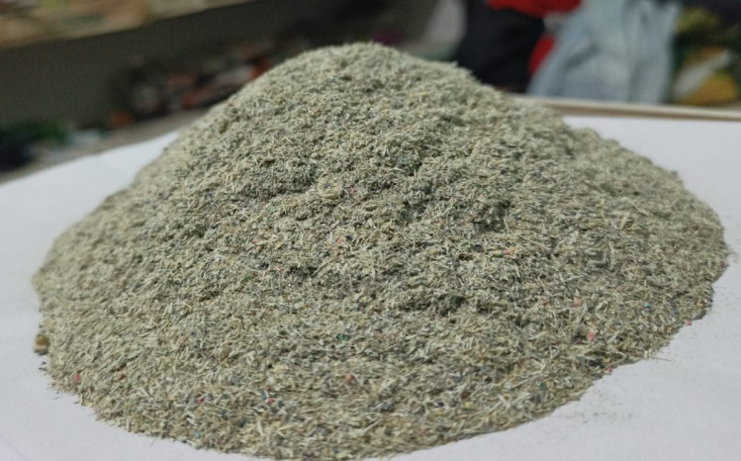
Figure 1. Processed E-waste
E-waste can be recycled to recover valuable metals, gold, silver, copper, palladium, plastics, and glass reducing the need for raw materials in industries and providing a sustainable source of raw materials. Refurbishment and reuse: Functional electronic devices can be refurbished and reused, extending their useful life and reducing the need for new devices (Kahhat et al.,2022; Mishra et al. 2023). E-waste can be disposed of in a landfill, but this is not a sustainable solution as it can lead to the release of hazardous materials into the environment.

  - Bottom Ash
Bottom ash is produced from the incineration of solid waste which is formed from municipal solid waste (MSW) incinerators. It is leftover of the combusted waste. As urbanization is on rapid growth so is the production of Bottom ash. According to a report by the Central Pollution Control Board (CPCB), the total generation of municipal solid waste (MSW) in India in 2019-2020 was estimated to be around 1,50,000 tonnes per day. Bottom ash is a byproduct of coal combustion that can be beneficially reused in various applications and disposed of in several ways (Kannan and Kumar, 2017; Ganesan et al. 2023; Plan et al., 2018). Bottom ash has a similar structure to sand which is porous (Meh et al., 2022). The use of bottom ash in road construction, landscaping, and manufacturing provides environmental and economic benefits while landfilling and other disposal methods should be minimized to reduce their environmental impact. (Kannan and Kumar, 2017) upon experimental investigation explained as the percentage of bottom ash increases in concrete density decreases so as the split strength of concrete. (Ganesan et al., 2023). Bottom ash upon mixing with soil (Phoak et al, 2018; Zhang, 2022) improves soil condition in terms that include a high plastic index, high free swell index, low UCS, and low CBR of pure soil with the addition of different percentages like 10%, 15%, 20%, 25%, and 30% by dry weight of soil. (Petrov and Stefanova, 2022; Hauashdh et al., 2011) concluded that bottom ash could be used in road filling.
2.3 Fly ash
Fly ash is a by-product of burning coal in thermal power plants. It is a fine powder that is carried away by the flue gases and collected by electrostatic precipitators or bag filters. Fly ash contains various components such as silica, alumina, iron, and calcium, which make it useful in various applications. However, fly ash can also be harmful to the environment and human health if not managed properly.
According to the World Bank, global fly ash production was estimated to be around 780 million tonnes in 2016. China is the largest producer of fly ash, followed by India and the United States. India with its high population required abundant of electricity. Coal is one of the major sources of generation of electricity, by burning of coal it produces fly ash.
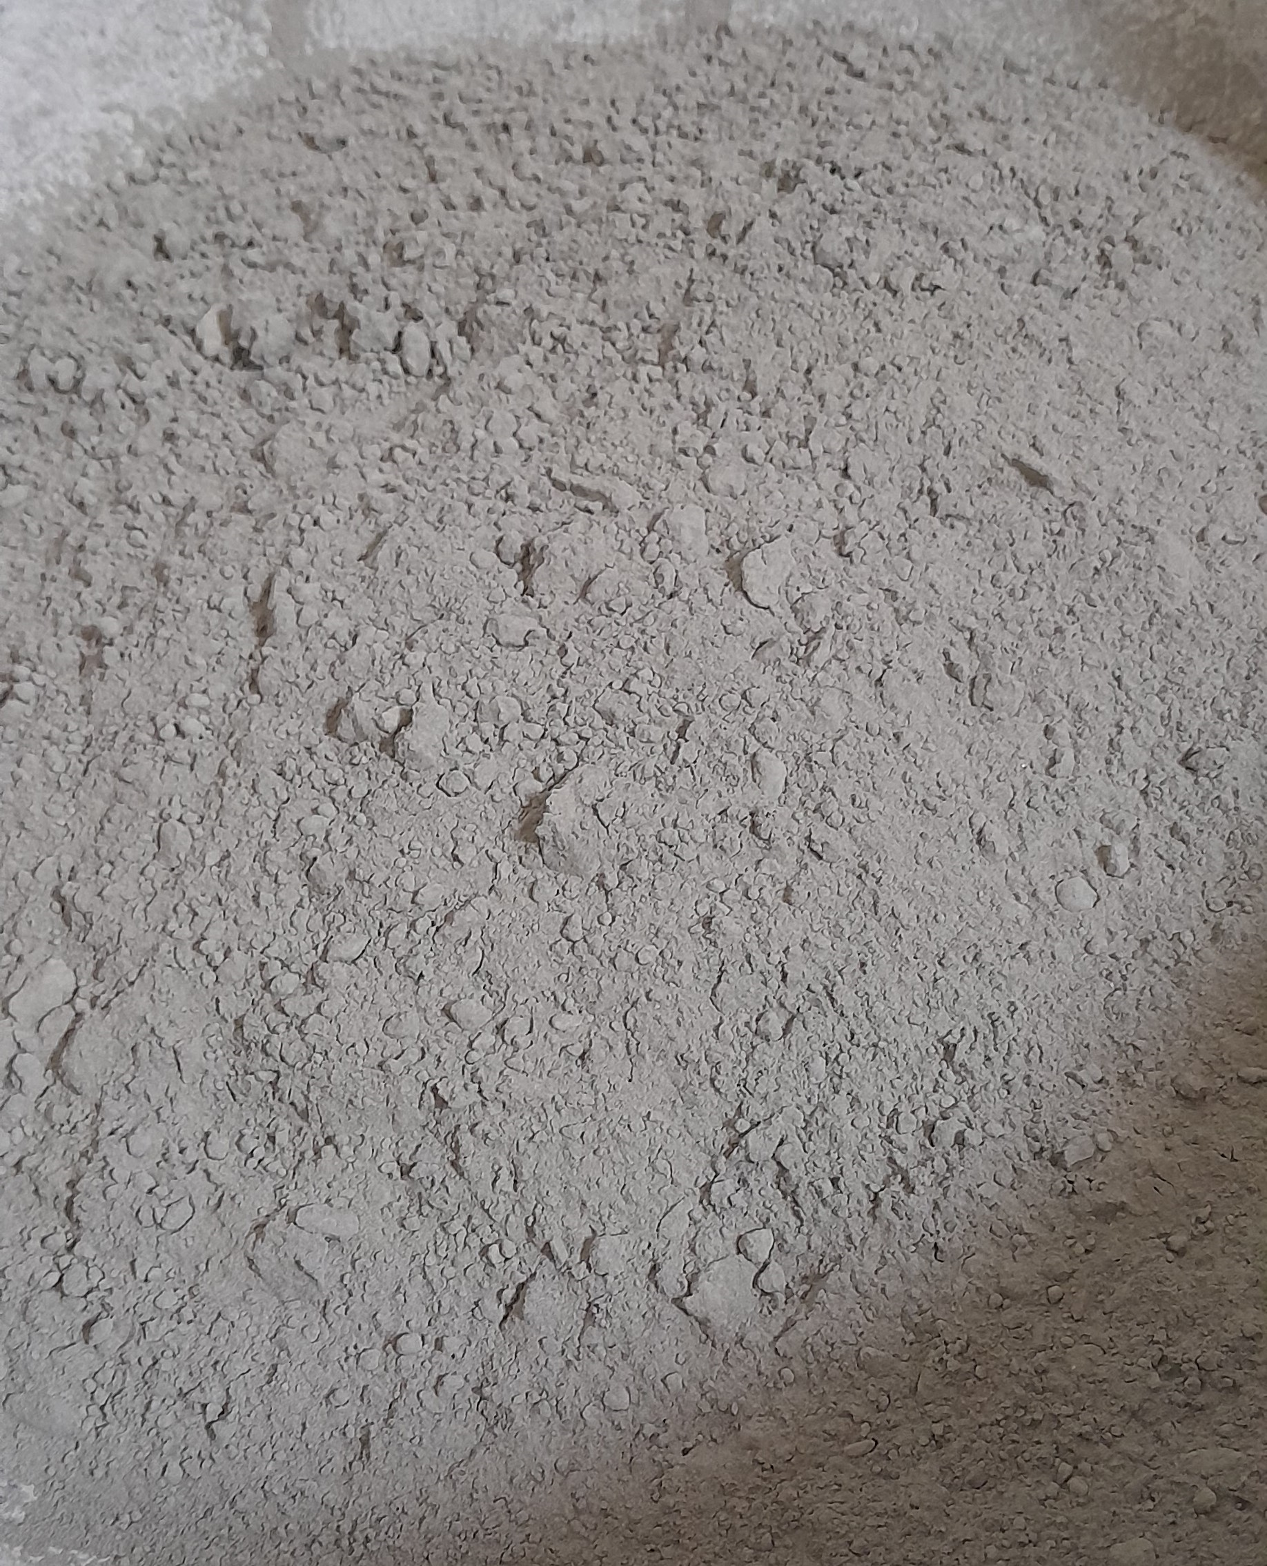
Figure 2. Fly ash
The main properties which fly ash possess is high water retention, no shrinkage, low permeability, low thermal conductivity. It can be used beneficially in various applications, such as cement and concrete production, road construction, bricks, agriculture, and landfill cover. If not used beneficially, it can be disposed of in landfills, surface impoundments, or ash ponds, which must be managed carefully to prevent environmental contamination
2.4 Plastic Strips
Plastic bottles are widely used for packaging beverages. The production, use, and disposal of plastic bottles have significant environmental impacts. According to a report by the Ellen MacArthur Foundation, the world produced over 480 billion plastic bottles, and this number is projected to reach 583.3 billion by 2021. Recycling and reuse are the most sustainable options for managing plastic bottle waste, while landfill and incineration should be used as a last resort.
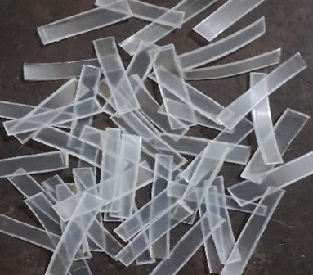
Figure 3. Waste Plastic strip from PET Bottle
A report published by the World Wildlife Fund (WWF), It is estimated that by 2050, the production of plastic will increase to 1,124 million tonnes. Plastic waste is a significant environmental issue that requires urgent attention to reduce its impact on the environment and human health. Plastic has various uses, but it is crucial to manage plastic waste properly through recycling, landfilling, or incineration to minimize its negative impact on the environment.

  - Stone Dust
Stone dust, also known as quarry dust or rock dust, is a byproduct of the crushing of stones, according to a study by Kandhal et al. (2005), the generation of stone dust during the crushing process can range from 5% to 25% of the total weight of the rock being crushed. It is a fine-grained and low-strength material. Stone dust has several applications in the construction industry, including Concrete production: Stone dust can be used as a partial replacement for sand in the production of concrete. Road construction: Stone dust can be used as a filling material in road construction projects, especially for the sub-base and base layers. Landscaping: Stone dust can be used as a decorative material for landscaping and garden pathways.
2.6 Slag
Slag is a byproduct of the metallurgical and smelting industries, generated during the extraction and refining of metal ores. It is a glass-like material that can be granulated or crystallized, depending on the cooling process used. Slag has various applications in construction and engineering, and its utilization helps to reduce waste generation and the environmental impact of the metallurgical industry. According to a report by the International Energy Agency (IEA), the global production of steel increased from 851 million tonnes in 2000 to 1.87 billion tonnes in 2019, and it can be disposed of through recycling, landfilling, or reuse.
2.7 Rice Husk/coffee husk ash
Rice husk and coffee husk are agricultural byproducts generated during the processing of rice and coffee, respectively. These husks are usually considered waste materials and are often burned, which leads to environmental pollution. The main properties of Rice husk ash are low thermal conductivity, high melting point, low bulk density, and high porosity. However, research has shown that these byproducts have various applications in agriculture, energy production, and other industries. A study by Demirbas (2005), the global production of rice husk was estimated at 130 million tonnes per year, while the global production of coffee husk was estimated at 7.5 million tonnes per year. They have various applications in agriculture, energy production, and construction. They can be disposed of through recycling, land application, or incineration.

2.8 Bagasse Ash
Bagasse ash is a byproduct of the sugarcane industry generated during the combustion of bagasse, which is the fibrous residue left after sugarcane juice extraction. It is Black in color, powder form material with irregular and rough texture. Generation of bagasse ash: According to a study by Kuo and Wu (2009), the global production of bagasse was estimated at 190 million tonnes per year, and the combustion of bagasse can generate approximately 25% of its weight as ash. It has several applications in agriculture, construction, and wastewater treatment. Its generation depends on the amount of bagasse burned and the combustion process used, and it can be disposed of through recycling, land application, or landfilling.
2.9 Coir Fibres
Coir fiber is a natural fiber extracted from the outer husk of coconut. It is a byproduct of the coconut industry. Coir fiber has several applications in various industries, including agriculture, construction, and textile manufacturing. However, improper disposal of coir fiber can lead to environmental pollution. According to a study by Babu et al. (2016), the global production of coir fiber was estimated at 550,000 tonnes per year. it can be disposed of through recycling, land application, or composting.

Figure 4. Effect of Fibers on CBR values
The above graph shows the finding of various research on the effect of CBR values of soil when added with different proportions of fibers. It is also concluded that with the addition of fibers CBR value increases with long fibers permeability of soil decreases partially.
2.10 Waste tyre chips
Waste tire chips, also known as tire-derived fuel, are small pieces of shredded tires used as fuel in various industries. The generation of waste tire chips is a significant environmental challenge due to the large volume of tires discarded worldwide every year. Tyre chips are non-bio degradable, it has a low density and high shear strength. Proper disposal of waste tire chips is crucial to prevent environmental pollution and promote sustainable development. According to a study by Kumar and Singh (2019), the global production of waste tires was estimated at 2.5 billion units per year, with approximately 75% of the discarded tires being either incinerated or landfilled.

2.11 Waste Glass

Waste glass, also known as a cullet, is a byproduct of glass production and the disposal of glass containers. The generation of waste glass is a significant environmental challenge due to the large volume of glass discarded worldwide every year. Proper disposal of waste glass is crucial to prevent environmental pollution and promote sustainable development. a study by Soares et al. (2020), the global production of glass containers was estimated at 130 million tonnes per year, with approximately 30% of the discarded glass being recycled.

2.12 Sewage Sludge
Sewage sludge is a semi-solid material that is generated during the treatment of wastewater. It is composed of organic and inorganic materials, including nutrients, pathogens, and heavy metals. The management and disposal of sewage sludge is an important environmental issue due to the potential health and environmental risks associated with its improper disposal. According to a report by the European Environment Agency (EEA) in 2021, around 12 million tonnes of dry sewage sludge are generated annually in the European Union. Sewage sludge can be used in various applications, including agriculture and energy recovery, and can be disposed of through land application, incineration, or landfilling.

2.13 Foundry sand
Foundry sand also known as green sand/ casting sand is high-quality silica sand that is used in the manufacturing of metal castings. American Foundry Society (AFS), predicts approximately 9 to 10 million tons of foundry sand are generated annually in the United States. India is the 4th largest casting producer with nearly 5000 foundry units. The management and disposal of foundry sand is an important environmental issue due to its potential impact on the environment and public health. It has the same properties as sand and it can be used as an alternate to river or sea sand in construction activities. Foundry sand can be used in various applications, road construction, landscaping and alternate construction material.

3. Methodology
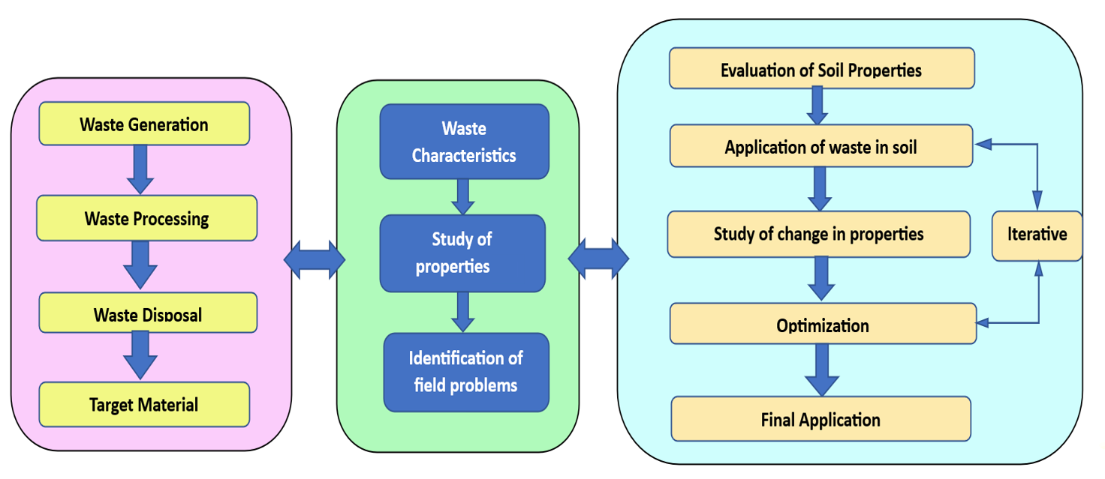
Figure 5. Methodology
The above methodology shows the process involved in this study. The whole process is defined in three blocks first is the generation of waste second is the technical analysis of waste material and last is the application of waste into the field, it can be soil stabilization, concrete manufacturing, agricultural application and many more.
First is the identification of waste material, the waste material that is generated from industries, factories or household waste. After the generation of the waste, the waste is processed and then the most suitable way of disposal is selected. So, in the current study, those waste material are selected who has engineering properties, which are identified by the researchers and are particularly targeted so that we can utilise them in solving engineering problems. The second block is the characterization of waste materials according to their properties, which could be grain size, shape, cohesion, porosity, activity and many more.
With the identification of field problems and selectively studying properties of waste material, they could be clubbed together to give possible solutions. As far as the geotechnical field is concerned there are many types of failures in soil due to lack of engineering properties in soil. So, to apply this waste material in soil stabilisation, the properties of waste material are important. When waste material and soil are blended the change in engineering properties of soil are noted and evaluated and continuous sampling and optimization techniques are applied to find the optimum dosage of waste material which will lead to the maximum improvement in engineering qualities. This is an iterative process, after various iterative processes the optimum dosage is determined. Once the lab results are evident, it is further applied to real-time field situations.

4. Material Application
This is the process of applying various materials in enhancing the required soil properties such as shear strength, bearing capacity, and reducing the chances of volumetric shrinkage. The properties of the materials used for this process should resemble the parent soil. The replacement of these wastes in different proportions reduces the cost of construction and it also helps in sustainable development. Various waste materials such as E-waste Bottom Ash, Fly ash, Plastic Strips, Stone Dust, Slag, Rice Husk/coffee husk, Bagasse Ash, Coir Fibres, Waste tyre chips, Waste Glass, Sewage Sludge, Foundry sand etc. are used in the different ratio in parent soil. The use of these wastes enhances the strength properties of soil.
The waste used in soil stabilization reacts chemically with the soil minerals and forms a bond, thus enhancing the engineering properties of different soil. Fly ash used with clay soil forms a stable compound that doesn’t show its affinity towards moisture and thus reducing the chances of differential swell. Slag is effective in stabilizing sandy soils by improving their strength and reducing their compressibility. It is less effective in stabilizing clay soils. Recycled plastic is a waste material that is used for soil stabilization. It is effective in stabilizing sandy soils and reducing their permeability. It can also be used to prevent soil erosion.
Due to rapid development, the waste generated from various industries is quite high. That causes challenges in handling and disposal of these materials. So, for the proper disposal of these wastes government bodies made different sets of rules. Despite these rules, the handling and disposal of these waste is not easy. So, for that, scientific community gives the idea of using these materials as a replacement for soil stabilization and it also helps in environmental sustainability.
Table 1. List of waste material applications
Waste | Source | Applications
E-waste | Electronic Devices  consist of metals, plastics, glass, ceramics, and various hazardous substances | Mining of precious metals  Reuse of plastic in manufacturing  Manufacturing of bricks  Stabilization of soil  Used in concrete  Bitumen mix design  Improving CBR value of Soil
Bottom Ash | Waste-to-Energy Facilities,  Power plants, coal furnace | Constructions of roads  Landfill cover  Landfill liner  Manufacturing of Blocks  Concrete mix design
Fly ash | Thermal power plants | Manufacturing of cement  Construction of roads  Manufacturing of masonry blocks  Concrete production  Agricultural sector  Synthesis of Zeolites  Absorbent in water treatment  Black cotton soil stabilization
Stone Dust | Marble Industries | Production of concrete  Base layer in stone pavement  Mortar preparation  Agriculture  plastering work  Soil stabilization
Plastic Strips | Plastic carry bags, disposable cups, PET bottles | Bricks  Concrete production  Soil stabilization  Road construction
Slag | Blast furnace | Road construction  Concrete  Cement production  Water and Wastewater Treatment
Rice Husk | Agricultural activities | Fertilizers  Concrete  produce refractory bricks  Soil Improvement  Preparation of activated carbon  fillers of rubber  water purification
Coir Fibres | Coconut fibers | Insulation panels  Packaging  Soil Stabilization  Household items  Landscaping and Gardening  Ropes and Netting
Waste tyre chips | Scrap tyre | Soil reinforcement  Replacement of aggregates in concrete  Pavement constructions  Asphalt Mixtures  backfill against retaining walls
Waste Glass | Glass bottles | Aggregates in concrete
Sewage Sludge | Sewage treatment plant | Improve fertility of soil  Sustainable agriculture
Foundry sand | Foundry industries | Concrete manufacturing
Bagasse Ash | sugar manufacturing industry | Fertilizers  A Filler in Concrete  Glass-ceramic material  Geopolymers  Phillipsite zeolite synthesis

5. Conclusions and recommendations
There are many waste materials applied in construction activities and their performance is measured with traditional materials. The use of waste material in suitable proportions enhances the desirable properties in soil and other building materials resulting in a decrease in environmental degradation and hence promoting sustainable development.
Waste material can be used in other fields fly ash is used in improving soil quality for agriculture, backfill, replacement in concrete, construction of embankments, and making bricks with all these rather than polluting and occupying space in landfill, it can be used in many efficient ways. All other materials analyzed E-waste, Fly ash, Plastic Strips, Stone dust, Slag, Rise Husk, Bottom ash, Bagasse Ash, Coir fibre, Waste tyre chips, Waste Glass, and Sewage Sludge Ash have the same condition rather than disposing of it can be used for manufacturing of bricks, stabilization of soil, production of concrete, improving CBR value of soil, manufacturing of cement, improving the fertility of soil, absorbent in water treatment and many more.
Now a day, the world is looking towards sustainable development the use of these waste materials gives desired results without causing any serious harm to the environment. It was proven that waste materials with advanced applications are more efficient than traditional materials in terms of economy and eco-friendly. Also, there are many other waste materials available that can be utilized by blending different wastes together with soil in various proportions.

With this study, many research gaps are encountered, and many future research work scopes are there. Further micro-level examination of the changes in soil, XRD, and SEM can be performed. For the large-scale application of waste materials, further research is needed on technical standardization and guidance by government bodies. For a larger application, supply chain management will be required between production and application. Long-term analysis is required for the impact of engineering properties in soil.

References
American Foundry Society (AFS). (2017). Foundry sand facts for civil engineers. Retrieved from https://www.afsinc.org/files/Facts_for_Civil_Engineers.pdf
Ardi, R., Handafiah, F.: Mapping Electronic Waste Flows in Depok, West Java. IOP Conference Series: Earth and Environmental Science, 401(1). (2019). https://doi.org/10.1088/1755-1315/401/1/012005
Babu, S., Aravindan, S., & Ravindran, K. Coconut coir pith and fiber as potential resources for sustainable agriculture, environmental, and industrial applications: A review. Journal of Cleaner Production, 123, 1-18. (2016). doi: 10.1016/j.jclepro.2015.12.057
Blessing, E., Kennedy, C., Amgbara, T. O.: Effectual Use of Costaceae Lacerus Bagasse Fibre and Lime as Expansive Soil Stabilizer. International Journal of Advances in Scientific Research and Engineering, 4(11), 06–16. (2018), https://doi.org/10.31695/ijasre.2018.32937
Boobalan, S. C., Sivakami Devi, M.: Investigational study on the influence of lime and coir fiber in the stabilization of expansive soil. Materials Today: Proceedings, 60, 311–314. (2022). https://doi.org/10.1016/j.matpr.2022.01.230
Carvalho, L. M. C., Monteiro, F. F., Casagrande, M. D. T. : Large-scale direct shear testing in coir fibers reinforced sand. Soils and Rocks, 46(1). (2023). https://doi.org/10.28927/SR.2023.002822
Chatrabhuj, Maheshwari, UK.: Experimental Investigation of Different Type of Soils with Addition of Geofibers. Journal of Geotechnical Engineering STM Journals. 8(2), 13–20 (2021).
Demirbas, A. Potential applications of renewable energy sources, biomass combustion problems in boiler power systems and combustion related environmental issues. Progress in Energy and Combustion Science, 31(2-3), 171-192. (2005). doi: 10.1016/j.pecs.2005.02.002
Dixit, A., Nigam, M., Mishra, R. Effect Of Fly Ash On Geotechnical Properties Of Soil. International Journal of Engineering Technologies and Management Research, 3(5), 7–14. (2020). https://doi.org/10.29121/ijetmr.v3.i5.2016.62
Dutta R K, Khatri V.: Compaction and CBR behaviour of clay reinforced with NaOH treated coir fibres. 2013. Pg 430-438.
European Environment Agency (EEA). (2021). Waste statistics — sewage sludge statistics. Retrieved from https://www.eea.europa.eu/data-and-maps/daviz/waste-statistics-sewage-sludge-statistics-4.1/waste-statistics-sewage-sludge-statistics-4.1-2
Ganesan, H., Sachdeva, A., Petrounias, P., Lampropoulou, P., Sharma, P. K., Kumar, A.: Impact of Fine Slag Aggregates on the Final Durability of Coal Bottom Ash to Produce Sustainable Concrete. Sustainability (Switzerland), 15(7). (2023). https://doi.org/10.3390/su15076076
Hamanaka, A., Sasaoka, T., Shimada, H., Matsumoto, S.: Amelioration of acidic soil using fly Ash for Mine Revegetation in Post-Mining Land. International Journal of Coal Science and Technology, 9(1). (2022). https://doi.org/10.1007/s40789-022-00499-9
Hauashdh, A., Radin Mohamed, R. M. S., Jailani, J., Abd Rahman, J.: Stabilization of Peat Soil Using Fly Ash, Bottom Ash and Portland Cement: Soil Improvement and Coal Ash Waste Reduction Approach. IOP Conference Series: Earth and Environmental Science, 498(1). (2020). https://doi.org/10.1088/1755-1315/498/1/012011
https://www.acaa-usa.org/What-is-Coal-Ash
https://www.itu.int/en/ITUD/Environment/Documents/Events/WGES_2020/Session_2/Global_E-waste_Monitor_2020.pdf
International Energy Agency. (2021). https://www.iea.org/reports/steel
Kahhat, R., Miller, T. R., Ojeda-Benitez, S., Cruz-Sotelo, S. E., Jauregui-Sesma, J., Gusukuma, M.: Proposal for used electronic products management in Mexicali. Resources, Conservation and Recycling Advances, 13. (2022). https://doi.org/10.1016/j.rcradv.2022.200065
Kai, K., Kannan, K., Vijaya Kumar, R.: An Experimental Study On Effective Utilization Of Bottom Ash, 5(6), 152. (2017). https://doi.org/10.5281/zenodo.818491
Kandhal, P. S., Parker, F., & Garcia, R. Stone Dust in Concrete: Effect on Compressive Strength. Highway Research Record, (193), 65-78. (2005). doi:10.3141/193-08
Katman, H. Y. B., Khai, W. J., Bheel, N., Kırgız, M. S., Kumar, A., Benjeddou, O.: Fabrication and Characterization of Cement-Based Hybrid Concrete Containing Coir Fiber for Advancing Concrete Construction. Buildings, 12(9). (2022). https://doi.org/10.3390/buildings12091450
Kennedy, C., Paulinus, A. P., Amgbara, T. O.: Hybridized Composite Materials Effect on Stabilization of Soft Clay Soils in Niger Delta Stabilization of Deltaic Soils using Costus Afer Bagasse Fiber. The Journal of Scientific and Engineering Research, 5(10), 97–103. (2018).
Kumar P S.: Investigation of glass fiber reinforcement effect on the CBR strength of cohesive soil a study on behaviour of suction caisson foundations. Indian Geotechnical Conference. 15-17 December 2016, IIT Madras.
Kumar P, Mir F A. Improvement in Subgrade Characteristics of Soil Reinforced with Jute Fiber. International Journal of Innovative Research in Science, Engineering and Technology2017, Vol. 6, Issue 2, doi: 10.15680/IJIRSET.2017.0602133.
Kumar, S., Singh, P.: Waste tire management and challenges: A review. Journal of Cleaner Production, 236, 117599. (2019). doi: 10.1016/j.jclepro.2019.117599
Kuo, W.-T., Wu, J.-H. Characterization and use of sugarcane bagasse ash as an agricultural soil amendment. Journal of Environmental Management, 90(8), 3013-3018. (2009). doi: 10.1016/j.jenvman.2009.04.018
Meh, K. M. F. K., Shahidan, S., Shamsuddin, S. M., Zuki, S. S. M., Senin, M. S.: An Experimental Investigation Of Coal Bottom Ash As Sand Replacement. International Journal of GEOMATE, 23(99), 17–24. (2022). https://doi.org/10.21660/2022.99.3515
Mishra. ON., Chatrabhuj, Prajapati, B.: Experimental Analysis of Bearing Capacity of Soil with Addition of Processed E-Waste. In: 2nd International Conference on sustainable materials and practices for built environment (SMPBE-2023), Jaipur. 19-20 Jan. (2023).
Mittal A. Effect of coir fibres on strength, thickness and cost of PMGSY roads. IOP Conf Ser Mater Sci Eng, vol. 1136, no. 1, p. 012042, Jun. 2021, doi: 10.1088/1757-899x/1136/1/012042
Munirwan, R. P., Munirwansyah, Marwan, Ramadhansyah, P. J., Kamchoom, V. :Performance of Coir Fiber Addition for Clay as a Sub-Grade for Pavement Design. IOP Conference Series: Materials Science and Engineering, 712(1). (2020). https://doi.org/10.1088/1757-899X/712/1/012009
Naresh, J., Kastro Kiran, V., Karthik Chary, T., Jayaram, M.: An investigation on stabilization of laterite soil using coconut coir fibres. IOP Conference Series: Earth and Environmental Science, 982(1). (2022). https://doi.org/10.1088/1755-1315/982/1/012041
Nik Daud, N. N., Aliff Rusdi, M.: Fly Ash Stabilized Lateritic Soil as Subbase Material: A Review. Earth Science Malaysia, 6(1), 15–23. (2022). https://doi.org/10.26480/esmy.01.2022.15.23
Nitish, S. S. S., De, S., Ramya, A. V. S. L., Kumar, G. S.: Comparative study on soil stabilization using industrial by products and coconut coir. Journal of Physics: Conference Series, 2040(1). (2021). https://doi.org/10.1088/1742-6596/2040/1/012014
Noaman, M. F., Khan, M. A., Ali, K., Hassan, A.: A review on the effect of fly ash on the geotechnical properties and stability of soil. In Cleaner Materials (Vol. 6). Elsevier Ltd. (2022). https://doi.org/10.1016/j.clema.2022.100151
Paulinus, A. P., Kennedy, C., Biamene Barine, N.: Performance of Expansive Soils Stabilized with Costaceae Lacerus Bagasse Fibre Ash and Cement Composition. The Journal of Scientific and Engineering Research, 5(10), 119–127. (2018).
Pederneiras, C. M., Veiga, R., de Brito, J.: Physical and mechanical performance of coir fiber-reinforced rendering mortars. Materials, 14(4), 1–15. (2021). https://doi.org/10.3390/ma14040823
Peter, L., Jayasree, P. K., Balan, K., Raj, S. A.: Laboratory Investigation in the Improvement of Subgrade Characteristics of Expansive Soil Stabilised with Coir Waste. Transportation Research Procedia, 17, 558–566. (2016). https://doi.org/10.1016/j.trpro.2016.11.110
Rusănescu, C. O., Rusănescu, M.: Application of Fly Ash Obtained from the Incineration of Municipal Solid Waste in Agriculture. In Applied Sciences (Switzerland) (Vol. 13, Issue 5). MDPI. (2023). https://doi.org/10.3390/app13053246
Salim, A. A., Bahaa, Z., Fattah, M. Y., Mohammed, Z. B., Fattah, M. Y.: Influence of Adding Plant Fly Ash on The Geotechnical Properties and Pollution of Sanitary Landfill Soil Finite element. Engineering and Technology Journal, 40(11). (2022). https://doi.org/10.30684/etj.v40i11.1136
Sivakumar Babu, G. L., Vasudevan, A. K.: Seepage Velocity and Piping Resistance of Coir Fiber Mixed Soils. Journal of Irrigation and Drainage Engineering, 134(4), 485–492. (2008). https://doi.org/10.1061/(asce)0733-9437(2008)134:4(485)
Soares, D., Ferreira, V. M., Baptista, J. D. C., Lapa, N.: Glass cullet from municipal solid waste: A review on generation, characterization, and applications. Waste Management, 102, 475-491. (2020). doi: 10.1016/j.wasman.2019.11.014
Taiyab, A., Islam, N. N., Rahman, M.: Desiccation characteristics and direct tension attributes of thin clayey soil containing discrete natural fibers. Soils and Rocks, 45(4). (2022). https://doi.org/10.28927/SR.2022.074421
Tariq, K. A., Ahmad, J., Husnain, S. A., Ijaz, M. S.: Influence on compressive and tensile strength properties of fiber-reinforced concrete using polypropylene, jute, and coir fiber. Journal of the Mechanical Behavior of Materials, 32(1). (2023). https://doi.org/10.1515/jmbm-2022-0263
Trung Phan, N., Sengsingkham, T., Tiyayon, P., Maneeintr, K.: Utilization of bottom ash for degraded soil improvement for sustainable technology. IOP Conference Series: Earth and Environmental Science, 268(1). (2019). https://doi.org/10.1088/1755-1315/268/1/012043
United Nations Environment Programme. (2018). Single-use Plastics: A roadmap for sustainability.
https://wedocs.unep.org/bitstream/handle/20.500.11822/25496/singleUsePlastic_sustainability.pdf?sequence=1&isAllowed=y
Venkatesan, P., Vasudevan, R.: Behaviour of Bagasse Ash and Bagasse Fibre in Concrete. YMER Digital, 21(02), 409–417. (2022). https://doi.org/10.37896/YMER21.02/40
Vikas Kumar, Pankaj Kumar.: Effect of partial cement replacement with sugarcane bagasse ash. International Journal of Science and Research Archive, 8(1), 781–787. (2023). https://doi.org/10.30574/ijsra.2023.8.1.0128
World Coal Association. (2018). https://www.worldcoal.org/resources/coal-and-fly-ash
World Wildlife Fund. (2021). Plastic waste: facts & figures. https://www.worldwildlife.org/stories/plastic-waste-facts-figures
Yenigalla, R. V., Slaney, G. V.: Effect of Epoxy Resin on CBR Improvement of Soft Clayey Subgrade Mixed with Coconut Coir Fibres. IOP Conference Series: Materials Science and Engineering, 1112(1), 012020. (2021). https://doi.org/10.1088/1757-899x/1112/1/012020

