Harnessing Nature's Pharmacy: Investigating Traditional Herbal Remedies for Immune Enhancement and Health Promotion

Ritambhara¹, Susmita Shukla^{1*}
¹Applied Plant Biotechnology Research Lab, Centre for Plant and Environment Biotechnology Amity Institute of Biotechnology, Amity University, Noida (U.P), India

Brijesh Shivhare²
Department of Bioscience, Faculty of Science
P.K. University, Shivpuri, Madhya Pradesh
India

ABSTRACT
The immune system is a complex network within the body that defends against a wide range of infections and diseases caused by pathogens. Traditional herbal remedies have been utilized for centuries in various cultures to support and boost the immune system. This research chapter provides an introduction to the concept of immunity and the role of the immune system in protecting the body against various pathogens.The chapter delves into the significance of medicinal plants in promoting immunity and preventing diseases caused by microorganisms. Various traditional herbs, such as Giloy, Ashwagandha, Garlic, Turmeric, Tomato and Ginger, are explored for their potential immunomodulatory properties. Each of these herbs contains bioactive compounds that have been linked to immune-enhancing effects. Lead toxicity was found to be a significant and safe way to reduce lead exposure and combat health issues in the general population. The primary objective of this review article is to provide a summary of lead poisoning identification, sources, and mechanism in light of various toxicological effects on human health. The role of cytokine modulation caused by herbal plants is discussed in detail, highlighting how different herbs can influence the production and regulation of cytokines, which are essential immune system messengers. The chapter emphasizes that these medicinal plants can help balance and enhance the immune response, leading to improved overall health and resistance against infections. Furthermore, the chapter touches upon the potential interactions and side effects of these herbal remedies, suggesting that careful usage and proper dosage are essential for safe and effective immunomodulation.In conclusion, this research chapter presents an overview of various traditional herbs and their potential as immune-boosting agents. The utilization of these herbs in promoting immune health and preventing diseases provides a valuable contribution to the field of immunomodulation research. As more scientific studies explore the efficacy of these traditional remedies, they may offer promising alternatives or complementary approaches to conventional immunomodulatory interventions.

Keywords—Immune System, Traditional herbs, Medicinal plants, Health

INTRODUCTION

The Immune System is the most intricate organic frameworks in the body. At the hour of disease invulnerable framework go under the assault of countless infections, microscopic organisms and growths. The invulnerable framework is a piece of body to distinguish the microbe by utilizing a particular receptor to create promptly reaction by the enactment of invulnerable parts cells, cytokines, chemokines and furthermore arrival of fiery arbiter. They regulate and potentiate the resistant framework. According to numerous studies, metal toxicity and carcinogenicity have been linked to the normal biological functioning of cells in both humans and animals. Zinc, copper, magnesium, lead, selenium, arsenic, iron, and a number of other essential metals will participate in metabolic activities through control mechanisms and signaling pathways. Lead poisoning is a threat from the environment that damages the body's oxidative system by accumulating free radicals (Massage et al. 2007). Human symptoms of lead poisoning include headache, abdominal pain, joint pain, high blood pressure, low sperm count, abnormal sperm, and miscarriage etc. The most serious side effect of lead exposure may leads to brain tissue damage, which can be irreversible. Lead poisoning can cause kidney, liver, and brain damage in children and adults, as well as death in some cases (Rader et al. 1981).
Restorative plants bestow huge jobs in the avoidance of person from different pathogenic microorganisms and the illnesses. In nature there are different restorative plants which are utilized as invulnerable modulator specialists. Certain therapeutic plants are accepted to advance positive wellbeing and keep up natural opposition against disease by restoring body harmony and molding the body tissues. It is enticing to estimate that the helpful and reviving force of these home-grown cures may be because of their activity on the resistant framework and a few of the restorative plants are accepted to upgrade the characteristic obstruction of the body to contaminations. Plant inferred materials (proteins, lections, polysaccharides, and so forth) have been appeared to invigorate the resistant framework. Ayurveda and other Indian writing notice the utilization of plants in treatment of different human sicknesses. There are various plants that have been accounted for to have invulnerable modulatory movement. The present paper audit plants which have shown trial and clinical safe modulatory movement [1-4]. An immunomodulator might be characterized as a substance, biological or engineered, which can animate, stifle or regulate any of the parts of the immune framework including both intrinsic and versatile arms of the insusceptible reaction. Resistant framework is an astoundingly complex safeguard framework inside vertebrates, to shield them from attacking specialists. Balance of the invulnerable framework signifies to any adjustment in the safe reaction that can include acceptance, articulation, enhancement or hindrance of any part or period of the invulnerable reaction. In this manner, immunomodulator is a substance utilized for its impact on the invulnerable framework. There are for the most part of two sorts immunomodulators in light of their belongings: invulnerable suppressants and invulnerable triggers. Explicit immunomodulators controlled along with antigens known as immunological assistants to help the safe reaction to the antibody constituents. For case, a plant beginning saponin utilized in veterinary medication. Though, the vague immunostimulatory offer a summed-up condition of protection from microbes or tumors. Parasitic item cyclosporin A specifically block the capacity of T lymphocyte and used to forestall unite dismissal. The idea of immunomodulation identifies with vague enactment of the capacity and productivity of macrophages, granulocytes, supplement, characteristic executioner cells and lymphocytes and furthermore to the creation of different effectors atoms created by initiated cells. It is normal that proposals vague impacts give security against various microorganisms including microscopic organisms, infections, growths and so on and comprise an option to traditional chemotherapy. The world we live in is one loaded with organisms. Our internal heat level also, abundance of supplements gives an ideal home to these miniature life forms to flourish. The human invulnerable framework has the fundamental capacity of securing the body against the harming impacts of microbial specialists that are pathogenic. The framework contains natural (vague) and gained (explicit) insusceptibility. Common executioner (NK) cells, supplement framework, macrophages, antigen introducing cells (APCs) and neutrophils make up the natural invulnerable framework and mounts a prompt vague reaction to unfamiliar microbial specialists. On the off chance that organisms by-pass this essential guard, the gained invulnerable reaction, containing humoral and cell intervened parts, will at that point act to contain the trespassers. The kind of antigen (parasites, infection, microbes, poison) prepared and introduced by APCs to the CD4+ T cell decides the sort of cytokines discharged, which thus, decide the separation of aide T (TH) cells into TH1 or TH2 cells and B-cells to give immunoglobulin subtypes. TH1 reaction includes the enactment of macrophages, which contain and annihilate mycobacteria and parasitic microorganisms. TH1 pathway additionally actuates cell-interceded insusceptibility. TH2 cells, then again, impact immunoglobulin separation and immunizer discharge, and subsequently intercede humoral invulnerability. CD8+ cytotoxic T cells prompt apoptosis in antigen-loaded cells.
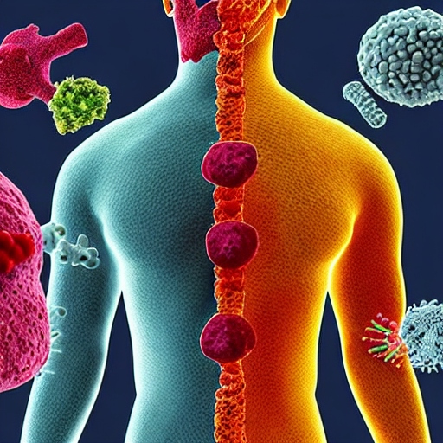
Figure 1: The immune system in humans is a highly sophisticated and complex network of cells, tissues, organs, and molecules that work together to defend the body against foreign invaders, such as bacteria, viruses, fungi, and parasites. Its primary function is to identify and eliminate harmful substances while distinguishing them from the body's own healthy cells and tissues.

2. Introduction to Herbs
Since days of yore, customary flavors and spices have assumed an imperative part as immuno-supporters in Indian food. Spices and flavors were notable from antiquated occasions for their restorative properties. More than 80 flavors are filled in various pieces of the world, especially in Asia. India is home to a few flavors that are utilized widely in conventional medication. Flavors like turmeric, saffron, cloves, cinnamon, carom seeds, ginger and garlic are known to have a plenty of valuable properties. Spices like mint, tulsi (Holy Basil), leaves of neem, ashwagandha, giloy are said to have a few medical advantages. Spices and flavors are great on the grounds that, in contrast to drugs, we don't have to "take" them. All things being equal, we can add them to our number one dishes for a kick of flavor and expanded resistance. Ayurveda, which is a customary Indian arrangement of medication and advances a few spices, flavors and roots that help support the insusceptible framework normally. In Ayurveda, flavors and spices are utilized to fix long standing wellbeing conditions by disposing of metabolic conditions and ordinarily named as 'chemicals'. Customarily, in Indian food, spices and flavors are utilized in a dish as indicated by their dietary advantages and their capacity to fortify our resistant framework, which thusly, can shield us from infirmities and diseases. A solid safe framework helps the body battle influenza, illness causing infections, just as microscopic organisms. Individuals with bargained invulnerability are more inclined to falling debilitated furthermore, their indications for any infection are more extreme when contrasted with others. That is the reason the need of solid safe framework is very significant on the grounds that that will empower us to carry on with a solid life. As per the World Health Organization, around 80% of the total populace utilizes natural meds for essential medical services, especially across South Asia and Europe. Examination contemplates demonstrate that alongside developing the body's invulnerability, they likewise have mitigating properties and moderately have less results.
Figure 2: These three herbs and spices, garlic, turmeric, and ginger, not only enhance the flavor of various dishes but also offer a wealth of potential health benefits. Their long history of use in traditional medicine and ongoing scientific research continue to highlight their importance in promoting overall well-being and maintaining a balanced and nutritious diet.

3. Different Herbs for Immune System
An expansive scope of medical care rehearses is needed to misuse the helpful impacts of Ayurveda, which is the oldest arrangement of prescriptions. Through several tremendous investigates led nearby, it is being investigated that a considerable lot of the synthetic compounds as alkaloids, flavonoids, terpenoids, polysaccharides, lactones, and glycoside items are capable to cause adjustments in the immunomodulatory properties. Remembering, the huge capability of the restorative plants and their determined medications, presenting this survey with a reason to around the world advocate the Indian home-grown meds as immunomodulators. It is an obvious from the mankind's set of experiences that therapeutic plants have been the treatment routine to fix an assortment of sicknesses, including illnesses brought about by bugs, parasites, microorganisms, and infections. The impacts appeared by the plants are because of the synthetics present in them and they work in the same way as the ordinary medications. Notwithstanding, there are similarly risks for these plants to have some potential hurtful and poisonous impacts too. These undesired results can be decreased by handling of the plant's unrefined item. Ethnobotany is the investigation of customary plants for their therapeutic properties and is a compelling strategy to find future prescriptions. As indicated by 2015-16 information, more than 300 plants have been distinguished to have remedial potential.[1] Around 122 synthetics got from plants have been distinguished as remedial substances which are additionally utilized in business drugs, for instance, bark of willow tree is very rich in salicylic corrosive, which is likewise a functioning metabolite of ibuprofen, and this bark has been utilized from old occasions as a torment executioner and antipyretic substance.[2] Some of the medications which are every now and again utilized by the doctors are additionally determined from plant sources, for instance, ibuprofen, digoxin, quinine what's more, opium, etc. They have a long history of utilization as home grown drug. At present, there is a lot developing interest to utilize these therapeutic plants as modulators of the intricate resistant framework. Through various investigates directed in the territory have investigated that a considerable lot of the synthetic substances as alkaloids, flavonoids, terpenoids, polysaccharides,[3] lactones, furthermore, glycoside items are dependable to cause adjustments in the immunomodulatory properties, immunomodulators, is acquiring a lot of interest. Age of home-grown medication as numerous segment specialist expected to tweak the mind-boggling invulnerable cycle in such a manner to forestall the contamination instead of treatment and fix of the illness. Considering every one of these viewpoints keeping, the present audit centers around an outline of various therapeutic plants and their immunomodulatory movement.
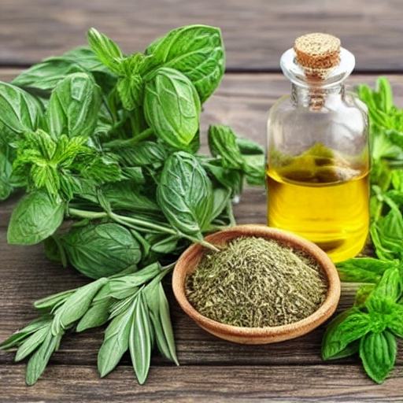
Figure 3: It's important to note that while these herbs have been traditionally used for immune support, individual responses to herbs may vary. Before incorporating any new herbs or supplements into your routine, especially if you have underlying health conditions or are taking medications, it's best to consult with a healthcare professional or a qualified herbalist to ensure they are safe and appropriate for your specific needs.

- Insusceptibility
The term insusceptibility characterizes body's normal guard framework against an immense range of illnesses and problems. Surprisingly refined and progressed among vertebrates, the complex safe framework is skilled to produce a boundless assortment of cells and particles to capture tremendous range of diseases and unfortunate substances. Immunomodulators allude to those substances equipped for inciting, intensifying, furthermore, restraining any part or period of the insusceptible framework. Immunostimulatory and immunosuppressant are two sorts of immunomodulators are known for use. Truth be told, immunopharmacology is a more current part of pharmacology worried about immunomodulators [4] Administration of immunostimulatory as on account of AIDS and utilization of immunosuppressor in instances of a misrepresented reaction of a resistant framework is appreciating to reconstitute the typical resistant framework and increment the life span of life. Immunomodulator consumption alongside antigen, the cycle is intended to help the invulnerable framework, and the modulator is known as safe adjuvant [5] Immunology is one of the quickly creating fields of biomedical exploration, holds extraordinary guarantees concerning different sicknesses and problems. The two different ways of safeguard of a safe component including momentary instrument which is the first line of guard and the other profoundly progressed versatile resistant reaction set apart by intricacy, variety, and memory [6]. A versatile resistant reaction likewise comprises of two subtypes of resistant reactions, humoral insusceptible reaction worried about β-lymphocytes and cell-intervened cytotoxic reaction intervened by T-cells. Well, all the part cells of the insusceptible framework start from bone marrow through hematopoiesis from bone marrow-determined undifferentiated cells. They are either form into develop cells or move to another fringe destinations for migration. Besides a tremendous scope of cells of invulnerable cells, certain particles called cytokines which are one of the significant goes between of the resistant framework intervene the cross talk between the specific cells of the resistant framework, consequently totally incorporating the conduct and activity reactions of the cells.
- Cytokine Modulation Caused by Herbal Plants
Through various in vitro and in vivo considers directed to see the impact of the natural medication on cytokines have appeared that they impact an enormous number of various cytokines. By nature, cytokines are a gathering of solvent extracellular proteins or then again glycoproteins as interleukins (ILs), interferons, chemokines, and so on, and are critical to both inborn and gained kinds of resistance. These cytokines through intermolecular get talks keep up physiological strength through them emissions taking all things together nucleated cells through inducible reaction to some injury.[7] truth be told, it is clear from information on the clinical writing of different illnesses that these sickness conditions are in associate with cytokine emissions. In illnesses of the focal sensory system, these cytokines have a prevalent part as in the assortment of mental problems, furthermore, strange emissions of these synthetics have been illustrated. Different neurochemicals, neuroendocrine, and neuroimmune substances have showed up at the order of cytokines. Their job has been set apart in instances of depression,[8] Alzheimer's disease,[9] and schizophrenia;[10] different social movements, positive and negative feelings, stress, disease, and so forth, have all been shown to animate cytokine secretion.[11] It is clear from the tremendous writing on cardiovascular illnesses what's more, the part of cytokines as these are bounteously predominant in the liver, heart, vessels, fat tissues, and so on, and these tissues add to provocative nature of cardiovascular illnesses. Developing acknowledgment of the reality, the convenience of cytokines, jobs, modifications in cytokine articulation, and focusing on their receptors may offer a novel way to deal with their utilization as a remedial objective. Various pharmacological specialists are required as an adversary, agonist, and initiator at incitement. Interferon agonist has been drawn nearer by the Food and Drug Administration in the year 1986, for bristly cell leukemia.[12] Similarly, for rheumatoid joint inflammation treatment, antigens of tumor putrefaction factor-α (TNF-α) have been drawn nearer as target.[13] In periodontal infections, IL-1β and TNF-α have been targeted.[14] Inhibition of TH cell-determined cytokines, utilization of IL-2 and IL-12, and TNF-α likewise give potential advantages restoratively in neuroblastomas.[9] Cytokines show different and pleiotropic characters, play a promising job likewise for different problems not identified with resistant system.[15] The utilization of interferon produces influenza like indications, wretchedness, weariness, and so forth, in patients.[16] Every one of these obstacles in the method of helpful convention make a test for cytokines. Unfavorable impacts created furthermore, experienced among the patients caused us to consider phytotherapy in changing the cytokine articulation. Plants for example, Astragalus membranous otherwise called "spleen chi tonic" is a Chinese plant utilized in different infections and squandering condition of the body. The root concentrate of the plant was found to bring down IL-6 in vitro human model.[17] IL-6 is incendiary and approaching crumbling marker.[17] Very notable plant of garlic or Allium sativum utilized in most of the Indian houses is found to bring down IL-1 and IL-6, acting as calming, hypocholesterolemia, cancer prevention agent, and furthermore angiotensin-changing over chemical inhibitor.[18] It has incredible potential as mitigating because of an inhibitory impact on IL-1, IL-6, TNF, IL-8 and boosting impact on IL-10 which is an adversary to supportive of provocative cytokines.[18] Other than mitigating, it additionally shows antimicrobial potential. Garlic use has been proposed in provocative gut infections. Its utilization is likewise shown in Alzheimer's illness because of IL-10 balance. Spelman et al. have announced in his survey, immunomodulatory movement of something else than 18 home grown plants including Acanthopanax gracilistylus, A. sativum, Ananas comosus, Cissampelossympodials, Coriolus versicolor, Curcuma longa, Tinospora cordifolia, what's more, Withaniasomnifera.[19] Aloe vera, an extremely famous plant which fills in bone-dry environment, is professed to have wound and consume mending properties because of its calming nature. It has been found to decrease TNF-α and IL-6 in different creature models [20]. Different home-grown meds have been found to balance different segments of natural and procured safe framework. Indeed, in view of legitimate comprehension of different immunomodulatory exercises of natural plants, plants determined the optional metabolites in characteristic items can be the lead particles for the future advancement of immunomodulators for helpful.

GILOY (TINOSPORA CORDIFOLIA)
(Tinospora cordifolia) regularly known as 'Guduchi' or 'Amrita', is a plant being utilized from hundreds of years for its restorative qualities. Numerous investigations have revealed the hypolipidemic, hypoglycemic, hepatoprotective, antibacterial, mitigating, anti-osteoporotic, anti-obesity, anticarcinogenic and antimutagenic properties of giloy.1–9 Its cell reinforcement possibilities were additionally explored in numerous studies.10 It is likewise compelling against lead harmfulness, diabetic foot ulcers and diabetic neuropathy. It likewise improves learning and memory power.11–13 The immunomodulator properties of giloy was concentrated in different models.14,15 α-D-glucan, the principle substance constituent of giloy invigorate characteristic executioner cells, B cells, and T cells with concurrent creation of different invulnerable stimulatory cytokines.15 It additionally diminishes the absolute leucocyte check (TLC), neutrophil and eosinophil tallies at the point when its concentrate has been given to Human Immuno-insufficiency Virus (HIV) positive patients.16 In an examination done on male wistar rodents utilizing alcoholic concentrate of giloy showed an increment in the white platelet (WBC) tallies, bone marrow cellularity, serum Ig fixations which further approves the immunomodulatory capability of this plant.16
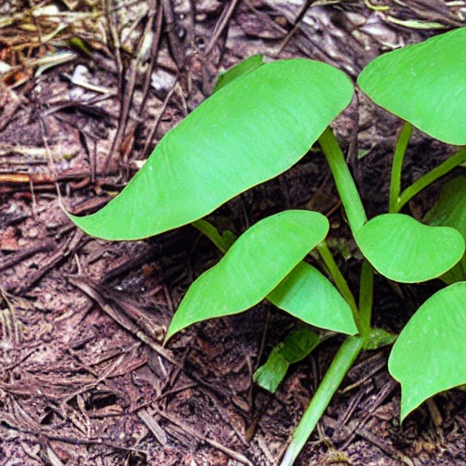
Figure 4: Giloy, scientifically known as Tinospora cordifolia, is a highly valued herb in traditional Ayurvedic medicine for its numerous health benefits and immune-boosting properties. It is also known by other names such as "Guduchi" and "Amrita." Giloy is native to the Indian subcontinent and has been used for centuries as a medicinal plant.

ASHWAGANDHA (WITHANIA SOMNIFERA)
(Withaniasomnifera) is an extremely respected spice of the Indian Ayurvedic framework. It is utilized for different sorts of sickness measures and particularly as a nervine tonic. In Sanskrit Ashwagandha, signifies "the smell of a horse" due to its energy and strength of a pony. Ashwagandha is an adaptogen which is a class of plants and spices that help to bring the body's pressure reaction to typical levels. Such spices make us stronger now and again of stress (physical/enthusiastic) and reestablish a condition of balance. The base of ashwagandha is viewed as tonic, sexual enhancer, opiate, diuretic, anthelmintic, astringent, thermogenic and stimulant.17 Studies show that withanolides,18 the significant constituent of ashwagandha is answerable for its antimicrobial, antitumor, furthermore, immunomodulating properties.19 The cell reinforcements found in ashwagandha assume an essential part in its capacity in boosting the safe system.20 Studies likewise showed that the body normally increments nitric oxide creation even with contamination, which represents a section of the insusceptible boosting impacts of the spice. Ashwagandha increments the creation of nitric oxide which is answerable for initiating the macrophage al activities of the insusceptible framework and improves the capacity to ingest trespasser unfamiliar cells.21 Ashwagandha likewise helps in bringing down the irritation by decreasing the quantity of C-responsive protein in the body. This bringing down impact of persistent aggravation helps our resistant framework to perform effectively by improving the activity of Natural Killer cells which are a piece of the intrinsic resistant framework, and in this way play a fundamental part in have dismissal of the two tumors and viral tainted cells.22 Examination showed that ashwagandha assists with expanding the regular executioner cells in people considers.

Figure: Ashwagandha is a plant that has been used for thousands of years in traditional Ayurvedic medicine in India. Its name comes from the Sanskrit words 'ashva', meaning horse, and 'gandha', meaning smell, as its roots have a strong horse-like odor.
Figure 5: Ashwagandha, scientifically known as Withaniasomnifera, is a prominent herb in traditional Ayurvedic medicine and is often referred to as the "Indian ginseng" or "winter cherry." It is a small shrub with yellow flowers, native to the Indian subcontinent, and is widely cultivated for its medicinal properties.

GARLIC (ALLIUM SATIVUM)
(Allium sativum) has a place with sort Allium which are known for their creation of organosulfur compounds, which have intriguing organic and pharmacological properties. The mixtures extricated also, detached from garlic shows an expansive range of helpful impacts against microbial contaminations just as cardioprotective, anti-cancerogenic, and calming activity.23–27 Recently, garlic has been recommended as a promising contender for keeping up the homeostasis of the invulnerable framework. A few investigations have been completed in creature models to look at the impact of various garlic segments and definitions on immunomodulatory activities.28–29 S-allyl-L-cysteine sulfoxide (alliin) and 𝛾-glutamyl cysteine subsidiaries are the significant constituents of garlic. At the point when garlic is squashed or then again bit, this compound transforms into allicin, the principle dynamic fixing in garlic liable for its particular smell and taste.30 However, allicin is temperamental, so it rapidly converts to other sulfur-containing intensifies which displays restorative properties.31 These mixtures have been appeared to support the sickness battling reaction of white blood cells in the body when they experience infections, for example, the infections that cause the normal cold or flu.32 Aged garlic remove contains fructans (fructoligosaccharides) which specifically animate some valuable microscopic organisms in colon, balancing invulnerable responses.33

TURMERIC (CURCUMA LONGA)
(Curcuma longa) the "Indian saffron" is a yellow orange flavor also, restorative spice that has been utilized for millennia. It is perhaps the most well-informed flavor, investigated for its remedial properties. Past finding has demonstrated that it has restorative potential as antifungal, antiviral, cell reinforcement, mitigating, and the board of other pharmacological activities.34–38 Curcumin, the significant constituent of turmeric has been demonstrated liable for its clinical helpful properties Curcumin likewise shows urgent part in the tweak of insusceptible framework. The prebiotic-like properties of turmeric have been investigated which empower it to make changes in the gut microbiota and uphold the gut-invulnerable connection.39 Curcumin is fit for bringing down cortisol levels which thus help in keeping up balance in the insusceptible framework. It is significant because all invulnerable cells contain cortisol receptors; change in cortisol levels causes impedance in safe responses.40–41 The unreasonable supportive of fiery movement of safe cells prompts imperfect medical issue; notwithstanding, concentrates likewise demonstrated that turmeric may help in directing hyperactivity of safe cells.42

GINGER (ZINGIBER OFFICINALE)
(Zingiber officinale) is generally utilized zest around the planet. In Chinese, Ayurvedic and Tibb-Unani home grown prescriptions it has been utilized for the treatment of catarrh, ailment, apprehensive sicknesses, gum disease, toothache, asthma, stroke, obstruction and diabetes.43 The therapeutic, synthetic, and pharmacological properties of ginger have been widely audited the proof for the viability of ginger as a cell reinforcement, mitigating specialist, antinausea compound, what's more, anticancer specialist just as the defensive impact of ginger against other sickness conditions are audited. Presence of ketones, particularly the gingerols, which give off an impression of being the essential segment of ginger, is answerable for its zesty aroma.43 The gingerols, paradols, sesquiterpenes, shogaols, and zingerone, are answerable for incredible calming and cell reinforcement properties.44–45 Studies on different models showed that the ginger concentrate decreases irritation in those with conditions like rheumatoid joint pain, provocative gut sickness, asthma, and certain malignancies. A clinical preliminary on human utilizing ginger powder essentially decreased degrees of fiery proteins like tumor corruption factor alpha (TNF-alpha) and C-receptive protein (CRP).46 In another investigation, male competitors who got 1.5 grams of ginger powder day by day for about a month and a half had a huge decrease in levels of fiery markers, for example, TNF-alpha, interleukin 6 (IL-6), furthermore, interleukin-1 beta (IL-1-beta), contrasted with competitors who got a placebo.47

OTHER MEDICINAL PLANTS FOR EVERYDAY USE
Ginseng [5-7]
Equivalent words: Ninjin, Pannag, Panax.
Organic source: Ginseng is the dried foundation of different types of panax like Panax ginseng (Korean), Panax japonica (Japanese), Panax notoginseng (Chinese) and Panax quinquefolium (American).
Family: Araliaceae.
Portrayal: Panax ginseng has a place with the Araliaceae family and is found all through East Asia and Russia. It fills locally in distant backwoods of Manchuria and North Korea, yet has become over-collected in different pieces of Asia. It is developed in Korea, China, and Japan for trade furthermore, use as a restorative spice. Panax ginseng is a conceal cherishing, deciduous perpetual with five fingered leaves, little white blossoms, red berries, also, a yellowish-earthy colored root. The root is used restoratively, albeit dynamic mixtures are present altogether different pieces of the plant.

Figure: Ginseng is a perennial plant that has been used for centuries in traditional medicine. It is native to Asia and North America and has been cultivated for its medicinal properties for over 5,000 years.
Dynamic Constituents: Panax ginseng contains triterpene glycosides, or saponins, generally alluded to as ginsenosides. Numerous dynamic mixtures can be found on the whole pieces of the plant, counting amino acids, alkaloids, phenols, proteins, polypeptides, and nutrients B1 and B2.
Instrument of Action: Panax ginseng is frequently alluded to as an adaptogen, which recommends it has shifted activities and consequences for the body that support vague protection from biochemical furthermore, actual stressors, improve essentialness and life span, and improve intellectual ability. Audits propose Panax ginseng has immuno-balancing movement by influencing the hypothalamic-pituitaryadrenal (HPA) pivot. In vitro explores uncover upgraded normal executioner (NK) cell movement and expanded insusceptible cell phagocytosis after ginsenoside exposure. According to a 1999 World Wellbeing Organization audit, ginseng saponins "are thought to diminish serum prolactin, in this way expanding drive" in male weakness. Clinical Indications: Panax ginseng has been broadly concentrated in twofold visually impaired, randomized, fake treatment-controlled preliminaries (RCTs). Despite the fact that ginseng has been utilized by Asian societies for a great many a long time for conditions like weakness, mental stress, glucose guideline, improving charisma, what's more, have centered around the utilization of Panax ginseng in disease anticipation, glucose guideline, exhaustion, and immunomodulation in human wellbeing and disease. Immune Modulation
Medication Botanical Interactions: According to a survey by Blumenthal et al, there are no known collaborations between Panax ginseng and drugs, as detailed by the German Commission E. A new survey by Seely et al recommends mindful utilization of Panax ginseng in pregnancy and lactation, albeit no particular teratogenic or chemical disturbing action was noted.
Results and Toxicity: Panax ginseng is related with low poisonousness; barely any unfriendly occasions have been accounted for with legitimate utilization. Antagonistic occasions have been related with high portions and long-haul utilization. Results, for example, hypertension, queasiness, loose bowels, migraine, mastalgia, a sleeping disorder, and skin rash have been noted.
Measurement: Ginseng root can be bitten, or taken as a powder, fluid concentrate, decoction, or mixture. Unrefined arrangements of 1-2 g dried root powder can be taken day by day for as long as a quarter of a year. Dose of Panax ginseng remove normalized to 4-percent ginsenosides is 200 mg each day, in partitioned portions, yielding 8 mg ginsenosides day by day.

Liquorice [8-11]
Equivalents: Glycyrrhiza, Glycyrrhizae radix, Mulethi.
Biolgical source: It comprises of dried, stripped, unpeeled, root and stolon of Glycyrrhiza glabra.
Family: Leguminosae.
Depiction: The licorice bush is an individual from the pea family and fills in subtropical environments in rich soil to a stature of four or five feet. It has oval flyers, white to purplish blossom bunches, more, level units. Subterranean, the licorice plant has a broad root framework with a principal taproot more, various sprinters. The primary taproot, which is gathered for restorative use, is delicate, sinewy, furthermore, has a dazzling yellow inside.
Dynamic Constituents: various segments have been separated from licorice, including a water-solvent, naturally dynamic complex that represents 40-50 percent of all out dry material weight. This complex is made from triterpene saponins, flavonoids, polysaccharides, gelatins, basic sugars, amino acids, mineral salts, and different substances.

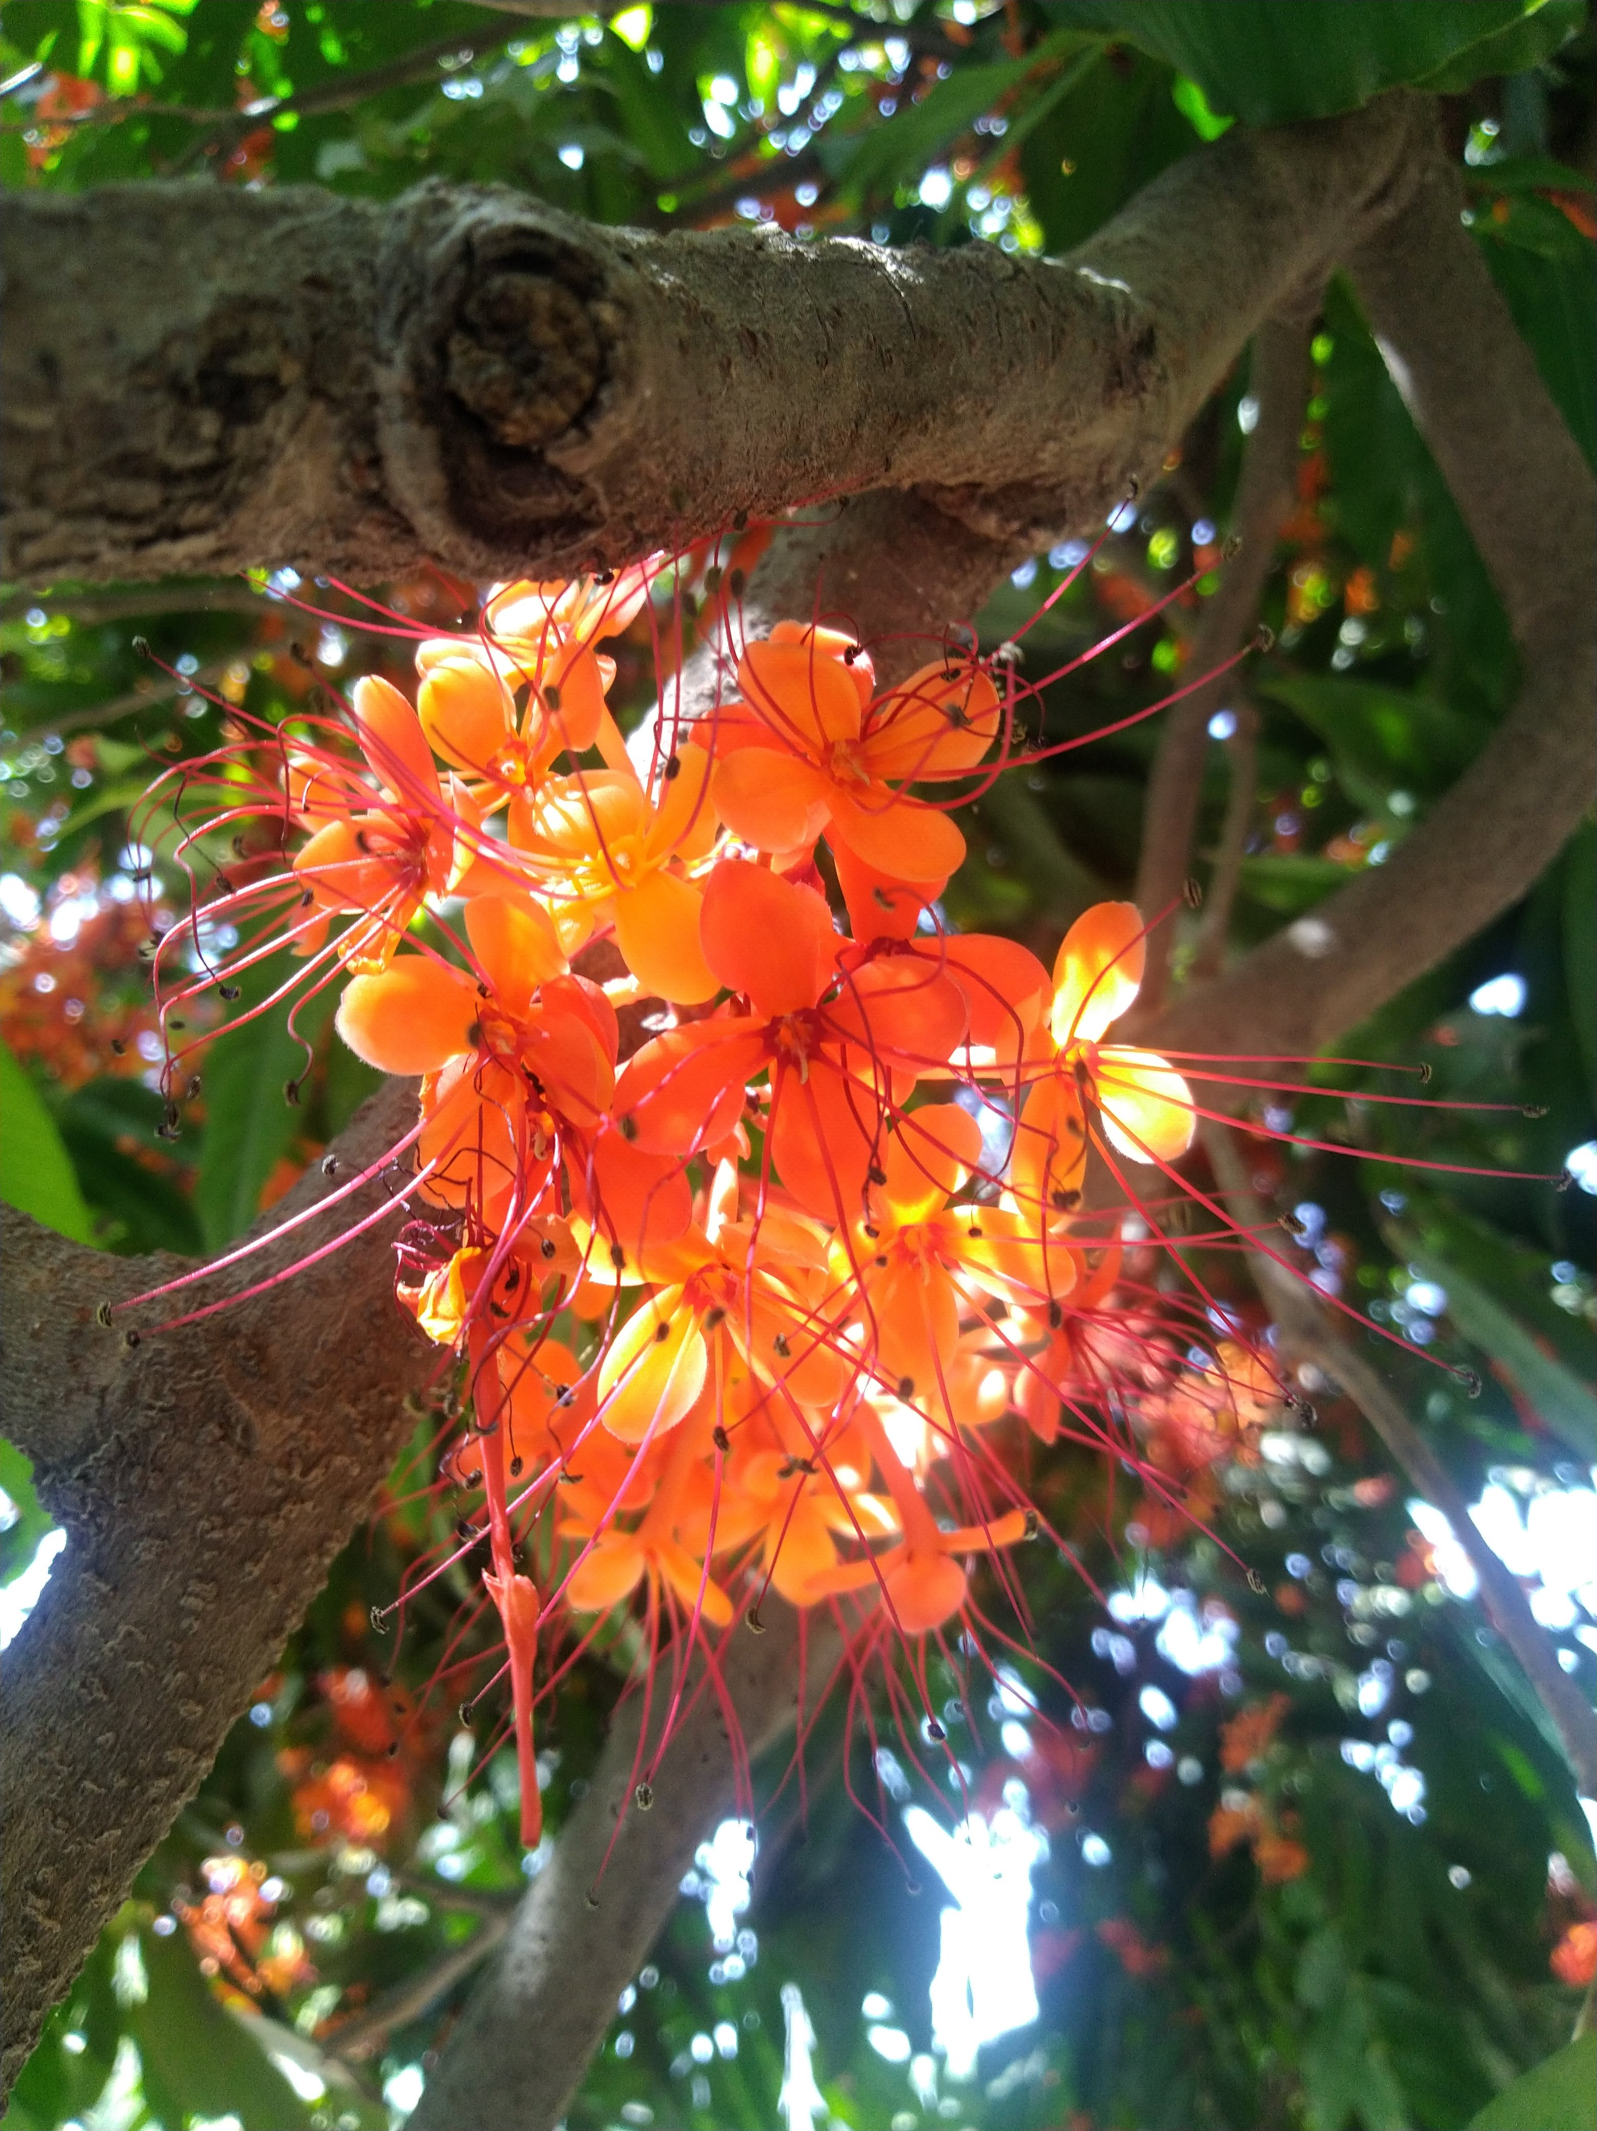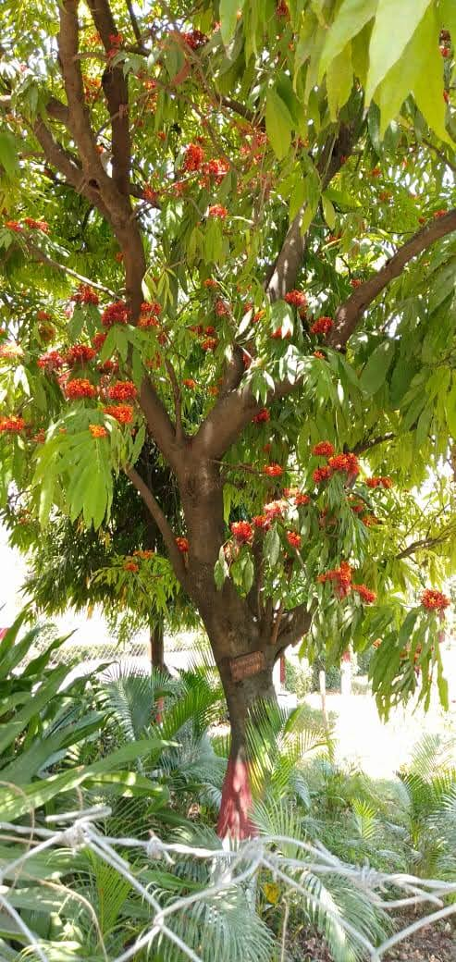
Figure 6: Ashoka, scientifically known as Saraca indica, is a prominent herb in traditional Ayurvedic medicine It is a medicinal plant with orange flowers, native to the Indian subcontinent, and is widely cultivated for its medicinal properties.

Natural products, vegetables, and other edible plants are important sources of essential minerals and nutrients in the diet. Supplementing with sufficient amounts of edible plants can raise the body's levels of essential nutrients and metals, lowering the risk associated with lead toxicity. In addition, edible plants supply a wide range of supplements, including phytochemicals and dietary protein, which have been shown to protect against Pb toxicity. From one region of the world to the next, garlic, ginger, and onion are utilized as ingredients for flavor, aroma, and taste enhancement throughout the world.
Garlic decreased the Pb burden and recovered immunological parameters in the blood and tissues [54]. Additionally, garlic is a well-known healing plant. In rats, Pb-induced brain, hepatic, renal, and hemolytic toxicity is reduced by garlic extract. Supplementing with these food fixings protected against Pb-induced renal and developmental harm because they have similar cell-strengthening properties to garlic.
Green tea is a common ingredient in Asian cuisine and has a number of known health benefits, including lowering oxidative stress, which is linked to diabetes. Green tea recovered hepatic function and alleviated histological changes in the liver [56].
Tomato (Lycopersicon esculentum) is one of the most well-known natural antioxidants and can prevent renal poisoning in rodents caused by Pb openness. When exposed to heavy metal particles, tomatoes have also been shown to produce metal-chelating proteins and phytochelatins. In point of fact, it has been demonstrated that taking tomatoes orally reduces the accumulation of heavy metals in rats' livers. Tomato intake recovered renal function and prevented the alterations of antioxidant enzymes activities in blood plasma [57].
Neem (Azadirachta indica), Torch ginger (Etlingera elatior), European columbine (Aquilegia vulgaris), and Tossa jute (Corchorus olitorius) are just a few of the plants that have been shown to protect against Pb poisoning.
Tossa jute, which is used as a vegetable and food fixing by people of Eastern Asia and Africa, it significantly restore the biochemical and haematological parameters and/or by preventing bioaccumulation of Pb within the tissues (Dewanjee et al. 2013).
Torch ginger, which is used in Malaysian neighbourhood dishes, are two examples of these plants that are well-known dietary components in particular regions. The increasing of enzymes levels in the oxidative biomarkers and histology of bone marrow was observed in the recent study (Haleagrahara et al. 2010).
Curcumin could be therapeutically used to chelate toxic metals. It potentially reduced their neurotoxicity and prevent tissue damage (Daneil et al. 2004). Spirulina and chlorella, two types of algae, can reduce Pb toxicity in animals' brain, kidneys, and liver. However, others of these plants are frequently used in drinks and confections (like liquorice). As a result, populations that are at risk of heavy metal exposure and who regularly consume these plants may benefit from their inclusion as dietary enhancements for the purpose of reducing and even eliminating symptoms of heavy metal intoxication.
Saraca indica (SI) belongs to the family Caesalpinaceae and is a crucial supporting plant with traditional importance. Saraca indica (SI) is important for uterine/ovarian fibroids, diseases, menorrhagia, uterine prolapse, and provocative conditions. It is primarily used for uterus prosperity. It is crucial for preventing unsuccessful labor beginning in the second trimester. The climate and human health are both significantly impacted by S. indica.
Saraca indica is an excellent source of natural antioxidants and their antioxidant activity may be due to phenolic and flavonoid content in different extracts like aqueous and ethanolic extract of S. indica [58]. The present study revealed that the various phytochemical components such as carbohydrates, flavonoids, saponins, phenols, tannins, glycosides, and steroids, are present in the leaves, bark, and flower of S. indica.
Recent studies have suggested that Saraca indica extracts (aqueous and ethanolic) may have potential in preventing initial damage caused by lead acetate toxicity in liver and kidney cells. HepG2 and HEK293 cells co-exposed to both compounds (lead acetate and S. indica extract) resulted in a significant (p<0.05) increase of cell growth and proliferation. These findings clearly showed evidence that S. indica extracts (aqueous and ethanolic) acts as a potential chelator of heavy metal that attenuates lead acetate induced toxicity in HepG2 and HEK293 cells [59].

Conclusion:
In conclusion, the research chapter explores the significant potential of traditional herbs in boosting the immune system and promoting overall health. The immune system, being a complex defense mechanism, plays a crucial role in protecting the body from harmful pathogens. Traditional herbal remedies have been used for centuries in different cultures, and their immunomodulatory properties have garnered attention in modern scientific research. The featured herbs, including Giloy, Ashwagandha, Garlic, Turmeric, and Ginger, have shown promising immunomodulatory effects. Their bioactive compounds, such as ginsenosides in Ginseng, allicin in Garlic, curcumin in Turmeric, and withanolides in Ashwagandha, have been linked to immune-enhancing actions. Numerous restorative plants play a significant role in treating lead damage. India is a rich source of numerous medicinal plants with many pharmacological properties. Herbal extracts rather than pure substances are used in the Ayurvedic medical system. One of the most appreciated and historic tree is Ashoka. Ashoka has numerous medicinal applications and is a nontoxic traditional medicinal herb, extract used to treat a variety of ailments. These herbs have been found to stimulate immune cells, regulate cytokine production, and support the body's natural defense mechanisms. The research highlights the importance of cytokine modulation caused by herbal plants, as cytokines play a crucial role in immune responses and inflammation regulation. Herbs like Ginseng, Garlic, and Turmeric have been shown to influence cytokine levels, promoting a balanced and efficient immune response. However, it is essential to exercise caution in using herbal remedies, as they may interact with certain medications or cause side effects in some individuals. Proper dosage and consultation with healthcare professionals are crucial to ensure safe and effective use of these herbal immunomodulators. Traditional herbal medicine, deeply rooted in ancient practices, continues to garner interest in the modern scientific community. As more studies are conducted to explore the immunomodulatory potential of these herbs, they may offer valuable insights and potential therapeutic alternatives for enhancing immune health and combating diseases. Overall, the research chapter underscores the importance of incorporating traditional herbal remedies into modern healthcare practices, especially in promoting immune system strength and resilience. As we continue to unlock the secrets of these natural agents, they may become integral components of immune-boosting strategies, complementing conventional approaches and contributing to improved public health outcomes.

REFERENCES

- StanelyMainzen PP, Menon VP, Gunasekaran G. Hypolipidaemic action of Tinospora cordifolia roots in alloxan diabetic rats. J Ethnopharmacol. 1999;64(1):53–57.
- Stanely P, Prince M, Menon VP. Hypoglycaemic and other related actions of Tinospora cordifolia roots in alloxan–induced diabetic rats. J Ethnopharmacol. 2000;70:9–15.
- Puranik N, Kammar KF, Devi S. Anti–diabetic activity of Tinospora cordifolia (Willd.) in streptozotocin diabetic rats; does it act like sulfonylureas?. Turk J Med Sci. 2010;40(2):265–270.
- Bishayi B, Roychowdhury S, Ghosh S, et al. Hepatoprotective and Immunomodulatory effects of Tinospora cordifolia in CCl4 Intoxicated Mature Albino Rats. J Toxicol Sci. 2002;27(3):139–146.
- Shanthi V, Nelson R. Anitbacterial activity of Tinospora cordifolia (Willd) Hook.F.Thoms on urinary tract pathogens. Int J CurrMicrobiol App Sci. 2013;2(6):190–194.
- Patgiri B, Umretia BL, Vaishnav PU, et al. Anti–inflammatory activity of Guduchi Ghana (aqueous extract of Tinospora cordifolia Miers.). Ayu. 2014;35(1):108–110.
- Kapur P, Jarry H, Wuttke W, et al. Evaluation of the antiosteoporotic potential of Tinospora cordifolia in female rats. Maturitas. 2008;59(4):329–338.
- Dhingra D, Jindal V, Sharma S, et al. Evaluation of antiobesity activity of Tinospora cordifolia stems in rats. Int J Res Ayur Pharmac. 2011;2(1):306–311.
- Verma R, Chaudhary HS, Agrawal RC. Evaluation of Anticarcinogenic and Antimutagenic Effect of Tinospora cordifolia in Experimental Animals. J Chem Pharm Res. 2011;3(6):877–881.
- Sharma V, Pandey D. Beneficial Effects of Tinospora cordifolia on Blood Profiles in Male Mice Exposed to Lead. Toxicol Int. 2010;17(1):8–11.
- Purandare H, Supe A. Immunomodulatory role of Tinospora cordifolia as an adjuvant in surgical treatment of diabetic foot ulcers: A prospective randomized controlled study. Indian J Med Sci. 2007;61(6):347–355.
- Nadig PD, Revankar RR, Dethe SM, et al. Effect of Tinospora cordifolia on experimental diabetic neuropathy. Indian J Pharmacol. 2012;44(5):580–583.
- Bairy KL, Rao Y, Kumar KB. Efficacy of Tinospora cordifolia on Learning and Memory in Healthy Volunteers: A Double–Blind, Randomized, Placebo Controlled Study. Iran J Pharmac Therap. 2004;3(2):57–60.
- More P, Pai K. Immunomodulatory effects of Tinospora cordifolia (Guduchi) on macrophage activation. Biol Med. 2011;3(2):134–140.
- Aher VD, Wahi AK. Pharmacological Study of Tinospora Cordifolia as an Immunomodulator. Int J Curr Pharm Res 2010;2(4):52–54.
- Kalikar MV, Thawani VR, Varadpande UK, et al. Immunomodulatory effect of Tinospora cordifolia extract in human immuno–deficiency virus positive patients. Indian J Pharmacol. 2008;40(3):107–110.
- Singh Narender, Bhalla Mohit, Jager PD, et al. An overview of ashwagandha; A rasayan (rejuvenator) of Ayurveda. AfrJ.Tradt Alter. Med. 2011;8(S):208–213.
- Mishra LC, Singh BB, Dagenais S. Scientific basis for the therapeutic use of Withaniasomnifera.(Ashwagandha): A review. Altern Med Rev. 2000;5:334–346.
- Ziauddin M, Phansalkar N, Patki P, et al. Studies on the immunomodulatory effects of Ashwagandha. J Ethnopharmacol. 1996;50(2):69–76.
- Hosny Mansour H, Farouk Hafez H. Protective effect of Withaniasomnifera against radiation–induced hepatotoxicity in rats. Ecotoxicol Environ Saf. 2012;80:14–19.
- Iuvone T, Esposito G, Capasso F, et al. Induction of nitric oxide synthase expression by Withaniasomnifera in macrophages. Life Sci. 2003;72(14):1617–1625.
- Deshpande A, Irani N, Balakrishnan R. Study protocol and rationale for a prospective, randomized, double–blind, placebo–controlled study to evaluate the effects of Ashwagandha (Withaniasomnifera) extract on nonrestorative sleep. Medicine (Baltimore). 2018;97(26):e11299.
- Salman H, Bergman M, Bessler H, et al. Effect of a garlic derivative (alliin) on peripheral blood cell immune responses. Int J of Immunopharmac. 1999;21(9);589–597.
- Reinhart KM, Talati R, White CM, et al. The impact of garlic on lipid parameters: a systematic review and meta–analysis. Nutr Res Rev. 2009;22(1)39– 48.
- Eilat–Adar S, Sinai T, Yosefy C, et al. Nutritional recommendations for cardiovascular disease prevention. Nutrients. 2013;5(9):3646–3683.
- Khatua TN, Adela R, Banerjee SK. Garlic and cardioprotection: insights into the molecular mechanisms. CanadianJPhysiolPharmac. 2013;91 (6),448– 458.
- Fridman S, Sinai T, Zilberg D. Efficacy of garlic based treatments against monogenean parasites infecting the guppy (Poecilia reticulata (Peters) Veterinary Parasit. 2014;203(1–2):51–58.
- Bauer D, Mazzio E, Soliman KF, et al. Diallyl disulfide inhibits TNFα– induced CCL2 release by MDA–MB–231 cells. Anticancer Res. 2014;34(6):2763–2770.
- Park SY, Seetharaman R, Ko MJ, et al. Ethyl linoleate from garlic attenuates lipopolysaccharide–induced pro–inflammatory cytokine production by inducing heme oxygenase–1 in RAW264.7 cells. Int Immunopharmacol. 2014;19(2):253–261.
- Borlinghaus J, Albrecht F, Gruhlke MC, et al. Allicin: chemistry and biological properties. Molecules. 2014;19(8):12591–12618.
- Whitaker JR, Development of Flavor, Odor, and Pungency in Onion and Garlic. Adv Food Res. 1976;22;73–133.
- Nantz MP, Rowe CA, Muller CE, et al. Supplementation with aged garlic extract improves both NK and γδ–T cell function and reduces the severity of cold and flu symptoms: a randomized, double–blind, placebo– controlled nutrition intervention. Clin Nutr. 2012;31(3):337–344.
- Chandrashekar PM, Prashanth KVH, Venkatesh YP. Isolation, structural elucidation and immunomodulatory activity of fructans from aged garlic extract. Phytochemistry. 2011;72(2–3):255–264.
- He Y, Yue Y, Zheng X, et al. Curcumin, inflammation, and chronic diseases: How are they linked? Molecules. 2015;20:9:183–213.
- Ghosh S, Banerjee S, Sil PC. The beneficial role of curcumin on inflammation, diabetes and neurodegenerative disease: A recent update. Food Chem Toxicol. 2015;83:111–124.
- Zandi K, Ramedani E, Mohammadi K, et al. Evaluation of antiviral activities of curcumin derivatives against HSV–1 in Vero cell line. Nat Prod Commun. 2010;5:1935–1938.
- Moghadamtousi SZ, Kadir HA, Hassandarvish P, et al. A review on antibacterial, antiviral, and antifungal activity of curcumin. Biomed Res Int. 2014;2014:186864.
- Sandur SK, Ichikawa H, Pandey MK, et al. Role of pro–oxidants and antioxidants in the anti–inflammatory and apoptotic effects of curcumin (diferuloylmethane). Free Radic Biol Med. 2007;43:568–580.
- Peterson CT, Vaughn AR, Sharma V, et al. Effects of Turmeric and Curcumin Dietary Supplementation on Human Gut Microbiota: A Double–Blind, Randomized, Placebo–Controlled Pilot Study. J Evid Based Integr Med. 2018;23:2515690X18790725.
- Adam EK, Quinn ME, Tavernier R, et al. Diurnal cortisol slopes and mental and physical health outcomes: A systematic review and meta– analysis. Psychoneuroendocrinology. 2017;83:25–41.
- Yu JJ, Pei LB, Zhang Y, et al. Chronic Supplementation of Curcumin Enhances the Efficacy of Antidepressants in Major Depressive Disorder: A Randomized, Double–Blind, Placebo–Controlled Pilot Study. J Clin Psychopharmacol. 2015;35(4):406–410.
- Bode AM, Dong Z. The Amazing and Mighty Ginger. In: Benzie IFF, Wachtel–Galor S, editors. Herbal Medicine: Biomolecular and Clinical Aspects. 2nd edition. Boca Raton (FL): CRC Press/Taylor & Francis; 2011.
- Mashhadi NS, Ghiasvand R, Askari G, et al. Anti–oxidative and anti– inflammatory effects of ginger in health and physical activity: review of current evidence. Int J Prev Med. 2013;4(Suppl 1):S36–S42.
- Da Silveira e Sá Rde C, Andrade LN, de Sousa DP. Sesquiterpenes from Essential Oils and Anti–Inflammatory Activity. Nat Prod Commun. 2015;10(10):1767–1774.
- Reddy AC, Lokesh BR. Studies on spiceprinciples as antioxidants in the inhibition of lipid peroxidation of rat liver microsomes. Mol Cell Biochem. 1992;111(1–2):117–124.
- Zehsaz F, Farhangi N, Mirheidari L. The effect of Zingiber officinale R. rhizomes (ginger) on plasma pro–inflammatory cytokine levels in well– trained male endurance runners. Cent Eur J Immunol. 2014;39(2):174– 180.
- Minghetti P, Sosa S, Cilurzo F, et al. Evaluation of the topical anti– inflammatory activity of ginger dry extracts from solutions and plasters. Planta Med. 2007;73(15):1525–1530.
- Ramalingum N, Mahomoodally MF. The therapeutic potential of medicinal foods. Adv Pharmacol Sci. 2014;2014:354264.
- Dias DA, Urban S, Roessner U. A historical overview of natural products in drug discovery. Metabolites. 2012;2(2):303-36.
- Wadood A, Ghufran M, Jamal SB, Naeem M, Khan A, Ghaffar R, et al. Phytochemical analysis of medicinal plants occurring in local area of Mardan. Biochem Anal Biochem. 2013;2(4):1-4.
- Daniel, S., Limson, J. L., Dairam, A., Watkins, G. M., & Daya, S. (2004). Through metal binding, curcumin protects against lead-and cadmium-induced lipid peroxidation in rat brain homogenates and against lead-induced tissue damage in rat brain. Journal of inorganic biochemistry, 98(2), 266-275.
- Dewanjee, S., Sahu, R., Karmakar, S., & Gangopadhyay, M. (2013). Toxic effects of lead exposure in Wistar rats: involvement of oxidative stress and the beneficial role of edible jute (Corchorus olitorius) leaves. Food and chemical toxicology, 55, 78-91.
- Haleagrahara, N., Jackie, T., Chakravarthi, S., Rao, M., & Pasupathi, T. (2010). Protective effects of Etlingera elatior extract on lead acetate-induced changes in oxidative biomarkers in bone marrow of rats. Food and Chemical Toxicology, 48(10), 2688-2694.
- Sharma, V.; Sharma, A.; Kansal, L. The effect of oral administration of Allium sativum extracts on lead nitrate induced toxicity in male mice. Food Chem. Toxicol. 2010, 48, 928–936.
- Massage AM, Al-Safi SA, Momani IF, Alomary AA, Jaradat QMand AlKofahi AS: Garlic (Allium sativum L.) as a potential antidote for cadmium and lead intoxication: cadmium and lead distribution and analysis in different mice organs. Biol Trace Elem Res 120: 227-234, 2007.
- Mehana, E.; Meki, A.R.; Fazili, K.M. Ameliorated effects of green tea extract on lead induced liver toxicity in rats. Exp. Toxicol. Pathol. 2012, 64, 291–295.
- Salawu, E.O.; Adeleke, A.A.; Oyewo, O.O.; Ashamu, E.A.; Ishola, O.O.; Afolabi, A.O.; Adesanya, T.A. Prevention of renal toxicity from lead exposure by oral administration of Lycopersicon esculentum. J. Toxicol. Environ. Health Sci. 2009, 1, 22–27.
- Shivhare B, Rani R, Pandey M and Kumar R. Antioxidant capacity and metabolic characterization of aqueous and ethanolic extract of Saraca indica, Journal of Pharmacognosy and Phytochemistry, Vol. 12, Issue 1, pp 44-51.
- Shivhare B, Pandey M and Kumar R. Antioxidant potential and in vitro cytotoxicity study of Saraca indica extract on lead-induced toxicity in HepG2 and HEK293 cell lines, Indian Journal of Natural Products and Resources, Vol. 14(1), pp 67-74.

